Cisco Packer Tracer

Objective:

1. Create 4 vlans id.(10,20,30,40)
2. Two remote site name Area_A and Area_B.
3. Area_A location. Installed :1 Router,3 switches and client PC’s with vlan id 10 and 20.
4. Area_B location .Installed:1 Router,3 switches, DNS server, WEB server and client PC’s with vlan id 30 and 40.
5. All client PC’s is able to access the website url name:www.talib.com
6. All client PC’s IP address is obtain and configured as DHCP.

**Steps 1:**

Create 4 switches 2960 and rename each switch as diagram below:

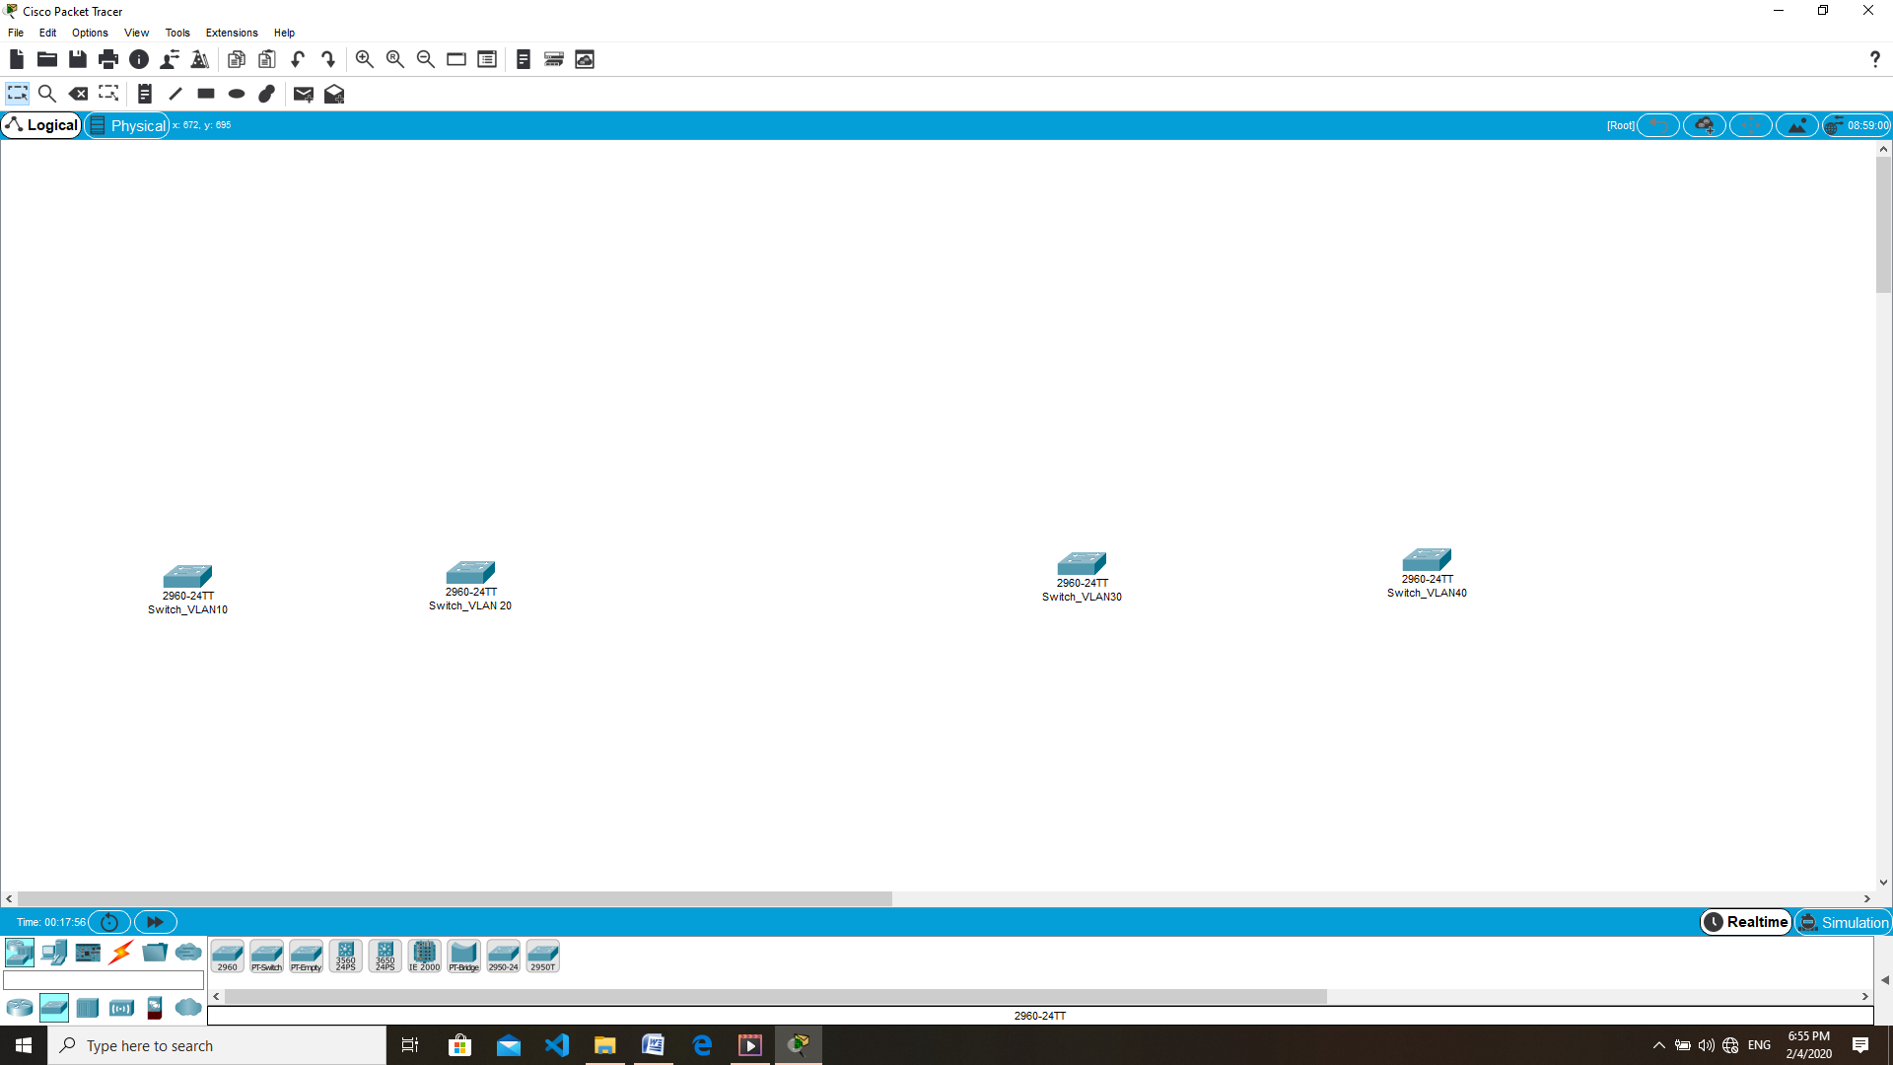

Double click the *switch_vlan10* and goto CLI tab.

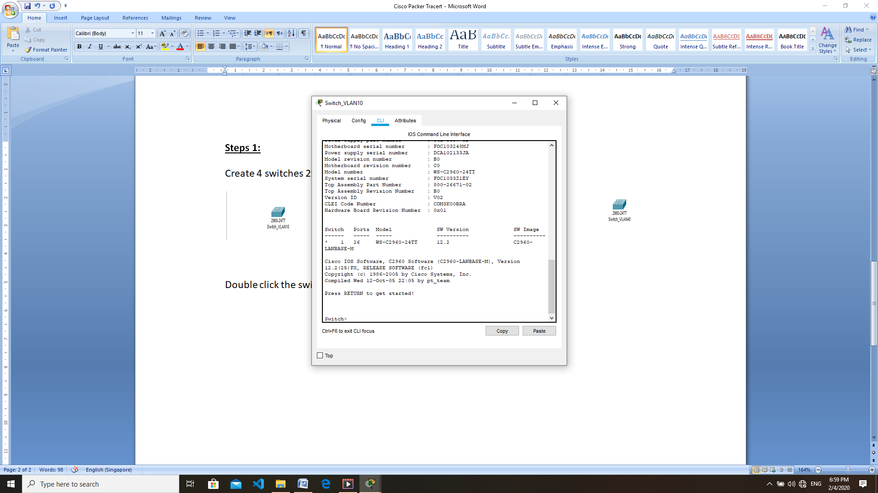

Enter the command:

switch#**config t**

**sw**itch(config)#vlan 10

switch(config-vlan)#exit

switch(config)#interface range fastEthernet 0/1-4

switch(config-if-range)#switchport mode access

switch(config-if-range)#switchport access vlan 10

switch(config-if-range)#do write

switch(config-if-range)#end

-------------------------------------------------------------------------------------------------------------------------------------

Next go to *switch_vlan20*

Enter the command:

switch#**config t**

**sw**itch(config)#vlan 20

switch(config-vlan)#exit

switch(config)#interface range fastEthernet 0/1-4

switch(config-if-range)#switchport mode access

switch(config-if-range)#switchport access vlan 20

switch(config-if-range)#do write

switch(config-if-range)#end

Next go to *switch_vlan30*

Enter the command:

switch#**config t**

**sw**itch(config)#vlan 30

switch(config-vlan)#exit

switch(config)#interface range fastEthernet 0/1-4

switch(config-if-range)#switchport mode access

switch(config-if-range)#switchport access vlan 30

switch(config-if-range)#do write

switch(config-if-range)#end

Next go to *switch_vlan40*

Enter the command:

switch#**config t**

**sw**itch(config)#vlan 40

switch(config-vlan)#exit

switch(config)#interface range fastEthernet 0/1-4

switch(config-if-range)#switchport mode access

switch(config-if-range)#switchport access vlan 40

switch(config-if-range)#do write

switch(config-if-range)#end

----------------------------------------------------------------------------------------------------------------------------------

Step 2:

Add 2 more switches for Area A and Area B as shown below.

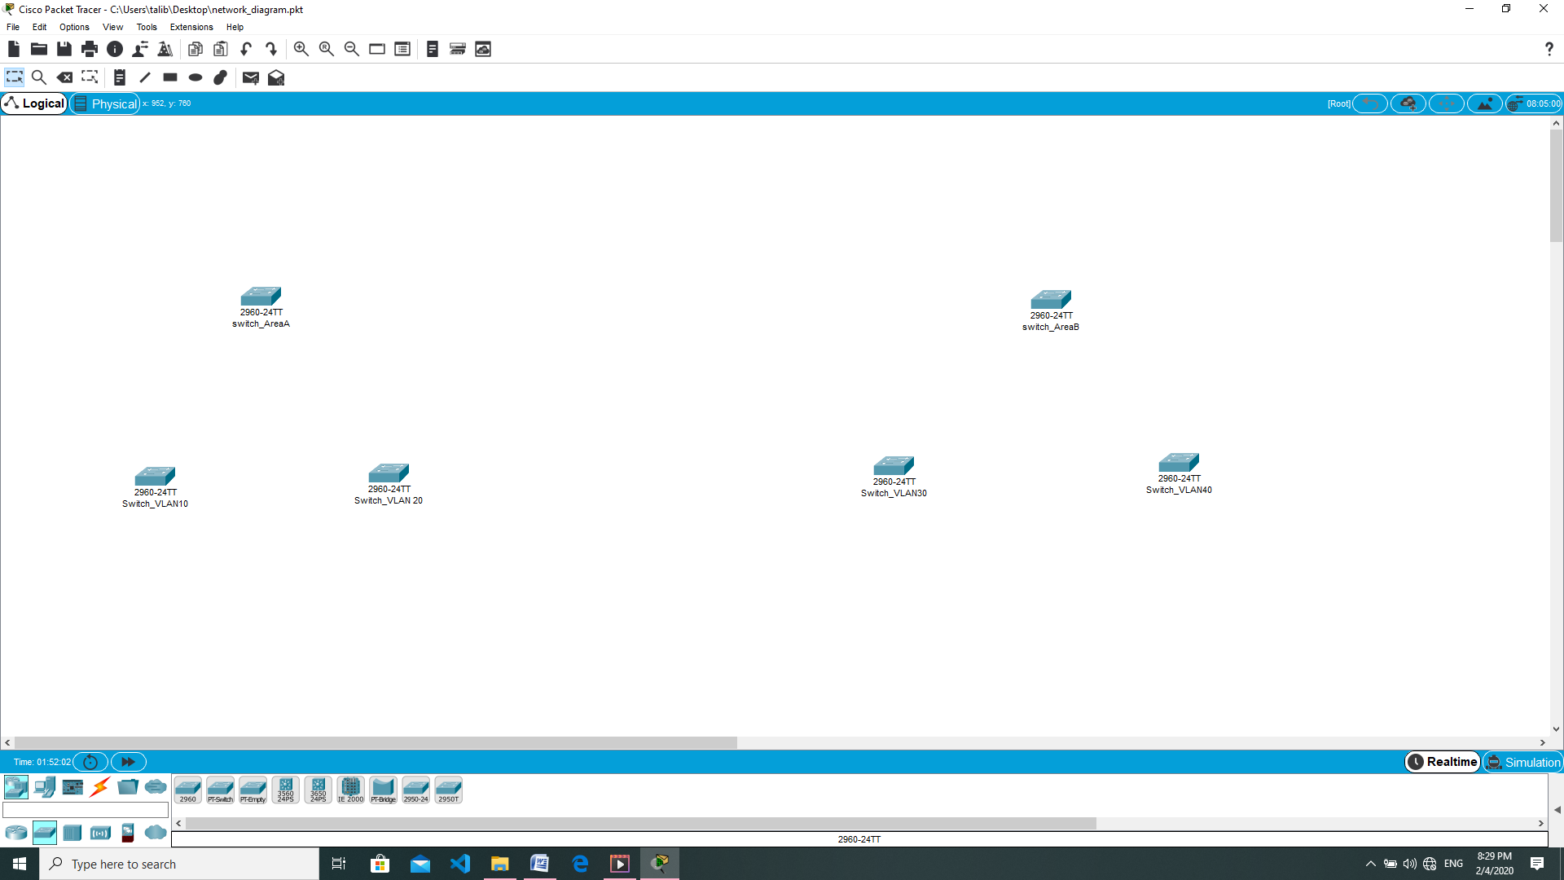

AreaA switch2960 CLI command:

switch>enable

switch#config t

switch(config)#vlan 10

switch(config-vlan)#exit

switch(config)#vlan 20

switch(config-vlan)#exit

switch(config)#interface fastEthernet 0/1

switch(config-if)#switchport mode access

switch(config-if)#switchport access vlan 10

switch(config-if)#exit

switch(config)#interface fastEthernet 0/2

switch(config-if)#switchport mode access

switch(config-if)#switchport access vlan 20

switch(config-if)#exit

//create trunk on port 4

switch(config)#interface fastEthernet 0/4

switch(config-if)#switchport mode trunk

switch(config-if)#do write

switch(config-if)#exit

switch(config)#end

AreaB switch2960 CLI command:

switch>enable

switch#config t

switch(config)#vlan 30

switch(config-vlan)#exit

switch(config)#vlan 40

switch(config-vlan)#exit

switch(config)#interface fastEthernet 0/1

switch(config-if)#switchport mode access

switch(config-if)#switchport access vlan 30

switch(config-if)#exit

switch(config)#interface fastEthernet 0/2

switch(config-if)#switchport mode access

switch(config-if)#switchport access vlan 40

switch(config-if)#exit

//create trunk on port 4

switch(config)#interface fastEthernet 0/4

switch(config-if)#switchport mode trunk

switch(config-if)#do write

switch(config-if)#exit

switch(config)#end