Step 3: Add a Router to AreaA

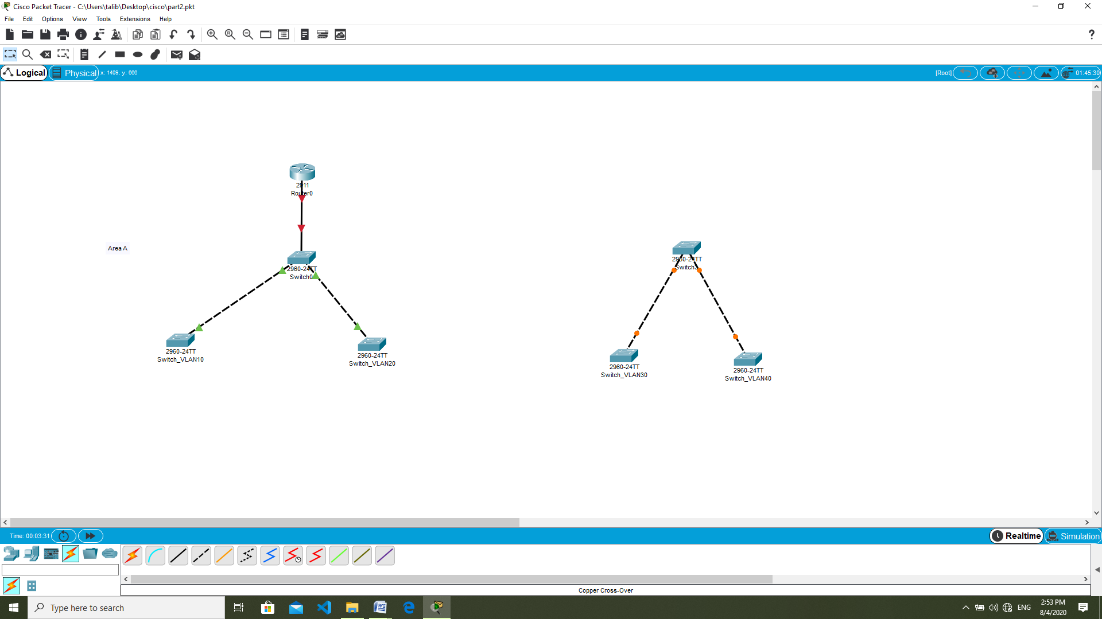

**\*(use router: PT-Router)**

**Enable interface FastEthernet 0/0 for Area A router.**

Type in the command

router > enable

router#config t

router(config)#interface fastEthernet 0/0

router(config-if)#no shutdown

router(config-if)exit

**Create 2 subinterface for Area A VLAN traffic.**

Type in the command

router(config)#interface fastEthernet 0/0.1

router(config-subif)#encapsulation dot1Q 10

router(config-subif)#ip address 192.168.1.1 255.255.255.0

router(config-subif)#exit

router(config)#interface fastEthernet 0/0.2

router(config-subif)#encapsulation dot1Q 20

router(config-subif)#ip address 192.168.2.1 255.255.255.0

router(config-subif)#exit

router#do write

**Create DHCP name: called pool 1 and pool 2.**

**Create Network ID.**

**Initialise the default route for VLAN 10 and 20.**

Type in the command

router(config)#ip dhcp pool 1

router(dhcp-config)#network 192.168.1.0 255.255.255.0

router(dhcp-config)#default-router 192.168.1.1

router(dhcp-config)#exit

router(config)#ip dhcp pool 2

router(dhcp-config)#network 192.168.2.0 255.255.255.0

router(dhcp-config)#default-router 192.168.2.1

router(dhcp-config)#exit

router#do write

Step 4: Add a Router to AreaB

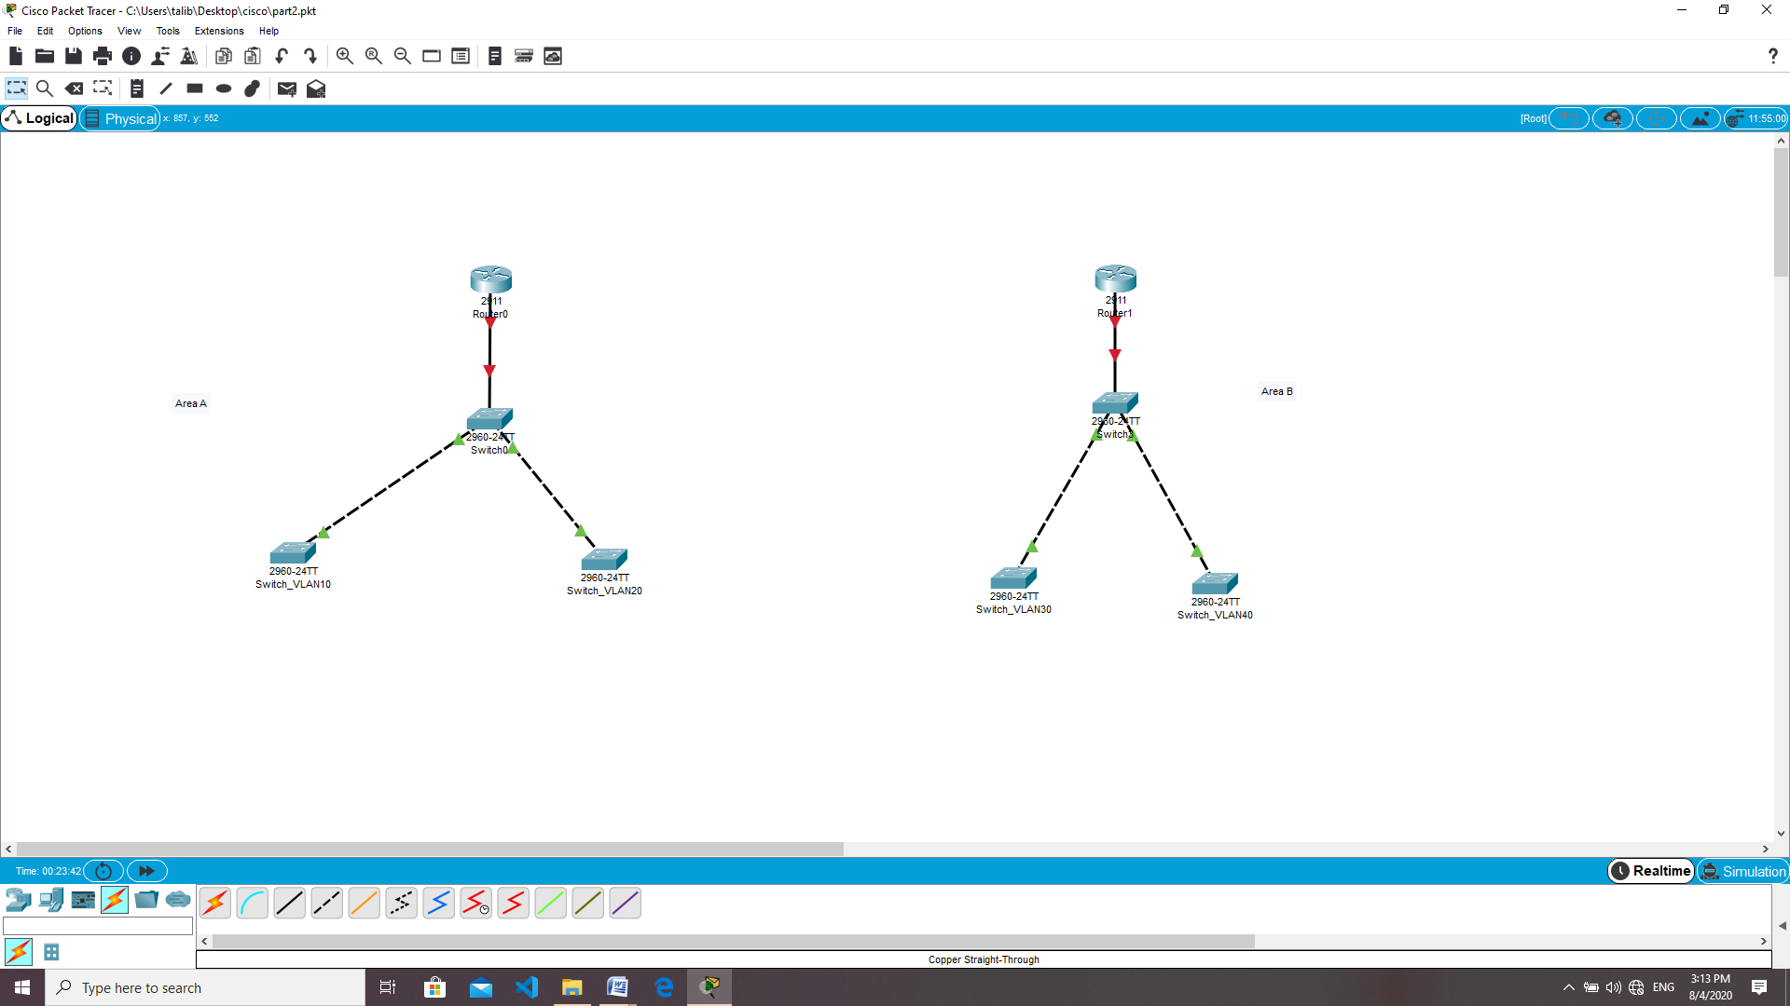

**Enable interface fastEthernet 0/0 for Area B router.**

Type in the command

router > enable

router#config t

router(config)#interface fastEthernet 0/0

router(config-if)#no shutdown

router(config-if)exit

**Create 2 subinterface for Area A VLAN traffic.**

Type in the command

router(config)#interface fastEthernet 0/0.1

router(config-subif)#encapsulation dot1Q 30

router(config-subif)#ip address 192.168.3.1 255.255.255.0

router(config-subif)#exit

router(config)#interface fastEthernet 0/0.2

router(config-subif)#encapsulation dot1Q 40

router(config-subif)#ip address 192.168.4.1 255.255.255.0

router(config-subif)#exit

router#do write

**Create DHCP name: called pool 3 and pool 4.**

**Create Network ID.**

**Initialise the default route for VLAN 30 and 40.**

Type in the command

router(config)#ip dhcp pool 3

router(dhcp-config)#network 192.168.3.0 255.255.255.0

router(dhcp-config)#default-router 192.168.3.1

router(dhcp-config)#exit

router(config)#ip dhcp excluded-address 192.168.3.1 – 5

*if command does not work. Copy and paste example:

ip dhcp excluded-address 192.168.3.1 – 5

ip dhcp excluded-address 192.168.3.2

ip dhcp excluded-address 192.168.3.3

ip dhcp excluded-address 192.168.3.4

ip dhcp excluded-address 192.168.3.5

router(config)#ip dhcp pool 4

router(dhcp-config)#network 192.168.4.0 255.255.255.0

router(dhcp-config)#default-router 192.168.4.1

router(dhcp-config)#exit

router#do write