Steps 5:

Add DNS and Web Server at Area B

Add all the workstation.

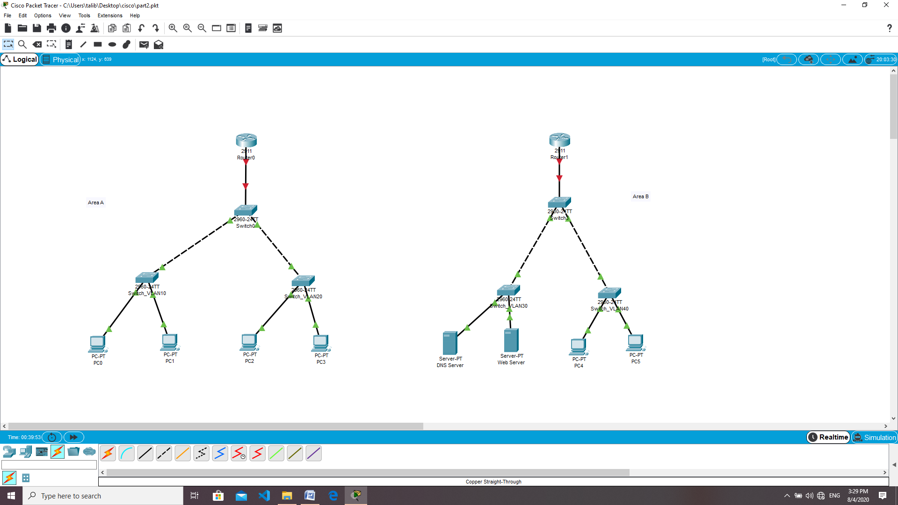

DNS server setup

Desktop tab:IP Configuration.

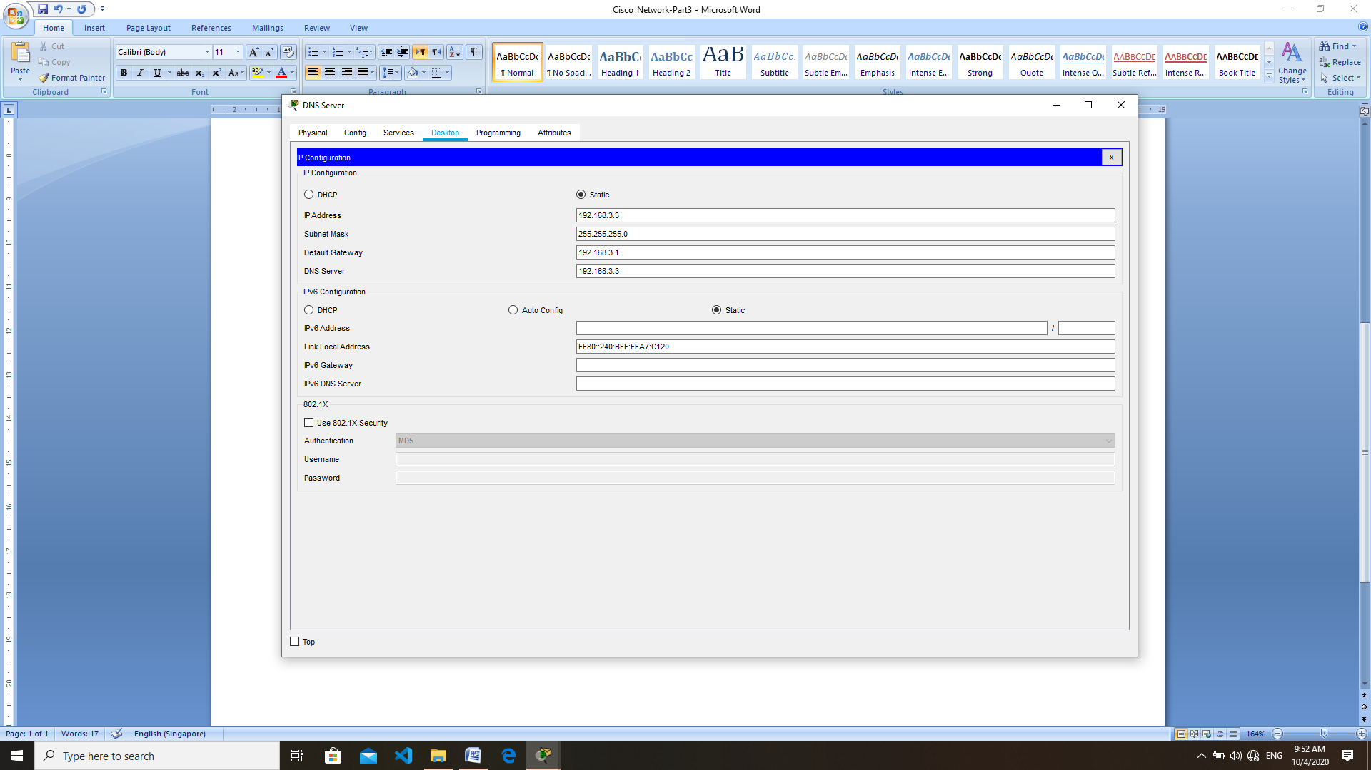

Services tab:Services DNS

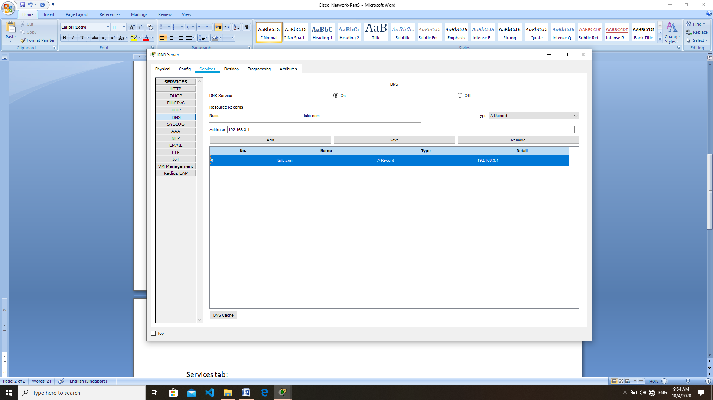

Web Server setup

