Add connection serial DTE from router_AreaA to router AreaB.

Used Router-PT.

Used serial interface 2/0.

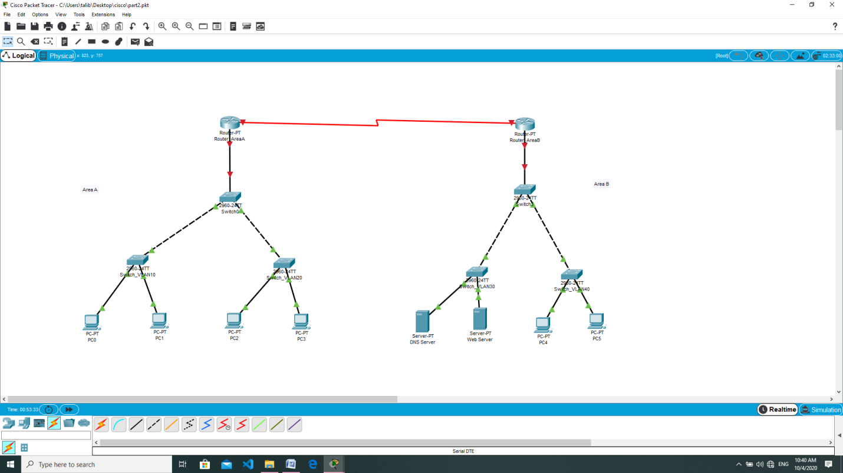

Router_Area A

At Config tab:Enable: Port status,Clock Rate, IP Address and Subnet at the Serial 2/0 interface.

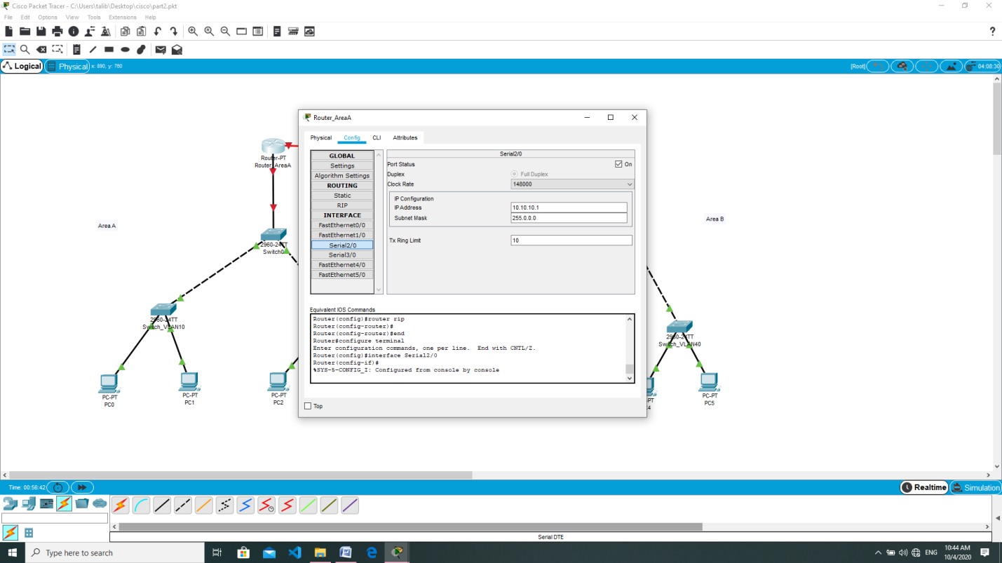

At RIP routing.

Add IP addresses.

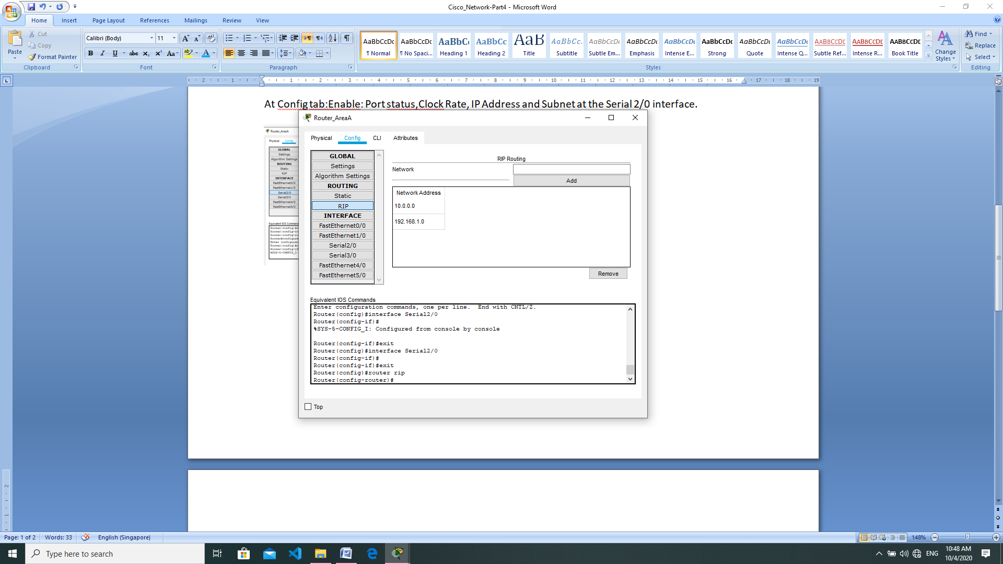

Router_Area B

At Config tab:Enable: Port status,Clock Rate, IP Address and Subnet at the Serial 2/0 interface.

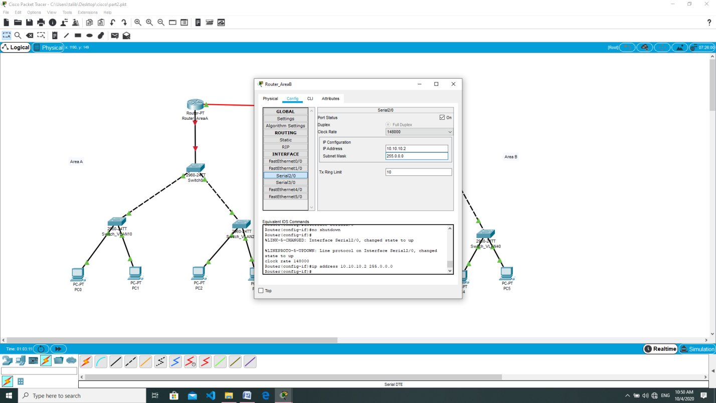

At RIP routing.

Add IP addresses.

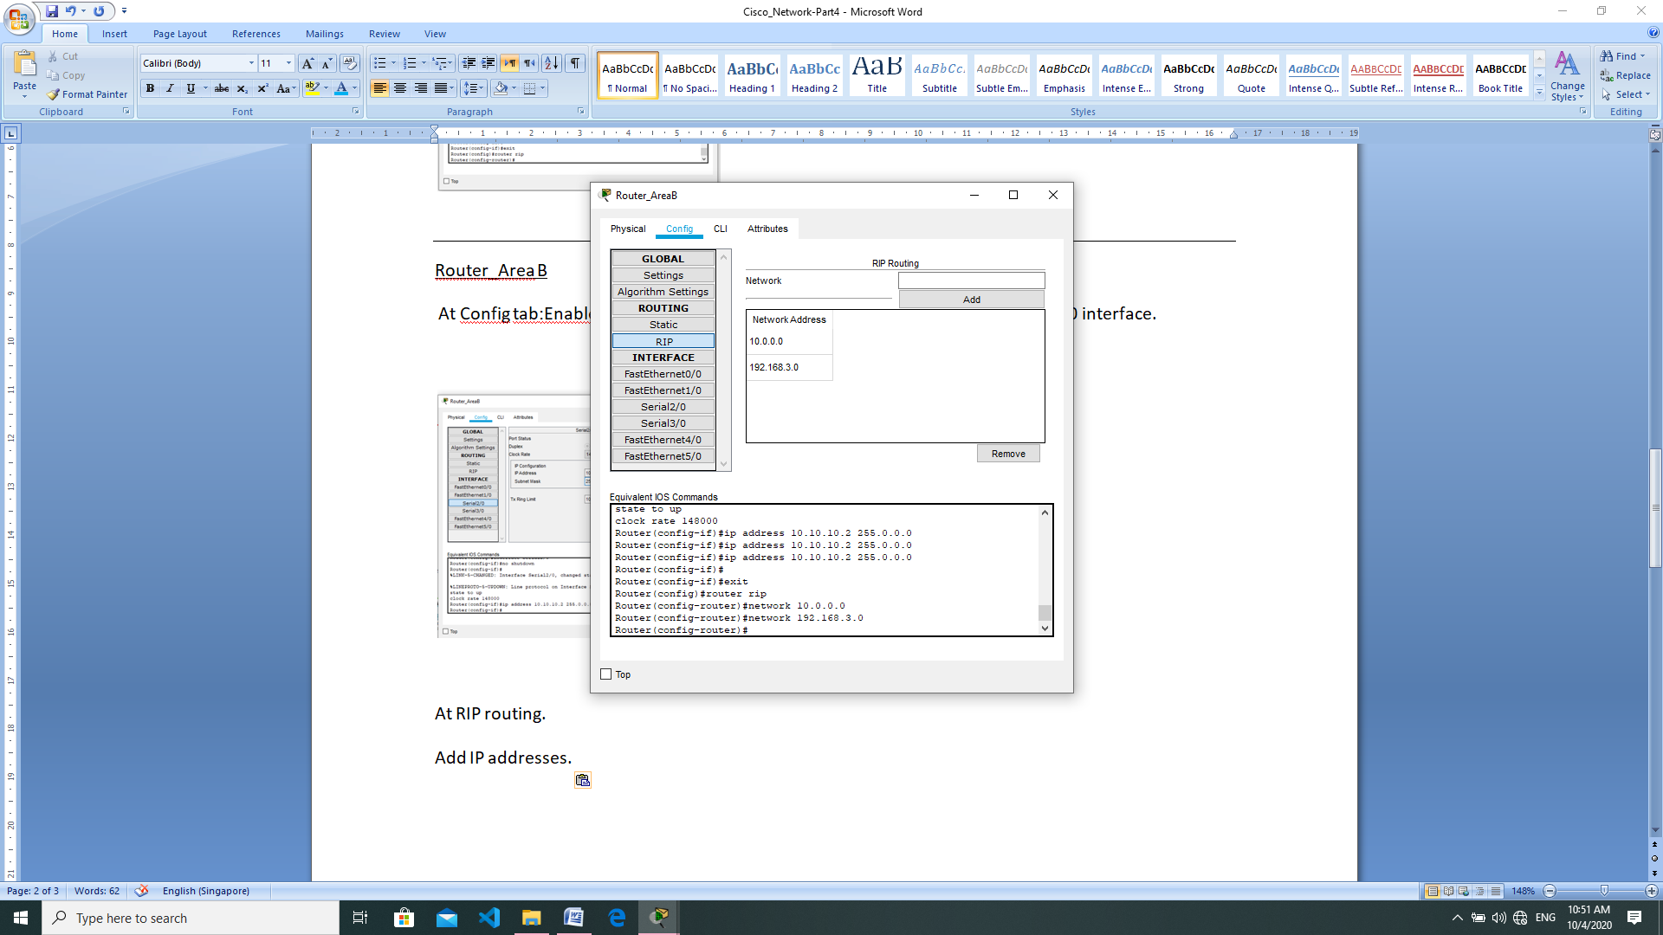

Add DNS domain-lookup for both router

Router(config)#ip domain-lookup

Router(config)#ip name-server 192.168.3.3

Router(config)#do write

At PC enable DCHP and browser type in talib.com

