Task 1:Working with unclean data

We are working with dataset.tsv The data is in a raw, unprocessed format and may therefore contain missing or logically incorrect values. The first warm-up task is to describe the data - try to answer what is the data about, what are the different features and their types and how many rows are there. Next take a look at the missing values (“?”, “”, NA) - are they missing systematically or randomly? What should you do with the missing values? (e.g. impute them? remove them? do nothing?) Justify your decision. Other than that, check for possible outliers outside 1.5IQR and decide what to do with them (e.g. remove them or not).
Report if you noticed any logically incorrect values.

The data seems to be records of money transfer transactions in the time period from 2016-01-01 to 2017-03-12.

Most frequent user of the service has the id 'ddbac55d04' and has done 152 transfers in total.
The user with highest total transfer amount is ‘d71d16e6b5’ and has a total transfer sum of 18849552.0 GBP.

Top 10 Users By Total Transfer Sum:

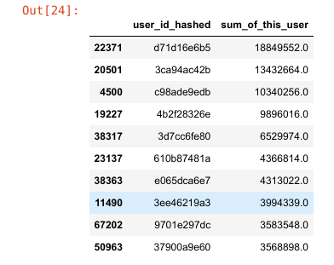

Most of the data was is in string format and hence needed to be converted to an appropriate format for further exploration.

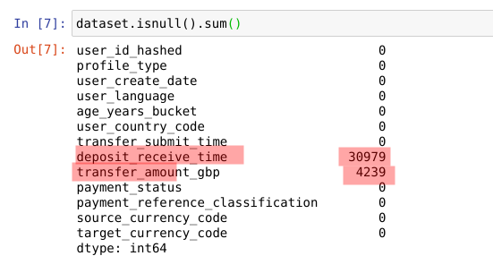

As can be seen from above table, columns of ‘deposit_receive_time’ and ‘transfer_amount_gbp’ contain missing values. All other columns do not contain missing values.

Missing Deposit Received Time values

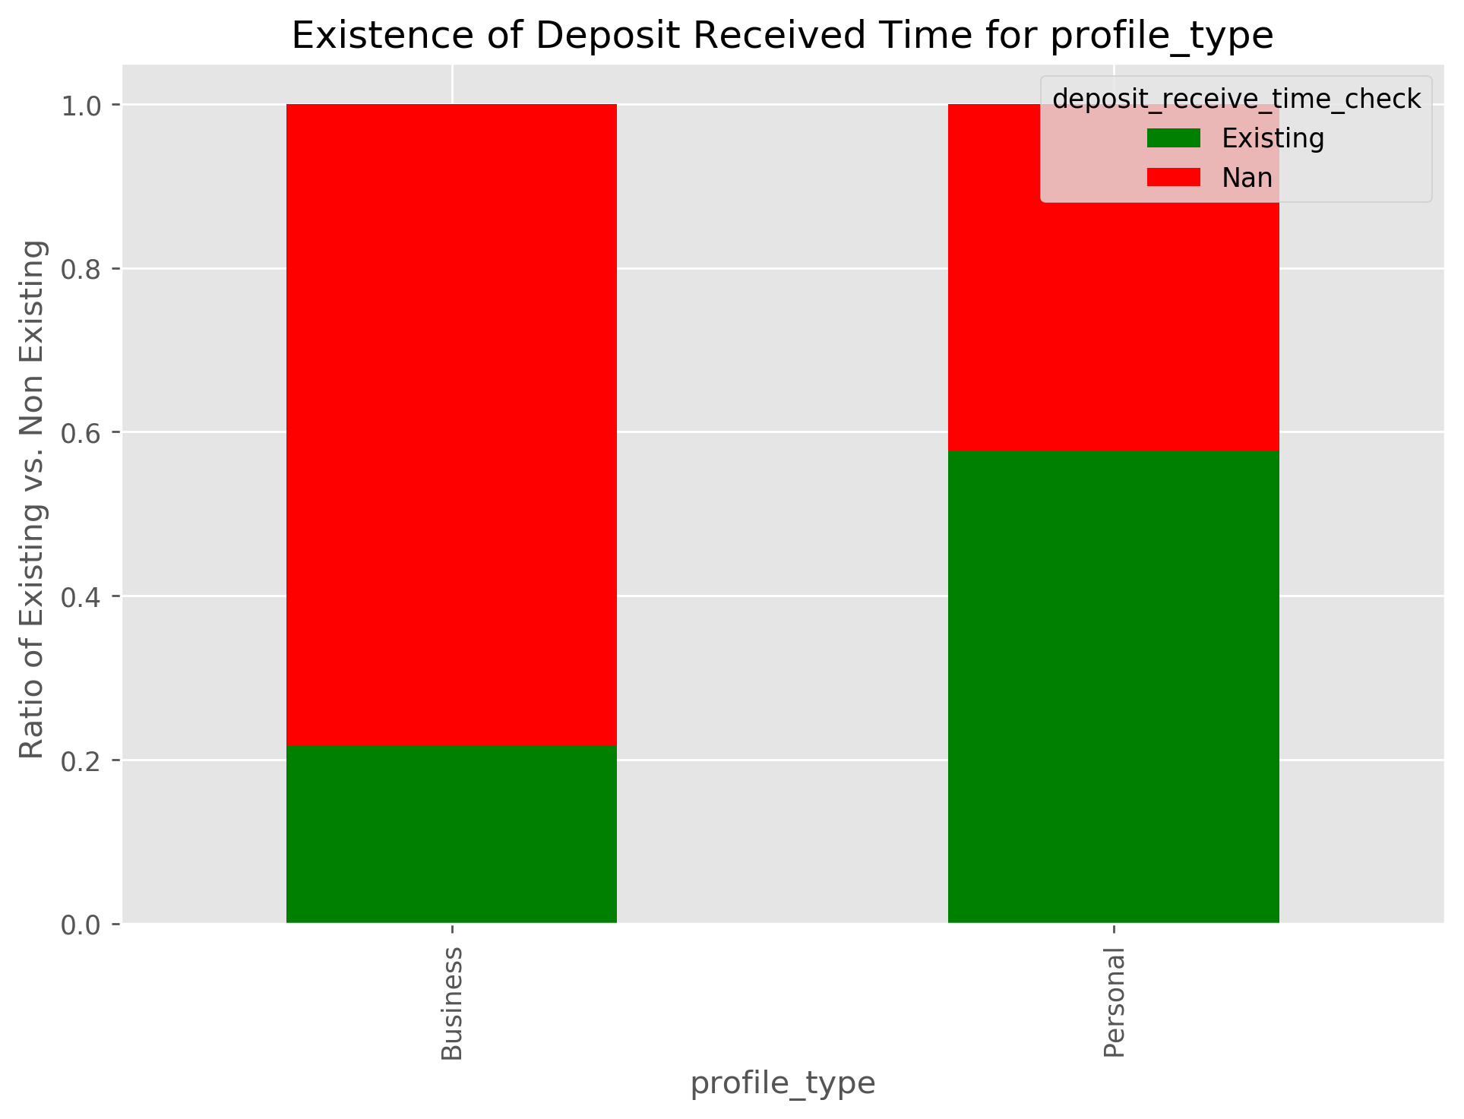

Records with the Profile Type category of ‘Business’ contain a high ratio of missing deposit received time values. Around 80% of 'Business' profile type records are missing deposit received time values.

However, most of these have Payment Status as 'Cancelled' as is shown below:

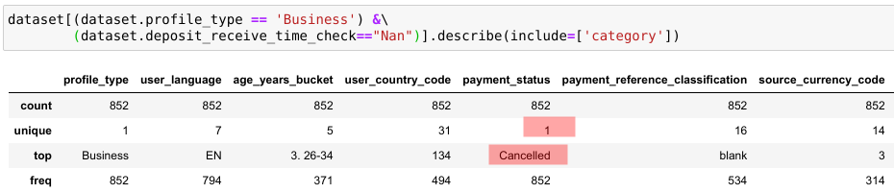

Records with the User Language category of 'JA' are entirely missing deposit received time values. This is not the case with any other user language category.However number of records with missing values with missing deposit received time values for 'JA' language category are only 2 out of 71k. Hence, missing values cannot be attributed to the user language being 'JA'.

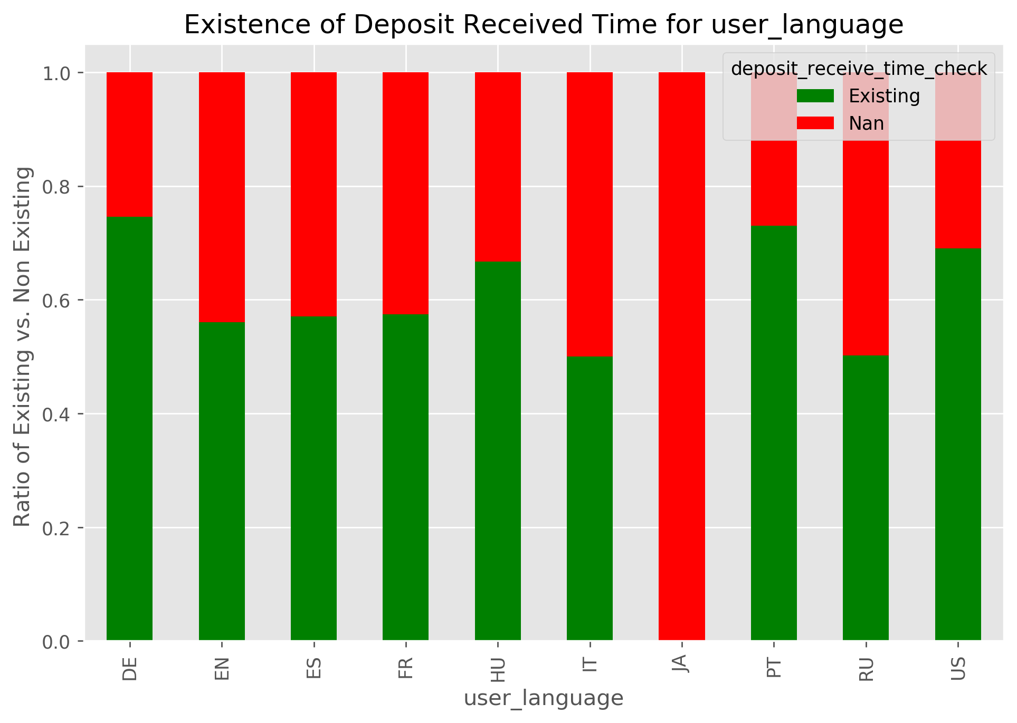

Records with the source curreny code of 11 and 35 and records with target currency code of 65 and 73 are entirely missing deposit received time values. This is not the case with any source/target curreny code .Records with user country code of 7,43,47,54,75,93,117,119,121,179,198,217,225 are entirely missing deposit received time values.

Despite the above facts almost all the records(>96%) with 'Cancelled' payment status are missing deposit received time values while none of the records with 'Transferred' payment status are missing deposit recived time values. Hence the mising of Deposit Received time values can be logically attributed to the 'Cancelled' payment status.

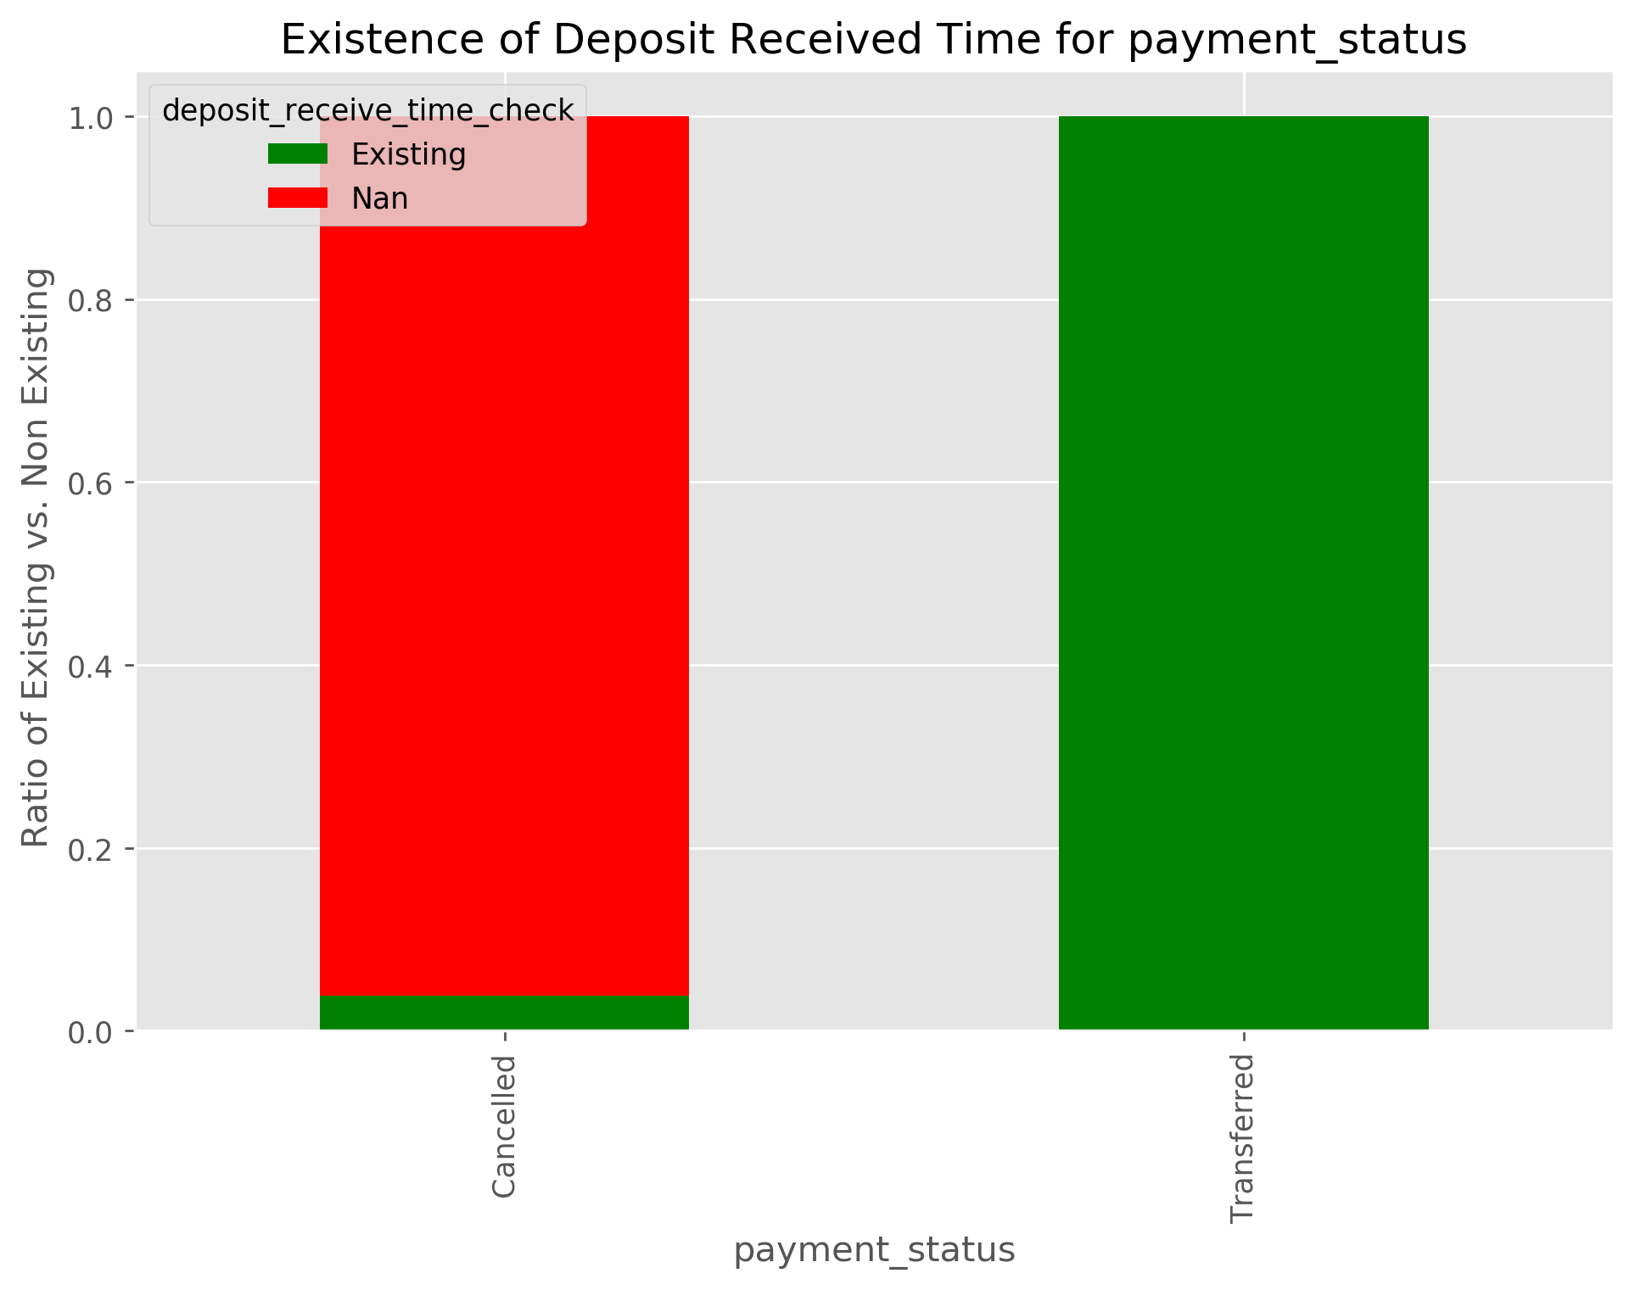

In addition, from the figure below we can see that records with payment status of ‘Cancelled’ make up for the (30977/30979 x 100) = 99.99% of the missing ‘Deposit Received time’ values. Hence, we can effectively conclude this as the cause of missing Deposit Missing time values. In this case, the missing values shall be given a new category. Imputation with some other values will necessarily mean introduction of false information into our data.

Missing Transfer Amount GBP values

Records with the Age Year bucket value of '2. 18-25' is the only age-years bucket value that is missing Transfer Amount values. All other age buckets are not missing Transger Amount GBP Values.

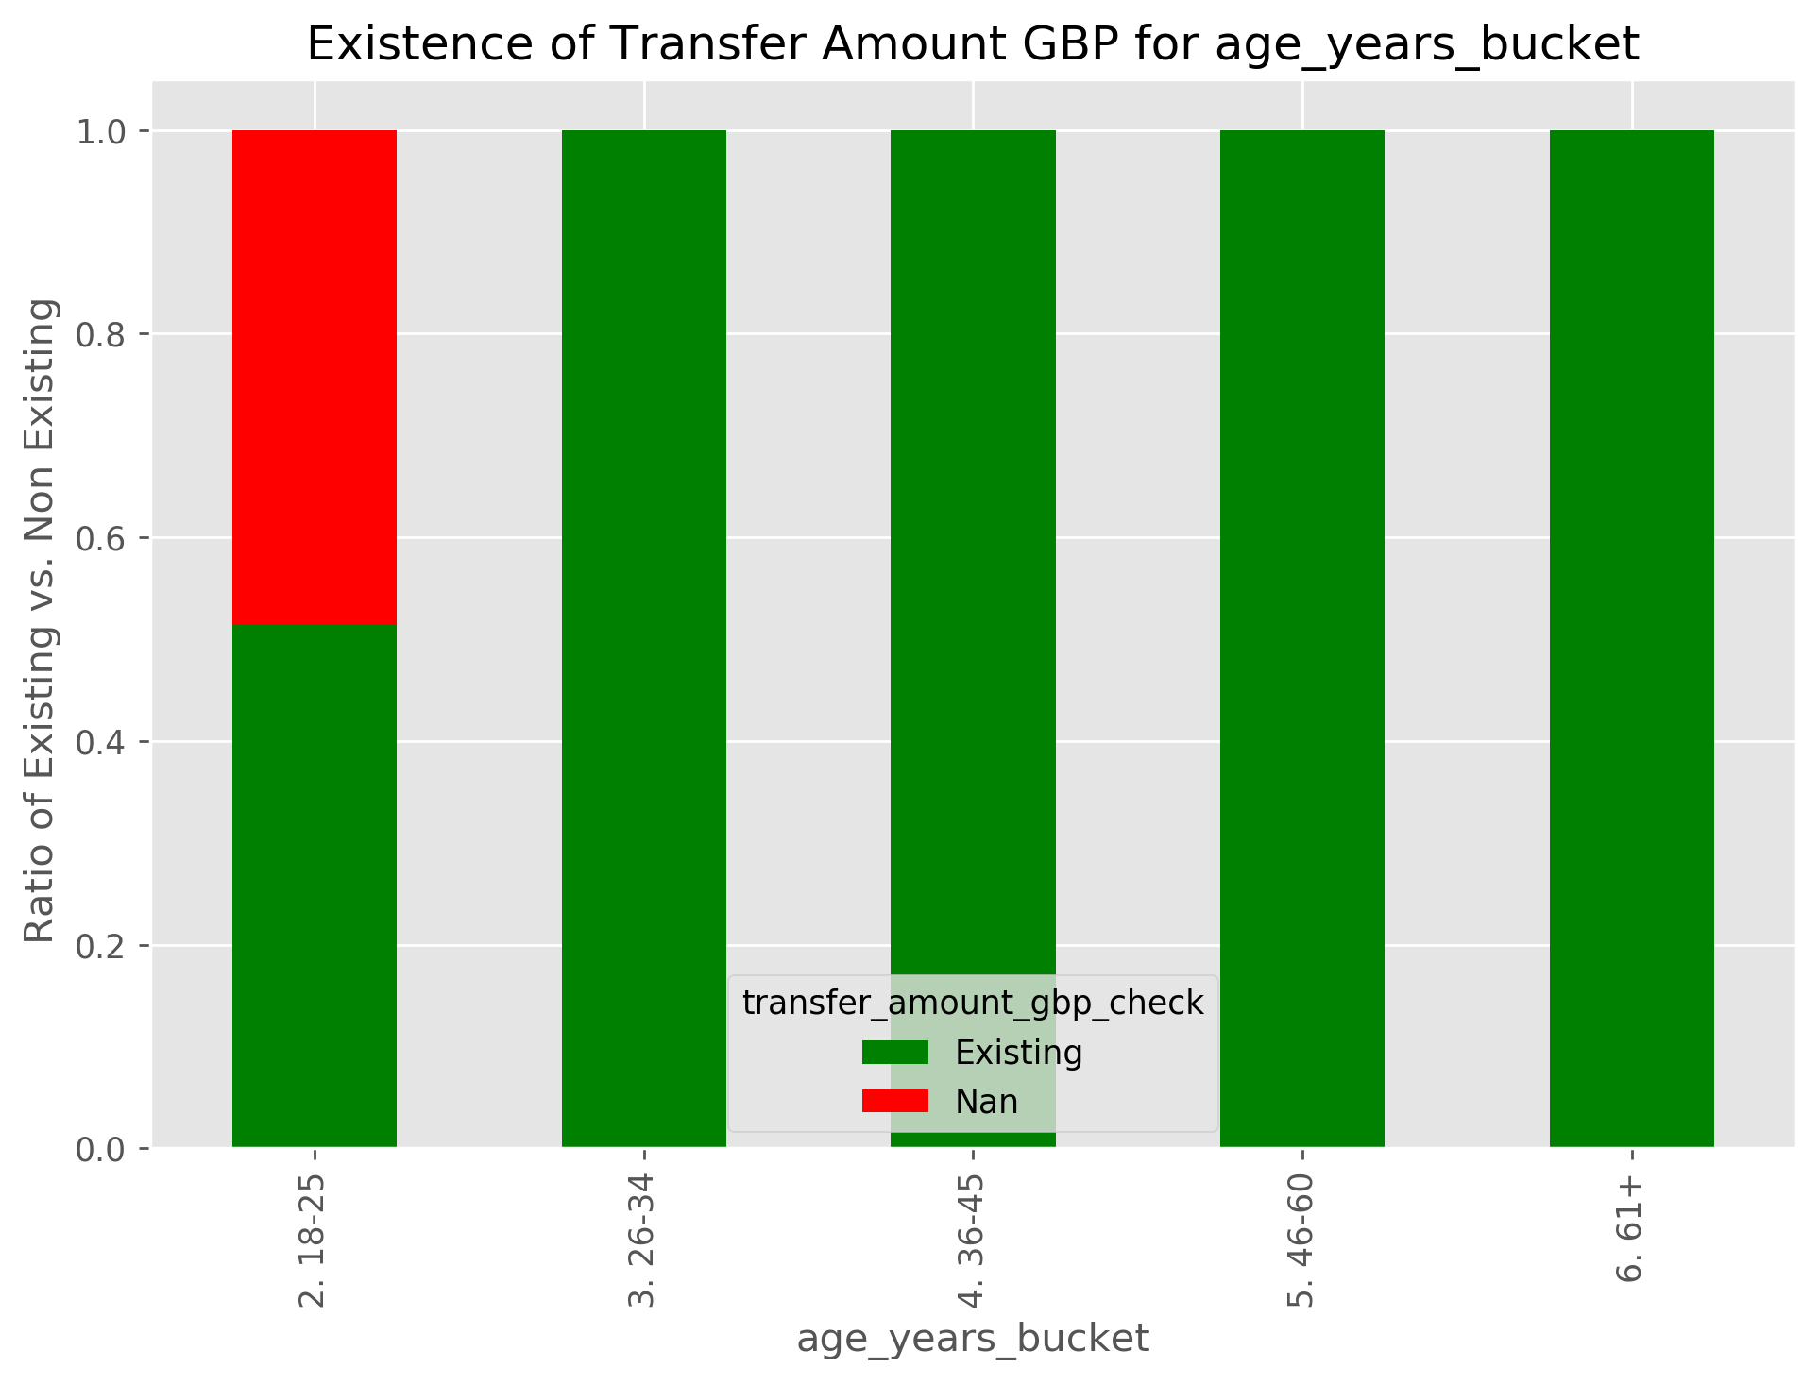

Records with the User country code of '134' is the only country code value that is missing Transfer Amount values. All other country code values are not missing Transger Amount GBP Values.

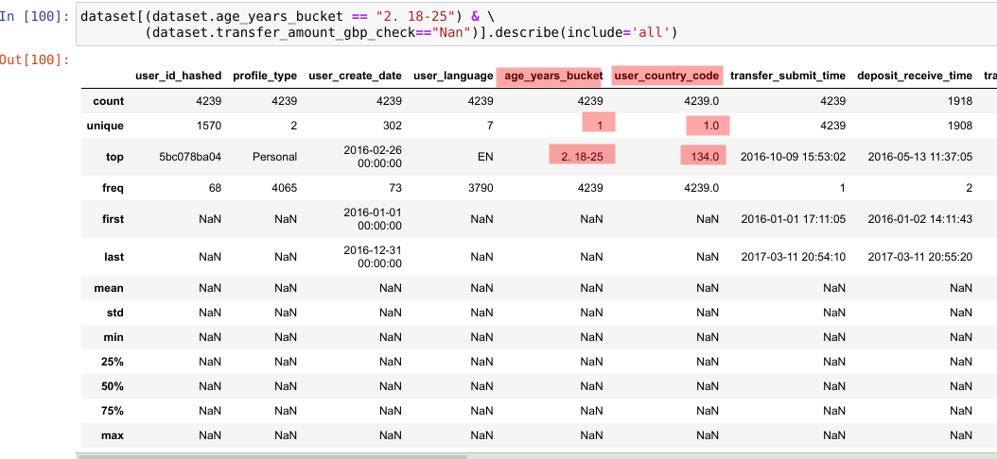
All the transfer amount values are attributed to the age bucket of "2. 18-25". Further more as can be seen from the above results there is only 1 unique value of country code in this subset of age bucket and missing transfer amount values. This country code value is 134. Hence we can conclude users with country code of “134” and age bucket of "2. 18-25" are the source of these missing values.

Check for possible outliers outside 1.5 IQR

It seems like only features that can suitably be assessed for being outside the IQR are 'transfer_amount_gbp'.

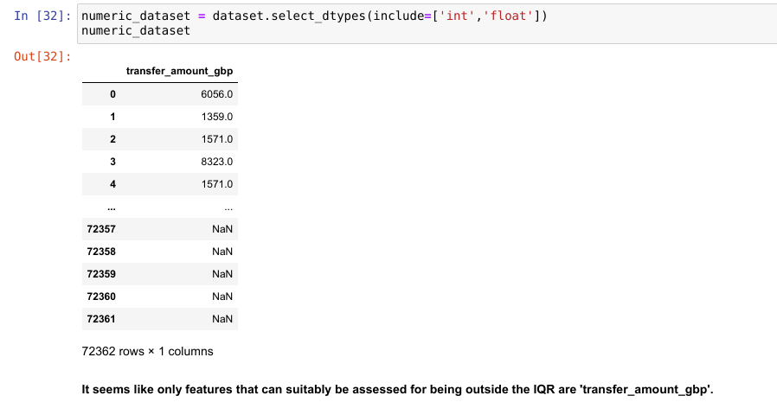

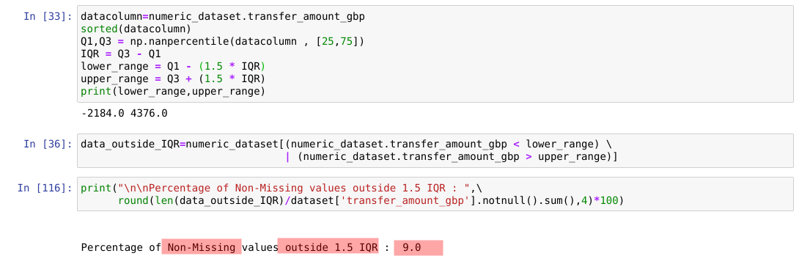

Percentage of Non-Missing values outside 1.5 IQR is 9%.
The data with values outside IQR covers most categories of other features. Hence, it is not advisable to remove the values that are outside IQR as by removeing them we may lose valuable information.

Task2

