Task 1:Working with unclean data

• For reference, Git Repository for the hometask is available at the following link : https://github.com/abdul0214/TransferwiseDataScience

• In order to see the repository, kindly send me an e-mail for making it public or send me GitHub username so that I add you the relevant person in it.

• Task1 has the corresponding Jupyter Notebook which contains detailed information along with detailed comments and figures.

• Kindly follow the Jupyter notebook along with this report as they contain code explanations and visualizations and valuable comments.

Working with unclean data

The data seems to be records of money transfer transactions in the time period from 2016-01-01 to 2017-03-12.

We have the following features available:

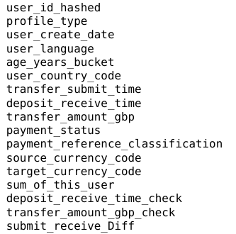

With the following initial feature data types:

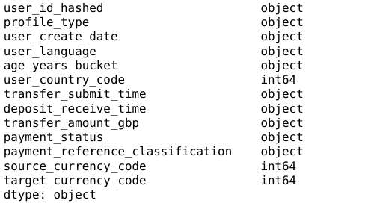

However, we convert the feature types to more relevant datatypes and we have the following corrected data types:
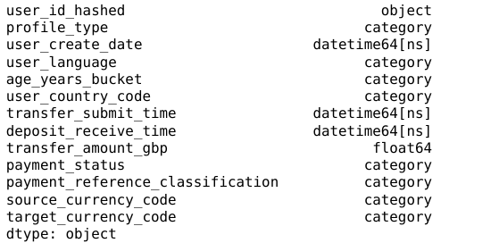

Most frequent user of the service has the id 'ddbac55d04' and has done 152 transfers in total.
The user with highest total transfer amount is ‘d71d16e6b5’ and has a total transfer sum of 18849552.0 GBP.

Top 10 Users By Total Transfer Sum:

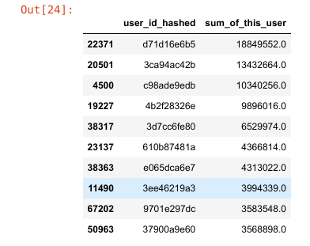

Missing Values

Most of the data was is in string format and hence needed to be converted to an appropriate format for further exploration.

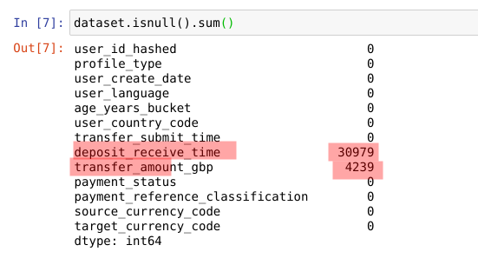

As can be seen from above table, columns of ‘deposit_receive_time’ and ‘transfer_amount_gbp’ contain missing values. All other columns do not contain missing values.

Missing Deposit Received Time values

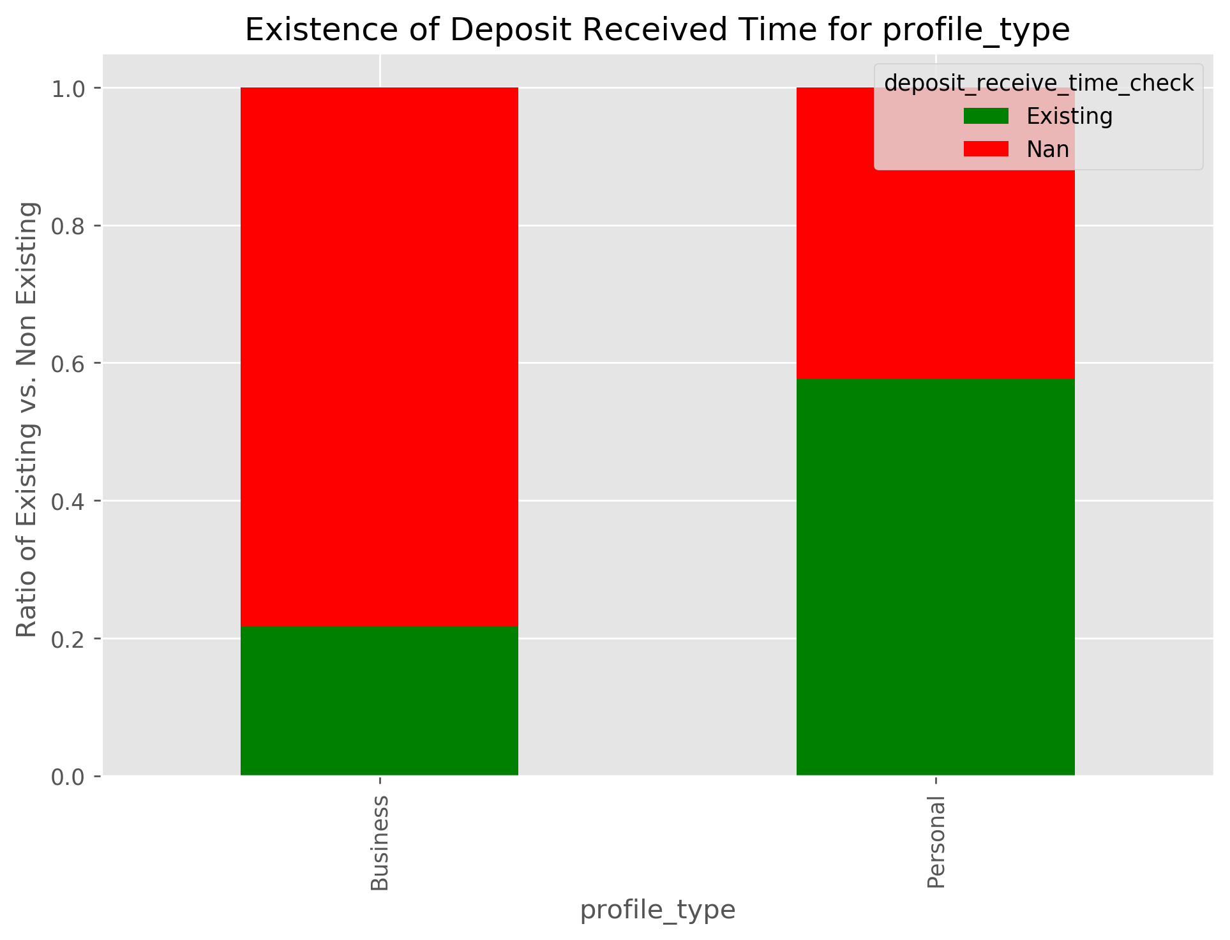

Records with the Profile Type category of ‘Business’ contain a high ratio of missing deposit received time values. Around 80% of 'Business' profile type records are missing deposit received time values.

However, most of these have Payment Status as 'Cancelled' as is shown below:

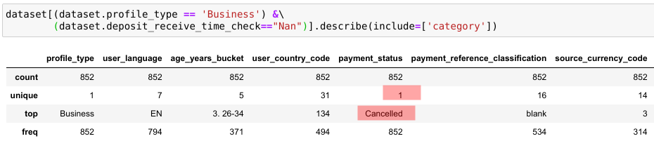

Records with the User Language category of 'JA' are entirely missing deposit received time values. This is not the case with any other user language category.However number of records with missing values with missing deposit received time values for 'JA' language category are only 2 out of 71k. Hence, missing values cannot be attributed to the user language being 'JA'.

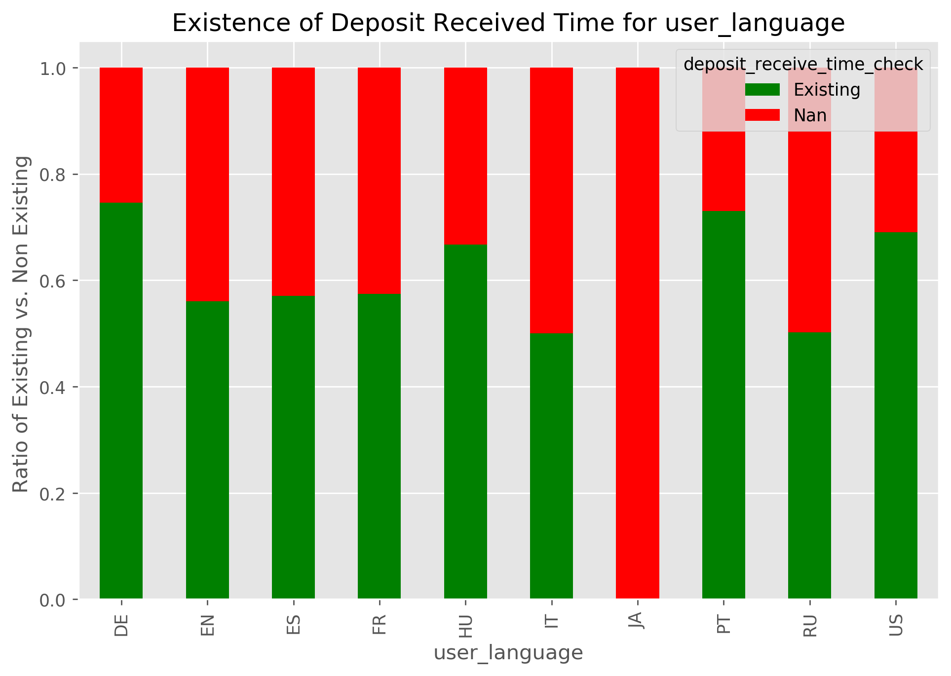

Records with the source curreny code of 11 and 35 and records with target currency code of 65 and 73 are entirely missing deposit received time values. This is not the case with any source/target curreny code .Records with user country code of 7,43,47,54,75,93,117,119,121,179,198,217,225 are entirely missing deposit received time values.

Despite the above facts almost all the records(>96%) with 'Cancelled' payment status are missing deposit received time values while none of the records with 'Transferred' payment status are missing deposit recived time values. Hence the mising of Deposit Received time values can be logically attributed to the 'Cancelled' payment status.

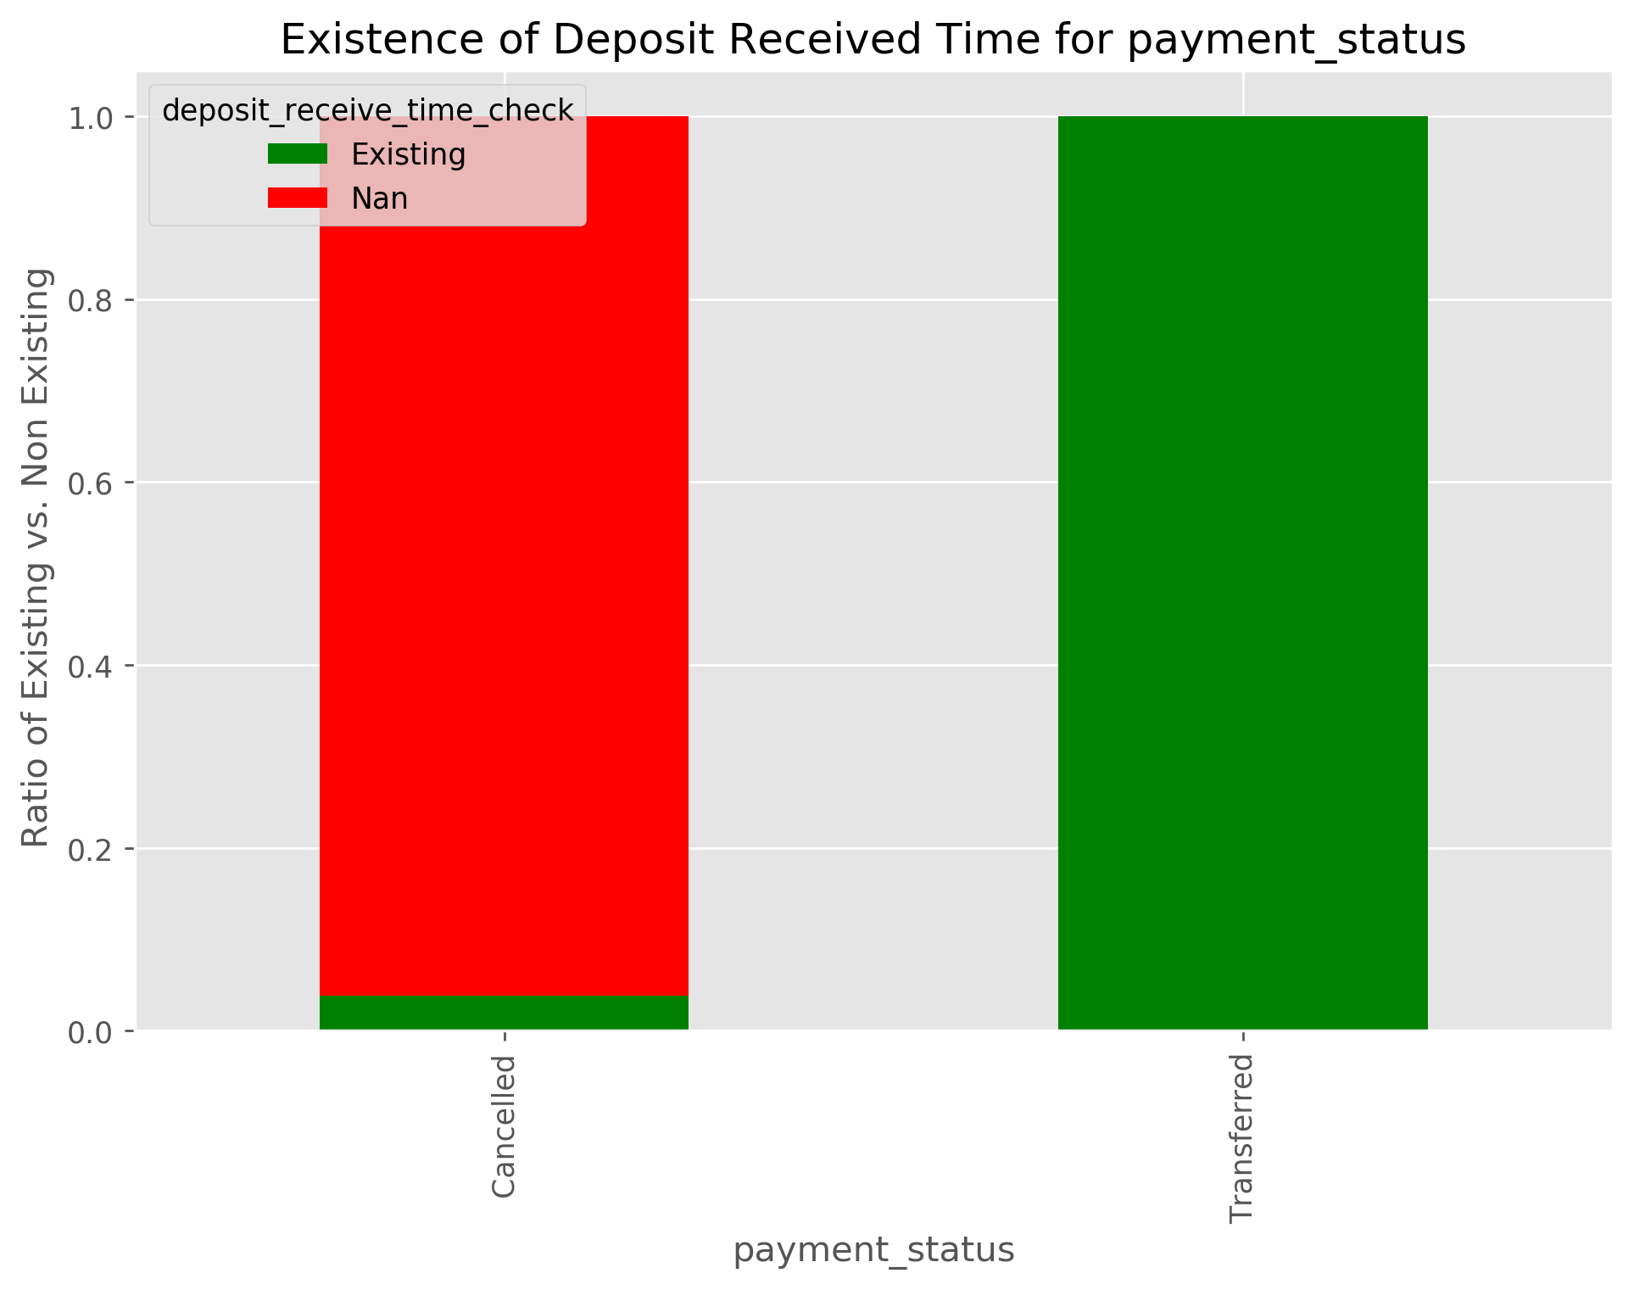

In addition, from the figure below we can see that records with payment status of ‘Cancelled’ make up for the (30977/30979 x 100) = 99.99% of the missing ‘Deposit Received time’ values. Hence, we can effectively conclude this as the cause of missing Deposit Missing time values. In this case, the missing values shall be given a new category. Imputation with some other values will necessarily mean introduction of false information into our data.

Missing Transfer Amount GBP values

Records with the Age Year bucket value of '2. 18-25' is the only age-years bucket value that is missing Transfer Amount values. All other age buckets are not missing Transger Amount GBP Values.

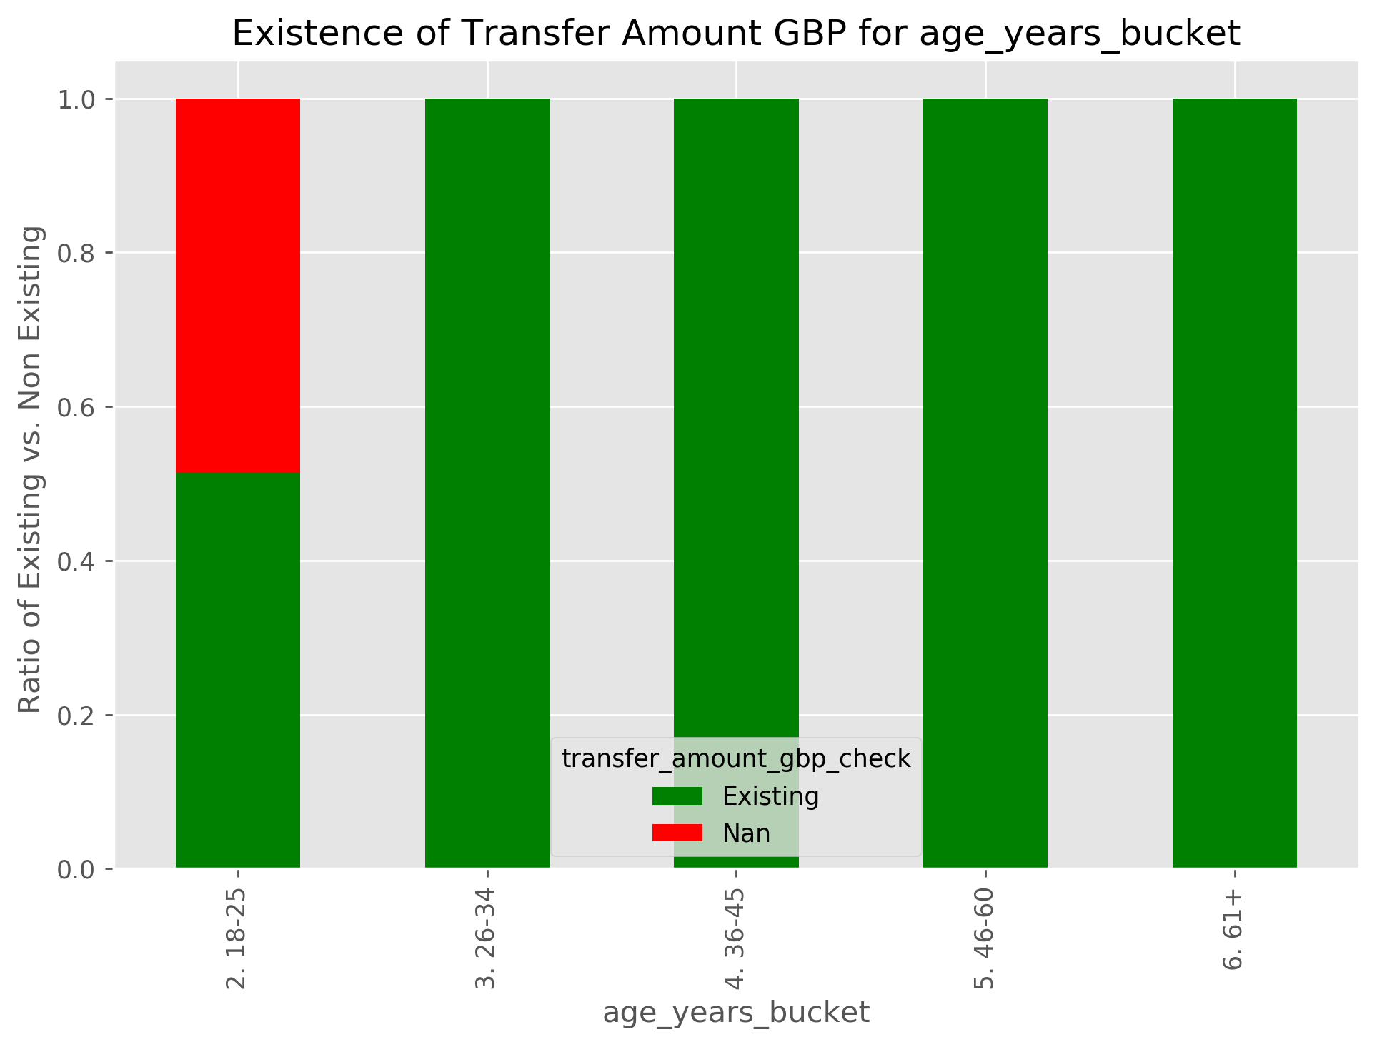

Records with the User country code of '134' is the only country code value that is missing Transfer Amount values. All other country code values are not missing Transger Amount GBP Values.

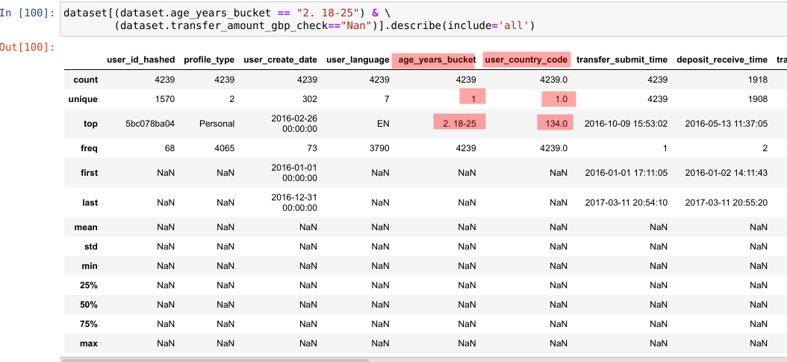
All the transfer amount values are attributed to the age bucket of "2. 18-25". Further more as can be seen from the above results there is only 1 unique value of country code in this subset of age bucket and missing transfer amount values. This country code value is 134. Hence we can conclude users with country code of “134” and age bucket of "2. 18-25" are the source of these missing values.

Check for possible outliers outside 1.5 IQR

It seems like only features that can suitably be assessed for being outside the IQR are 'transfer_amount_gbp'.

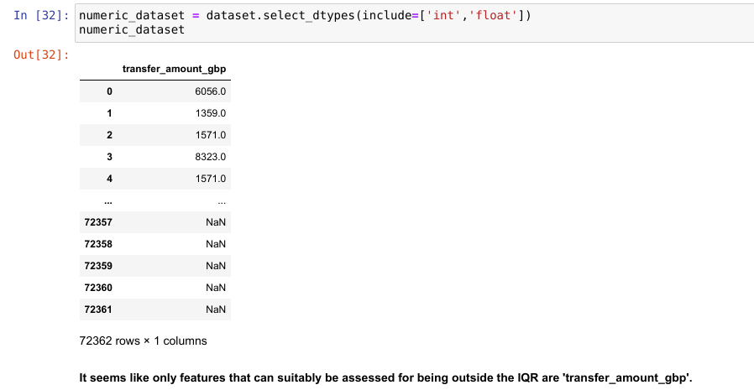

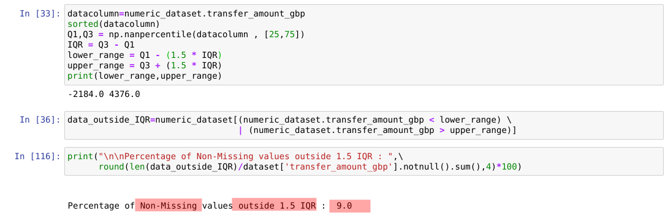

Percentage of Non-Missing values outside 1.5 IQR is 9%.
The data with values outside IQR covers most categories of other features. Hence, it is not advisable to remove the values that are outside IQR as by removing them we may lose valuable information.

In addition, just like wealth distribution in the world, where some small fraction of people have worlds most wealth, similarly, some users of Transferwise can be rich and have large transfer amounts.

Hence, it may not be reasonable to remove values outside IQR especially since we do not information on how the statistical model built on top it will react to these values.

Logically Incorrect Values

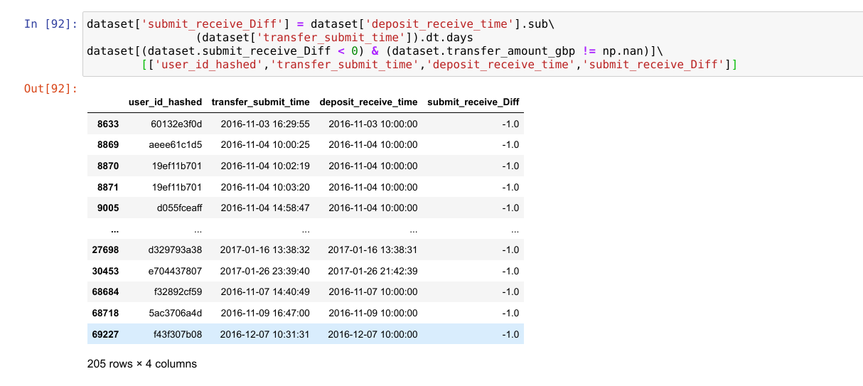
The above 205 rows logically incorrect values of 'transfer_submit_time' and 'deposit_receive_time' pair. This is because transfer_submit_time seems to be later than deposit_Receive_time which is logically incorrect.

