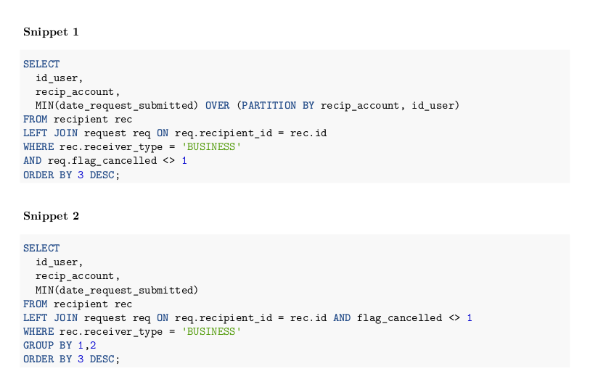
Expected Results:

Snippet 1: summarize on all the (id_user, recip_account, date_request_submitted) and return all the records.
Snippet 2: summarize on all the (id_user, recip_account, date_request_submitted) but only return summarized results.

Computational Complexity:

Although both queries may give the desired result, but Group by is not the optimal solution. We see that in Snippet 2, there is a JOIN statement and a sub-query. This increases the complexity of the query leading to a solution that is not efficient.

The better approach is in the Snippet 1 through the use of OVER and PARTITION BY clauses.

