How to show current zero for : DC source (through capacitor). ‘ scilab,xcos’

peter.vlasschaert@gmail.com,21/12/2019

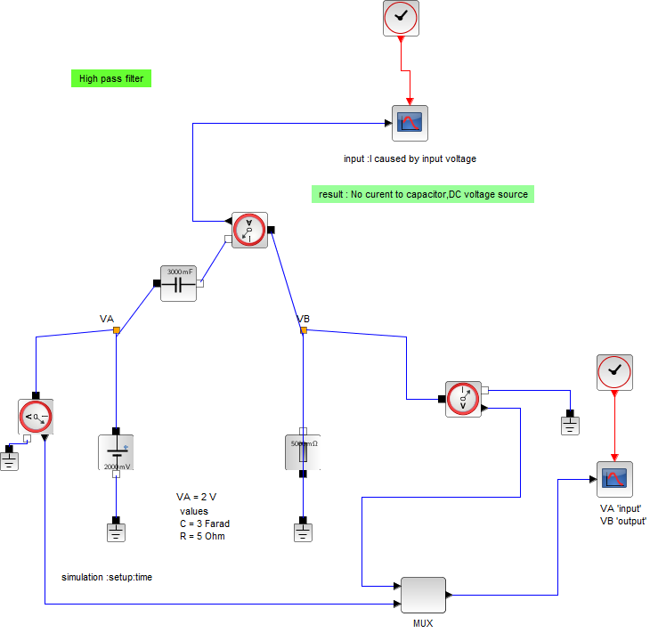
1e) DC source : period = T = infinity
2e) find f ? => T*f = 1 => 1/infinity = 0 => f=0
3e) from laplace transform : impedance = Z(capacitor)=1/(sC)
4e) complex plane s = j*w
j = sqrt(-1)
w = 2*pi*f
C = capacity
5e) Z(capacitor) =1/(j*w C) = 1/(j2*pi*f*C) =1/0 = inifinity
6e) i = current ciruit = (VA-VB)/Z(capacitor) = value/infinity = 0
7e) DC connection between VA & VB = regular wire.

