# Disaster Recovery Setup – RDS Snapshots & Cross-Region Backup

## Overview

This project implements a disaster recovery solution using Amazon RDS automated snapshots and cross-region replication. The solution ensures database backup compliance, retention management, and improved resilience against regional failures.

## Architecture Diagram

The diagram below illustrates the overall architecture of the disaster recovery setup:

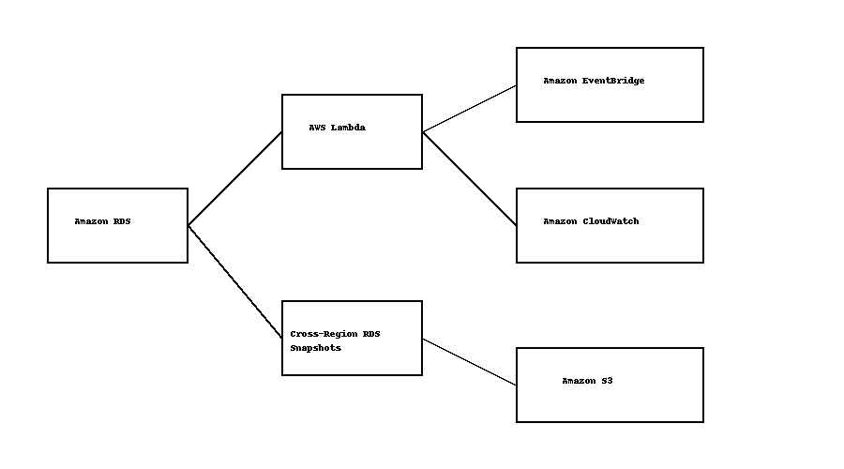

## Architecture Components

1. Amazon RDS (Free Tier DB instance) – primary database.

2. AWS Lambda (Python) – automates snapshot creation, cleanup, and cross-region

copy.

3. Amazon EventBridge – schedules daily snapshot jobs.

4. Amazon CloudWatch – monitors and logs execution.

5. (Optional) Amazon S3 – stores exported snapshots for long-term archival/compliance.

## Implementation Steps

## Phase 1 – Setup RDS Instance

## - Created a free-tier RDS instance (MySQL/Postgres).

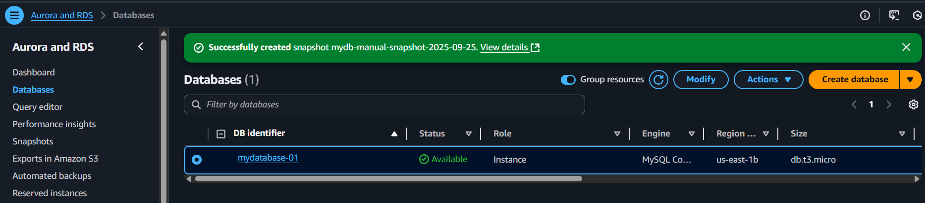

## - Noted the DB Identifier for automation scripts.

## Phase 2 – Manual Snapshots

## - Verified snapshot creation manually via AWS Console.

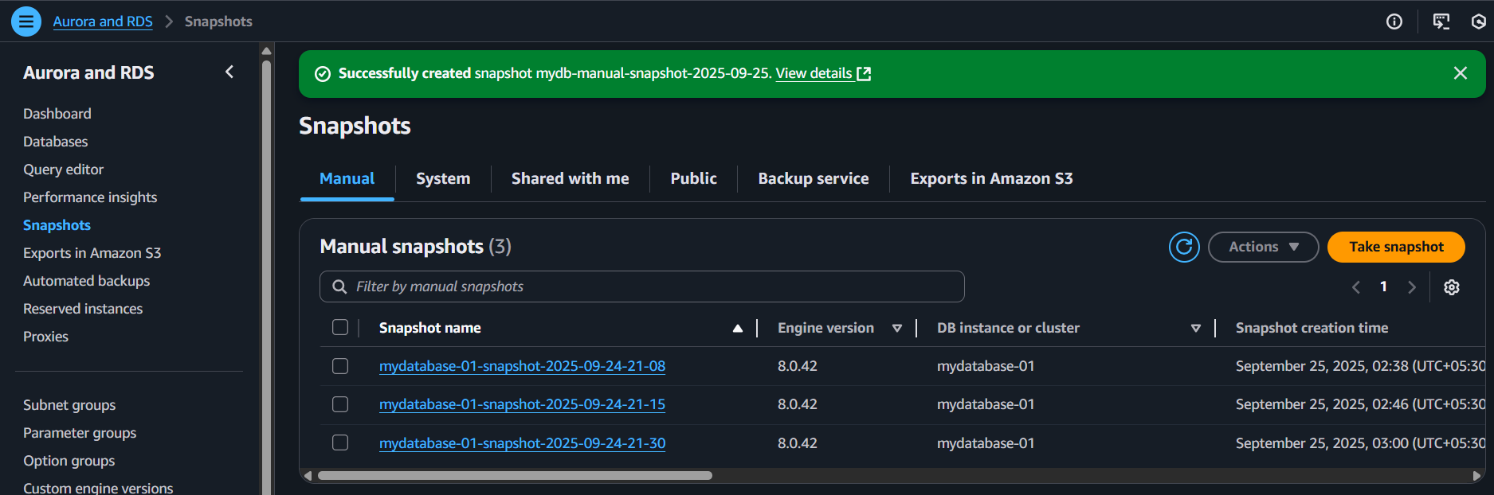

- Ensured snapshot recovery process works.

**Phase 3 – Automated Snapshots with Lambda**

- Created a Lambda function (Python + boto3):

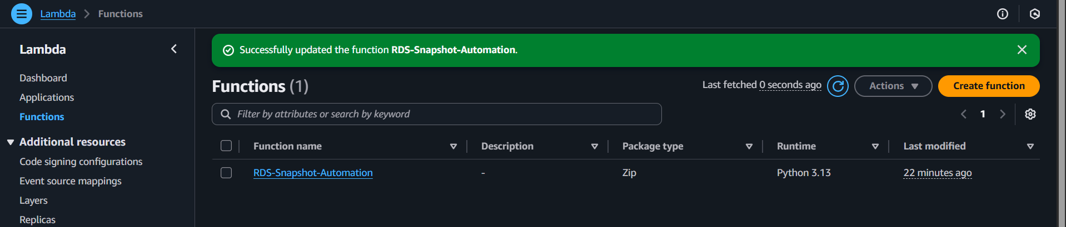

- Generates snapshots daily with timestamp IDs.

- Retains only the last 3 snapshots (auto-deletes older ones).

## - Returns clean JSON logs for monitoring.

## - Used Lambda environment variables:

## - DB_IDENTIFIER → database instance name.

## - SNAPSHOT_RETENTION_DAYS → number of snapshots to keep.

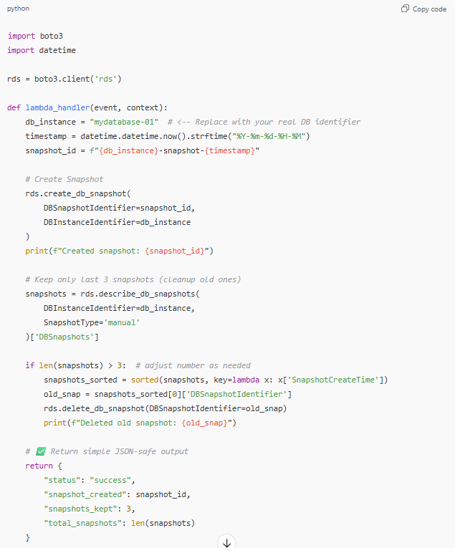

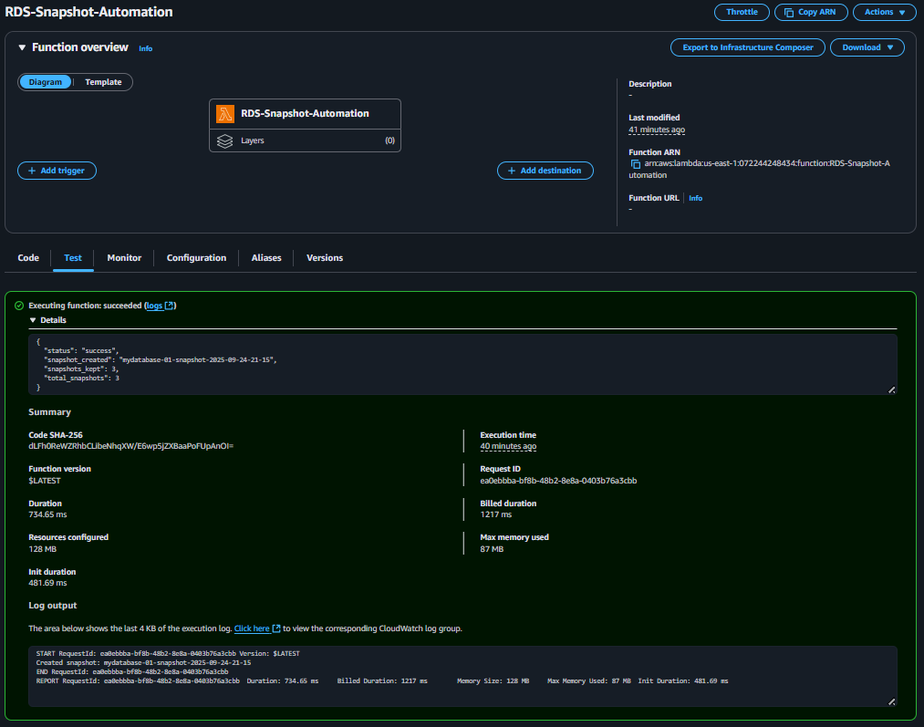

## Phase 4 – Scheduling with EventBridge

## - Created an EventBridge rule with Cron expression (e.g., Cron (0 3 * * ? *) → 3AM

IST)

## - Attached Lambda as the rule’s target.

## - Verified automation by manually testing the rule + checking CloudWatch logs

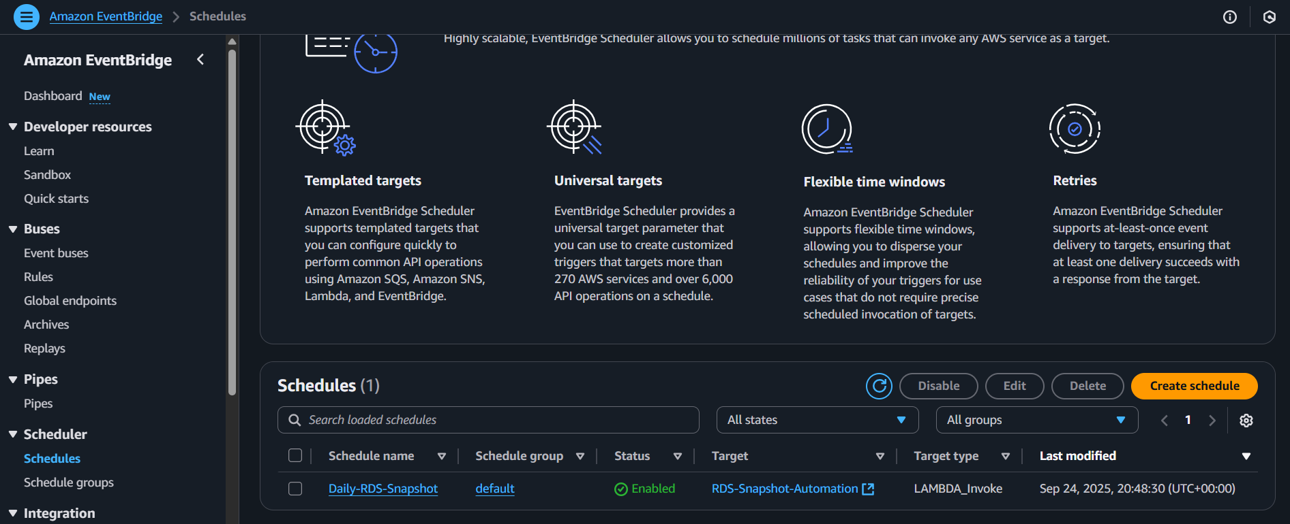

**Phase 5 – Cross-Region Backup**

- Implemented snapshot copy to secondary region (e.g., from us-east-1 →us-west-2).

- (Optional) Configured export to Amazon S3 for compliance archiving.

- IAM roles updated to allow RDS + S3 access.

## Monitoring & Compliance

CloudWatch logs and alarms help ensure snapshot automation works reliably.

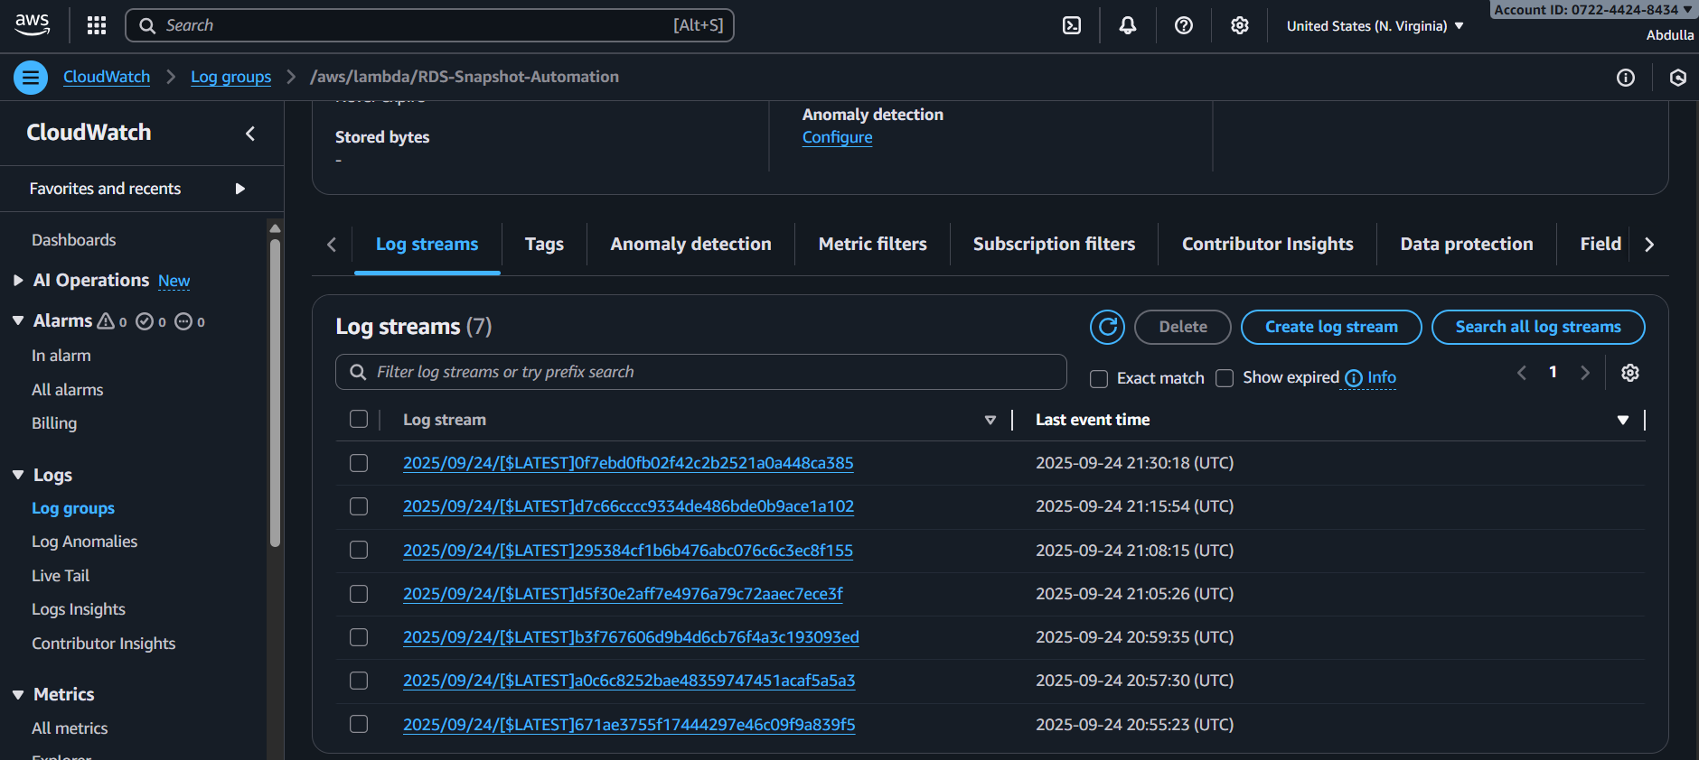

**Outcome**

- Automated daily RDS snapshots.

- Retains only the last N snapshots (configurable).

- Cross-region snapshot replication for disaster recovery.

- Cloud-native, cost-effective, and Free Tier friendly solution.