**Final Project Report**

**Maritime Education System & Job Portal**



**Project Supervisor**

Zaid Ismail

**Submitted By**

Group Id: F230296634

Student Id BC180403321

Student Id BC180402472

**Software Projects & Research Section,**

**Department of Computer Sciences,**

**Virtual University of Pakistan**



|  |
| --- |

**CERTIFICATE**

This is to certify that BC180403321 ,BC200400689 have worked on and completed their Software Project at Software & Research Projects Section, Department of Computer Sciences, Virtual University of Pakistan in partial fulfillment of the requirement for the degree of BS in Computer Sciences under my guidance and supervision.

In our opinion, it is satisfactory and up to the mark and therefore fulfills the requirements of BS in Computer Sciences.

**Supervisor / Internal Examiner**

Zaid Ismail

Supervisor,

Software Projects & Research Section,

Department of Computer Sciences

Virtual University of Pakistan

___________________

(Signature)

**External Examiner/Subject Specialist**

<<External Supervisor Name>>

___________________

(Signature)

**Accepted By:**

**_____________**

(For office use)

**EXORDIUM**

**In the name of Allah, the Compassionate, the Merciful.**

**Praise be to Allah, Lord of Creation,**

**The Compassionate, the Merciful,**

**King of Judgment-day!**

**You alone we worship, and to You alone we pray for help,**

**Guide us to the straight path**

**The path of those who You have favored,**

**Not of those who have incurred Your wrath,**

**Nor of those who have gone astray.**

**DEDICATION**

This humble work is dedicated to my family, who educated me and supports me to reach this level.

**ACKNOWLEDGEMENT**

I sincerely thank Sir Zaid Ismail , my supervisor, for his guidance in carrying out my project. I wish to express my sincere gratitude to my project’s supervisor for providing me with the knowledge to execute my project. I am also thankful to VU for providing me templates and helping material during the period of my project work.

**PREFACE**

I’m required to make a final report on **Maritime Education System & Job Portal** to gain practical knowledge in the field of computer science. The objective of doing this project is to get knowledge about different tools used in the project.

**TABLE OF CONTENTS**

|  |
| --- |

**CHAPTER NO. 1**

**GATHERING & ANALYZING INFO 9**

1.1 Introduction

1.2 purpose

1.3 scope

1.4 definitions, acronyms and abbreviations

1.5 Project requirements

1.5.1 Functional Requirements

1.5.2 Non-Functional Requirements

1.6 use cases and usage scenarios

1.6.1 Use Case Diagrams

1.6.2 Usage Scenarios

1.7 Development Methodology

1.7.1 Chosen Methodology

1.7.2 Reasons for Chosen Methodology

1.7.2 Work Plan (Gantt Chart)

1.7.2 Project Schedule (Submission Calendar)

**CHAPTER NO. 2**

**DESIGNING THE PROJECT 15**

2.1 Introduction

2.2 purpose

2.3 scope

2.4 definitions, acronyms and abbreviations

2.5 Architectural Representation (Architecture Diagram)

2.6 Dynamic Model: Sequence Diagrams

2.7 Object Model/Logical Model: Class Diagram

2.8 Database Model (Database Diagram)

2.9 Graphical User Interfaces

**CHAPTER NO.3**

**DEVELOPMENT 19**

3.1 Development plan (Architecture Diagram)

**CHAPTER 1**

Gathering & Analyzing Info

1.1 Introduction

The Maritime Education System and Job Portal represents an online platform tailored to offer a holistic resource for maritime education and career prospects within the maritime sector.

This plan details the creation of a website aimed at providing a diverse array of maritime courses and training initiatives, alongside functioning as a hub for industry-specific job vacancies.

By consolidating maritime education and employment opportunities, the Maritime Education System and Job Portal will serve as a centralized platform. Administrators will have the capability to oversee courses, training programs, and job postings, while students and job seekers can navigate through available courses and employment openings, and submit applications.

1.2 purpose

The purpose of the Maritime Education System and Job Portal is to serve as a comprehensive online platform catering to both maritime education and employment needs.

1.3 scope

The scope of the Maritime Education System and Job Portal encompasses the development of a web-based platform that offers a wide range of maritime courses, training programs, and industry-specific job postings. It aims to be a central hub for both maritime education seekers and job seekers within the maritime industry, providing a convenient and efficient way to access relevant resources and opportunities.

1.4 definitions, acronyms and abbreviations

1.5 Project requirements

1.5.1 Functional Requirements

**Maritime Education System:**

* Course and training program management
* User registration and profile creation
* Course and program search and filtering
* Application for courses and programs
* Course progress tracking
* Messaging and notifications

**Maritime Job Portal:**

* Job posting and management
* Employer registration and profile creation
* Job search and advanced filtering
* Job application submission
* Communication with job applicants
* Resume storage for job seekers

**User Roles**

* Administrator
* Student (Course Applicant)
* Job Seeker
* Client (Employer)

1.5.2 Non-Functional Requirements

1. **Performance:** Ensure the app responds promptly, providing quick access to services.
2. **Reliability:** Minimize downtime, ensuring continuous availability for users and service providers.
3. **Scalability:** Design the app to handle an increasing number of users, vendors, and data.
4. **Security:** Implement robust measures to safeguard user data and maintain confidentiality.
5. **Usability:** Design an intuitive and user-friendly interface for a positive user experience.
6. **Compatibility:** Ensure the app works seamlessly across different devices and operating systems.
7. **Maintainability:** Design the app with ease of maintenance in mind for updates and enhancements.
8. **Interoperability:** Ensure the app can integrate smoothly with existing systems and standards.

1.6 use cases and usage scenarios

1.6.1 Use Case Diagrams

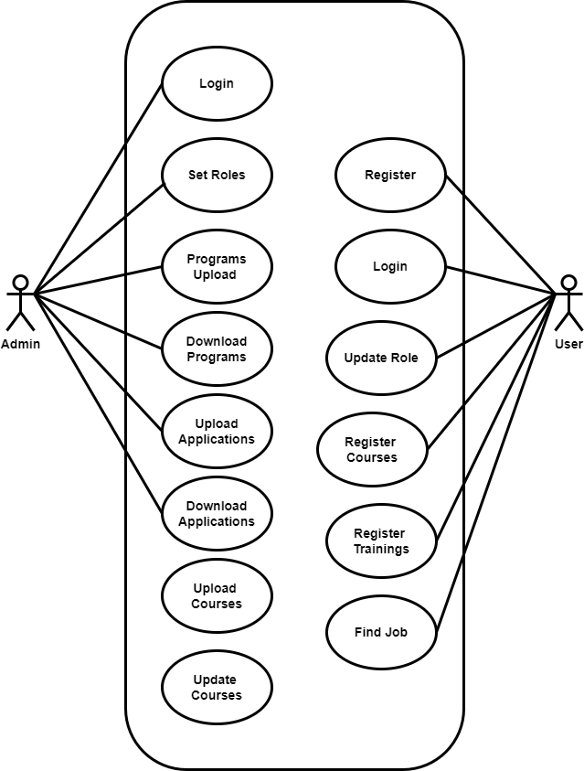

1.6.2 Usage Scenarios

| Use Case Title | **Register** |
| --- | --- |
| Use Case Id | 01 |
| Actions | * User provides required information during registration. * System validates the information and creates a new user account. |
| Description | * Users register to access Maritime App. |
| Alternative Paths | * If the user provides invalid information, the system displays an error message and prompts the user to correct the information. |
| Pre-Conditions | * The user has downloaded and installed the Maritime App. |
| Post Condition | * User account is created. |
| Exceptions | * If there are issues with the registration process the system displays an error message. |
| *Author* | *BC180403321,BC180402472* |

| Use Case Title | **Login** |
| --- | --- |
| Use Case Id | 02 |
| Actions | * User enters credentials to log in. * System verifies credentials and grants access. |
| Description | * Users log in to access personalized services |
| Alternative Paths | * If the entered credentials are incorrect, the system displays an error and prompts the user to enter valid credentials. |
| Pre-Conditions | * Registered user account exists |
| Post Condition | * User is Logged in |
| Exceptions | * If there is a system error during the login process, the user is informed, and the login attempt is aborted. |
| *Author* | *BC180403321,BC180402472* |

| Use Case Title | **Browse Services** |
| --- | --- |
| Use Case Id | 03 |
| Actions | * User navigates through available courses and job services. * System displays service options. |
| Description | * Users explore offered services. |
| Alternative Paths | * If no services are available, the system informs the user and suggests checking back later. |
| Pre-Conditions | * User is Logged in |
| Post Condition | * User views available services. |
| Exceptions | * If there is a system error during service retrieval, the user is informed, and the process is terminated. |
| *Author* | *BC180403321,BC180402472* |

| Use Case Title | **Register Courses** |
| --- | --- |
| Use Case Id | 04 |
| Actions | * User selects a service and register courses. * System confirms the registration and notifies the user. |
| Description | * Users register courses.. |
| Alternative Paths | * If no courses or jobs are available, the system informs the user and suggests checking back later. |
| Pre-Conditions | * User is logged in, and courses and jobs are available. |
| Post Condition | * Courses are registered is scheduled. |
| Exceptions | * If there is a system error during the appointment scheduling, the user is informed, and the process is halted. |
| *Author* | *BC180403321,BC180402472* |

1.7 Development Methodology

1.7.1 Chosen Methodology

“Methodology is a frame work that is used to structure, plan and control the process of developing an information system”.

Vu process model is a combination of the water fall and spiral model.

1.7.2 Reasons for Chosen Methodology

The VU Process Model is a blend of the classic waterfall and spiral models, it is also call hybrid approach of system development. It goes through five stages: ***Gathering and analyzing requirements, Planning, Analysis and design, Development, and Implementation*.** During the requirement phase, goals, services, and limits are defined through discussions with users. The aim of the model is to upgrade system quality and cut down on risks and errors.

This model is depicted in the following diagram.

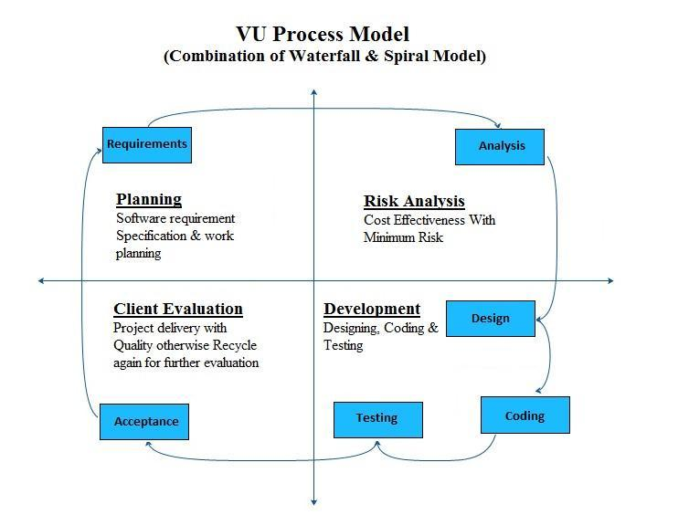

1.7.2 Work Plan (Gantt Chart)  
 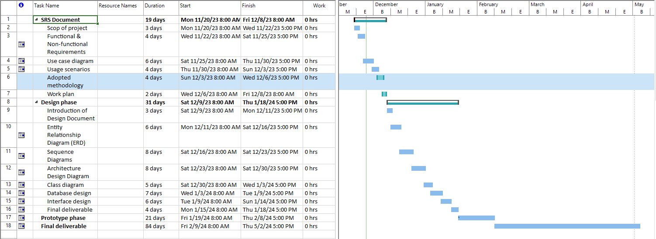

**CHAPTER 2**

Designing the Project

2.1 Introduction

The Maritime Education System and Job Portal represents an online platform tailored to offer a holistic resource for maritime education and career prospects within the maritime sector.

This plan details the creation of a website aimed at providing a diverse array of maritime courses and training initiatives, alongside functioning as a hub for industry-specific job vacancies.

By consolidating maritime education and employment opportunities, the Maritime Education System and Job Portal will serve as a centralized platform. Administrators will have the capability to oversee courses, training programs, and job postings, while students and job seekers can navigate through available courses and employment openings, and submit applications.

2.2 purpose

The purpose of the Maritime Education System and Job Portal is to serve as a comprehensive online platform catering to both maritime education and employment needs.

2.3 scope

The scope of the Maritime Education System and Job Portal encompasses the development of a web-based platform that offers a wide range of maritime courses, training programs, and industry-specific job postings. It aims to be a central hub for both maritime education seekers and job seekers within the maritime industry, providing a convenient and efficient way to access relevant resources and opportunities.

2.4 definitions, acronyms and abbreviations

2.5 Architectural Representation (Architecture Diagram)

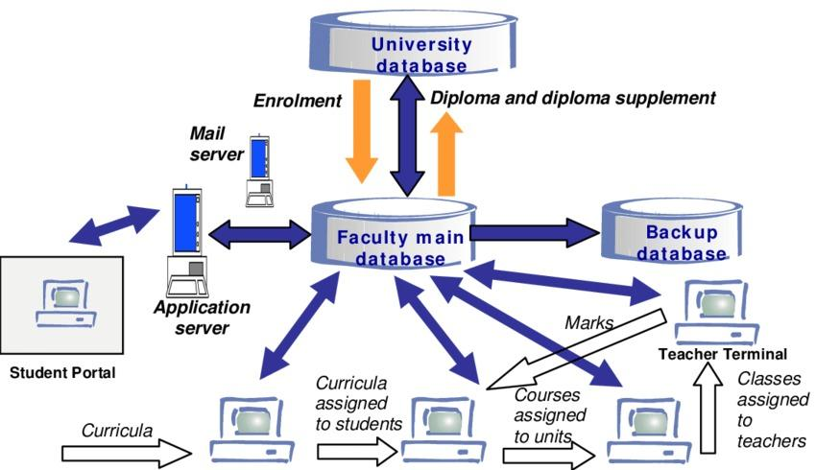

2.6 Dynamic Model: Sequence Diagrams

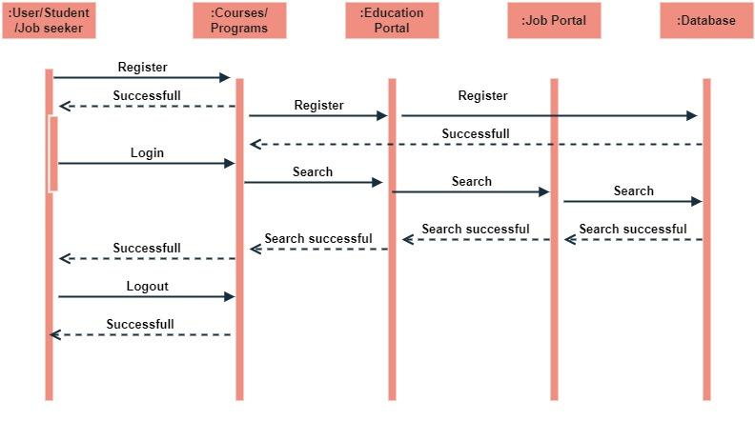

2.7 Object Model/Logical Model: Class Diagram

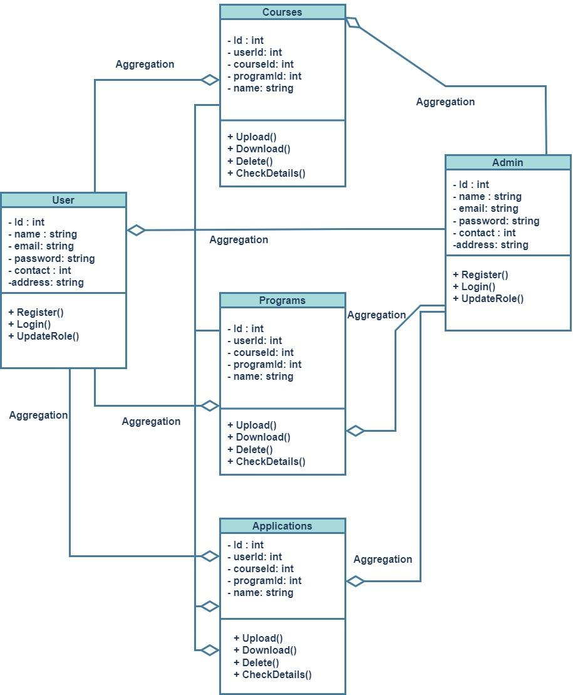

2.8 Database Model (Database Diagram)

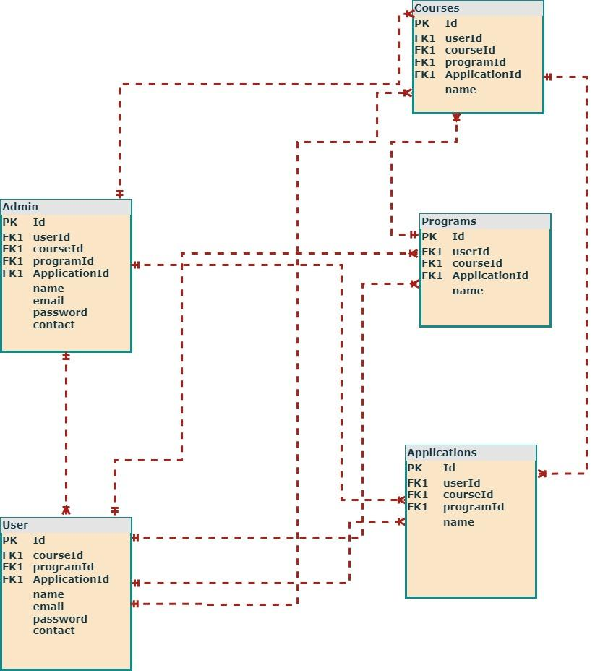

2.9 Graphical User Interfaces

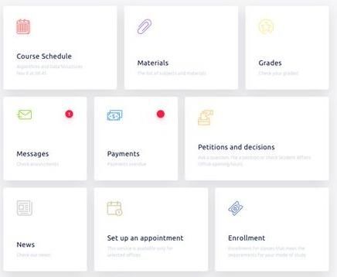

**CHAPTER 3**

Development

3.1 Development plan (Architecture Diagram)



**REFERENCES**

**APPENDIX**