Mongo DB Interview Questions
List of Questions

✅ Core MongoDB Concepts
- What is the difference between MongoDB and a relational database?
  - (Follow-up: When would you choose one over the other?)
- What is a document in MongoDB? How is it different from a row in SQL?
- What are collections in MongoDB?
- Explain schema-less nature of MongoDB. How do you enforce structure?
  - (Hint: Use of Mongoose schemas or schema validation)

✅ CRUD Operations
- How do you insert, read, update, and delete a document in MongoDB?
  - Example-based questions:
    - "Write a query to find all users aged between 20 and 30."
    - "Update the status field to active for users who haven’t logged in for 6 months."
- What’s the difference between updateOne and updateMany?
- What’s the difference between findOne() and find()?

✅ Indexes & Performance
- What is an index in MongoDB? How does it improve performance?
- What are different types of indexes in MongoDB?
  - Single field, compound, text, hashed, geospatial
- What happens if a collection has no index and you run a complex query?
- How would you identify slow queries in MongoDB?
- (Hint: Use of explain() and MongoDB Atlas monitoring)

✅ Aggregation Framework
- What is the aggregation pipeline in MongoDB?
- Can you explain a few stages like $match, $group, $sort, $project?
- Write an aggregation to get the average order amount per customer.
- How is aggregation different from simple queries with .find()?

✅ Mongoose (ODM for Node.js)
- What is Mongoose? Why do we use it in Node.js projects?
- How do you define a schema and a model in Mongoose?
- What are middleware in Mongoose?
- (e.g., pre, post hooks)
- How do you handle relationships in MongoDB with Mongoose?
- (e.g., population using ref, or embedding subdocuments)

✅ Transactions & ACID
- Are MongoDB operations ACID-compliant?
- (Bonus: Explain transactions in MongoDB 4.0+)
- How would you implement a transaction in MongoDB using Mongoose?

✅ Real-world Scenarios / Best Practices
- How do you handle large datasets in MongoDB?
- How do you perform pagination efficiently in MongoDB?
- (e.g., skip/limit vs. using _id based pagination)
- What is the difference between embedding and referencing documents? When would you use each?
- How do you ensure data validation in MongoDB?
- What’s the use of MongoDB’s TTL index? Give a practical use case.

Additional MongoDB Questions:
- What is the difference between embedded documents and references in MongoDB? When would you use each?
- How does MongoDB handle transactions? Explain multi-document transactions.
- What is sharding in MongoDB? How does it help with scaling?
- Explain replication in MongoDB. What is a replica set?
- How do you enforce data validation in MongoDB?
- What are Aggregation Pipelines in MongoDB? Give an example of a common use case.
- Explain the difference between updateOne(), updateMany(), and replaceOne() in MongoDB.
- What is the difference between $set, $unset, and $inc update operators?
- How can you optimize query performance besides using indexes?
- Explain the use of capped collections in MongoDB.
- How do you perform text search in MongoDB? What are some limitations?
- What are the advantages and disadvantages of MongoDB’s schema-less design?
- How do you handle data backup and restore in MongoDB?
- What is the significance of the WiredTiger storage engine in MongoDB?
- How does MongoDB handle concurrency and locking?

🔁 Bonus: Behavioral MongoDB Qs
- “Describe a time when you had to debug a performance issue in a MongoDB query.”
- “Have you worked with MongoDB Atlas? What monitoring or backup features have you used?”

📄 Pro Tip:
You can back your answers with real-world examples from your projects — this adds credibility and shows practical understanding.
If you’d like, I can also give you:
- Coding-based MongoDB questions
- MongoDB questions in Node.js context (e.g., with Express/Mongoose)
- Or even help you mock interview for MongoDB
***************************************************************************
Q1. What is mongo DB?
- MongoDB is an open-source document-oriented, NoSQL database designed for high performance, scalability, and flexibility.
- It stores data in JSON-like documents (BSON format), not tables and rows like SQL databases.
- Developed and manage by MongoDB Inc. under SSPL(Server Side Public License) and initially released in February 2009.
- It's an open-source and widely used modern database.
Explain BSON
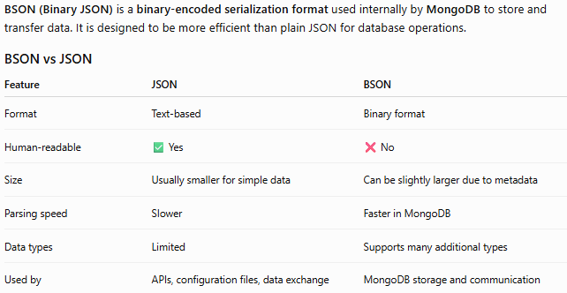
Q2. What is the difference between MongoDB and a relational database?
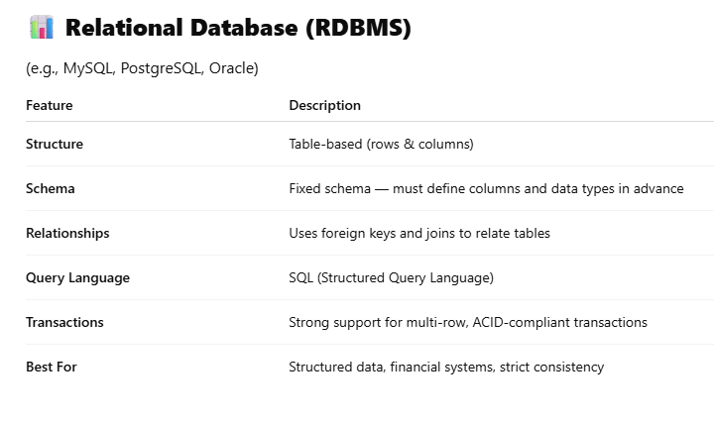
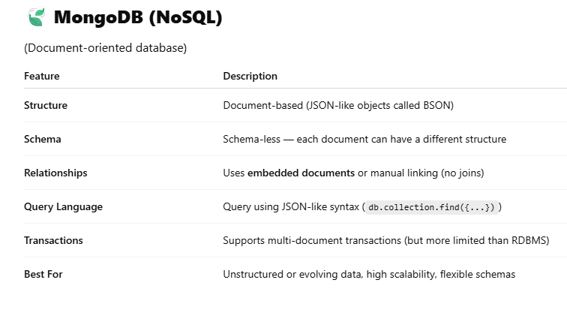
Q3. When would you choose one over the other?
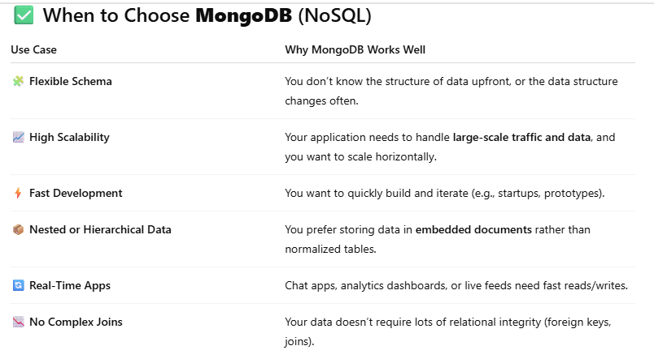
Examples: Content management systems (CMS), product catalogs, user profiles, logging systems, IoT data, social media apps.
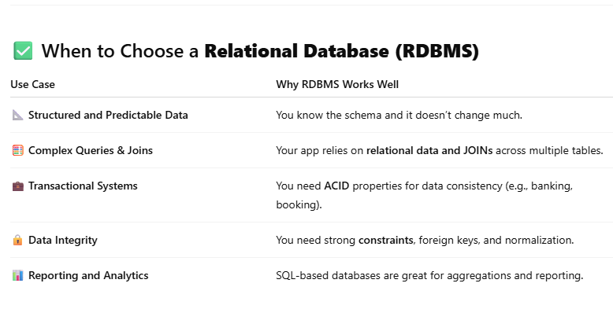
Examples: Banking apps, inventory systems, HR systems, CRM platforms, ERP software.
Q4. What Are Collections in MongoDB?
- A collection is a group of MongoDB documents.
- It holds multiple documents, just like a SQL table holds multiple rows.
- Unlike SQL tables, collections do not enforce a strict schema — documents can have different structures.
- Collections are created automatically when you insert the first document, or manually using db.createCollection().
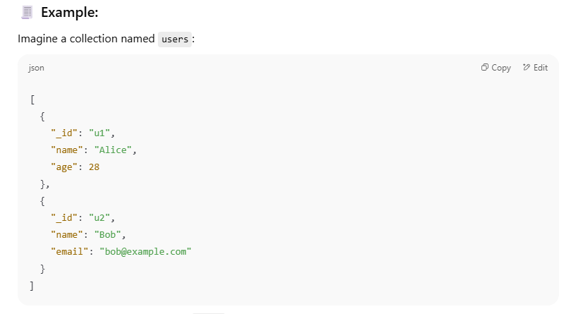
Q5. What is a Document in MongoDB?
- A document in MongoDB is a single record in a collection.
- It is stored in BSON format (Binary JSON), which supports rich data types.
- A document is similar to a JavaScript object or JSON.
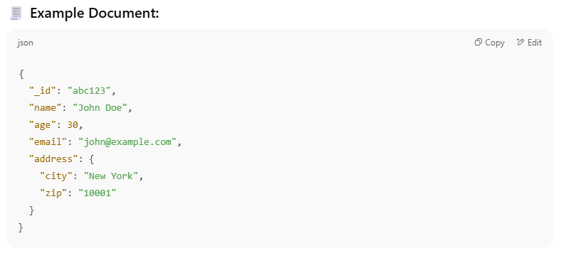
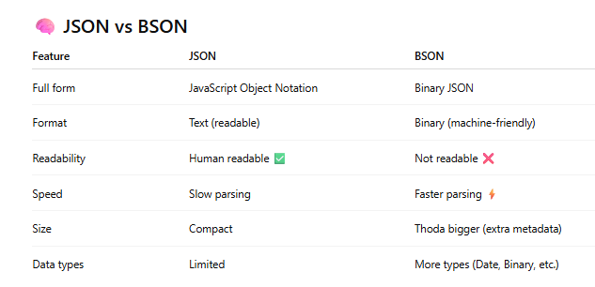
Image of Database, Collection and Document
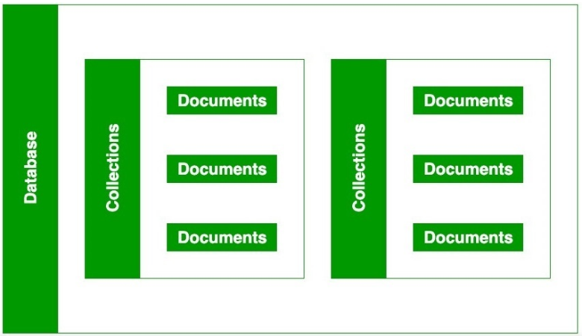

Q6. Explain schema-less nature of MongoDB. How do you enforce structure?
(Hint: Use of Mongoose schemas or schema validation)
📌 Schema-less Nature of MongoDB
What Does "Schema-less" Mean?
- MongoDB is schema-less, meaning:
  - Documents in the same collection can have different structures.
  - There’s no need to define columns or data types ahead of time.
  - This gives developers flexibility to store varied data in one collection.
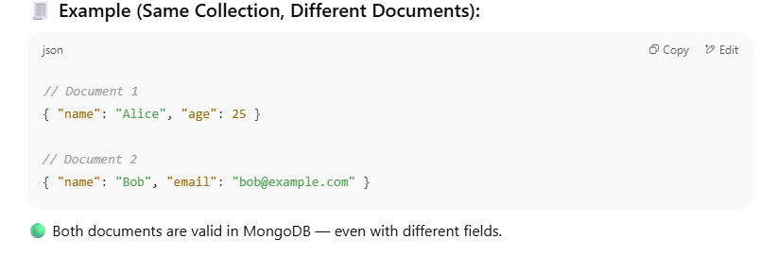
You can enforce structure using one of the following
1. Mongoose
2. MongoDB Native Schema Validation
-> MongoDB Native Schema Validation
Starting from MongoDB 3.2+, you can use JSON Schema validation directly in the database.
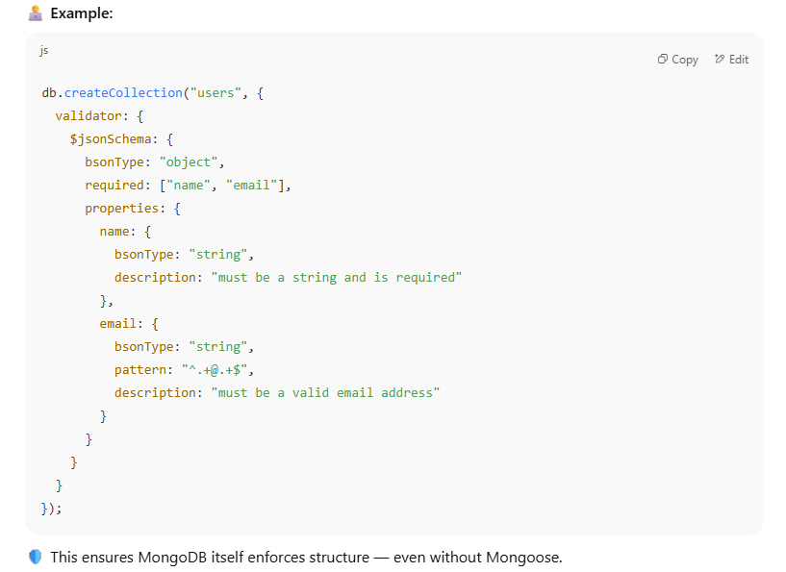
-> Mongoose (for Node.js)
- Mongoose is an ODM (Object Data Modeling) library for MongoDB and Node.js.
- It allows you to define schemas with data types, validations, defaults, etc.
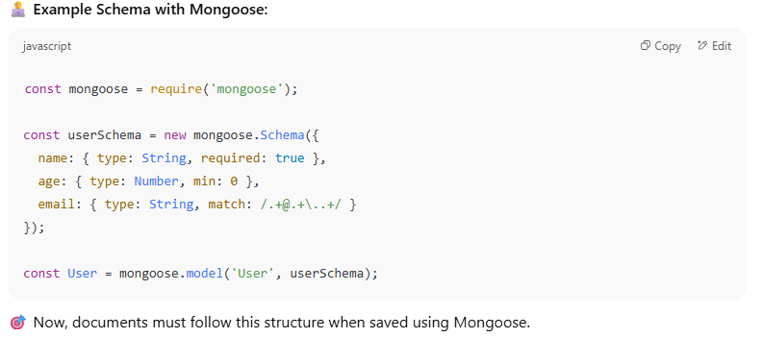
Q7. What is the role of _id in MongoDB documents? Can it be customized?
Role of _id:
- In MongoDB, every document must have a unique _id field.
- This field acts as the primary key for the document within a collection.
- It is used to uniquely identify and access each document efficiently.
By Default:
- MongoDB automatically creates an _id field if you don’t specify one.
- The default value is an ObjectId, a 12-byte unique identifier that includes:
  - Timestamp
  - Machine ID
  - Process ID
  - Incrementing counter
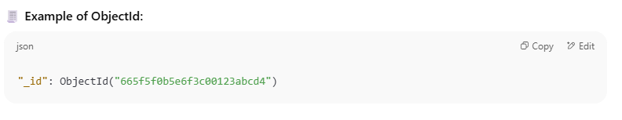
✏️ Can It Be Customized?
Yes — you can manually set your own _id when inserting a document.
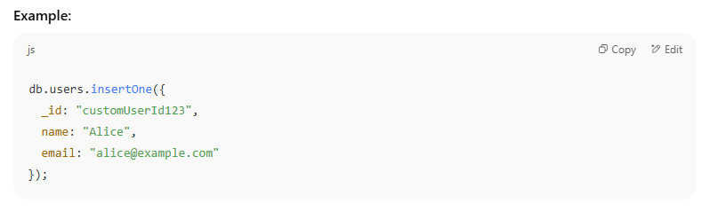
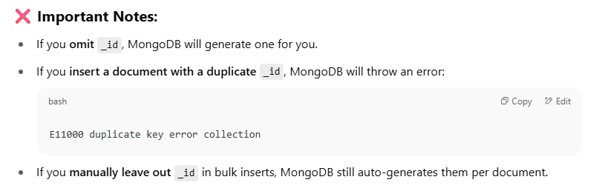
Q8. What is an index in MongoDB? How does it improve performance?
An index in MongoDB is a special data structure (B-Tree-like data structure) that improves the speed of queries on a collection.
- It’s similar to an index in a book — it helps MongoDB quickly locate documents without scanning every single one.
- By default, MongoDB creates an index on the _id field of every collection.
Why is Indexing Important in MongoDB?
MongoDB provides a method called createIndex() that allows users to create an index.
The key determines the field on the basis of which we want to create an index and 1 (or -1) determines the order in which these indexes will be arranged(ascending or descending).

Indexing improves the performance of:
- Find queries (db.collection.find()).
- Range queries (e.g., queries with <, >, <=, >= operators).
- Sorting (e.g., db.collection.find().sort()).
- Aggregation operations involving filtering, grouping, and sorting.
- Reduce Resource Usage Lowers CPU and memory usage for operations.

How to Create an Index in MongoDB?
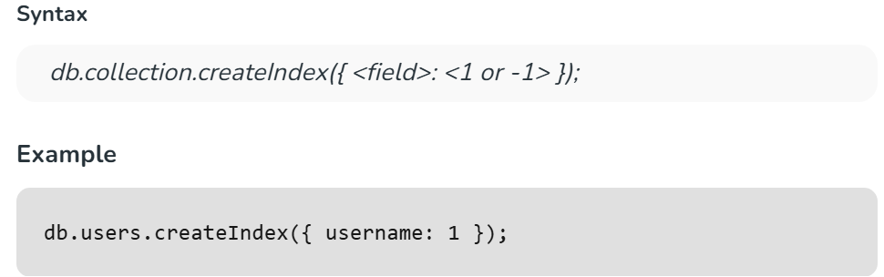

What are the parameters to create an index?
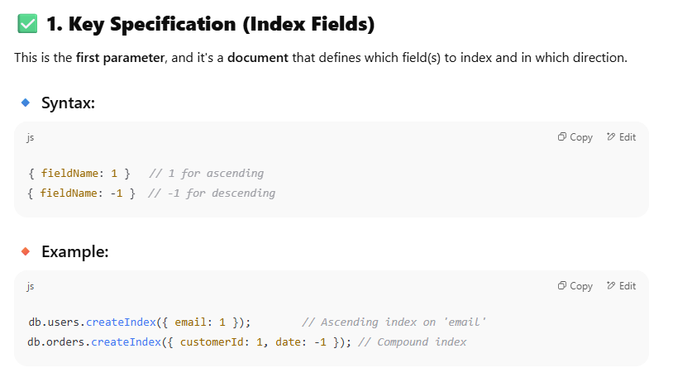
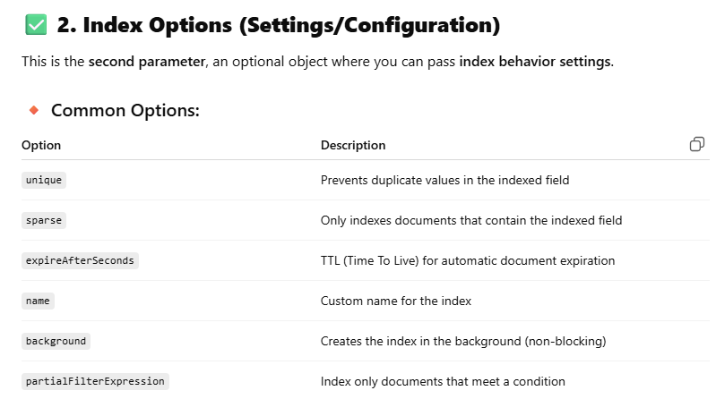

How to Drop an Index in MongoDB ?
- We can drop an index using the dropIndex() method.
- To drop multiple indexes, use dropIndexes().

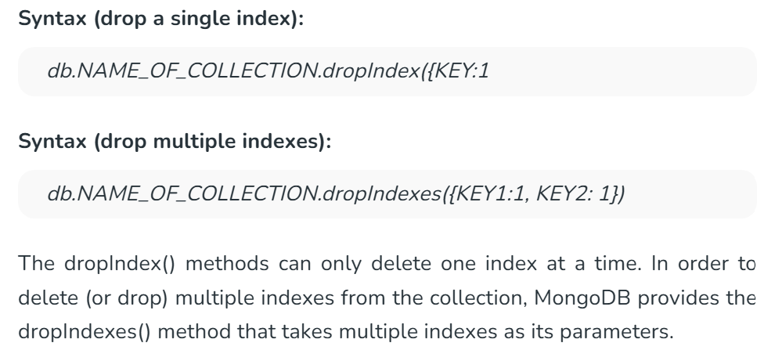

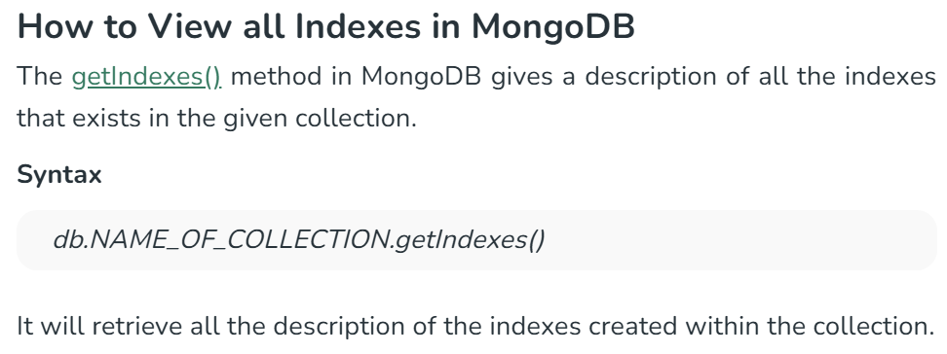
How does it improve performance?
Without indexes:
- MongoDB performs a collection scan, checking each document one by one — slow for large datasets.
With indexes:
- MongoDB uses the index to jump directly to matching documents, skipping irrelevant ones — much faster.
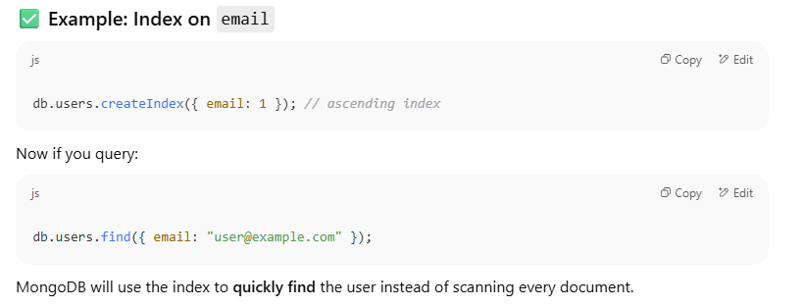
Why Do Inserts, Updates, and Deletes Affect Indexes?
📌 1. Insert Operations
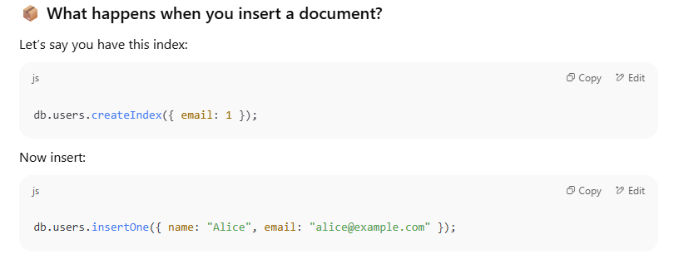
MongoDB must:
- Insert the document into the users collection.
- Insert the email field into the index tree.
  - The index structure (like a B-tree) must be updated to include "alice@example.com" at the correct position.
Note: This extra step takes CPU, memory, and disk I/O, especially when there are multiple indexes.

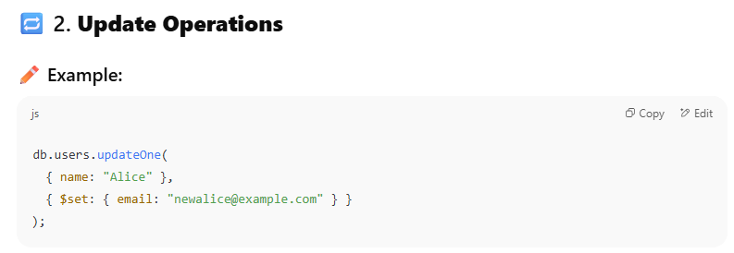
If email is indexed:
- MongoDB must remove the old email from the index.
- Then insert the new email into the correct position in the index.
If the update modifies a field that is not indexed, then indexes don’t change.
But if indexed fields are updated, each affected index must be rebalanced.
This can slow down update-heavy applications if too many indexes are involved.

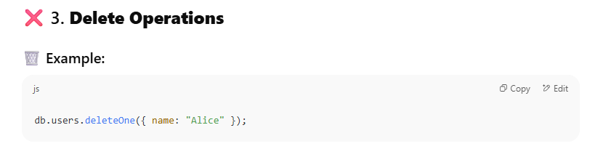
- MongoDB deletes the document from the collection.
- But it also must find and remove all corresponding index entries for that document.
This involves locating the document’s entry in each index and removing it — which takes additional processing time.

Other Overhead of using Index
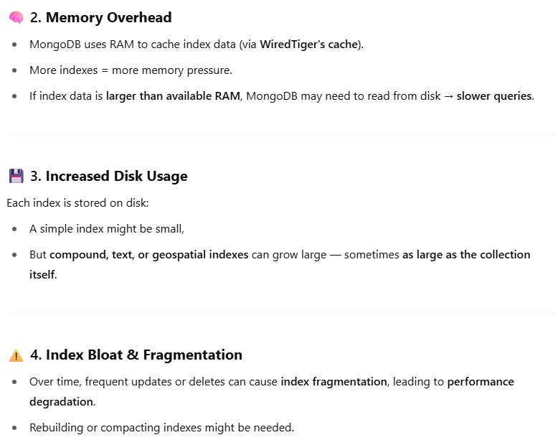

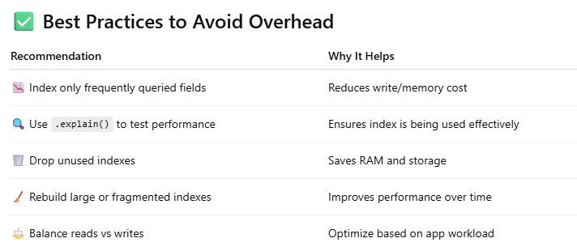
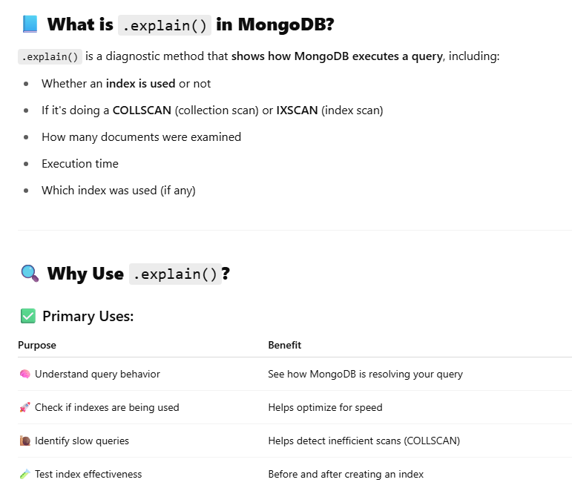
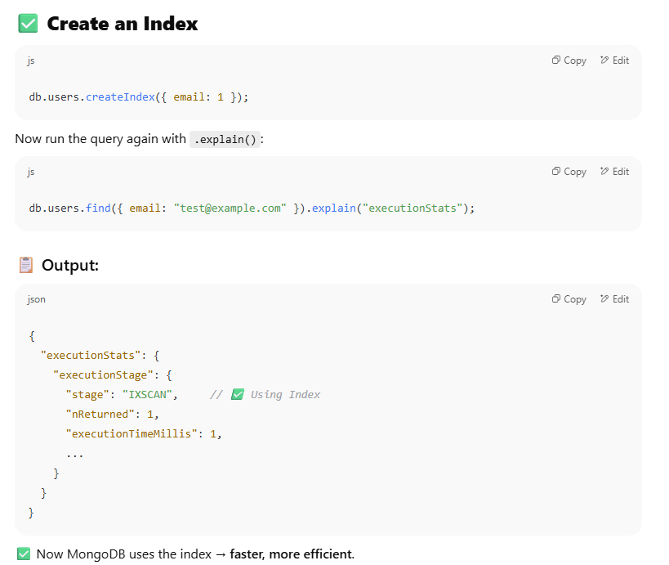
Q9. What are different types of indexes in MongoDB?
MongoDB provides different types of indexes that are used according to the data type or queries. The indexes supported by MongoDB is are as follows:
1. Single field Index:
- A single field index means index on a single field of a document.
- This index is helpful for fetching data in ascending as well as descending order.
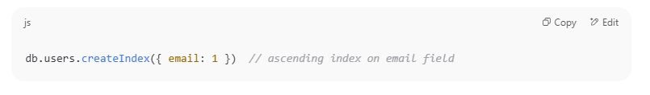
- 1 represents ascending order, meaning that MongoDB will store the values in increasing order.
- -1 can be used for descending order.
- Ideal for querying or sorting based on a single field, such as searching for a student's studentId.

2. Compound Index
Indexes multiple fields to optimize queries filtering/sorting by those fields.
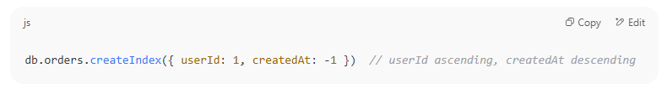
3. Unique Indexing
Indexes on unique filed like email, etc.

4. Multikey Index
Indexes each element of an array field separately.
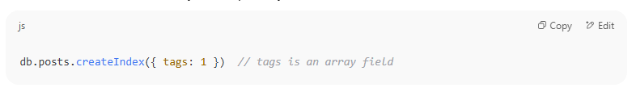 tags:["JavaScript", "React", "Node"]
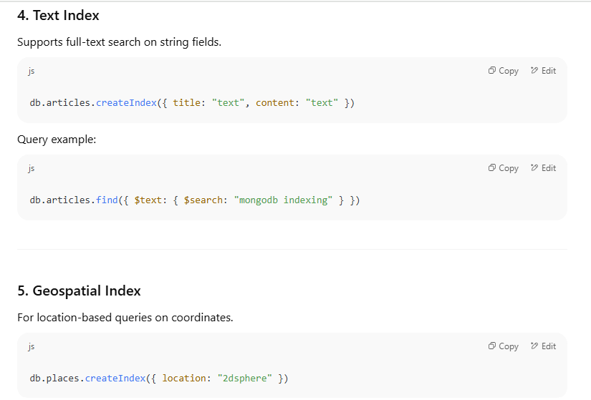
6. Hash Indexing
7. TTL (Time-To-Live) Index
Q10. What happens if a collection has no index and you run a complex query?
If a collection has no indexes and you run a complex query, here’s what happens:
- Full Collection Scan:
MongoDB will scan every document in the collection to find matches — this is called a collection scan.
- Slow Performance:
Since it checks every document, the query will be much slower, especially as the collection grows larger.
- High Resource Usage:
Full scans use more CPU, memory, and I/O, which can impact overall database performance.
- No Sorting Optimization:
Without indexes, sorting operations also become slower because MongoDB cannot use an index to quickly order results.
Q 11. How to Identify Slow Queries in MongoDB
- Enable the MongoDB Slow Query Log
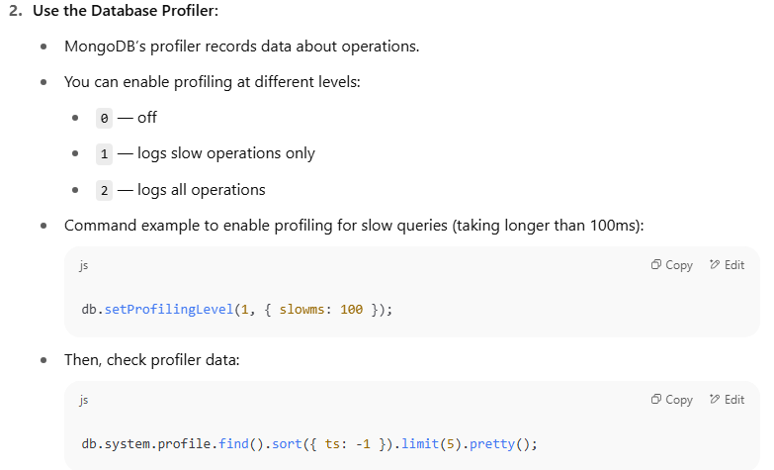

3. Use the explain() Method:
- Run .explain("executionStats") on your queries to see detailed info about execution time and index usage.
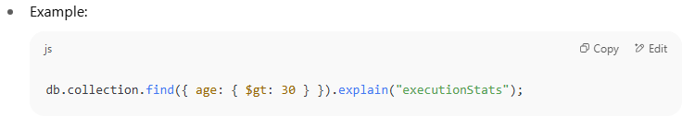

4. MongoDB Atlas Performance Advisor (If using Atlas):
- It automatically identifies slow queries and recommends indexes.

Q12. What is the aggregation pipeline in MongoDB?
The MongoDB Aggregation Pipeline allows you to perform a sequence of data processing operations on the documents in a collection.
The aggregation pipeline consists of a series of stages, where each stage represents a specific operation or transformation.
The output of each stage serves as the input for the next stage, allowing you to create complex data processing workflows.
OR
Aggregation Pipeline in MongoDB is a process where data passes through multiple stages like filtering, grouping, and sorting to transform it into the desired result
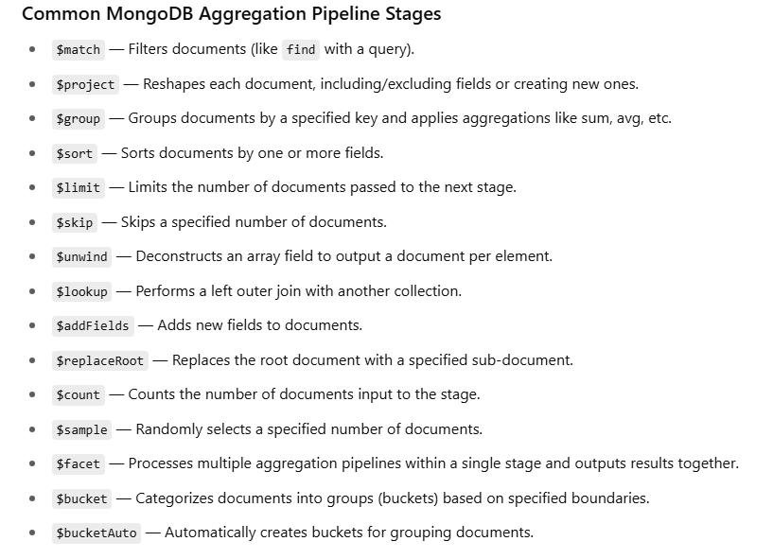
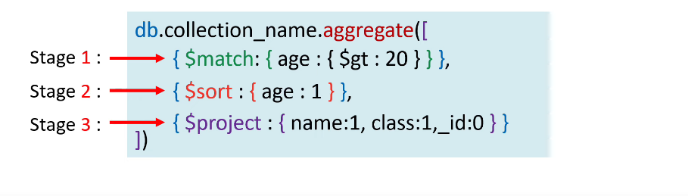

Some more example
$bucket :
The $bucket operator in MongoDB is used in aggregation pipelines to group documents into buckets (ranges) based on a specified field's value
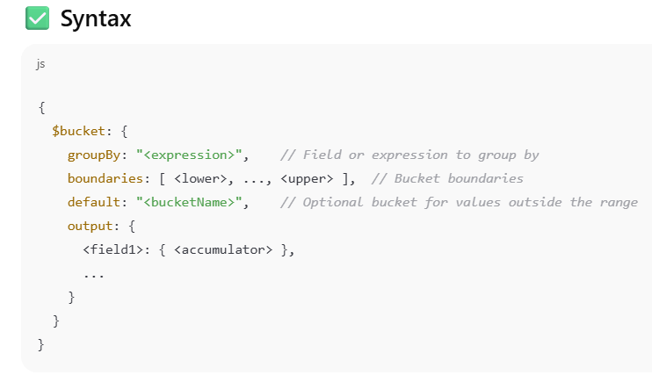
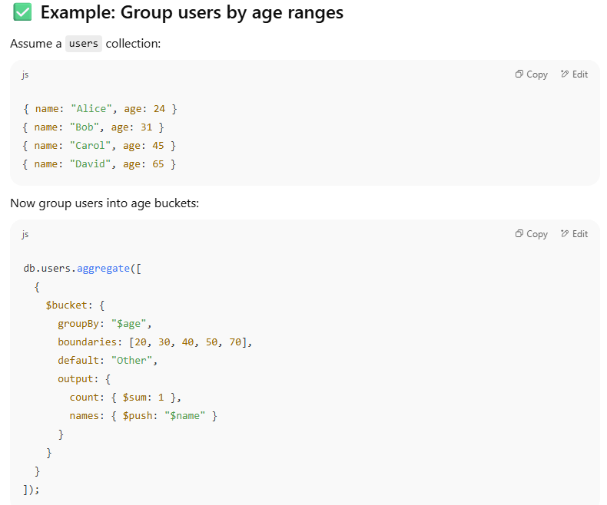
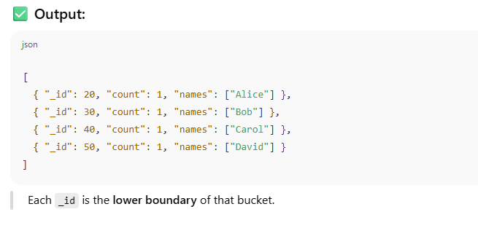
$bucketAuto in MongoDB Aggregation
$bucketAuto is an aggregation stage that automatically groups documents into buckets (ranges) based on the values of a specified field.
Use Case
- You want to create n ranges (or buckets) from a numeric field like price, age, score, etc.
- MongoDB automatically determines how to divide the values evenly.
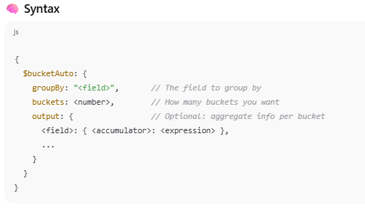
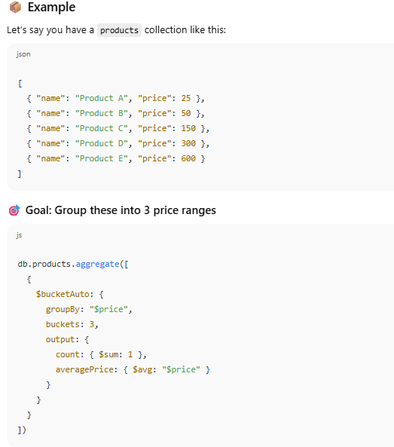
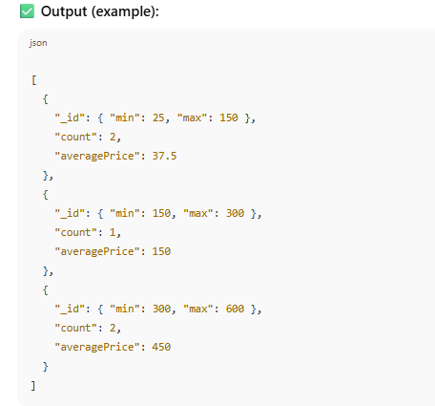
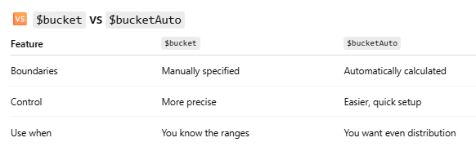
$project:
The $project stage in MongoDB's aggregation pipeline is used to reshape documents, i.e., to:
- Include or exclude specific fields
- Add new computed fields
- Rename fields
- Reformat or transform field values
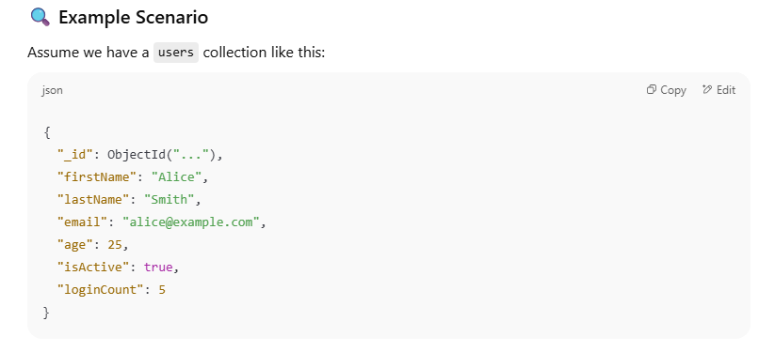
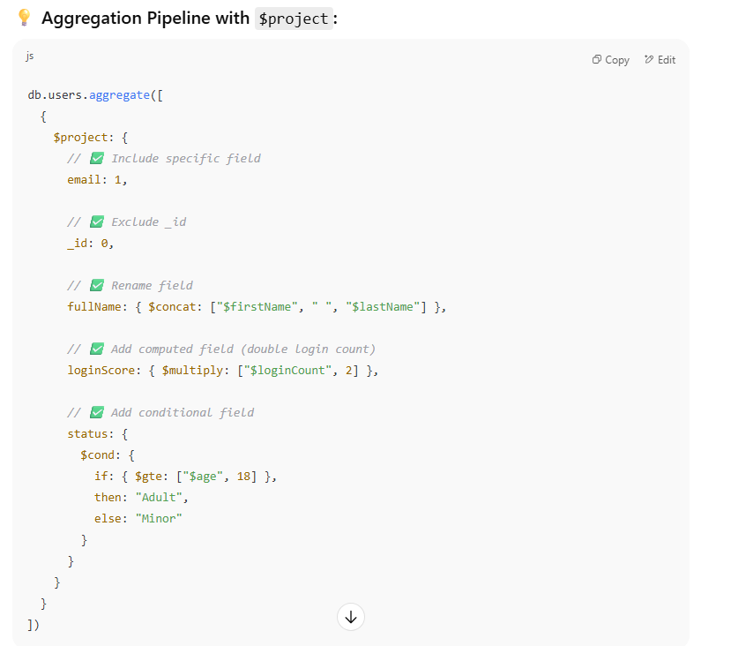
$addFields
Adds new fields or modifies existing ones in the documents without removing other fields.
Example
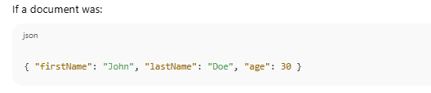
Use $addField
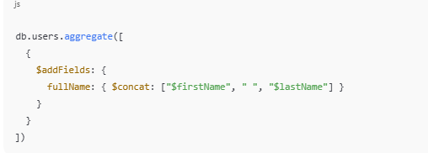
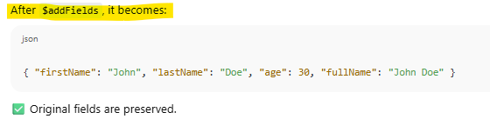
Note: If we don’t want existing field then use $$REMOVE
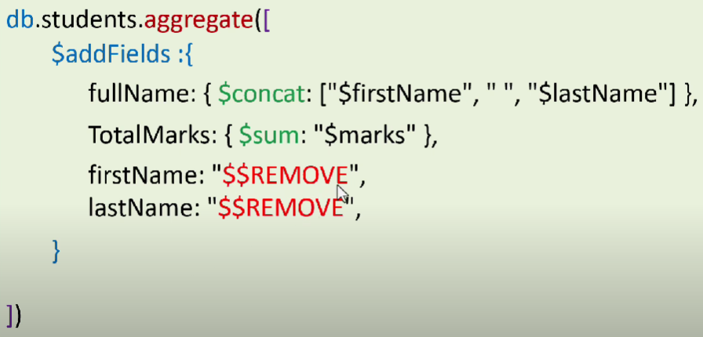
$lookup:
The $lookup stage in MongoDB's aggregation pipeline performs a left outer join between documents in two collections — kind of like an SQL JOIN.
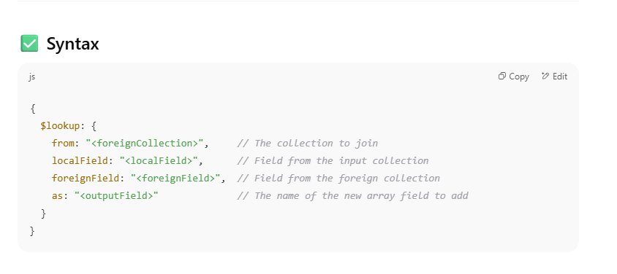
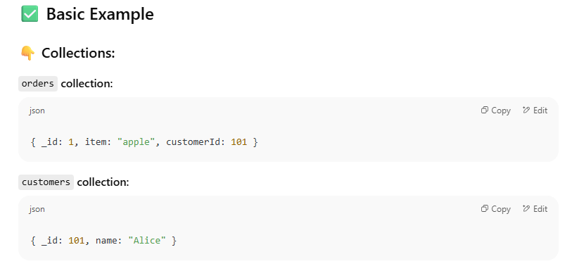
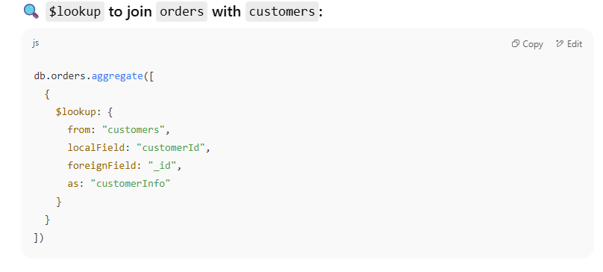
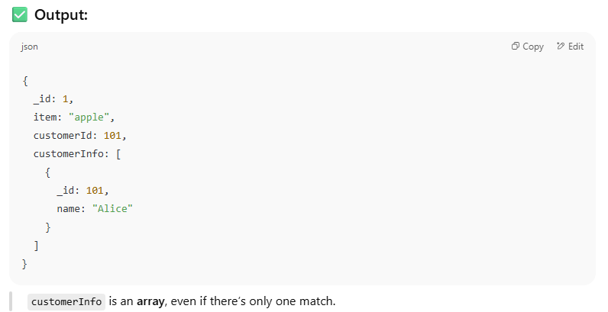
$group
The $group stage in MongoDB's Aggregation Pipeline is used to group documents by a specific field (or expression), and then apply accumulator operations like $sum, $avg, $max, $min, etc., to compute aggregate values for 1 group.
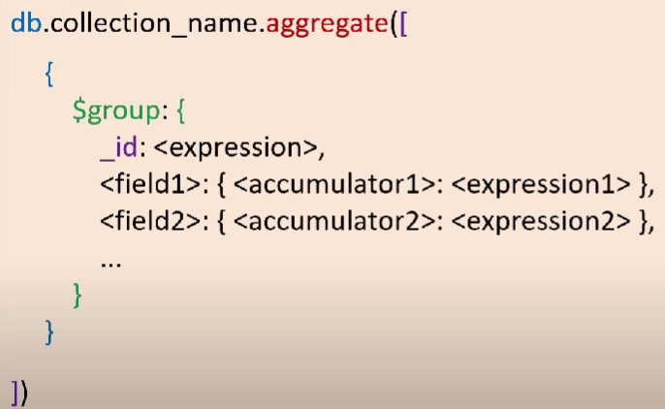
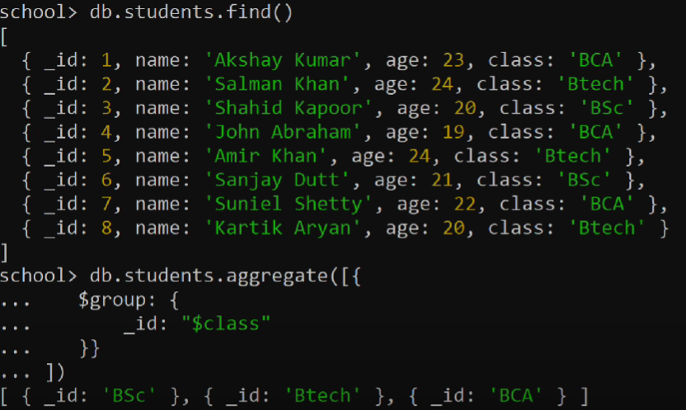
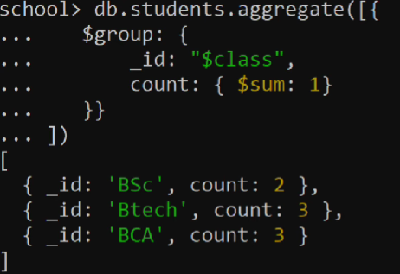
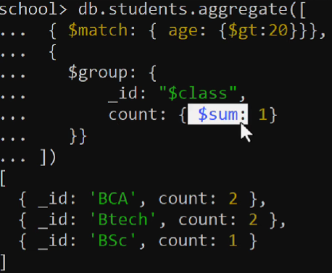
$push in $group
The $push operator adds values to an array in each group. It collects data from documents and "pushes" them into an array for that group.
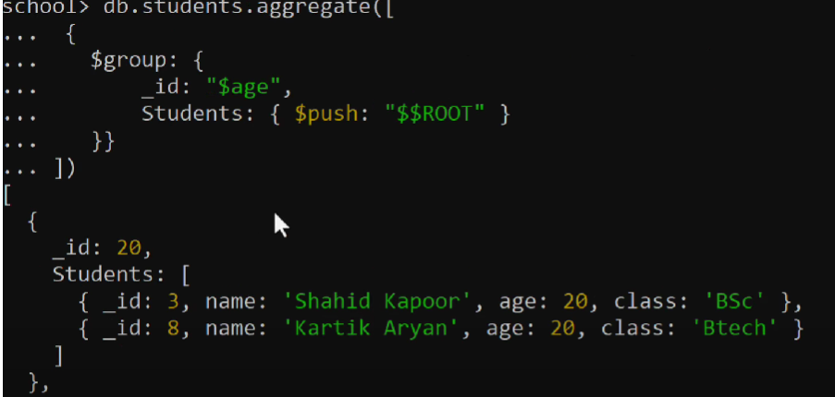
Note: $addToSet is same as $push in $group but it only includes unique values.
Q13. Write an aggregation to get the average order amount per customer.
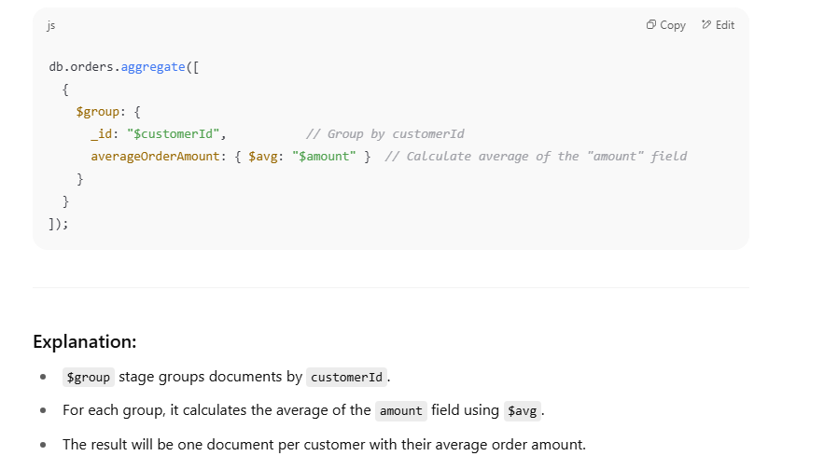
$unwind
MongoDB $unwind operator is an essential tool for handling arrays within documents. It helps deconstruct arrays, converting each array element into a separate document, which simplifies querying, filtering, and aggregation in MongoDB.
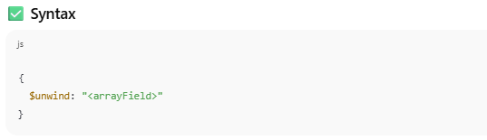
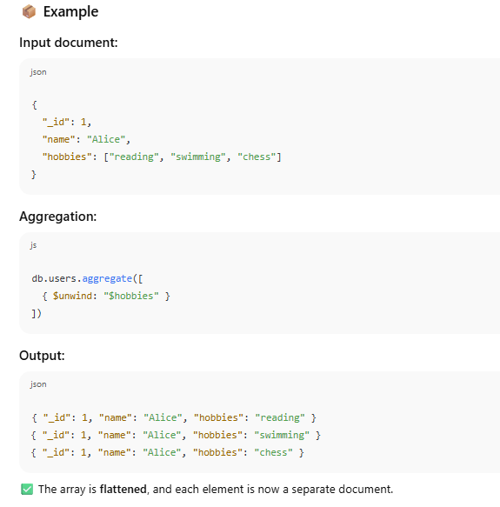
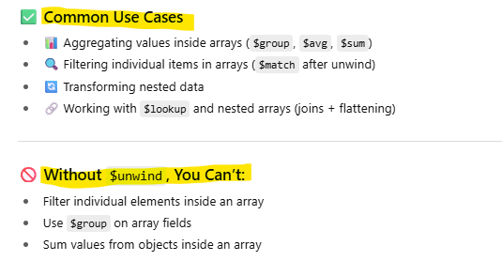

$out
$out is an aggregation pipeline stage that allows us to save the results of an aggregation operation to a specified collection.
Instead of returning documents to the client (like .find() or most aggregations), $out saves the result to a collection — either:
- Replacing an existing collection (if it exists), or
- Creating a new one (if it doesn’t exist)
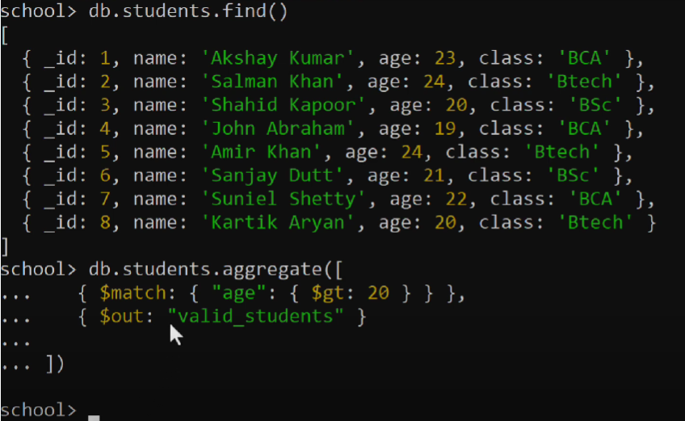
In the upper example we create a valid_students so it will not return any document instead of this it will add the new collection in DB valid_students if not exist or if it is exist so replace the collection.
If we check the collection we get the valid_students
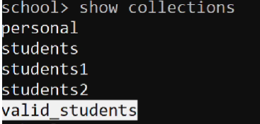

$merge
The $merge stage is used in MongoDB’s aggregation framework to output the results of an aggregation pipeline to a specified collection.
It either updates existing documents, inserts new ones, or replaces the entire collection.
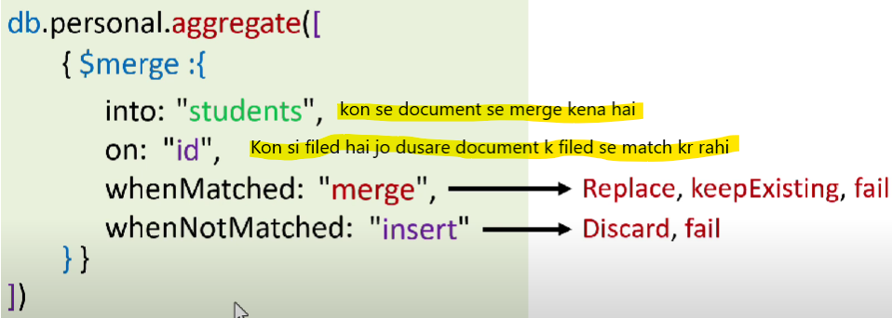
Example
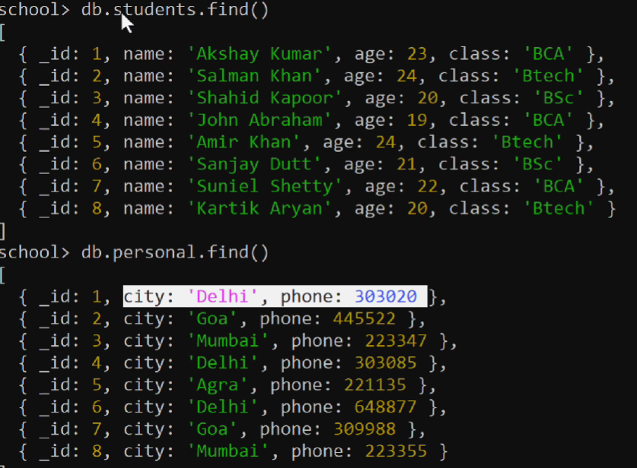
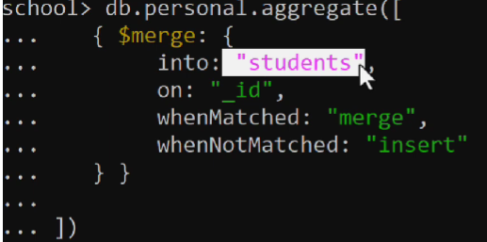
Note : It will add the data of personal in student document but not return the document.
Check the student collection it will come with personal data.
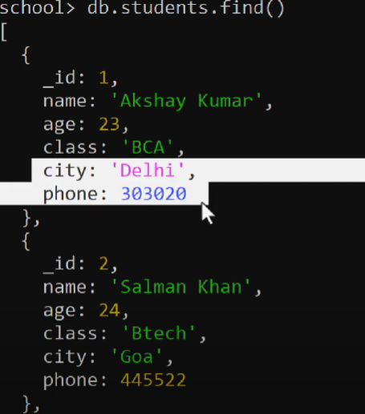
$unionwith
$unionWith is used to combine documents from multiple collections into a single aggregation pipeline.
It’s like doing a UNION in SQL, where you join the result of two or more queries vertically.
Use Case
- Combine data from two collections with similar or related structures
- Query archived data and current data together
- Create a unified feed from different content sources
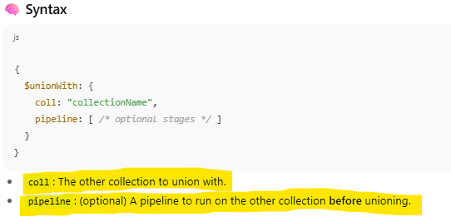
Note:
Does NOT create a new collection.
It simply combines the documents from two (or more) collections temporarily during the aggregation and returns the combined result set.
Example
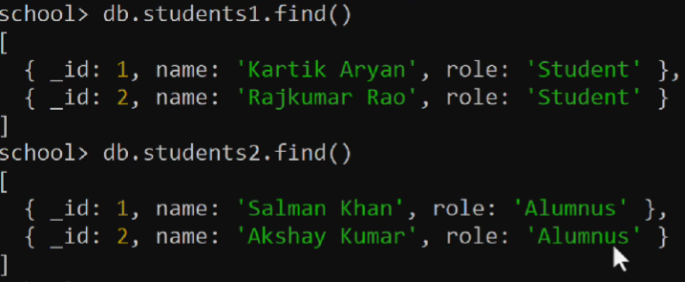
Output
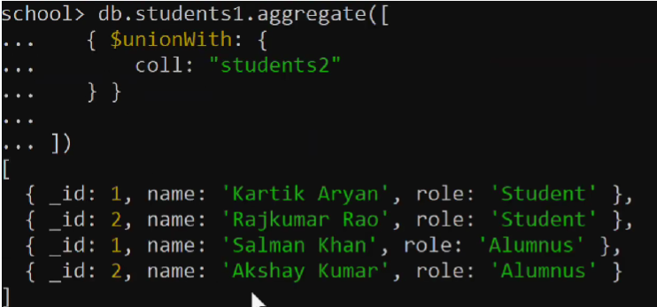
$facet
$facet allows you to run multiple aggregation pipelines in parallel on the same input and return all their results in a single document.
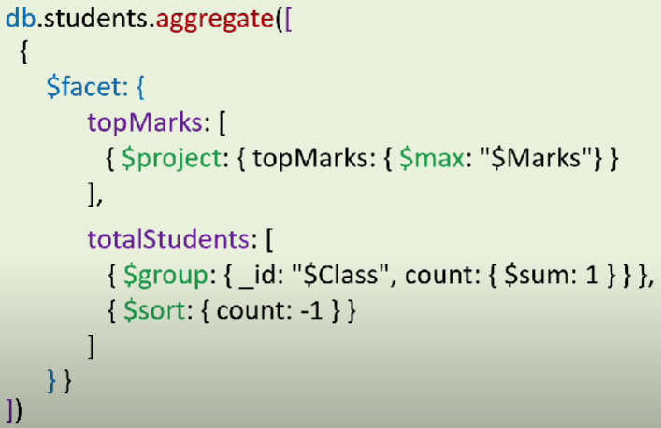
Q14. What is Mongoose? Why do we use it in Node.js projects?
- Mongoose is an Object Data Modeling (ODM) library for MongoDB and Node.js.
- It provides a straightforward, schema-based solution to model your application data.

Why do we use Mongoose in Node.js projects?
- Schema definition: Unlike MongoDB which is schema-less, Mongoose lets you define schemas to enforce structure and data types on your documents.
- Data validation: It helps validate data before saving it to the database.
- Middleware support: You can add hooks (pre/post) for operations like save, update, delete, etc.
- Query building: Simplifies querying MongoDB with a fluent, chainable API.
- Population: Makes it easy to work with references between collections (like JOINs).
- Better error handling: Provides consistent and meaningful errors.
Q15. How do you define a schema and a model in Mongoose?
What is a Schema?
- A Schema in Mongoose defines the structure of documents within a MongoDB collection.
- It specifies fields, data types, validations, default values, and more.
What is a Model?
- A Model is a constructor compiled from the schema.
- It provides an interface to interact with the database — create, read, update, and delete documents.

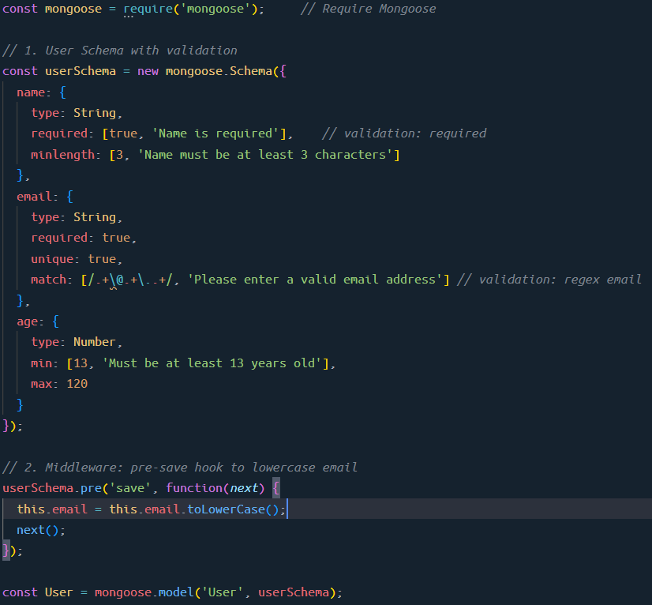
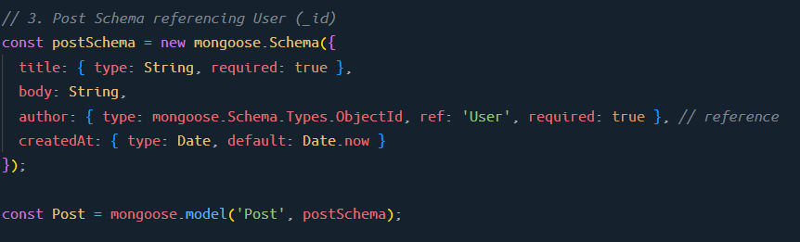
Q16. What are middleware in Mongoose?
Middleware in Mongoose are functions that run before or after certain lifecycle events on documents or models.
They allow you to add logic to run automatically during operations like saving, updating, validating, or removing documents.
Types of Middleware in Mongoose
- Pre middleware – runs before an operation.
- Post middleware – runs after an operation.
Common Middleware Use Cases
- Validate or modify data before saving.
- Hash passwords before storing.
- Log or audit changes.
- Cleanup related data after removal.
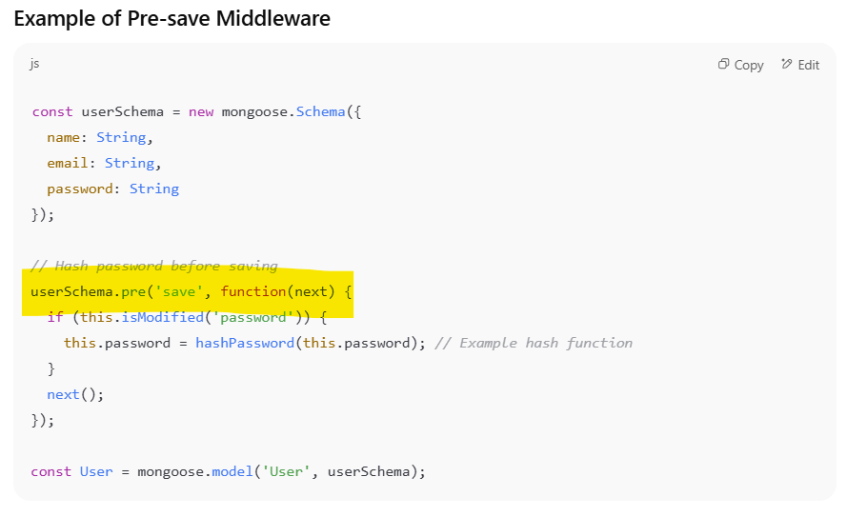
Q17. How do you handle relationships in MongoDB with Mongoose?
Handling relationships in MongoDB with Mongoose is done mainly in two ways:
Embedding documents and Referencing documents (also called population).
1. Embedding (Denormalization)
- You store related data inside the parent document as a nested object or array.
- Good for closely related data that is always accessed together.
Example: A blog post with embedded comments.
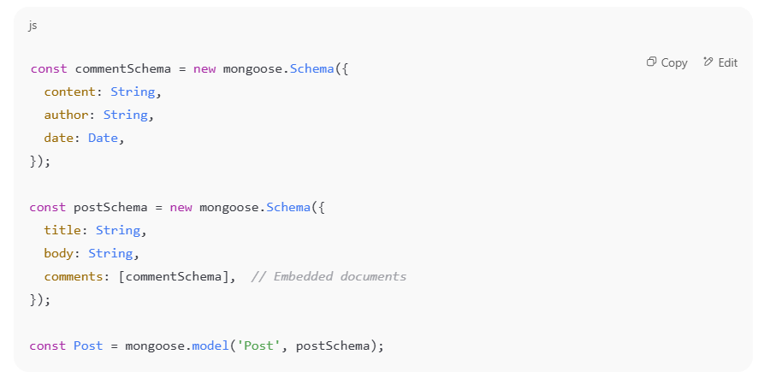
Pros: Faster reads since all data is in one document.
Cons: Can cause document size to grow large and harder to update nested data independently.
2. Referencing (Normalization with Population)
- You store only the ObjectId of the related document.
- Mongoose provides .populate() method to fetch related documents.
- Useful when related data is large or shared across documents.
Example: Users and Posts relationship where a post references its author:
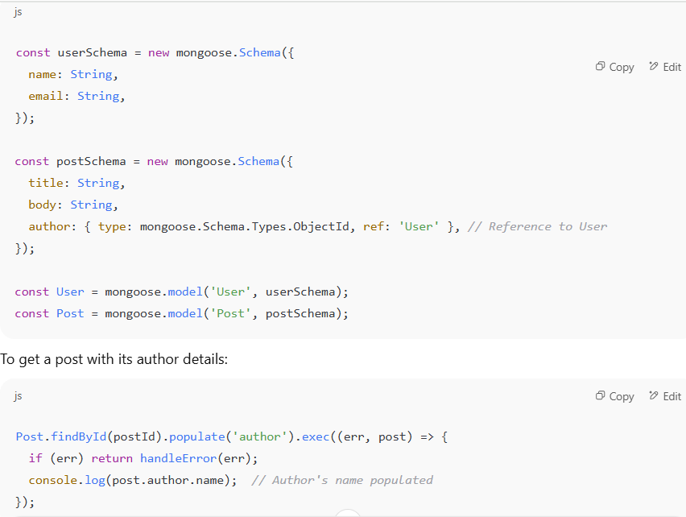
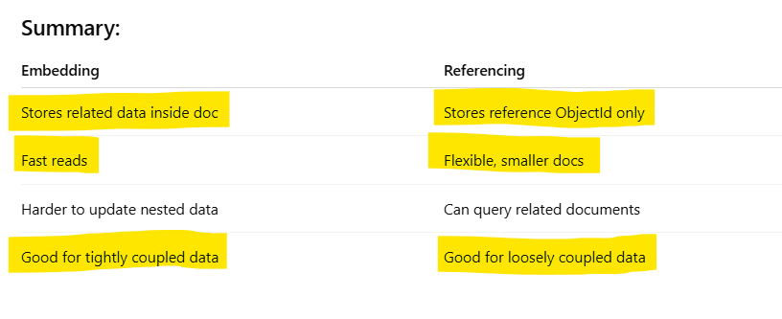
Q22. How do you handle large datasets in MongoDB?
1. Schema Design for Large Data
- Embed vs. Reference:
  - Embed related documents if they are frequently accessed together.
  - Use references for large or less-frequently accessed data.
- Avoid deep nesting: MongoDB documents can only be 16MB — keep nesting reasonable.
- Use flat and lean schemas: Store only what’s needed

2. Indexing
- Create indexes on fields used in queries, sorting, or filtering.
- Use compound indexes if querying multiple fields.
- Use covered queries to return results directly from the index.
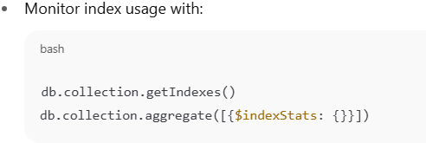
3. Sharding (Horizontal Scaling)
- Split large collections across multiple shards (servers).
- Choose a good shard key that avoids:
  - Hot spots (too many inserts in one shard).
  - Poor cardinality (too few unique values).
- MongoDB handles routing automatically once sharded.
4. Aggregation Framework Optimization
- Use $match early in pipeline to filter before processing.
- Use $project to limit fields.
- Avoid loading entire documents if not needed.
- Run explain() on aggregation pipelines to understand performance.
5. Monitoring and Profiling
- Use MongoDB tools:
  - Atlas Performance Advisor
  - mongotop, mongostat
  - Query profiler: db.setProfilingLevel()
  - db.collection.explain("executionStats")

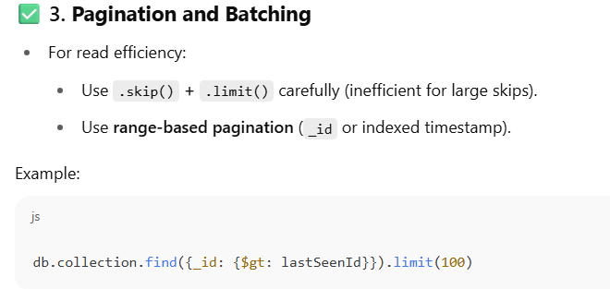
Q23. How do you perform pagination efficiently in MongoDB?
(e.g., skip/limit vs. using _id based paginationpp)
1. skip() / limit() Pagination (Offset-based)
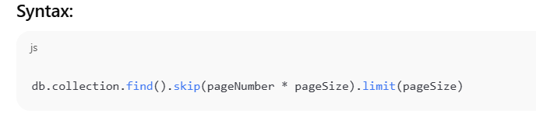
Pros:
- Simple to implement.
- Good for small datasets or admin dashboards.
Cons:
- Performance degrades with high skip values — MongoDB must scan and discard skipped documents.
- Not suitable for infinite scroll or APIs with deep pagination.
2. _id-based Pagination (Cursor-based / Range-based)
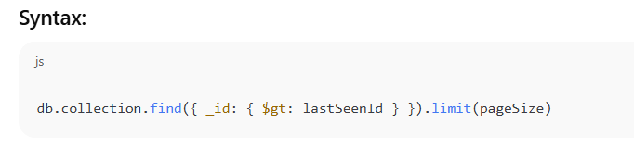
Pros:
- Very efficient — uses indexed field (e.g., _id, createdAt, etc.).
- Ideal for infinite scroll or real-time feeds.
- Consistent under changing data (no skipping over new inserts).
Cons:
- Cannot jump to arbitrary pages (no page number).
- Requires maintaining the last seen document's key.
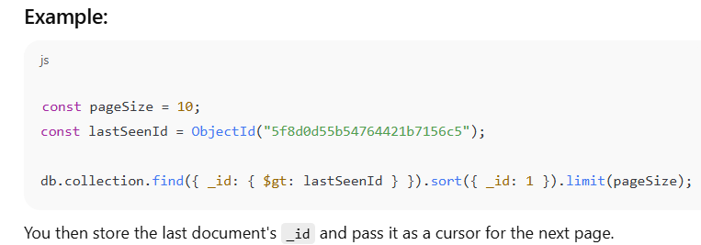
Q24. How do you ensure data validation in MongoDB?
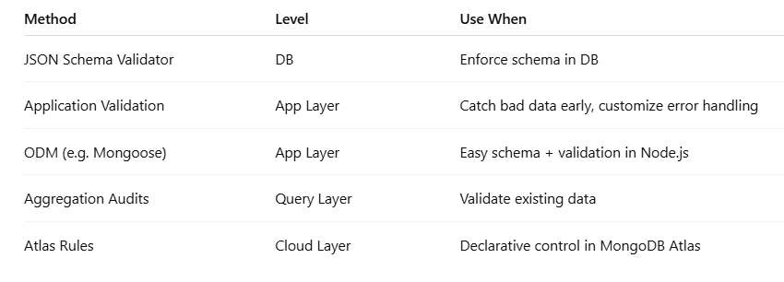
Q25. What’s the use of MongoDB’s TTL index? Give a practical use case.
A TTL (Time-To-Live) index in MongoDB automatically removes documents from a collection after a certain period — based on a timestamp field.
It’s useful for automatic data expiration without manual cleanup scripts.
How TTL Index Works
- You create a TTL index on a field that stores a date/time value.
- MongoDB automatically deletes documents after the date + expiration window.
- Cleanup runs every 60 seconds (not immediate).
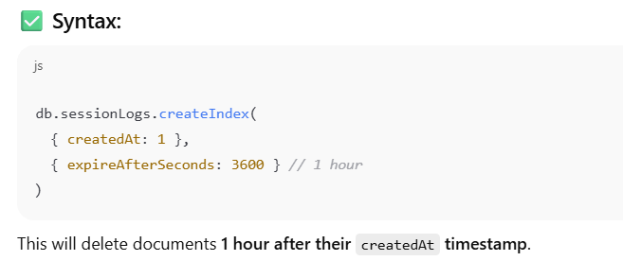
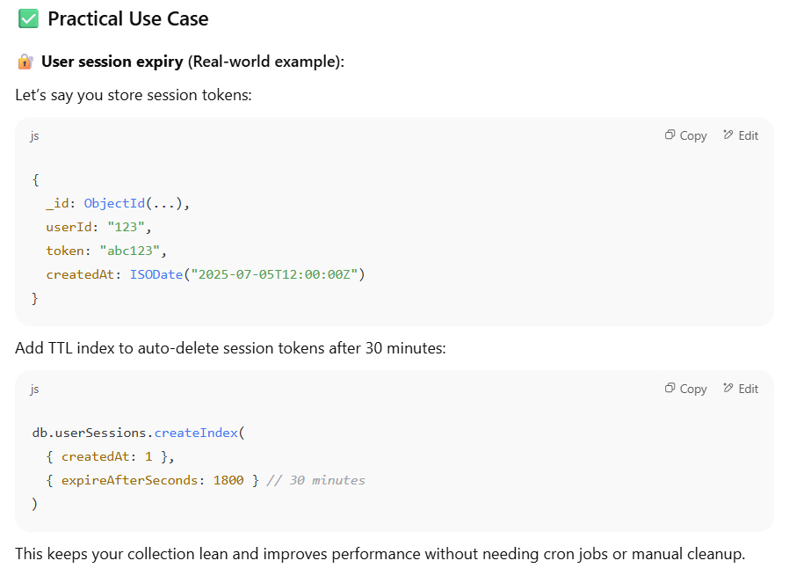
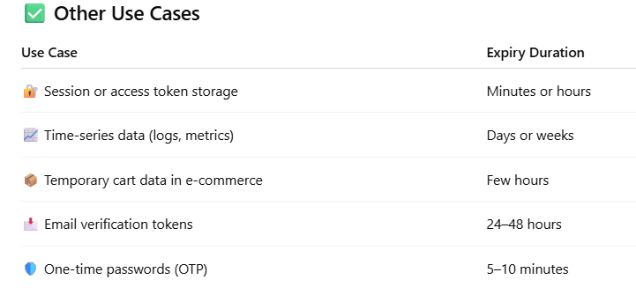
Q26. Explain Vertical and Horizenta Scalling in MongoDB.
1. Vertical Scaling (Scaling Up)
📌 Definition:
Vertical scaling means adding more resources (CPU, RAM, Disk) to a single MongoDB server to handle increased load.
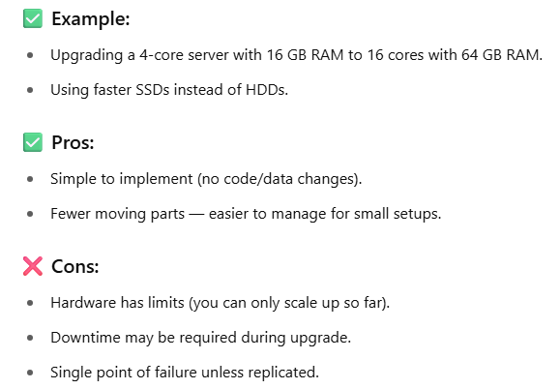
2. Horizontal Scaling (Scaling Out)
📌 Definition:
Horizontal scaling means adding more servers (nodes) to distribute data and load across multiple machines.
In MongoDB, this is done via sharding.
✅ How it works:
- A large collection is split (sharded) across multiple shards (nodes).
- Each shard holds a portion of the data based on a shard key.
- A mongos router routes queries to the correct shard(s).
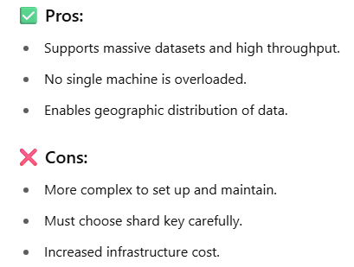
Q27. Replication in Databases
Replication is the process of creating multiple copies of a database on different servers to ensure high availability, fault tolerance, and scalability.
In MongoDB, replication is implemented using replica sets, with one primary server handling writes and multiple secondaries copying data and providing read scalability.Why Replication is Needed
- High Availability
  - If the primary server fails, a replica can take over.
- Data Redundancy
  - Protects against hardware or software failures.
- Load Balancing
  - Read operations can be distributed across replicas, reducing the load on the primary server.
- Disaster Recovery
  - Replicas can exist in different geographic locations.
Q28. Explain Transaction
“A transaction in MongoDB is a set of operations executed as a single unit, ensuring that either all operations succeed or none are applied, maintaining data consistency.”
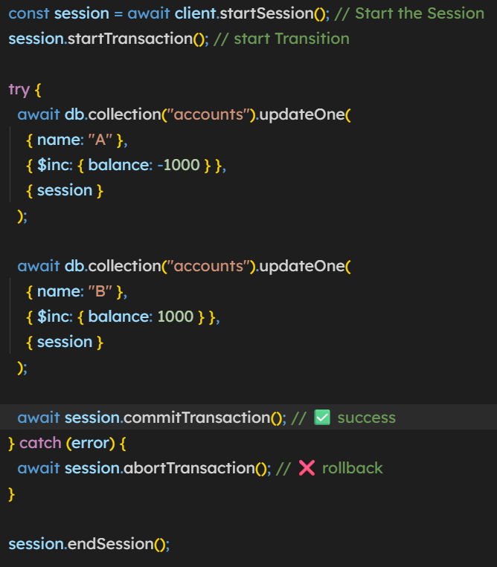
What is client in the startSession?
