**1. What is PHP?**

* PHP (Hypertext Preprocessor) is a popular server-side scripting language designed for web development. It can be embedded into HTML and is used to create dynamic web pages.

**2. What are the differences between echo and print in PHP?**

* **echo**: A language construct used to output data, can accept multiple parameters (though rarely used), and does not return a value.
* **print**: A language construct that outputs data but returns 1, meaning it can be used in expressions. It accepts only one argument.

**3. What are the different data types supported in PHP?**

PHP supports the following data types:

* **Scalar types**:
  + int (integer)
  + float (floating-point number)
  + string
  + bool (boolean)
* **Compound types**:
  + array
  + object
* **Special types**:
  + NULL
  + resource

**4. What is the difference between == and === in PHP?**

* **==**: Compares values, allowing type conversion (loose comparison).
* **===**: Compares both value and type (strict comparison).

**5**. **What is Cookie ?**

A cookie is a small piece of data that is stored on the user's computer by the web browser while browsing a website.

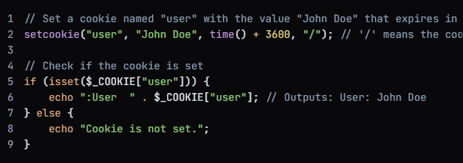

**Example: Real-Life Scenario of Cookies in PHP**

Let’s imagine a real-life scenario where you have a website with a **dark mode/light mode** theme. You can use cookies to remember the user's theme preference (dark or light) even when they return to the website later.

**Scenario: Dark Mode/Light Mode Preference**

1. **Set the cookie** when the user selects a theme (dark mode or light mode).
2. **Read the cookie** on subsequent page loads to apply the correct theme.
3. **Delete the cookie** if the user logs out or wishes to reset their theme.

**6.What is session?**

In PHP, a session is a way to store information (in variables) to be used across multiple pages.

Unlike cookies, which store data on the client-side (in the user's browser), sessions store data on the server-side.

This makes sessions more secure and suitable for storing sensitive information, such as user login credentials.

**7. What are the types of errors in PHP?**

PHP has the following error types:

* **Parse Errors**: Syntax errors in the code.
* **Fatal Errors**: Critical errors that stop the script from running.
* **Warning Errors**: Non-fatal errors that do not stop the script.
* **Notice Errors**: Minor errors indicating potential issues, such as using an undefined variable.

**8. What is the use of include() and require() in PHP?**

* **include()**: Includes and evaluates a specified file. If the file is not found, a warning is issued, but the script continues executing.
* **require()**: Similar to include(), but if the file is not found, it results in a fatal error and stops the script execution.

**9. What is Array?**

In PHP, an **array** is a data structure that allows you to store multiple values in a single variable. Arrays can hold a collection of values of different types, including strings, integers, objects, and even other arrays.

**Types of Arrays in PHP**

PHP supports three types of arrays:

1. **Indexed Arrays**:
   * These are arrays where each element is assigned a numeric index, starting from 0. You can access the elements using their index values.

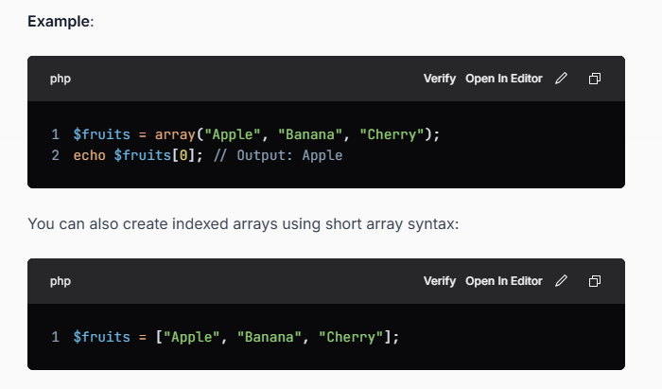

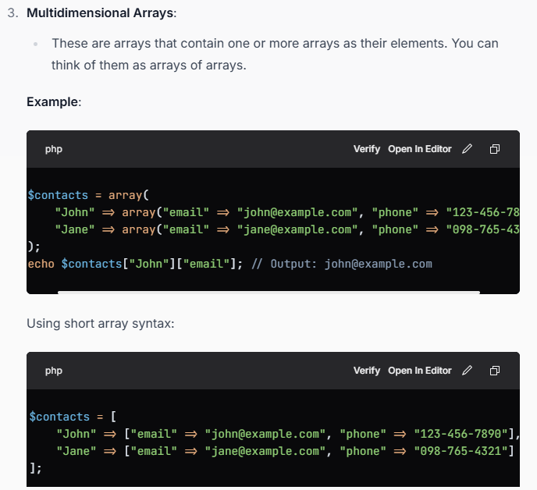

Common Array Function

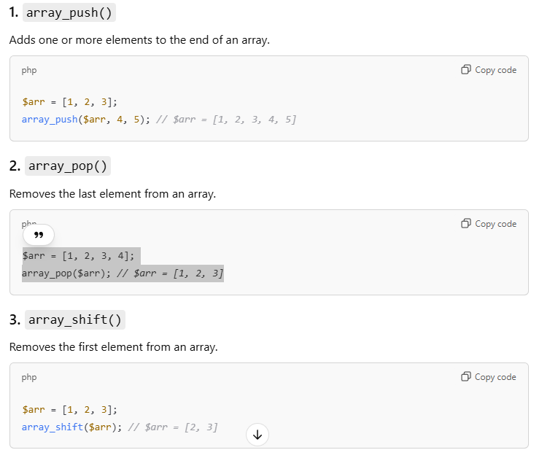

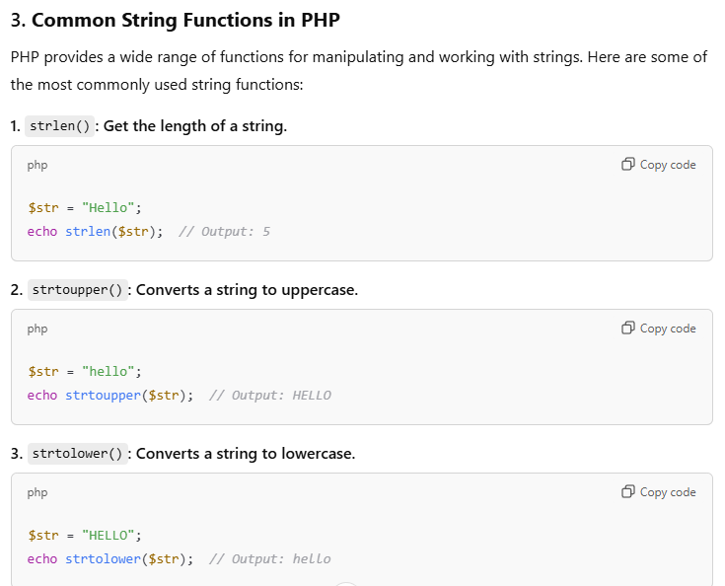

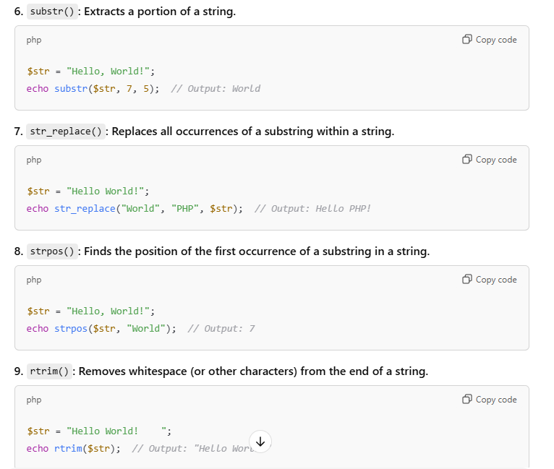

**11. Explain the difference between unset() and unlink() in PHP.**

* **unset()**: Destroys a variable, freeing up memory.
* **unlink()**: Deletes a file from the file system.

**12. What is the difference between GET and POST methods in PHP?**

* **GET**: Sends data through the URL, which is visible. It is limited in the amount of data it can send.
* **POST**: Sends data in the HTTP body, making it more secure for transmitting sensitive data. It is not limited by size like GET.

**10.What is String?**

In PHP, a string is a sequence of characters used to represent text.

It is one of the most commonly used data types in PHP and can be created using single quotes (') or double quotes (").

**11. What is** **$_SERVER**

The **$_SERVER** superglobal in PHP.

It is an associative array that contains information about headers, paths, and script locations.

It provides a way to access server and execution environment information, which can be useful for various tasks such as debugging, handling requests, and managing user sessions.

**Purpose of $_SERVER**

The **$_SERVER** superglobal is primarily used to retrieve information about the server environment and the current request. This includes details such as:

* Server software and version
* Request method (GET, POST, etc.)
* Client IP address
* Script name and path
* HTTP headers
* Server protoco

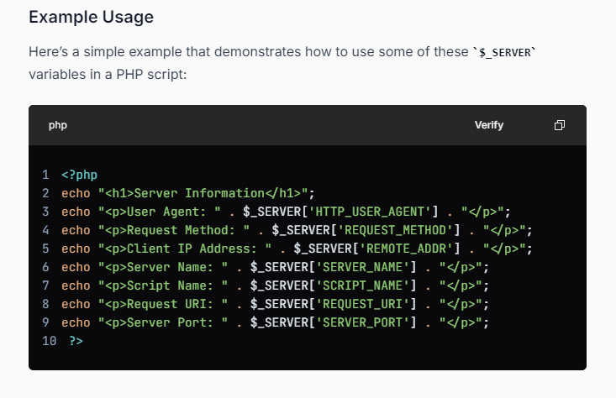

**12. Exception Handling in PHP**

An exception is an unexpected program result that can be handled by the program itself.

PHP provides the following specialized keywords for this purpose.

* **try:** It represents a block of code in which exceptions can arise.
* **catch:** It represents a block of code that will be executed when a particular exception has been thrown.
* **throw:** It is used to throw an exception. It is also used to list the exceptions that a function throws, but doesn’t handle itself.
* **finally:** It is used in place of a catch block or after a catch block basically it is put for cleanup activity in PHP code.

**Benefits of Exception Handling**

* **Separation of Error Handling Logic**: Exception handling separates error handling from regular code, making the code cleaner and easier to read.
* **Control Flow**: It allows for more flexible control flow, enabling you to handle errors at different levels of the application.
* **Stack Trace**: When an exception is thrown, PHP provides a stack trace, which can help in debugging by showing where the exception occurred.

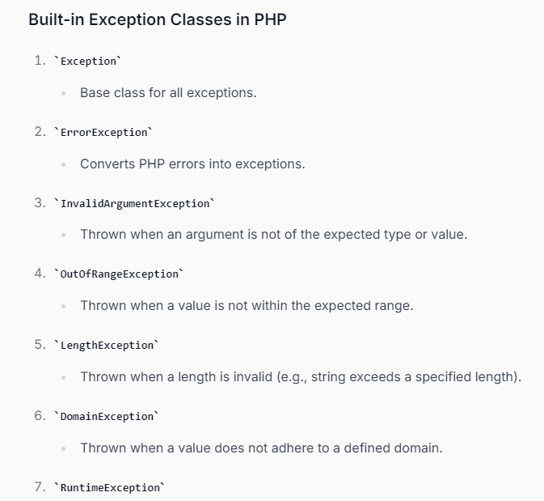

**13. What is use of namespace in php?**

PHP namespaces are a way of encapsulating classes, functions, and constants to avoid name conflicts and to logically group related code.

OR

Namespaces are a powerful tool in PHP for organizing code and preventing name conflicts. They are especially useful in large projects or when integrating multiple libraries or frameworks.

Using namespaces properly can lead to cleaner, more maintainable, and more scalable PHP code.

14. What is Type Casting in PHP

Note : In php we have settype function to change the type of variable

**15. How to connect Database in php using Normal and PDO**

**2. Connecting to MySQL Using PDO**

PDO (PHP Data Objects) is a database access layer that provides a uniform method of access to multiple databases. It is more flexible and secure than MySQLi, especially when it comes to prepared statements.

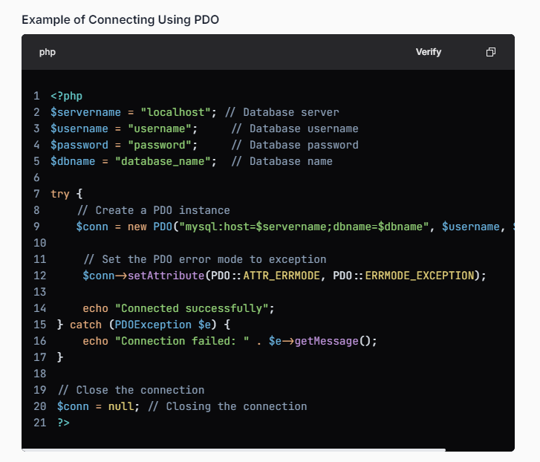

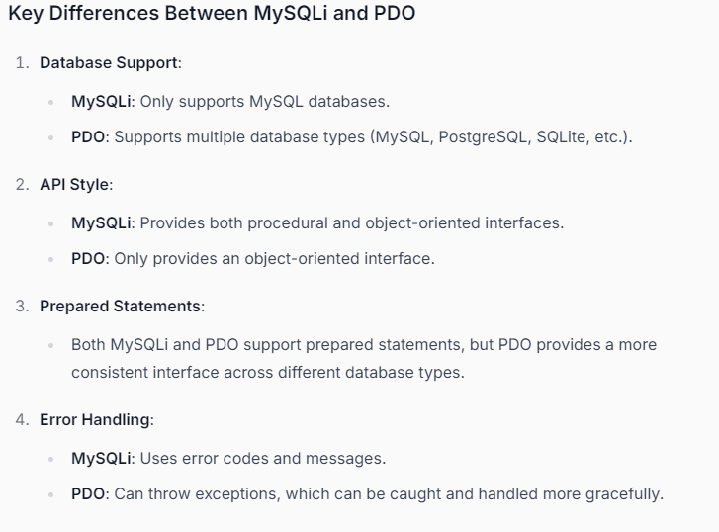

15.What is Filter_var() function in php?

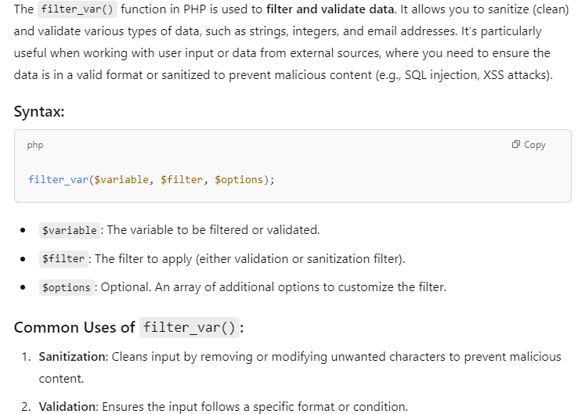

File Handling in PHP

In PHP, file handling involves performing operations such as opening, reading, writing, and closing files. These operations are performed using built-in PHP functions, and file handling is often necessary when you need to interact with files on the server (e.g., saving user data, logging, or reading configuration files).

*********************************************************************************

**What is XML ?**

XML (eXtensible Markup Language) is a text-based markup language

It was designed to store and transport data across different systems.

XML is both human-readable and machine-readable.

As HTML there is also tags but we can create our own tag not predefine tag.

**Key Features of XML:**

**Self-Descriptive:** XML documents contain both data and its structure. The tags used in XML describe the data's meaning, making it self-descriptive.

**Extensible**: Unlike HTML, XML is not predefined. You can create your own custom tags to structure data in any way you want.

**Platform-Independent**: XML is platform-agnostic, meaning it can be used across different operating systems and applications.

**Human-Readable**: XML files are plain text, meaning they are easy for humans to read and understand. However, for larger datasets, XML may become complex and difficult to read.

**Hierarchical Structure**: XML organizes data in a tree-like structure, with elements nested inside other elements. This makes it easy to represent hierarchical relationships.

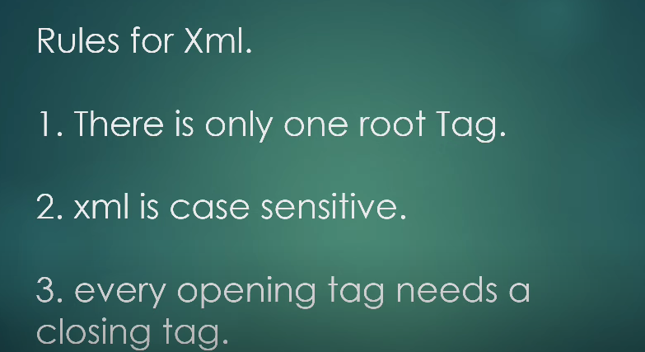

**Types of XML**

While well-formedness is mandatory, validation is optional and can be enforced using a schema (like DTD or XSD). Here are some validation rules:

* **Document Type Definition (DTD)**: A DTD defines the structure and the legal elements and attributes of an XML document. It can be declared internally or externally.
* **XML Schema Definition (XSD)**: An XSD provides a more powerful and flexible way to define the structure of an XML document, including data types, element relationships, and constraints.

**Basic Structure of an XML Document:**

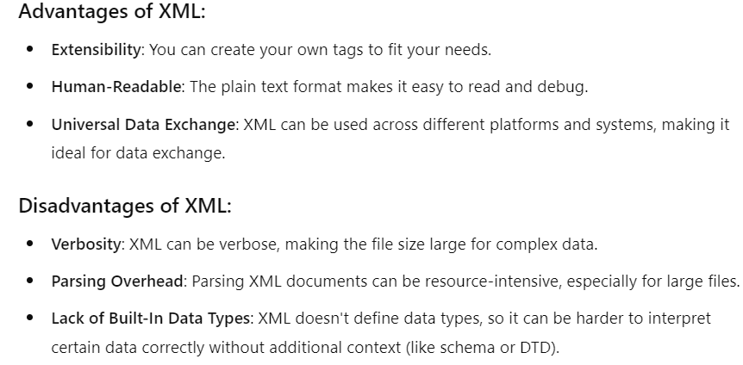

**How AJAX Works – Step**

1. **Create an XMLHttpRequest Object**: You create an instance of the **XMLHttpRequest** object.
2. **Configure the Request**: You specify the type of request (GET or POST), the URL to send the request to, and whether the request should be asynchronous.
3. **Send the Request**: You send the request to the server.
4. **Handle the Response**: You define a callback function that will be executed when the server responds. This function can process the response data and update the web page accordingly.

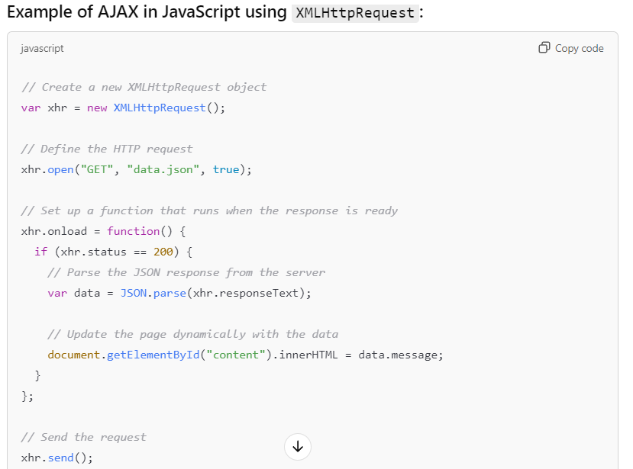

**Common Methods of XMLHttpRequest:**

**open(method, url, async, user, password)**

* This method is used to configure the request. It initializes a request with the specified HTTP method (GET, POST, PUT, DELETE, etc.), the URL to which the request will be sent, and whether the request should be asynchronous or synchronous.

**send(data)**

* This method sends the request to the server. If the request method is POST or PUT, you can pass data to be sent to the server. For GET requests, the data argument is usually not needed.

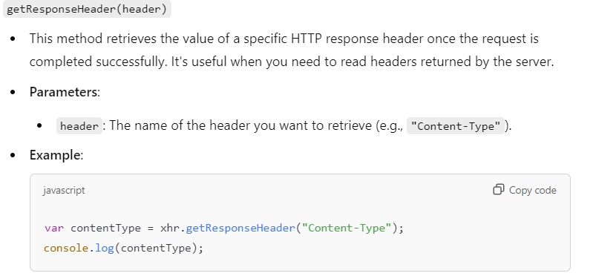

**Properties of XMLHttpRequest:**

1. **readyState**
   * This property holds the current state of the request. It can have values ranging from 0 to 4:
     + 0: UNSENT – The request has not been opened yet.
     + 1: OPENED – The open() method has been called, but the request has not yet been sent.
     + 2: HEADERS_RECEIVED – The request has been sent, and the headers have been received.
     + 3: LOADING – The response is being received (if the response is large, this state can be reached).
     + 4: DONE – The request has completed (either successfully or with an error)

**Basic AJAX Questions:**

1. **What is AJAX, and why is it used in web development?**
   * **Answer**: AJAX stands for Asynchronous JavaScript and XML. It is used to make asynchronous requests to a server, allowing parts of a web page to update without reloading the entire page. This improves the user experience by making web pages faster and more interactive.
2. **What are the main benefits of using AJAX in a web application?**
   * **Answer**: The main benefits include:
     + **Faster Web Pages**: Only parts of the page are updated, reducing the need to reload the entire page.
     + **Improved User Experience**: Web applications can perform actions without refreshing the page.
     + **Reduced Server Load**: Only the necessary data is fetched from the server.
     + **Real-Time Data**: Allows for real-time updates, such as live notifications or chat messages.
3. **What are the different ways to make an AJAX request in JavaScript?**
   * **Answer**: You can make AJAX requests using:
     + **XMLHttpRequest** object.
     + **Fetch API** (modern, promise-based).
     + **jQuery's $.ajax() method** (with simplified syntax).
4. **What is the difference between GET and POST methods in AJAX?**
   * **Answer**:
     + **GET**: Used to retrieve data from the server. The data is passed in the URL as query parameters.
     + **POST**: Used to send data to the server, typically for creating or updating resources. The data is included in the request body.
5. **What is the readyState property in the XMLHttpRequest object?**
   * **Answer**: The readyState property indicates the current state of the request. It has values ranging from 0 (request not initialized) to 4 (request completed). The most common state is 4, which means the request has completed successfully.
6. **What is the status property in the XMLHttpRequest object?**
   * **Answer**: The status property holds the HTTP status code returned by the server (e.g., 200 for success, 404 for not found, 500 for server errors).
7. **How does the XMLHttpRequest object handle asynchronous operations?**
   * **Answer**: When making an AJAX request asynchronously, JavaScript continues executing other code while the request is being processed. Once the server responds, the onreadystatechange or onload event handler is triggered, allowing you to process the response.
8. **Explain the difference between XMLHttpRequest and the Fetch API.**
   * **Answer**:
     + **XMLHttpRequest** is an older API that uses callback functions to handle responses.
     + **Fetch API** is a more modern, promise-based approach, providing a cleaner and more flexible API for handling HTTP requests and responses.
9. **What is the purpose of the setRequestHeader() method in XMLHttpRequest?**
   * **Answer**: The setRequestHeader() method is used to set custom HTTP headers for the request. For example, to set the content type or authentication headers before sending the request.
10. **How can you handle JSON data with AJAX?**
    * **Answer**: JSON data can be sent and received with AJAX. In XMLHttpRequest, you would use JSON.stringify() to send JSON data and JSON.parse() to parse the response. With fetch(), .json() can be used to parse the JSON response.

**Advanced AJAX Questions:**

1. **What is the role of the onreadystatechange property in XMLHttpRequest?**
   * **Answer**: The onreadystatechange property is an event handler that is triggered every time the readyState of the XMLHttpRequest object changes. This allows developers to check the request's state and determine when to process the response.
2. **How would you handle errors in AJAX requests?**
   * **Answer**: Errors can be handled using the onerror event handler or by checking the status property in XMLHttpRequest. In the fetch API, errors can be caught using .catch() for promise rejection handling.
3. **What is the abort() method in XMLHttpRequest?**
   * **Answer**: The abort() method is used to cancel an ongoing AJAX request. It's useful when the user navigates away from the page or when you need to stop an incomplete request.
4. **How can you prevent issues like multiple simultaneous AJAX requests in JavaScript?**
   * **Answer**:
     + One way is to use the abort() method to cancel any previous requests before sending a new one.
     + Another approach is to use **Debouncing** or **Throttling** techniques to limit the number of requests sent within a time frame, especially in search or autocomplete features.
5. **What is Cross-Origin Resource Sharing (CORS), and how does it relate to AJAX?**
   * **Answer**: CORS is a security feature implemented by browsers to prevent unauthorized cross-origin HTTP requests. When making AJAX requests to a different domain, the browser will check for CORS headers in the response. If the server allows it, the request will succeed; otherwise, it will fail with a CORS error.
6. **What is the XMLHttpRequest responseXML property used for?**
   * **Answer**: The responseXML property is used when the server returns an XML document. It contains the parsed XML document, which can be accessed as a DOM object for further manipulation.
7. **What is the async parameter in the open() method of XMLHttpRequest, and what are the consequences of using true or false?**
   * **Answer**: The async parameter specifies whether the request should be asynchronous (true) or synchronous (false). If true, the request is non-blocking, and the code continues to execute while the request is processed. If false, the request is blocking, meaning it will halt the execution of JavaScript until the request is completed.
8. **What is the difference between synchronous and asynchronous AJAX requests?**
   * **Answer**:
     + **Synchronous** requests block the execution of further code until the request is complete, leading to slower user experiences.
     + **Asynchronous** requests allow the code to run in the background without blocking, providing a more fluid user experience.
9. **How can you handle large datasets with AJAX without affecting performance?**
   * **Answer**:
     + Use **pagination** or **lazy loading** to load data in chunks rather than fetching the entire dataset at once.
     + Consider using **compression** techniques on the server to reduce the size of the data sent over the network.
     + **Caching** can also be used to avoid repeated requests for the same data.
10. **Can you explain the concept of "callback hell" and how it relates to AJAX?**
    * **Answer**: "Callback hell" refers to the situation where multiple nested callback functions lead to difficult-to-read and maintain code, especially in AJAX requests. This is often avoided by using **promises** or the **async/await** syntax, which provides a cleaner, more readable way to handle asynchronous code.

**Practical Scenario-Based AJAX Questions:**

1. **How would you implement a search suggestion feature using AJAX?**
   * **Answer**: You can implement this by sending a request to the server with the search query as the user types. The server returns matching suggestions, and the client dynamically displays them as a list. This can be done using XMLHttpRequest or fetch() with a GET request to send the query.
2. **How would you handle form submissions using AJAX?**
   * **Answer**: Use AJAX to submit form data without reloading the page. This can be done by serializing the form data (using FormData or manually), sending it via POST, and then updating the UI based on the response (e.g., showing success or error messages).

**\*\*\*\*\*\*\*\*\*\*\*\*\*\*\*\*\*\*\*\*\*\*\*\*\*\*\*\*\*\*\*\*\*\*\*\*\*\*\*\*\*\*\*\*\*\*\*\*\*\*\*\*\*\*\*\*\*\*\*\*\*\*\*\*\*\***

**jQuery Ajax**

**What is the $.ajax() method in jQuery and how is it used?**

* **Answer**: $.ajax() is a low-level method in jQuery that provides full control over an AJAX request. It accepts an object with various options such as URL, data type, HTTP method, success and error callbacks, etc.

**What is the dataType option in $.ajax(), and what values can it accept?**

* **Answer**: The dataType option specifies the type of data expected from the server. It can accept several values:
  + "json": Parses the response as JSON.
  + "xml": Parses the response as XML.
  + "html": Parses the response as HTML.
  + "text": Returns the response as plain text.
  + "script": Executes the response as JavaScript.

**What is the beforeSend function in jQuery AJAX, and how can it be used?**

* **Answer**: The beforeSend function is a callback that is invoked before the request is sent. It can be used to modify the request, such as adding custom headers, or showing a loading spinner.

