1. Event Loop & Async Performance
Q. How does the Node.js event loop work, and how can it impact application performance?
GOOD Performance Impact (Why Event Loop is Helpful)
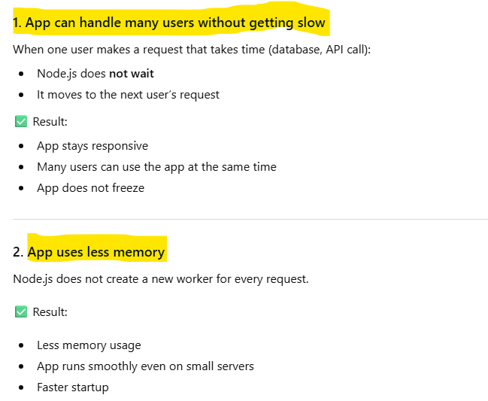
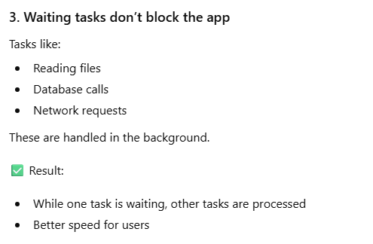

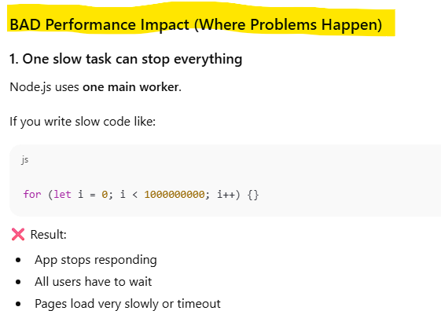
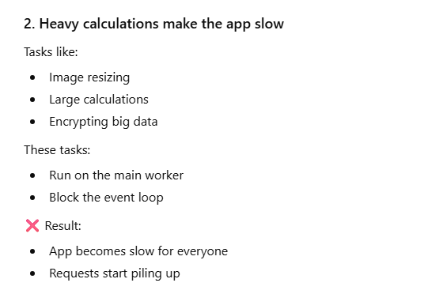
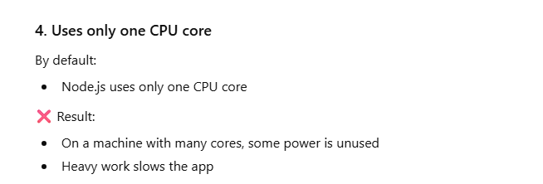

Q. What is the difference between setImmediate(), setTimeout(), and process.nextTick()? When would misuse cause performance issues?
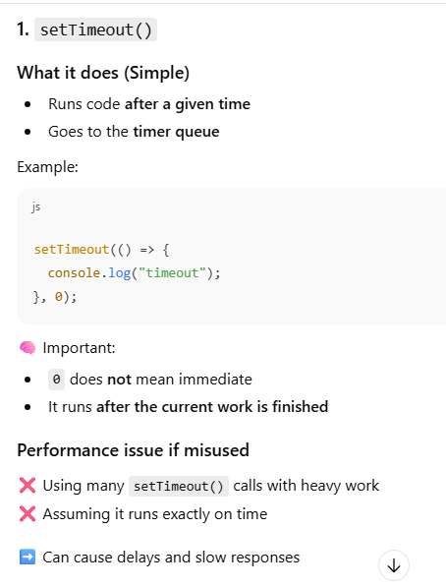
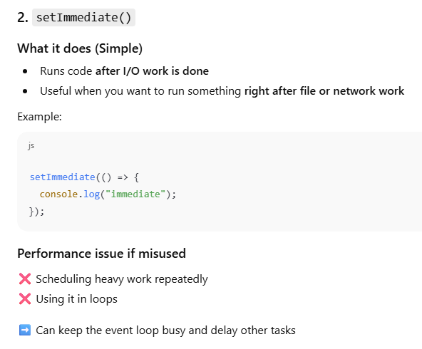
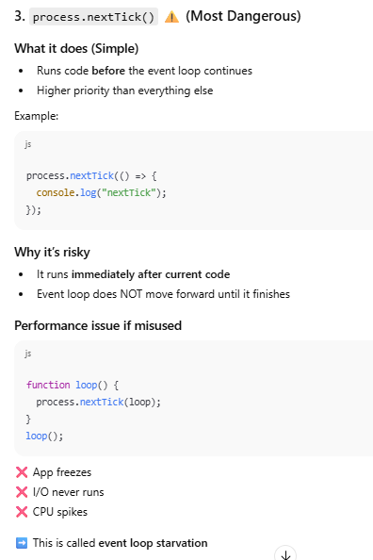
Q. How do blocking operations affect Node.js performance?
First: What is a blocking operation? (Simple)
A blocking operation is any code that:
- Runs for a long time
- Does not let Node.js move to the next task
Node.js has one main worker.
If that worker is busy, nothing else can run.

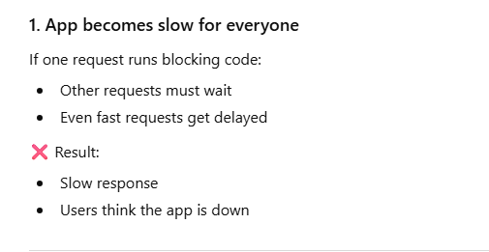
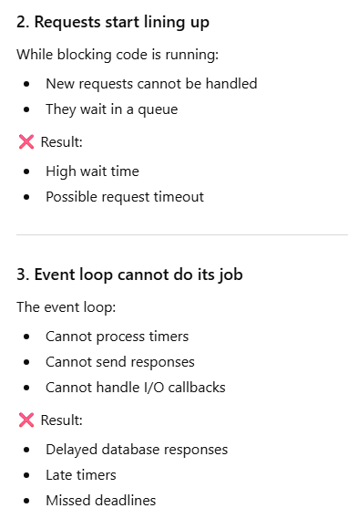
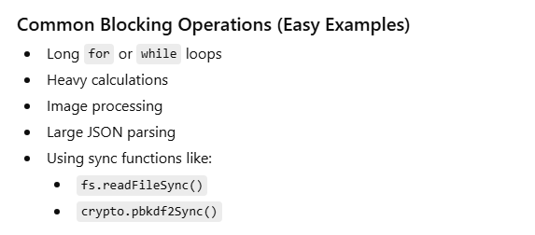

Q.What happens if the event loop is blocked for a long time?
• Application stops responding
- New requests cannot be processed
- Existing requests have to wait
• All users are affected
- One blocking task impacts everyone
- Even small requests become slow
• Very slow response time
- Pages load late
- APIs respond slowly
• Timers run late
- setTimeout and setInterval do not run on time
• Database and file responses are delayed
- Data may be ready
- But Node.js cannot send it back
• Requests start piling up
- Incoming requests wait in line
- Memory usage increases
• Requests may timeout
- Clients stop waiting
- Errors occur
• High CPU usage
- CPU stays busy with blocking code
• Application appears frozen
- Server is running
- But nothing works properly
• Poor user experience
- Users get frustrated
- Trust in the app drops
Q. How can you scale nodejs application?

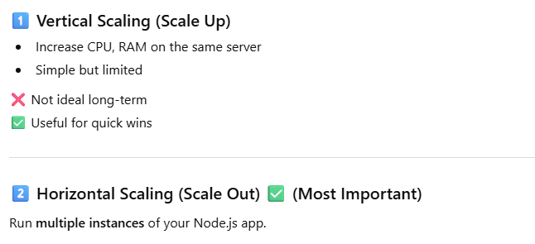
a. Use Clustering
b. Load Balancer
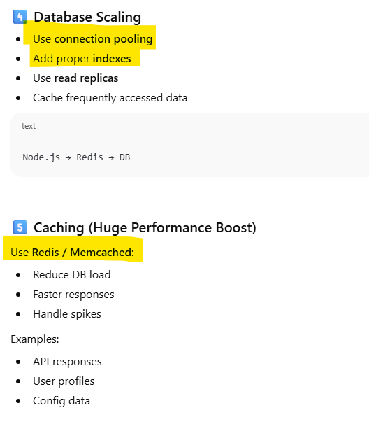
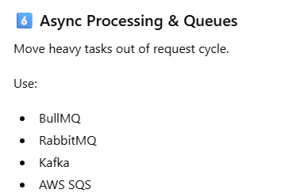
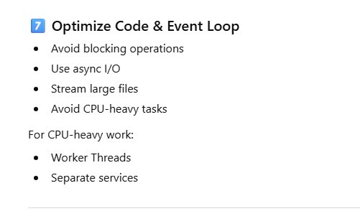

2. CPU & Memory Optimization
Q. How do you handle CPU-intensive tasks in Node.js?
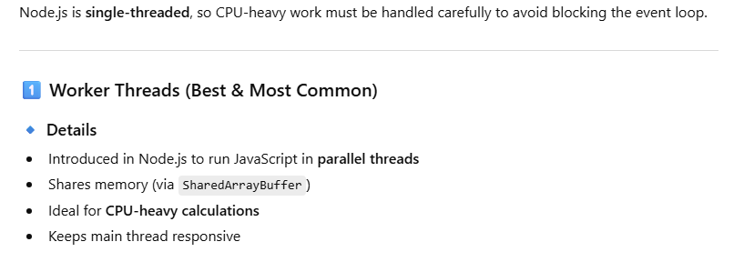
A worker thread is a separate thread in Node.js used to run CPU-intensive JavaScript code without blocking the main event loop.
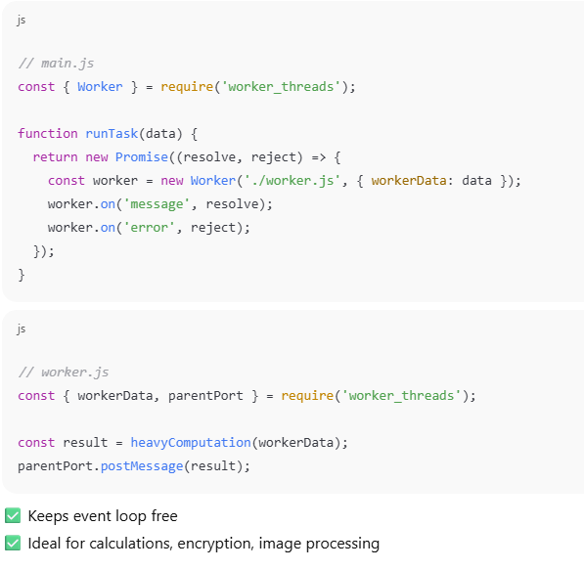
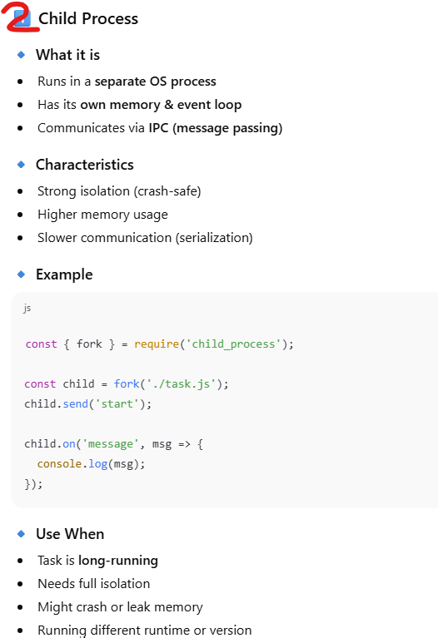
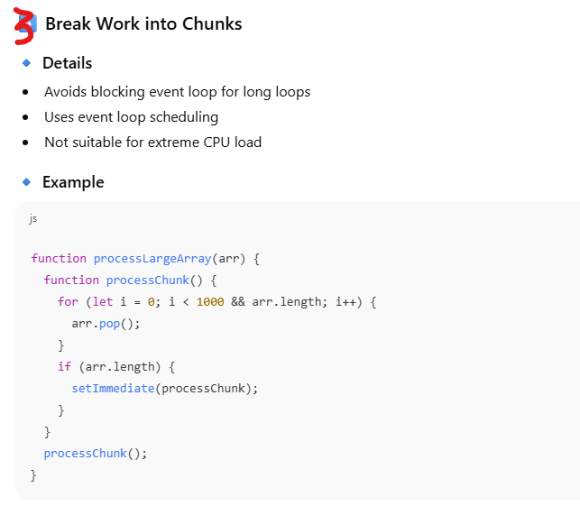
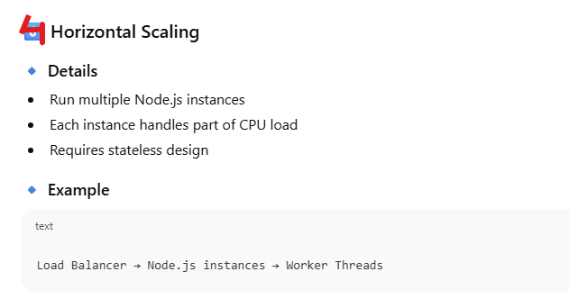
Q. What are worker threads, and when should you use them?
A worker thread is a separate background thread that runs heavy or time-consuming tasks without blocking the main program.
Normally, JavaScript (Node.js) runs on one single thread.
That means:
- Only one task runs at a time
- Heavy tasks can freeze the app
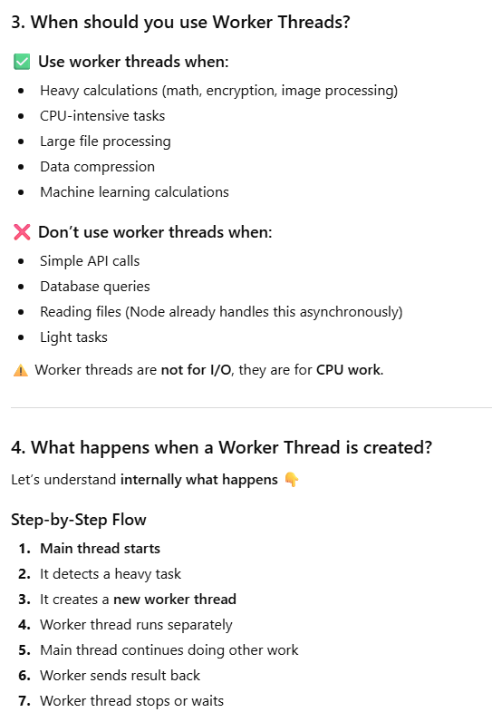
Q. How does clustering improve Node.js performance?
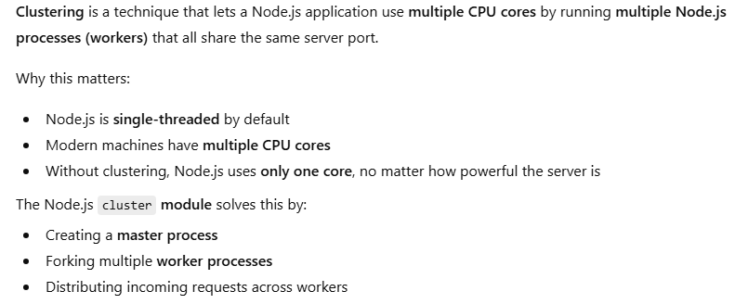
How clustering improve performance
1. Uses All CPU Cores
2. Higher Throughput
3. Better Fault Tolerance
4. Prevents Event Loop Blocking
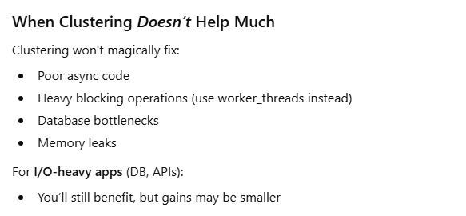
Q. What causes memory leaks in Node.js applications?How do you identify and fix memory leaks?
A memory leak happens when a Node.js application keeps using more and more memory over time because unused objects are not released.
Even though JavaScript has automatic garbage collection, memory leaks still occur when:
- References to unused objects are kept
- Garbage Collector cannot free that memory
👉 Result:
- Increased RAM usage
- Slower performance
- Application crash (Out of Memory)

Why Memory Leaks Are Dangerous
- Application becomes slow
- High memory consumption
- Frequent restarts
- Server crashes in production
In simple words:
Memory leak = memory is allocated but never released
Common Causes of Memory Leaks in Node.js
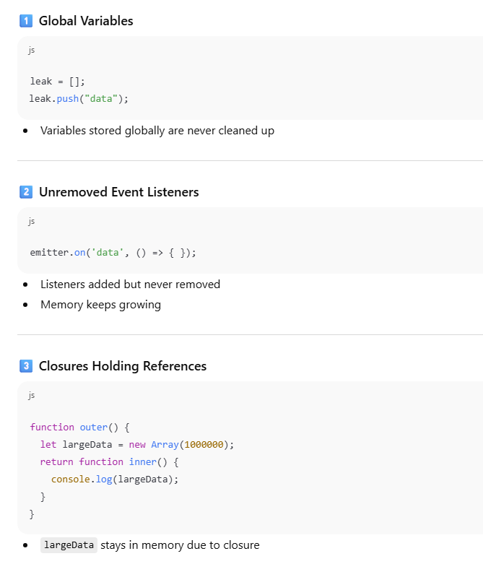
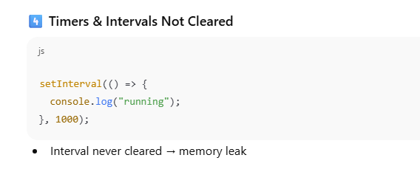
How Do We Identify Memory Leaks?
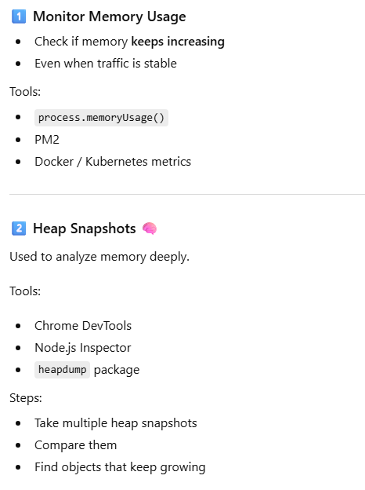
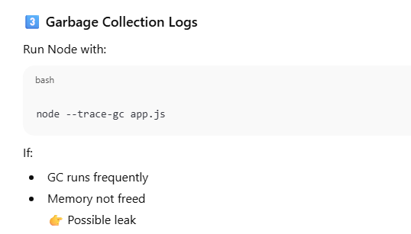
How Do We Fix Memory Leaks?

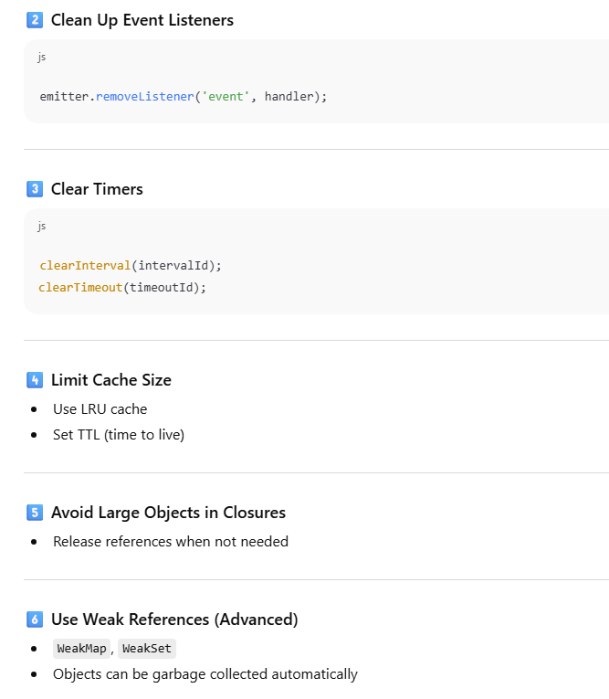

3. Database & I/O Performance
Q. How do you FIND slow queries?
For MongoDB:
1. Use Profile log
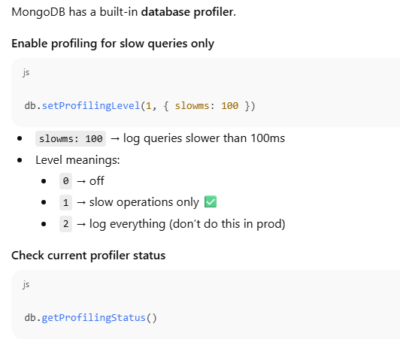
2. Use Explain for analysing the query
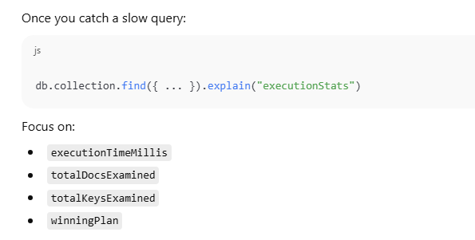
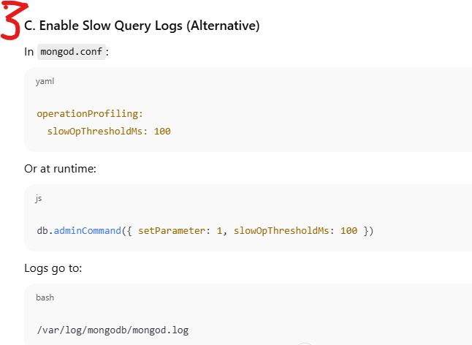
2. MYSQL
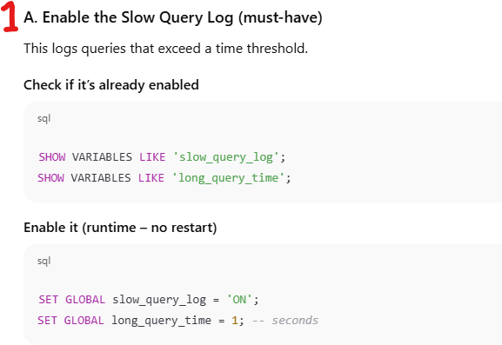
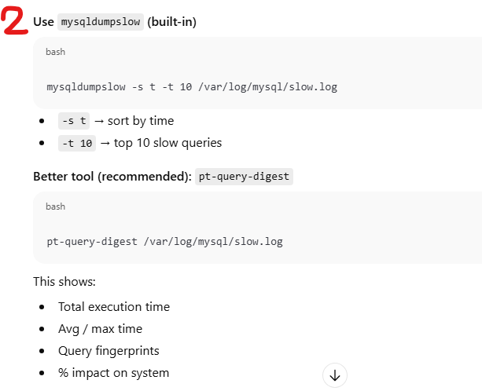
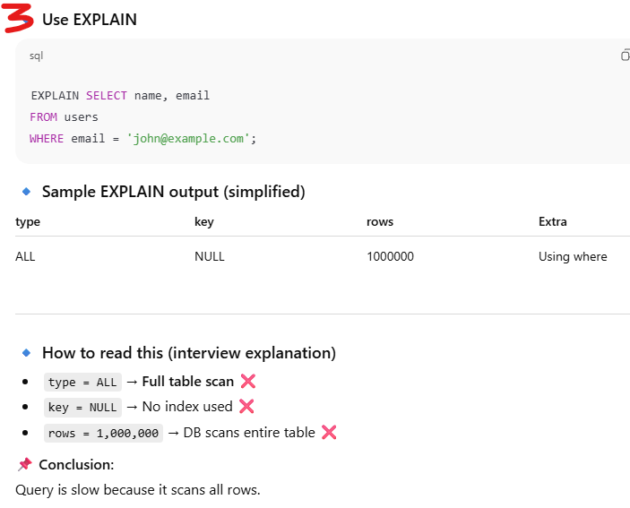
Q. Why is a database query slow?
- Missing or wrong indexes
- Full table scans
- Too much data returned (SELECT *)
- Poor query design
- Lock contention
- Network latency
- Disk I/O bottlenecks
Q. How do you optimize database queries in a Node.js application?
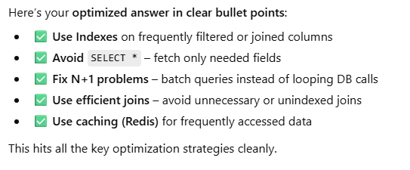
Q. What is the N+1 query problem, and how do you avoid it?
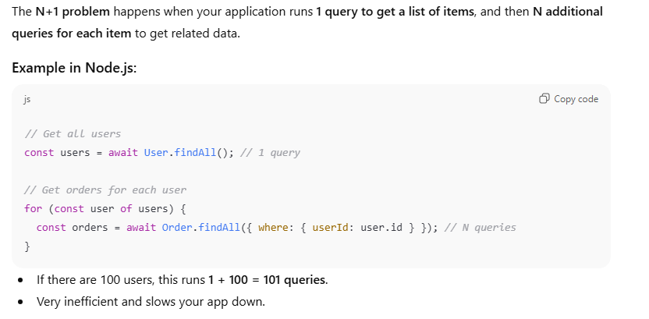
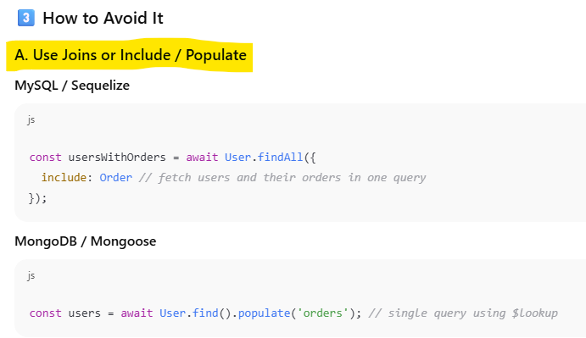
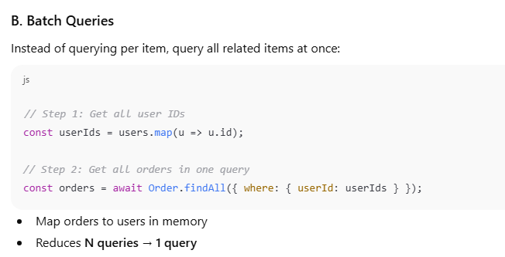

Q. What is connection pooling, and why is it important?
Connection pooling is a technique where a set of database connections is created and reused by an application instead of opening a new connection for every request.
- Connections are created once
- Reused across multiple requests
- Returned to the pool after use
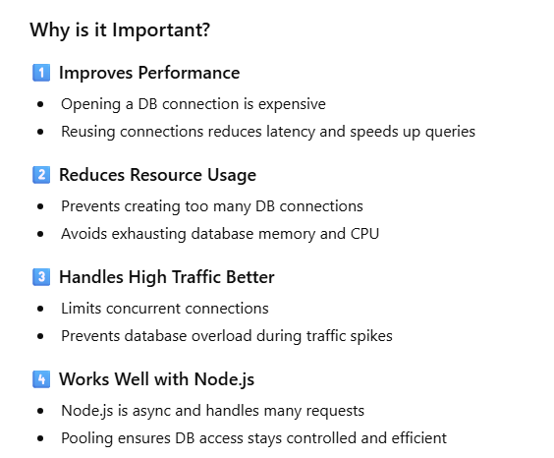
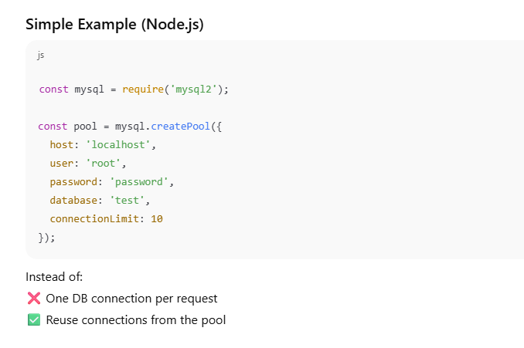
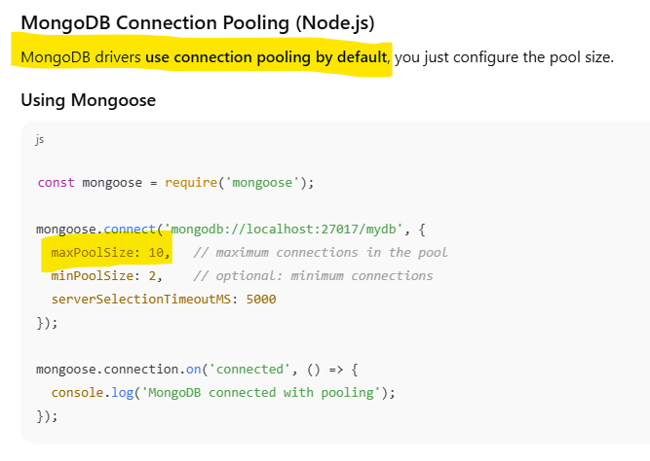
Q. How can improper use of async/await slow down DB operations?
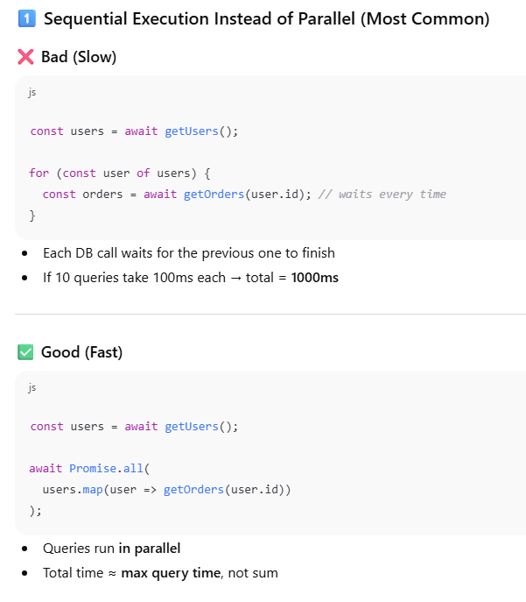
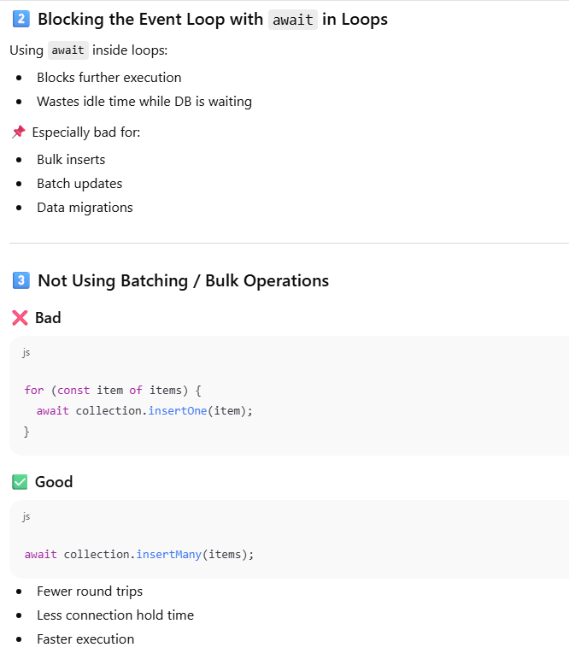
Q. How does indexing help performance in databases used with Node.js?
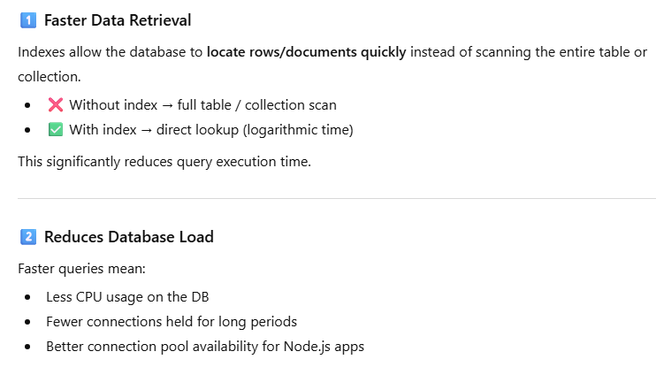
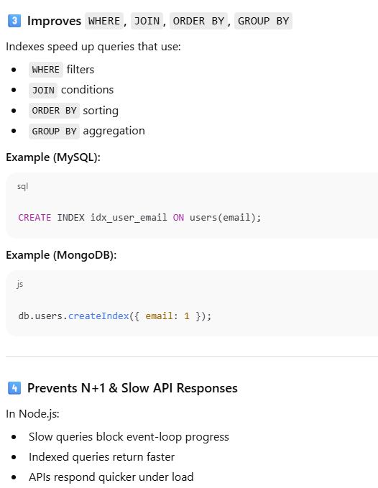


4. API & Network Performance
Q. How do you optimize REST APIs built with Node.js?
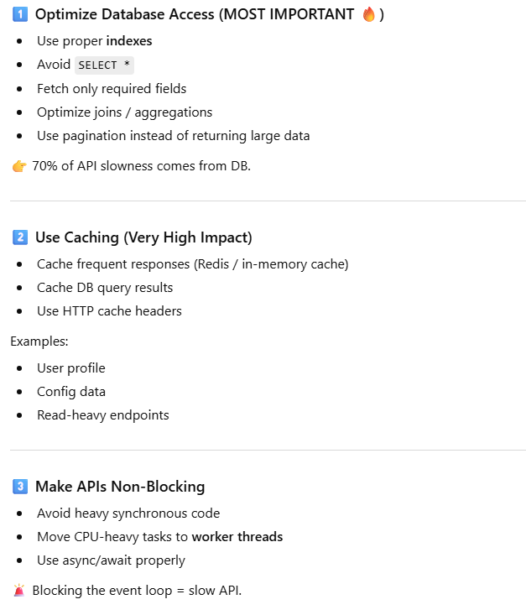
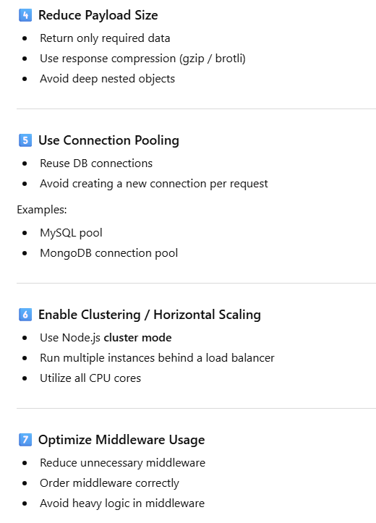
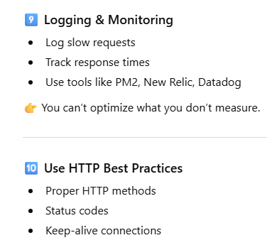
Q. What is compression middleware, and how does it affect performance?
Compression middleware is used in Node.js/Express to compress HTTP responses (using gzip or Brotli) before sending them to the client.
It reduces the size of the response data sent over the network.
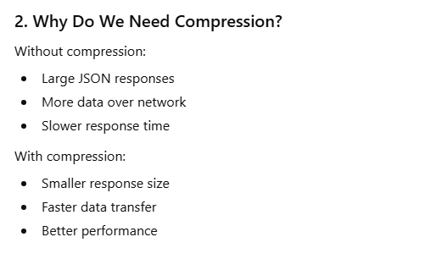
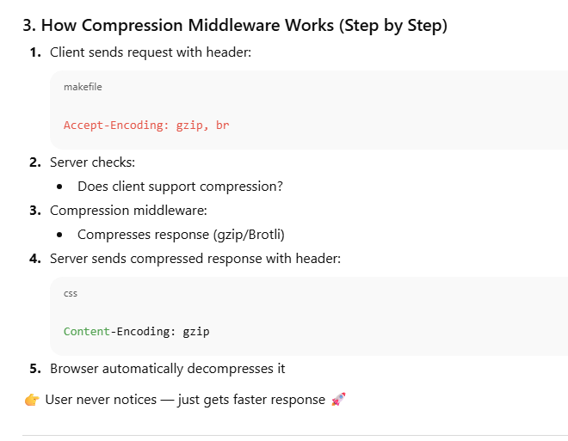
Q. How do you implement caching in a Node.js application?
Caching means storing frequently used data temporarily so that:
- We don’t recompute it
- We don’t hit the database again and again
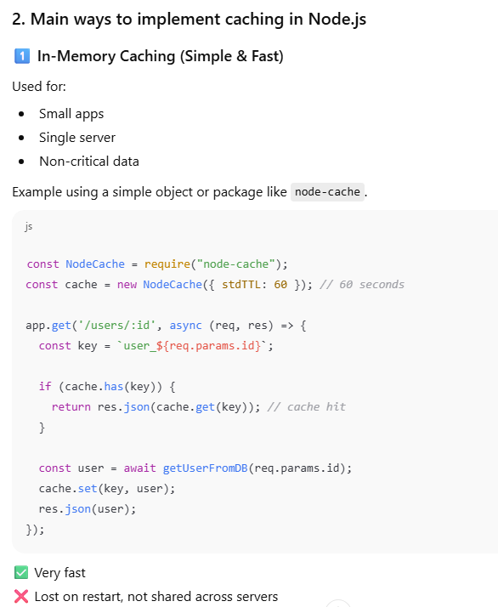
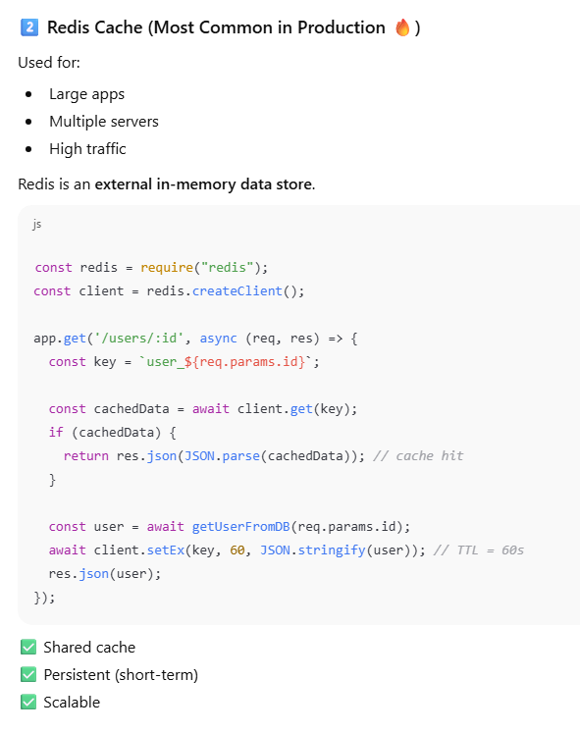
Q. When should you use in-memory caching vs Redis?
Already given in previous question.
Q. How do HTTP keep-alive and connection reuse improve performance?
HTTP keep-alive means:
Don’t close the connection after one request. Reuse it for the next requests.
Why opening a new connection is slow?
Each new HTTP connection needs:
- TCP handshake
- (For HTTPS) SSL/TLS handshake
- Network round trips
👉 This costs time + CPU + network resources
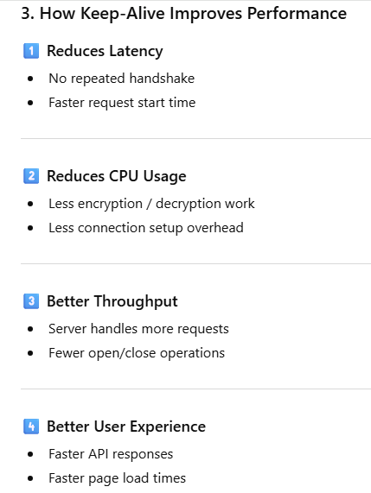

Connection Reuse (What it means)
Connection reuse means:
- Multiple HTTP requests share the same TCP connection
- Common in:
  - Browsers
  - API clients
  - Microservices
Keep-alive enables connection reuse.
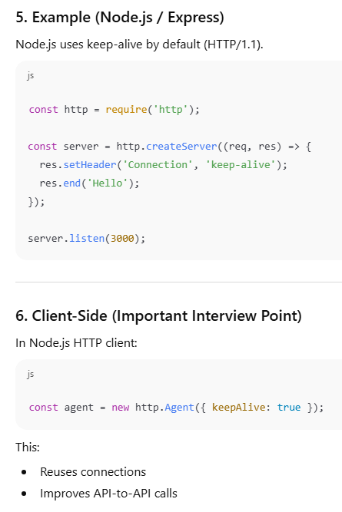

5. Application-Level Optimization
Q. What is lazy loading, and how can it improve performance in Node.js?
Lazy loading means: Load something only when it is actually needed, not at application startup.
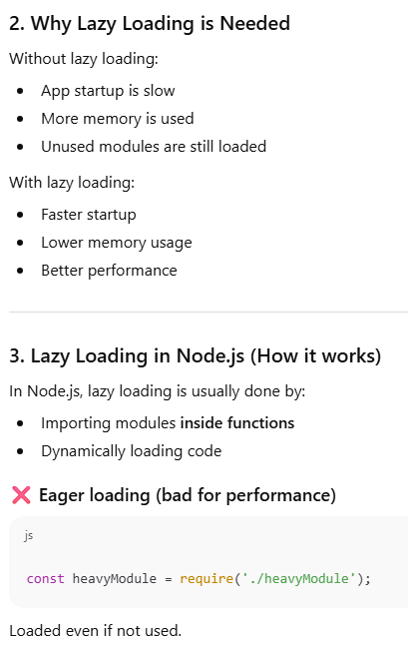
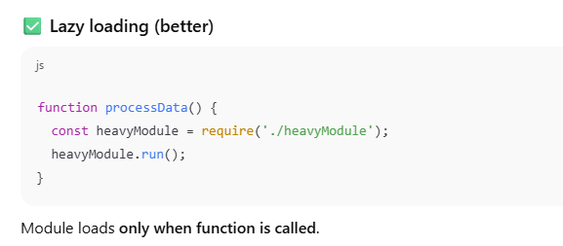
Q. How do you reduce response time in a high-traffic Node.js application?
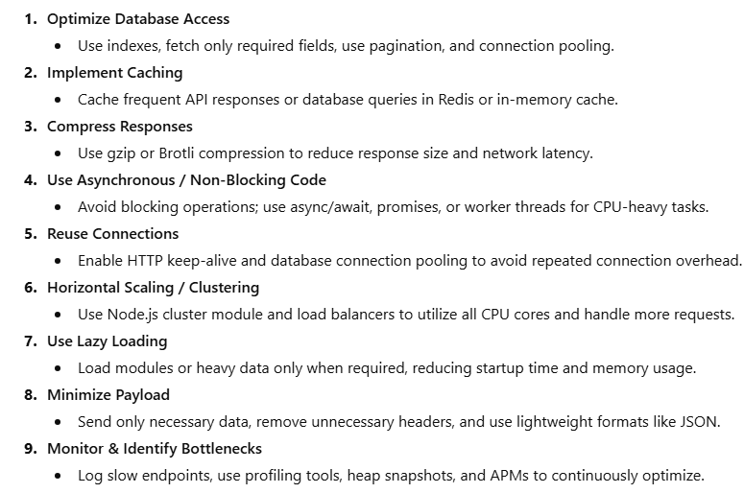
Q. What are streams, and why are they more performant than buffers?
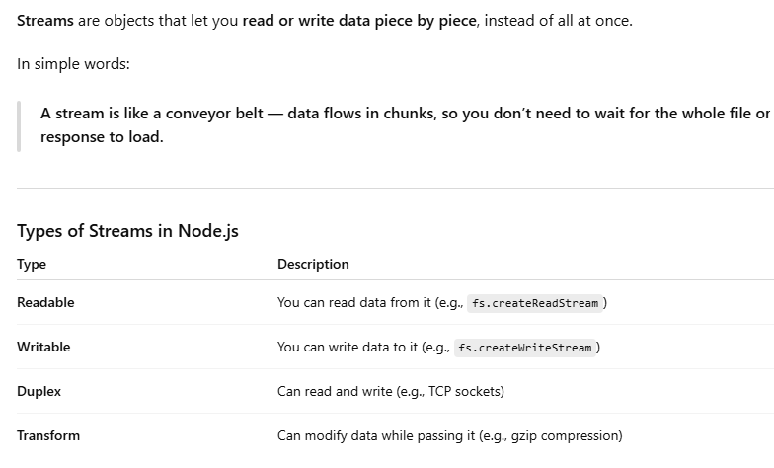
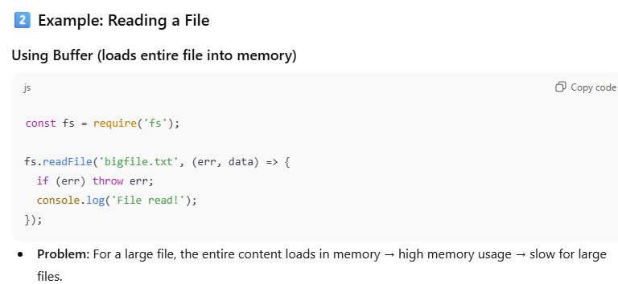
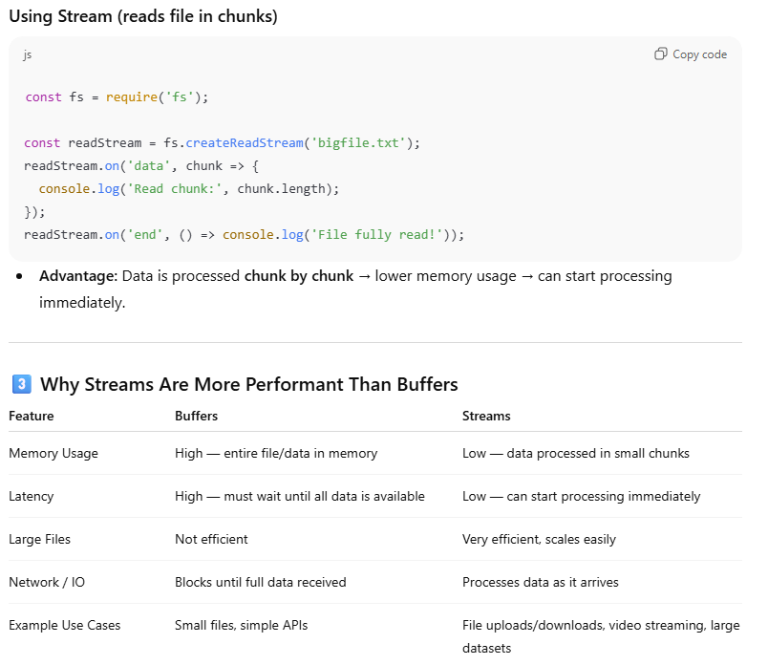
Q. How does batching requests improve performance?

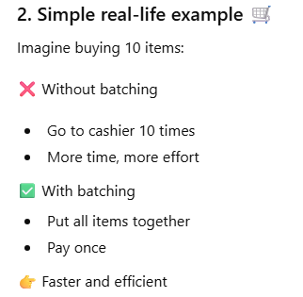
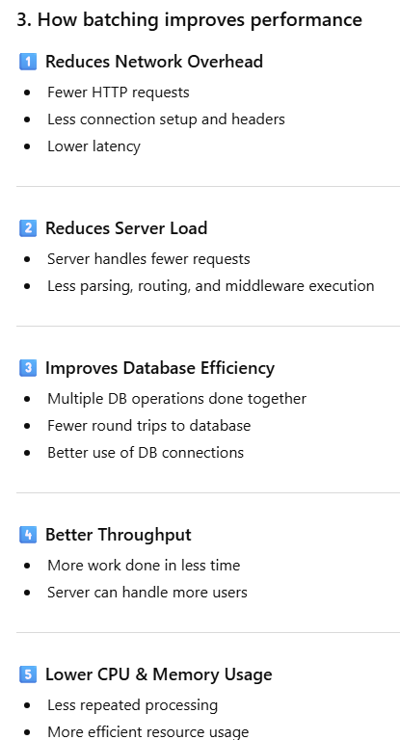
Q. How do you handle large file uploads efficiently?

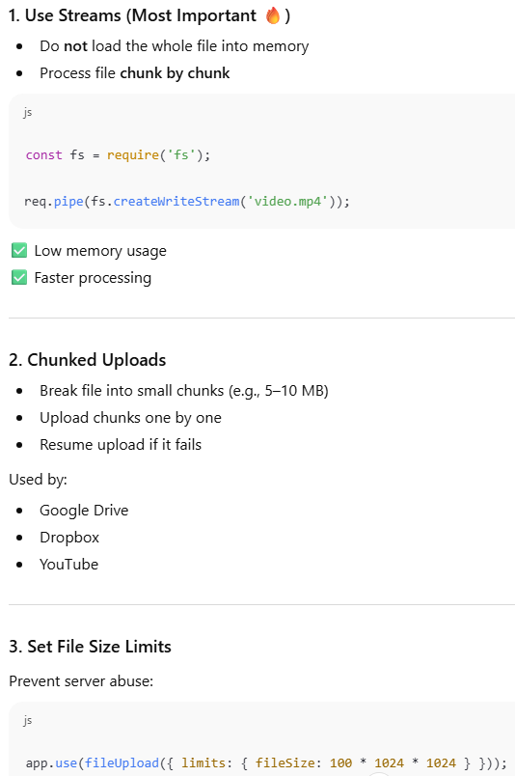

6. Monitoring & Debugging Performance
Q. What tools do you use to monitor Node.js performance?

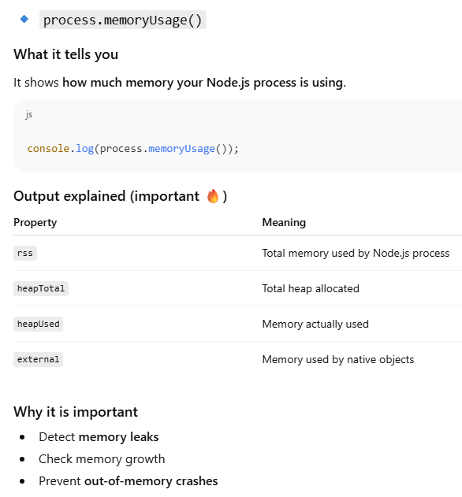
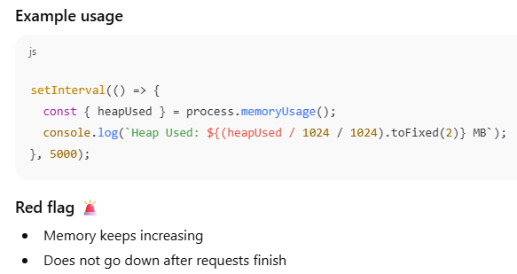
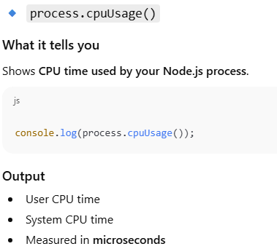
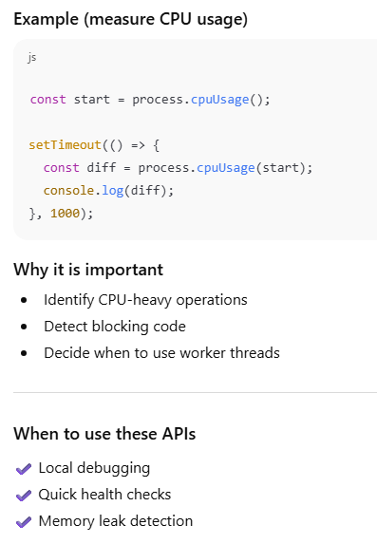
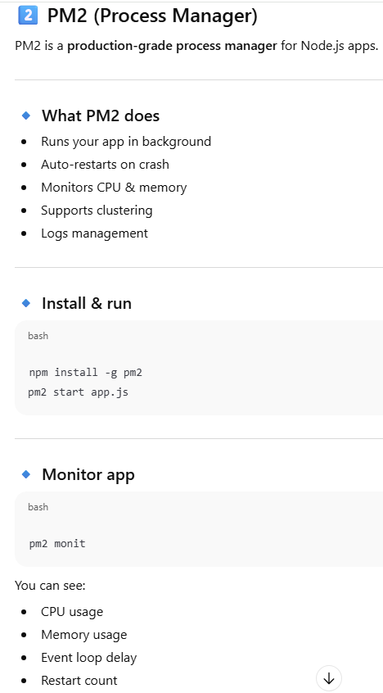
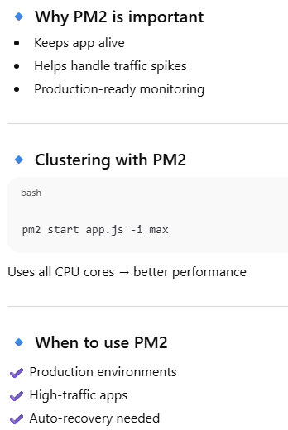
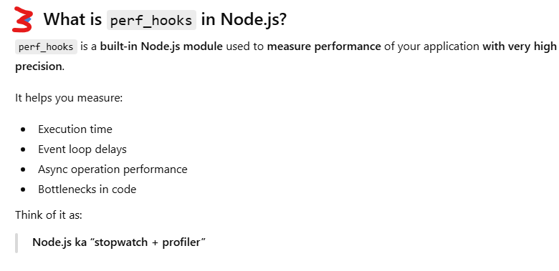
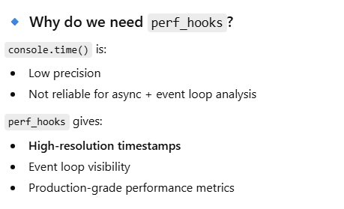
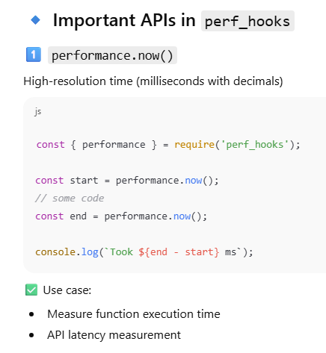
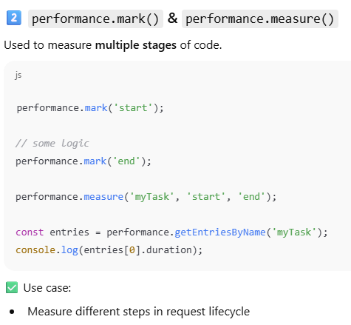
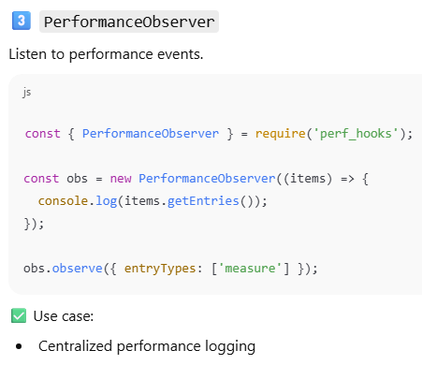
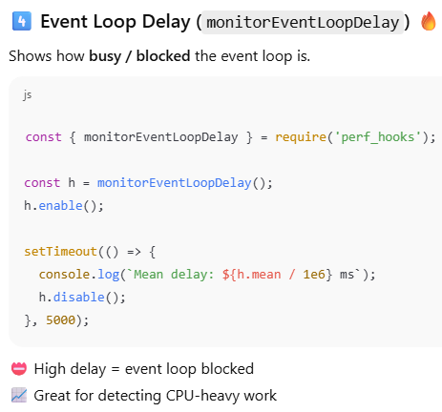
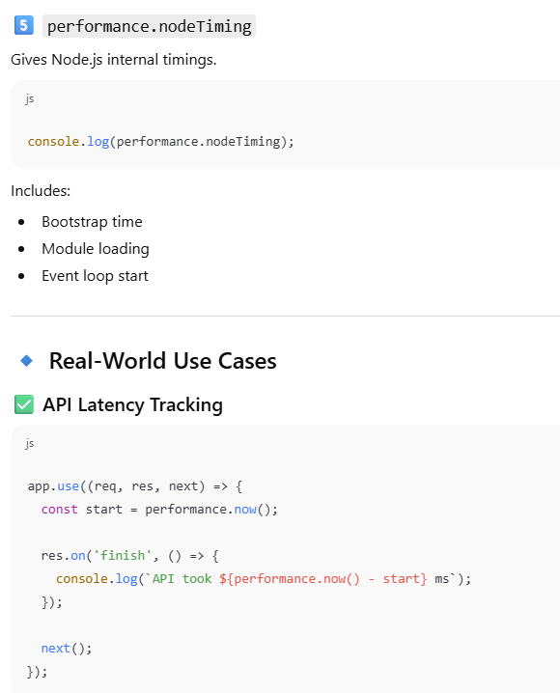

Q. How do you profile CPU usage in Node.js?
- How do you measure event loop delay?
- What are common performance metrics you track in production?
- How do you debug slow APIs in Node.js?

7. Scaling & Architecture
- How do you scale a Node.js application horizontally?
- What role does a load balancer play in performance optimization?
- How do microservices impact performance in Node.js?
- What are the performance trade-offs between monolith and microservices?
- How does message queuing (RabbitMQ/Kafka) help with performance?

Bonus: Scenario-Based Questions (Very Important for 3–5 YOE)
- Your Node.js API response time suddenly increased. How would you troubleshoot it?
- How would you optimize a Node.js app that consumes high CPU?
- How would you handle 1 million concurrent connections in Node.js?
- What would you do if a single API endpoint is slowing down the entire application?
- How do you ensure Node.js performance in production?

