Q1. What is Object Literal?
In JavaScript, an object literal is a way to define an object using {}.
It’s basically a comma-separated list of key-value pairs wrapped inside curly braces {}.
It has method and property.
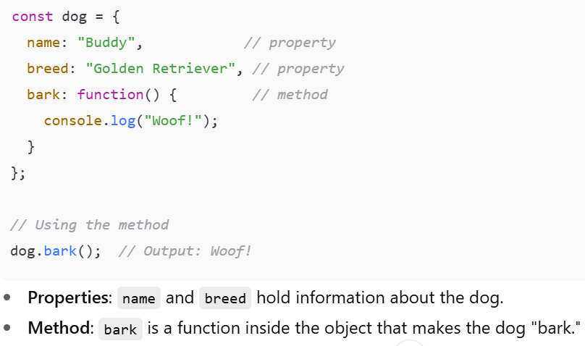
Q2. Explain dynamic key in object literal?
It was introduced in ES6.
Dynamic keys in an object literal let you use a variable or an expression as a property name, instead of a fixed string or identifier. This means the key is calculated when the object is created.
How to do it?
Use square brackets [] around the expression inside the object literal.
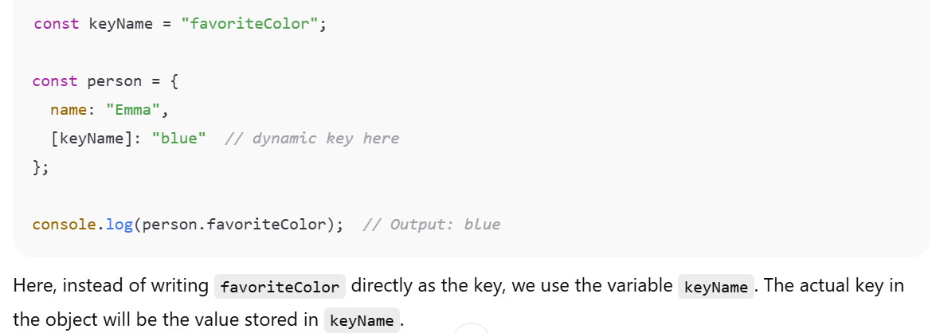
Why use dynamic keys?
- When you don’t know the property name until runtime.
- When property names come from variables, user input, or function results.
Q3. Can we define ready only property in object literal? If yes then how?
Yes, you can define a read-only property in an object, but not directly using just the plain object literal syntax.
To make a property read-only, you use Object.defineProperty() after creating the object. This lets you set the property’s attributes, including making it read-only (non-writable).
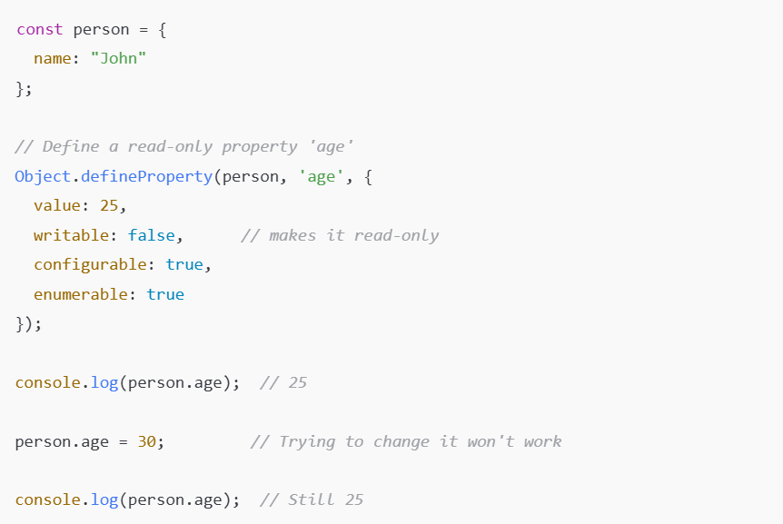
Point to remember
Use Object.defineProperty() to add or modify a property with attributes like writable: false (read-only).
Q4. Explain Property value short hand?
It is a shortest way to create an object where key and values are same.
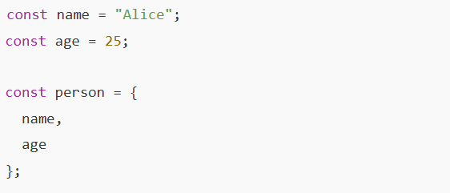
Q5. Explain the output?
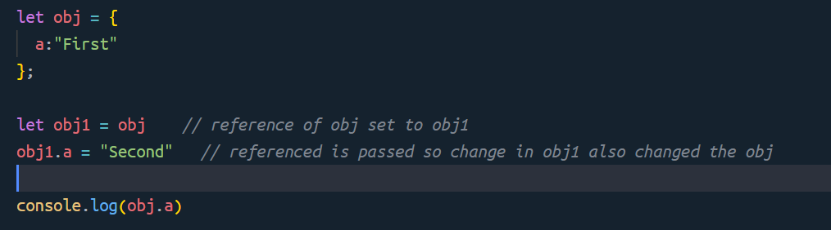
Output: Second
What can we do so the value of obj will not change?
- Use Object.assign
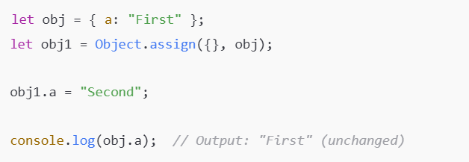
- Use spread operator
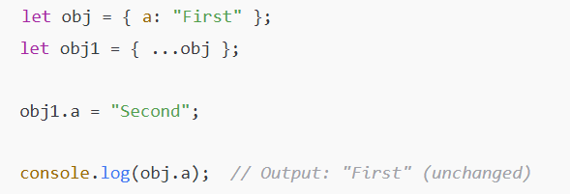
Q6. What is this?
In JavaScript, this is a special keyword that refers to the context in which a function is executed.
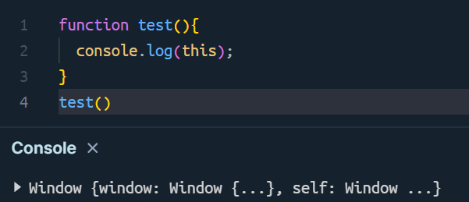
Here this refer to window object because this code written in browser.
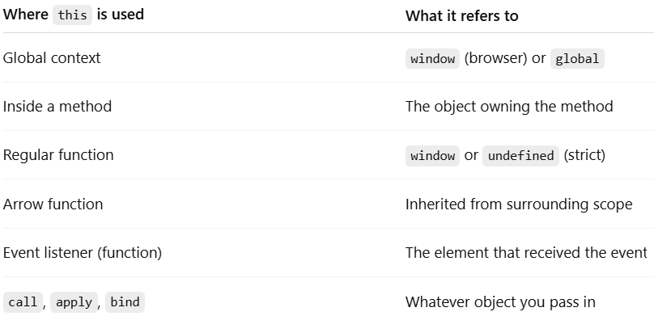

Q7. Explain call, apply, bind in js
Call is used to change the reference or context or value of this object within a function.
The first argument to call() sets the this value for the function being called, and the remaining arguments are passed to the function as arguments.
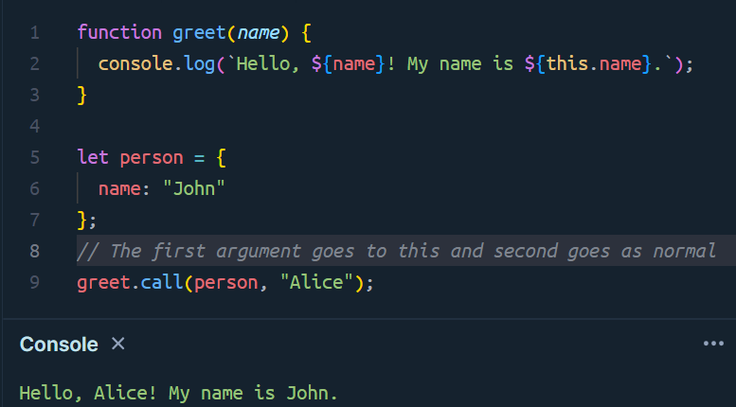
apply()
The apply() method is similar to the call() method, but it takes an array of arguments instead of individual arguments.
The first argument to apply() sets the this value for the function being called, and the second argument is an array of arguments to pass to the function.
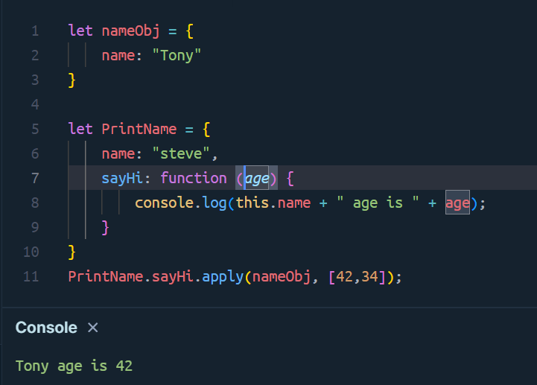

bind(); (Bind Method)
The bind() method returns a new function with a specified this value and any arguments that are passed to it.
The bind() method does not call the function immediately but instead returns a new function that can be called later.
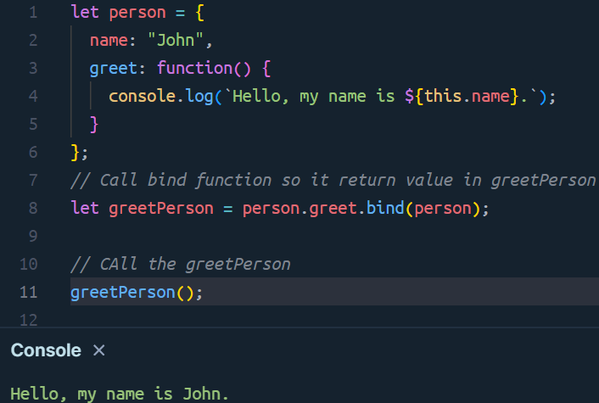
Q8. What is Class in javascript?
A class is like a blueprint for creating objects.
Think of a class as a template, and objects as actual things made from that template.
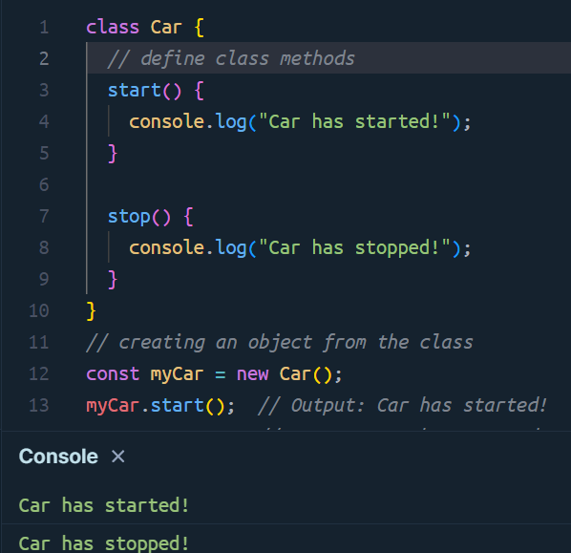
Q9. What is Constructor in class?
A constructor is a special method inside a class that runs automatically when you create a new object.
It is used to initialize properties (like giving default values).
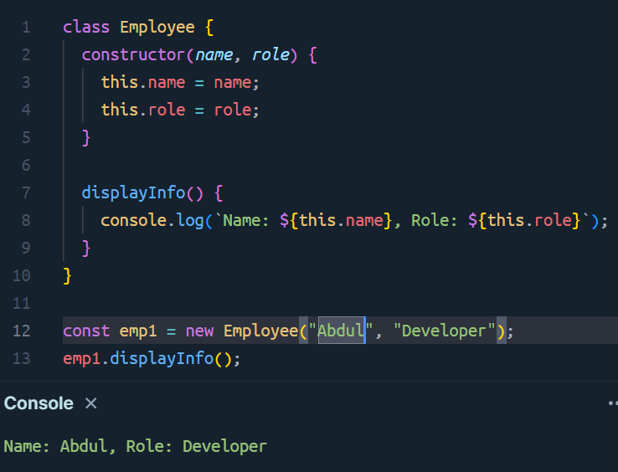
Q10. Explain dynamic property in class?
In JavaScript, you can add or access object properties dynamically — meaning the property name can come from a variable instead of being hardcoded.
Normally, we use dot notation (obj.name) when we know the property name in advance.
But if we don’t know the property name until runtime, we use square brackets (obj[variable]).
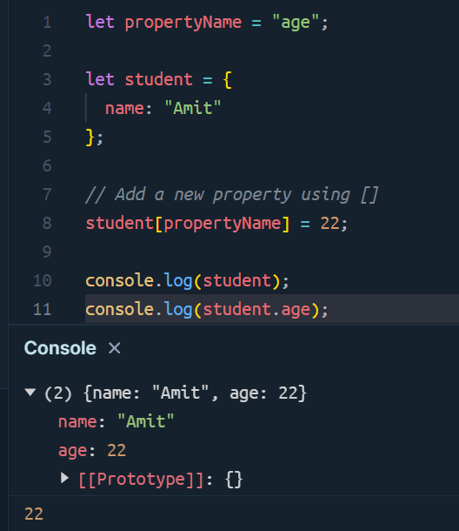
Here:
- propertyName = "age" (it could come from user input, API, etc.)
- We used student[propertyName] instead of student.age
- JavaScript replaced [propertyName] with "age" at runtime
Q11. What is the static keyword?
Static keyword is a way to create static method which we can call without creating an instance of the calss.
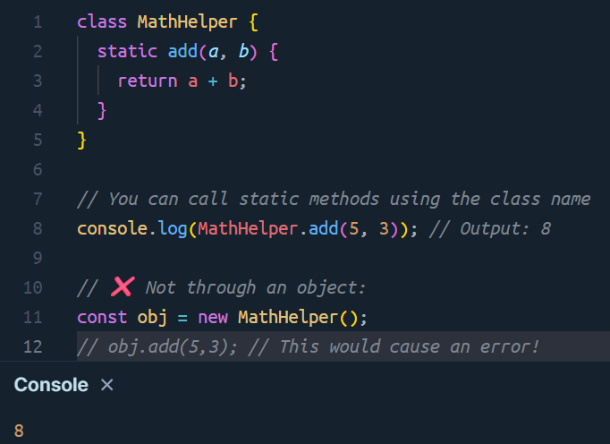
Key idea:
- static methods are used for utility functions that don’t depend on a specific object.
- You call them using the class name, not the object.
Calling a Static Method from Another Static Method
1. Using the class name
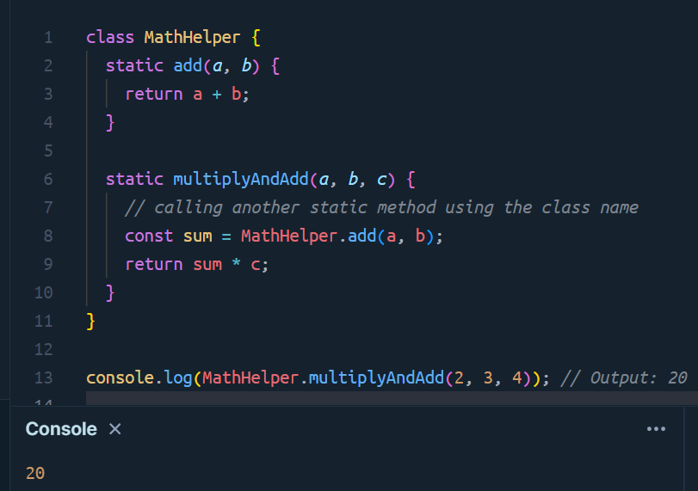
Explanation:
- add() is static.
- multiplyAndAdd() is also static.
- Inside multiplyAndAdd, we called the other static method using the class name (MathHelper.add()).
2. Using the this keyword
Inside a static method, the this keyword refers to the class itself,
so you can also call another static method using this.
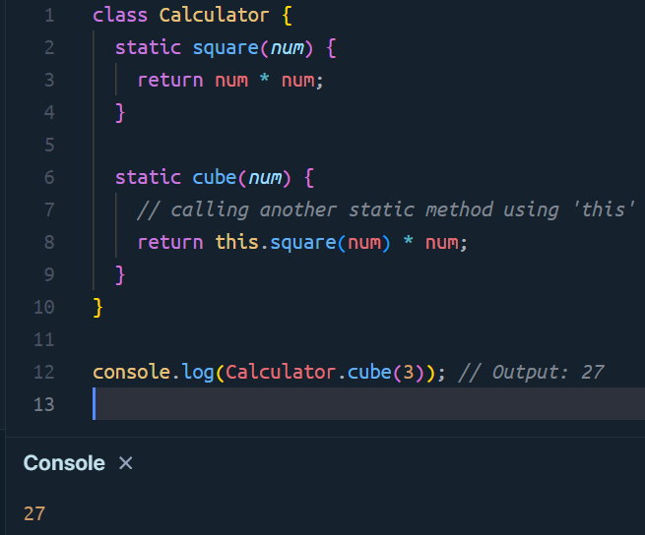
Explanation:
- this here refers to the Calculator class, not an object.
- So this.square(num) works just like Calculator.square(num).
Q12. What is Inheritance?
Inheritance in JavaScript means one class (child) can use or extend the properties and methods of another class (parent).
We use extends keyword to inherit Parent class.
It is also known as subclassing.
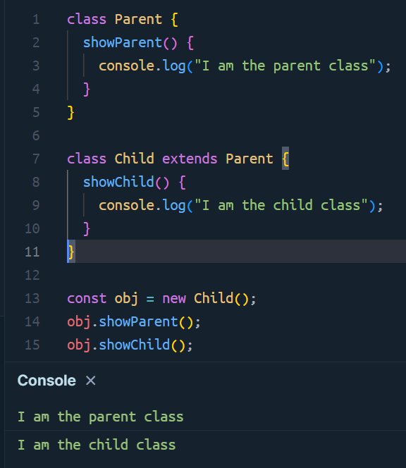
Important Points
- Child inherits everything from Parent.
- Child can use both its own and parent’s methods.
Constructor in Inheritance
When using constructors in both parent and child classes,
you must call the parent’s constructor using super() inside the child’s constructor.
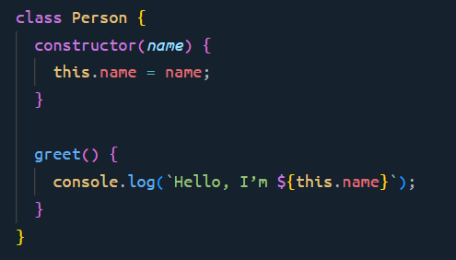
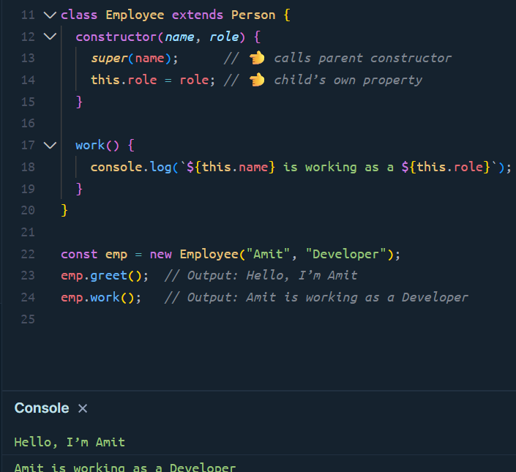
What is super()?
- super() is used to call the parent class’s constructor.
- It helps the child class inherit and initialize the parent’s properties.
What happens if we don’t use super()?
If you omit super() in a subclass (child class) that has a constructor,
JavaScript will throw an error before even running your code.
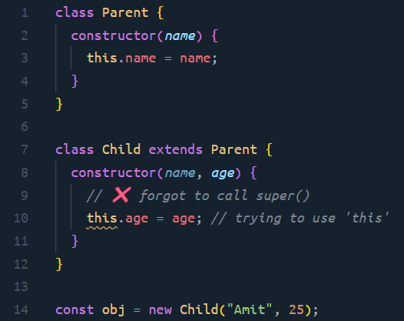
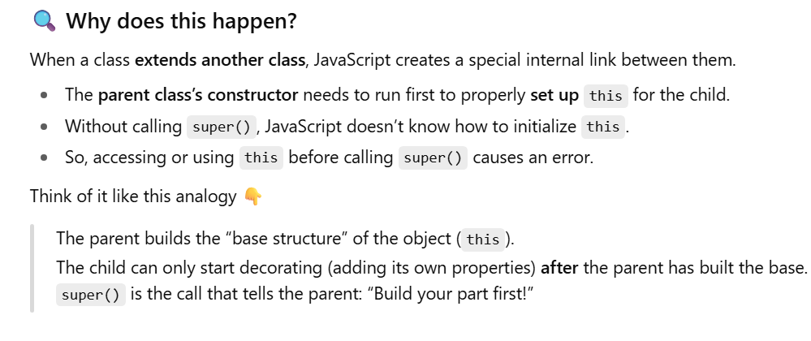
What if you don’t define a constructor in the child class?
If your child class doesn’t have a constructor, JavaScript automatically creates one and calls super() for you.
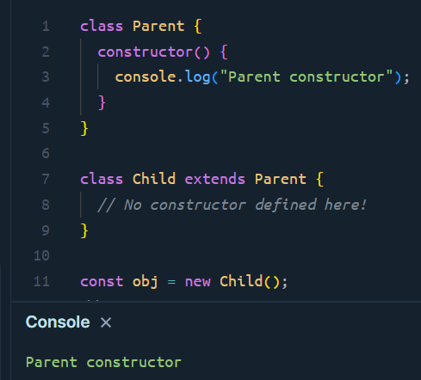
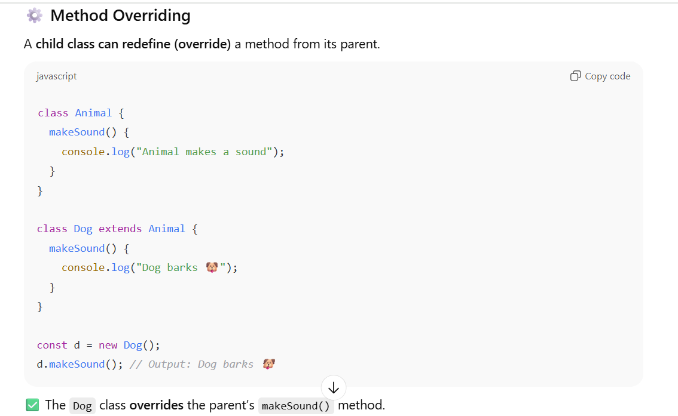
Using super to call the parent method
Even after overriding, you can still call the parent’s method using super.methodName().
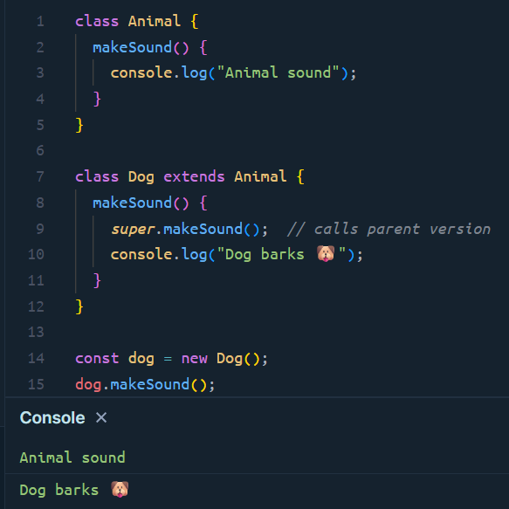

What does "extend a built-in class" mean?
JavaScript has many built-in classes, such as:
- Array
- String
- Date
- Error
- Map, Set, etc.
Sometimes, you may want to add your own behavior or custom methods on top of these built-in classes — without rewriting everything.
That’s when you use extends to inherit from a built-in class.
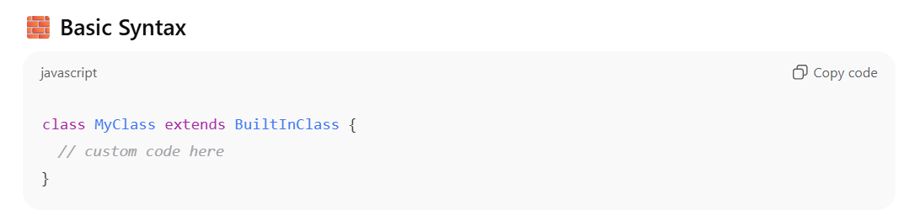
Example : Extending the Array class
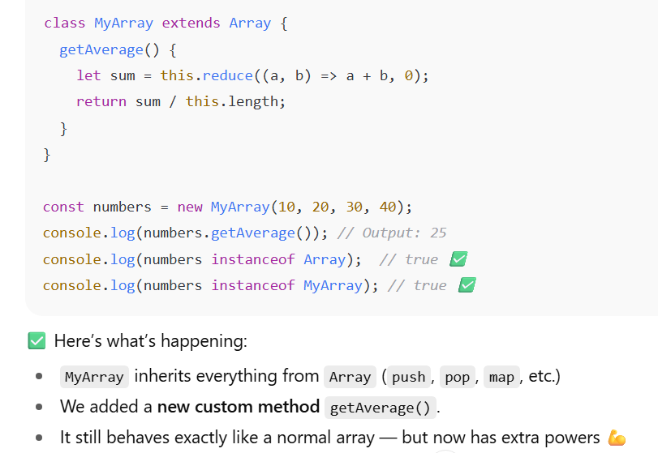

Q13. What is Destructuring?
Destructuring is the concept of breaking data structure like array or object literals into data pieces or in other words individual variables.
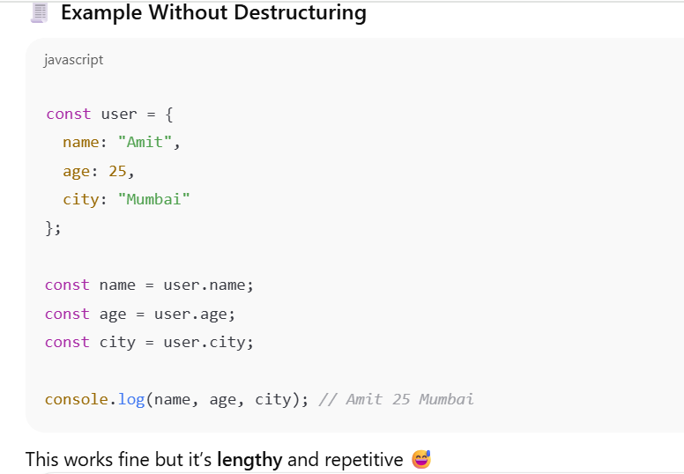
Using Destructuring
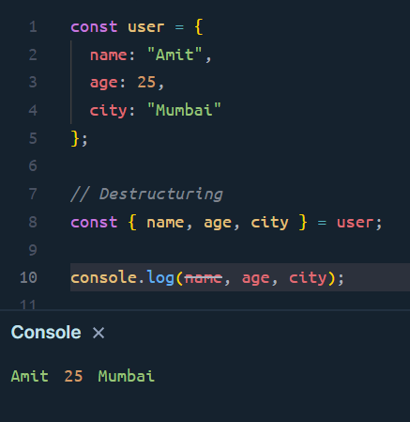

Explanation:
- { name, age, city } on the left side is a pattern.
- It tells JavaScript: “Take these properties from the user object and create variables with the same names.”
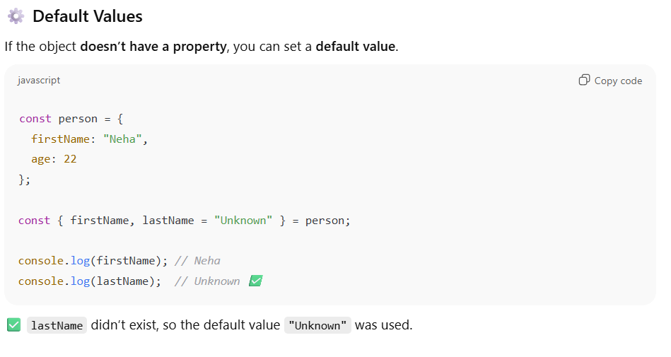
Extracting data from API responses
When you fetch data from an API, you often get a large object.
Destructuring helps you pick out only the pieces you need.
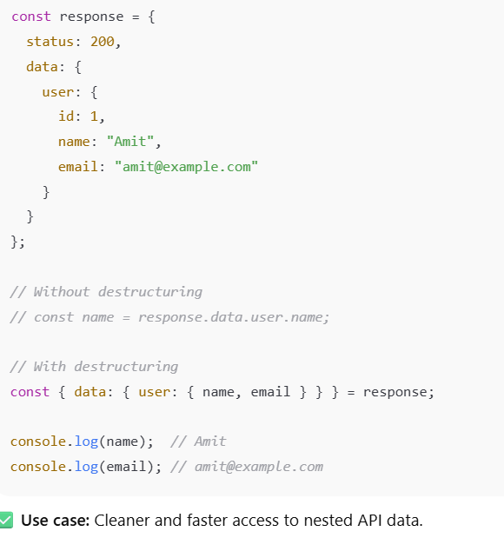
Q14. What are Accessors in JavaScript?
Accessors are special methods that allow you to get or set the value of an object’s property indirectly, instead of accessing it directly.
There are two types of accessors:
- Getter (get) → To read (get) a property
- Setter (set) → To write (set) or modify a property
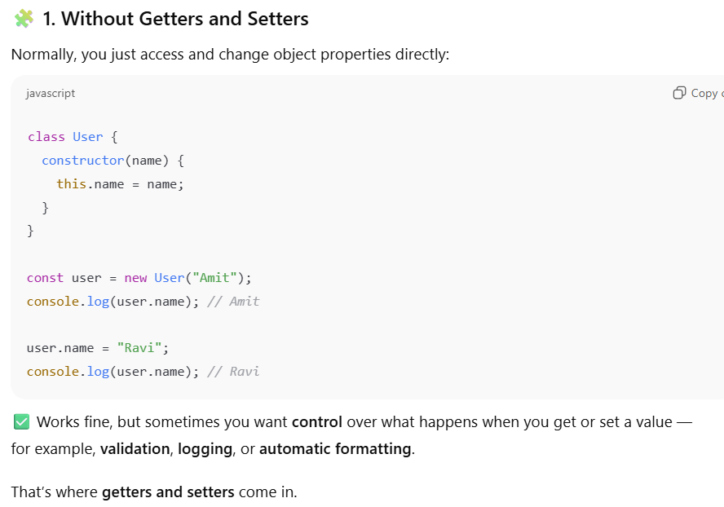
2. Using Getter and Setter
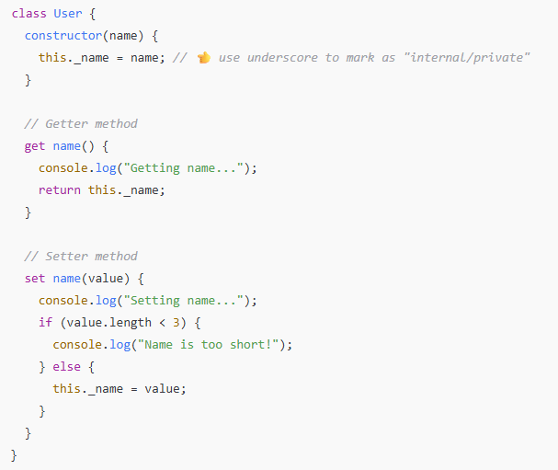
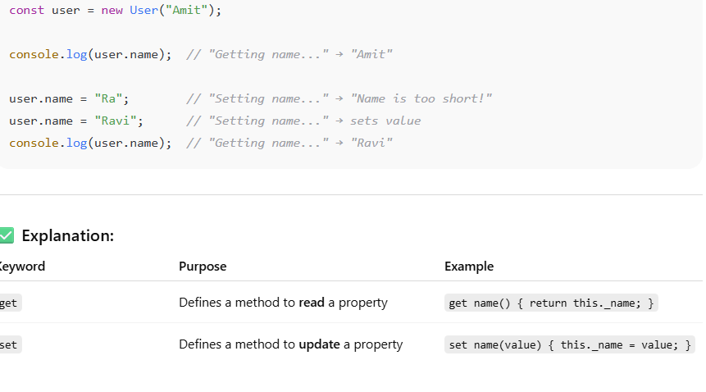
Why use getters and setters?
Because they let you:
- ✅ Validate data before setting it
- ✅ Modify data automatically (e.g., uppercase names)
- ✅ Hide internal/private properties (encapsulation)
- ✅ Compute values dynamically (getter returns calculated value)

***************** SET, MAP, WEEKMAP, WEEKSET********************
Q1. What is MAP?
A Map is a special built-in object that stores key–value pairs — just like an object —
but with some big advantages over normal objects ({}).
Key Features of Map:
- You can use any type of key — not just strings (like in objects).keys can be objects, numbers, functions, etc.
- Map remembers the order in which items were inserted.
- Easy built-in methods to add, delete, loop, and check data.
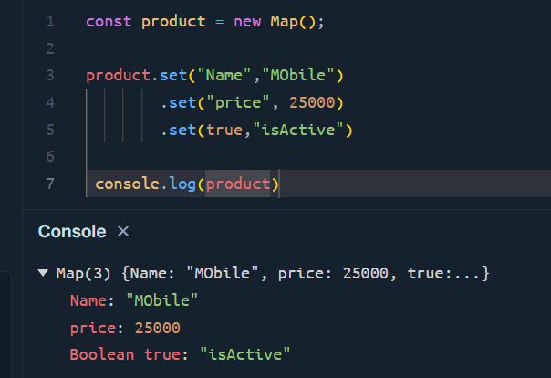
Important Map Methods (with examples)
1. set(key, value)
- Adds or updates an entry in the Map.
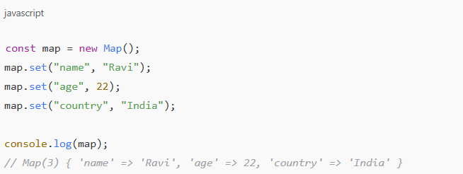
Note: If you call set() on an existing key, it updates the value.
2.get(key)
- Retrieves the value for a given key.
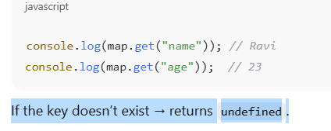
3. has(key)
- Checks if a key exists in the Map.
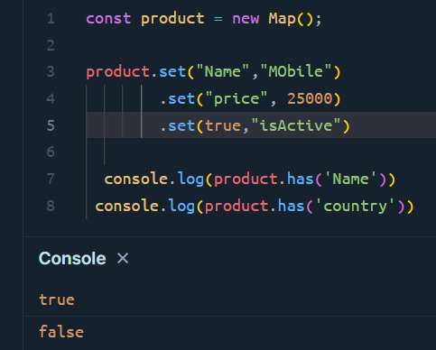
If the key is present then it return true else false.
- Delete(key)
- Deletes an entry by key.
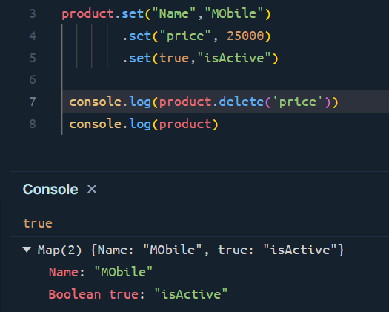
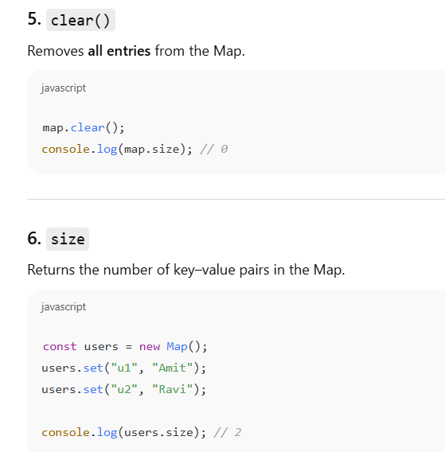
7. keys()
- Returns an iterator containing all keys in insertion order.
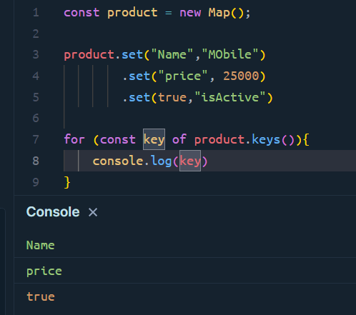
8. values()
- Returns an iterator containing all values in insertion order.
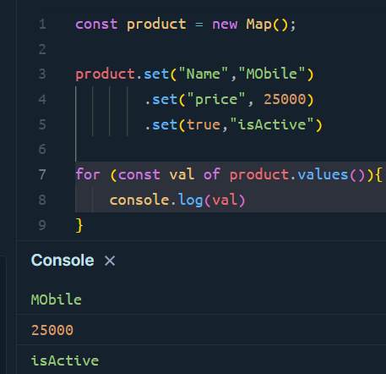
9. entries()
- Returns an iterator of [key, value] pairs — useful for looping.
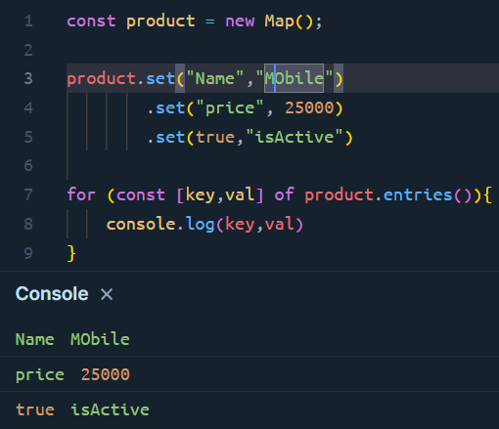
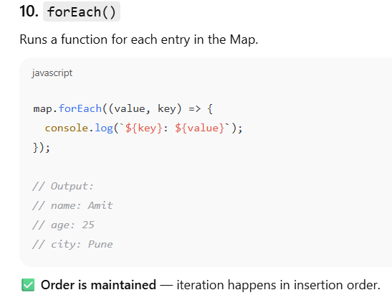
Q2. What are the advantages of using Map over objects?
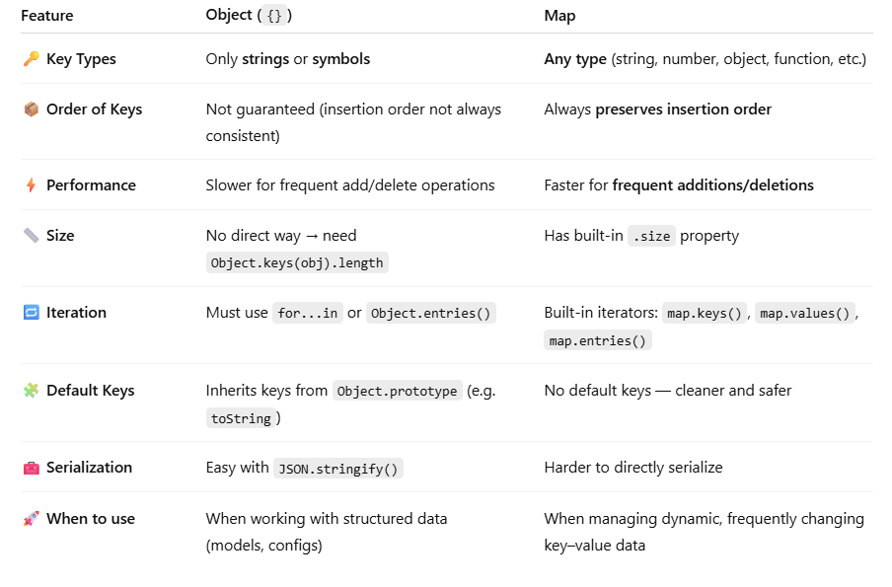
Q3. How will you iterate through Map ?
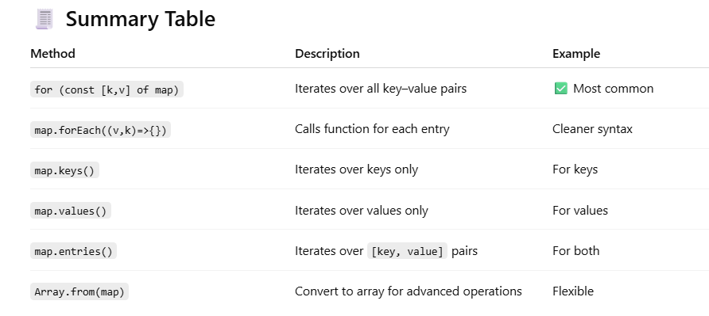
Q4. Can you assign key/values with this syntax?
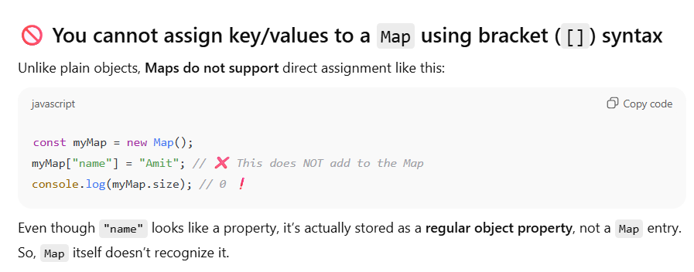
We can do using array but it will not add that value and key in Map.
Use .set to add key-value
Q5. How can you convert a simple Object → Map?
JavaScript gives us a built-in, easy way to do this using the Object.entries() method.
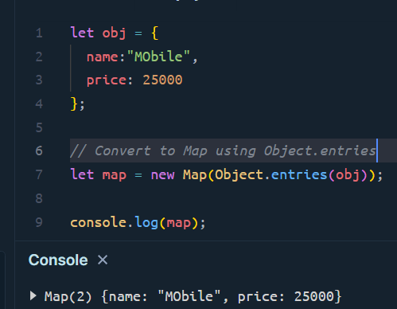
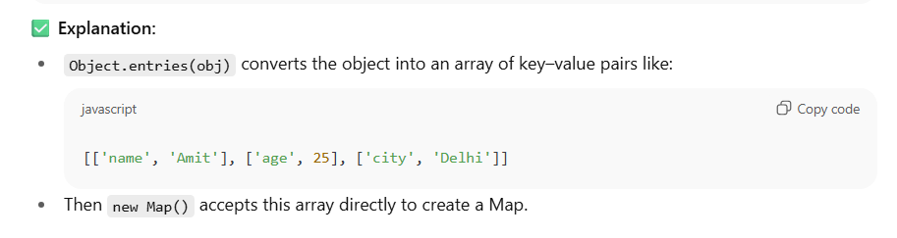
Q6. How can you convert a Map into a simple Object?
In JavaScript, you can easily convert a Map into an Object using:
- Object.fromEntries() — the modern, built-in method
- Or using a manual loop (older approach)
Using Object.fromEntries
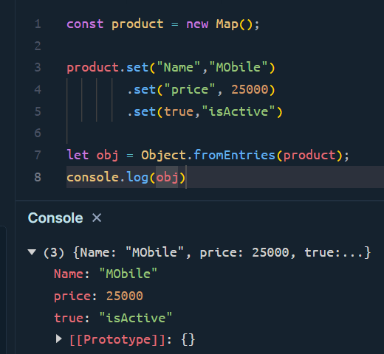
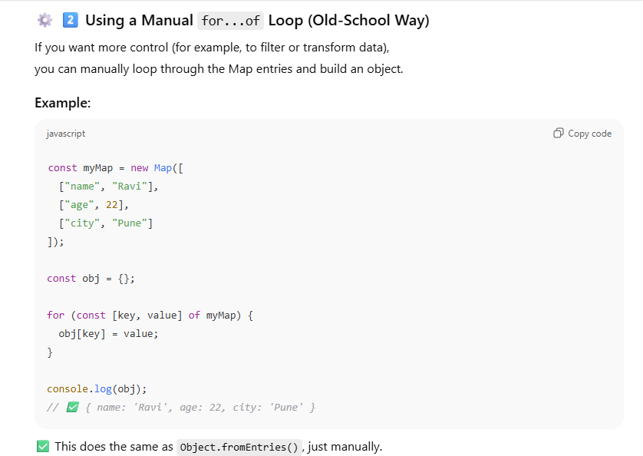
Q7. What is set in Javascript?
A Set is a collection of unique values in JavaScript.
- It cannot have duplicates.
- It can store any type of value — primitive values (numbers, strings, booleans) or object references.
- Values in a Set are unordered (no index like arrays).
Think of it as a bag where you can only put unique items.
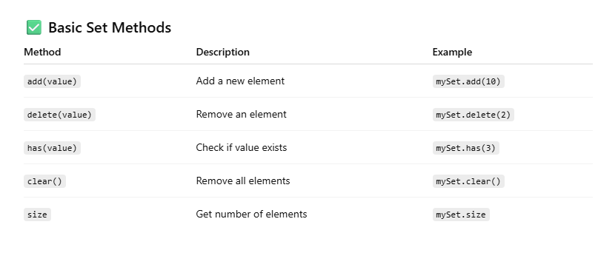
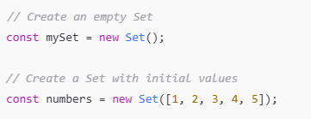
Example:
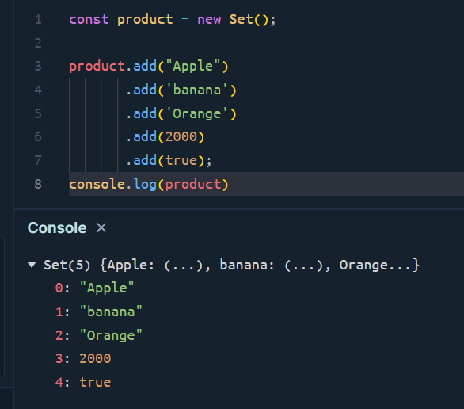
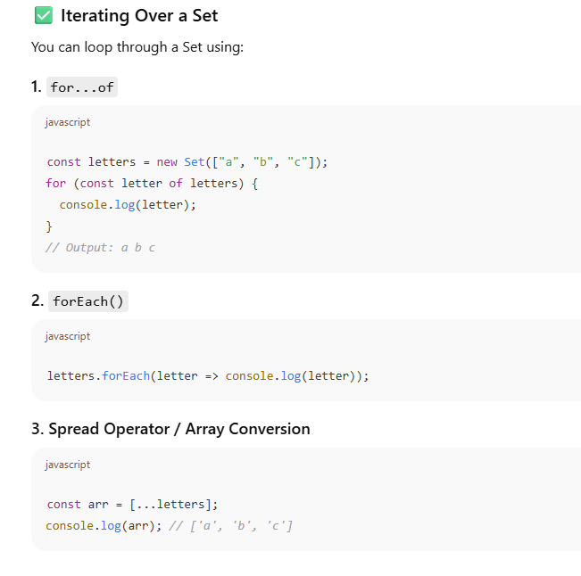
Note: We have values, keys, entries method which we also use in Set but ideally there is no real use of these values.
Because set have only value no key exist in the set.
Q8. What is a WeakMap in JavaScript?
A WeakMap is just like a Map, but with a few key differences that make it special and memory-efficient.
Think of a WeakMap as a Map that only holds weak references to its keys.
This means:
- Keys must be objects (not strings, numbers, etc.)
- If there are no other references to that object, it gets garbage-collected automatically
- Because of weak key it does not have any iterable method like values, keys and entries.
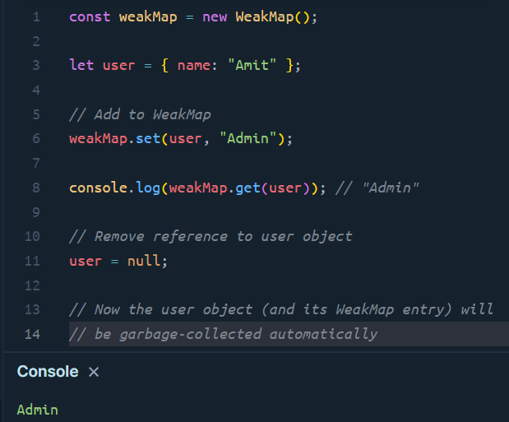
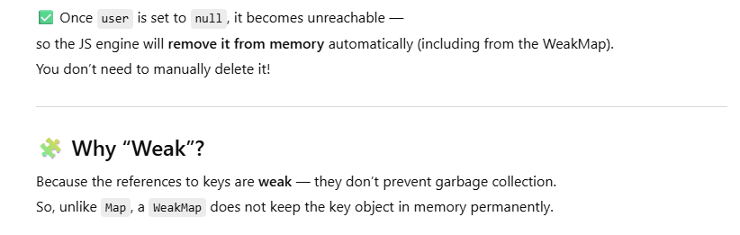
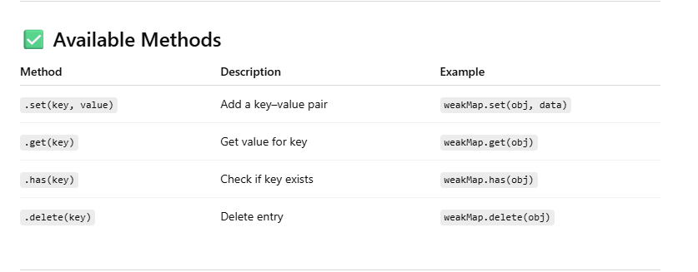
Q. Difference between Map and WeekMap?
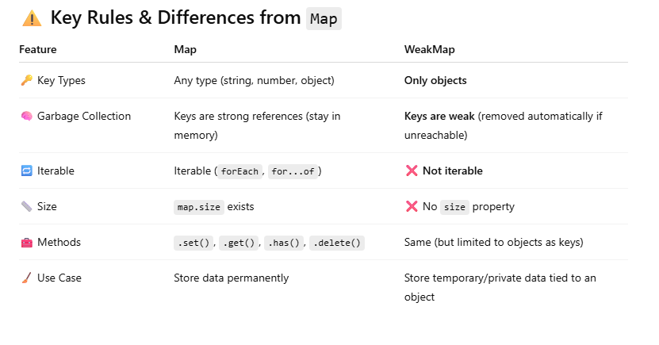
Q9. What is a WeakSet in JavaScript?
A WeakSet is similar to a normal Set, but with some special behavior designed for memory efficiency.
You can think of a WeakSet as a Set that only stores objects,
and those objects are held weakly — meaning they can be garbage-collected if no longer used anywhere else.

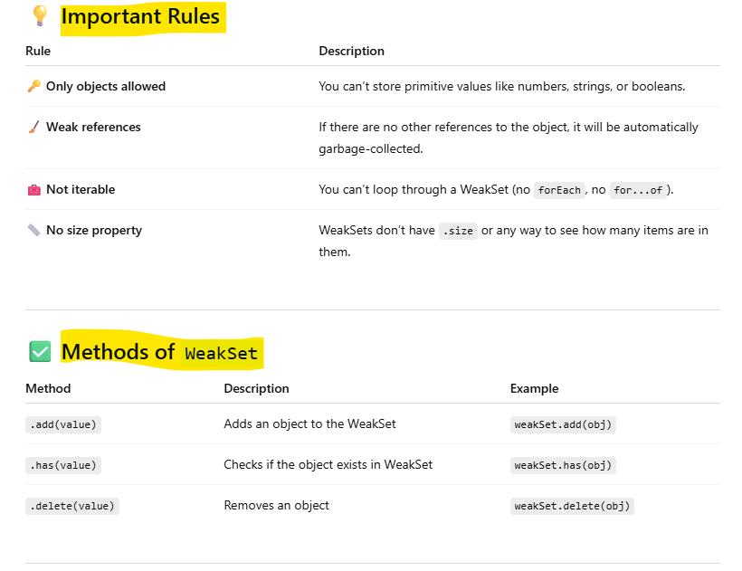
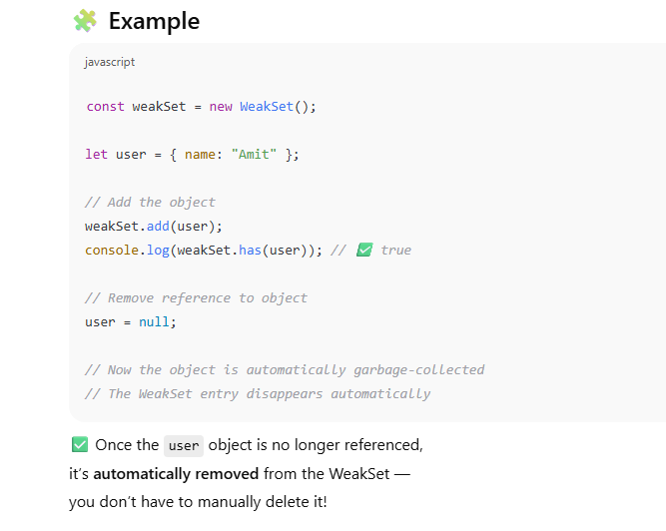
Q10. Difference between Set and WeekSet
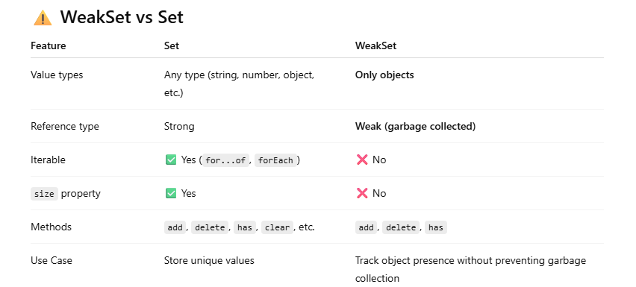
************************ DOM and WEB ****************************
Q1. What is Dom and DOM API?
DOM stands for Document Object Model.
It’s a tree-like structure that represents your entire web page in the browser.
Every element (like <div>, <p>, <img>, etc.) is represented as a node (object) in this tree.
So, when your HTML page loads, the browser converts it into a DOM —
and JavaScript can use it to read, change, or delete parts of the page dynamically.
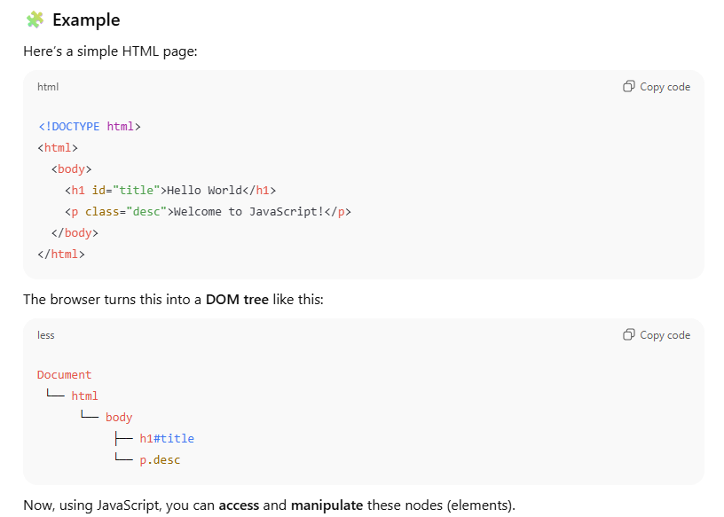
DOM API
The DOM API is the set of methods and properties provided by the browser that lets you interact with this structure using JavaScript.
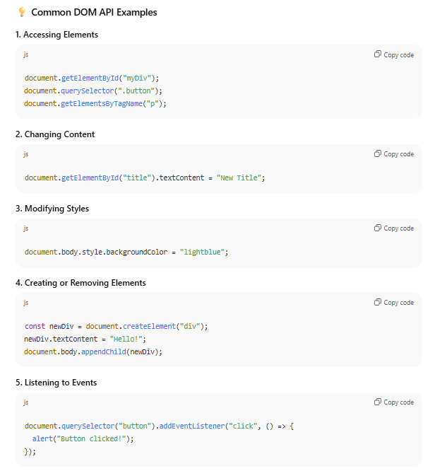
Q2. What is the difference between Window and Document Object?
window Object
The window object is the global object in the browser environment.
It represents the browser window or tab that contains a web page.
Key Points:
- It is the top-level object in the browser's JavaScript hierarchy.
- Everything in the browser (like document, console, localStorage, etc.) is a property of window.
- All global variables and functions you declare automatically become properties/methods of the window object.

document Object
The document object is a property of the window object:
window.document
It represents the HTML document (the web page’s content) that is loaded in the browser window.
Key Points:
- It is part of the DOM (Document Object Model).
- You use it to access and manipulate HTML elements.
- It doesn’t represent the browser window — only the content inside it.
What is BOM?
The BOM stands for Browser Object Model.
It represents everything provided by the browser to interact with the outside world of the web page — that is, the browser window itself.
In short:
The BOM allows JavaScript to interact with the browser, not just the web page (DOM).
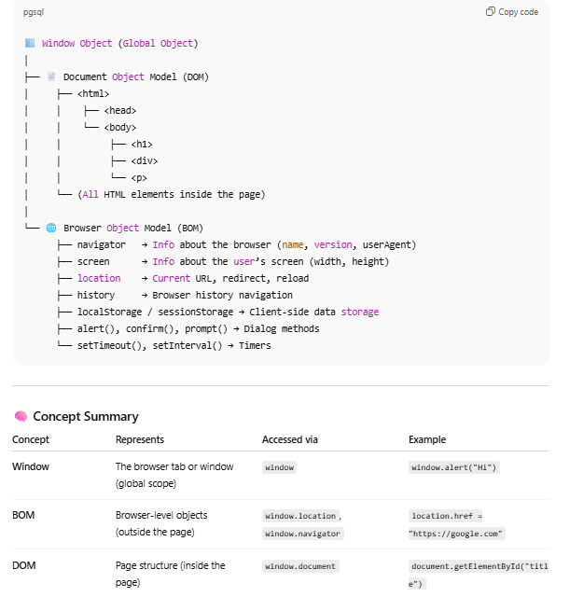
Q3. Explain setTimeout and setInterval?
setTimeout
The setTimeout() method in JavaScript is used to execute a function or a block of code once, after a specified time delay (in milliseconds).
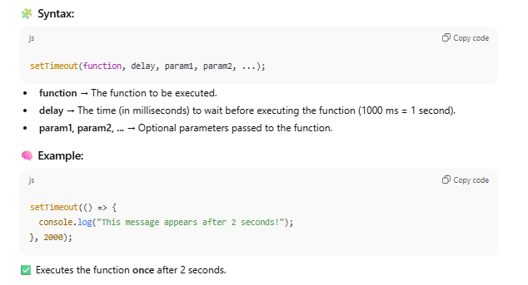
setInterval()
The setInterval() method in JavaScript is used to repeatedly execute a function or a block of code at fixed time intervals (in milliseconds).
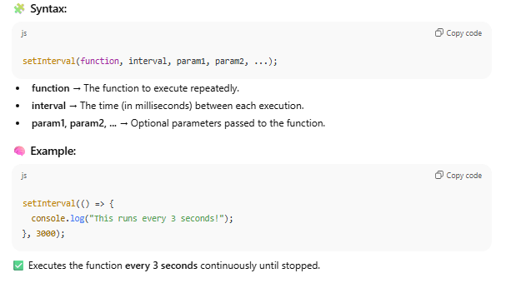
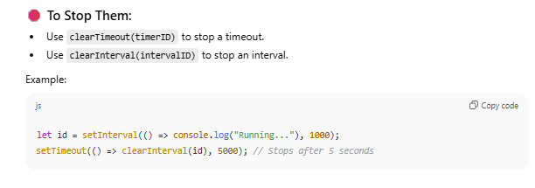
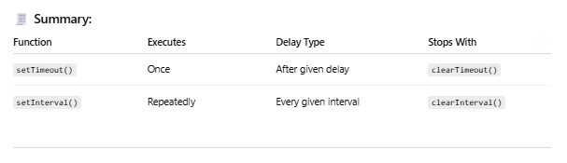
Important Points
- Both setTimeout and setInterval belongs to window object not document object.
- To stop both function we use clearTimeout and clearInterval
Q4. How events work in js?
Event Propagation
Event propagation describes the order in which events travel through the DOM (Document Object Model) when an event is triggered (like a click).
When you click on an element (say a <button> inside a <div>), the event doesn’t just stay on that element — it travels through different phases:

🔹 Three Phases of Event Propagation:
- Capturing Phase (a.k.a. trickling down)
→ Event starts from the root (window / document) and moves down to the target element.
- Target Phase
→ Event reaches the target element (the element that was actually clicked).
- Bubbling Phase
→ Event then bubbles up from the target element back to the root.
Event Bubbling
In event bubbling, the event starts at the target element and bubbles up (propagates upward) through its ancestors in the DOM tree — from child to parent.
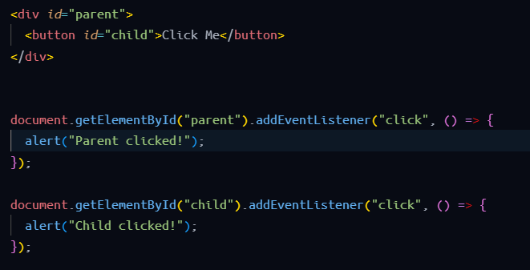
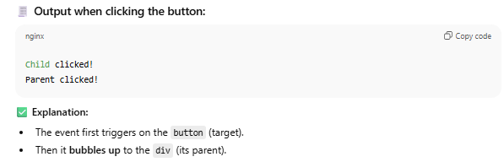
Event Capturing (Trickling)
In event capturing, the event travels from the top (document) down to the target element before bubbling up.
By default, browsers use bubbling phase, but you can enable capturing by passing true as the third parameter to addEventListener().
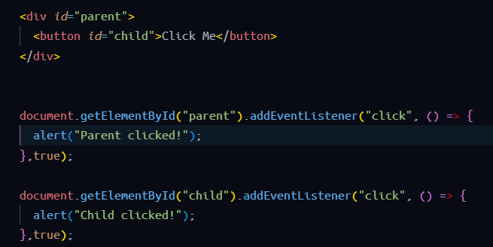
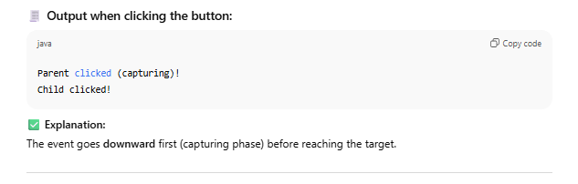
Stopping Propagation
You can stop the event from continuing its journey using:
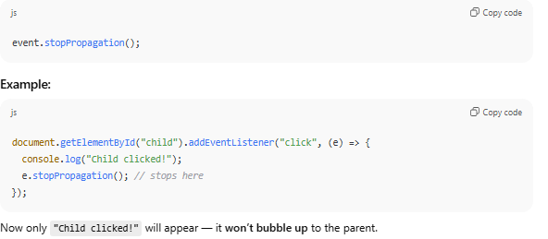
Event Delegation
Event Delegation is a powerful pattern that uses event bubbling to handle events efficiently.
Instead of adding event listeners to multiple child elements, you attach one listener to a parent element and use event.target to identify which child triggered the event.
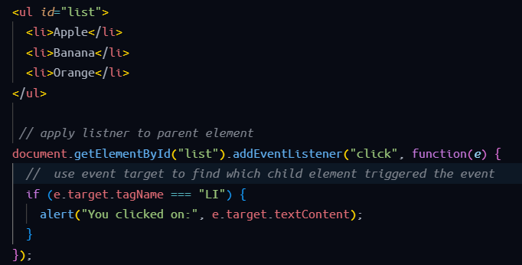
Explanation:
- The click event is attached to the <ul>, not each <li>.
- When you click an <li>, the event bubbles up to <ul>.
- e.target identifies the actual element clicked.
This saves memory and makes your code more efficient and maintainable.
How to check the Tag Name?
Use “event.target.tagName”
Q5. What is “getting a reference” from the DOM?
When an HTML page is loaded, the browser creates a DOM tree — a structured representation of the HTML.
JavaScript can access and modify these elements using various DOM selection methods.
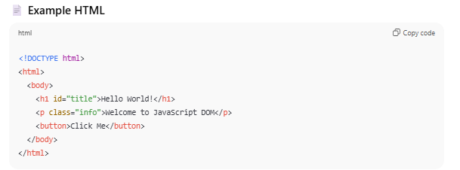
DOM Selection Methods
- document.getElementById()
- Returns one element with the specified id.
- Since IDs are unique, it always returns a single element or null if not found.
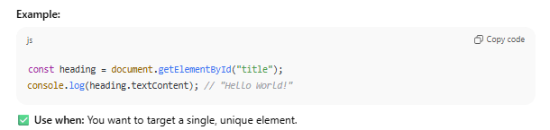
- document.getElementsByClassName()
- Returns a collection (HTMLCollection) of all elements that share a class name.
- You must use an index ([0], [1], etc.) to access individual elements.
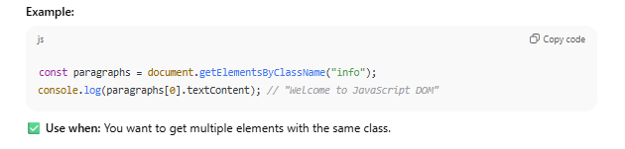
- document.getElementsByTagName()
- Returns all elements with a specific HTML tag name (like div, p, h1).
- Returns an HTMLCollection (live list of elements).
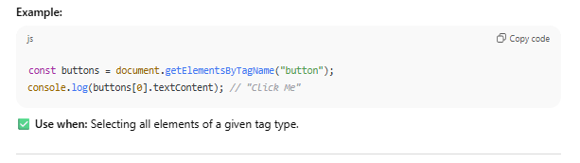
- document.querySelector()
- Returns the first element that matches a CSS selector.
- Very flexible — can select by ID, class, tag, attribute, etc.
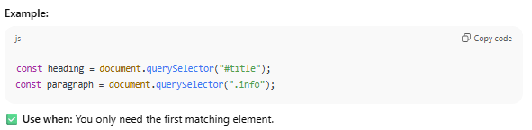
- document.querySelectorAll()
- Returns all elements that match a CSS selector.
- Returns a NodeList (not live, but can be looped with forEach()).
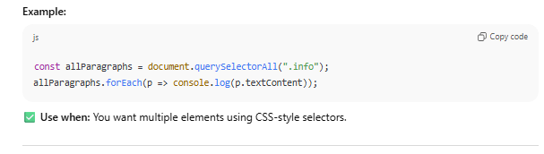
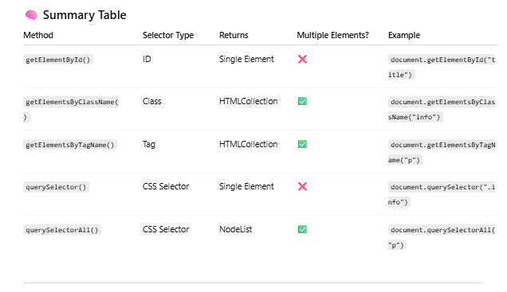
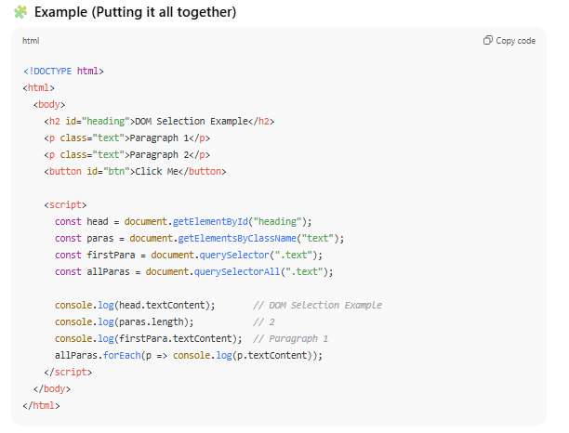
Note: getElementById works on all browser but querySelector works on IE-8 and above

Q6. What is Event in JavaScript?
An event is simply an action or occurrence that happens in the browser — something the user or the browser itself does.
What is the Event Object in JavaScript?
When an event (like a click, keypress, or scroll) occurs in the browser, the browser automatically creates an object that contains information about that event.
This object is called the Event Object — usually referred to as event or e.
👉 In simple words:
The Event Object is a special object automatically passed to the event handler that contains details about the event that just happened.
How to Configure (Attach) an Event with an HTML Element
There are three main ways to handle or configure events in JavaScript:
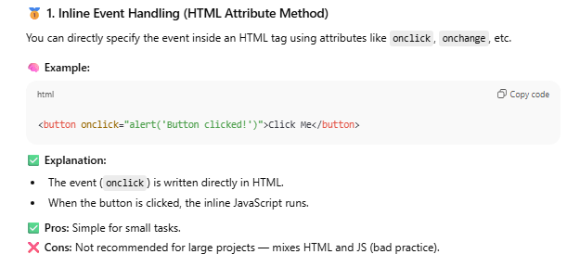
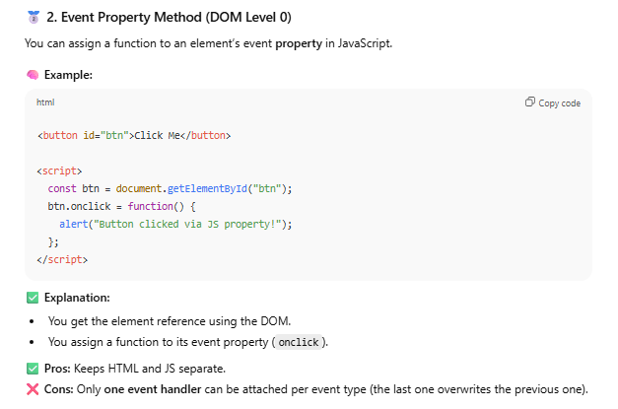
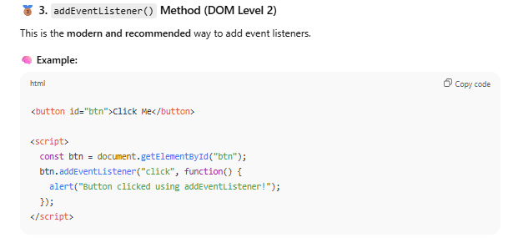
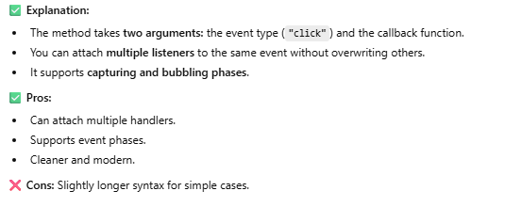
Q7. What Are Mouse Events?
Mouse events are events that occur when a user interacts with a pointing device (like a mouse, trackpad, or touchscreen in “mouse mode”).
They belong to the Event Object family, and you can listen for them using addEventListener() or inline handlers like onclick.
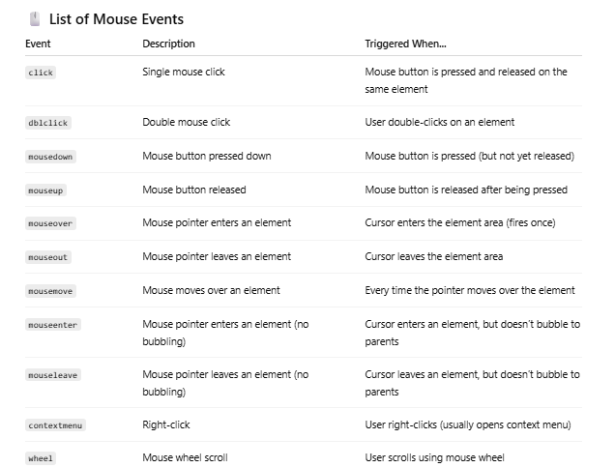
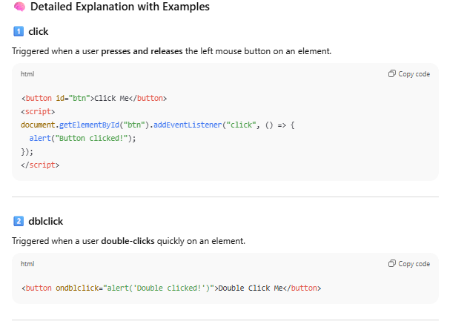
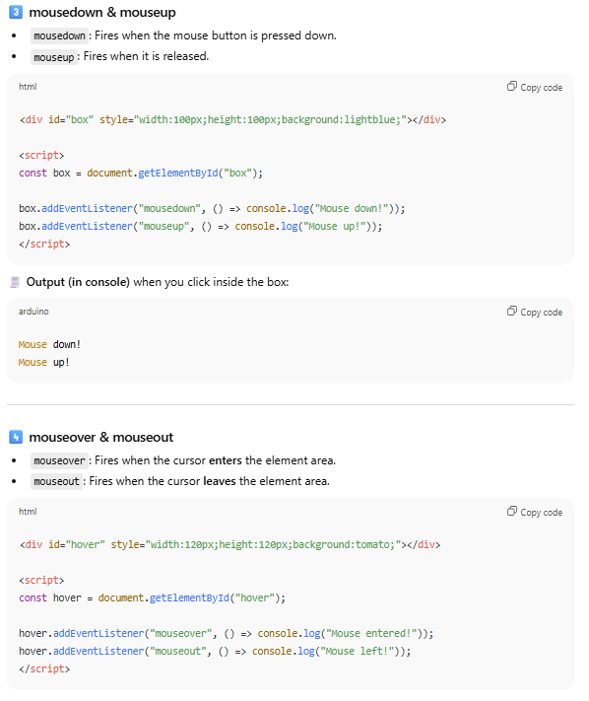
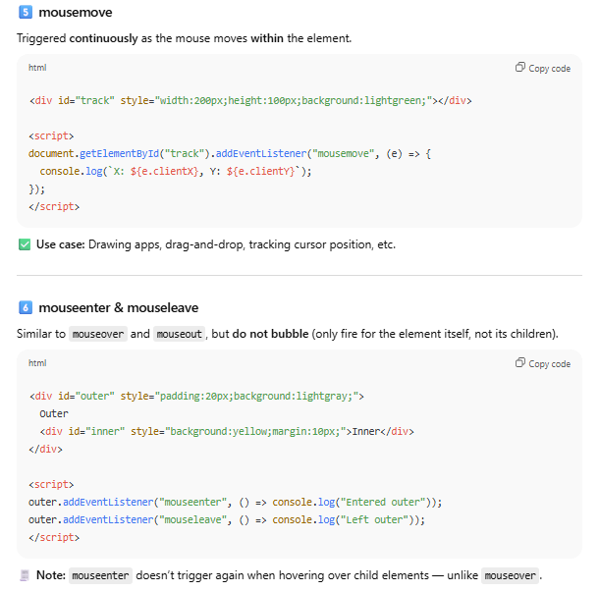
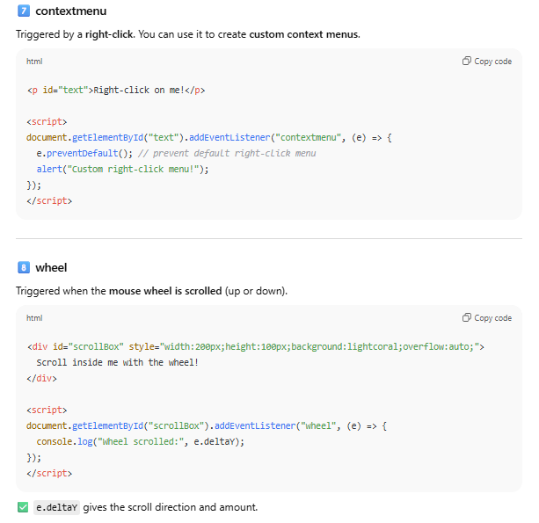
Q8. What Are Keyboard Events?
A keyboard event is fired when the user interacts with the keyboard — pressing or releasing keys.
These events help you:
- Validate user input (e.g., numbers only)
- Create shortcuts (Ctrl + S, etc.)
- Detect Enter key for form submissions
- Build interactive applications (games, search bars, etc.)
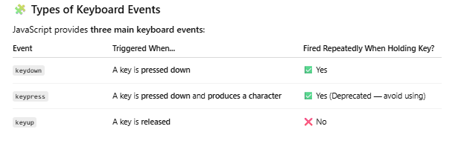
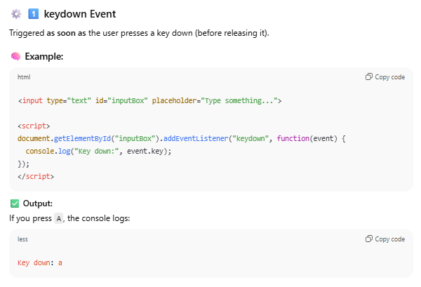
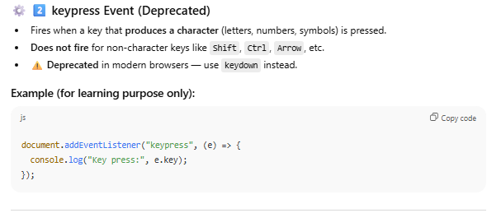

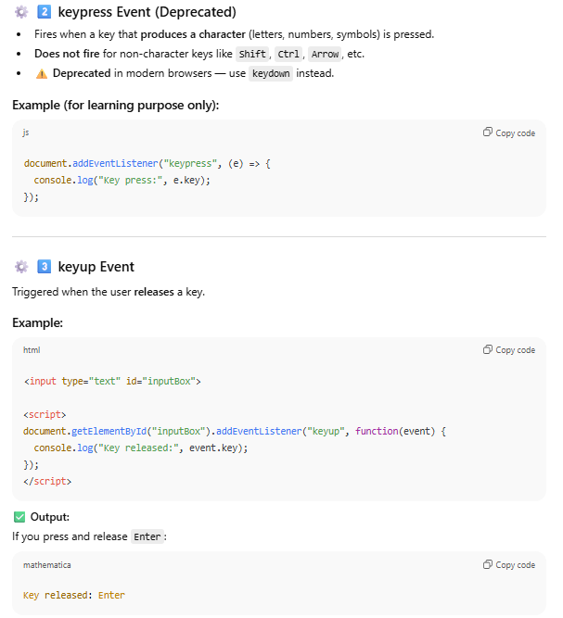
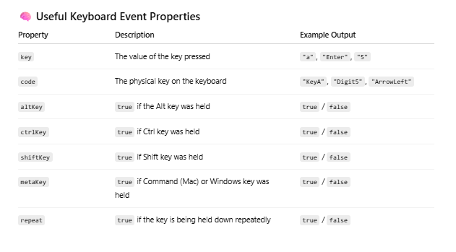
Q9. How can you check if control or Z key is pressed or not?
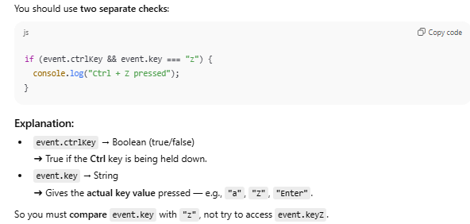

************************ Debouncing and Throttling ********************
Before going to these concept let understand that these words are not any keyword in js they are just concept using this we can handle the event in more accurate way.
Q1. What is Throttling?
Throttling is a technique in which a function (or event handler) is allowed to run only once in a specific time period.
If the event happens again before that time is over, the function waits until the time has passed before running again.

Example:
If you set a throttle time of 2 seconds, and the user keeps scrolling:
- The function will run once every 2 seconds,
- Even if the scroll event happens many times in between.
Q2. What is Debouncing?
Debouncing is a technique in which a function runs only after a certain amount of time has passed since the last event.
If the event keeps happening again and again, the timer resets each time, and the function waits until the events stop.
If you are typing in a search box:
- The search function will run only after you stop typing for a short time (like 1 second).
- If you keep typing, the function waits until you finish.
Implementation of Throttling and Debouncing
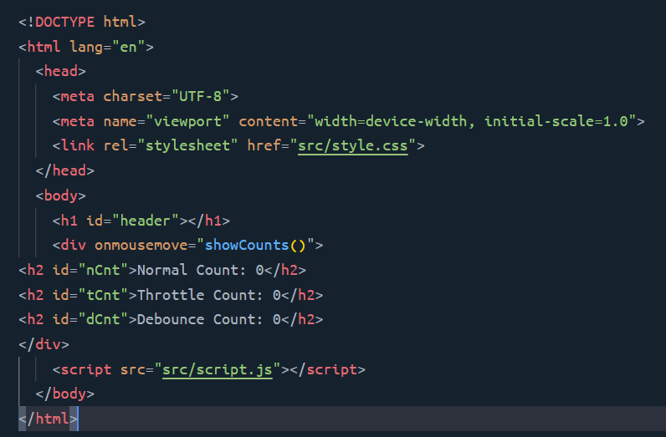
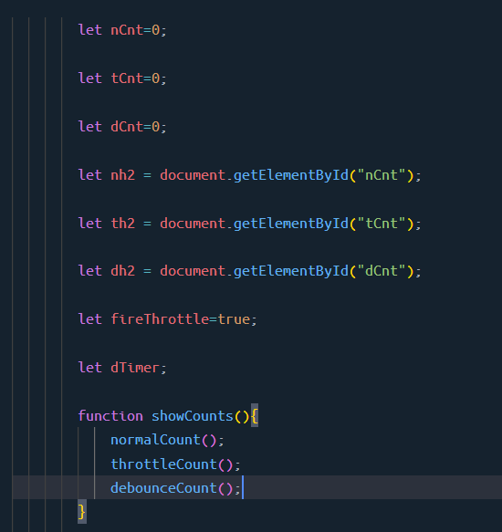
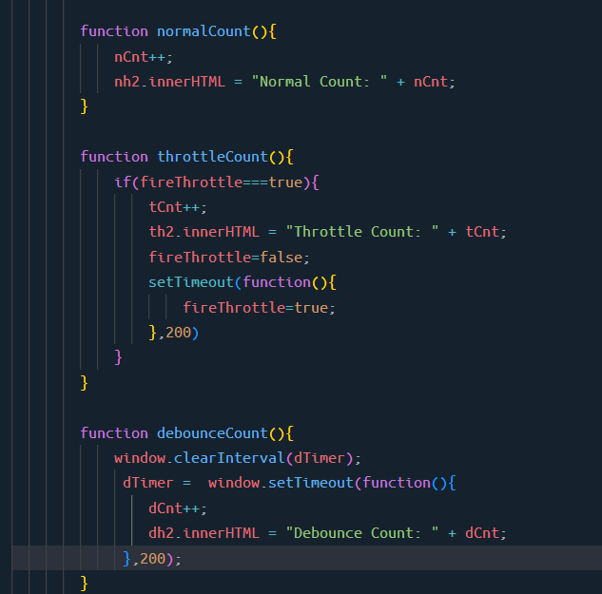

Practical use

Throttling:

Real Case: Scroll Event
When you scroll a webpage, the scroll event can fire hundreds of times per second.
If your code runs every time, it can lag or freeze the browser.
So we use throttling:
- It runs the scroll handler once every 200ms (for example),
- Even if the user keeps scrolling nonstop.
Result:
The page scrolls smoothly, and your code updates position or animations efficiently.
Another Example of Throttling
- Button clicks: Limit how often a “submit” or “save” button can be clicked (once every 2 seconds).
- Mouse movement tracking: When tracking cursor position, update it at fixed intervals instead of every pixel move.
Debouncing — “Wait until the user stops”
Real Case: Search Box (Live Search)
When you type in a search box (like Google), every letter you type could send a request to the server.
That would be too many requests and slow down the website.
So instead, we use debouncing:
- It waits until you stop typing for, say, 500ms (half a second).
- Then it sends just one request to get search results.
Result:
The search feels fast and smooth, and the server isn’t overloaded with extra requests.

