MicroService in Nodejs
Questions

🔹 Basic Microservices Concepts
- What are Microservices?
- How are Microservices different from a Monolithic architecture?
- What are the advantages of Microservices?
- What are the disadvantages of Microservices?
- When should we use Microservices instead of Monolithic architecture?
- What does “loosely coupled services” mean?
- What is service independence?

🔹 Architecture & Design
- What is Service Discovery?
- What is API Gateway? Why is it used?
- What is the role of a Load Balancer in Microservices?
- What is synchronous vs asynchronous communication?
- What are RESTful services?
- What is a stateless service?
- What is Circuit Breaker pattern?
- What is Database per service pattern?

🔹 Communication & Integration
- How do Microservices communicate with each other?
- What protocols are commonly used in Microservices?
- What is JSON?
- What is message-based communication?
- What is Kafka / RabbitMQ (basic understanding)?

🔹 Data Management
- Can multiple Microservices share a database?
- What problems occur if services share a database?
- What is eventual consistency?
- What is data duplication in Microservices?

🔹 Deployment & DevOps Basics
- What is Docker?
- Why is Docker used in Microservices?
- What is containerization?
- What is Kubernetes (basic idea)?
- What is CI/CD?
- How does Microservices help in continuous deployment?
🔹 Monitoring & Security (Basic)
- What is logging in Microservices?
- What is centralized logging?
- What is monitoring?
- What is authentication vs authorization?
- How do you secure Microservices?
***************************************************************
Q1. What is Microservice?
Definition:
Microservices architecture is a software design pattern where a large application is divided into a collection of small, independent services, each responsible for a specific business function.
Each service:
- Runs independently.
- Has its own database.
- Communicates with others via APIs (usually REST or message queues).
- Can be deployed, scaled, and updated separately.
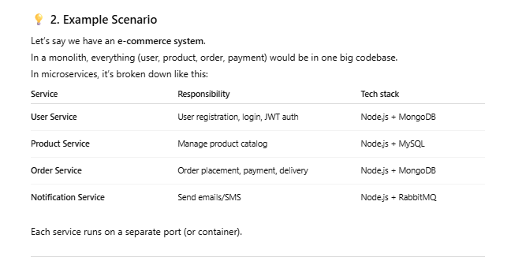

Advantages of Microservices
✅ Independent deployment
✅ Easier to scale specific components
✅ Fault isolation (one service down ≠ whole app down)
✅ Technology flexibility (Node.js + Python + Java can coexist)
✅ Easier for teams to work in parallel

Challenges of Microservices
❌ Complex communication between services
❌ Harder debugging (logs spread across many services)
❌ Requires DevOps expertise (Docker, CI/CD, load balancing)
❌ Data consistency (since each service has its own DB)
❌ Network overhead (more API calls)
Q2. How are Microservices different from a Monolithic architecture?
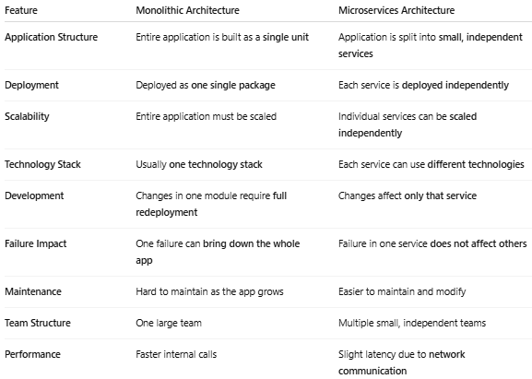
Q3. What are the advantages and disadvantages of Microservices?
• Independent Deployment
Each service can be developed and deployed separately without affecting other services.
• Scalability
Individual services can be scaled independently based on load (e.g., scale only payment service).
• Fault Isolation
Failure in one service does not bring down the entire application.
• Technology Flexibility
Different services can use different technologies (Node.js, Java, Python, etc.).
• Faster Development
Multiple teams can work on different services at the same time.
• Easier Maintenance
Smaller codebases are easier to understand, modify, and test.
• Better Continuous Delivery
Supports CI/CD and frequent releases.
Dis-Advantage
Increased Complexity
• Managing multiple services, deployments, and environments is complex.
• Network Latency
Services communicate over the network, which can be slower than in-process calls.
• Difficult Debugging
Tracing issues across multiple services is harder.
• Data Management Challenges
Maintaining data consistency across services is difficult.
• Operational Overhead
Requires DevOps tools like Docker, Kubernetes, monitoring, and logging.
• Higher Initial Cost
Infrastructure and setup cost is higher compared to monolithic architecture.
Q5. What does “loosely coupled services” mean?
Loosely coupled services mean that each microservice is independent and has minimal dependency on other services. Changes in one service do not require changes in other services.
Key Points:
- Each service can be developed, deployed, and scaled independently
- Services communicate using well-defined APIs (HTTP/REST, events, messages)
- Services do not share internal code or databases
- Failure in one service does not directly break others
Q6. What is Service Independence?
Service independence means that each microservice can operate on its own without depending on other services for its development, deployment, or execution.
Key Points:
- Each service has its own codebase
- Each service can be developed, tested, and deployed independently
- Services can be scaled independently
- A service can continue working even if another service is down (with proper fallback)
Q7. What is Service Discovery in microservices?
Service Discovery in Microservices is the mechanism that enables microservices to automatically locate and communicate with each other without hard-coded network addresses.
Explanation
In a microservices architecture, services are:
- Independently deployed
- Dynamically scaled
- Running on changing IP addresses and ports
Because of this, services cannot rely on fixed endpoints. Service Discovery maintains a registry of available services and their network locations, allowing services to find each other at runtime.

How it works
- Service Registration – Each microservice registers itself with a service registry when it starts.
- Service Lookup – When a service needs to call another service, it queries the registry.
- Health Monitoring – Unhealthy service instances are automatically removed from the registry.

Types of Service Discovery
- Client-side discovery: The client queries the registry and selects a service instance (e.g., Netflix Eureka).
- Server-side discovery: A load balancer or platform handles service lookup (e.g., Kubernetes Services).

Benefits
- Supports dynamic scaling
- Improves fault tolerance
- Eliminates hard-coded service endpoints
- Enables seamless inter-service communication
In short: Service Discovery allows microservices to dynamically find and communicate with each other in a scalable and resilient way.

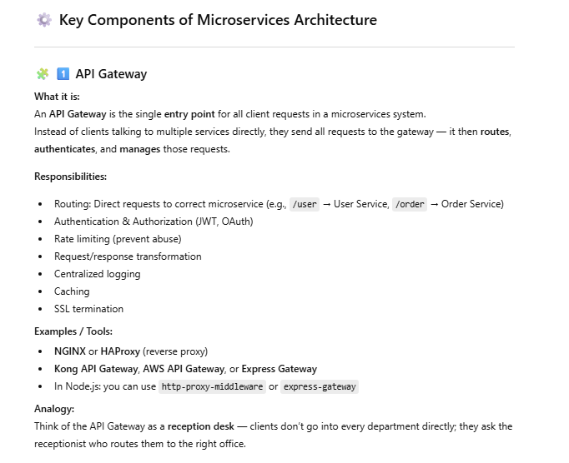
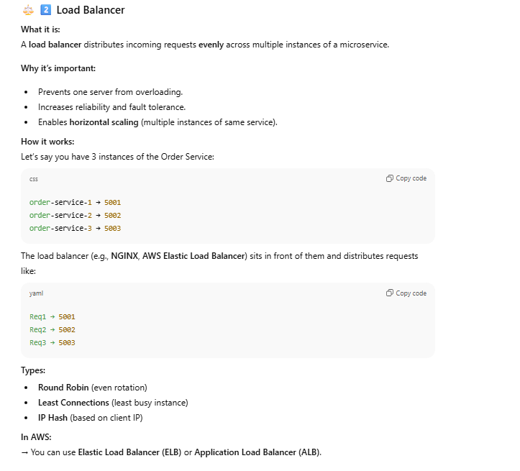
Basic Example of Microservice using NOdejs

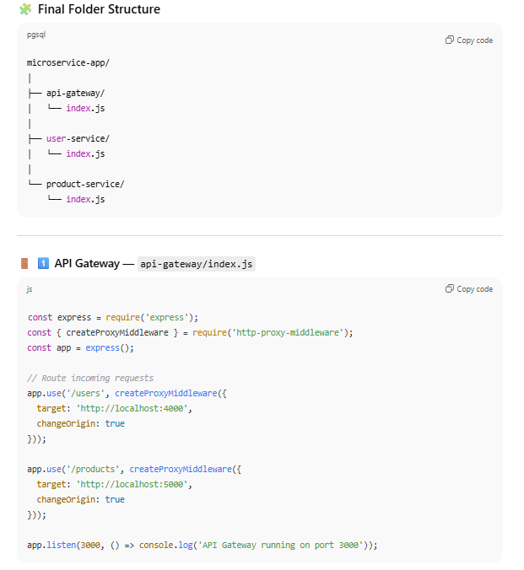
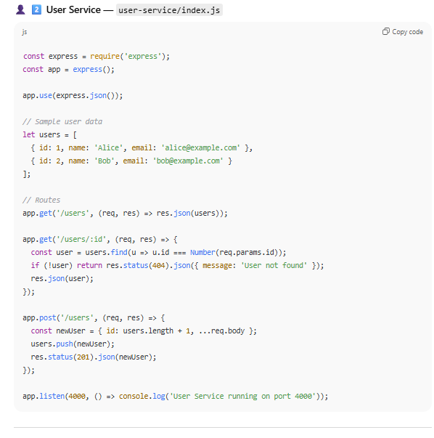
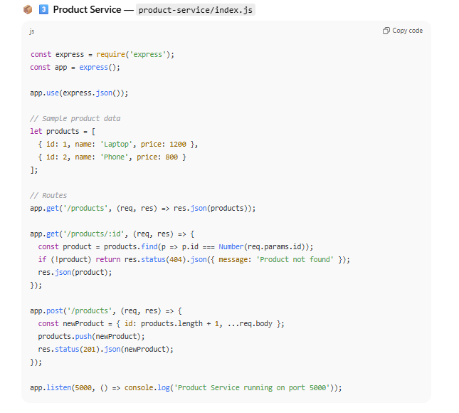
Q. Synchronous vs Asynchronous Communication?
1. Synchronous Communication
Synchronous communication is a request–response interaction where the caller waits (blocks) until the receiver processes the request and sends back a response.
How it works (Flow)
- Service A sends a request to Service B.
- Service A waits until Service B finishes processing.
- Service B returns a response (success or failure).
- Service A resumes execution.
If Service B is slow or unavailable, Service A is also impacted.

Common Technologies
- REST APIs (HTTP/HTTPS)
- gRPC (blocking calls)
- SOAP services

Characteristics
- Blocking communication
- Tight temporal coupling
- Immediate feedback
- Strong consistency

Advantages (Why use it?)
- Simple to implement and debug
- Immediate response needed
- Easier transaction handling
- Suitable for read/query operations

Disadvantages (Challenges)
- Tight coupling between services
- Cascading failures
- Poor scalability under heavy load
- Increased latency
- Requires timeout, retries, and circuit breakers

Example in Microservices
Order Service → User Service → Payment Service

If Payment Service is down:
- Order Service waits
- Requests pile up
- System may fail completely
2. Asynchronous Communication
Asynchronous communication is a non-blocking interaction where the sender sends a message and continues processing without waiting for a response.

How it works (Flow)
- Service A sends a message/event.
- Message is stored in a broker (queue/topic).
- Service A continues its work.
- Service B processes the message when available.
- Optional response via another message.

Common Technologies
- Message Queues: RabbitMQ, Amazon SQS
- Event Streaming: Apache Kafka
- Pub/Sub systems

Characteristics
- Non-blocking
- Loosely coupled services
- Event-driven
- Eventual consistency

Advantages (Why use it?)
- High scalability
- Fault tolerance
- Better system resilience
- Handles traffic spikes
- No cascading failures

Disadvantages (Challenges)
- More complex architecture
- Eventual consistency
- Harder debugging and tracing
- Message duplication & ordering issues
Q10. What are RESTful services?
RESTful services are web services that follow the principles of REST (Representational State Transfer), an architectural style used to design scalable, stateless, and lightweight APIs, especially in microservices architectures.
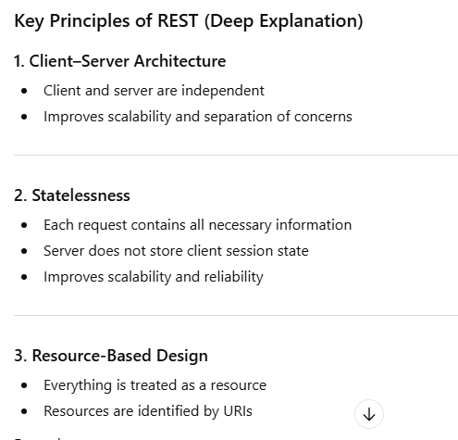
Example:
GET /products/10

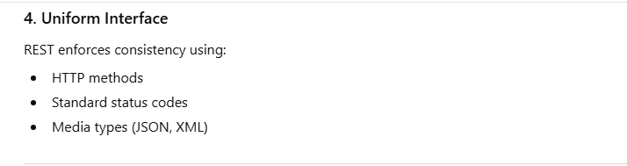
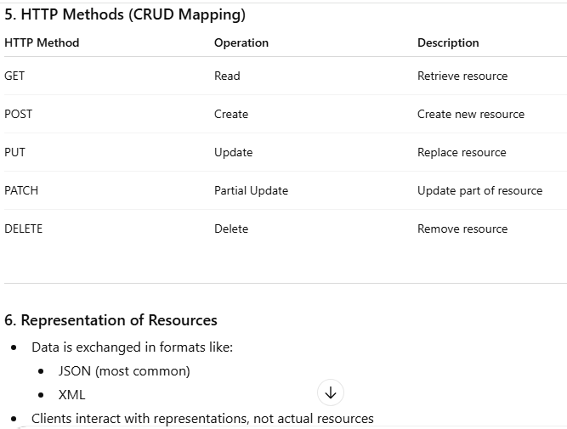
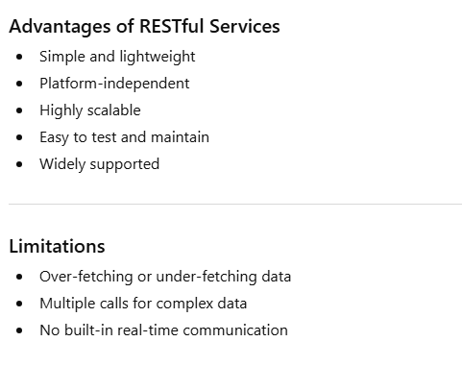
Q What is a Stateless Service?
A stateless service is a service that does not store any client-specific state or session data between requests.
Each request is independent and contains all the information required for the service to process it.
Explanation
In a stateless service:
- The server does not remember past requests
- Every request is treated as new
- Client state (authentication, session data, context) is sent with each request
This concept is a core principle of RESTful services and is widely used in microservices architectures

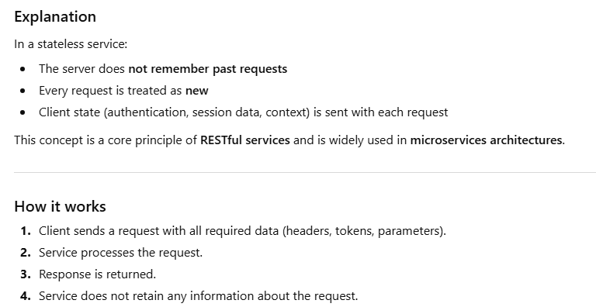

Q. What is Message Queue in Microservices?
A Message Queue (MQ) is a communication mechanism that allows different applications or services to send and receive messages asynchronously through a queue, without needing to communicate directly with each other.
Explanation
In a message queue system:
- A producer sends a message to the queue
- The queue stores the message temporarily
- A consumer retrieves and processes the message later
The producer and consumer do not need to run at the same time, which makes systems more flexible and reliable.
Why Message Queues are Used
- Decouple services
- Enable asynchronous communication
- Improve scalability
- Increase fault tolerance
- Handle traffic spikes
How it Works
- Producer sends a message
- Message is stored in the queue
- Consumer reads the message
- Message is acknowledged and removed after processing
Common Message Queue Technologies
- RabbitMQ
- Apache Kafka
- Amazon SQS
- ActiveMQ
- Azure Service Bus
RabbitMQ (RMQ) – Detailed Explanation
1. What is RabbitMQ (RMQ)?
RabbitMQ (RMQ) is an open-source message broker that implements message queueing using the AMQP (Advanced Message Queuing Protocol).
It enables applications and microservices to communicate asynchronously by sending messages through queues instead of making direct calls.
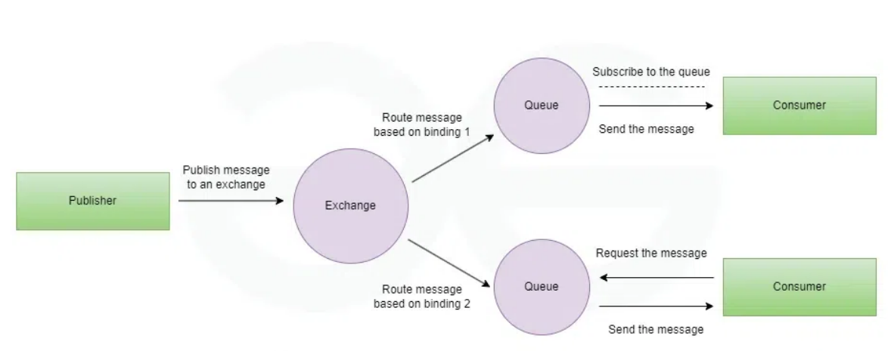
Why Do We Use RabbitMQ?
In distributed systems and microservices, direct synchronous communication causes problems such as:
- Decoupling Services
- Asynchronous Processing
- Load Balancing & Scalability
- Complex Routing & Messaging Patterns
When RabbitMQ Might Not Be Ideal
❌ Ultra-low latency streaming (Kafka is better)
❌ Simple monolithic apps
❌ Extremely high-throughput event logs
Core components of RabbitMQ
1. Producer
- A producer in RabbitMQ is an application that is responsible for sending messages to the RabbitMQ server.
- These messages can carry various kinds of data such as JSON, XML, or simple plain text.

2. Exchange
- Routes messages to queues
- Does not store messages
- Decides where messages go based on rules

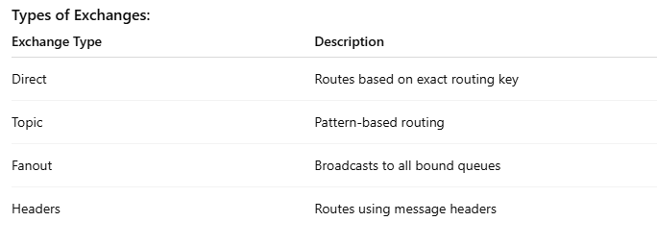
3.Queue
A queue is:
- A named data structure inside RabbitMQ
- Holds messages in FIFO order (First In, First Out)
- Delivers messages to consumers
- Can be durable or temporary
📌 Important:
Producers never send messages directly to a queue — they send them to an exchange, which routes messages to queues.
4. Binding
- In RabbitMQ a connection between queue and exchange is called binding.
- The message route from the exchange to the queue is defined by binding based on specific criteria such as routing keys.

5. Routing Key
The routing key plays a very important role in RabbitMW, the exchange in RabbitMQ uses the routing key attribute to determine how to route the message to the appropriate queue(s).
It ensures the correct message between exchanges.

6. Consumer
As the producer is responsible for sending, the Consumer in RabbitMQ is responsible for reading and processing messages from the queue.
On receiving the message consumer can acknowledge which means it tells RabbitMQ that the message has been processed successfully.
Apache Kafka – Detailed Explanation

1. What is Kafka?
Apache Kafka is a distributed event streaming platform used to:
- Publish events
- Store events
- Process events
- Consume events in real time
It is designed to handle high-throughput, fault-tolerant, scalable data streams.
📌 Kafka is often used as a central data backbone for modern systems.
2. Why Kafka Was Created
Kafka was created to solve problems like:
- Handling millions of events per second
- Reliable real-time data streaming
- Decoupling data producers and consumers
- Processing large-scale event data
Traditional message queues were not enough for:
- Very high throughput
- Event replay
- Long-term storage of streams
3. Core Kafka Components
1. Producer
- Sends (publishes) data to Kafka
- Data is sent as records (events)
- Producers choose:
  - Topic
  - Partition
  - Key (optional)
2. Topic
- A logical category where events are stored
- Similar to a table or log
- Topics are append-only
3. Partition
- Topics are split into partitions
- Each partition is an ordered, immutable log
- Enables parallelism and scalability
3.4 Broker
- A Kafka server
- Stores data and serves clients
- Kafka cluster = multiple brokers
Each broker:
- Stores partitions
- Handles read/write requests
3.5 Consumer
- Reads data from Kafka topics
- Consumers pull data (not pushed)
- Tracks its position using offsets
3.6 Consumer Group
- A group of consumers working together
- Each partition is consumed by only one consumer in a group
- Enables horizontal scaling
Difference between Apache Kafka and RabbitMQ
Feature | Apache Kafka | RabbitMQ
What is | distributed event streaming platform | Message Broke
Message Model | Queue-based | Log-Based
Throughput | Moderate | Very High
Fault Tolerance | Good | Excelent

