# Lab 1: Login to remote machine through a terminal

## Description:

* Getting a terminal window
* Logging into lab
* Going to the right directory

## Task 1: Opening a Terminal Window

### Activity Procedure

#### For a Mac:

**Step 1:** Go to the far upper right hand corner of your screen and click on the magnifying glass icon.

**Step 2:** Type in terminal and select Terminal application.

#### For a PC:

**Step 1:** You will need an SSH client like *putty* or *SecureCRT*. Your instructor will direct you on the appropriate application on your machine.

**Step 2:** Invoke putty and specify an ssh connection to the remote machine.

### Activity Verification

When the job completes, you will see a terminal window on your screen.

## Task 2: Logging into the lab

### Activity Procedure

#### For a Mac:

**Step 1.** In your terminal window type

$ ssh shrek@<machinename>

Your instructor will tell you the <machinename> allocated to you.

**Step 2:** To the question “Are you sure you want to continue connecting?”, type yes

**Step 3:** Then type the password provided by your instructor.

#### For a PC:

**Step 1**: Bring up a terminal window in putty. To avoid typing in the machine name every time, you should save the configuration and load it next time.

**Step 2**: Enter the username shrek

**Step 3**: Enter the password provided by your instructor.

### Activity Verification

When the job completes you will be logged in to the remote machine and see the prompt

shrek@<machinename>:[~]

*<machinename>* will be replaced with the actual name of your machine.

## Task 3: Find out the contents of your home directory

### Activity Procedure

**Step 1:** Check your current directory

$ pwd

Your directory should be /home/shrek

**Step 2:** Check the contents of your home directory

$ ls

### Activity Verification

When the job completes, you will see the contents of your home directory:

Desktop Developer Documents Downloads Music Pictures Public Templates Videos workspace

Your source code is in the folder Developer/heffalump. Data files are in the folder Developer/heffalump/data.

# Lab 2: Get familiar with HDFS commands

## Description:

* Practice basic HDFS file-system commands

## Task 1: File listing related commands

### Activity Procedure and Verification

**Step 1:** Let’s browse the HDFS directory structure. Note that, by default, it shows the listing of your home directory - which is /user/shrek.

$ hadoop fs –ls

**Step 2:** Check the root folder of the HDFS.

$ hadoop fs –ls /

**Step 3:** To check the directory structure recursively:

$ hadoop fs –ls -R /user/shrek

## Task 2: File/Directory creation/deletion commands

### Activity Procedure and Verification

**Step 1:** Make a new directory in HDFS

$ hadoop fs –mkdir test

**Step 2:** Make a new sub-directory in HDFS

$ hadoop fs –mkdir test/test1

$ Hadoop fs –mkdir test/test2/test3

**Step 3:** Make sure the directory has been created. Do a recursive directory listing:

$ hadoop fs –ls -R /user/shrek/

You should see:

$ hadoop fs -ls -R /user/shrek

drwxr-xr-x - shrek supergroup 0 2013-06-03 21:44 /user/shrek/test

drwxr-xr-x - shrek supergroup 0 2013-06-03 21:44 /user/shrek/test/test1

drwxr-xr-x - shrek supergroup 0 2013-06-03 21:44 /user/shrek/test/test2

drwxr-xr-x - shrek supergroup 0 2013-06-03 21:44 /user/shrek/test/test2/test3

**Step 4:** Copy input data file to the HDFS home directory

$ cd ~/Developer/heffalump/data

$ hadoop fs –mkdir input

$ hadoop fs –put sample1.txt input

**Step 5:** Check to see if the file was copied correctly to HDFS.

$ hadoop fs -ls -R

drwxr-xr-x - shrek supergroup 0 2013-06-03 21:52 input

-rw-r--r-- 1 shrek supergroup 2777 2013-06-03 21:52 input/sample1.txt

drwxr-xr-x - shrek supergroup 0 2013-06-03 21:44 test

drwxr-xr-x - shrek supergroup 0 2013-06-03 21:44 test/test1

drwxr-xr-x - shrek supergroup 0 2013-06-03 21:44 test/test2

drwxr-xr-x - shrek supergroup 0 2013-06-03 21:44 test/test2/test3

**Step 6:** Make a copy of the file in HDFS to another file within HDFS.

$ hadoop fs –cp input/sample1.txt input/copy_of_sample1.txt

**Step 7:** Check to see that both files exist:

$ hadoop fs -ls -R input

Found 2 items

-rw-r--r-- 1 shrek supergroup 2777 2013-06-03 21:58 input/copy_of_sample1.txt

-rw-r--r-- 1 shrek supergroup 2777 2013-06-03 21:52 input/sample1.txt

**Step 8:** Now remove the copied file we just created.

$ hadoop fs –rm input/copy_of_sample1.txt

**Step 9:** Check that the file was removed.

$ hadoop fs –ls -R input

**Step 10:** Remove the entire directory test and input

$ hadoop fs –rm -r input  
$ hadoop fs –rm –r test

## Task 3: File/Directory permissions related commands

### Activity Procedure and Verification

**Step 1:** Copy the test file again from local file system to HDFS:

$ cd ~/Developer/heffalump  
$ hadoop fs –mkdir input  
$ hadoop fs –copyFromLocal data/sample1.txt input  
$ hadoop fs –ls input

**Step 2:** Change the file permission on the HDFS file:

$ hadoop fs –chmod 777 input/sample1.txt

**Step 3:** Look at the file that you changed permissions for:

$ hadoop fs –ls input

## Task 4: Commands to read a file

### Activity Procedure and Verification

**Step 1:** Check the contents of the file in HDFS

$ hadoop fs –cat input/sample1.txt

**Step 2:** To check the contents of an HDFS file, but page wise:

$ hadoop fs –cat input/sample1.txt | more

**Step 3:** To check the contents of an HDFS file, but last 20 lines:

$ hadoop fs –tail input/sample1.txt

## Task 5: Other useful commands

### Activity Procedure and Verification

**Step 1:** To find out the disk usage in you HDFS directory, use the following. You should have access permission to be able to view this.

$ hadoop fs –du

**Step 2:** To count the number of directories, files and bytes under the paths that match the specified file pattern, use the following.

$ hadoop fs -count /user/shrek

2 1 2777 /user/shrek

The output columns are DIR_COUNT, FILE_COUNT, CONTENT_SIZE, FILE_NAME.

**Step 3:** To get help on other hadoop fs commands, type.

$ hadoop fs –help [cmd]

## Task 6: Exercise – Learning the ‘getmerge’ command

### Activity Procedure and Verification

**Step 1:** Create 2 different data files (5 records each) using following fields:

Item, Manufacturer, SKU, Price, Stock

e.g. File1.txt  
Table Lamp, Plantronics, 4432553434, 19.99, 15  
Mouse, Dell, 8343840409, 26.95, 20  
Headphone, Sony, 8043904973, 19.99, 10  
Keyboard, Logitech, 8034790540, 34.99, 15  
USB Cable, Fastdata, 8453597693, 3.99, 13

e.g. File2.txt  
Hard Disk, Maxtor, 4358340984, 119.99,   
Stylus, Nexis, 8304803480, 15.49, 10  
Adapter, Fry, 7400340943, 14.99, 14  
Stapler, Staples, 8944739774, 5.99, 9  
Monitor, Samsung, 884084038, 199.99, 5

**Step 2:** Copy these files to HDFS in a new directory /user/shrek/merge.

**Step 3:** Get help on getmerge command and use it for these two data files.

$ hadoop fs –help getmerge

**Step 4:** Review the output file. Do you notice any merging happening in the results?

# Lab 3: Program HDFS

## Description:

* Use Java to accomplish HDFS tasks
* Read a file from local Linux file system
* Write a file to the HDFS

## Task 1: Set up the build environment

### Activity Procedure and Verification

**Step 1:** Go to the location of the source code for the labs.

$ cd ~/Developer/heffalump

**Step 2:** Check that your environment variables are set correctly. We will be using Maven to build our sources. Thus at the beginning make sure that the following are correct.

$ set | grep JAVA_HOME

JAVA_HOME=/usr/java/latest

$ set | grep M2_HOME

M2_HOME=/usr/local/apache-maven/apache-maven-3.0.5

You only need to ensure that these values are set. They need not necessarily exactly match the above.

**Step 3:** Try building the source code using Maven.

$ mvn package

You’ll see something similar to the following:

[INFO] Scanning for projects...

[INFO]

[INFO] ------------------------------------------------------------------------

[INFO] Building heffalump 1.0

[INFO] ------------------------------------------------------------------------

[WARNING] The POM for org.json:JSON:jar:1.0 is missing, no dependency information available

[WARNING] The POM for com.maxmind:geoip-api:jar:1.2.11 is missing, no dependency information available

[INFO]

[INFO] --- maven-resources-plugin:2.5:resources (default-resources) @ heffalump ---

[debug] execute contextualize

[WARNING] Using platform encoding (UTF-8 actually) to copy filtered resources, i.e. build is platform dependent!

[INFO] skip non existing resourceDirectory /home/shrek/Developer/heffalump/src/main/resources

[INFO]

[INFO] --- maven-compiler-plugin:2.3.1:compile (default-compile) @ heffalump ---

[INFO] Nothing to compile - all classes are up to date

[INFO]

[INFO] --- maven-resources-plugin:2.5:testResources (default-testResources) @ heffalump ---

[debug] execute contextualize

[WARNING] Using platform encoding (UTF-8 actually) to copy filtered resources, i.e. build is platform dependent!

[INFO] Copying 1 resource

[INFO]

[INFO] --- maven-compiler-plugin:2.3.1:testCompile (default-testCompile) @ heffalump ---

[INFO] Nothing to compile - all classes are up to date

[INFO]

[INFO] --- maven-surefire-plugin:2.10:test (default-test) @ heffalump ---

[INFO] Surefire report directory: /home/shrek/Developer/heffalump/target/surefire-reports

-------------------------------------------------------

T E S T S

-------------------------------------------------------

Running com.hadooptraining.test.lab7.TestLogProcessorWithCustomWritable

WARNING: org.apache.hadoop.metrics.jvm.EventCounter is deprecated. Please use org.apache.hadoop.log.metrics.EventCounter in all the log4j.properties files.

Tests run: 2, Failures: 0, Errors: 0, Skipped: 0, Time elapsed: 0.624 sec

Results :

Tests run: 2, Failures: 0, Errors: 0, Skipped: 0

[INFO]

[INFO] --- maven-jar-plugin:2.3.1:jar (default-jar) @ heffalump ---

[INFO] ------------------------------------------------------------------------

[INFO] BUILD SUCCESS

[INFO] ------------------------------------------------------------------------

[INFO] Total time: 3.231s

[INFO] Finished at: Thu Jun 06 06:20:54 PDT 2013

[INFO] Final Memory: 13M/309M

[INFO] ------------------------------------------------------------------------

The first time, Maven may download some jar files from the internet, which will be indicated in the output. Thus your compilation may take longer.

## Task 2: Identify the input file for the program

### Activity Procedure and Verification

**Step 1:** Identify the location of the input file for this lab and see the first few lines.

$ pwd

/home/shrek/Developer/heffalump

$ ls -al data/sample1.txt

-rw-r--r--. 1 shrek shrek 2777 May 24 19:59 data/sample1.txt

$ head data/sample1.txt

2. Friendship

A certain father was doubly blessed—he had reached a good old age, and

had ten sons. One day he called them to his side, and after repeated

expressions of affection, told them that he had acquired a fortune by

industry and economy, and would give them one hundred gold pieces each

before his death, so that they might begin business for themselves, and

not be obliged to wait until he had passed away. It happened, however,

that, soon after, he lost a portion of his property, much to his regret,

and had only nine hundred and fifty gold pieces left. So he gave one

## Task 3: Write a Java class to explore programming HDFS

In this class we are going to write a Java program to copy the input file from the local file system to HDFS. We provide below a step-by-step program to accomplish the above.

The source code is arranged according to the lab number. Since this is lab3, the source code for this lab will be found in the following directory:

$ ls -l src/main/java/com/hadooptraining/lab3

total 12

drwxrwxr-x. 2 shrek shrek 4096 May 27 15:08 .

drwxrwxr-x. 14 shrek shrek 4096 May 30 06:44 ..

-rw-rw-r--. 1 shrek shrek 2492 May 27 15:08 FileCopy.java

For every lab, you are supposed to create or modify an existing file in the appropriate location (as per the lab number), and run the build using mvn package.

### Activity Procedure and Verification

**Step 1:** Edit the file for this lab. You can use your favorite editor. vi and emacs are both available on the machine.

vi src/main/java/com/hadooptraining/lab3/FileCopy.java

**Step 2:** Declare the package for this class.

package com.hadooptraining.lab3;

**Step 3:** Include the required libraries for HDFS APIs.

import org.apache.hadoop.conf.Configuration;

import org.apache.hadoop.fs.FSDataInputStream;

import org.apache.hadoop.fs.FSDataOutputStream;

import org.apache.hadoop.fs.FileSystem;

import org.apache.hadoop.fs.LocalFileSystem;

import org.apache.hadoop.fs.Path;

**Step 4:** Import the library for file I/O.

import java.io.IOException;

**Step 5:** Create a class to work with the local file system and HDFS.

public class FileCopy {

**Step 6:** Declare a method to copy a file. It takes two parameters - an inPath and an outPath. The inPath takes a file path in the local file system. The outPath is the output path in the HDFS.

public void copyFile(Path inPath, Path outPath) throws IOException {

**Step 7:** Instantiate a default Configuration object. This is needed for our work with the FileSystem factory methods.

Configuration config = new Configuration();

**Step 8:** We want to write to HDFS. Acquire a FileSystem object which represents HDFS by invoking the public static FileSystem factory method get(Configuration conf) such as:

FileSystem hdfs = FileSystem.get(config);

**Step 9:** We want to read a file from the Linux file-system. Acquire a LocalFileSystem object which represents the local Linux file-system by invoking the public static FileSystem factory method getLocal(Configuration conf) such as:

LocalFileSystem local = FileSystem.getLocal(config);

**Step 10:** We want to read the data from the local file system using a filesystem data input stream. The input stream we want is one wrapped around out input Path argument to this method, we can just pass that directly to the FileSystem open() factory method, such as:

FSDataInputStream inStream = local.open(inPath);

**Step 11:** We want to write data to HDFS using a file-system data output stream. The output stream we want is one wrapped around our output Path argument to this method, we can just pass that directly to the FileSystem create() factory method, such as:

FSDataOutputStream outStream = hdfs.create(outPath);

**Step 12:** When we read from the file, we need to hold the file’s data in memory in a byte array buffer. We just picked 1000 bytes as a general number.

byte[] fromFile = new byte[1000];

**Step 13:** Read the input file. This can be achieved by a simple read() method inherited from the java.io.DataInputStream. This read() method requires that byte buffer to be passed as an argument, to get it’s work done. Also, read() stores the bytes into the array, and returns each byte read (as an int) from the file. When it reaches the end of the file (EOF), as value of -1 is returned. Loop over the input stream’s read() method until you reach the end of the file, for example:

int datalength;

while ((datalength = inStream.read(fromFile)) > 0) {

**Step 11:** Write the buffer data out to HDFS. The output stream has a write() method which requires three arguments respectively, a byte array (our buffer array “fromFile”), an offset into that array, and lastly the length (number of bytes to write):

outStream.write(fromFile, 0, datalength);

**Step 12:** Close the streams:

}

inStream.close();

outStream.close();

}

**Step 13:** Write the main() method for the class. main() methods always have the same signature.

public static void main(String[] args){

**Step 14:** We need an inputPath and an outputPath as arguments to the main(). If the number of arguments is less that two, then you should send an error message to the output. Proceed to copy the file if the number of arguments is exactly two.

if (args.length == 2) {

**Step 15:** Assign two variables - the inputPath from the first argument, and the outputPath from the second argument.

String inputPath = args[0];

String outputPath = args[1];

**Step 16:** Since our method could throw an exception, we have to put our copy code inside a try-catch block.

try {

**Step 17:** Create a new object for the current class. This object will be used to execute the file copy operation.

FileCopy copier = new FileCopy();

**Step 18:** Use the object’s copyFile method to copy the file. We are calling the method copyFile(Path, Path) that we just wrote above.

copier.copyFile(new Path(inputPath), new Path(outputPath));

**Step 19:** Catch the exception and print a stack trace. This is written out if a problem happened with the copy operation.

} catch (IOException e) {

e.printStackTrace();

}

**Step 20:** If the number of arguments provided does not match two, write a message on the screen and exit.

} else {

System.out.println(“You need to provide two arguments when calling FileCopy”);

}

}

}

**Step 21:** Exit out of your editor (:x for vi users, Ctrl-X Ctrl-C for emacs users). Compile the file and make it part of the package.

$ mvn package

This results in a jar file inside your target directory.

$ ls -l target

total 128

drwxrwxr-x. 3 shrek shrek 4096 Jun 2 23:25 classes

drwxrwxr-x. 4 shrek shrek 4096 Jun 2 23:25 generated-sources

-rw-rw-r--. 1 shrek shrek 104158 Jun 6 06:20 heffalump-1.0.jar

drwxrwxr-x. 2 shrek shrek 4096 Jun 2 23:39 maven-archiver

drwxrwxr-x. 2 shrek shrek 4096 Jun 6 06:20 surefire

drwxrwxr-x. 2 shrek shrek 4096 Jun 2 23:25 surefire-reports

drwxrwxr-x. 3 shrek shrek 4096 Jun 2 23:25 test-classes

Make sure that you see the jar file heffalump-1.0.jar in your output.

**Step 22:** Prepare the input file to copy. We have several files in the data directory. This time we are going to copy a file called sample1.txt. In Task 2 above we have already validated that the file exists and seen the first few lines of this file.

**Step 23:** Invoke the script hadoop with the generated jar file and the appropriate arguments to copy the file. hadoop is a script that sets up the appropriate classpaths containing the Hadoop jar files.

$ hadoop jar /home/shrek/Developer/heffalump/target/heffalump-1.0.jar com.hadooptraining.lab3.FileCopy data/sample1.txt output/sample1_copy.txt

**Step 24:** Check if the file got copied.

$ hadoop fs -ls output

Found 1 items

-rw-r--r-- 1 shrek supergroup 2777 2013-06-08 10:12 output/sample1_copy.txt

**Step 25:** See the contents of the copied file:

$ hadoop fs -cat output/sample1_copy.txt

2. Friendship

A certain father was doubly blessed—he had reached a good old age, and

had ten sons. One day he called them to his side, and after repeated

expressions of affection, told them that he had acquired a fortune by

...

# Lab 4: Monitor HDFS

## Description:

* Practice using basic monitoring tasks in HDFS and explore various configurations and variables
* Explore NameNode and DataNode configuration
* Use the HDP web-based GUI to browse web user interfaces
* Examine Hadoop primary daemons and environmental variables
* Start and stop Hadoop services

## Task 1: Checking Hadoop configuration files

Hadoop has two kinds of configuration files.

1. Default configuration files that reside inside the hadoop-common.jar file.
2. The other kind are user editable configuration files, which can be found under /etc/hadoop/conf.

### Activity Procedure and Verification

**Step 1:** Identify the configuration files under /etc/hadoop/conf.

$ cd /etc/hadoop/conf

$ ls -l

total 32

-rwxr-xr-x. 1 root root 1461 May 27 20:00 core-site.xml

-rwxr-xr-x. 1 root root 2890 May 27 20:00 hadoop-metrics.properties

-rwxr-xr-x. 1 root root 1875 May 27 20:00 hdfs-site.xml

-rwxr-xr-x. 1 root root 8735 May 27 20:00 log4j.properties

-rwxr-xr-x. 1 root root 582 May 27 20:00 mapred-site.xml

-rwxr-xr-x. 1 root root 1344 May 27 20:00 README

**Step 2:** Examine the configuration file hdfs-site.xml.

$ less hdfs-site.xml

<configuration>

<property>

<name>dfs.replication</name>

<value>1</value>

</property>

<!-- Immediately exit safemode as soon as one DataNode checks in.

On a multi-node cluster, these configurations must be removed. -->

<property>

<name>dfs.safemode.extension</name>

<value>0</value>

</property>

<property>

<name>dfs.safemode.min.datanodes</name>

<value>1</value>

</property>

...

Notice how the data directory is defined.

<property>

<name>dfs.namenode.name.dir</name>

<value>file:///var/lib/hadoop-hdfs/cache/${user.name}/dfs/name</value>

</property>

<property>

<name>dfs.namenode.checkpoint.dir</name>

<value>file:///var/lib/hadoop-hdfs/cache/${user.name}/dfs/namesecondary</value>

</property>

<property>

<name>dfs.datanode.data.dir</name>

<value>file:///var/lib/hadoop-hdfs/cache/${user.name}/dfs/data</value>

</property>

Type ‘q’ to exit out of less.

**Step 3:** Examine the MapReduce configurations.

$ less mapred-site.xml

<configuration>

<property>

<name>mapred.job.tracker</name>

<value>localhost:8021</value>

</property>

<!-- Enable Hue plugins -->

<property>

<name>mapred.jobtracker.plugins</name>

<value>org.apache.hadoop.thriftfs.ThriftJobTrackerPlugin</value>

<description>Comma-separated list of jobtracker plug-ins to be activated.

</description>

</property>

<property>

<name>jobtracker.thrift.address</name>

<value>0.0.0.0:9290</value>

</property>

</configuration>

## Task 2: Checking Hadoop core configuration files

Let us now examine the configuration files embedded inside the hadoop-common.jar file.

### Activity Procedure and Verification

**Step 1:** Expand the hadoop-common.jar file and look at the configuration file embedded inside it.

$ mkdir /tmp/hadoop-jars

$ cd /tmp/hadoop-jars

$ jar -xvf /usr/lib/hadoop/hadoop-common.jar

$ less core-default.xml

<property>

<name>hadoop.common.configuration.version</name>

<value>0.23.0</value>

<description>version of this configuration file</description>

</property>

<property>

<name>hadoop.tmp.dir</name>

<value>/tmp/hadoop-${user.name}</value>

<description>A base for other temporary directories.</description>

</property>

...

You will see many more properties, all of which are well documented within the file. Some properties in the common file will be same as the editable configuration file you had seen earlier under /etc/hadoop/conf.

Exit out of less by pressing ‘q’. Then, clean up the temporary directory.

$ rm -rf /tmp/hadoop-jars

## Task 3: Check Hadoop primary daemons and Environment variables

### Activity Procedure and Verification

**Step 1:** To view a list of Hadoop processes running on your machine, create the following alias.

$ alias hps="ps -ef | grep \"Dproc\" | awk '{print \$1 \"\t\" \$2 \"\t\" \$9}'"

Then run the alias to see a list of Hadoop daemons running on your machine.

$ hps

shrek 2525 Dproc

mapred 2621 -Dproc_jobtracker

mapred 2722 -Dproc_tasktracker

hdfs 2808 -Dproc_datanode

hdfs 2902 -Dproc_namenode

hdfs 3038 -Dproc_secondarynamenode

**Step 2:** Find out where the Hadoop binaries are located.

$ which hadoop

/usr/bin/hadoop

## Task 4: Checking Hadoop web-based GUI

### Activity Procedure and Verification

**Step 1:** Open the following URLs in your browser.

1. <http://localhost:50070> - for Namenode GUI
2. <http://localhost:50030> - for JobTracker GUI

Click the links on these pages to explore what the GUI has to offer. We will get into these pages in more detail later.

## Task 5: Starting and stopping Hadoop

### Activity Procedure and Verification

**Step 1:** Hadoop may be started/stopped through a script or manually by choosing each process individually. All of these commands work only as super-user. We will first stop all Hadoop individual processes and then start them again.

$ su -

Ask instructor for the password.

$ sudo service hadoop-httpfs stop

$ sudo service hadoop-mapreduce-historyserver stop

$ sudo service hadoop-0.20-mapreduce-tasktracker stop

$ sudo service hadoop-0.20-mapreduce-jobtracker stop

$ sudo service hadoop-hdfs-secondarynamenode stop

$ sudo service hadoop-hdfs-namenode stop

$ sudo service hadoop-hdfs-datanode stop

**Step 2:** Hadoop may be started by providing similar commands.

$ sudo service hadoop-hdfs-datanode start

$ sudo service hadoop-hdfs-namenode start

$ sudo service hadoop-hdfs-secondarynamenode start

$ sudo service hadoop-0.20-mapreduce-jobtracker start

$ sudo service hadoop-0.20-mapreduce-tasktracker start

$ sudo service hadoop-mapreduce-historyserver start

$ sudo service hadoop-httpfs start

Check that all Hadoop processes are up.

$ alias hps="ps -ef | grep \"Dproc\" | awk '{print \$1 \"\t\" \$2 \"\t\" \$9}'"

Then run the alias to see a list of Hadoop daemons running on your machine.

$ hps

mapred 2621 -Dproc_jobtracker

mapred 2722 -Dproc_tasktracker

hdfs 2808 -Dproc_datanode

hdfs 2902 -Dproc_namenode

hdfs 3038 -Dproc_secondarynamenode

root 3493 Dproc

You should see the Hadoop processes with different process numbers than before.

**Step 3:** Exit out of root for your next lab.

$ exit

# Lab 5: Run a MapReduce job

## Description:

* Build and run a MapReduce job that is already written
* Inspect Hadoop built-in map() and reduce() code
* Review code for Job setup and Configuration
* Run the job

## Task 1: Loading data into HDFS

### Activity Procedure

Most text searching systems rely on inverted indices to look up set of documents that contains a given word or a term. In this lab, we are going to run a simple inverted index program that computes a list of terms in the documents, the set of documents that contains each term, and the term frequency in each of the documents. Retrieval of results from an inverted index can be as simple as returning the set of documents that contain the given terms, or involve much more complex operations such as returning the set of documents ordered based on a particular ranking.

**Step 1:** Go to the location of the source code for the labs.

$ cd ~/Developer/heffalump

**Step 2:** Inspect the code at the appropriate lab directory. Since this is lab5, you need to look at files under

$ cd src/main/java/com/hadooptraining/lab5

$ vi TextOutInvertedIndexer.java

Notice that the class has three sub-classes, IndexingMapper, IndexingReducer and IndexingCombiner. These are the mapper, reducer and combiner classes. We will talk more about the role of these classes as we go along. This class also has a main function at the end where we set up a configuration object and a job, then assign the mapper, reducer and combiner, and finally call the job execution method. This is part of a boiler-plate code that you will reuse for almost all following labs. Note down the pattern of calls very carefully.

**Step 3:** The inputs to this program are a set of files with some text in it. This program will analyze that text and report how many times the words appeared in each file. You thus need to copy some text files to the HDFS input folder after cleaning it up. After copying, list the files to see how many files are being analyzed.

$ hadoop fs -rm -r output

$ hadoop fs -rm -r input

$ hadoop fs -mkdir input

$ hadoop fs -copyFromLocal -f data/sample*.txt input

### Activity Verification

After copying the files, you’ll find something similar to the following.

$ hadoop fs -ls input

Found 5 items

-rw-r--r-- 1 shrek supergroup 2777 2013-06-09 11:46 input/sample1.txt

-rw-r--r-- 1 shrek supergroup 19374 2013-06-09 11:46 input/sample2.txt

-rw-r--r-- 1 shrek supergroup 3701 2013-06-09 11:46 input/sample3.txt

-rw-r--r-- 1 shrek supergroup 3677 2013-06-09 11:46 input/sample4.txt

-rw-r--r-- 1 shrek supergroup 14921 2013-06-09 11:46 input/sample5.txt

## Task 2: Building and Running the MapReduce job

### Activity Procedure

**Step 1:** Build the program, as is.

$ cd ~/Developer/heffalump

$ mvn package

**Step 2:** Run the MapReduce job.

$ hadoop jar $HOME/Developer/heffalump/target/heffalump-1.0.jar com.hadooptraining.lab5.TextOutInvertedIndexer input output

### Activity Verification

As the job runs, you’ll see output on the screen that looks like the following:

13/06/09 16:26:16 WARN mapred.JobClient: Use GenericOptionsParser for parsing the arguments. Applications should implement Tool for the same.

13/06/09 16:26:16 INFO input.FileInputFormat: Total input paths to process : 5

13/06/09 16:26:16 INFO mapred.JobClient: Running job: job_201306011545_0011

13/06/09 16:26:17 INFO mapred.JobClient: map 0% reduce 0%

13/06/09 16:26:24 INFO mapred.JobClient: map 40% reduce 0%

13/06/09 16:26:28 INFO mapred.JobClient: map 80% reduce 0%

13/06/09 16:26:30 INFO mapred.JobClient: map 100% reduce 0%

13/06/09 16:26:33 INFO mapred.JobClient: map 100% reduce 100%

13/06/09 16:26:33 INFO mapred.JobClient: Job complete: job_201306011545_0011

13/06/09 16:26:33 INFO mapred.JobClient: Counters: 32

13/06/09 16:26:33 INFO mapred.JobClient: File System Counters

13/06/09 16:26:33 INFO mapred.JobClient: FILE: Number of bytes read=60815

13/06/09 16:26:33 INFO mapred.JobClient: FILE: Number of bytes written=1286319

13/06/09 16:26:33 INFO mapred.JobClient: FILE: Number of read operations=0

13/06/09 16:26:33 INFO mapred.JobClient: FILE: Number of large read operations=0

13/06/09 16:26:33 INFO mapred.JobClient: FILE: Number of write operations=0

13/06/09 16:26:33 INFO mapred.JobClient: HDFS: Number of bytes read=45025

13/06/09 16:26:33 INFO mapred.JobClient: HDFS: Number of bytes written=48099

13/06/09 16:26:33 INFO mapred.JobClient: HDFS: Number of read operations=10

13/06/09 16:26:33 INFO mapred.JobClient: HDFS: Number of large read operations=0

13/06/09 16:26:33 INFO mapred.JobClient: HDFS: Number of write operations=1

13/06/09 16:26:33 INFO mapred.JobClient: Job Counters

13/06/09 16:26:33 INFO mapred.JobClient: Launched map tasks=5

13/06/09 16:26:33 INFO mapred.JobClient: Launched reduce tasks=1

13/06/09 16:26:33 INFO mapred.JobClient: Data-local map tasks=5

13/06/09 16:26:33 INFO mapred.JobClient: Total time spent by all maps in occupied slots (ms)=19958

13/06/09 16:26:33 INFO mapred.JobClient: Total time spent by all reduces in occupied slots (ms)=8810

13/06/09 16:26:33 INFO mapred.JobClient: Total time spent by all maps waiting after reserving slots (ms)=0

13/06/09 16:26:33 INFO mapred.JobClient: Total time spent by all reduces waiting after reserving slots (ms)=0

13/06/09 16:26:33 INFO mapred.JobClient: Map-Reduce Framework

13/06/09 16:26:33 INFO mapred.JobClient: Map input records=838

13/06/09 16:26:33 INFO mapred.JobClient: Map output records=8610

13/06/09 16:26:33 INFO mapred.JobClient: Map output bytes=180359

13/06/09 16:26:33 INFO mapred.JobClient: Input split bytes=575

13/06/09 16:26:33 INFO mapred.JobClient: Combine input records=8610

13/06/09 16:26:33 INFO mapred.JobClient: Combine output records=2516

13/06/09 16:26:33 INFO mapred.JobClient: Reduce input groups=1665

13/06/09 16:26:33 INFO mapred.JobClient: Reduce shuffle bytes=60839

13/06/09 16:26:33 INFO mapred.JobClient: Reduce input records=2516

13/06/09 16:26:33 INFO mapred.JobClient: Reduce output records=1665

13/06/09 16:26:33 INFO mapred.JobClient: Spilled Records=5032

13/06/09 16:26:33 INFO mapred.JobClient: CPU time spent (ms)=5940

13/06/09 16:26:33 INFO mapred.JobClient: Physical memory (bytes) snapshot=1356472320

13/06/09 16:26:33 INFO mapred.JobClient: Virtual memory (bytes) snapshot=4020080640

13/06/09 16:26:33 INFO mapred.JobClient: Total committed heap usage (bytes)=1102577664

## Task 3: Viewing the output

### Activity Procedure

**Step 1:** List the files in the HDFS output directory.

$ hadoop fs -ls output

**Step 2:** Copy the output HDFS file to local folder to inspect it.

$ hadoop fs -get output/part-r-00000 /tmp/inverted.txt

**Step 3:** View the output of your MapReduce job

$ less /tmp/inverted.txt

### Activity Verification

If the job completes as intended, the first few lines of your output will look as follows:

177 sample3.txt:1,

1770 sample3.txt:1,

178 sample3.txt:1,

180 sample4.txt:1,

1826 sample3.txt:1,

1838 sample5.txt:1,

1844 sample3.txt:1,

198 sample5.txt:1,

199 sample5.txt:1,

2 sample1.txt:1,

200 sample5.txt:1,

204 sample2.txt:1,

205 sample2.txt:1,

206 sample2.txt:1,

207 sample2.txt:1,

208 sample2.txt:1,

209fallen sample2.txt:1,

4 sample3.txt:1,

6 sample3.txt:1,

A sample1.txt:1,sample3.txt:2,sample2.txt:1,

ANDERSEN sample5.txt:1,sample4.txt:1,sample2.txt:1,

Ages sample4.txt:1,

Aha sample5.txt:1,

Alice sample4.txt:1,

All sample5.txt:1,sample2.txt:1,

An sample3.txt:1,

Ancient sample3.txt:1,

And sample5.txt:11,sample3.txt:2,sample4.txt:1,sample2.txt:22,

Andersen sample5.txt:2,sample4.txt:3,

As sample4.txt:1,

# Lab 6: Write a simple MapReduce job

## Description:

* Write a MapReduce program to count the occurrences of distinct words
* Create an input file and copy it to HDFS
* Create a Java file that adds the Java and Hadoop imports, the MapReduce class and sub-classes, map() and reduce() methods, and specify other aspects of the job
* Compile and run the program

## Task 1: Create an input file and copy it to HDFS

### Activity Procedure

**Step 1:** Go to the location of the source code for the labs and inspect the file that we are going to perform word-count on.

$ cd ~/Developer/heffalump

$ ls -l data/humpty.txt

-rw-rw-r--. 1 shrek shrek 142 May 27 10:02 data/humpty.txt

$ cat data/humpty.txt

Humpty Dumpty sat on a wall.

Humpty Dumpty had a great fall.

All the king's horses and all the king's men

Couldn't put Humpty together again!

**Step 2:** Copy the file to HDFS. Clear up the old input directory, create a new one and then copy the file.

$ hadoop fs -rm -r input

$ hadoop fs -mkdir input

$ hadoop fs -copyFromLocal -f data/humpty.txt input

$ hadoop fs -ls input

Found 1 items

-rw-r--r-- 1 shrek supergroup 142 2013-06-09 22:34 input/humpty.txt

### Activity Verification

On successful completion you should be able to see the contents of the input file in HDFS.

$ hadoop fs -cat input/humpty.txt

Humpty Dumpty sat on a wall.

Humpty Dumpty had a great fall.

All the king's horses and all the king's men

Couldn't put Humpty together again!

## Task 2: Step-by-step development of your first MapReduce program

### Activity Procedure

**Step 1:** Open in an editor (vi or emacs) the Java file for this exercise.

$ vi src/main/java/com/hadooptraining/lab6/WordCount.java

**Step 2:** Declare package.

package com.hadooptraining.lab6;

**Step 3:** Import necessary libraries.

import java.io.IOException;

import java.util.StringTokenizer;

import org.apache.hadoop.conf.Configuration;

import org.apache.hadoop.fs.Path;

import org.apache.hadoop.io.IntWritable;

import org.apache.hadoop.io.Text;

import org.apache.hadoop.mapreduce.Job;

import org.apache.hadoop.mapreduce.Mapper;

import org.apache.hadoop.mapreduce.Reducer;

import org.apache.hadoop.mapreduce.lib.input.FileInputFormat;

import org.apache.hadoop.mapreduce.lib.output.FileOutputFormat;

import org.apache.hadoop.util.GenericOptionsParser;

**Step 4:** Start writing the WordCount class.

public class WordCount {

**Step 5:** Create the mapper class as a subclass of the WordCount class. The mapper extends from the org.apache.hadoop.mapreduce.Mapper interface. When Hadoop runs, it receives each new line in the input files as an input to the mapper. The "map" function tokenizes the line, and for each token (word) emits (word,1) as the output.

Key 1 = Object

Value 1 = Text

Key 2 = Text - the word itself

Value 2 = IntWritable - the number 1

This class uses two fields.

public static class TokenizerMapper

extends Mapper<Object, Text, Text, IntWritable>{

// Create a static variable to store the number 1, (used many times)

private final static IntWritable one = new IntWritable(1);

// Create a variable to store the word in the mapper

private Text word = new Text();

**Step 6:** Write the map() method that takes each line and emits a key-value pair.

The map function takes the document and splits up the words using blanks as the separator. For each word found in the document, it emits a K2,V2 pair where K2 is the word, and V2 is the number 1.

public void map(Object key, Text value, Context context)

throws IOException, InterruptedException {

// Create a String tokenizer to break up the string into parts

StringTokenizer itr = new StringTokenizer(value.toString());

// Loop through the words found in the line

while (itr.hasMoreTokens()) {

// Set the key as the word itself

word.set(itr.nextToken());

// Set the value as number 1, and push it to the context object

context.write(word, one);

}

}

}

**Step 7:** Create a Reducer class.

public static class IntSumReducer

extends Reducer<Text, IntWritable, Text, IntWritable> {

private IntWritable result = new IntWritable();

**Step 8:** Write the reduce() method. This function takes the keys (word, count) and aggregates the count for each key. Reduce function receives all the values that has the same key as the input, and it outputs the key and the number of occurrences of the key as the output.

public void reduce(Text key, Iterable<IntWritable> values, Context context

) throws IOException, InterruptedException {

// Create a local variable to store the sum

int sum = 0;

// Loop through each value received, and increment sum

for (IntWritable val : values) {

sum += val.get();

}

// Set the value of the result based on sum

result.set(sum);

// Write the result

context.write(key, result);

}

}

**Step 9:** Write the main() method for the WordCount program. As input, this program takes any input path in HDFS. It also needs the output path in HDFS where it would write the results.

public static void main(String[] args) throws Exception {

// This is the configuration object.

Configuration conf = new Configuration();

String[] otherArgs = new GenericOptionsParser(conf, args).getRemainingArgs();

// If the number of arguments is not correct, print an error message and exit

if (otherArgs.length != 2) {

System.out.println("Usage: wordcount <input_hdfs_dir> <output_hdfs_dir>");

System.out.println("Example: wordcount input output");

System.exit(2);

}

// Your job is handled by the Job object - managed by the JobTracker

Job job = Job.getInstance(conf, "word count");

// This locates the jar file that needs to be run by using a class name

job.setJarByClass(WordCount.class);

// Set the Mapper class

job.setMapperClass(TokenizerMapper.class);

// Set the Reducer class

job.setReducerClass(IntSumReducer.class);

// Set the reducer key-value classes

job.setOutputKeyClass(Text.class);

job.setOutputValueClass(IntWritable.class);

// Set the input and output paths based on program arguments

FileInputFormat.addInputPath(job, new Path(otherArgs[0]));

FileOutputFormat.setOutputPath(job, new Path(otherArgs[1]));

// Fire the job and return job status based on success of job

System.exit(job.waitForCompletion(true) ? 0 : 1);

}

}

## Task 3: Compile and run your MapReduce program

### Activity Procedure

**Step 1:** Compile the program through Maven and create a package.

$ cd ~/Developer/heffalump

$ mvn package

**Step 2:** Run the MapReduce job.

$ hadoop jar $HOME/Developer/heffalump/target/heffalump-1.0.jar com.hadooptraining.lab6.WordCount input output

### Activity Verification

As the job runs, you’ll see output on the screen that looks similar to the following:

13/06/09 23:07:17 WARN mapred.JobClient: Use GenericOptionsParser for parsing the arguments. Applications should implement Tool for the same.

13/06/09 23:07:17 INFO input.FileInputFormat: Total input paths to process : 1

13/06/09 23:07:18 INFO mapred.JobClient: Running job: job_201306092215_0001

13/06/09 23:07:19 INFO mapred.JobClient: map 0% reduce 0%

13/06/09 23:07:25 INFO mapred.JobClient: map 100% reduce 0%

13/06/09 23:07:28 INFO mapred.JobClient: map 100% reduce 100%

13/06/09 23:07:29 INFO mapred.JobClient: Job complete: job_201306092215_0001

13/06/09 23:07:29 INFO mapred.JobClient: Counters: 32

13/06/09 23:07:29 INFO mapred.JobClient: File System Counters

13/06/09 23:07:29 INFO mapred.JobClient: FILE: Number of bytes read=304

13/06/09 23:07:29 INFO mapred.JobClient: FILE: Number of bytes written=386303

13/06/09 23:07:29 INFO mapred.JobClient: FILE: Number of read operations=0

13/06/09 23:07:29 INFO mapred.JobClient: FILE: Number of large read operations=0

13/06/09 23:07:29 INFO mapred.JobClient: FILE: Number of write operations=0

13/06/09 23:07:29 INFO mapred.JobClient: HDFS: Number of bytes read=256

13/06/09 23:07:29 INFO mapred.JobClient: HDFS: Number of bytes written=148

13/06/09 23:07:29 INFO mapred.JobClient: HDFS: Number of read operations=2

13/06/09 23:07:29 INFO mapred.JobClient: HDFS: Number of large read operations=0

13/06/09 23:07:29 INFO mapred.JobClient: HDFS: Number of write operations=1

13/06/09 23:07:29 INFO mapred.JobClient: Job Counters

13/06/09 23:07:29 INFO mapred.JobClient: Launched map tasks=1

13/06/09 23:07:29 INFO mapred.JobClient: Launched reduce tasks=1

13/06/09 23:07:29 INFO mapred.JobClient: Data-local map tasks=1

13/06/09 23:07:29 INFO mapred.JobClient: Total time spent by all maps in occupied slots (ms)=5980

13/06/09 23:07:29 INFO mapred.JobClient: Total time spent by all reduces in occupied slots (ms)=3234

13/06/09 23:07:29 INFO mapred.JobClient: Total time spent by all maps waiting after reserving slots (ms)=0

13/06/09 23:07:29 INFO mapred.JobClient: Total time spent by all reduces waiting after reserving slots (ms)=0

13/06/09 23:07:29 INFO mapred.JobClient: Map-Reduce Framework

13/06/09 23:07:29 INFO mapred.JobClient: Map input records=4

13/06/09 23:07:29 INFO mapred.JobClient: Map output records=26

13/06/09 23:07:29 INFO mapred.JobClient: Map output bytes=246

13/06/09 23:07:29 INFO mapred.JobClient: Input split bytes=114

13/06/09 23:07:29 INFO mapred.JobClient: Combine input records=0

13/06/09 23:07:29 INFO mapred.JobClient: Combine output records=0

13/06/09 23:07:29 INFO mapred.JobClient: Reduce input groups=20

13/06/09 23:07:29 INFO mapred.JobClient: Reduce shuffle bytes=304

13/06/09 23:07:29 INFO mapred.JobClient: Reduce input records=26

13/06/09 23:07:29 INFO mapred.JobClient: Reduce output records=20

13/06/09 23:07:29 INFO mapred.JobClient: Spilled Records=52

13/06/09 23:07:29 INFO mapred.JobClient: CPU time spent (ms)=1510

13/06/09 23:07:29 INFO mapred.JobClient: Physical memory (bytes) snapshot=387842048

13/06/09 23:07:29 INFO mapred.JobClient: Virtual memory (bytes) snapshot=1542811648

13/06/09 23:07:29 INFO mapred.JobClient: Total committed heap usage (bytes)=313458688

## Task 4: Viewing the output

### Activity Procedure

**Step 1:** List the files in the HDFS output directory. You’ll find three files there.

$ hadoop fs -ls output

Found 3 items

-rw-r--r-- 1 shrek supergroup 0 2013-06-09 23:07 output/_SUCCESS

drwxr-xr-x - shrek supergroup 0 2013-06-09 23:07 output/_logs

-rw-r--r-- 1 shrek supergroup 148 2013-06-09 23:07 output/part-r-00000

**Step 2:** View the output of your MapReduce job

$ hadoop fs -cat output/part-r-00000

### Activity Verification

If the job completes as intended, your output will look as follows:

All 1

Couldn't 1

Dumpty 2

Humpty 3

a 2

again! 1

all 1

and 1

fall. 1

great 1

had 1

horses 1

king's 2

men 1

on 1

put 1

sat 1

the 2

together 1

wall. 1

## Task 5: Rewrite WordCount using Tools interface

### Activity Procedure

We are going to rewrite the WordCount main program using the Tools interface. Often Hadoop jobs are executed through a command line. Therefore, each Hadoop job has to support reading, parsing, and processing command-line arguments. To avoid each developer having to rewrite this code, Hadoop provides a org.apache.hadoop.util.Tool interface. When a job extends from the Tool interface, Hadoop will intercept the command-line arguments, parse the options, and configure the JobConf object accordingly. Therefore, the job will support standard generic options.

**Step 1:** Open in an editor (vi or emacs) the Java file for this exercise.

$ vi src/main/java/com/hadooptraining/lab6/WordCountWithTools.java

**Step 2:** Declare the package.

package com.hadooptraining.lab6;

**Step 3:** Import necessary libraries.

import org.apache.hadoop.conf.Configuration;

import org.apache.hadoop.conf.Configured;

import org.apache.hadoop.fs.Path;

import org.apache.hadoop.io.IntWritable;

import org.apache.hadoop.io.Text;

import org.apache.hadoop.mapreduce.Job;

import org.apache.hadoop.mapreduce.lib.input.FileInputFormat;

import org.apache.hadoop.mapreduce.lib.output.FileOutputFormat;

import org.apache.hadoop.mapreduce.lib.reduce.IntSumReducer;

import org.apache.hadoop.util.Tool;

import org.apache.hadoop.util.ToolRunner;

**Step 4:** We will be using the same Mapper and Reducer classes we wrote earlier. So it is not necessary to write them again. We will only write the class that contains the main() function and the run() method. First let’s write the run() method that contains the meat.

public class WordCountWithTools extends Configured implements Tool {

public int run(String[] args) throws Exception {

// If the number of arguments is insufficient, print error message & exit

if (args.length < 2) {

System.out.println("Usage: WordCountWithTools <inDir> <outDir>");

System.out.println("Example: WordCountWithTools input output");

ToolRunner.printGenericCommandUsage(System.out);

System.out.println("");

return -1;

}

// Your job is handled by the Job object - managed by the JobTracker

Job job = Job.getInstance(getConf(), "Word count with tools");

// This locates the jar file that needs to be run by using a class name

job.setJarByClass(WordCount.class);

// Set the mapper class

job.setMapperClass(WordCount.TokenizerMapper.class);

// Set the reducer class

job.setReducerClass(IntSumReducer.class);

// Set the output key class

job.setOutputKeyClass(Text.class);

// Set the output value class

job.setOutputValueClass(IntWritable.class);

// Add the input and output paths from program arguments

FileInputFormat.addInputPath(job, new Path(args[0]));

FileOutputFormat.setOutputPath(job, new Path(args[1]));

// Fire the job and return job status based on success of job

return job.waitForCompletion(true) ? 0 : 1;

}

**Step 5:** Now let’s write the main() method that calls the run() method.

public static void main(String[] args) throws Exception {

// Invoke the ToolRunner's run method with required arguments

int res = ToolRunner.run(new Configuration(), new WordCountWithTools(), args);

// Return the same exit code that was returned by ToolRunner.run()

System.exit(res);

}

}

## Task 6: Compile and run your MapReduce program

### Activity Procedure

**Step 1:** Compile the program through Maven and create a package.

$ cd ~/Developer/heffalump

$ mvn package

**Step 2:** Run the MapReduce job.

$ hadoop jar $HOME/Developer/heffalump/target/heffalump-1.0.jar com.hadooptraining.lab6.WordCountWithTools input output

### Activity Verification

As the job runs, you’ll see output on the screen that looks similar to the following:

13/06/10 07:48:50 WARN mapred.JobClient: Use GenericOptionsParser for parsing the arguments. Applications should implement Tool for the same.

13/06/10 07:48:51 INFO input.FileInputFormat: Total input paths to process : 1

13/06/10 07:48:51 INFO mapred.JobClient: Running job: job_201306092215_0002

13/06/10 07:48:52 INFO mapred.JobClient: map 0% reduce 0%

13/06/10 07:48:57 INFO mapred.JobClient: map 100% reduce 0%

13/06/10 07:49:00 INFO mapred.JobClient: map 100% reduce 100%

13/06/10 07:49:01 INFO mapred.JobClient: Job complete: job_201306092215_0002

13/06/10 07:49:01 INFO mapred.JobClient: Counters: 32

13/06/10 07:49:01 INFO mapred.JobClient: File System Counters

13/06/10 07:49:01 INFO mapred.JobClient: FILE: Number of bytes read=304

…

13/06/10 07:49:01 INFO mapred.JobClient: Job Counters

13/06/10 07:49:01 INFO mapred.JobClient: Launched map tasks=1

…

13/06/10 07:49:01 INFO mapred.JobClient: Total time spent by all maps in occupied slots (ms)=5732

13/06/10 07:49:01 INFO mapred.JobClient: Total time spent by all reduces in occupied slots (ms)=3155

13/06/10 07:49:01 INFO mapred.JobClient: Total time spent by all maps waiting after reserving slots (ms)=0

13/06/10 07:49:01 INFO mapred.JobClient: Total time spent by all reduces waiting after reserving slots (ms)=0

13/06/10 07:49:01 INFO mapred.JobClient: Map-Reduce Framework

…

13/06/10 07:49:01 INFO mapred.JobClient: Spilled Records=52

13/06/10 07:49:01 INFO mapred.JobClient: CPU time spent (ms)=1510

13/06/10 07:49:01 INFO mapred.JobClient: Physical memory (bytes) snapshot=406200320

13/06/10 07:49:01 INFO mapred.JobClient: Virtual memory (bytes) snapshot=1563443200

13/06/10 07:49:01 INFO mapred.JobClient: Total committed heap usage (bytes)=316866560

If the job completes successfully, the output of your MapReduce job will look the same as before.

$ hadoop fs -cat output/part-r-00000

Compare your output with your previous run.

# Lab 7: Create a custom Writable Type

## Description:

* Create a new Hadoop datatype that can be passed as a value between your map() and reduce() code. It can be serialized to disk or transmitted across the network.
* We will analyze log data in this exercise. Each line of the log file will be parsed and selected values from there will be stored in a custom writable object. The key will be set as the IP address found in the line, while the value will be the custom type we build.
* On the reducer side, we’ll gather all log lines received for a certain key, and sum up the response size (in bytes) from those values.
* The output should have a list of IP addresses, along with the total number of bytes sent to that IP address.

## Task 1: Open the sample input data and copy it to HDFS

### Activity Procedure

**Step 1:** Go to the location of the source code for the labs. Inspect the data file.

$ cd ~/Developer/heffalump

$ less data/NASA_access_log.txt

Notice the format of the line, e.g.

unicomp6.unicomp.net - - [01/Jul/1995:00:00:06 -0400] "GET /shuttle/countdown/ HTTP/1.0" 200 3985

It will have the following fields:

*ip_address,<blank_field>,<blank_field>,date,request,status,response_size.*

Your parser must be able to parse these values and set the custom writable object you are about to create.

Type the letter q to get out of less.

**Step 2:** Clean up the input directory in HDFS and copy the data file to HDFS.

$ hadoop fs -rm -r input

$ hadoop fs -mkdir input

$ hadoop fs -copyFromLocal -f data/NASA_access_log.txt input

$ hadoop fs -ls input

Found 1 items

-rw-r--r-- 1 shrek supergroup 1290399 2013-06-11 07:29 input/NASA_access_log.txt

## Task 2: Write the custom writable object LogWritable

Most of the code is written for you. You just need to edit the file and add a few key functions.

### Activity Procedure

**Step 1:** Edit the file containing the custom writable object LogWritable.

$ vi src/main/java/com/hadooptraining/lab7/LogWritable.java

Fill in the following functions where they are missing:

First write the set function:

public void set (String userIP, String timestamp, String request, int bytes, int status) {

this.userIP.set(userIP);

this.timestamp.set(timestamp);

this.request.set(request);

this.responseSize.set(bytes);

this.status.set(status);

}

Next write the method to read value from a DataInput object.

public void readFields(DataInput in) throws IOException {

userIP.readFields(in);

timestamp.readFields(in);

request.readFields(in);

responseSize.readFields(in);

status.readFields(in);

}

Then write the method for writing the record to a DataOutput object.

public void write(DataOutput out) throws IOException {

userIP.write(out);

timestamp.write(out);

request.write(out);

responseSize.write(out);

status.write(out);

}

Finally insert a way to calculate hash code for sorting.

public int hashCode()

{

return userIP.hashCode();

}

## Task 3: Write the Mapper and Reducer class

### Activity Procedure

**Step 1:** Edit the file containing the Mapper and Reducer class. Fill in the missing lines in the map() function below.

$ vi src/main/java/com/hadooptraining/lab7/LogProcessorWithCustomWritable.java

Fill in the missing functions by looking up the code below.

public static class LogProcessorMap extends

Mapper<LongWritable, Text, Text, LogWritable> {

// The following two are the <K,V> pairs for the mapper.

// We reuse these variables for each call to map() function.

private Text userHostText = new Text();

private LogWritable logValue = new LogWritable();

public void map(LongWritable key, Text value, Context context)

throws IOException, InterruptedException {

// prepare the log pattern string

String logEntryPattern = "^(\\S+) (\\S+) (\\S+) \\[([\\w:/]+\\s[+\\-]\\d{4})\\] \"(.+?)\" (\\d{3}) (\\d+)";

// Compile the pattern and keep it in a local variable

Pattern p = Pattern.compile(logEntryPattern);

Matcher matcher = p.matcher(value.toString());

// if line in log file did not match, get out of the mapper method

if (!matcher.matches()) {

return;

}

// Set the KEY of the mapper by using one of the extracted values from log

userHostText.set(matcher.group(1));

// Set the VALUE of the mapper by using other extracted values from log

logValue.set(matcher.group(1), matcher.group(4), matcher.group(5), Integer.parseInt(matcher.group(7)),

Integer.parseInt(matcher.group(6)));

// Write the key and value to the context object

context.write(userHostText, logValue);

}

}

**Step 2:** Fill in the missing lines in the reduce() function below.

public static class LogProcessorReduce extends

Reducer<Text, LogWritable, Text, IntWritable> {

// Create a common IntWritable object to hold your result

private IntWritable result = new IntWritable();

public void reduce(Text key, Iterable<LogWritable> values, Context context)

throws IOException, InterruptedException {

// Create a local variable to store the sum

int sum = 0;

// Iterate through each value received

for (LogWritable logLine : values) {

// extract the response size and add it up

sum += logLine.getResponseSize().get();

}

// Set the value of the output as calculated sum

result.set(sum);

// Write to the context object

context.write(key, result);

}

}

**Step 3:** Fill in the missing lines in the run() function below.

public int run(String[] args) throws Exception {

// If the number of arguments is insufficient, print an error message and exit

if (args.length < 2) {

System.err.println("Usage: <input_path> <output_path>");

System.exit(-1);

}

// Your job is handled by the Job object - managed by the JobTracker

Job job = Job.getInstance(getConf(), "log-analysis");

// This locates the jar file that needs to be run by using a class name

job.setJarByClass(LogProcessorWithCustomWritable.class);

// Set the mapper class

job.setMapperClass(LogProcessorMap.class);

// Set the reducer class

job.setReducerClass(LogProcessorReduce.class);

// Set the reducer output key class

job.setOutputKeyClass(Text.class);

// Set the reducer output value class

job.setOutputValueClass(IntWritable.class);

// Set the mapper output key class

job.setMapOutputKeyClass(Text.class);

// Set the mapper output value class

job.setMapOutputValueClass(LogWritable.class);

// Add the input and output paths from program arguments

FileInputFormat.setInputPaths(job, new Path(args[0]));

FileOutputFormat.setOutputPath(job, new Path(args[1]));

// Fire the job and return job status based on success of job

return job.waitForCompletion(true) ? 0 : 1;

}

## Task 4: Compile and run the MapReduce job

### Activity Procedure

**Step 1:** Compile the program through Maven and create a package.

$ cd ~/Developer/heffalump

$ mvn package

**Step 2:** Run the MapReduce job.

$ hadoop jar $HOME/Developer/heffalump/target/heffalump-1.0.jar com.hadooptraining.lab7.LogProcessorWithCustomWritable input output

### Activity Verification

As the job runs, you’ll see output on the screen that looks similar to the following:

13/06/11 07:29:55 WARN mapred.JobClient: Use GenericOptionsParser for parsing the arguments. Applications should implement Tool for the same.

13/06/11 07:29:56 INFO input.FileInputFormat: Total input paths to process : 1

13/06/11 07:29:56 INFO mapred.JobClient: Running job: job_201306092215_0003

13/06/11 07:29:57 INFO mapred.JobClient: map 0% reduce 0%

13/06/11 07:30:04 INFO mapred.JobClient: map 100% reduce 0%

13/06/11 07:30:08 INFO mapred.JobClient: map 100% reduce 100%

13/06/11 07:30:09 INFO mapred.JobClient: Job complete: job_201306092215_0003

13/06/11 07:30:09 INFO mapred.JobClient: Counters: 32

13/06/11 07:30:09 INFO mapred.JobClient: File System Counters

13/06/11 07:30:09 INFO mapred.JobClient: FILE: Number of bytes read=1433238

13/06/11 07:30:09 INFO mapred.JobClient: FILE: Number of bytes written=3254361

13/06/11 07:30:09 INFO mapred.JobClient: FILE: Number of read operations=0

13/06/11 07:30:09 INFO mapred.JobClient: FILE: Number of large read operations=0

13/06/11 07:30:09 INFO mapred.JobClient: FILE: Number of write operations=0

13/06/11 07:30:09 INFO mapred.JobClient: HDFS: Number of bytes read=1290522

13/06/11 07:30:09 INFO mapred.JobClient: HDFS: Number of bytes written=29137

13/06/11 07:30:09 INFO mapred.JobClient: HDFS: Number of read operations=2

13/06/11 07:30:09 INFO mapred.JobClient: HDFS: Number of large read operations=0

13/06/11 07:30:09 INFO mapred.JobClient: HDFS: Number of write operations=1

13/06/11 07:30:09 INFO mapred.JobClient: Job Counters

13/06/11 07:30:09 INFO mapred.JobClient: Launched map tasks=1

13/06/11 07:30:09 INFO mapred.JobClient: Launched reduce tasks=1

13/06/11 07:30:09 INFO mapred.JobClient: Data-local map tasks=1

13/06/11 07:30:09 INFO mapred.JobClient: Total time spent by all maps in occupied slots (ms)=7359

13/06/11 07:30:09 INFO mapred.JobClient: Total time spent by all reduces in occupied slots (ms)=3957

13/06/11 07:30:09 INFO mapred.JobClient: Total time spent by all maps waiting after reserving slots (ms)=0

13/06/11 07:30:09 INFO mapred.JobClient: Total time spent by all reduces waiting after reserving slots (ms)=0

13/06/11 07:30:09 INFO mapred.JobClient: Map-Reduce Framework

13/06/11 07:30:09 INFO mapred.JobClient: Map input records=11676

13/06/11 07:30:09 INFO mapred.JobClient: Map output records=11552

13/06/11 07:30:09 INFO mapred.JobClient: Map output bytes=1410014

13/06/11 07:30:09 INFO mapred.JobClient: Input split bytes=123

13/06/11 07:30:09 INFO mapred.JobClient: Combine input records=0

13/06/11 07:30:09 INFO mapred.JobClient: Combine output records=0

13/06/11 07:30:09 INFO mapred.JobClient: Reduce input groups=1085

13/06/11 07:30:09 INFO mapred.JobClient: Reduce shuffle bytes=1433238

13/06/11 07:30:09 INFO mapred.JobClient: Reduce input records=11552

13/06/11 07:30:09 INFO mapred.JobClient: Reduce output records=1085

13/06/11 07:30:09 INFO mapred.JobClient: Spilled Records=23104

13/06/11 07:30:09 INFO mapred.JobClient: CPU time spent (ms)=3790

13/06/11 07:30:09 INFO mapred.JobClient: Physical memory (bytes) snapshot=424099840

13/06/11 07:30:09 INFO mapred.JobClient: Virtual memory (bytes) snapshot=1560547328

13/06/11 07:30:09 INFO mapred.JobClient: Total committed heap usage (bytes)=321781760

## Task 5: Viewing the output

### Activity Procedure

**Step 1:** List the files in the HDFS output directory. You’ll find three files there.

$ hadoop fs -ls output

Found 3 items

-rw-r--r-- 1 shrek supergroup 0 2013-06-11 07:30 output/_SUCCESS

drwxr-xr-x - shrek supergroup 0 2013-06-11 07:29 output/_logs

-rw-r--r-- 1 shrek supergroup 29137 2013-06-11 07:30 output/part-r-00000

**Step 2:** View the output of your MapReduce job

$ hadoop fs -cat output/part-r-00000

### Activity Verification

If the job completes as intended, your output will look as follows:

128.187.140.171 60655

129.188.154.200 1607516

129.193.116.41 46353

129.59.205.2 109598

129.79.164.64 1037740

129.94.144.152 321543

130.161.103.176 143215

130.231.92.40 8677

130.54.33.130 14992

131.112.168.40 142516

...

To confirm, type the following and verify the number of lines in the output.

$ hadoop fs -cat output/part-r-00000 | wc -l

1085

# Lab 8: Create a custom InputFormat

## Description:

* Write an InputFormat that can read input files that contain log data
* The real work is in the implementation of interface RecordReader. We will implement the nextKeyValue() method of this class.
* You must also keep a counter to keep track of the file offset. The initial offset will have been calculated in the constructor.
* The actual code you will create is fairly trivial - the real work is in understanding how RecordReader is called and what it is expected to do.
* The goal of this lab is same as the previous lab - to count the number of bytes from each IP address.
* In this lab, we implement an InputFormat and a RecordReader for the HTTP log files. This InputFormat will generate LongWritable instances as keys and LogWritable instances as the values.

## Task 1: Open the sample input data and copy it to HDFS

### Activity Procedure

**Step 1:** Go to the location of the source code for the labs. Inspect the data file.

$ cd ~/Developer/heffalump

$ less data/access.log

Notice the format of the line (which is different from the previous exercise), e.g.

**208.115.111.68 - - [10/Apr/2013:13:47:26 -0400] "GET /events/purchase-event-tickets HTTP/1.1" 200 56520 "-" "Mozilla/5.0 (compatible; Ezooms/1.0; ezooms.bot@gmail.com)"**

It will have the following fields:

*ip_address,<blank_field>,<blank_field>,date,request,status,response_size,<blank_field>, response_size,http_agent*

Your parser must be able to parse these values and set the custom writable object you are about to create.

Type the letter q to get out of less.

**Step 2:** Clean up the input directory in HDFS and copy the data file to HDFS.

$ hadoop fs -rm -r input

$ hadoop fs -mkdir input

$ hadoop fs -copyFromLocal -f data/access.log input

$ hadoop fs -ls input

Found 1 items

-rw-r--r-- 1 shrek supergroup 2907856 2013-06-11 23:41 input/access.log

## Task 2: Create a FileInputFormat class

LogFileInputFormat extends the FileInputFormat, which provides a generic splitting mechanism for HDFS-file based InputFormat. We override the createRecordReader() method in the LogFileInputFormat to provide an instance of our custom RecordReader implementation, LogFileRecordReader. Optionally, we can also override the isSplitable() method of the FileInputFormat to control whether the input files are split-up into logical partitions or used as whole files.

Most of the code is written for you. You just need to edit the file and add a few key functions.

### Activity Procedure

**Step 1:** Edit the file containing the input format LogFileInputFormat.

$ cd ~/Developer/heffalump

$ vi src/main/java/com/hadooptraining/lab8/LogFileInputFormat.java

**Step 2:** Fill in the missing pieces of the file by looking below:

public class LogFileInputFormat extends FileInputFormat<LongWritable, LogWritable> {

@Override

public RecordReader<LongWritable, LogWritable> createRecordReader(

InputSplit arg0, TaskAttemptContext arg1)

throws IOException, InterruptedException {

return new LogFileRecordReader();

}

}

## Task 3: Create a RecordReader class

LogFileRecordReader is the custom input format that reads the log line and parses its values. The LogFileRecordReader class extends the org.apache.hadoop.mapreduce.RecordReader<K,V> abstract class and uses LineRecordReader internally to perform the basic parsing of the input data.

### Activity Procedure

**Step 1:** Edit the file containing the record reader LogFileRecordReader.

$ vi src/main/java/com/hadooptraining/lab8/LogFileRecordReader.java

**Step 2:** Fill in the missing lines in the initialize() function.

@Override

public void initialize(InputSplit inputSplit, TaskAttemptContext attempt)

throws IOException, InterruptedException {

lineReader = new LineRecordReader();

lineReader.initialize(inputSplit, attempt);

}

**Step 3:** Fill in the missing lines in the nextKeyValue() function.

@Override

public boolean nextKeyValue() throws IOException, InterruptedException {

if (!lineReader.nextKeyValue()) {

return false;

}

// Start parsing the log line by defining the pattern

String logEntryPattern = "^(\\S+) (\\S+) (\\S+) \\[([\\w:/]+\\s[+\\-]\\d{4})\\] \"(.+?)\" (\\d{3}) (\\d+) \"(\\S+)\" \"(.+?)\"";

Pattern p = Pattern.compile(logEntryPattern);

Matcher matcher = p.matcher(lineReader.getCurrentValue().toString());

// If no match found, flag an error

if (!matcher.matches()) {

System.out.println("Bad Record:"+ lineReader.getCurrentValue());

return nextKeyValue();

}

// Assign local variables to the values parsed out of the log line

String userIP = matcher.group(1);

String timestamp = matcher.group(4);

String request = matcher.group(5);

int status = Integer.parseInt(matcher.group(6));

int bytes = Integer.parseInt(matcher.group(7));

// Create a new output value object

value = new LogWritable();

// And assign its values

value.set(userIP, timestamp, request, bytes, status);

return true;

}

## Task 4: Enhance the LogWritable class

You have already seen this class before in the previous lab. This time we are going to use the same class with some enhancements.

### Activity Procedure

**Step 1:** Edit the file containing the record reader LogWritable.

$ vi src/main/java/com/hadooptraining/lab8/LogWritable.java

**Step 2:** Fill in the new function compareTo().

@Override

public int compareTo(LogWritable o) {

if (userIP.compareTo(o.userIP) == 0) {

return timestamp.compareTo(o.timestamp);

} else

return userIP.compareTo(o.userIP);

}

## Task 5: Write the Mapper class

In this exercise we have broken down the Mapper and Reducer into separate classes rather than being a sub-class of another class.

### Activity Procedure

**Step 1:** Edit the file containing the Mapper LogProcessorMap.

$ vi src/main/java/com/hadooptraining/lab8/LogProcessorMap.java

**Step 2:** Define a custom counter to count the number of bad or corrupted records in our log processing application.

public static enum LOG_PROCESSOR_COUNTER {

BAD_RECORDS

}

**Step 3:** The only difference in this Mapper is that now its incoming value is the LogWritable object instead of the log line. Parsing is handled by the LogFileRecordReader class which you have already defined. Fill in the missing lines in the map() function. Note that we are incrementing the bad record counter for every record that has a response size less than 1.

public void map(Object key, LogWritable value, Context context)

throws IOException, InterruptedException {

// If the response size is less than 1, we consider it a bad record

if (value.getResponseSize().get() < 1) {

context.getCounter(LOG_PROCESSOR_COUNTER.BAD_RECORDS).increment(1);

}

// Send the key and value to the context object

context.write(value.getUserIP(), value.getResponseSize());

}

## Task 5: Write the Reducer class

The Reducer is pretty much same as before. It just resides in a file of its own.

### Activity Procedure

**Step 1:** Edit the file containing the Reducer LogProcessorReduce.

$ vi src/main/java/com/hadooptraining/lab8/LogProcessorReduce.java

**Step 2:** Fill in the missing parts of the reduce() function.

public void reduce(Text key, Iterable<IntWritable> values, Context context)

throws IOException, InterruptedException {

// Create a local variable to store the sum

int sum = 0;

// Loop through all the values which are IntWritable objects

for (IntWritable val : values) {

sum += val.get();

}

// Set the output IntWritable object with the sum

result.set(sum);

// Write to the context object

context.write(key, result);

}

## Task 6: Write the LogProcessorWithCustomInputFormat class

Finally write the main program that constructs the Hadoop job.

### Activity Procedure

**Step 1:** Edit the file containing the main() and run() methods: LogProcessorWithCustomInputFormat.

$ vi src/main/java/com/hadooptraining/lab8/LogProcessorWithCustomInputFormat.java

**Step 2:** Fill in the missing parts of the run() method.

public int run(String[] args) throws Exception {

//If the number of arguments is insufficient, print an error message/exit

if (args.length < 3) {

System.err.println("Usage: <input_path> <output_path> <num_reduce_tasks>");

System.exit(-1);

}

// Your job is handled by the Job object - managed by the JobTracker

Job job = Job.getInstance(getConf(), "log-analysis");

// This locates the jar file that needs to be run by using a class name

job.setJarByClass(LogProcessorWithCustomInputFormat.class);

// Set the mapper class

job.setMapperClass(LogProcessorMap.class);

// Set the reducer class

job.setReducerClass(LogProcessorReduce.class);

// Set the reducer output key class

job.setOutputKeyClass(Text.class);

// Set the reducer output value class

job.setOutputValueClass(IntWritable.class);

// Set the input format class

job.setInputFormatClass(LogFileInputFormat.class);

// Add the input and output paths from program arguments

FileInputFormat.setInputPaths(job, new Path(args[0]));

FileOutputFormat.setOutputPath(job, new Path(args[1]));

// Get the number of reduce tasks from the third argument

int numReduce = Integer.parseInt(args[2]);

// Set the number of reduce tasks

job.setNumReduceTasks(numReduce);

// Run the job and store the result

boolean jobResult = job.waitForCompletion(true);

// Find the counters from the Job object

Counters counters = job.getCounters();

// Retrieve the bad records and print it

Counter badRecords = counters.findCounter(LogProcessorMap.LOG_PROCESSOR_COUNTER.BAD_RECORDS);

System.out.println("Number of Bad Records: " + badRecords.getValue());

// Return the status depending on the success of the job

return jobResult ? 0 : 1;

}

**Step 3:** Ensure that the main() method is in place.

public static void main(String[] args) throws Exception {

// Invoke the ToolRunner's run method with required arguments

int res = ToolRunner.run(new Configuration(), new LogProcessorWithCustomInputFormat(), args);

// Return the same exit code that was returned by ToolRunner.run()

System.exit(res);

}

## Task 4: Compile and run the MapReduce job

### Activity Procedure

**Step 1:** Compile the program through Maven and create a package.

$ cd ~/Developer/heffalump

$ mvn package

**Step 2:** Run the MapReduce job.

$ hadoop jar $HOME/Developer/heffalump/target/heffalump-1.0.jar com.hadooptraining.lab8.LogProcessorWithCustomInputFormat input output 2

Note that we are passing three arguments to this program. The third parameter is the number of reduce tasks.

### Activity Verification

As the job runs, you’ll see output on the screen that looks similar to the following:

13/06/12 09:12:12 WARN mapred.JobClient: Use GenericOptionsParser for parsing the arguments. Applications should implement Tool for the same.

13/06/12 09:12:12 INFO input.FileInputFormat: Total input paths to process : 1

13/06/12 09:12:13 INFO mapred.JobClient: Running job: job_201306092215_0005

13/06/12 09:12:14 INFO mapred.JobClient: map 0% reduce 0%

13/06/12 09:12:21 INFO mapred.JobClient: map 100% reduce 0%

13/06/12 09:12:25 INFO mapred.JobClient: map 100% reduce 50%

13/06/12 09:12:26 INFO mapred.JobClient: map 100% reduce 100%

13/06/12 09:12:26 INFO mapred.JobClient: Job complete: job_201306092215_0005

13/06/12 09:12:26 INFO mapred.JobClient: Counters: 33

13/06/12 09:12:26 INFO mapred.JobClient: File System Counters

13/06/12 09:12:26 INFO mapred.JobClient: FILE: Number of bytes read=229721

13/06/12 09:12:26 INFO mapred.JobClient: FILE: Number of bytes written=1039358

13/06/12 09:12:26 INFO mapred.JobClient: FILE: Number of read operations=0

13/06/12 09:12:26 INFO mapred.JobClient: FILE: Number of large read operations=0

13/06/12 09:12:26 INFO mapred.JobClient: FILE: Number of write operations=0

13/06/12 09:12:26 INFO mapred.JobClient: HDFS: Number of bytes read=2907970

13/06/12 09:12:26 INFO mapred.JobClient: HDFS: Number of bytes written=26921

13/06/12 09:12:26 INFO mapred.JobClient: HDFS: Number of read operations=2

13/06/12 09:12:26 INFO mapred.JobClient: HDFS: Number of large read operations=0

13/06/12 09:12:26 INFO mapred.JobClient: HDFS: Number of write operations=2

13/06/12 09:12:26 INFO mapred.JobClient: Job Counters

13/06/12 09:12:26 INFO mapred.JobClient: Launched map tasks=1

13/06/12 09:12:26 INFO mapred.JobClient: Launched reduce tasks=2

13/06/12 09:12:26 INFO mapred.JobClient: Data-local map tasks=1

13/06/12 09:12:26 INFO mapred.JobClient: Total time spent by all maps in occupied slots (ms)=7120

13/06/12 09:12:26 INFO mapred.JobClient: Total time spent by all reduces in occupied slots (ms)=9096

13/06/12 09:12:26 INFO mapred.JobClient: Total time spent by all maps waiting after reserving slots (ms)=0

13/06/12 09:12:26 INFO mapred.JobClient: Total time spent by all reduces waiting after reserving slots (ms)=0

13/06/12 09:12:26 INFO mapred.JobClient: Map-Reduce Framework

13/06/12 09:12:26 INFO mapred.JobClient: Map input records=11516

13/06/12 09:12:26 INFO mapred.JobClient: Map output records=11516

13/06/12 09:12:26 INFO mapred.JobClient: Map output bytes=206677

13/06/12 09:12:26 INFO mapred.JobClient: Input split bytes=114

13/06/12 09:12:26 INFO mapred.JobClient: Combine input records=0

13/06/12 09:12:26 INFO mapred.JobClient: Combine output records=0

13/06/12 09:12:26 INFO mapred.JobClient: Reduce input groups=1352

13/06/12 09:12:26 INFO mapred.JobClient: Reduce shuffle bytes=229721

13/06/12 09:12:26 INFO mapred.JobClient: Reduce input records=11516

13/06/12 09:12:26 INFO mapred.JobClient: Reduce output records=1352

13/06/12 09:12:26 INFO mapred.JobClient: Spilled Records=23032

13/06/12 09:12:26 INFO mapred.JobClient: CPU time spent (ms)=5450

13/06/12 09:12:26 INFO mapred.JobClient: Physical memory (bytes) snapshot=566046720

13/06/12 09:12:26 INFO mapred.JobClient: Virtual memory (bytes) snapshot=2329321472

13/06/12 09:12:26 INFO mapred.JobClient: Total committed heap usage (bytes)=431882240

13/06/12 09:12:26 INFO mapred.JobClient: com.hadooptraining.lab8.LogProcessorMap$LOG_PROCESSOR_COUNTER

13/06/12 09:12:26 INFO mapred.JobClient: BAD_RECORDS=30

Number of Bad Records: 30

## Task 5: Viewing the output

### Activity Procedure

**Step 1:** List the files in the HDFS output directory. You’ll find four files there.

$ hadoop fs -ls output

Found 4 items

-rw-r--r-- 1 shrek supergroup 0 2013-06-12 09:12 output/_SUCCESS

drwxr-xr-x - shrek supergroup 0 2013-06-12 09:12 output/_logs

-rw-r--r-- 1 shrek supergroup 13289 2013-06-12 09:12 output/part-r-00000

-rw-r--r-- 1 shrek supergroup 13632 2013-06-12 09:12 output/part-r-00001

**Step 2:** View the output of your MapReduce job. Notice that this time we have two files in the output folder. Why? Because we specified two reducers and each creates a file of its own.

$ hadoop fs -cat output/part-r-00000

$ hadoop fs -cat output/part-r-00001

### Activity Verification

If the job completes as intended, your output will look as follows. Both files will have the same format but different data sets.

1.187.209.117 32768

1.202.219.2 0

1.202.219.84 304

1.202.219.86 2407

1.22.116.88 15902

101.226.168.228 26

101.226.168.231 13

101.226.168.233 51604

...

To confirm, type the following and verify the number of lines in the output.

$ hadoop fs -cat output/part-r-00000 > /tmp/access.count

$ hadoop fs -cat output/part-r-00001 >> /tmp/access.count

$ wc -l /tmp/access.count

1352

# Lab 9: Use combiner with MapReduce

## Description:

* After running the map function, if there are many key-value pairs with the same key, Hadoop has to move all those values to the reduce function. This can incur a significant overhead. To optimize such scenarios, Hadoop supports a special function called Combiner . If provided, Hadoop will call the combiner from the same node as the map node before invoking the reducer and after running the mapper. This can significantly reduce the amount of data transferred to the reduce step.
* This lab explains how to use the combiner in a stock price analysis program. Since the data is large, using a combiner in such problems makes sense.
* This program uses the NYSE_daily data-set, which has a scheme as follows: *exchange,stock_symbol,date,stock_price_open,stock_price_high,stock_price_low,stock_price_close,stock_volume,stock_price_adj_close*
* It finds the maximum high price for each stock over the course of all the data.

## Task 1: Open the sample input data and copy it to HDFS

### Activity Procedure

**Step 1:** Go to the location of the source code for the labs. Inspect the location of data files.

$ cd ~/Developer/heffalump

$ ls -l data/NYSEStockData.tar.gz

-rw-rw-r--. 1 shrek shrek 129432738 May 28 09:07 data/NYSEStockData.tar.gz

**Step 2:** Clean up the input directory in HDFS and copy the data file to HDFS.

$ hadoop fs -rm -r input

$ hadoop fs -mkdir input

$ tar -xzvf data/NYSEStockData.tar.gz

$ hadoop fs -copyFromLocal -f nyse/* input

$ rm -rf nyse

$ hadoop fs -ls input

Found 26 items

-rw-r--r-- 1 shrek supergroup 40990992 2013-06-12 22:32 input/NYSE_daily_prices_A.csv

-rw-r--r-- 1 shrek supergroup 32034760 2013-06-12 22:32 input/NYSE_daily_prices_B.csv

-rw-r--r-- 1 shrek supergroup 45790256 2013-06-12 22:32 input/NYSE_daily_prices_C.csv

-rw-r--r-- 1 shrek supergroup 19234471 2013-06-12 22:32 input/NYSE_daily_prices_D.csv

-rw-r--r-- 1 shrek supergroup 22104043 2013-06-12 22:32 input/NYSE_daily_prices_E.csv

-rw-r--r-- 1 shrek supergroup 17387253 2013-06-12 22:32 input/NYSE_daily_prices_F.csv

-rw-r--r-- 1 shrek supergroup 22608522 2013-06-12 22:32 input/NYSE_daily_prices_G.csv

-rw-r--r-- 1 shrek supergroup 23127143 2013-06-12 22:32 input/NYSE_daily_prices_H.csv

-rw-r--r-- 1 shrek supergroup 20680033 2013-06-12 22:32 input/NYSE_daily_prices_I.csv

-rw-r--r-- 1 shrek supergroup 9537527 2013-06-12 22:32 input/NYSE_daily_prices_J.csv

-rw-r--r-- 1 shrek supergroup 14782892 2013-06-12 22:32 input/NYSE_daily_prices_K.csv

-rw-r--r-- 1 shrek supergroup 12958785 2013-06-12 22:32 input/NYSE_daily_prices_L.csv

-rw-r--r-- 1 shrek supergroup 38124545 2013-06-12 22:32 input/NYSE_daily_prices_M.csv

-rw-r--r-- 1 shrek supergroup 31488945 2013-06-12 22:32 input/NYSE_daily_prices_N.csv

-rw-r--r-- 1 shrek supergroup 8865718 2013-06-12 22:32 input/NYSE_daily_prices_O.csv

-rw-r--r-- 1 shrek supergroup 31943478 2013-06-12 22:32 input/NYSE_daily_prices_P.csv

-rw-r--r-- 1 shrek supergroup 190989 2013-06-12 22:32 input/NYSE_daily_prices_Q.csv

-rw-r--r-- 1 shrek supergroup 16808595 2013-06-12 22:32 input/NYSE_daily_prices_R.csv

-rw-r--r-- 1 shrek supergroup 31852353 2013-06-12 22:32 input/NYSE_daily_prices_S.csv

-rw-r--r-- 1 shrek supergroup 28754690 2013-06-12 22:32 input/NYSE_daily_prices_T.csv

-rw-r--r-- 1 shrek supergroup 9951590 2013-06-12 22:32 input/NYSE_daily_prices_U.csv

-rw-r--r-- 1 shrek supergroup 9503196 2013-06-12 22:32 input/NYSE_daily_prices_V.csv

-rw-r--r-- 1 shrek supergroup 15972013 2013-06-12 22:32 input/NYSE_daily_prices_W.csv

-rw-r--r-- 1 shrek supergroup 3613198 2013-06-12 22:32 input/NYSE_daily_prices_X.csv

-rw-r--r-- 1 shrek supergroup 686216 2013-06-12 22:32 input/NYSE_daily_prices_Y.csv

-rw-r--r-- 1 shrek supergroup 2093424 2013-06-12 22:32 input/NYSE_daily_prices_Z.csv

**Step 3:** Inspect the format of the data.

$ hadoop fs -cat input/NYSE_daily_prices_A.csv | head -10

exchange,stock_symbol,date,stock_price_open,stock_price_high,stock_price_low,stock_price_close,stock_volume,stock_price_adj_close

NYSE,AEA,2010-02-08,4.42,4.42,4.21,4.24,205500,4.24

NYSE,AEA,2010-02-05,4.42,4.54,4.22,4.41,194300,4.41

NYSE,AEA,2010-02-04,4.55,4.69,4.39,4.42,233800,4.42

NYSE,AEA,2010-02-03,4.65,4.69,4.50,4.55,182100,4.55

...

Notice the format of the line, e.g.

**NYSE,AEA,2010-02-08,4.42,4.42,4.21,4.24,205500,4.24**

It will have the following fields:

*exchange,stock_symbol,date,stock_price_open,stock_price_high,stock_price_low,stock_price_close,stock_volume,stock_price_adj_close*

Your parser must be able to parse these values to extract the stock symbol and the high price of the day.

## Task 2: Create a StockAnalyzer class

We will create a much simpler class here just to demonstrate the partitioner. The StockAnalyzer class is an all-in-one class that has an embedded Mapper and Reducer.

Most of the code is written for you. You just need to edit the file and add a few key functions.

### Activity Procedure

**Step 1:** Edit the file StockPriceAnalyzer.java containing the Mapper and Reducer.

$ cd ~/Developer/heffalump

$ vi src/main/java/com/hadooptraining/lab9/StockPriceAnalyzer.java

**Step 2:** Fill in the missing pieces of the map() method by looking below:

public void map(LongWritable key, Text value, Context context)

throws IOException, InterruptedException {

// Convert to a String so we can use the StringTokenizer on it.

String line = value.toString();

// Split the line into fields, using comma as the delimiter

StringTokenizer tokenizer = new StringTokenizer(line, ",");

// We only care about the 2nd and 5th fields

String stock_symbol = null;

String stock_price_high = null;

// Simple loop to find out the values of interest to us

for (int i = 0; i < 5 && tokenizer.hasMoreTokens(); i++) {

switch (i) {

case 1: // The second field in data line

stock_symbol = tokenizer.nextToken();

break;

case 4: // The fifth field in the data line

stock_price_high = tokenizer.nextToken();

break;

default:

tokenizer.nextToken();

break;

}

}

// Exit out of reducer when a bad record is found

if (stock_symbol == null || stock_price_high == null) {

// This is a bad record, throw it out and return

System.err.println("Warning, bad record!");

return;

}

// Discard the schema line at the head of each file

if (stock_symbol.equals("stock_symbol")) {

// Do nothing

} else {

// Set the key to be the stock symbol

stock.set(stock_symbol);

// Set the value to be the high price of the stock

FloatWritable high= new FloatWritable(Float.valueOf(stock_price_high));

// Write the key-value to the context object

context.write(stock, high);

}

}

}

**Step 3:** Fill in the missing pieces of the reduce() method by looking below:

public void reduce(Text key, Iterable<FloatWritable> values, Context context)

throws IOException, InterruptedException {

// assume prices are never negative

float max = 0.0f;

// Loop through the values

for (FloatWritable price : values) {

float current = price.get();

// Set the max value if current value found to be > current max

if (current > max)

max = current;

}

// Write the key-value to the context object

context.write(key, new FloatWritable(max));

}

**Step 4:** Fill in the missing pieces of the main() method by looking below. Notice that we set the combiner class to be same as Reducer.

public int run(String[] args) throws Exception {

// If the number of arguments is insufficient, print an error message and exit

if (args.length < 2) {

System.err.println("Usage: <input_path> <output_path>");

System.exit(-1);

}

// Your job is handled by the Job object - managed by the JobTracker

Job job = Job.getInstance(getConf(), "stock-analysis");

// This locates the jar file that needs to be run by using a class name

job.setJarByClass(StockPriceAnalyzer.class);

// Set the mapper and reducer classes

job.setMapperClass(StockMapper.class);

job.setReducerClass(StockReducer.class);

// Set a combiner for the task

job.setCombinerClass(StockReducer.class);

// Set reducer output key and value classes

job.setOutputKeyClass(Text.class);

job.setOutputValueClass(FloatWritable.class);

// Set mapper output key and value classes

job.setMapOutputKeyClass(Text.class);

job.setMapOutputValueClass(FloatWritable.class);

// Add the input and output paths from program arguments

FileInputFormat.setInputPaths(job, new Path(args[0]));

FileOutputFormat.setOutputPath(job, new Path(args[1]));

// Fire the job and return job status based on success of job

return job.waitForCompletion(true) ? 0 : 1;

}

## Task 3: Compile and run the MapReduce job

### Activity Procedure

**Step 1:** Compile the program through Maven and create a package.

$ cd ~/Developer/heffalump

$ mvn package

**Step 2:** Run the MapReduce job.

$ hadoop jar $HOME/Developer/heffalump/target/heffalump-1.0.jar com.hadooptraining.lab9.StockPriceAnalyzer input output

### Activity Verification

As the job runs, you’ll see output on the screen that looks similar to the following:

13/06/12 22:33:02 WARN mapred.JobClient: Use GenericOptionsParser for parsing the arguments. Applications should implement Tool for the same.

13/06/12 22:33:02 INFO input.FileInputFormat: Total input paths to process : 26

13/06/12 22:33:03 INFO mapred.JobClient: Running job: job_201306092215_0006

13/06/12 22:33:04 INFO mapred.JobClient: map 0% reduce 0%

13/06/12 22:33:12 INFO mapred.JobClient: map 4% reduce 0%

13/06/12 22:33:13 INFO mapred.JobClient: map 8% reduce 0%

13/06/12 22:33:19 INFO mapred.JobClient: map 15% reduce 0%

13/06/12 22:33:22 INFO mapred.JobClient: map 15% reduce 5%

13/06/12 22:33:24 INFO mapred.JobClient: map 23% reduce 5%

13/06/12 22:33:25 INFO mapred.JobClient: map 23% reduce 8%

13/06/12 22:33:29 INFO mapred.JobClient: map 31% reduce 8%

13/06/12 22:33:34 INFO mapred.JobClient: map 38% reduce 12%

13/06/12 22:33:37 INFO mapred.JobClient: map 38% reduce 13%

13/06/12 22:33:38 INFO mapred.JobClient: map 42% reduce 13%

13/06/12 22:33:39 INFO mapred.JobClient: map 46% reduce 13%

13/06/12 22:33:40 INFO mapred.JobClient: map 46% reduce 15%

13/06/12 22:33:43 INFO mapred.JobClient: map 54% reduce 17%

13/06/12 22:33:47 INFO mapred.JobClient: map 62% reduce 18%

13/06/12 22:33:50 INFO mapred.JobClient: map 62% reduce 21%

13/06/12 22:33:51 INFO mapred.JobClient: map 69% reduce 21%

13/06/12 22:33:53 INFO mapred.JobClient: map 69% reduce 23%

13/06/12 22:33:55 INFO mapred.JobClient: map 77% reduce 23%

13/06/12 22:33:56 INFO mapred.JobClient: map 77% reduce 24%

13/06/12 22:33:59 INFO mapred.JobClient: map 85% reduce 26%

13/06/12 22:34:02 INFO mapred.JobClient: map 88% reduce 28%

13/06/12 22:34:03 INFO mapred.JobClient: map 92% reduce 28%

13/06/12 22:34:05 INFO mapred.JobClient: map 92% reduce 31%

13/06/12 22:34:06 INFO mapred.JobClient: map 100% reduce 31%

13/06/12 22:34:08 INFO mapred.JobClient: map 100% reduce 100%

13/06/12 22:34:09 INFO mapred.JobClient: Job complete: job_201306092215_0006

13/06/12 22:34:09 INFO mapred.JobClient: Counters: 32

13/06/12 22:34:09 INFO mapred.JobClient: File System Counters

13/06/12 22:34:09 INFO mapred.JobClient: FILE: Number of bytes read=54137

13/06/12 22:34:09 INFO mapred.JobClient: FILE: Number of bytes written=5338292

13/06/12 22:34:09 INFO mapred.JobClient: FILE: Number of read operations=0

13/06/12 22:34:09 INFO mapred.JobClient: FILE: Number of large read operations=0

13/06/12 22:34:09 INFO mapred.JobClient: FILE: Number of write operations=0

13/06/12 22:34:09 INFO mapred.JobClient: HDFS: Number of bytes read=511088929

13/06/12 22:34:09 INFO mapred.JobClient: HDFS: Number of bytes written=27922

13/06/12 22:34:09 INFO mapred.JobClient: HDFS: Number of read operations=53

13/06/12 22:34:09 INFO mapred.JobClient: HDFS: Number of large read operations=0

13/06/12 22:34:09 INFO mapred.JobClient: HDFS: Number of write operations=1

13/06/12 22:34:09 INFO mapred.JobClient: Job Counters

13/06/12 22:34:09 INFO mapred.JobClient: Launched map tasks=26

13/06/12 22:34:09 INFO mapred.JobClient: Launched reduce tasks=1

13/06/12 22:34:09 INFO mapred.JobClient: Data-local map tasks=26

13/06/12 22:34:09 INFO mapred.JobClient: Total time spent by all maps in occupied slots (ms)=115797

13/06/12 22:34:09 INFO mapred.JobClient: Total time spent by all reduces in occupied slots (ms)=55492

13/06/12 22:34:09 INFO mapred.JobClient: Total time spent by all maps waiting after reserving slots (ms)=0

13/06/12 22:34:09 INFO mapred.JobClient: Total time spent by all reduces waiting after reserving slots (ms)=0

13/06/12 22:34:09 INFO mapred.JobClient: Map-Reduce Framework

13/06/12 22:34:09 INFO mapred.JobClient: Map input records=9211057

13/06/12 22:34:09 INFO mapred.JobClient: Map output records=9211031

13/06/12 22:34:09 INFO mapred.JobClient: Map output bytes=72907161

13/06/12 22:34:09 INFO mapred.JobClient: Input split bytes=3302

13/06/12 22:34:09 INFO mapred.JobClient: Combine input records=9212372

13/06/12 22:34:09 INFO mapred.JobClient: Combine output records=4204

13/06/12 22:34:09 INFO mapred.JobClient: Reduce input groups=2853

13/06/12 22:34:09 INFO mapred.JobClient: Reduce shuffle bytes=28599

13/06/12 22:34:09 INFO mapred.JobClient: Reduce input records=2863

13/06/12 22:34:09 INFO mapred.JobClient: Reduce output records=2853

13/06/12 22:34:09 INFO mapred.JobClient: Spilled Records=8286

13/06/12 22:34:09 INFO mapred.JobClient: CPU time spent (ms)=69360

13/06/12 22:34:09 INFO mapred.JobClient: Physical memory (bytes) snapshot=6774849536

13/06/12 22:34:09 INFO mapred.JobClient: Virtual memory (bytes) snapshot=20755681280

13/06/12 22:34:09 INFO mapred.JobClient: Total committed heap usage (bytes)=5331943424

## Task 4: Run the same job without combiner

### Activity Procedure

**Step 1:** Comment out the line that includes the combiner.

// job.setCombinerClass(StockReducer.class);

Compile and run the job again. The execution would go somewhat like this.

13/06/15 17:58:21 WARN mapred.JobClient: Use GenericOptionsParser for parsing the arguments. Applications should implement Tool for the same.

13/06/15 17:58:21 INFO input.FileInputFormat: Total input paths to process : 26

13/06/15 17:58:22 INFO mapred.JobClient: Running job: job_201306092215_0009

13/06/15 17:58:23 INFO mapred.JobClient: map 0% reduce 0%

13/06/15 17:58:34 INFO mapred.JobClient: map 8% reduce 0%

13/06/15 17:58:48 INFO mapred.JobClient: map 15% reduce 0%

13/06/15 17:58:50 INFO mapred.JobClient: map 15% reduce 5%

13/06/15 17:58:59 INFO mapred.JobClient: map 23% reduce 5%

13/06/15 17:59:03 INFO mapred.JobClient: map 23% reduce 8%

13/06/15 17:59:05 INFO mapred.JobClient: map 31% reduce 8%

13/06/15 17:59:09 INFO mapred.JobClient: map 31% reduce 10%

13/06/15 17:59:10 INFO mapred.JobClient: map 38% reduce 10%

13/06/15 17:59:12 INFO mapred.JobClient: map 38% reduce 13%

13/06/15 17:59:15 INFO mapred.JobClient: map 46% reduce 13%

13/06/15 17:59:21 INFO mapred.JobClient: map 54% reduce 15%

13/06/15 17:59:24 INFO mapred.JobClient: map 54% reduce 18%

13/06/15 17:59:25 INFO mapred.JobClient: map 62% reduce 18%

13/06/15 17:59:27 INFO mapred.JobClient: map 62% reduce 21%

13/06/15 17:59:33 INFO mapred.JobClient: map 65% reduce 21%

13/06/15 17:59:34 INFO mapred.JobClient: map 69% reduce 21%

13/06/15 17:59:36 INFO mapred.JobClient: map 69% reduce 23%

13/06/15 17:59:37 INFO mapred.JobClient: map 77% reduce 23%

13/06/15 17:59:39 INFO mapred.JobClient: map 77% reduce 26%

13/06/15 17:59:43 INFO mapred.JobClient: map 85% reduce 26%

13/06/15 17:59:46 INFO mapred.JobClient: map 85% reduce 28%

13/06/15 17:59:47 INFO mapred.JobClient: map 88% reduce 28%

13/06/15 17:59:48 INFO mapred.JobClient: map 92% reduce 28%

13/06/15 17:59:49 INFO mapred.JobClient: map 92% reduce 31%

13/06/15 17:59:51 INFO mapred.JobClient: map 100% reduce 31%

13/06/15 17:59:52 INFO mapred.JobClient: map 100% reduce 33%

13/06/15 17:59:55 INFO mapred.JobClient: map 100% reduce 100%

13/06/15 17:59:56 INFO mapred.JobClient: Job complete: job_201306092215_0009

13/06/15 17:59:56 INFO mapred.JobClient: Counters: 32

13/06/15 17:59:56 INFO mapred.JobClient: File System Counters

13/06/15 17:59:56 INFO mapred.JobClient: FILE: Number of bytes read=172380218

13/06/15 17:59:56 INFO mapred.JobClient: FILE: Number of bytes written=268950465

13/06/15 17:59:56 INFO mapred.JobClient: FILE: Number of read operations=0

13/06/15 17:59:56 INFO mapred.JobClient: FILE: Number of large read operations=0

13/06/15 17:59:56 INFO mapred.JobClient: FILE: Number of write operations=0

13/06/15 17:59:56 INFO mapred.JobClient: HDFS: Number of bytes read=511088929

13/06/15 17:59:56 INFO mapred.JobClient: HDFS: Number of bytes written=27922

13/06/15 17:59:56 INFO mapred.JobClient: HDFS: Number of read operations=53

13/06/15 17:59:56 INFO mapred.JobClient: HDFS: Number of large read operations=0

13/06/15 17:59:56 INFO mapred.JobClient: HDFS: Number of write operations=1

13/06/15 17:59:56 INFO mapred.JobClient: Job Counters

13/06/15 17:59:56 INFO mapred.JobClient: Launched map tasks=26

13/06/15 17:59:56 INFO mapred.JobClient: Launched reduce tasks=1

13/06/15 17:59:56 INFO mapred.JobClient: Data-local map tasks=26

13/06/15 17:59:56 INFO mapred.JobClient: Total time spent by all maps in occupied slots (ms)=168313

13/06/15 17:59:56 INFO mapred.JobClient: Total time spent by all reduces in occupied slots (ms)=81158

13/06/15 17:59:56 INFO mapred.JobClient: Total time spent by all maps waiting after reserving slots (ms)=0

13/06/15 17:59:56 INFO mapred.JobClient: Total time spent by all reduces waiting after reserving slots (ms)=0

13/06/15 17:59:56 INFO mapred.JobClient: Map-Reduce Framework

13/06/15 17:59:56 INFO mapred.JobClient: Map input records=9211057

13/06/15 17:59:56 INFO mapred.JobClient: Map output records=9211031

13/06/15 17:59:56 INFO mapred.JobClient: Map output bytes=72907161

13/06/15 17:59:56 INFO mapred.JobClient: Input split bytes=3302

13/06/15 17:59:56 INFO mapred.JobClient: Combine input records=0

13/06/15 17:59:56 INFO mapred.JobClient: Combine output records=0

13/06/15 17:59:56 INFO mapred.JobClient: Reduce input groups=2853

13/06/15 17:59:56 INFO mapred.JobClient: Reduce shuffle bytes=91329379

13/06/15 17:59:56 INFO mapred.JobClient: Reduce input records=9211031

13/06/15 17:59:56 INFO mapred.JobClient: Reduce output records=2853

13/06/15 17:59:56 INFO mapred.JobClient: Spilled Records=26597820

13/06/15 17:59:56 INFO mapred.JobClient: CPU time spent (ms)=77900

13/06/15 17:59:56 INFO mapred.JobClient: Physical memory (bytes) snapshot=6821113856

13/06/15 17:59:56 INFO mapred.JobClient: Virtual memory (bytes) snapshot=20781477888

13/06/15 17:59:56 INFO mapred.JobClient: Total committed heap usage (bytes)=5404033024

Notice that the job takes much longer to do compared to your previous lab exercises. Also note that the first run with combiner on this machine takes 1min 7 sec while the second run without combiner takes 1min 35 sec. Look at your output and compare the time for both cases.

## Task 5: Viewing the output

### Activity Procedure

**Step 1:** List the files in the HDFS output directory. You’ll find three files there.

$ hadoop fs -ls output

Found 3 items

-rw-r--r-- 1 shrek supergroup 0 2013-06-12 22:34 output/_SUCCESS

drwxr-xr-x - shrek supergroup 0 2013-06-12 22:33 output/_logs

-rw-r--r-- 1 shrek supergroup 27922 2013-06-12 22:34 output/part-r-00000

**Step 2:** View the output of your MapReduce job.

$ hadoop fs -cat output/part-r-00000

### Activity Verification

If the job completes as intended, your output will look as follows.

AA 94.62

AAI 57.88

AAN 35.21

AAP 83.65

AAR 25.25

AAV 24.78

AB 94.94

ABA 27.94

ABB 33.39

ABC 84.35

...

# Lab 10: Create a custom Partitioner

## Description:

* Hadoop partitions the intermediate data generated from the Map tasks across the reduce tasks of the computations. A proper partitioning function ensuring balanced load for each reduce task is crucial to the performance of MapReduce computations. Partitioning can also be used to group together related set of records to specific reduce tasks, where you want the certain outputs to be processed or grouped together. Hadoop partitions the intermediate data based on the key space of the intermediate data and decides which reduce task will receive which intermediate record. The sorted set of keys and their values of a partition would be the input for a reduce task. In Hadoop, the total number of partitions should be equal to the number of reduce tasks for the MapReduce computation. Hadoop Partitioners should extend the org.apache.hadoop.mapreduce.Partitioner<KEY,VALUE> abstract class. Hadoop uses org.apache.hadoop.mapreduce.lib.partition.HashPartitioner as the default Partitioner for the MapReduce computations. HashPartitioner partitions the keys based on their hashcode(), using the formula key.hashcode() *mod* r, where r is the number of reduce tasks. There can be scenarios where our computation logic would require or can be better implemented using an application's specific data-partitioning schema.
* In this lab, we implement a custom Partitioner for our HTTP log processing application, which partitions the keys (IP addresses) based on their geographic regions.
* This lab will be an enhancement to the same log-processing application we did in Lab 8.

## Task 1: Open the sample input data and copy it to HDFS

### Activity Procedure

**Step 1:** Clean up the input directory in HDFS and copy the data file to HDFS.

$ hadoop fs -rm -r input

$ hadoop fs -mkdir input

$ hadoop fs -copyFromLocal -f data/access.log input

$ hadoop fs -ls input

Found 1 items

-rw-r--r-- 1 shrek supergroup 2907856 2013-06-11 23:41 input/access.log

## Task 2: Create an IPBasedPartitioner class

IPBasedPartitioner extends the Partioner<KEY,VALE>, which defines a getPartition() method to be overridden by its subclasses.

### Activity Procedure

**Step 1:** Edit the file containing the partitioner IPBasedPartitioner.

$ cd ~/Developer/heffalump

$ vi src/main/java/com/hadooptraining/lab10/IPBasedPartitioner.java

**Step 2:** Fill in the missing pieces of the file by looking below:

public int getPartition(Text ipAddress, IntWritable value,

int numPartitions) {

// Tokenize the IP address by breaking it into its 4 components

StringTokenizer tokenizer = new StringTokenizer(ipAddress.toString(), ".");

if (tokenizer.hasMoreTokens()) {

String token = tokenizer.nextToken();

// return a partition Id based on first component of IP address

return ((token.hashCode() & Integer.MAX_VALUE) % numPartitions);

}

return 0;

}

## Task 3: Create the LogProcessor class including the partitioner

You have already written this class before in Lab 8. Here you’ll inspect the code below and insert a partitioner in the job.

### Activity Procedure

**Step 1:** Edit the file containing the main() and run() functions LogProcessorWithPartitioner.

$ vi src/main/java/com/hadooptraining/lab10/LogProcessorWithPartitioner.java

**Step 2:** Fill in the missing parts of the run() method.

**public int run(String[] args) throws Exception {**

**// If the number of arguments is insufficient, print an error message and exit**

**if (args.length < 3) {**

**System.err.println("Usage: <input_path> <output_path> <num_reduce_tasks>");**

**System.exit(-1);**

**}**

**// Your job is handled by the Job object - managed by the JobTracker**

**Job job = Job.getInstance(getConf(), "log-analysis");**

**// This locates the jar file that needs to be run by using a class name**

**job.setJarByClass(LogProcessorWithPartitioner.class);**

**// Set the mapper and reducer classes**

**job.setMapperClass(LogProcessorMap.class);**

**job.setReducerClass(LogProcessorReduce.class);**

**// Set reducer output key and value classes**

**job.setOutputKeyClass(Text.class);**

**job.setOutputValueClass(IntWritable.class);**

**// Set the InputFormat class**

**job.setInputFormatClass(LogFileInputFormat.class);**

**// Configure the partitioner**

**job.setPartitionerClass(IPBasedPartitioner.class);**

**// Add the input and output paths from program arguments**

**FileInputFormat.setInputPaths(job, new Path(args[0]));**

**FileOutputFormat.setOutputPath(job, new Path(args[1]));**

**// Extract the number of reduce tasks from one of the arguments**

**int numReduce = Integer.parseInt(args[2]);**

**// Set the number of reduce tasks**

**job.setNumReduceTasks(numReduce);**

**// Fire the job and return job status based on success of job**

**return job.waitForCompletion(true) ? 0 : 1;**

**}**

## Task 4: Compile and run the MapReduce job

### Activity Procedure

**Step 1:** Compile the program through Maven and create a package.

$ cd ~/Developer/heffalump

$ mvn package

**Step 2:** Run the MapReduce job.

$ hadoop jar $HOME/Developer/heffalump/target/heffalump-1.0.jar com.hadooptraining.lab10.LogProcessorWithPartitioner input output 10

Note that we are passing three arguments to this program. The third parameter is the number of reduce tasks.

### Activity Verification

As the job runs, you’ll see output on the screen that looks similar to the following:

13/06/13 06:56:22 WARN mapred.JobClient: Use GenericOptionsParser for parsing the arguments. Applications should implement Tool for the same.

13/06/13 06:56:23 INFO input.FileInputFormat: Total input paths to process : 1

13/06/13 06:56:23 INFO mapred.JobClient: Running job: job_201306092215_0007

13/06/13 06:56:24 INFO mapred.JobClient: map 0% reduce 0%

13/06/13 06:56:30 INFO mapred.JobClient: map 100% reduce 0%

13/06/13 06:56:34 INFO mapred.JobClient: map 100% reduce 10%

13/06/13 06:56:35 INFO mapred.JobClient: map 100% reduce 20%

13/06/13 06:56:38 INFO mapred.JobClient: map 100% reduce 30%

13/06/13 06:56:39 INFO mapred.JobClient: map 100% reduce 40%

13/06/13 06:56:43 INFO mapred.JobClient: map 100% reduce 60%

13/06/13 06:56:47 INFO mapred.JobClient: map 100% reduce 80%

13/06/13 06:56:51 INFO mapred.JobClient: map 100% reduce 90%

13/06/13 06:56:52 INFO mapred.JobClient: map 100% reduce 100%

13/06/13 06:56:53 INFO mapred.JobClient: Job complete: job_201306092215_0007

13/06/13 06:56:53 INFO mapred.JobClient: Counters: 33

13/06/13 06:56:53 INFO mapred.JobClient: File System Counters

13/06/13 06:56:53 INFO mapred.JobClient: FILE: Number of bytes read=229769

13/06/13 06:56:53 INFO mapred.JobClient: FILE: Number of bytes written=2590825

13/06/13 06:56:53 INFO mapred.JobClient: FILE: Number of read operations=0

13/06/13 06:56:53 INFO mapred.JobClient: FILE: Number of large read operations=0

13/06/13 06:56:53 INFO mapred.JobClient: FILE: Number of write operations=0

13/06/13 06:56:53 INFO mapred.JobClient: HDFS: Number of bytes read=2907970

13/06/13 06:56:53 INFO mapred.JobClient: HDFS: Number of bytes written=26921

13/06/13 06:56:53 INFO mapred.JobClient: HDFS: Number of read operations=2

13/06/13 06:56:53 INFO mapred.JobClient: HDFS: Number of large read operations=0

13/06/13 06:56:53 INFO mapred.JobClient: HDFS: Number of write operations=10

13/06/13 06:56:53 INFO mapred.JobClient: Job Counters

13/06/13 06:56:53 INFO mapred.JobClient: Launched map tasks=1

13/06/13 06:56:53 INFO mapred.JobClient: Launched reduce tasks=10

13/06/13 06:56:53 INFO mapred.JobClient: Data-local map tasks=1

13/06/13 06:56:53 INFO mapred.JobClient: Total time spent by all maps in occupied slots (ms)=6712

13/06/13 06:56:53 INFO mapred.JobClient: Total time spent by all reduces in occupied slots (ms)=42630

13/06/13 06:56:53 INFO mapred.JobClient: Total time spent by all maps waiting after reserving slots (ms)=0

13/06/13 06:56:53 INFO mapred.JobClient: Total time spent by all reduces waiting after reserving slots (ms)=0

13/06/13 06:56:53 INFO mapred.JobClient: Map-Reduce Framework

13/06/13 06:56:53 INFO mapred.JobClient: Map input records=11516

13/06/13 06:56:53 INFO mapred.JobClient: Map output records=11516

13/06/13 06:56:53 INFO mapred.JobClient: Map output bytes=206677

13/06/13 06:56:53 INFO mapred.JobClient: Input split bytes=114

13/06/13 06:56:53 INFO mapred.JobClient: Combine input records=0

13/06/13 06:56:53 INFO mapred.JobClient: Combine output records=0

13/06/13 06:56:53 INFO mapred.JobClient: Reduce input groups=1352

13/06/13 06:56:53 INFO mapred.JobClient: Reduce shuffle bytes=229769

13/06/13 06:56:53 INFO mapred.JobClient: Reduce input records=11516

13/06/13 06:56:53 INFO mapred.JobClient: Reduce output records=1352

13/06/13 06:56:53 INFO mapred.JobClient: Spilled Records=23032

13/06/13 06:56:53 INFO mapred.JobClient: CPU time spent (ms)=16220

13/06/13 06:56:53 INFO mapred.JobClient: Physical memory (bytes) snapshot=1775591424

13/06/13 06:56:53 INFO mapred.JobClient: Virtual memory (bytes) snapshot=8640368640

13/06/13 06:56:53 INFO mapred.JobClient: Total committed heap usage (bytes)=1295384576

13/06/13 06:56:53 INFO mapred.JobClient: com.hadooptraining.lab8.LogProcessorMap$LOG_PROCESSOR_COUNTER

13/06/13 06:56:53 INFO mapred.JobClient: BAD_RECORDS=30

## Task 5: Viewing the output

### Activity Procedure

**Step 1:** List the files in the HDFS output directory. You’ll find twelve files there this time.

$ hadoop fs -ls output

Found 12 items

-rw-r--r-- 1 shrek supergroup 0 2013-06-13 06:56 output/_SUCCESS

drwxr-xr-x - shrek supergroup 0 2013-06-13 06:56 output/_logs

-rw-r--r-- 1 shrek supergroup 3833 2013-06-13 06:56 output/part-r-00000

-rw-r--r-- 1 shrek supergroup 1482 2013-06-13 06:56 output/part-r-00001

-rw-r--r-- 1 shrek supergroup 3049 2013-06-13 06:56 output/part-r-00002

-rw-r--r-- 1 shrek supergroup 4279 2013-06-13 06:56 output/part-r-00003

-rw-r--r-- 1 shrek supergroup 506 2013-06-13 06:56 output/part-r-00004

-rw-r--r-- 1 shrek supergroup 2462 2013-06-13 06:56 output/part-r-00005

-rw-r--r-- 1 shrek supergroup 2783 2013-06-13 06:56 output/part-r-00006

-rw-r--r-- 1 shrek supergroup 3166 2013-06-13 06:56 output/part-r-00007

-rw-r--r-- 1 shrek supergroup 3071 2013-06-13 06:56 output/part-r-00008

-rw-r--r-- 1 shrek supergroup 2290 2013-06-13 06:56 output/part-r-00009

**Step 2:** View the output of your MapReduce job.

$ hadoop fs -cat output/part-r-00000

$ hadoop fs -cat output/part-r-00001

...

### Activity Verification

If the job completes as intended, your output will contain the same number of lines as in Lab 8.

$ hadoop fs -cat output/part-r-000* | wc -l

1352

# Lab 11: Use Python for MapReduce

## Description:

* Hadoop Streaming feature allows us to use any executable or a script as the mapper or the reducer of a Hadoop MapReduce job.
* Hadoop Streaming enables us to perform rapid prototyping of the MapReduce computations using Linux shell utility programs or using scripting languages.
* Hadoop Streaming also allows the users with some or no Java knowledge to utilize Hadoop to process data stored in HDFS.
* In this lab, we implement a mapper for our HTTP log processing application using Python and use a Hadoop aggregate package based reducer.

## Task 1: Clean up HDFS input folder and copy the data file

### Activity Procedure

**Step 1:** Go to the location of the source code for the labs. There is no Java programming involved in this lab. Instead we will be working with a short Python script. The data file for this lab is the same one we used in Lab 7.

$ cd ~/Developer/heffalump

$ hadoop fs -rm -r input

$ hadoop fs -mkdir input

$ hadoop fs -copyFromLocal -f data/NASA_access_log.txt input

$ hadoop fs -ls input

Found 1 items

-rw-r--r-- 1 shrek supergroup 1290399 2013-06-11 07:29 input/NASA_access_log.txt

## Task 2: Write a Mapper script

### Activity Procedure

**Step 1:** Write a Python script to analyze lines from the webserver log file and produce key-value pairs.

$ vi scripts/logProcessor.py

Fill in the missing lines by looking at the script below:

#!/usr/bin/python

import sys

import re

def main(argv):

regex = re.compile(('(\\S+) (\\S+) (\\S+) \\[([\\w:/]+\\s[+\\-]\\d{4})\\] \"(.+?)\" (\\d{3}) (\\d+)'))

line = sys.stdin.readline()

try:

while line:

fields = regex.match(line)

if (fields != None):

print "LongValueSum:" + fields.group(1) + "\t" + fields.group(7);

line = sys.stdin.readline();

except "end of file":

return None

if __name__ == "__main__":

main(sys.argv)

In our example, we use the Hadoop Aggregate package for the reduction part of our computation. Hadoop aggregate package provides reducer and combiner implementations for simple aggregate operations such as sum, max, unique value count, and histogram. When used with Hadoop Streaming, the mapper outputs must specify the type of aggregation operation of the current computation as a prefix to the output key, which is "LongValueSum" in our example.

More details may be found at <http://hadoop.apache.org/docs/stable/api/org/apache/hadoop/mapred/lib/aggregate/ValueAggregator.html>

## Task 3: Compile and run the MapReduce job

### Activity Procedure

**Step 1:** Run the MapReduce job.

$ cd ~/Developer/heffalump/scripts

$ hadoop jar /usr/lib/hadoop-0.20-mapreduce/contrib/streaming/hadoop-streaming-2.0.0-mr1-cdh4.3.0.jar -input input -output output -mapper logProcessor.py -reducer aggregate -file logProcessor.py

### Activity Verification

As the job runs, you’ll see output on the screen that looks similar to the following:

packageJobJar: [logProcessor.py, /tmp/hadoop-shrek/hadoop-unjar7511978391587441854/] [] /tmp/streamjob5661718521908057094.jar tmpDir=null

13/06/16 18:48:52 WARN mapred.JobClient: Use GenericOptionsParser for parsing the arguments. Applications should implement Tool for the same.

13/06/16 18:48:52 INFO mapred.FileInputFormat: Total input paths to process : 1

13/06/16 18:48:52 INFO streaming.StreamJob: getLocalDirs(): [/var/lib/hadoop-hdfs/cache/shrek/mapred/local]

13/06/16 18:48:52 INFO streaming.StreamJob: Running job: job_201306092215_0017

13/06/16 18:48:52 INFO streaming.StreamJob: To kill this job, run:

13/06/16 18:48:52 INFO streaming.StreamJob: UNDEF/bin/hadoop job -Dmapred.job.tracker=localhost:8021 -kill job_201306092215_0017

13/06/16 18:48:52 INFO streaming.StreamJob: Tracking URL: http://localhost:50030/jobdetails.jsp?jobid=job_201306092215_0017

13/06/16 18:48:53 INFO streaming.StreamJob: map 0% reduce 0%

13/06/16 18:48:59 INFO streaming.StreamJob: map 100% reduce 0%

13/06/16 18:49:02 INFO streaming.StreamJob: map 100% reduce 100%

13/06/16 18:49:04 INFO streaming.StreamJob: Job complete: job_201306092215_0017

13/06/16 18:49:04 INFO streaming.StreamJob: Output: output

## Task 4: Viewing the output

### Activity Procedure

**Step 1:** List the files in the HDFS output directory. You’ll find three files there.

$ hadoop fs -ls output

Found 3 items

-rw-r--r-- 1 shrek supergroup 0 2013-06-16 18:49 output/_SUCCESS

drwxr-xr-x - shrek supergroup 0 2013-06-16 18:48 output/_logs

-rw-r--r-- 1 shrek supergroup 29137 2013-06-16 18:49 output/part-00000

Notice that the file naming convention in the output folder is slightly different. This used to be the old format of output files.

**Step 2:** View the output of your MapReduce job

$ hadoop fs -cat output/part-00000

### Activity Verification

If the job completes as intended, your output will look as follows:

128.187.140.171 60655

129.188.154.200 1607516

129.193.116.41 46353

129.59.205.2 109598

129.79.164.64 1037740

129.94.144.152 321543

130.161.103.176 143215

130.231.92.40 8677

130.54.33.130 14992

131.112.168.40 142516

131.128.2.155 443162

To confirm, type the following and verify the number of lines in the output.

$ hadoop fs -cat output/part-00000 | wc -l

1085

# Lab 12: MapReduce with Distributed Cache

## Description:

* We can use the Hadoop DistributedCache to distribute read-only file based resources to the Map and Reduce tasks. These resources can be simple data files, archives or JAR files that are needed for the computations performed by the mappers or the reducers.
* In this exercise we will solve the same log processing application as in Lab 10, but instead of using the IP address as the key, we'll use the country. This requires us to lookup the country for every IP address. We'll be using the free GeoIP database for this purpose. The GeoIP database may be downloaded from <http://dev.maxmind.com/geoip>. The database itself is a data file that needs to be referenced by the mapper. We'll be using the distributed cache to copy the data file over to every machine so that it is available locally for reference.
* When the job completes successfully, you should be able to see the number of bytes downloaded listed by country.

## Task 1: Open the sample input data and copy it to HDFS

### Activity Procedure

**Step 1:** Clean up the input directory in HDFS and copy the data file to HDFS.

$ hadoop fs -rm -r input

$ hadoop fs -mkdir input

$ hadoop fs -copyFromLocal -f data/access.log input

$ hadoop fs -ls input

Found 1 items

-rw-r--r-- 1 shrek supergroup 2907856 2013-06-11 23:41 input/access.log

**Step 2:** Copy the IP lookup data file to HDFS.

$ hadoop fs -copyFromLocal -f data/GeoIP.dat

$ hadoop fs -ls

Found 4 items

-rw-r--r-- 1 shrek supergroup 1301452 2013-06-15 15:58 GeoIP.dat

drwxr-xr-x - shrek supergroup 0 2013-06-15 15:58 input

drwxr-xr-x - shrek supergroup 0 2013-06-04 00:09 merge

drwxr-xr-x - shrek supergroup 0 2013-06-15 15:58 output

Make sure that you see the data file at the top of your HDFS home directory.

## Task 2: Create a Mapper using Distributed Cache

LogProcessorMapDistributed is an enhancement to the LogProcessorMap that you wrote in Lab 8. In this distributed version, we have a setup() and cleanup() method to set up and close our country-from-IP lookup object. Secondly, in the map() method we use the country as the key instead of the IP address.

### Activity Procedure

**Step 1:** Edit the file containing the mapper LogProcessorMapDistributed.

$ cd ~/Developer/heffalump

$ vi src/main/java/com/hadooptraining/lab12/LogProcessorMapDistributed.java

**Step 2:** Fill in the missing pieces of the file by looking below. Notice that we have a setup() method that initializes the IP lookup object LookupService. This object is defined in the Java library found at <https://github.com/maxmind/>. The cleanup() method closes any file connections after the map() task finishes. The map() method itself first looks up the Country for the IP address, and then uses that as the key when it writes the key-value pair to the context object. The reducer remains the same as before - which adds the bytes for each key (country in this case).

import com.maxmind.geoip.Country;

import com.maxmind.geoip.LookupService;

public class LogProcessorMapDistributed

extends Mapper<Object, LogWritable, Text, IntWritable> {

// Store the cache file locally in a Path[] variable

Path[] localCachePath;

// Create and keep a lookup object for querying country from IP

private LookupService lookupService;

public void setup(Context context) throws IOException{

Configuration conf = context.getConfiguration();

// Get the local cache file path from the distributed cache

localCachePath = DistributedCache.getLocalCacheFiles(conf);

// Create a lookup object to use when resolving IP addresses

File lookupDbDir = new File(localCachePath[0].toString());

// Create a lookup object

lookupService = new LookupService(lookupDbDir, LookupService.GEOIP_MEMORY_CACHE);

}

public void cleanup(Context context) throws IOException{

// Close the database connection for the lookup service

lookupService.close();

}

public void map(Object key, LogWritable value, Context context)

throws IOException, InterruptedException {

// Lookup the country from the user's IP address

Country country = lookupService.getCountry(value.getUserIP().toString());

// Write the key-value pair to the context object

context.write(new Text(country.getName()), value.getResponseSize());

}

}

## Task 3: Create the LogProcessor class using distributed cache

You have already written this class before in Lab 10. Here you’ll inspect the code below and insert .

### Activity Procedure

**Step 1:** Edit the file containing the main() and run() functions LogProcessorDistributed.

$ vi src/main/java/com/hadooptraining/lab12/LogProcessorDostributed.java

**Step 2:** Fill in the missing parts of the run() method.

**public int run(String[] args) throws Exception {**

**// If the number of arguments is insufficient, print error message & exit**

**if (args.length < 3) {**

**System.err.println("Usage: <input_path> <output_path> <num_reduce_tasks>");**

**System.exit(-1);**

**}**

**// Your job is handled by the Job object - managed by the JobTracker**

**Job job = Job.getInstance(getConf(), "log-analysis");**

**// Add the GeoIP database in job's cache. The data file must be**

**// available on HDFS.**

**DistributedCache.addCacheFile(new URI("/user/shrek/GeoIP.dat"), job.getConfiguration());**

**// This locates the jar file that needs to be run by using a class name**

**job.setJarByClass(LogProcessorDistributed.class);**

**// Set the mapper and reducer classes**

**job.setMapperClass(LogProcessorMapDistributed.class);**

**job.setReducerClass(LogProcessorReduce.class);**

**// Set reducer output key and value classes**

**job.setOutputKeyClass(Text.class);**

**job.setOutputValueClass(IntWritable.class);**

**// Set the InputFormat class**

**job.setInputFormatClass(LogFileInputFormat.class);**

**// Configure the partitioner**

**job.setPartitionerClass(IPBasedPartitioner.class);**

**// Add the input and output paths from program arguments**

**FileInputFormat.setInputPaths(job, new Path(args[0]));**

**FileOutputFormat.setOutputPath(job, new Path(args[1]));**

**// Extract the number of reduce tasks from one of the arguments**

**int numReduce = Integer.parseInt(args[2]);**

**// Set the number of reduce tasks**

**job.setNumReduceTasks(numReduce);**

**// job.setOutputFormatClass(SequenceFileOutputFormat.class);**

**// Fire the job and return job status based on success of job**

**return job.waitForCompletion(true) ? 0 : 1;**

**}**

## Task 4: Compile and run the MapReduce job

### Activity Procedure

**Step 1:** Compile the program through Maven and create a package.

$ cd ~/Developer/heffalump

$ mvn package

**Step 2:** Create a fat jar file containing the GeoIP library. Execute the following set of commands carefully to create a jar file with all dependencies.

$ export $DEV_HOME=$HOME/Developer/heffalump

$ pushd /tmp

$ mkdir fatjar

$ cd fatjar

$ jar -xf $DEV_HOME/lib/com/maxmind/geoip-api/1.2.11/*.jar

$ jar -xf $DEV_HOME/target/heffalump-1.0.jar

$ rm $DEV_HOME/target/heffalump-1.0.jar

$ jar -cf $DEV_HOME/target/heffalump-1.0.jar *

$ popd

$ rm -rf /tmp/fatjar

**Step 3:** Run the MapReduce job.

$ hadoop jar $HOME/Developer/heffalump/target/heffalump-1.0.jar com.hadooptraining.lab12.LogProcessorDistributed input output 2

Note that again we are passing three arguments to this program. The third parameter is the number of reduce tasks.

### Activity Verification

As the job runs, you’ll see output on the screen that looks similar to the following:

13/06/15 15:58:26 WARN mapred.JobClient: Use GenericOptionsParser for parsing the arguments. Applications should implement Tool for the same.

13/06/15 15:58:26 INFO input.FileInputFormat: Total input paths to process : 1

13/06/15 15:58:26 INFO mapred.JobClient: Running job: job_201306092215_0008

13/06/15 15:58:28 INFO mapred.JobClient: map 0% reduce 0%

13/06/15 15:58:34 INFO mapred.JobClient: map 100% reduce 0%

13/06/15 15:58:38 INFO mapred.JobClient: map 100% reduce 50%

13/06/15 15:58:39 INFO mapred.JobClient: map 100% reduce 100%

13/06/15 15:58:40 INFO mapred.JobClient: Job complete: job_201306092215_0008

13/06/15 15:58:40 INFO mapred.JobClient: Counters: 32

13/06/15 15:58:40 INFO mapred.JobClient: File System Counters

13/06/15 15:58:40 INFO mapred.JobClient: FILE: Number of bytes read=190479

13/06/15 15:58:40 INFO mapred.JobClient: FILE: Number of bytes written=970087

13/06/15 15:58:40 INFO mapred.JobClient: FILE: Number of read operations=0

13/06/15 15:58:40 INFO mapred.JobClient: FILE: Number of large read operations=0

13/06/15 15:58:40 INFO mapred.JobClient: FILE: Number of write operations=0

13/06/15 15:58:40 INFO mapred.JobClient: HDFS: Number of bytes read=2907970

13/06/15 15:58:40 INFO mapred.JobClient: HDFS: Number of bytes written=987

13/06/15 15:58:40 INFO mapred.JobClient: HDFS: Number of read operations=2

13/06/15 15:58:40 INFO mapred.JobClient: HDFS: Number of large read operations=0

13/06/15 15:58:40 INFO mapred.JobClient: HDFS: Number of write operations=2

13/06/15 15:58:40 INFO mapred.JobClient: Job Counters

13/06/15 15:58:40 INFO mapred.JobClient: Launched map tasks=1

13/06/15 15:58:40 INFO mapred.JobClient: Launched reduce tasks=2

13/06/15 15:58:40 INFO mapred.JobClient: Data-local map tasks=1

13/06/15 15:58:40 INFO mapred.JobClient: Total time spent by all maps in occupied slots (ms)=6953

13/06/15 15:58:40 INFO mapred.JobClient: Total time spent by all reduces in occupied slots (ms)=7793

13/06/15 15:58:40 INFO mapred.JobClient: Total time spent by all maps waiting after reserving slots (ms)=0

13/06/15 15:58:40 INFO mapred.JobClient: Total time spent by all reduces waiting after reserving slots (ms)=0

13/06/15 15:58:40 INFO mapred.JobClient: Map-Reduce Framework

13/06/15 15:58:40 INFO mapred.JobClient: Map input records=11516

13/06/15 15:58:40 INFO mapred.JobClient: Map output records=11516

13/06/15 15:58:40 INFO mapred.JobClient: Map output bytes=167435

13/06/15 15:58:40 INFO mapred.JobClient: Input split bytes=114

13/06/15 15:58:40 INFO mapred.JobClient: Combine input records=0

13/06/15 15:58:40 INFO mapred.JobClient: Combine output records=0

13/06/15 15:58:40 INFO mapred.JobClient: Reduce input groups=61

13/06/15 15:58:40 INFO mapred.JobClient: Reduce shuffle bytes=190479

13/06/15 15:58:40 INFO mapred.JobClient: Reduce input records=11516

13/06/15 15:58:40 INFO mapred.JobClient: Reduce output records=61

13/06/15 15:58:40 INFO mapred.JobClient: Spilled Records=23032

13/06/15 15:58:40 INFO mapred.JobClient: CPU time spent (ms)=5280

13/06/15 15:58:40 INFO mapred.JobClient: Physical memory (bytes) snapshot=578961408

13/06/15 15:58:40 INFO mapred.JobClient: Virtual memory (bytes) snapshot=2352939008

13/06/15 15:58:40 INFO mapred.JobClient: Total committed heap usage (bytes)=435552256.

## Task 5: Viewing the output

### Activity Procedure

**Step 1:** List the files in the HDFS output directory. You’ll find four files there.

$ hadoop fs -ls output

Found 4 items

-rw-r--r-- 1 shrek supergroup 0 2013-06-15 15:58 output/_SUCCESS

drwxr-xr-x - shrek supergroup 0 2013-06-15 15:58 output/_logs

-rw-r--r-- 1 shrek supergroup 395 2013-06-15 15:58 output/part-r-00000

-rw-r--r-- 1 shrek supergroup 592 2013-06-15 15:58 output/part-r-00001

**Step 2:** View the output of your MapReduce job. You’ll see that the number of bytes downloaded are listed by country.

$ hadoop fs -cat output/part-r-00000

Australia 438893

Brazil 71734

Canada 1133384

Denmark 1390

Europe 598

Hungary 1469880

Indonesia 244708

Israel 133797

Japan 3398749

Kazakhstan 1402

Luxembourg 181256

Mongolia 5253

Nepal 309086

Netherlands 273561

Norway 30426

Poland 1350348

Russian Federation 3270010

Saudi Arabia 1386635

Serbia 102811

Singapore 8608

Slovakia 30426

Sweden 1733474

Taiwan 30426

Turkey 162007

United Kingdom 1059516

$ hadoop fs -cat output/part-r-00001

Anonymous Proxy 756077

Austria 138989

Bangladesh 5693168

Belgium 85356

Chile 219628

China 38194761

Czech Republic 11120

Egypt 22780

France 3896578

Germany 7663032

Ghana 225127

Greece 1390

Hong Kong 1390

India 18386185

Ireland 342802

Italy 134054

Korea, Republic of 1243

Kuwait 22780

Latvia 1026405

Lithuania 1070993

Malaysia 566034

Mexico 203454

Moldova, Republic of 252577

New Zealand 5253

Oman 29093

Pakistan 230061

Philippines 60852

Qatar 25272

Romania 6950

Sri Lanka 128801

Sudan 1868569

Switzerland 3056

Thailand 34614

Ukraine 3011672

United Arab Emirates 165837

United States 119941503

# Lab 13: Monitor a Job with JobTracker

## Description:

* Running a MapReduce job and analyze statistics in JobTracker
* Run a Java MapReduce program
* Use JobTracker GUI to analyze the job

## Task 1: Run a MapReduce job and monitor it during execution

### Activity Procedure

**Step 1:** Open your browser and go to <http://localhost:50030> . If this URL does not work, find out your hostname where the MapReduce jobs are running, and type the full host name instead of *localhost*. You will see something similar to the following:

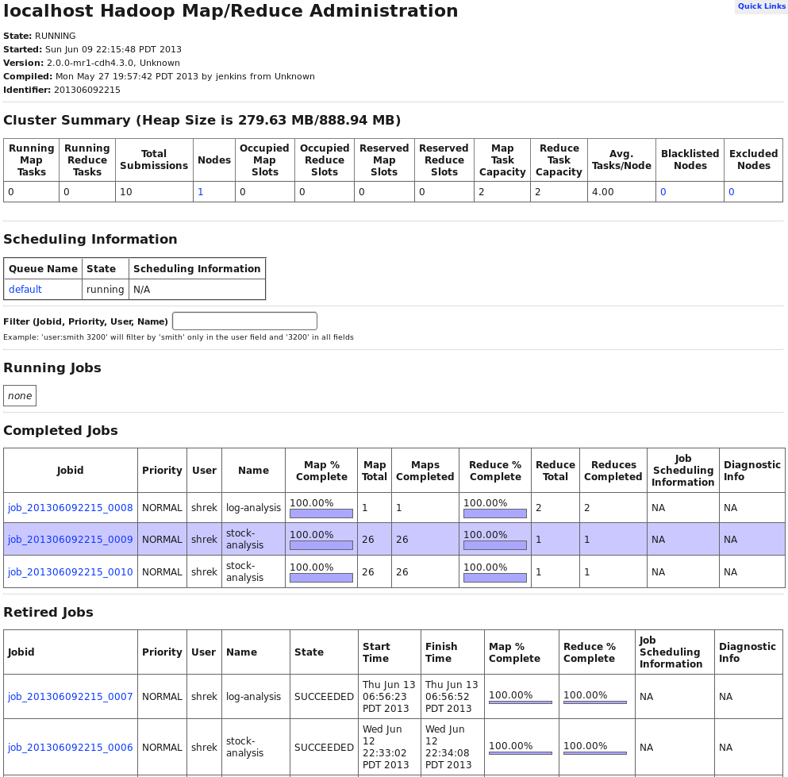

Notice that the jobs are categorized under three sections: Running jobs, Completed jobs and Retired jobs.

Let us now run a MapReduce job and monitor it while it is running.

**Step 2:** Run a MapReduce job. Type the following and immediately, go and refresh the Job Tracker page on your browser.

$ hadoop jar $HOME/Developer/heffalump/target/heffalump-1.0.jar com.hadooptraining.lab9.StockPriceAnalyzer input output

While the job is running, you’ll see an entry under running jobs:

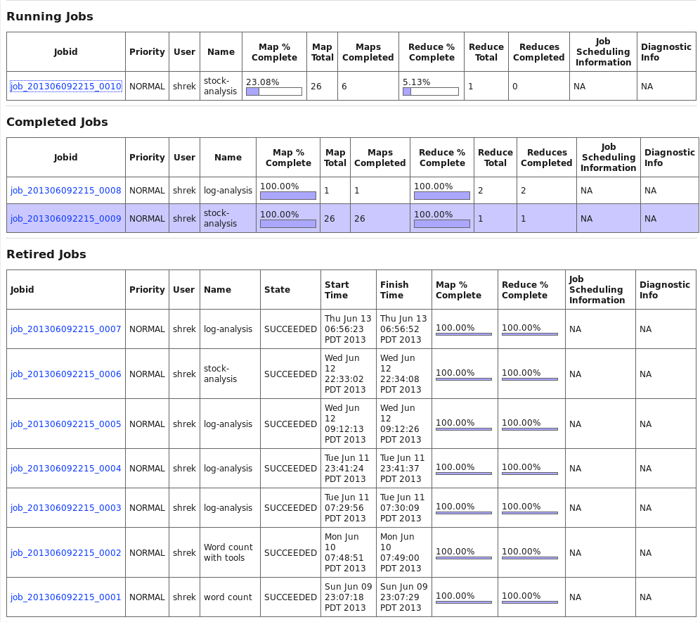

**Step 3:** Click the link under Running jobs, to find out more details about the job.

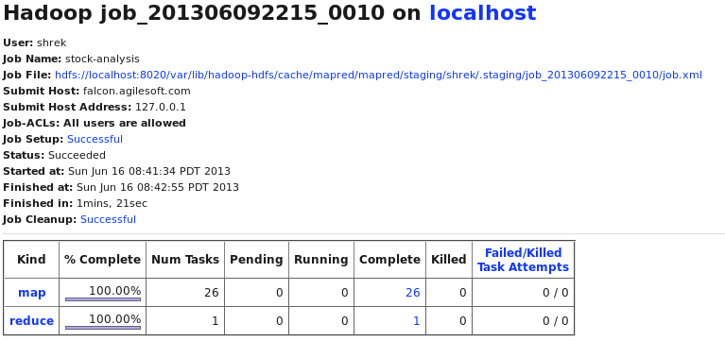

Click on the map and reduce links while the job is running. These links will not work once the job is over. Also the percentage of the map and reduce tasks changes rapidly, so you need to capture it while the job is in progress.

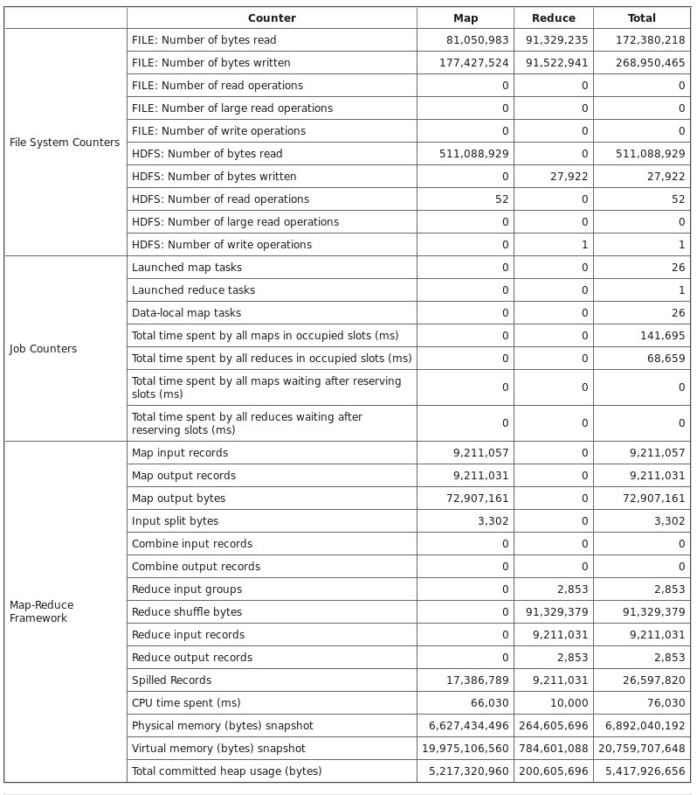

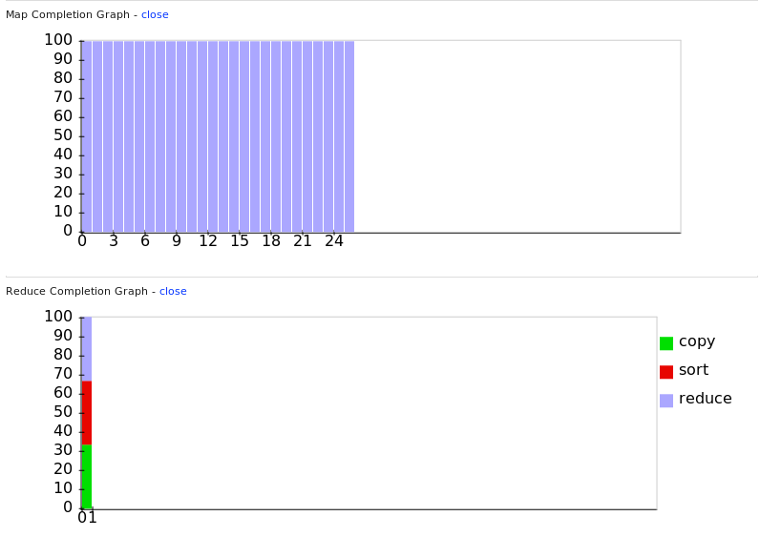

**Step 4:** Analyze the map task and the reduce task by clicking on the blue link **map** and **reduce** on the job detail page.

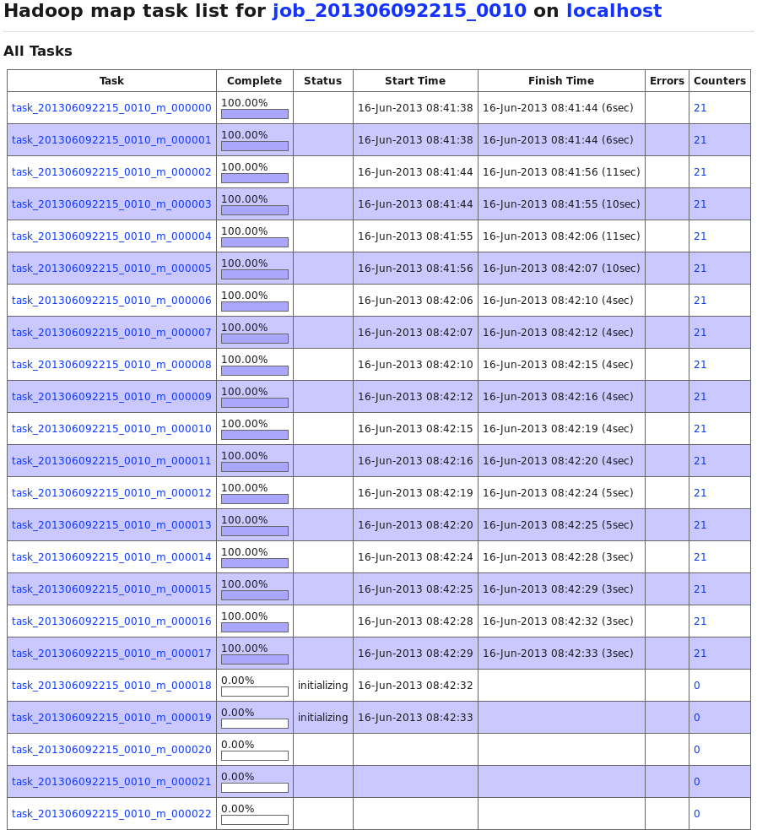

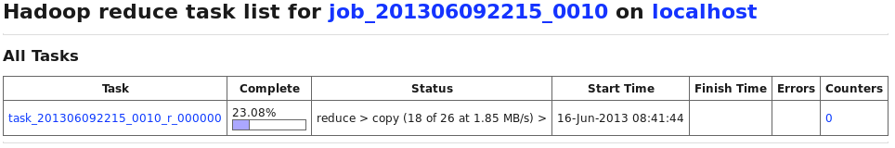

Clicking on the task id, provides more details.

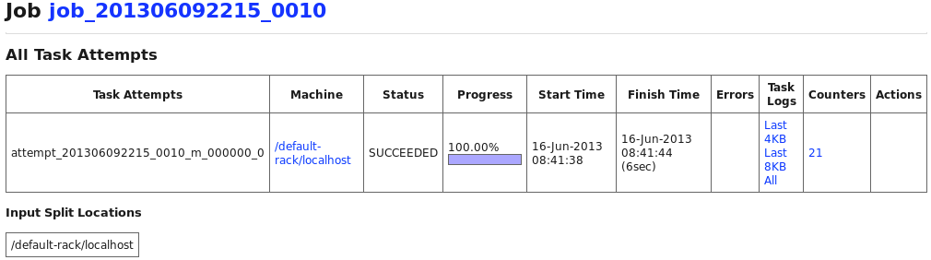

## Task 2: Deep analysis of a retired job

### Activity Procedure

**Step 1:** Go to the job tracker page <http://localhost:50030> and find a retired job. Click on the link to see more details. You’ll find something similar to the following:

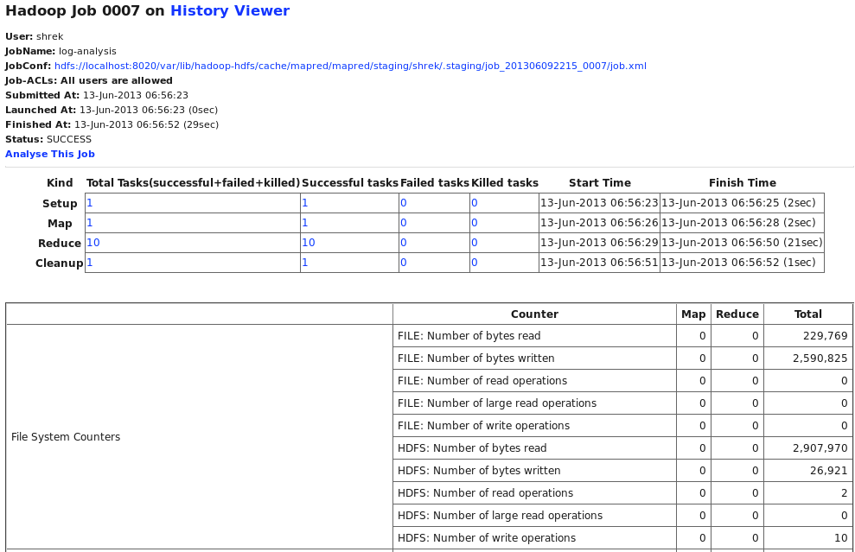

**Step 2:** Click on the JobConf link (the very first link) to see the job configuration.

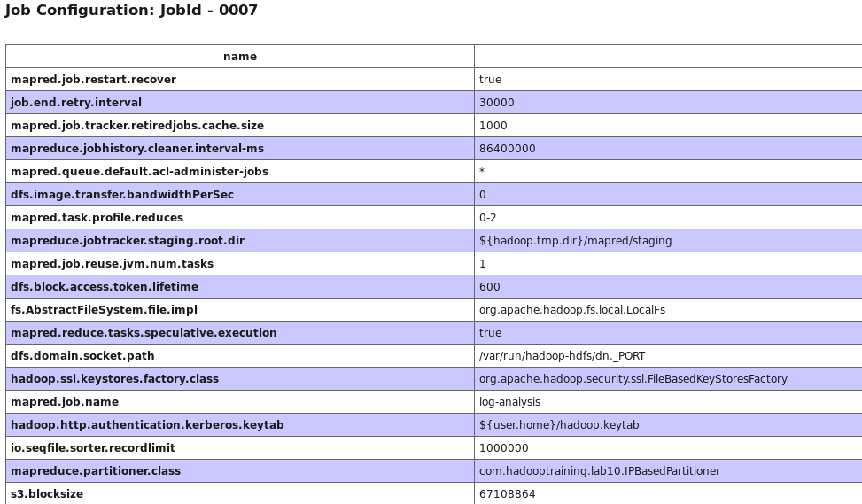

**Step 3:** Click on the link **Analyse This Job** to see the job execution details.

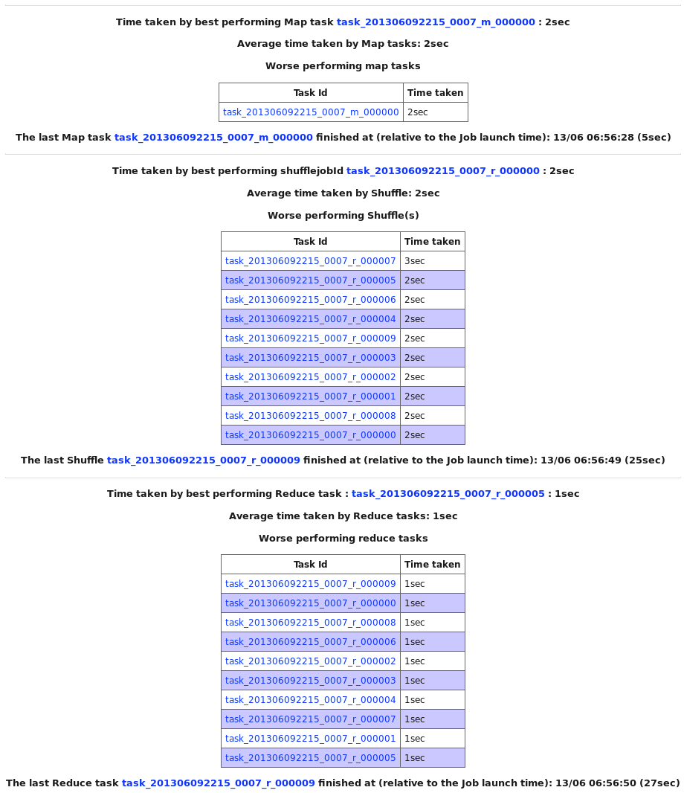

**Step 3:** Click on the link **All** under task details to see the raw log files.

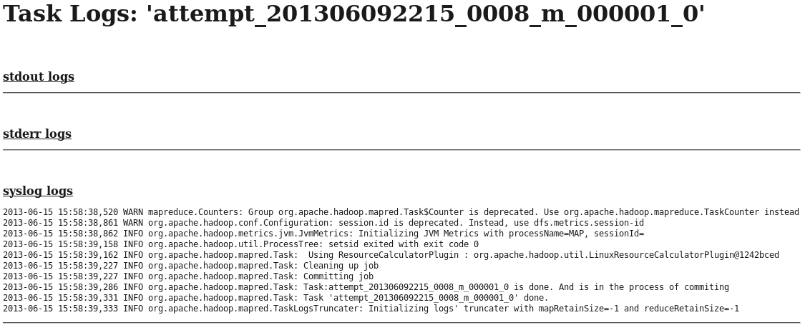

# Lab 14: Debug MapReduce code

## Description:

* Write a simple MapReduce program that uses log4j and standard error output (stderr) to debug code.
* We will reuse one of our earlier lab exercises (Lab 7) and add some debugging code in it.
* The output will be written to the file system under /var/log. We will then look up the log files and find the log messages.

## Task 1: Prepare HDFS with the appropriate data files

### Activity Procedure

**Step 1:** We will be re-doing Lab 7 - that analyzes log files using custom Writable type.

$ cd ~/Developer/heffalump

**Step 2:** Clean up the input directory in HDFS and copy the data file to HDFS.

$ hadoop fs -rm -r input

$ hadoop fs -mkdir input

$ hadoop fs -copyFromLocal -f data/NASA_access_log.txt input

## Task 2: Write the custom writable object LogWritable

Most of the code is written for you. You just need to edit the file and add a few key functions.

### Activity Procedure

**Step 1:** Edit the file containing the Mapper and Reducer class. Fill in the missing lines in the map() function below.

$ vi src/main/java/com/hadooptraining/lab14/LogProcessorWithDebug.java

Fill in the missing lines in the function map() by looking up the code below.

public void map(LongWritable key, Text value, Context context)

throws IOException, InterruptedException {

// prepare the log pattern string

String logEntryPattern = "^(\\S+) (\\S+) (\\S+) \\[([\\w:/]+\\s[+\\-]\\d{4})\\] \"(.+?)\" (\\d{3}) (\\d+)";

// Example: unicomp6.unicomp.net - - [01/Jul/1995:00:00:14 -0400] "GET /shuttle/countdown/count.gif HTTP/1.0" 200 40310

// Compile the pattern and keep it in a local variable

Pattern p = Pattern.compile(logEntryPattern);

Matcher matcher = p.matcher(value.toString());

// if line in log file did not match, get out of the mapper method

if (!matcher.matches()) {

System.err.println("Bad record found: " + value.toString());

return;

}

// Set the KEY of the mapper by using one of the extracted values from log line

userHostText.set(matcher.group(1));

// Set the VALUE of the mapper by using other extracted values from log line

logValue.set(matcher.group(1), matcher.group(4), matcher.group(5), Integer.parseInt(matcher.group(7)), Integer.parseInt(matcher.group(6)));

// Print out some values to the console for debugging purposes

System.out.println("Host: " + userHostText.toString() + "\t\tbytes read: " + logValue.getResponseSize());

// Write the key and value to the context object

context.write(userHostText, logValue);

}

}

Next fill in the missing lines in the function reduce() by looking up the code below.

public void reduce(Text key, Iterable<LogWritable> values, Context context)

throws IOException, InterruptedException {

// Create a local variable to store the sum

int sum = 0;

// Iterate through each value received

for (LogWritable logLine : values) {

// extract the response size and add it up

sum += logLine.getResponseSize().get();

}

// Set the value of the output as calculated sum

result.set(sum);

// Send some diagnostic messages to the log4j logger

logger.info("[" + key.toString() + "] -> " + result.toString());

// Write to the context object

context.write(key, result);

}

}

## Task 3: Compile and run the MapReduce job

### Activity Procedure

**Step 1:** Compile the program through Maven and create a package.

$ cd ~/Developer/heffalump

$ mvn package

**Step 2:** Run the MapReduce job.

$ hadoop jar $HOME/Developer/heffalump/target/heffalump-1.0.jar com.hadooptraining.lab14.LogProcessorWithDebug input output

### Activity Verification

As the job runs, you’ll see output on the screen that looks similar to the following:

13/06/16 12:28:11 WARN mapred.JobClient: Use GenericOptionsParser for parsing the arguments. Applications should implement Tool for the same.

13/06/16 12:28:11 INFO input.FileInputFormat: Total input paths to process : 1

13/06/16 12:28:12 INFO mapred.JobClient: Running job: job_201306092215_0012

13/06/16 12:28:13 INFO mapred.JobClient: map 0% reduce 0%

13/06/16 12:28:19 INFO mapred.JobClient: map 100% reduce 0%

13/06/16 12:28:22 INFO mapred.JobClient: map 100% reduce 100%

13/06/16 12:28:23 INFO mapred.JobClient: Job complete: job_201306092215_0012

13/06/16 12:28:23 INFO mapred.JobClient: Counters: 32

13/06/16 12:28:23 INFO mapred.JobClient: File System Counters

13/06/16 12:28:23 INFO mapred.JobClient: FILE: Number of bytes read=1433238

13/06/16 12:28:23 INFO mapred.JobClient: FILE: Number of bytes written=3254351

13/06/16 12:28:23 INFO mapred.JobClient: FILE: Number of read operations=0

13/06/16 12:28:23 INFO mapred.JobClient: FILE: Number of large read operations=0

13/06/16 12:28:23 INFO mapred.JobClient: FILE: Number of write operations=0

13/06/16 12:28:23 INFO mapred.JobClient: HDFS: Number of bytes read=1290522

13/06/16 12:28:23 INFO mapred.JobClient: HDFS: Number of bytes written=29137

13/06/16 12:28:23 INFO mapred.JobClient: HDFS: Number of read operations=2

13/06/16 12:28:23 INFO mapred.JobClient: HDFS: Number of large read operations=0

13/06/16 12:28:23 INFO mapred.JobClient: HDFS: Number of write operations=1

13/06/16 12:28:23 INFO mapred.JobClient: Job Counters

13/06/16 12:28:23 INFO mapred.JobClient: Launched map tasks=1

13/06/16 12:28:23 INFO mapred.JobClient: Launched reduce tasks=1

13/06/16 12:28:23 INFO mapred.JobClient: Data-local map tasks=1

13/06/16 12:28:23 INFO mapred.JobClient: Total time spent by all maps in occupied slots (ms)=6546

13/06/16 12:28:23 INFO mapred.JobClient: Total time spent by all reduces in occupied slots (ms)=3507

13/06/16 12:28:23 INFO mapred.JobClient: Total time spent by all maps waiting after reserving slots (ms)=0

13/06/16 12:28:23 INFO mapred.JobClient: Total time spent by all reduces waiting after reserving slots (ms)=0

13/06/16 12:28:23 INFO mapred.JobClient: Map-Reduce Framework

13/06/16 12:28:23 INFO mapred.JobClient: Map input records=11676

13/06/16 12:28:23 INFO mapred.JobClient: Map output records=11552

13/06/16 12:28:23 INFO mapred.JobClient: Map output bytes=1410014

13/06/16 12:28:23 INFO mapred.JobClient: Input split bytes=123

13/06/16 12:28:23 INFO mapred.JobClient: Combine input records=0

13/06/16 12:28:23 INFO mapred.JobClient: Combine output records=0

13/06/16 12:28:23 INFO mapred.JobClient: Reduce input groups=1085

13/06/16 12:28:23 INFO mapred.JobClient: Reduce shuffle bytes=1433238

13/06/16 12:28:23 INFO mapred.JobClient: Reduce input records=11552

13/06/16 12:28:23 INFO mapred.JobClient: Reduce output records=1085

13/06/16 12:28:23 INFO mapred.JobClient: Spilled Records=23104

13/06/16 12:28:23 INFO mapred.JobClient: CPU time spent (ms)=4020

13/06/16 12:28:23 INFO mapred.JobClient: Physical memory (bytes) snapshot=413298688

13/06/16 12:28:23 INFO mapred.JobClient: Virtual memory (bytes) snapshot=1525846016

13/06/16 12:28:23 INFO mapred.JobClient: Total committed heap usage (bytes)=317128704

However, the intent of this exercise is to see the debug log output written by the logger and println() statements.

## Task 4: Look at debug logs on the file system

### Activity Procedure

**Step 1:** The debug logs are generally under /var/log which can only be accessed by root user. Type the following to become root user. Your instructor will tell you the password.

$ su -

$ cd /var/log/hadoop-0.20-mapreduce/userlogs

$ ls -lrt

### Activity Verification

You’ll see a listing similar to the following.

total 20

drwx--x---. 2 mapred mapred 4096 Jun 15 15:58 job_201306092215_0008

drwx--x---. 2 mapred mapred 4096 Jun 15 17:59 job_201306092215_0009

drwx--x---. 2 mapred mapred 4096 Jun 16 08:42 job_201306092215_0010

drwx--x---. 2 mapred mapred 4096 Jun 16 09:11 job_201306092215_0011

drwx--x---. 2 mapred mapred 4096 Jun 16 12:28 job_201306092215_0012

Select the last one in this list and change directory to that job.

$ cd job_201306092215_0012

$ ls -lrt

lrwxrwxrwx. 1 mapred mapred 114 Jun 16 12:28 attempt_201306092215_0012_m_000002_0 -> /var/lib/hadoop-hdfs/cache/mapred/mapred/local/userlogs/job_201306092215_0012/attempt_201306092215_0012_m_000002_0

lrwxrwxrwx. 1 mapred mapred 114 Jun 16 12:28 attempt_201306092215_0012_m_000000_0 -> /var/lib/hadoop-hdfs/cache/mapred/mapred/local/userlogs/job_201306092215_0012/attempt_201306092215_0012_m_000000_0

lrwxrwxrwx. 1 mapred mapred 114 Jun 16 12:28 attempt_201306092215_0012_r_000000_0 -> /var/lib/hadoop-hdfs/cache/mapred/mapred/local/userlogs/job_201306092215_0012/attempt_201306092215_0012_r_000000_0

lrwxrwxrwx. 1 mapred mapred 114 Jun 16 12:28 attempt_201306092215_0012_m_000001_0 -> /var/lib/hadoop-hdfs/cache/mapred/mapred/local/userlogs/job_201306092215_0012/attempt_201306092215_0012_m_000001_0

You’ll notice that these are soft links to the folders for each of the jobs. There are three map jobs and one reduce job in the listing above. Those marked with _m_are map jobs while those markes with _r_ are reduce jobs. Change directory to one to the map jobs.

$ cd attempt_201306092215_0012_m_000001_0

$ ls -lrt

total 528

-rw-r--r--. 1 mapred mapred 15060 Jun 16 12:28 stderr

-rw-r--r--. 1 mapred mapred 512927 Jun 16 12:28 stdout

-rw-r--r--. 1 mapred mapred 1805 Jun 16 12:28 syslog

-rw-r--r--. 1 mapred mapred 143 Jun 16 12:28 log.index

Finally you will see the stderr and stdout log files here. Look at the files using less command.

$ less stderr

Bad record found: dd15-062.compuserve.com - - [01/Jul/1995:00:01:12 -0400] "GET /news/sci.space.shuttle/archive/sci-space-shuttle-22-apr-1995-40.txt HTTP/1.0" 404 -

Bad record found: dynip42.efn.org - - [01/Jul/1995:00:02:14 -0400] "GET /software HTTP/1.0" 302 -

Bad record found: ix-or10-06.ix.netcom.com - - [01/Jul/1995:00:02:40 -0400] "GET /software/winvn HTTP/1.0" 302 -

Bad record found: ix-or10-06.ix.netcom.com - - [01/Jul/1995:00:03:24 -0400] "GET /software HTTP/1.0" 302 -

Bad record found: link097.txdirect.net - - [01/Jul/1995:00:05:06 -0400] "GET /shuttle HTTP/1.0" 302 -

Bad record found: ix-war-mi1-20.ix.netcom.com - - [01/Jul/1995:00:05:13 -0400] "GET /shuttle/missions/sts-78/news HTTP/1.0" 302 -

Type ‘q’ to get out of less.

$ less stdout

Host: 199.72.81.55 bytes read: 6245

Host: unicomp6.unicomp.net bytes read: 3985

Host: 199.120.110.21 bytes read: 4085

Host: burger.letters.com bytes read: 0

Host: 199.120.110.21 bytes read: 4179

Host: burger.letters.com bytes read: 0

Host: burger.letters.com bytes read: 0

Host: 205.212.115.106 bytes read: 3985

Host: d104.aa.net bytes read: 3985

Host: 129.94.144.152 bytes read: 7074

Type ‘q’ to get out of less. Now change directory to the reduce task.

$cd attempt_201306092215_0012_r_000001_0

$ ls -lrt

total 124

-rw-r--r--. 1 mapred mapred 0 Jun 16 12:28 stdout

-rw-r--r--. 1 mapred mapred 0 Jun 16 12:28 stderr

-rw-r--r--. 1 mapred mapred 122156 Jun 16 12:28 syslog

-rw-r--r--. 1 mapred mapred 143 Jun 16 12:28 log.index

Your log4j output can be found in the syslog file.

$ less syslog

2013-06-16 12:28:18,398 WARN mapreduce.Counters: Group org.apache.hadoop.mapred.Task$Counter is deprecated. Use org.apache.hadoop.mapreduce.TaskCounter instead

2013-06-16 12:28:18,745 WARN org.apache.hadoop.conf.Configuration: session.id is deprecated. Instead, use dfs.metrics.session-id

2013-06-16 12:28:18,746 INFO org.apache.hadoop.metrics.jvm.JvmMetrics: Initializing JVM Metrics with processName=SHUFFLE, sessionId=

2013-06-16 12:28:19,036 INFO org.apache.hadoop.util.ProcessTree: setsid exited with exit code 0

2013-06-16 12:28:19,040 INFO org.apache.hadoop.mapred.Task: Using ResourceCalculatorPlugin : org.apache.hadoop.util.LinuxResourceCalculatorPlugin@2c97c9cf

2013-06-16 12:28:19,108 INFO org.apache.hadoop.mapred.ReduceTask: Using ShuffleConsumerPlugin: org.apache.hadoop.mapred.ReduceTask$ReduceCopier

2013-06-16 12:28:19,113 INFO org.apache.hadoop.mapred.ReduceTask: ShuffleRamManager: MemoryLimit=130514944, MaxSingleShuffleLimit=32628736

2013-06-16 12:28:19,121 INFO org.apache.hadoop.mapred.ReduceTask: attempt_201306092215_0012_r_000000_0 Thread started: Thread for merging on-disk files

2013-06-16 12:28:19,121 INFO org.apache.hadoop.mapred.ReduceTask: attempt_201306092215_0012_r_000000_0 Thread started: Thread for merging in memory files

2013-06-16 12:28:19,121 INFO org.apache.hadoop.mapred.ReduceTask: attempt_201306092215_0012_r_000000_0 Thread waiting: Thread for merging on-disk files

2013-06-16 12:28:19,123 INFO org.apache.hadoop.mapred.ReduceTask: attempt_201306092215_0012_r_000000_0 Need another 1 map output(s) where 0 is already in progress

2013-06-16 12:28:19,123 INFO org.apache.hadoop.mapred.ReduceTask: attempt_201306092215_0012_r_000000_0 Thread started: Thread for polling Map Completion Events

2013-06-16 12:28:19,123 INFO org.apache.hadoop.mapred.ReduceTask: attempt_201306092215_0012_r_000000_0 Scheduled 0 outputs (0 slow hosts and0 dup hosts)

2013-06-16 12:28:19,127 INFO org.apache.hadoop.mapred.ReduceTask: attempt_201306092215_0012_r_000000_0 Scheduled 1 outputs (0 slow hosts and0 dup hosts)

2013-06-16 12:28:19,302 INFO org.apache.hadoop.mapred.ReduceTask: GetMapEventsThread exiting

2013-06-16 12:28:19,303 INFO org.apache.hadoop.mapred.ReduceTask: getMapsEventsThread joined.

2013-06-16 12:28:19,303 INFO org.apache.hadoop.mapred.ReduceTask: Closed ram manager

2013-06-16 12:28:19,303 INFO org.apache.hadoop.mapred.ReduceTask: Interleaved on-disk merge complete: 0 files left.

2013-06-16 12:28:19,303 INFO org.apache.hadoop.mapred.ReduceTask: In-memory merge complete: 1 files left.

2013-06-16 12:28:19,333 INFO org.apache.hadoop.mapred.Merger: Merging 1 sorted segments

2013-06-16 12:28:19,334 INFO org.apache.hadoop.mapred.Merger: Down to the last merge-pass, with 1 segments left of total size: 1433234 bytes

2013-06-16 12:28:19,484 INFO org.apache.hadoop.mapred.ReduceTask: Merged 1 segments, 1433234 bytes to disk to satisfy reduce memory limit

2013-06-16 12:28:19,484 INFO org.apache.hadoop.mapred.ReduceTask: Merging 1 files, 1433238 bytes from disk

2013-06-16 12:28:19,485 INFO org.apache.hadoop.mapred.ReduceTask: Merging 0 segments, 0 bytes from memory into reduce

2013-06-16 12:28:19,485 INFO org.apache.hadoop.mapred.Merger: Merging 1 sorted segments

2013-06-16 12:28:19,487 INFO org.apache.hadoop.mapred.Merger: Down to the last merge-pass, with 1 segments left of total size: 1433234 bytes

2013-06-16 12:28:19,538 INFO com.hadooptraining.lab14.LogProcessorWithDebug: [128.187.140.171] -> 60655

2013-06-16 12:28:19,540 INFO com.hadooptraining.lab14.LogProcessorWithDebug: [129.188.154.200] -> 1607516

2013-06-16 12:28:19,540 INFO com.hadooptraining.lab14.LogProcessorWithDebug: [129.193.116.41] -> 46353

2013-06-16 12:28:19,540 INFO com.hadooptraining.lab14.LogProcessorWithDebug: [129.59.205.2] -> 109598

2013-06-16 12:28:19,540 INFO com.hadooptraining.lab14.LogProcessorWithDebug: [129.79.164.64] -> 1037740

2013-06-16 12:28:19,540 INFO com.hadooptraining.lab14.LogProcessorWithDebug: [129.94.144.152] -> 321543

2013-06-16 12:28:19,541 INFO com.hadooptraining.lab14.LogProcessorWithDebug: [130.161.103.176] -> 143215

Remember to type ‘q’ to get out of less. The lines at the bottom are coming from the code that we introduced in our program.

## Task 5: Get out of superuser mode

### Activity Procedure

**Step 1:** Since you are seeing these logs as superuser, you need to get out of it and become a normal user for your next exercise.

$ exit

# Lab 15: Practice MapReduce use-case

## Description:

* You will be asked to analyze a fairly large set of statistics - batching and pitching records of baseball players since 1871.
* This lab has two parts:
* In **part A**, you will be writing a MapReduce application that will determine the total number of runs allowed by a pitcher in their lifetime.
* In **part B**, you will be calculating the runs made in each year since baseball records are available.
* Using this data, you will find out the year in recent history when the highest runs were scored.
* Instructions for this lab are intentionally kept at a minimum - for your practice.
* You can download baseball statistics data from <http://seanlahman.com>

## Task 1: Open the input data for Part A, analyze it and copy it to HDFS

### Activity Procedure

**Step 1:** Go to the location of the source code for the labs. Inspect the data file for part A of this exercise. In the first part you will be calculating the lifetime runs allowed by a pitcher.

$ cd ~/Developer/heffalump

$ less data/baseballstats/Pitching.csv

Notice that the pitching data is in the following format:

PITCHING TABLE

==============

1 playerID Player ID code

2 yearID Year

3 stint player's stint (order of appearances within a season)

4 teamID Team

5 lgID League

6 W Wins

7 L Losses

8 G Games

9 GS Games Started

10 CG Complete Games

11 SHO Shutouts

12 SV Saves

13 IPOuts Outs Pitched (innings pitched x 3)

14 H Hits

15 ER Earned Runs

16 HR Homeruns

17 BB Walks

18 SO Strikeouts

19 BAOpp Opponent's Batting Average

20 ERA Earned Run Average

21 IBB Intentional Walks

22 WP Wild Pitches

23 HBP Batters Hit By Pitch

24 BK Balks

25 BFP Batters faced by Pitcher

26 GF Games Finished

27 R Runs Allowed

28 SH Sacrifices by opposing batters

29 SF Sacrifice flies by opposing batters

30 GIDP Grounded into double plays by opposing batter

**Step 2:** Clean up the input directory in HDFS and copy the data file to HDFS.

$ hadoop fs -rm -r input

$ hadoop fs -mkdir input

$ hadoop fs -copyFromLocal -f data/baseballstats/Pitching.csv input

$ hadoop fs -ls input

## Task 2: Write the custom writable object for storing Pitching data

You can use Lab 7 as your base for the LogWritable object. Instructions below are minimal.

### Activity Procedure

**Step 1:** Edit the file containing the custom writable object PitchingWritable.

$ vi src/main/java/com/hadooptraining/lab15/PitchingWritable.java

Fill in the missing lines below.

public class PitchingWritable implements Writable {

private Text playerID, year;

private IntWritable runsAllowed;

public PitchingWritable() {

// TODO

}

public void set (String playerID, String year, int runsAllowed) {

// TODO

}

@Override

public void readFields(DataInput in) throws IOException {

// TODO

}

@Override

public void write(DataOutput out) throws IOException {

// TODO

}

public int hashCode() {

// TODO

}

public Text getPlayerID() {

// TODO

}

public Text getYear() {

// TODO

}

public IntWritable getRunsAllowed() {

// TODO

}

}

## Task 3: Write the Mapper and Reducer class

### Activity Procedure

**Step 1:** Edit the file containing the Mapper and Reducer class. Fill in the missing lines in the map() and reduce() functions below.

$ vi src/main/java/com/hadooptraining/lab15/PitchingDataProcessor.java

Fill in the missing functions below.

public class PitchingDataProcessor extends Configured implements Tool {

public static class PitchingDataProcessorMap extends

Mapper<LongWritable, Text, Text, PitchingWritable> {

private Text playerIDText = new Text();

private PitchingWritable pitchingValue = new PitchingWritable();

/**

* Mapper class using 'playerID' as key and 'PitchingWritable' as VALUE.

*/

public void map(LongWritable key, Text value, Context context)

throws IOException, InterruptedException {

// TODO

}

}

public static class PitchingDataProcessorReduce extends

Reducer<Text, PitchingWritable, Text, IntWritable> {

private IntWritable result = new IntWritable();

public void reduce(Text key, Iterable<PitchingWritable> values, Context context)

throws IOException, InterruptedException {

// TODO

}

}

@Override

public int run(String[] args) throws Exception {

if (args.length < 2) {

System.err.println("Usage: <input_path> <output_path>");

System.exit(-1);

}

Job job = Job.getInstance(getConf(), "pitching-analysis");

job.setJarByClass(PitchingDataProcessor.class);

job.setMapperClass(PitchingDataProcessorMap.class);

job.setReducerClass(PitchingDataProcessorReduce.class);

job.setMapOutputKeyClass(Text.class);

job.setMapOutputValueClass(PitchingWritable.class);

job.setOutputKeyClass(Text.class);

job.setOutputValueClass(IntWritable.class);

FileInputFormat.setInputPaths(job, new Path(args[0]));

FileOutputFormat.setOutputPath(job, new Path(args[1]));

return job.waitForCompletion(true) ? 0 : 1;

}

public static void main(String[] args) throws Exception {

int res = ToolRunner.run(new Configuration(), new PitchingDataProcessor(), args);

System.exit(res);

}

## Task 4: Compile and run the MapReduce job

### Activity Procedure

**Step 1:** Compile the program through Maven and create a package.

$ cd ~/Developer/heffalump

$ mvn package

**Step 2:** Run the MapReduce job.

$ hadoop jar $HOME/Developer/heffalump/target/heffalump-1.0.jar com.hadooptraining.lab15.PitchingDataProcessor input output

### Activity Verification

As the job runs, you’ll see familiar output on the screen.

Your output will look like:

$ hadoop fs -cat output/part-r-00000

aardsda01 132

aasedo01 503

abadfe01 51

abbeybe01 442

abbeych01 3

abbotda01 14

abbotgl01 707

Confirm the number of lines in your output by checking the following:

$ hadoop fs -cat output/part-r-00000 | wc -l

8673

## Task 5: Open the input data for Part B, analyze it and copy it to HDFS

### Activity Procedure

**Step 1:** Go to the location of the source code for the labs. Inspect the data file for part B of this exercise. In the second part you will be calculating the total runs made each year in baseball since it started.

$ cd ~/Developer/heffalump

$ less data/baseballstats/Batting.csv

Notice that the batting data is in the following format:

Batting TABLE

=============

1 playerID Player ID code

2 yearID Year

3 stint player's stint (order of appearances within a season)

4 teamID Team

5 lgID League

6 G Games

7 G_batting Game as batter

8 AB At Bats

9 R Runs

10 H Hits

11 2B Doubles

12 3B Triples

13 HR Homeruns

14 RBI Runs Batted In

15 SB Stolen Bases

16 CS Caught Stealing

17 BB Base on Balls

18 SO Strikeouts

19 IBB Intentional walks

20 HBP Hit by pitch

21 SH Sacrifice hits

22 SF Sacrifice flies

23 GIDP Grounded into double plays

24 G_Old Old version of games (deprecated)

**Step 2:** Clean up the input directory in HDFS and copy the data file to HDFS.

$ hadoop fs -rm -r input

$ hadoop fs -mkdir input

$ hadoop fs -copyFromLocal -f data/baseballstats/Batting.csv input

$ hadoop fs -ls input

## Task 6: Write the custom writable object for storing Batting data

You can use the previous class you wrote PitchingWritable as your base for the BattingWritable class.

### Activity Procedure

**Step 1:** Edit the file containing the custom writable object BattingWritable.

$ vi src/main/java/com/hadooptraining/lab15/BattingWritable.java

Fill in the missing lines below.

public class BattingWritable implements Writable {

private Text playerID, year;

private IntWritable runs;

public BattingWritable() {

// TODO

}

public void set (String playerID, String year, int runsAllowed) {

// TODO

}

@Override

public void readFields(DataInput in) throws IOException {

// TODO

}

@Override

public void write(DataOutput out) throws IOException {

// TODO

}

public int hashCode() {

// TODO

}

public Text getPlayerID() {

// TODO

}

public Text getYear() {

// TODO

}

public IntWritable getRuns() {

// TODO

}

}

## Task 7: Write the Mapper and Reducer class

### Activity Procedure

**Step 1:** Edit the file containing the Mapper and Reducer class. Fill in the missing lines in the map() and reduce() functions below.

$ vi src/main/java/com/hadooptraining/lab15/BattingDataProcessor.java

Fill in the missing functions below.

public class BattingDataProcessor extends Configured implements Tool {

/**

* Mapper class using 'year' as key and 'BattingWritable' as VALUE.

*/

public static class BattingDataProcessorMap extends

Mapper<LongWritable, Text, Text, BattingWritable> {

private Text year = new Text();

private BattingWritable battingValue = new BattingWritable();

public void map(LongWritable key, Text value, Context context)

throws IOException, InterruptedException {

// Format: playerID,yearID,stint,teamID,lgID,G,G_batting,AB,R,H,2B,3B,HR,RBI,SB,CS,BB,SO,IBB,HBP,SH,SF,GIDP,G_old

String entryPattern = "^(\\S+),(\\d{4}),(\\d+),(\\S+),(\\S+),(\\d+),(\\d*),(\\d*),(\\d*),(\\d*),(\\d*),(\\d*),(\\d*),(\\d*),(\\d*),(\\d*),(\\d*),(\\d*),(\\d*),(\\d*),(\\d*),(\\d*),(\\d*),(\\d*)";

// TODO

}

}

/**

* Reducer class to add up all numbers associated with key.

*/

public static class BattingDataProcessorReduce extends

Reducer<Text, BattingWritable, Text, IntWritable> {

private IntWritable result = new IntWritable();

public void reduce(Text key, Iterable<BattingWritable> values, Context context)

throws IOException, InterruptedException {

// TODO

}

}

@Override

public int run(String[] args) throws Exception {

if (args.length < 2) {

System.err.println("Usage: <input_path> <output_path>");

System.exit(-1);

}

Job job = Job.getInstance(getConf(), "batting-analysis");

job.setJarByClass(BattingDataProcessor.class);

job.setMapperClass(BattingDataProcessorMap.class);

job.setReducerClass(BattingDataProcessorReduce.class);

job.setMapOutputKeyClass(Text.class);

job.setMapOutputValueClass(BattingWritable.class);

job.setOutputKeyClass(Text.class);

job.setOutputValueClass(IntWritable.class);

FileInputFormat.setInputPaths(job, new Path(args[0]));

FileOutputFormat.setOutputPath(job, new Path(args[1]));

return job.waitForCompletion(true) ? 0 : 1;

}

public static void main(String[] args) throws Exception {

int res = ToolRunner.run(new Configuration(), new BattingDataProcessor(), args);

System.exit(res);

}

}

## Task 8: Compile and run the MapReduce job

### Activity Procedure

**Step 1:** Compile the program through Maven and create a package.

$ cd ~/Developer/heffalump

$ mvn package

**Step 2:** Run the MapReduce job.

$ hadoop jar $HOME/Developer/heffalump/target/heffalump-1.0.jar com.hadooptraining.lab15.BattingDataProcessor input output

### Activity Verification

As the job runs, you’ll see familiar output on the screen.

Your output will look like:

$ hadoop fs -cat output/part-r-00000

1871 2659

1872 3390

1873 3580

1874 3470

1875 4234

1876 3066

1877 2040

1878 1904

1879 3409

1880 3191

...

Records for the last few years look like this:

...

1985 18216

1986 18545

1987 19883

1988 17380

1989 17405

1990 17919

1991 18127

1992 17341

1993 20864

1994 15752

1995 19554

1996 22831

1997 21604

1998 23297

1999 24691

2000 24971

2001 23199

2002 22408

2003 22978

2004 23376

2005 22325

2006 23599

2007 23322

2008 22585

2009 22419

2010 21308

2011 20808

2012 21017

Can you now answer the question about trends in the last few years? In which year was the highest cumulative score made in recent history?