**Objectives**:

Extraction, transformation, and loading is a data movement technology where we can get information from one application, store information, and move it into another area. The **Extract function** process reads information from a source database and extracts the desired subset of data. The reason for this progression is to recover all the required data from the source framework with minimum resources. **Transform process** is filters, cleanses, and prepares the extracted data using lookup tables or rules or by creating combinations with other data and converts it to the desired state. The **Loading process** is the last phase of an ETL procedure. The load function writes the resulting data. Moreover, this aides in avoiding application’s rationale and experiencing data layer. ETL tools are outlined fundamentally for integrating systems. It incorporates coordinating information from various sources or either moving the data. ETL mechanism gives live stream of system’s logic that is how data travels through various stages and integrating that information. Significant position of ETL tools is that they give ability of joining organized data with unstructured information in one mapping. Moreover, ETL is significantly easier and quicker to utilize when contrasted with the traditional methods for moving data. ETL tools contain graphical interfaces which accelerate the way toward mapping tables and segments between the source and target databases tools can gather, read and relocate data from numerous data structures and crosswise over various platforms. In addition, ETL tools are utilize operations like filtering, aggregation, reformatting, joining, sorting and merging. Moreover, the ETL tools support version control, transformation scheduling, unified metadata management and monitoring whereas some the tools are integrated with business intelligence tools. Furthermore,

the most importantly favorable position of utilizing an ETL tools is the usability. The device itself determines information sources and the guidelines for extricating and handling information, and afterward, it executes the procedure and burdens that information. This wipes out the requirement for coding in a conventional programming sense, where you need to compose the techniques and code. Moreover, ETL tools offer better utility for moving expansive volumes of information and moving them in bunches. In case of complex rules and transformations, ETL tools simplify the task and assist you with the calculations, string manipulation, data changes and integration of multiple sets of data. Beside that, ETL tools improve the access to data as it simplifies the process of extracting, transforming and loading. Enhanced access to data specifically impacts the key and operational choices that depend on data-driven facts. ETL devices likewise empower business pioneers to recover data dependent on their particular needs and take choices in like manner.

**Summarize the steps**

In this project, we experienced an SSIS undertaking and bundles to explore the usefulness and structure of these objects. We made an SSIS bundle and explore the advancement condition includes in SQL Server Data Tools (SSDT) for Integration Services. We preformed the following actions. First, **Control Flow tab**, in this model, we began working with the Control Flow assignment, utilize File System Task to move a document, and furthermore utilize Execute SQL Task to associate with a database and compose a log passage. We worked with Precedence Constraint to characterize the need and request of execution of things in the Control Flow tab. Second, we worked with The **Data Flow Tab** Which is a standout amongst the most helpful and powerful task in Control Flow is Data Flow Task. The significance of this task is for the most part since it works like the real piece of ETL, which extract date from various sources, changes it, and loads it into the destination. we experienced a case of fetching data from a CSV record that contains client data. At that point, we connected a basic change to ascertain the age of a client dependent on their birthday, lastly, we stacked the outcome set into a database table. We utilized a **Data Flow Task** with **Flat File Source,** Derived Column Transformation, and OLE DB Destination. Then we looped through csv files and we utilized the Foreach Loop container to loop through records in a directory, and after that we set the connection manager of the source file dynamically in the flat file source, and load the content of the source record into the destination database table. At that point, we write a log passage into the database with the name of the file and load date time. **Finally, we deployed the SSIS packages** into the production environment which is called SSIS catalog. SSIS catalog. SSIS inventory stores ventures, bundles, connections of factors, execution log, and numerous different sorts of sending and execution-related data that is helpful. SSIS catalog stores ventures, bundles, connections of factors, execution log, and numerous different sorts of sending and execution-related data that is helpful, in production environments. At the end we Executed the master package. **After executing the SSRS reports we saw summary of high-level information about packages and detailed information about each task and error messages if there is any.**

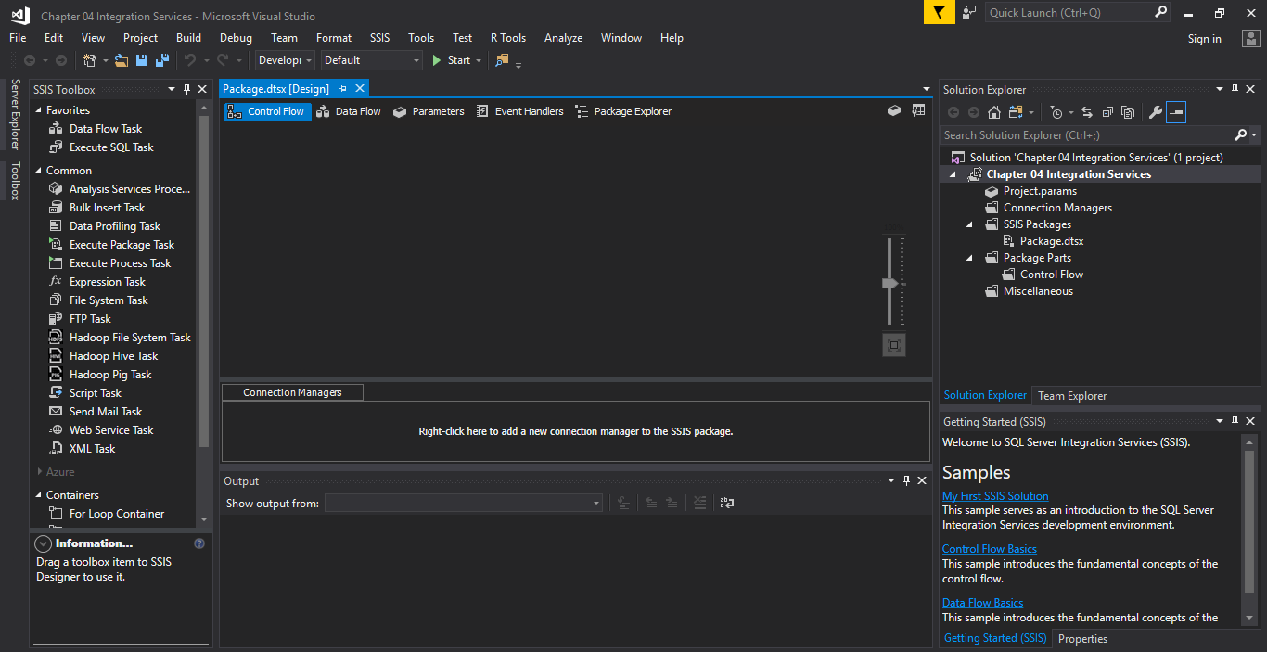

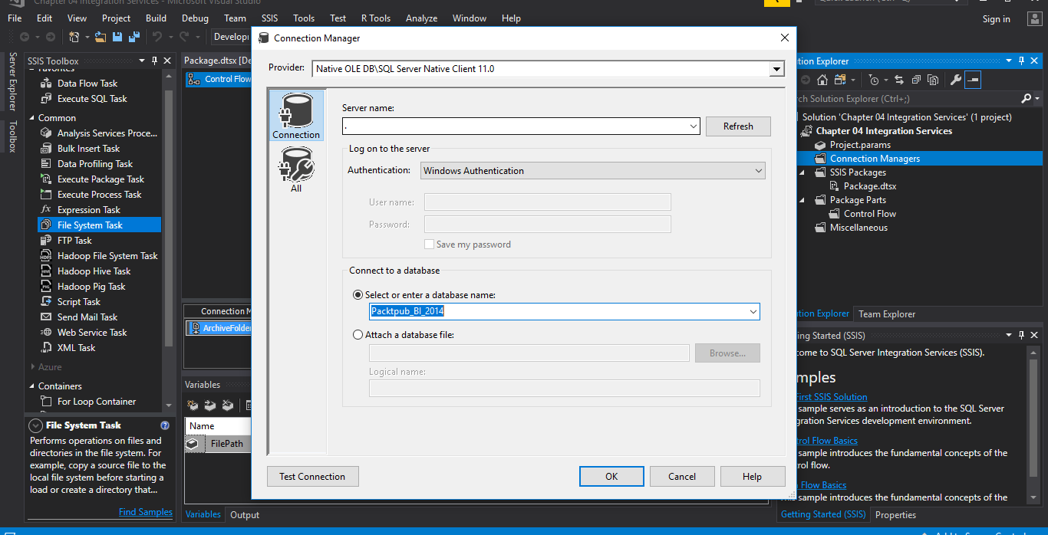

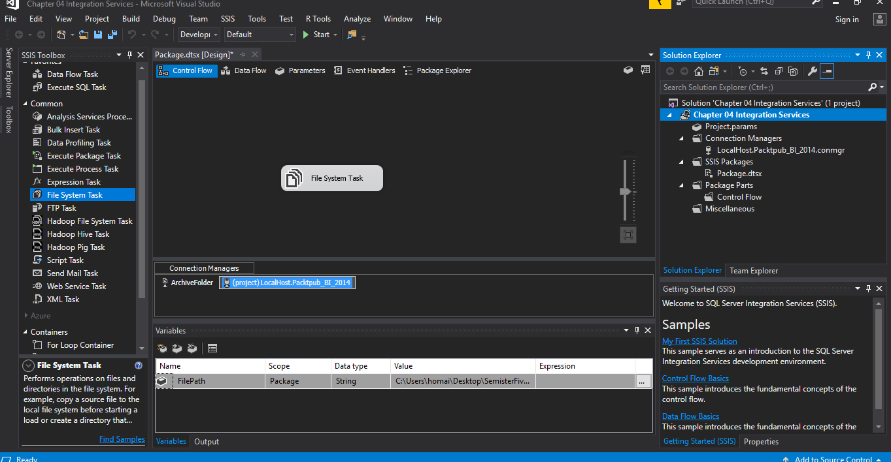

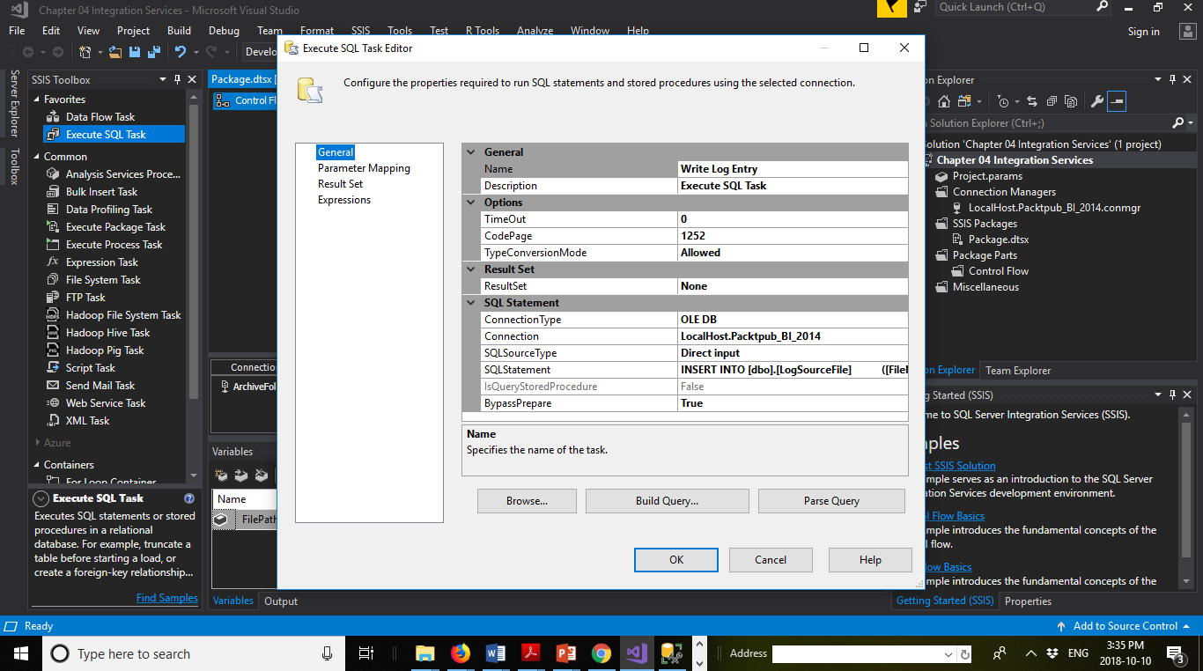

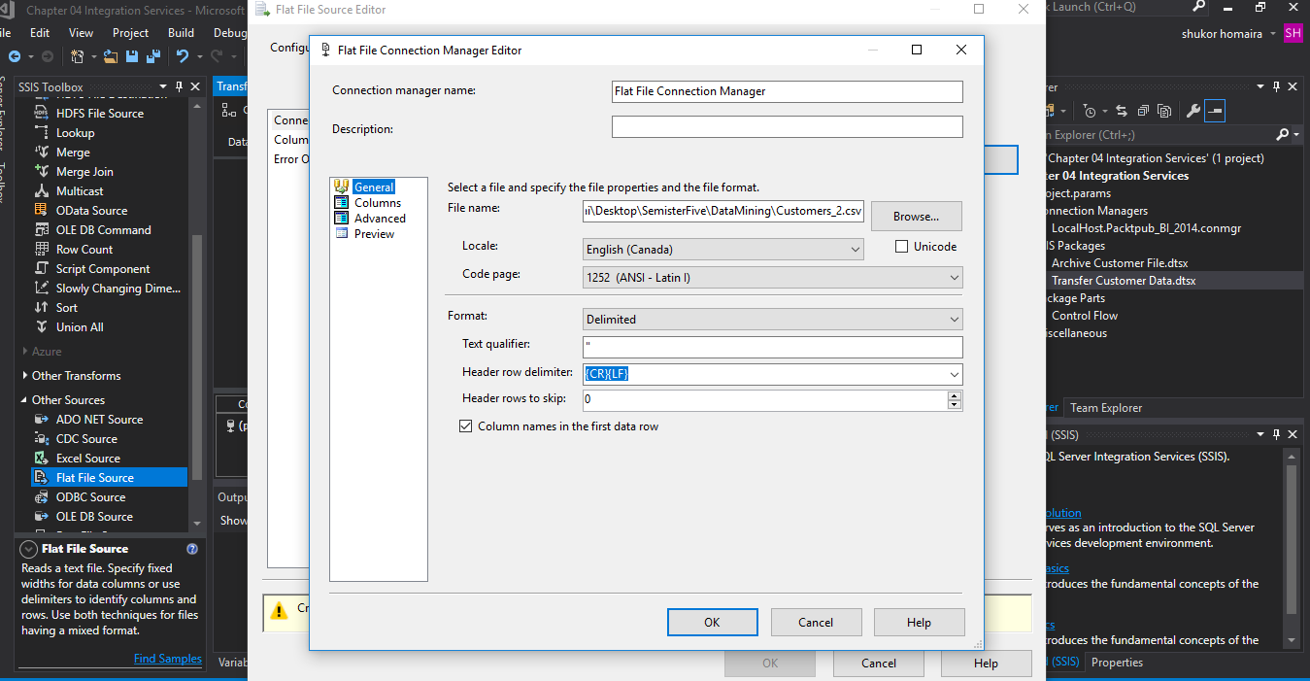

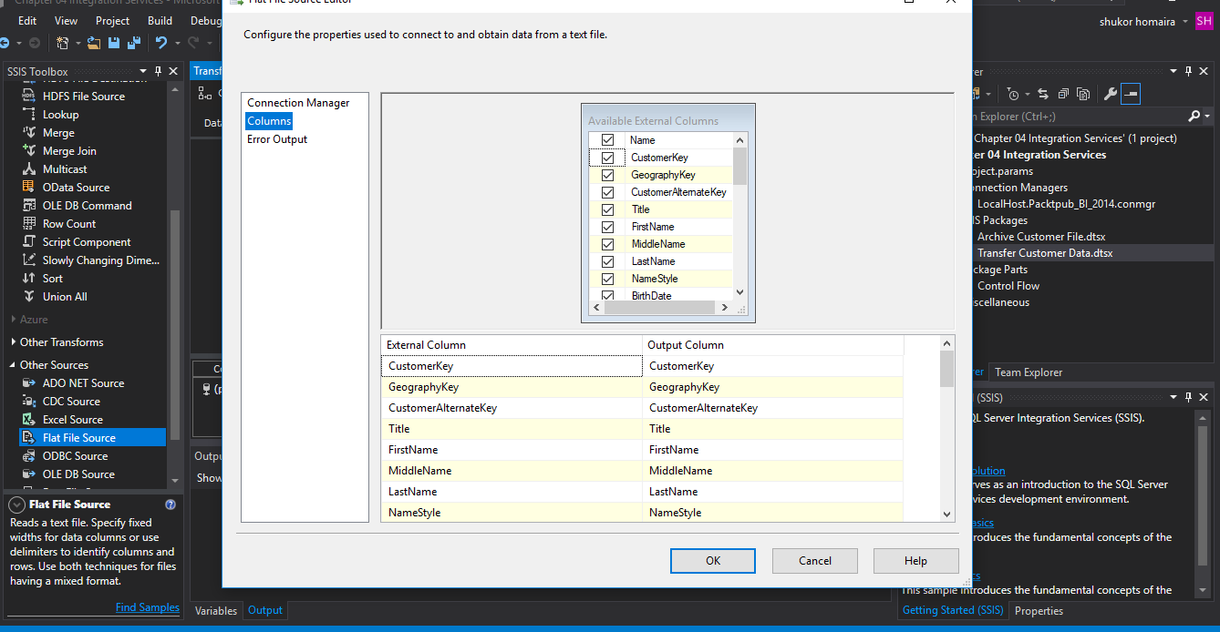

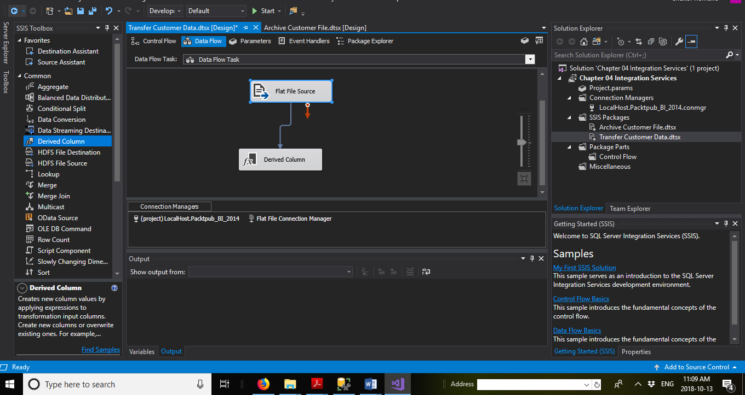

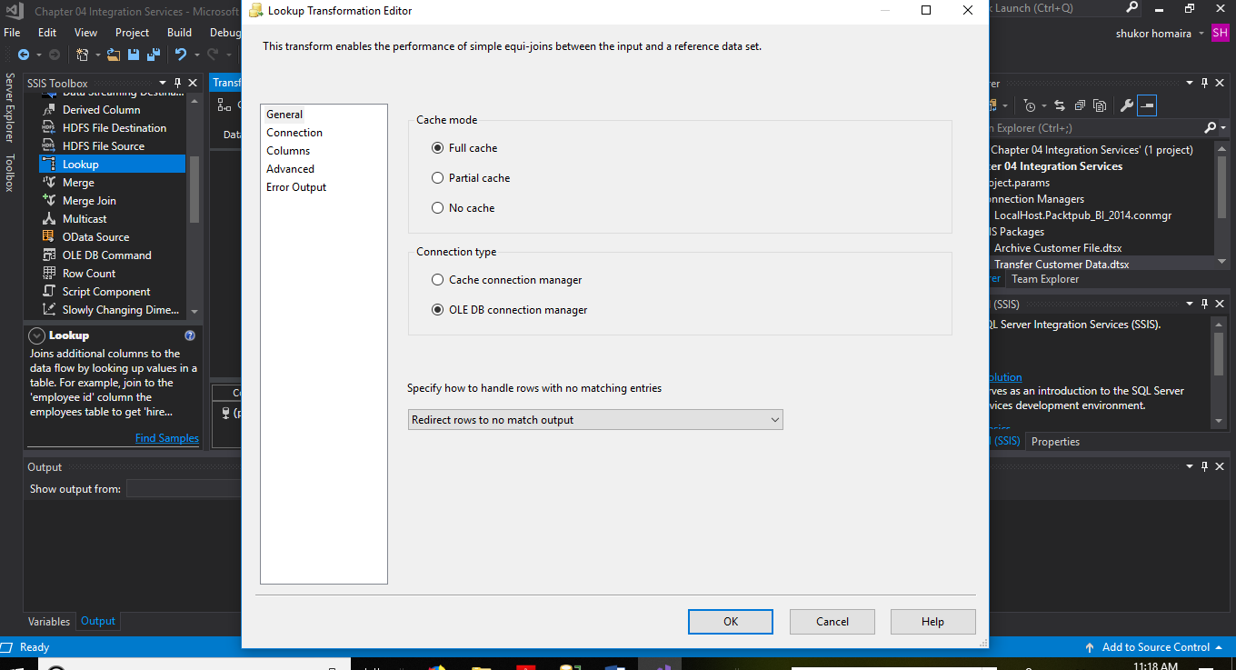

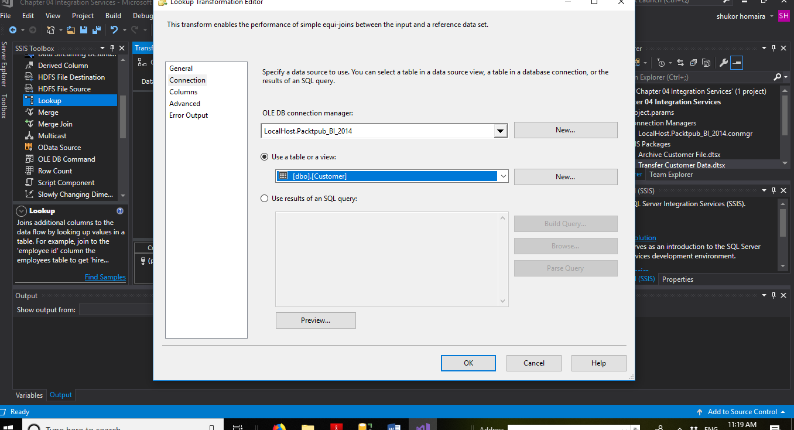

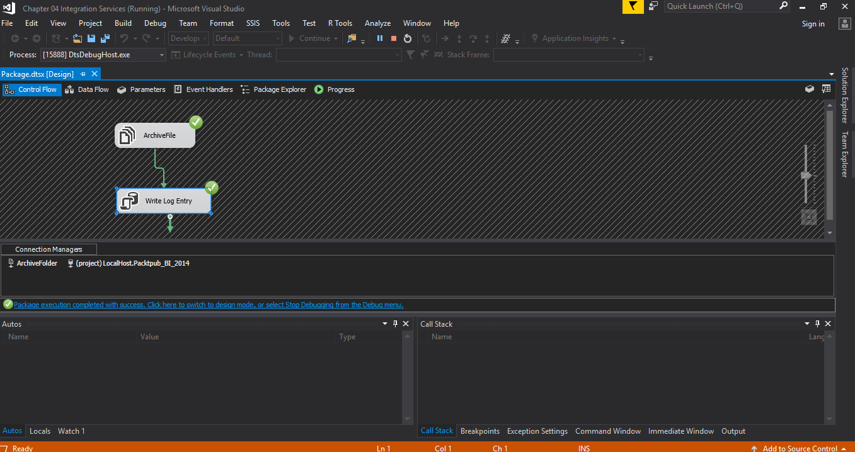

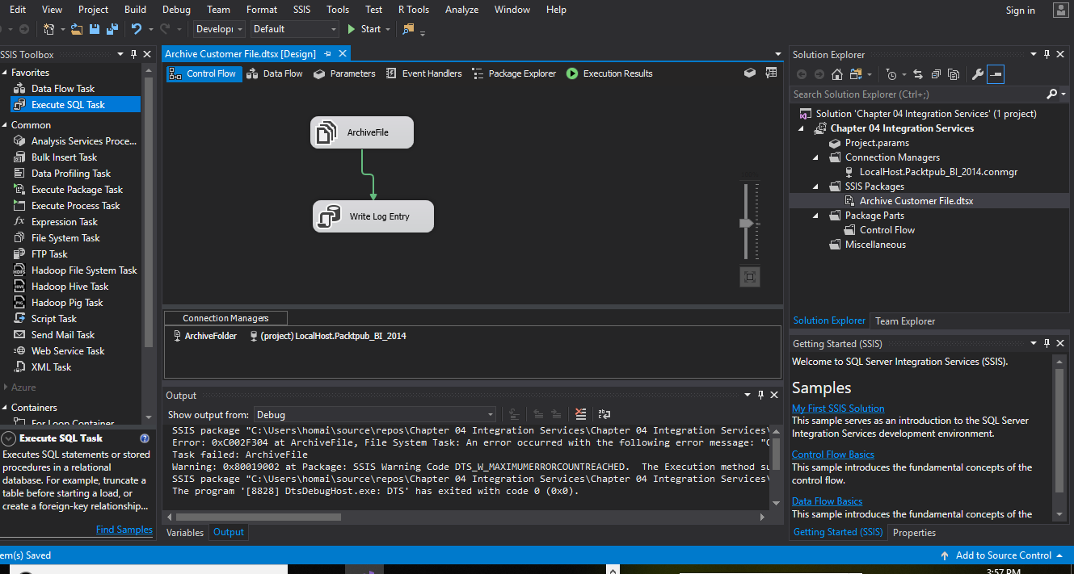

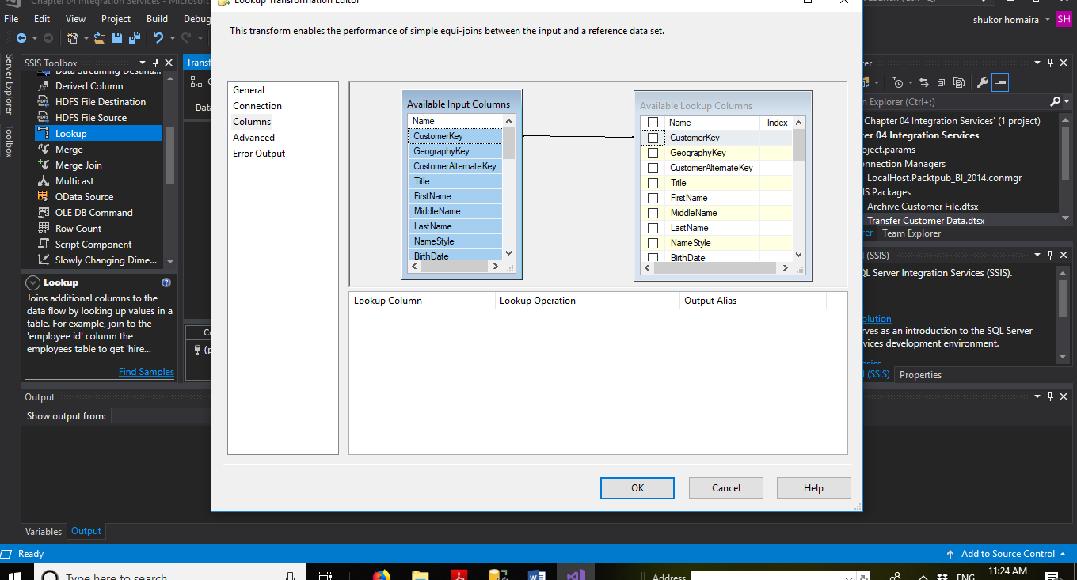

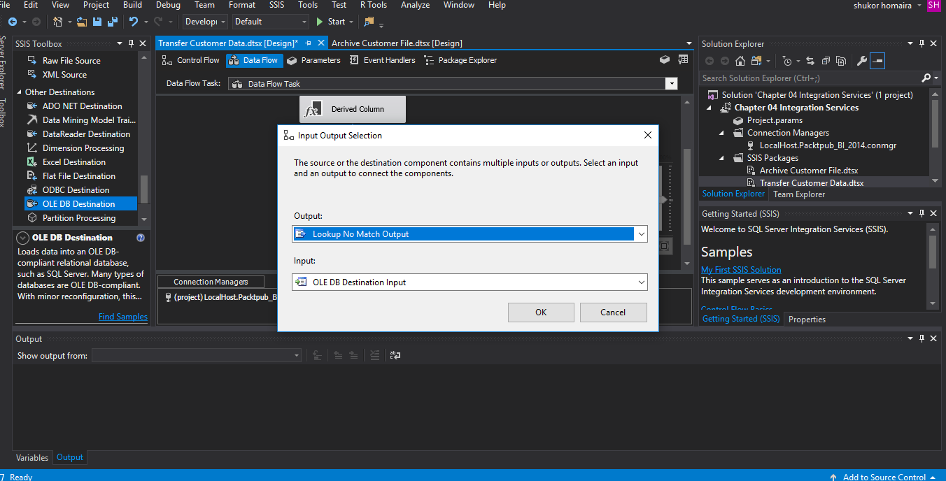

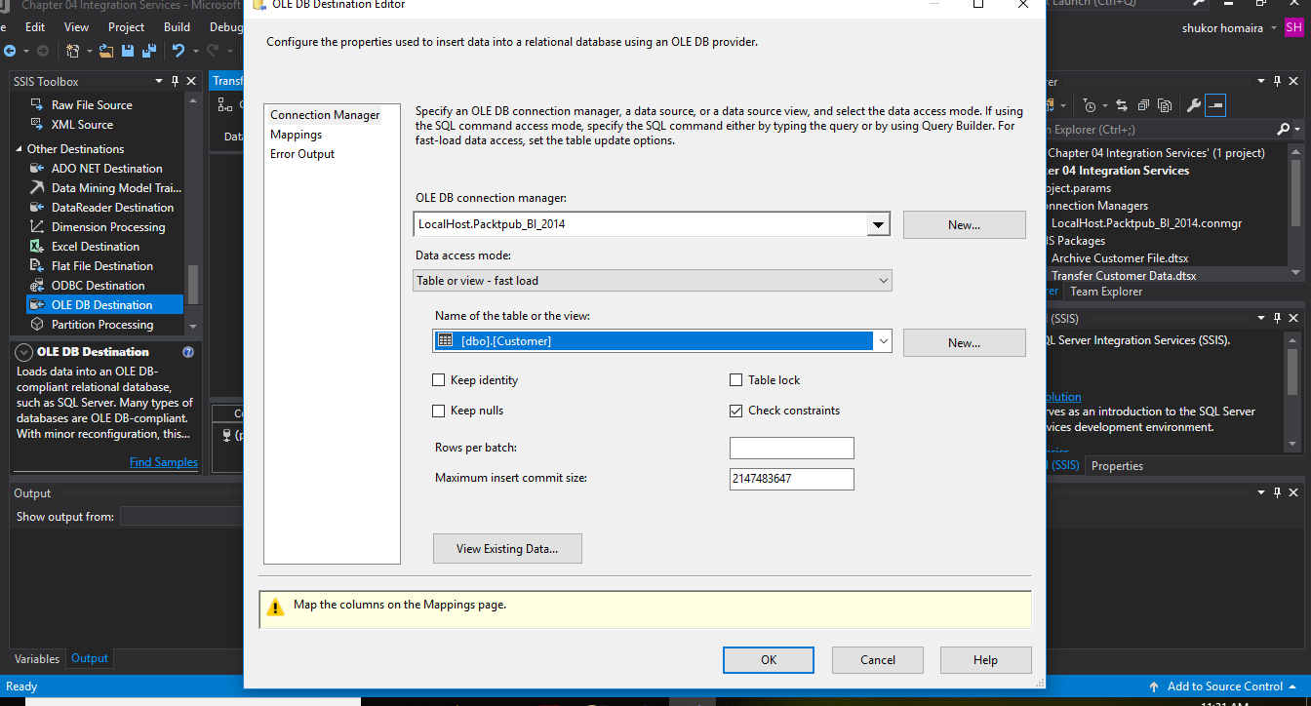

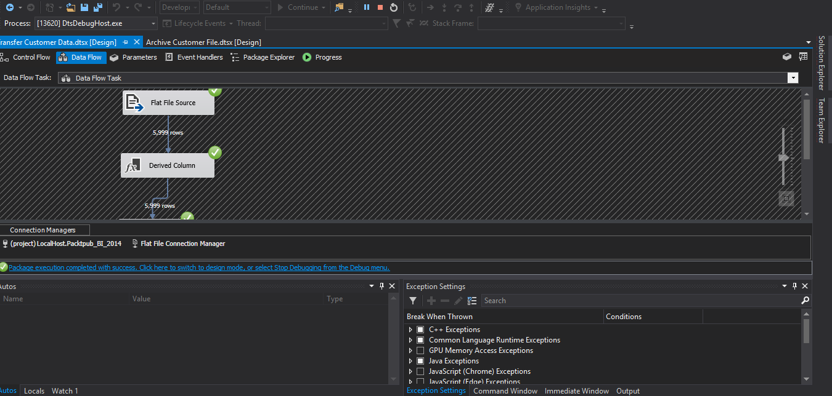

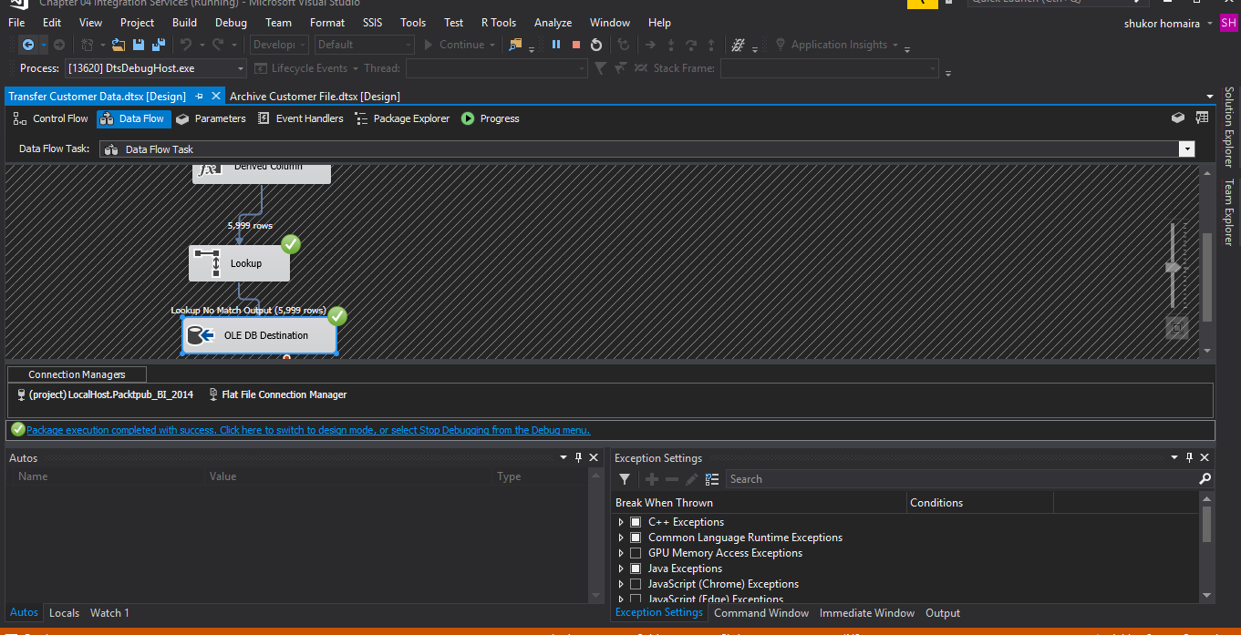

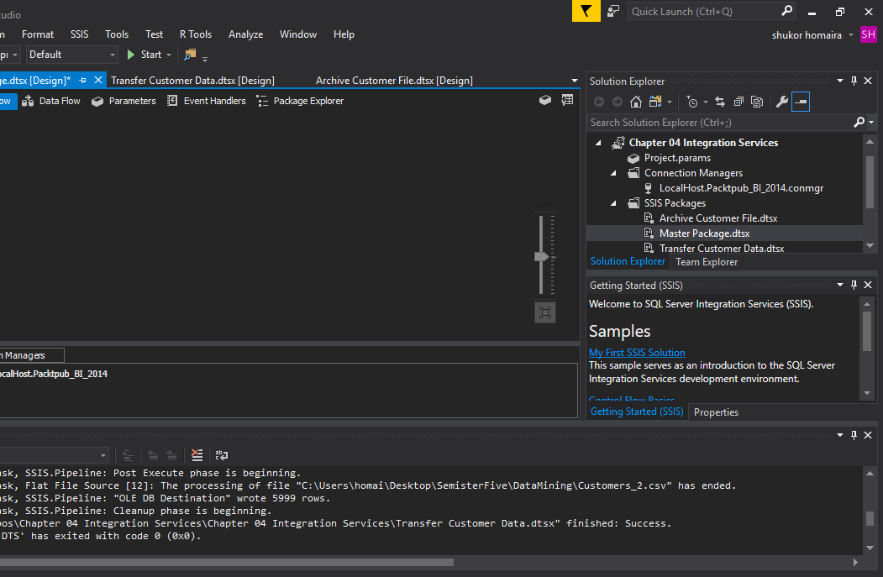

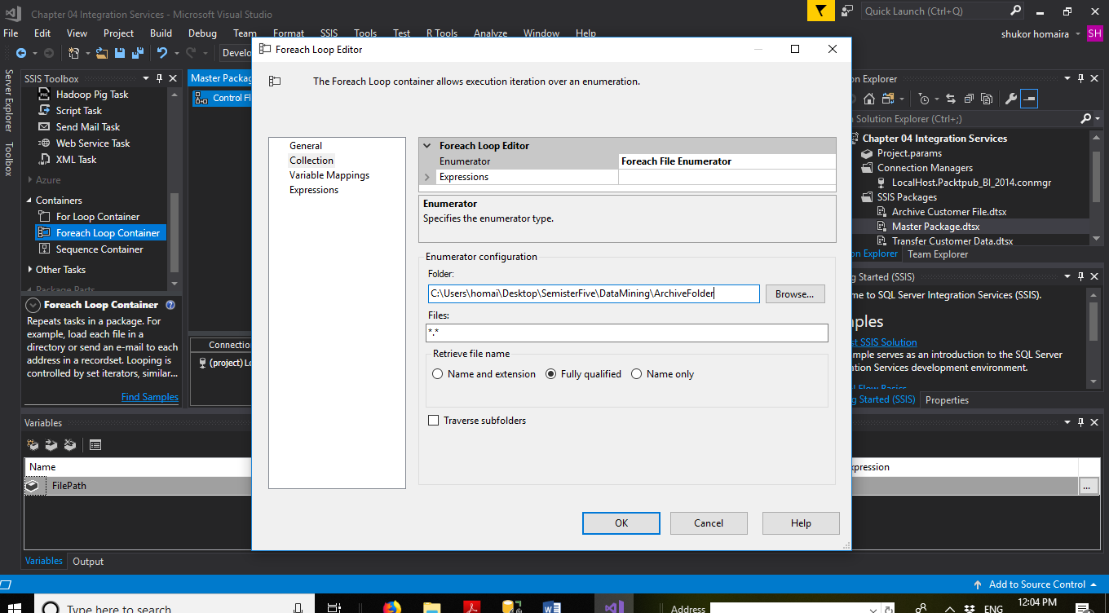

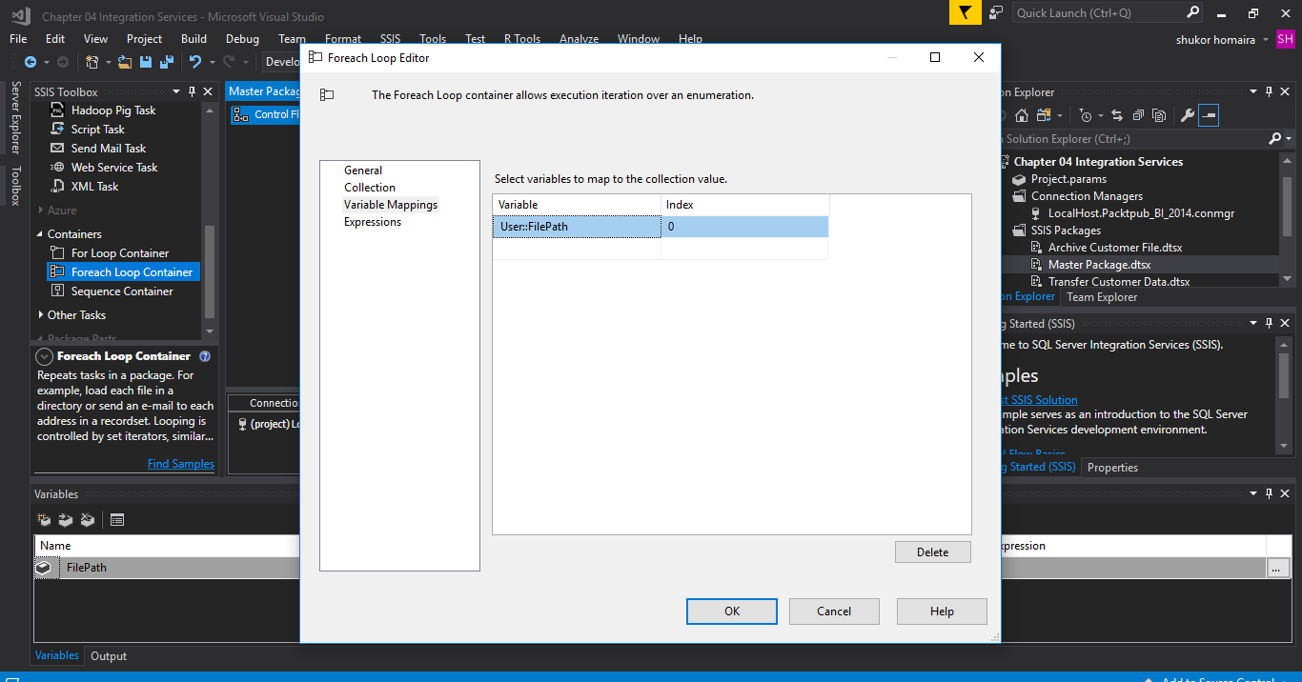

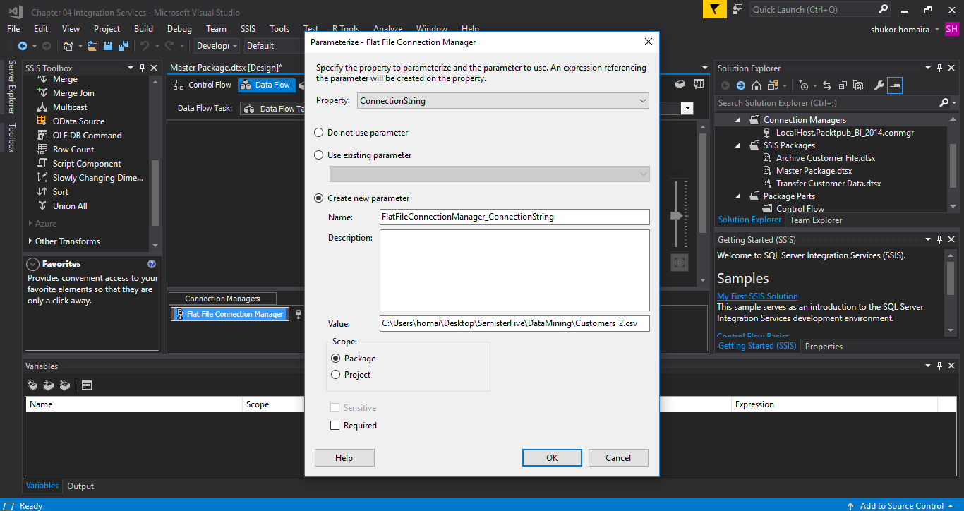

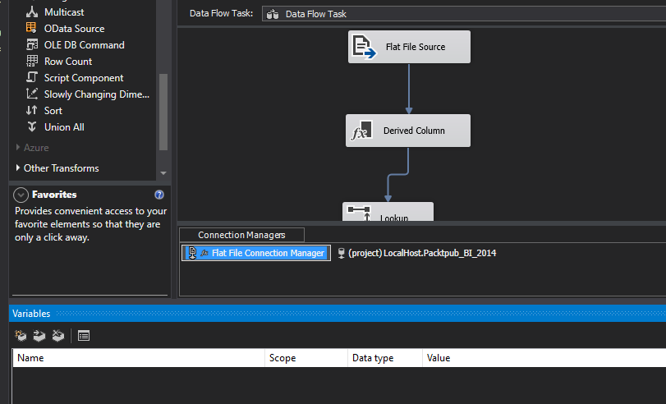

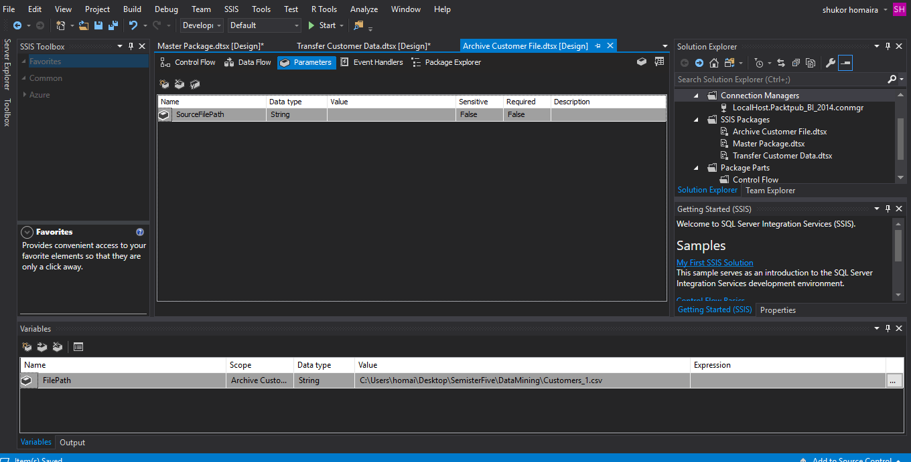

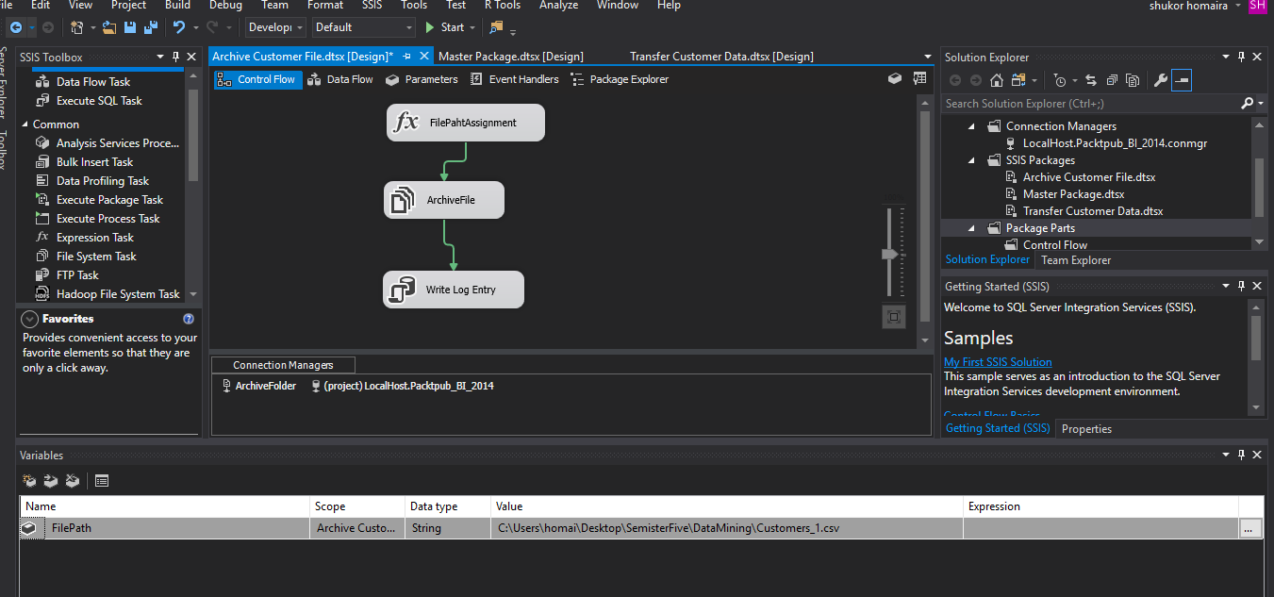

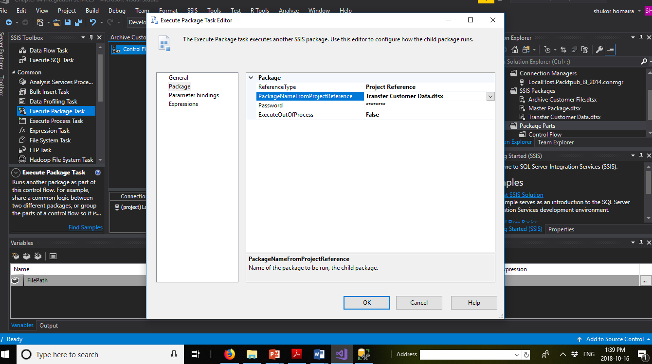

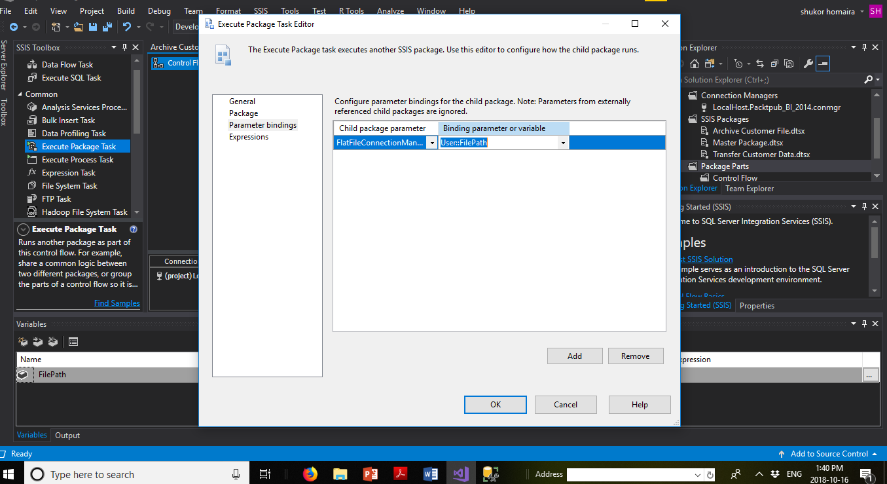

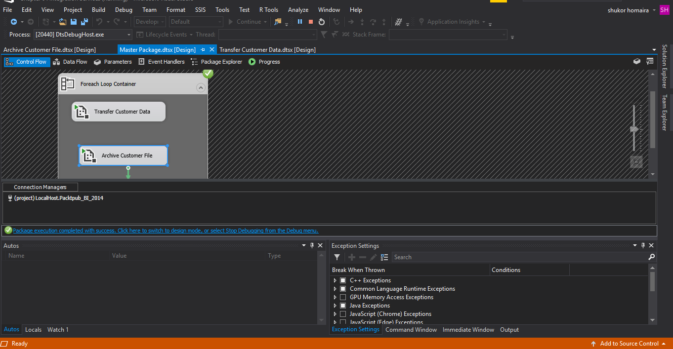

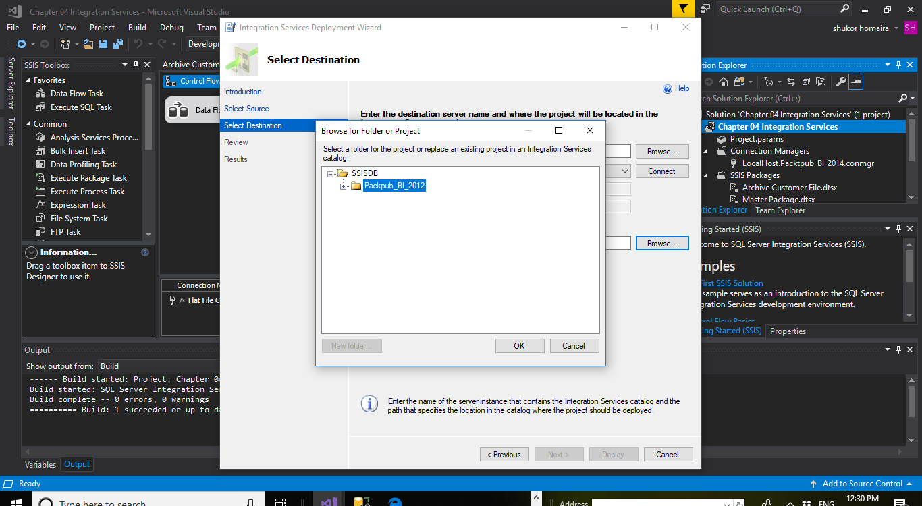

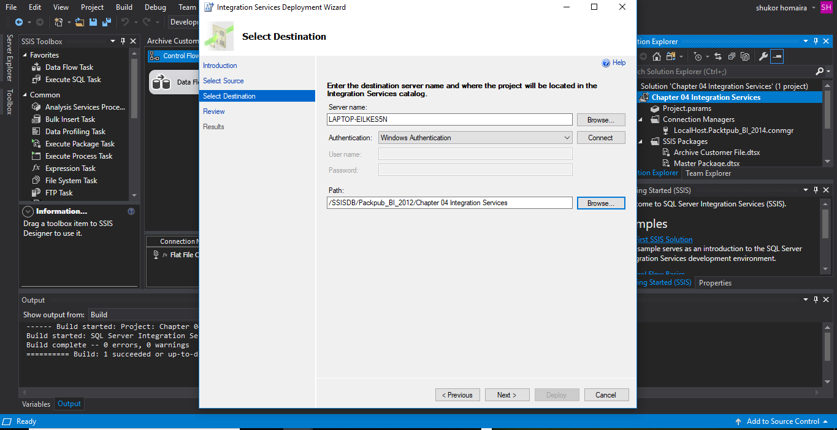

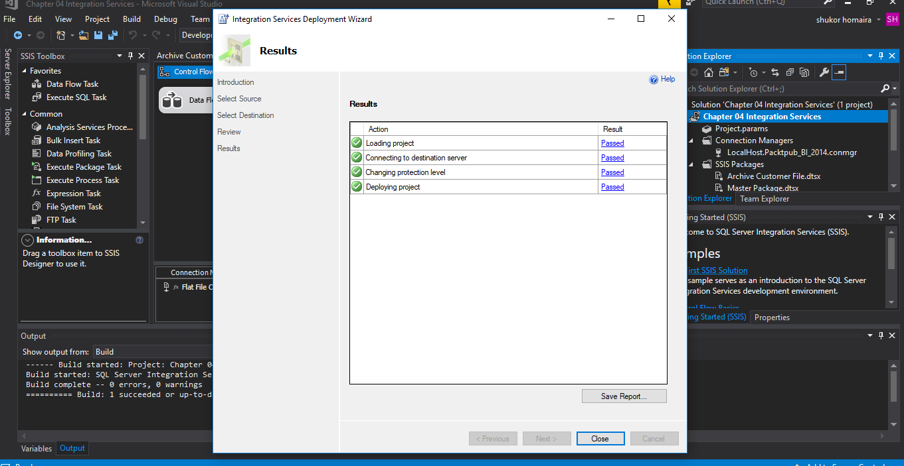

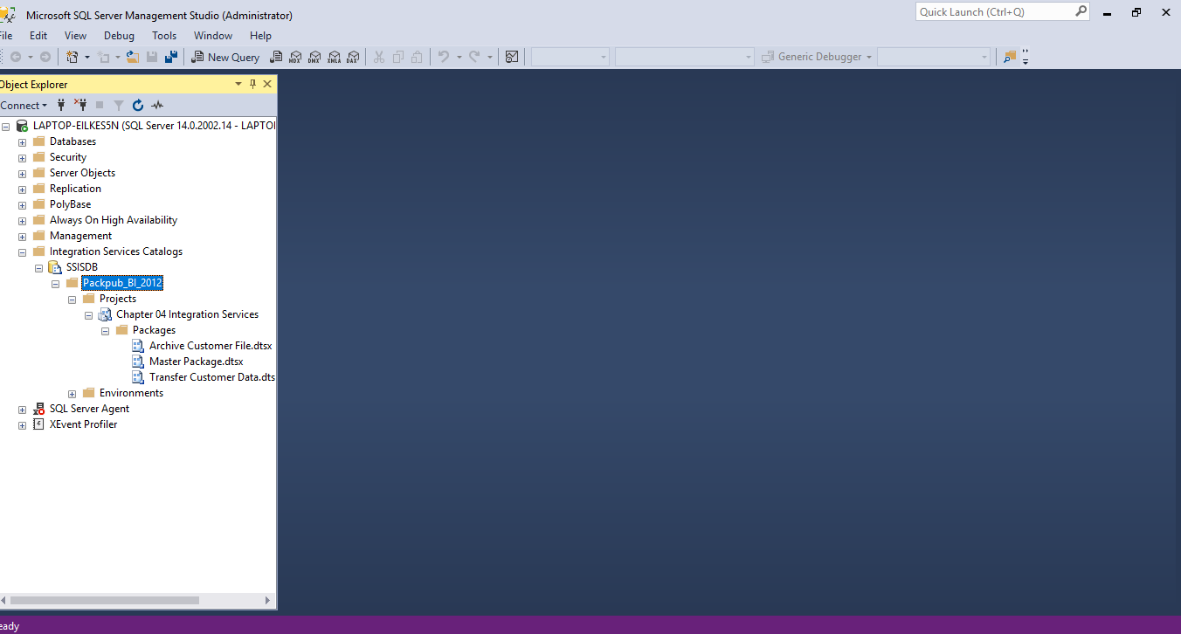

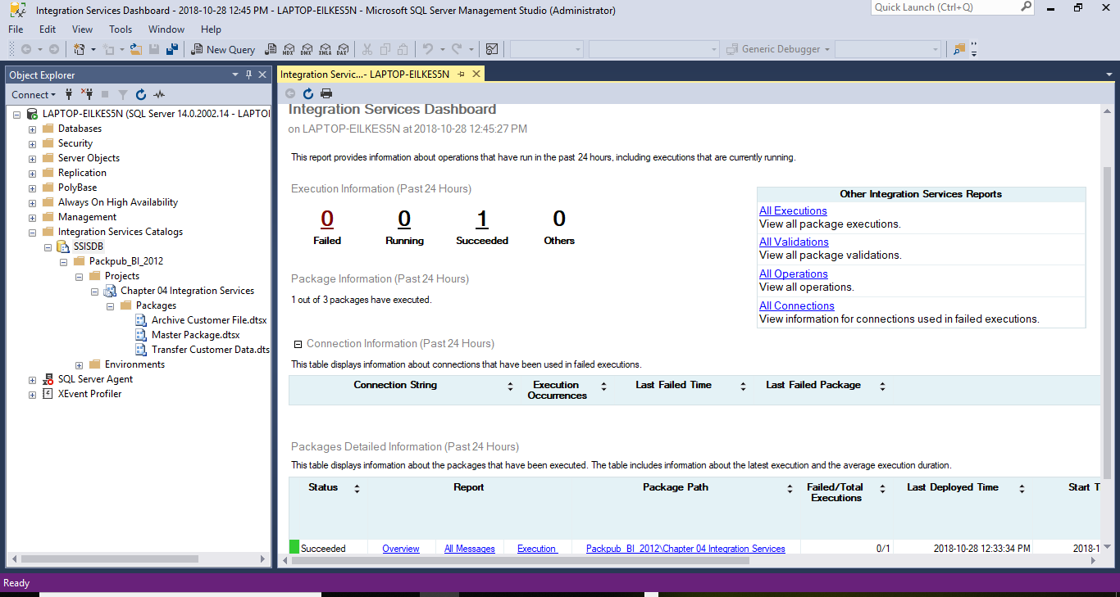

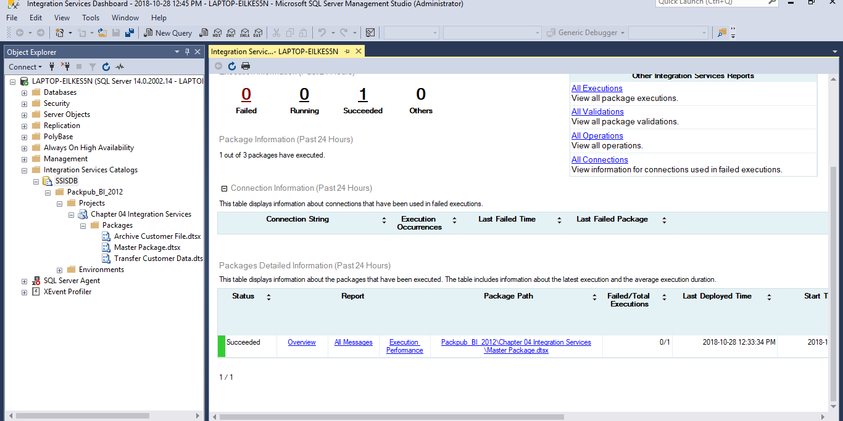

**Conclusion:**

Integration services dashboard demonstrating achievement of execution of different operations that are as of now running. Preparing the cube advantages as utilizing traditional languages like SQL to express sort of queries against operational databases can be troublesome for unexperienced clients and furthermore it requires long decision making and response time. Cube can help in decision making processes are enterprise specific facts. ETL process helps sources in single format. This procedure separates information from local configurations and stores in a single place. At that point of transformation cleans down the information and guide the information to steady arrangement of query esteem lastly changed information is stacked to data warehouse. ETL tools is more beneficial than using conventional methods of moving data from a source database to a target data repository. ETL tools improve the access of information from data and at the same time ease the task of database workers. ETL tools depend on Graphical User Interface (GUI) and offer a visual stream of the framework's rationale. The graphical interface empowers you to indicate rules utilizing a simplified interface to demonstrate the stream of information in a procedure. **At the end, the most favorable benefits of ETL tools are Ease of Use,** **Visual Flow,** **Good for Complex Data Management Situations,** **Advanced Data Profiling and Cleansing,** **Enhanced Business Intelligence, High Return on Investment (ROI), and Performance**

**Reference**

<https://www.springpeople.com/blog/data-warehousing-essentials-what-is-etl-tool-what-are-its-benefits/>