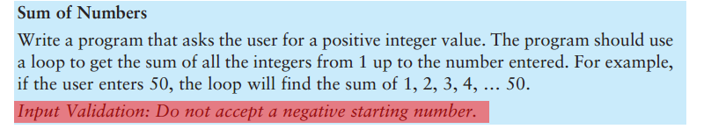
Sum of Integers

Run the following C++ program (and convert it to ARM Assembly Language):
https://github.com/PaulConradRCC/asm/blob/master/sum_of_integers/sum_of_integers.cpp

Note that for full credit, your Assembly Language program must have the same exact output as the C++ program!
This assignment is due by 11:10AM on October 24th, 2016.

