% Parameters

num_nodes = 10;

num_channels = 1; % Single channel

channel_capacity = 1000; % bits per second

packet_arrival_rate = 0.1;

transmission_time = 50; % milliseconds

energy_consumption_per_packet = 5; % Joules

simulation_time = 1000; % milliseconds

% Initialization

num_packets = round(simulation_time * packet_arrival_rate);

received_packets = zeros(num_nodes, 1);

dropped_packets = zeros(num_nodes, 1);

average_delay = zeros(num_nodes, 1);

throughput = zeros(num_nodes, 1);

energy_consumption = zeros(num_nodes, 1);

efficiency = zeros(num_nodes, 1);

for node = 1:num_nodes

successful_transmissions = 0;

total_delay = 0;

total_energy = 0;

for packet = 1:num_packets

if rand() < packet_arrival_rate

% Simulate transmission

transmission_delay = transmission_time;

total_delay = total_delay + transmission_delay;

% Update energy consumption

total_energy = total_energy + energy_consumption_per_packet;

successful_transmissions = successful_transmissions + 1;

received_packets(node) = received_packets(node) + 1;

else

dropped_packets(node) = dropped_packets(node) + 1;

end

end

average_delay(node) = total_delay / successful_transmissions;

throughput(node) = successful_transmissions * transmission_time / simulation_time;

energy_consumption(node) = total_energy;

efficiency(node) = throughput(node) / energy_consumption(node);

end

% Calculate average energy, average throughput, received packet rate, dropped packet rate

avg_energy_single_channel = mean(energy_consumption);

avg_throughput_single_channel = mean(throughput);

received_packet_rate_single_channel = mean(received_packets) / simulation_time;

dropped_packet_rate_single_channel = mean(dropped_packets) / simulation_time;

% Display metrics for single-channel scenario...

disp('Metrics for Single-Channel Scenario:');

disp(['Average Energy Consumption: ', num2str(avg_energy_single_channel), ' Joules']);

disp(['Average Throughput: ', num2str(avg_throughput_single_channel), ' bits per second']);

disp(['Received Packet Rate: ', num2str(received_packet_rate_single_channel), ' packets per millisecond']);

disp(['Dropped Packet Rate: ', num2str(dropped_packet_rate_single_channel), ' packets per millisecond']);

disp(newline);

% Display received and dropped packets for Single-Channel Scenario

disp('Received and Dropped Packets for Single-Channel Scenario:');

for node = 1:num_nodes

disp(['Node ', num2str(node), ': Received = ', num2str(received_packets(node)), ', Dropped = ', num2str(dropped_packets(node))]);

end

disp(newline);

% Parameters

num_nodes = 10;

num_channels = 5; % Multi channel

channel_capacity = 1000; % bits per second

packet_arrival_rate = 0.1;

transmission_time = 50; % milliseconds

energy_consumption_per_packet = 5; % Joules

simulation_time = 1000; % milliseconds

% Initialization

num_packets = round(simulation_time * packet_arrival_rate);

received_packets = zeros(num_nodes, 1);

dropped_packets = zeros(num_nodes, 1);

average_delay = zeros(num_nodes, 1);

throughput = zeros(num_nodes, 1);

energy_consumption = zeros(num_nodes, 1);

efficiency = zeros(num_nodes, 1);

for node = 1:num_nodes

successful_transmissions = 0;

total_delay = 0;

total_energy = 0;

for packet = 1:num_packets

if rand() < packet_arrival_rate

selected_channel = randi(num_channels);

% Simulate channel contention

contention_delay = rand() * transmission_time;

% Simulate transmission

transmission_delay = transmission_time;

total_delay = total_delay + transmission_delay + contention_delay;

% Update energy consumption

total_energy = total_energy + energy_consumption_per_packet;

successful_transmissions = successful_transmissions + 1;

received_packets(node) = received_packets(node) + 1;

else

dropped_packets(node) = dropped_packets(node) + 1;

end

end

average_delay(node) = total_delay / successful_transmissions;

throughput(node) = successful_transmissions * transmission_time / simulation_time;

energy_consumption(node) = total_energy;

efficiency(node) = throughput(node) / energy_consumption(node);

end

% Calculate average energy, average throughput, received packet rate, dropped packet rate

avg_energy_multichannel = mean(energy_consumption);

avg_throughput_multichannel = mean(throughput);

received_packet_rate_multichannel = mean(received_packets) / simulation_time;

dropped_packet_rate_multichannel = mean(dropped_packets) / simulation_time;

% Display metrics for multichannel scenario...

disp('Metrics for Multichannel Scenario:');

disp(['Average Energy Consumption: ', num2str(avg_energy_multichannel), ' Joules']);

disp(['Average Throughput: ', num2str(avg_throughput_multichannel), ' bits per second']);

disp(['Received Packet Rate: ', num2str(received_packet_rate_multichannel), ' packets per millisecond']);

disp(['Dropped Packet Rate: ', num2str(dropped_packet_rate_multichannel), ' packets per millisecond']);

disp(newline);

% Display received and dropped packets for Multichannel Scenario

disp('Received and Dropped Packets for Multichannel Scenario:');

for node = 1:num_nodes

disp(['Node ', num2str(node), ': Received = ', num2str(received_packets(node)), ', Dropped = ', num2str(dropped_packets(node))]);

end

disp(newline);

% Plotting

% Metrics comparison plot

figure;

subplot(2, 2, 1);

plot(1:num_nodes, energy_consumption, 'o-', 1:num_nodes, repmat(avg_energy_single_channel, 1, num_nodes), '--');

xlabel('Node');

ylabel('Energy Consumption (Joules)');

legend('Multichannel', 'Single-Channel Avg', 'Location', 'best');

title('Energy Consumption Comparison');

subplot(2, 2, 2);

plot(1:num_nodes, throughput, 'o-', 1:num_nodes, repmat(avg_throughput_single_channel, 1, num_nodes), '--');

xlabel('Node');

ylabel('Throughput (bits/s)');

legend('Multichannel', 'Single-Channel Avg', 'Location', 'best');

title('Throughput Comparison');

subplot(2, 2, 3);

plot(1:num_nodes, received_packets / simulation_time, 'o-', 1:num_nodes, repmat(received_packet_rate_single_channel, 1, num_nodes), '--');

xlabel('Node');

ylabel('Received Packet Rate (packets/ms)');

legend('Multichannel', 'Single-Channel Avg', 'Location', 'best');

title('Received Packet Rate Comparison');

subplot(2, 2, 4);

plot(1:num_nodes, dropped_packets / simulation_time, 'o-', 1:num_nodes, repmat(dropped_packet_rate_single_channel, 1, num_nodes), '--');

xlabel('Node');

ylabel('Dropped Packet Rate (packets/ms)');

legend('Multichannel', 'Single-Channel Avg', 'Location', 'best');

title('Dropped Packet Rate Comparison');

**OUTPUT:**

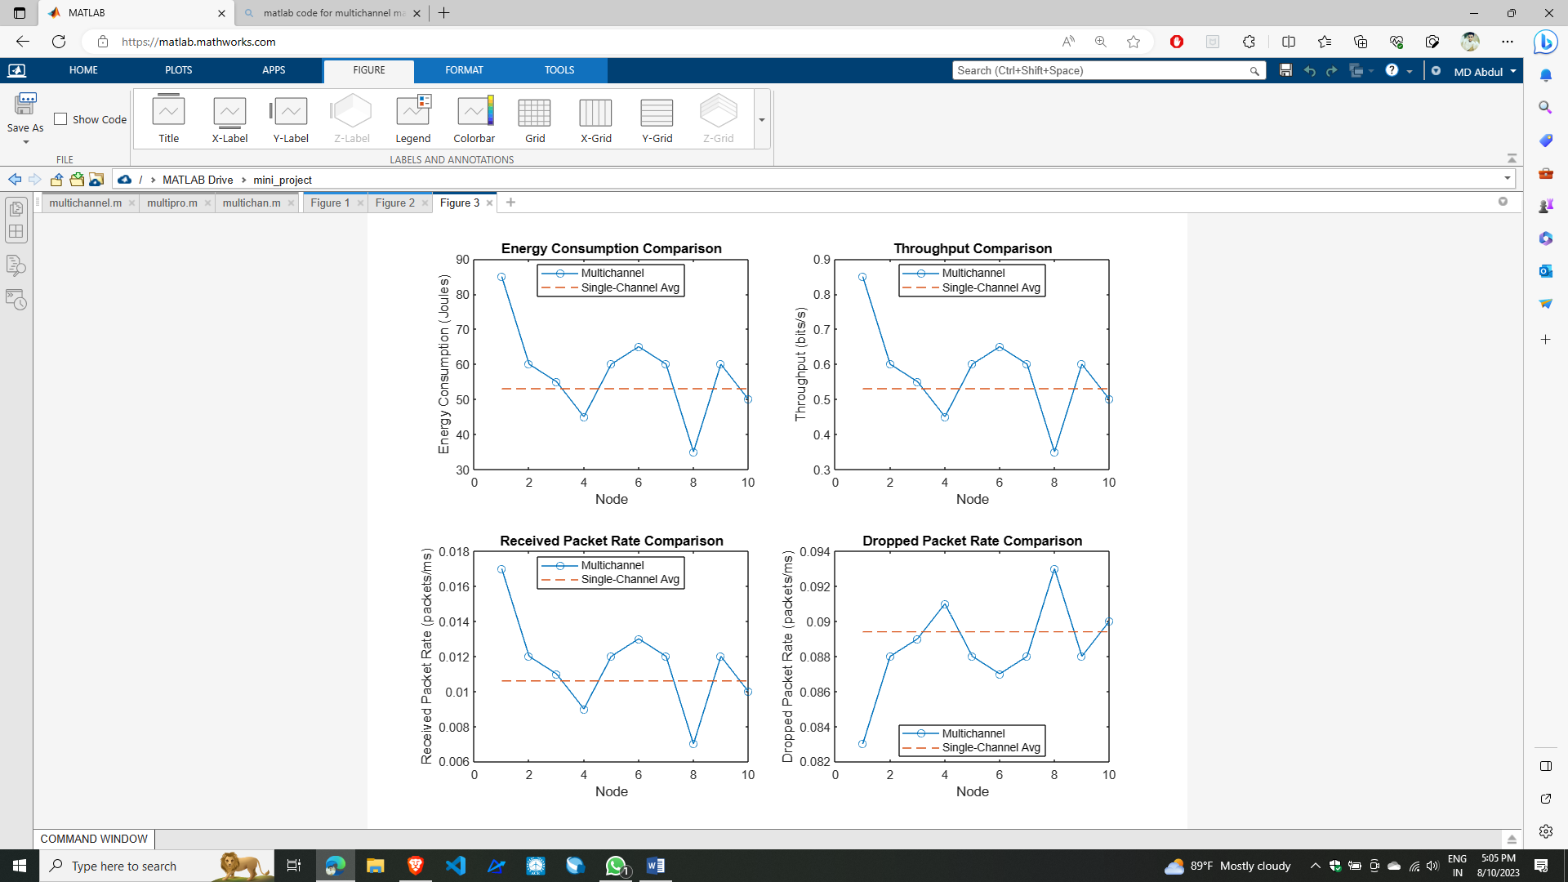

**COMMAND WINDOW:**

Metrics for Single-Channel Scenario:  
Average Energy Consumption: 53 Joules  
Average Throughput: 0.53 bits per second  
Received Packet Rate: 0.0106 packets per millisecond  
Dropped Packet Rate: 0.0894 packets per millisecond  
  
  
Received and Dropped Packets for Single-Channel Scenario:  
Node 1: Received = 8, Dropped = 92  
Node 2: Received = 7, Dropped = 93  
Node 3: Received = 10, Dropped = 90  
Node 4: Received = 11, Dropped = 89  
Node 5: Received = 17, Dropped = 83  
Node 6: Received = 12, Dropped = 88  
Node 7: Received = 12, Dropped = 88  
Node 8: Received = 11, Dropped = 89  
Node 9: Received = 9, Dropped = 91  
Node 10: Received = 9, Dropped = 91  
  
  
Metrics for Multichannel Scenario:  
Average Energy Consumption: 57.5 Joules  
Average Throughput: 0.575 bits per second  
Received Packet Rate: 0.0115 packets per millisecond  
Dropped Packet Rate: 0.0885 packets per millisecond  
  
  
Received and Dropped Packets for Multichannel Scenario:  
Node 1: Received = 17, Dropped = 83  
Node 2: Received = 12, Dropped = 88  
Node 3: Received = 11, Dropped = 89  
Node 4: Received = 9, Dropped = 91  
Node 5: Received = 12, Dropped = 88  
Node 6: Received = 13, Dropped = 87  
Node 7: Received = 12, Dropped = 88  
Node 8: Received = 7, Dropped = 93  
Node 9: Received = 12, Dropped = 88  
Node 10: Received = 10, Dropped = 90