Tymchenko, B., Marchenko, P., & Spodarets, D. (Year). Deep Learning Approach to Diabetic Retinopathy Detection. arXiv:2003.02261v1

**Short Summray:**

The paper describes an automated deep learning technique that uses single fundus imaging to detect the stage of diabetic retinopathy. Using a multistage transfer learning strategy, the method ranks 54 out of 2943 competing methods on the APTOS 2019 Blindness Detection Dataset, with a sensitivity and specificity of 0.99. The approach exhibits stability and resilience by fine-tuning on the target dataset and integrating an ensemble of three CNN architectures. Prospective enhancements encompass comprehensive ensemble SHAP computations, enhanced hyperparameter optimization, and investigation of pretrained encoders for associated assignments. The paper emphasizes how deep learning can improve the diagnosis of diabetic retinopathy and calls for more research on meta-learning strategies.

**Brief:**

**Dataset:** [Diabetic Retinopathy Detection | Kaggle](https://www.kaggle.com/competitions/diabetic-retinopathy-detection/data)

**Evaluation Metrices:** Quadratic weighted Cohen’s kappa score as main metric. (Quadratic weighted kappa is calculated between the scores assigned by the human rater and the predicted scores. This metric varies from -1 (complete disagreement between raters) to 1 (complete agreement between raters)

**Methods:**

**Pre-processing:** Image cropping followed by resizing.

**Augmentation:** Online Augmentation. From following [ Albumentations (A. Buslaev and Kalinin, 2018)] library: optical distortion, grid distortion, piecewise affine transform, horizontal flip, vertical flip, random rotation, random shift, random scale, a shift of RGB values, random brightness and contrast, additive Gaussian noise, blur, sharpening, embossing, random gamma, and cutout (Devries and Taylor, 2017).

**Network Architecture:** Imagenet-pretrained CNNs as initialization for encoder (Iglovikov and Shvets, 2018). Used three decoders. Each is trained to solve its task based on features extracted with CNN backbone: • classification head, • regression head, • ordinal regression head.

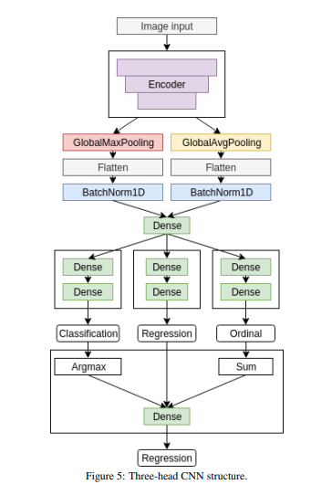

**Training:** Multi Stage training

**Pre-Training:** Minimizing the loss function for every head.

**Main-Training:** 5 Fold cross-validation. Each fold for 75 epochs using Rectified Adam Optimizer.

**Post-Training:** Only fitting linear regression model to outputs of different heads.

**Regularization:** Weight decay & Dropout, penalizing using label smoothing.

**Ensembling:** 3 encoder architectures at different resolution that scored best on the holdout dataset :

* EfficientNet-B4 (380x380),
* EfficientNet-B5 (456x456) (Tan and Le, 2019),
* SE-ResNeXt50 (380x380 and 512x512) (Hu et al., 2017).

**Result:**

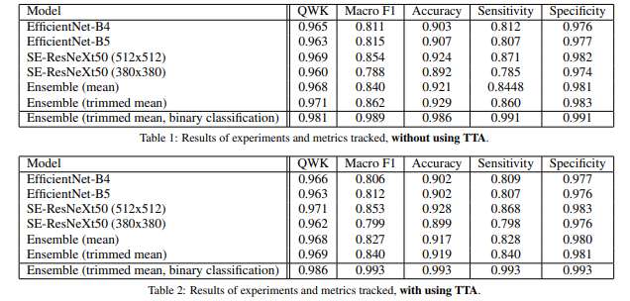

Hagos, M. T., & Kant, S. (Year). Transfer Learning based Detection of Diabetic Retinopathy from Small Dataset.

**Short Summray:**

With the goal to overcome the problem of limited annotated training data in medical picture classification, this work investigates the effectiveness of transfer learning utilizing a pre-trained Inception-V3 model for Diabetic Retinopathy (DR) detection. Through subsampling a smaller dataset from the Kaggle DR challenge, the authors outperform existing methods in binary classification. Their method, which combines a cosine loss function and an ascending learning rate with stochastic gradient descent, demonstrates how deep learning can effectively learn from tiny datasets in the medical field. The results point to the wider applicability of such methods to solve the lack of labeled data in other medical picture classification tasks. For a thorough assessment, more testing with different pre-trained convolutional networks is advised.

**Brief:**

**Methodology: Result:**

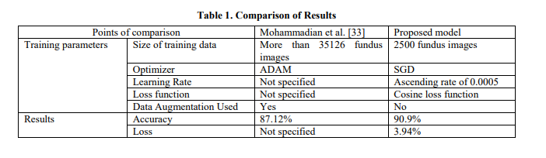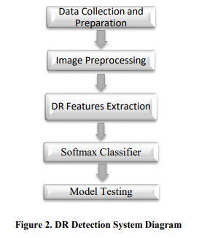

Rubina Sarki, Sandra Michalska, K. A. H. W. Y. Z. (2019). Convolutional neural networks for mild diabetic retinopathy detection: an experimental study. bioRxiv.

**Short Summray:**

The objective of this work is to identify cases of mild diabetic retinopathy (DR), which are difficult to diagnose because convolutional neural networks (CNNs) frequently overlook minor signals. Experiments were carried out using 13 CNN architectures pre-trained on ImageNet utilizing transfer learning, using annotated fundus photos from public sources. To enhance performance, methods like volume growth, data augmentation, and fine-tuning were used. The best accuracy of 86% was obtained by the fine-tuned ResNet50 model on the No DR/Mild DR classification assignment. The work suggests a system for mild DR detection and highlights the significance of early DR identification. Through the utilization of deep learning and performance enhancement methodologies, the system exhibits resilience and flexibility in real-world scenarios, optimizing eye-screening processes and functioning as a diagnostic tool.

**Brief:**

**Results:**

