Bug_01:
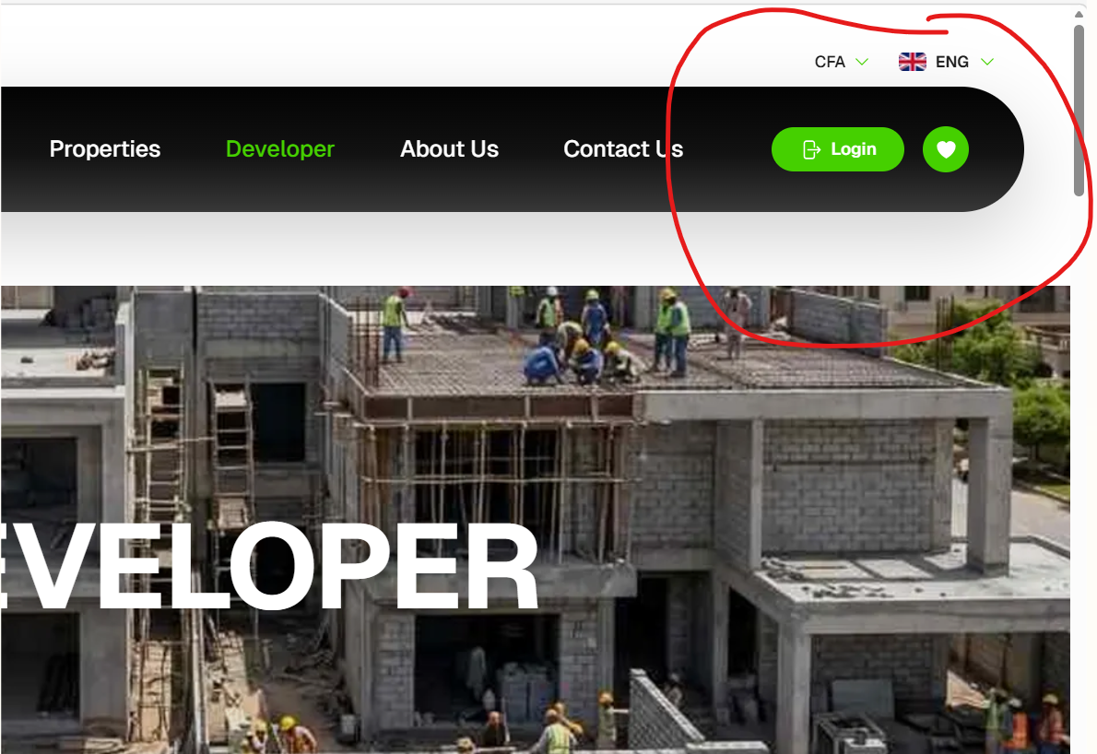
Background Green shade missing on right side

Bug_02:
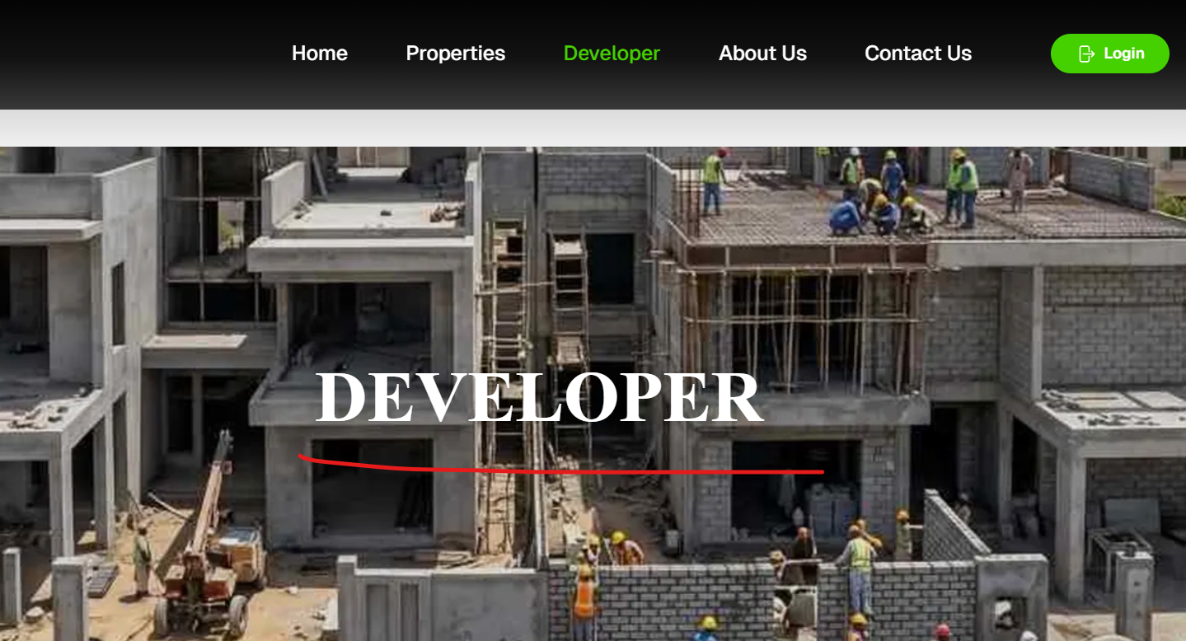
Wrong Font Style

Bug_03:
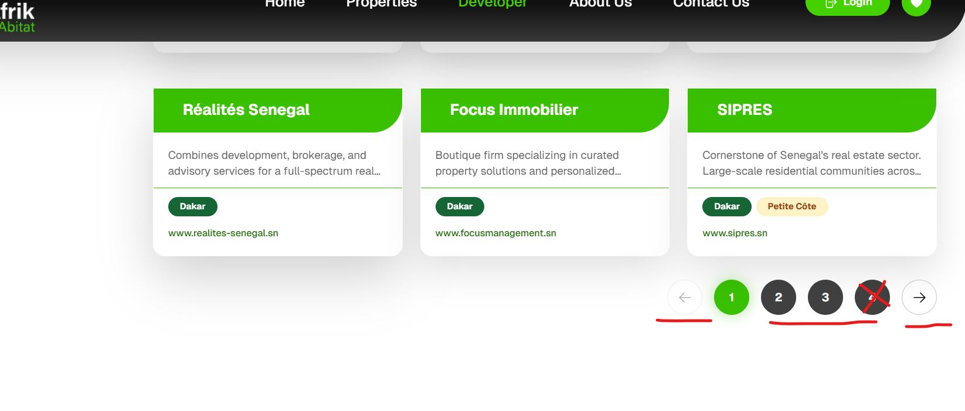
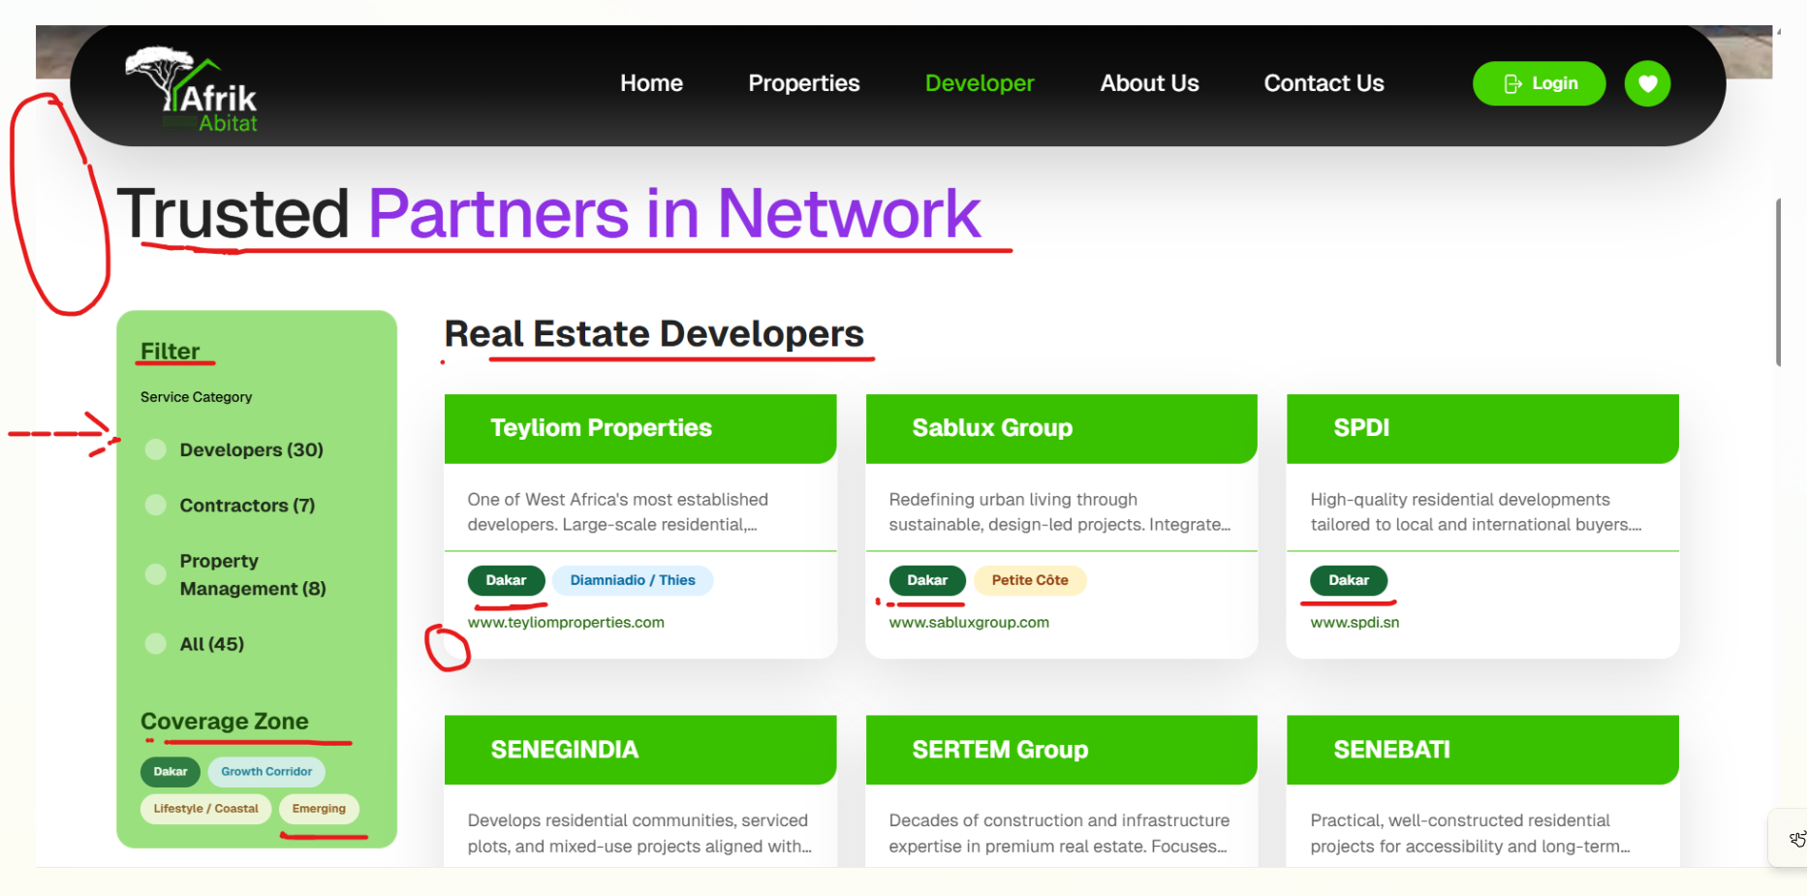
background Green shade missing on left side, Color issues on FILTER container, spelling issue on cards , Trusted Partners in Network should be smaller in size, Real Estate Developers should be smaller and not bold
Bug_04:
Arrow border issue, black shadow missing on 2 and3
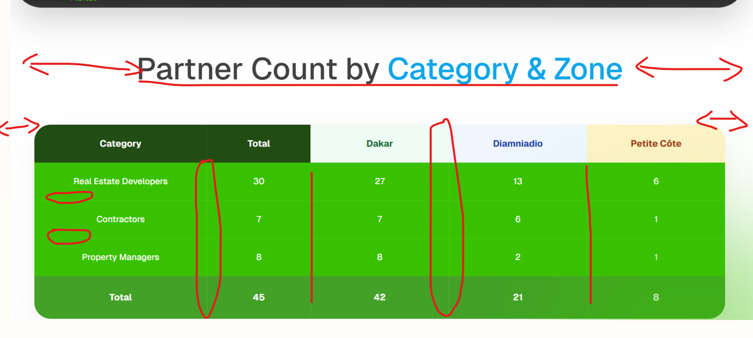
Bug_05:
Heading size should be small, table is too wide in size, horizontal lines in table should not be visible, vertical lines should be dark, last row should be darker in color
Bug_06:
