**TASK RESULTS**

**TASK 1**

**Write a query to fetch all customer names and sort them alphabetically. (Topic Soring)**

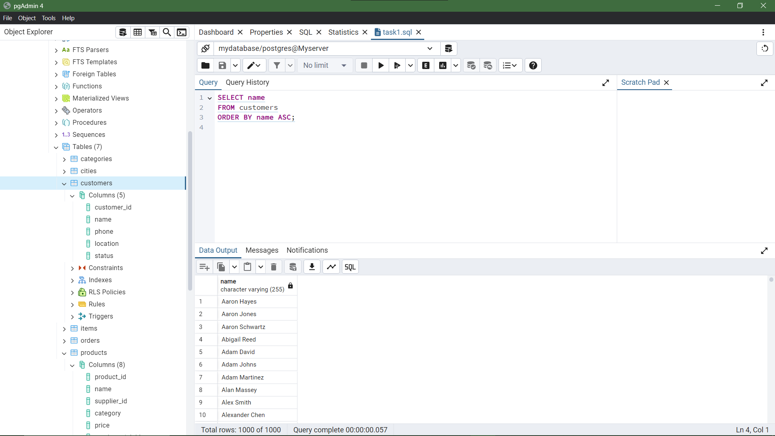

**TASK 2**

**Write a query to fetch all product names and their prices, sorted by price from low to high. (Topic Sorting)**

**TASK 3**

**Write a query to fetch supplier names that start with the letter 'A' and sort them by their names. (Topic Sorting with Operators and Wildcards)**

**TASK 4**

**Write a query to fetch all items and sort them by their status, placing NULL values first.**

**TASK 5**

**Write a query to fetch all products, sort them first by category and then by price in descending order.**

**TASK 6**

**Write a query to fetch all customer names and phone numbers, but sort them by the last four digits of their phone numbers in ascending order. (Hint use sorting with substings)**

