**TASK 05**

**Using the same database you previously created perform the following tasks:**

**1). Write a query to calculate the percentage contribution of each item's amount to its order's total amount, grouped by order_id. (Topics: Partition BY)**

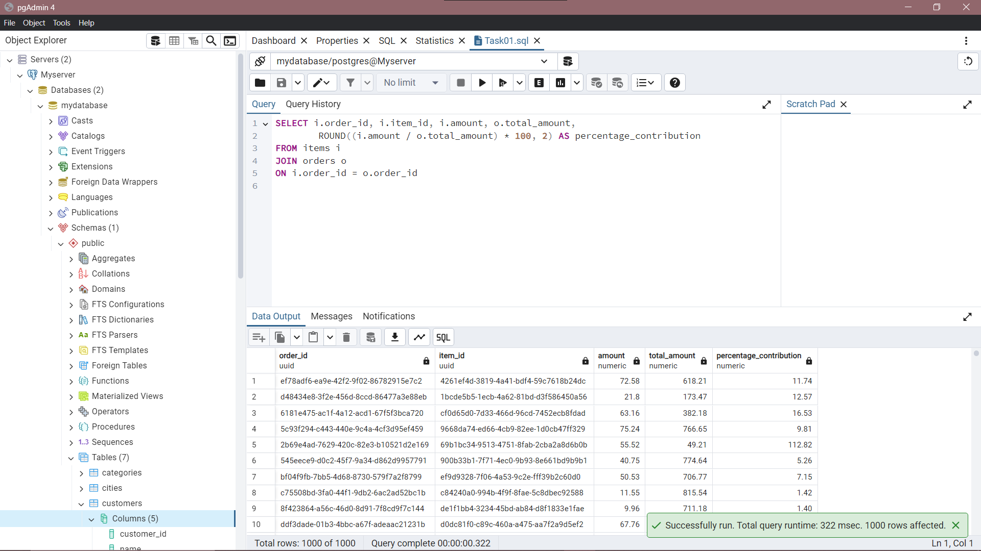

**2). Write a query to rank orders by their total amount within each customer, ordering them from highest to lowest total amount. (Topics: Window functions like RANK, PARTITION BY, and ORDER BY)**

**3). Write a query to calculate the average price of products supplied by each supplier. Exclude suppliers who have no products in the result. (Topics: JOINS, AGGREGATE FUNCTIONS, GROUP BY)**

**4). Write a query to count the number of products in each category. Include categories with zero products in the result set. (WINDOW FUNCTIONS, AGGREGATE FUNCTIONS, JOINS, GROUP BY)**

**5). Write a query to retrieve the total amount spent by each customer, along with their name and phone number. Ensure customers with no orders also appear with a total amount of 0. (WINDOW FUNCTIONS, AGGREGATE FUNCTIONS, JOINS, GROUP BY)**

