DATA ANALYTICS LABORATORY
Practical Lab Report — Spring 2026

Labs 1–5: Environment Setup, Python, NumPy, Pandas, Visualization

Contributors
Abdul Ahad • Abdullah Jabbar • Anonymous

Group Members
Abdullah Jabbar • Abdul Ahad • Quarrat ul Ain Jeelani • Javeria Zainab • Hadia Shahid

Lab 1: Environment Setup & Introduction
This lab covers the installation and verification of Anaconda/Python, setting up Jupyter Notebook, installing essential libraries (pandas, NumPy, matplotlib, seaborn), performing basic Python operations, and exploring data analytics use cases across industries.
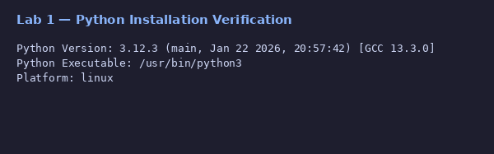
Python version and platform verification
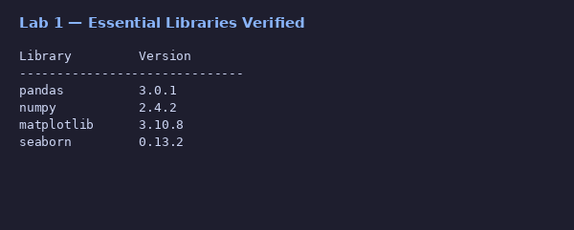
Essential libraries installed and verified
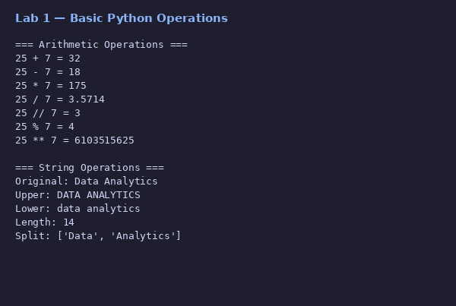
Basic arithmetic and string operations
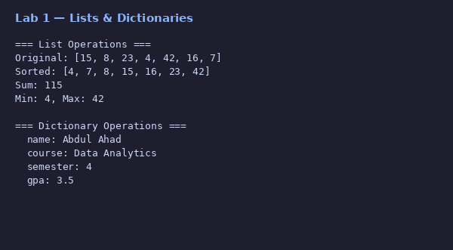
List and dictionary operations
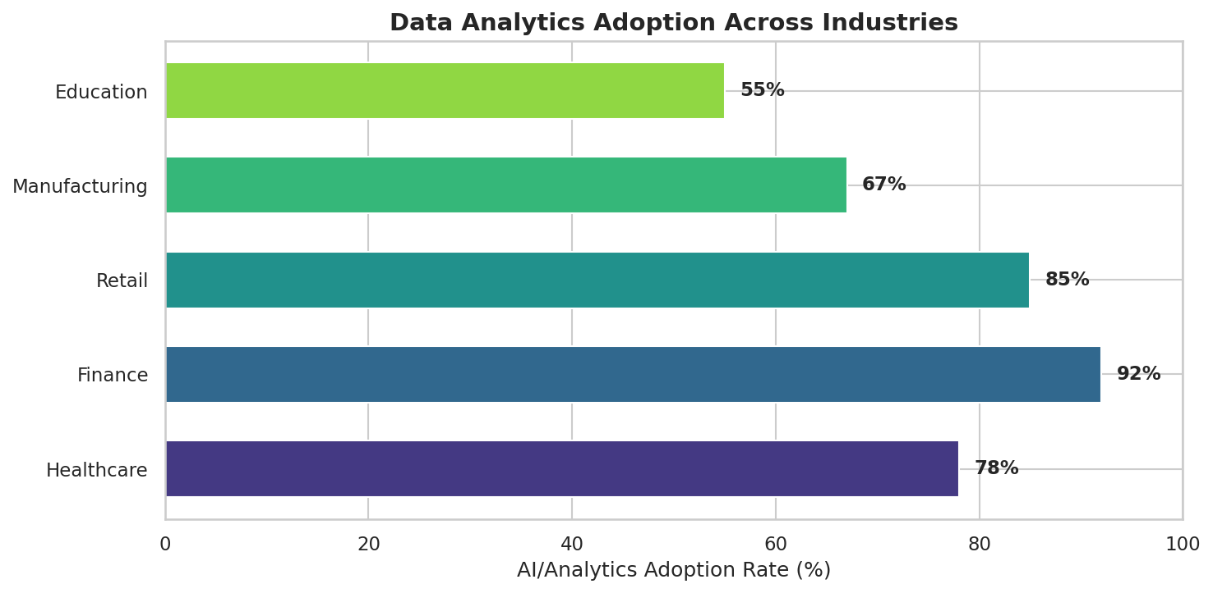
Data analytics adoption across industries

Lab 2: Python Fundamentals for Data Processing
This lab demonstrates proficiency in Python data structures (lists, dictionaries, tuples, sets), custom functions for data processing, file I/O operations across CSV, JSON, and text formats, list comprehensions with performance benchmarks, and error handling patterns.
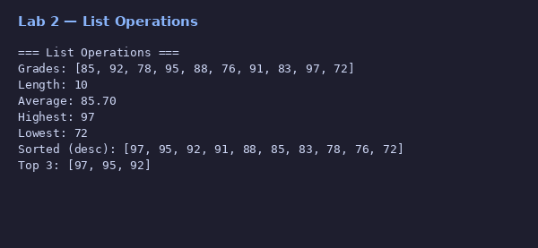
List operations — sorting, slicing, aggregation
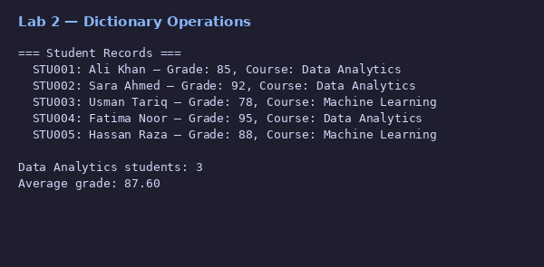
Dictionary operations — student records
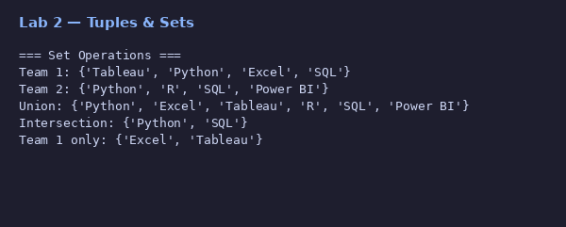
Set operations — union, intersection, difference
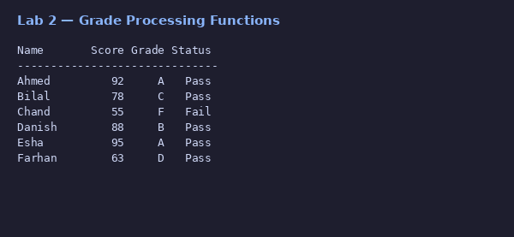
Grade processing functions
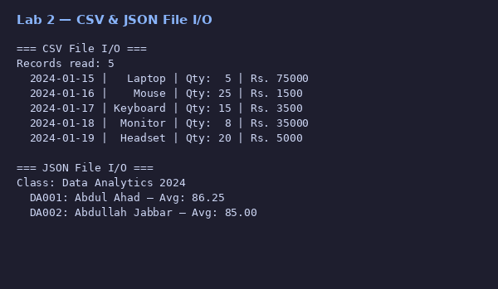
CSV and JSON file I/O operations
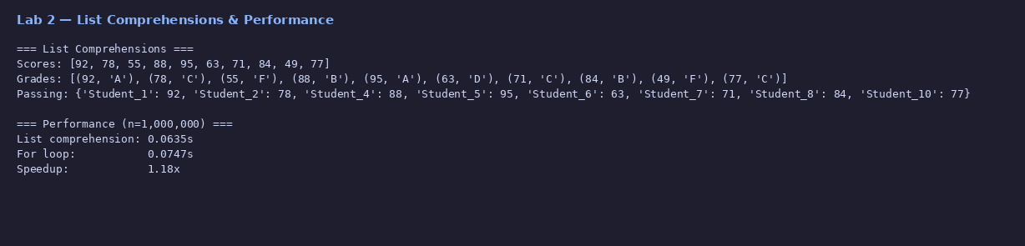
List comprehensions with performance comparison
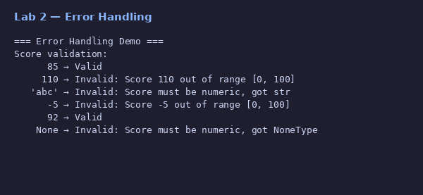
Error handling and data validation

Lab 3: Numerical Computing with NumPy
This lab covers NumPy array creation (1D, 2D, 3D), indexing, slicing, reshaping, element-wise and broadcasting operations, statistical analysis on simulated stock price data, linear algebra operations, random sampling, and a Monte Carlo Pi estimation.
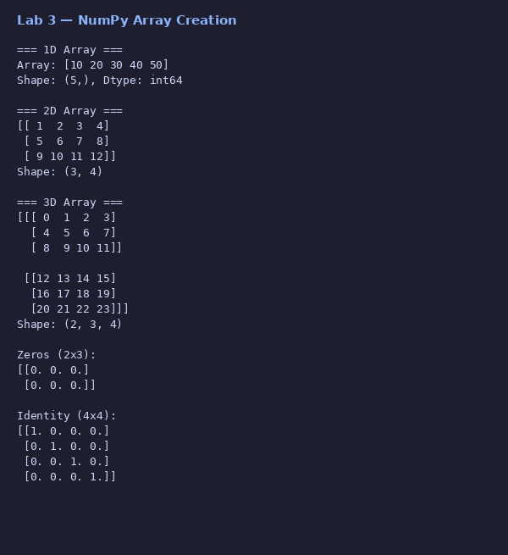
NumPy array creation — 1D, 2D, 3D arrays
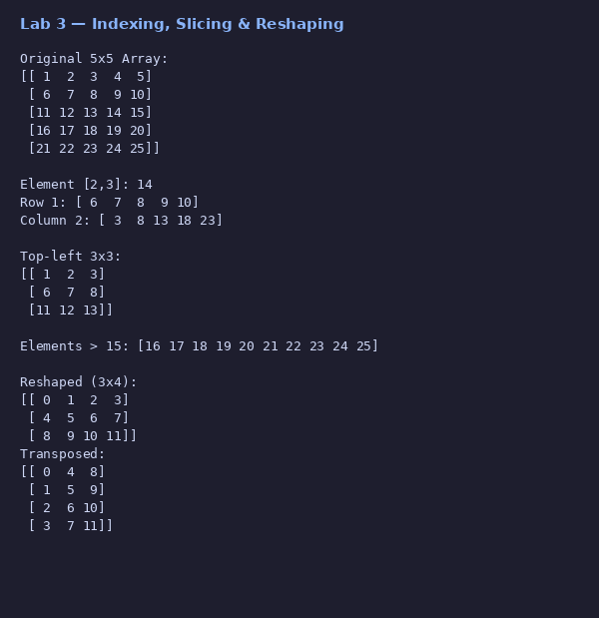
Array indexing, slicing, and reshaping
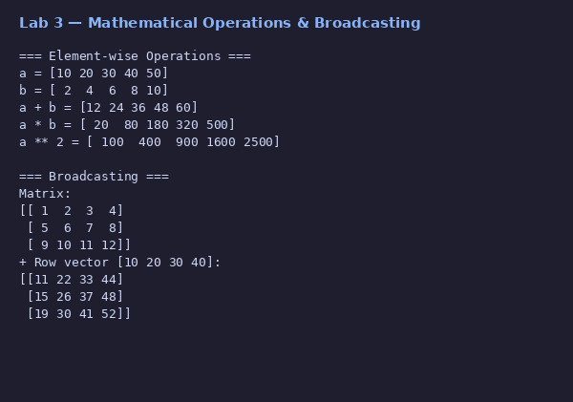
Element-wise operations and broadcasting
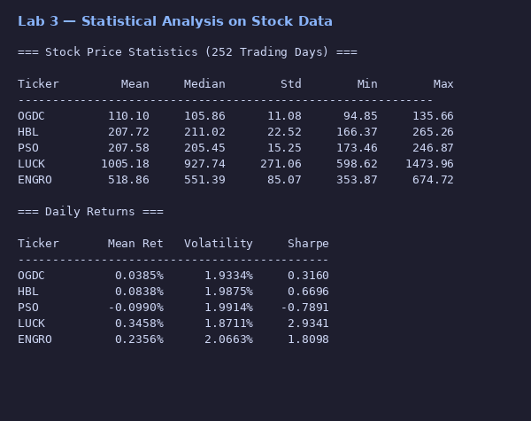
Statistical analysis on PSX stock data
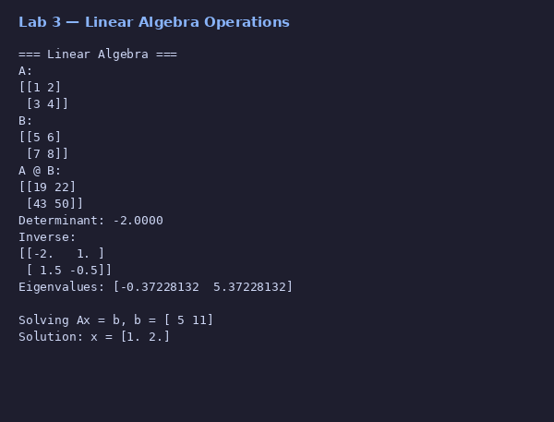
Linear algebra — determinant, inverse, eigenvalues
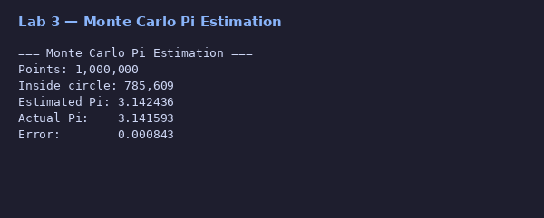
Monte Carlo estimation of Pi (1M points)
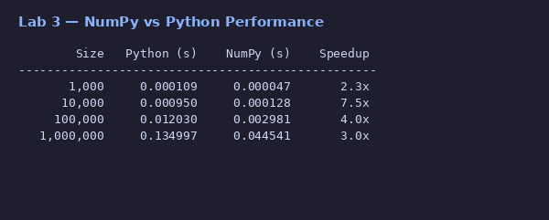
NumPy vs Python performance benchmark

Lab 4: Data Wrangling with Pandas
This lab demonstrates loading data from CSV, Excel, and JSON, exploring datasets with head(), info(), describe(), Boolean filtering, multi-column sorting, missing data handling with median imputation, and feature engineering on the Titanic dataset.
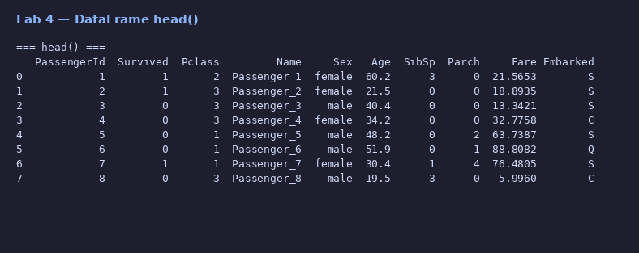
DataFrame head() — first 8 rows
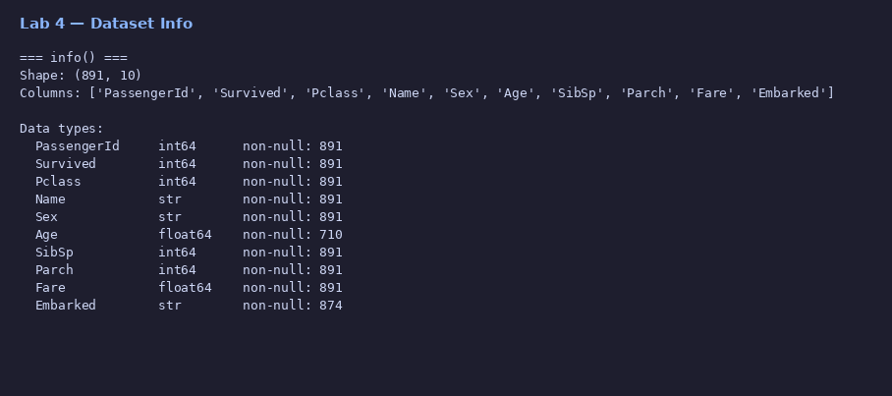
Dataset info — columns, dtypes, non-null counts
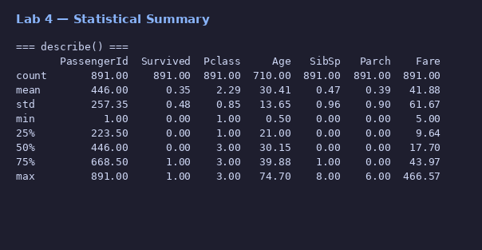
Statistical summary — describe()
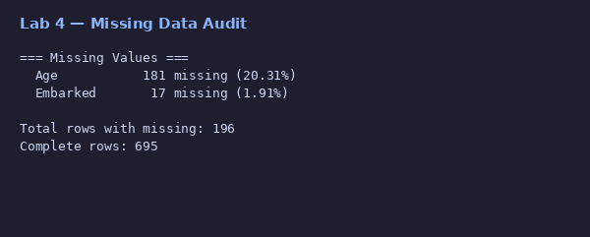
Missing data audit
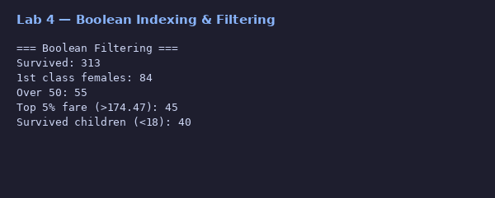
Boolean indexing and row filtering
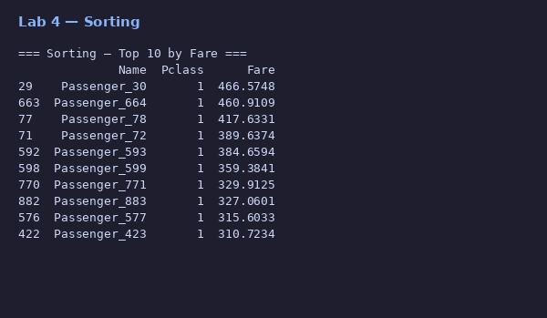
Sorting — top 10 passengers by fare
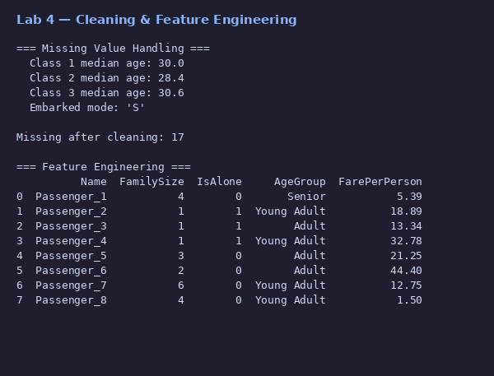
Missing value handling and feature engineering
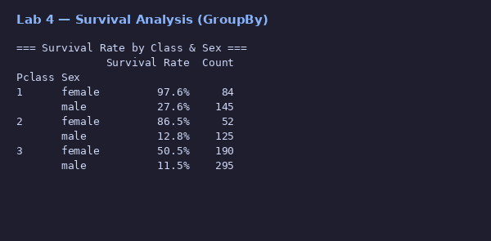
Survival rate analysis by class and sex

Lab 5: Data Visualization Portfolio
This lab presents a comprehensive visualization portfolio featuring 12 distinct chart types built on simulated COVID-19 data across 5 countries. Each chart demonstrates different analytical techniques and customization approaches using matplotlib and seaborn.
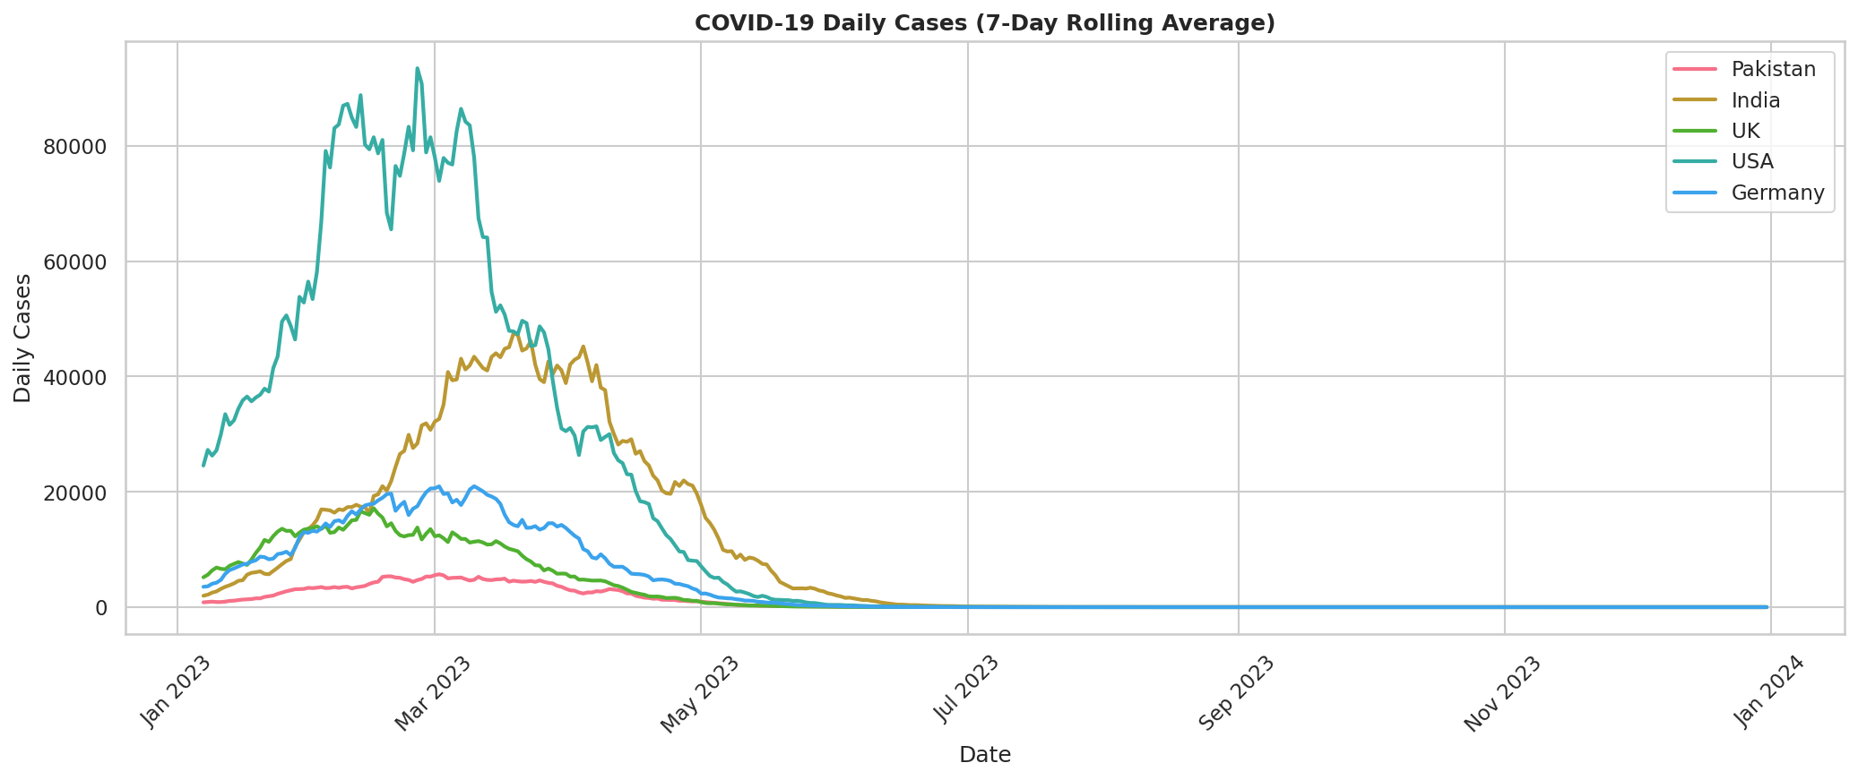
Chart 1: Line plot — daily cases (7-day rolling average)
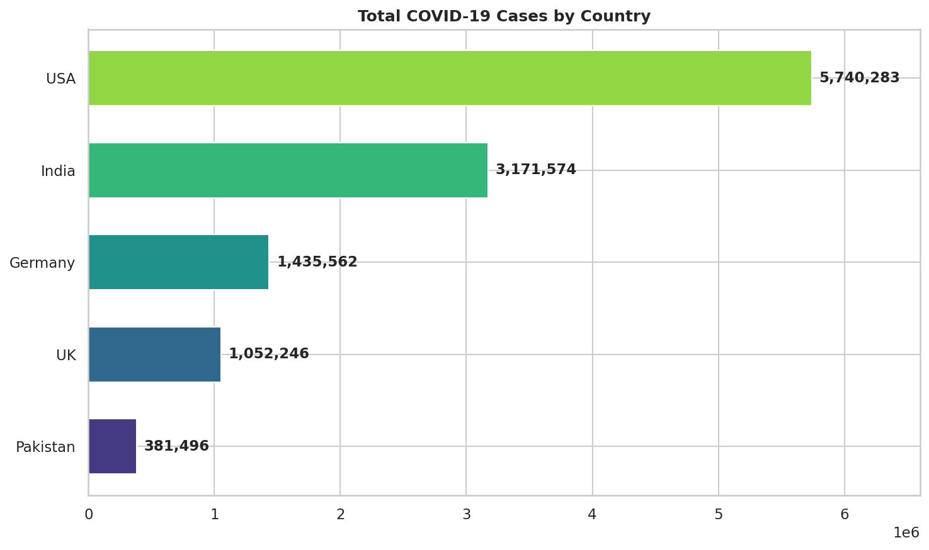
Chart 2: Horizontal bar — total cases by country
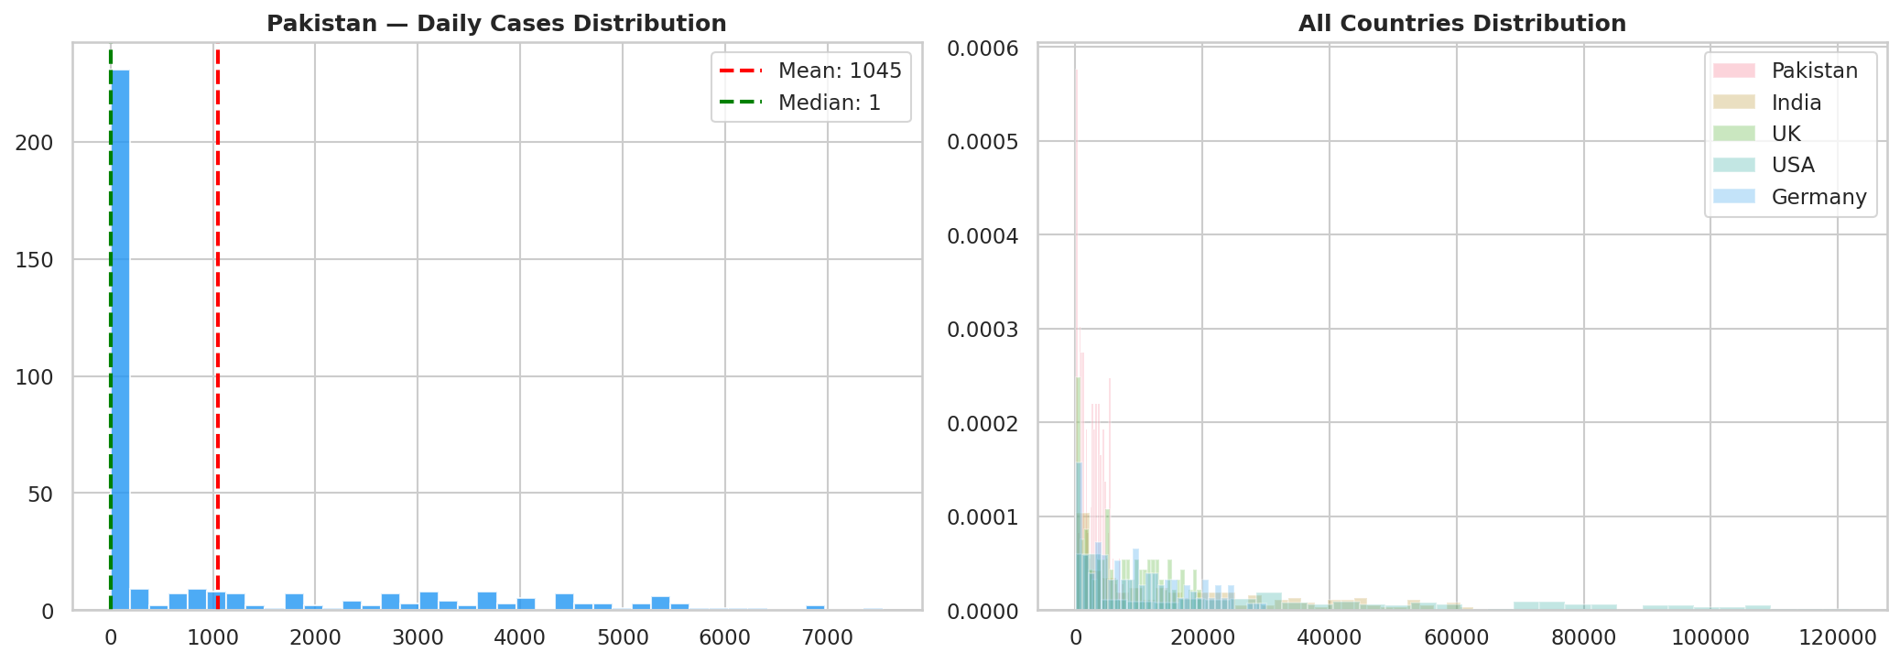
Chart 3: Histogram — daily cases distribution
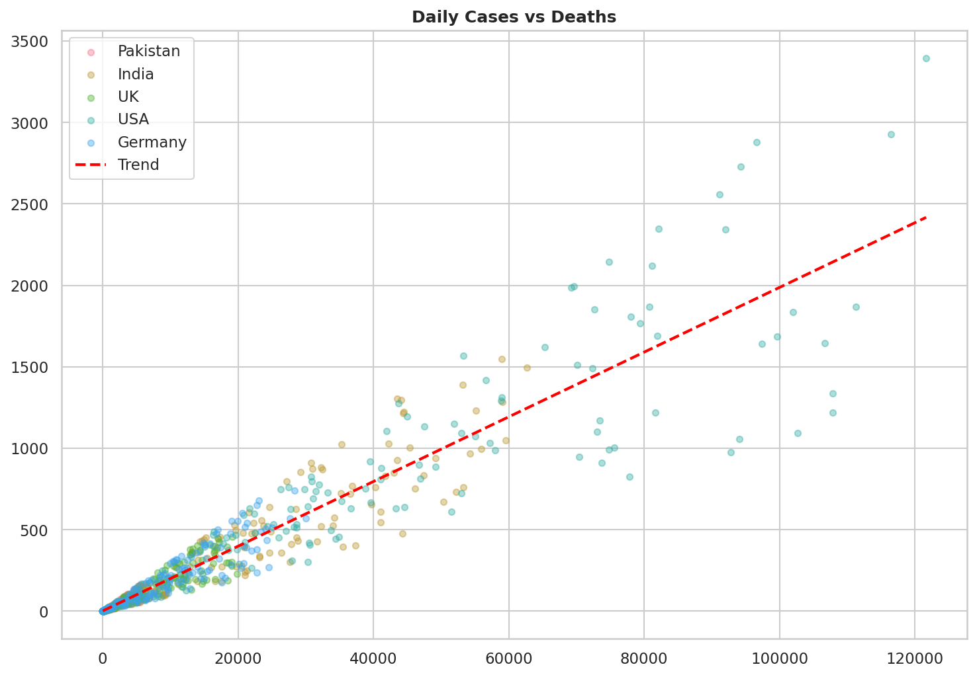
Chart 4: Scatter plot — cases vs deaths correlation
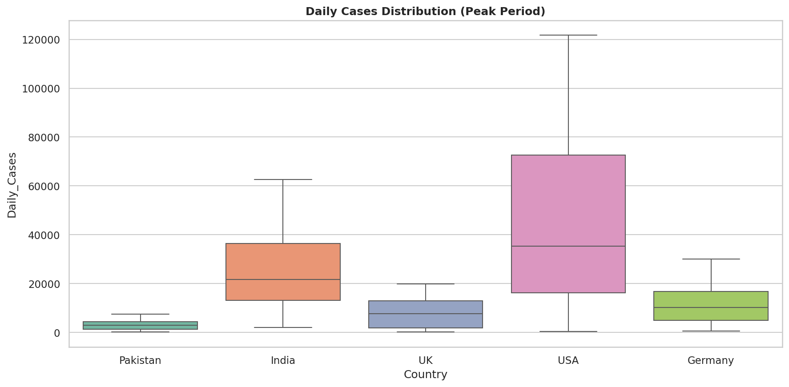
Chart 5: Box plot — distribution by country
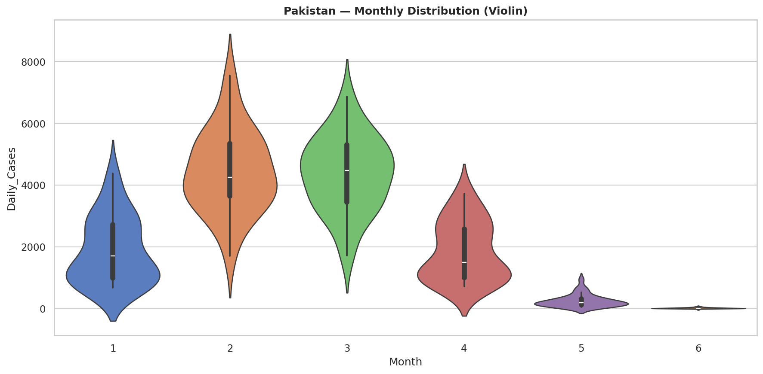
Chart 6: Violin plot — monthly distribution (Pakistan)
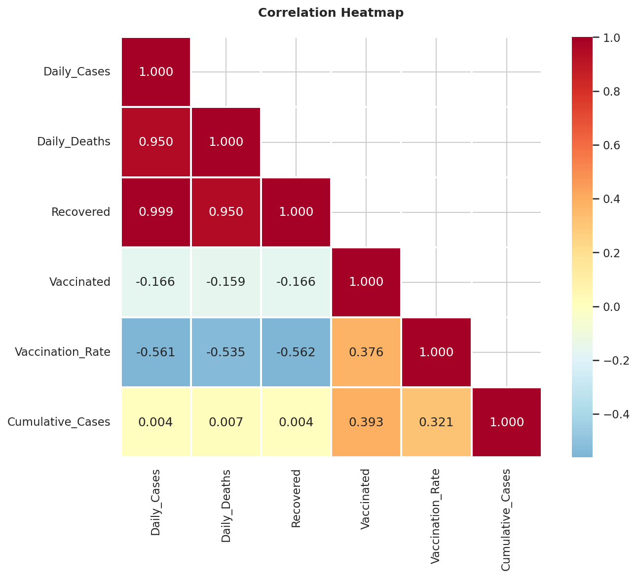
Chart 7: Heatmap — correlation matrix
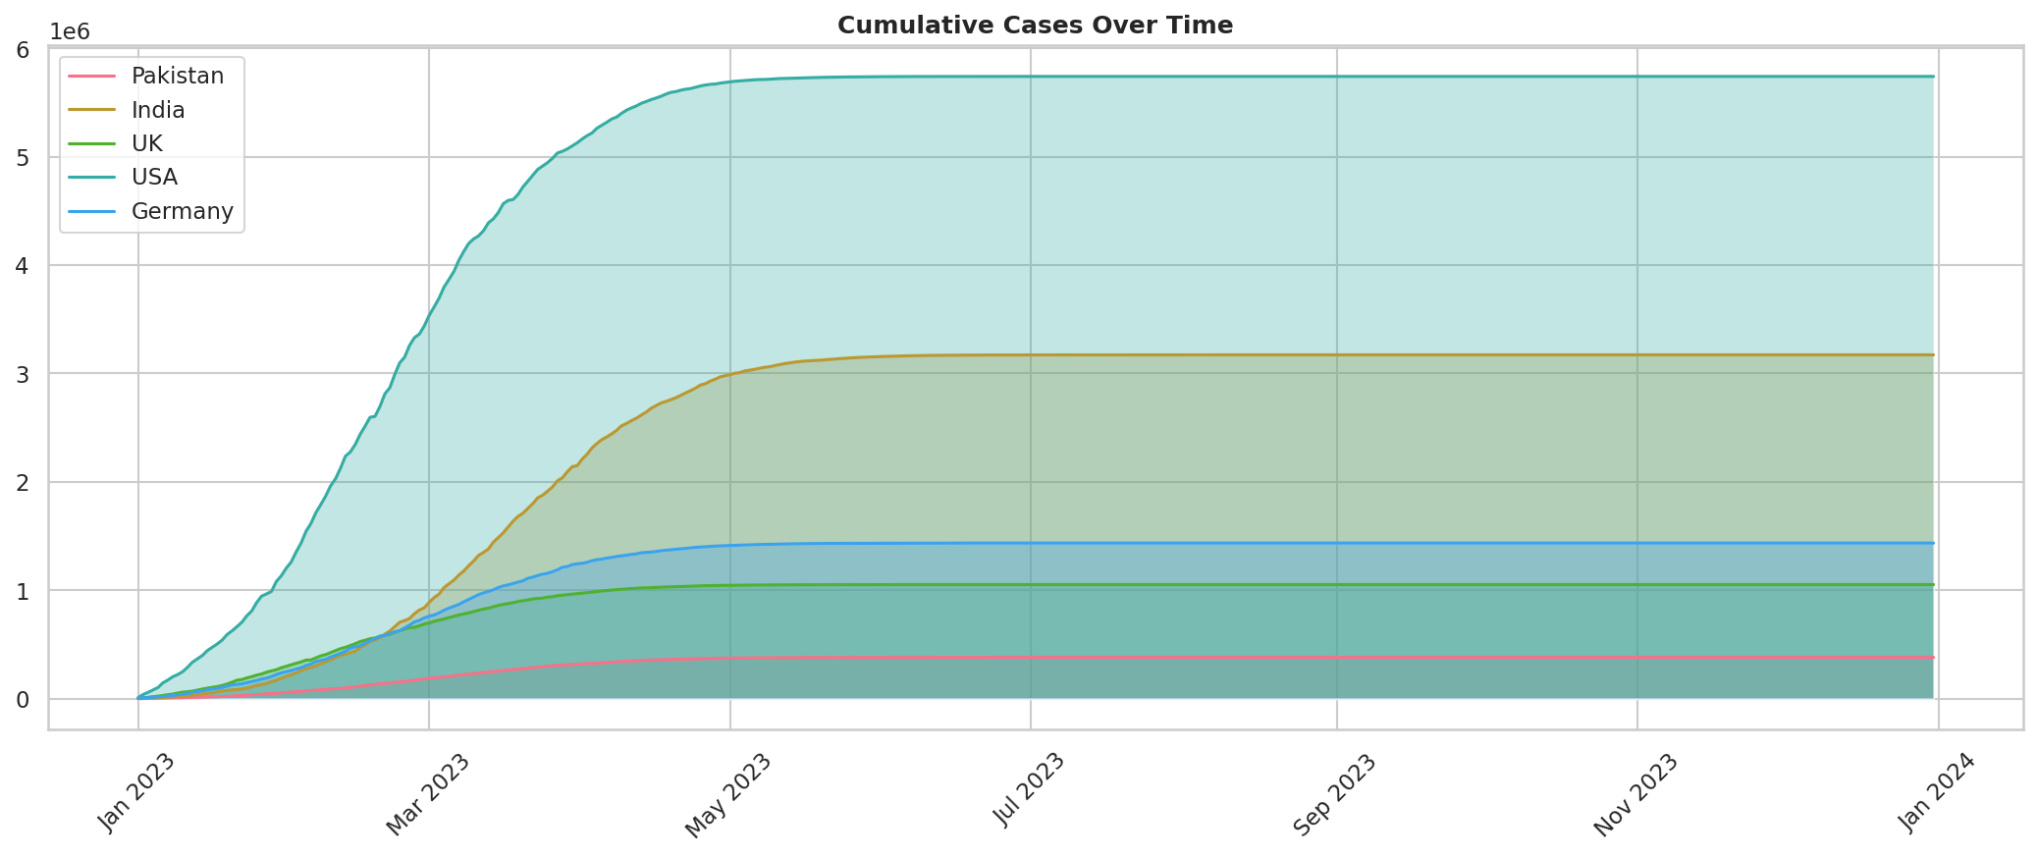
Chart 8: Area chart — cumulative cases
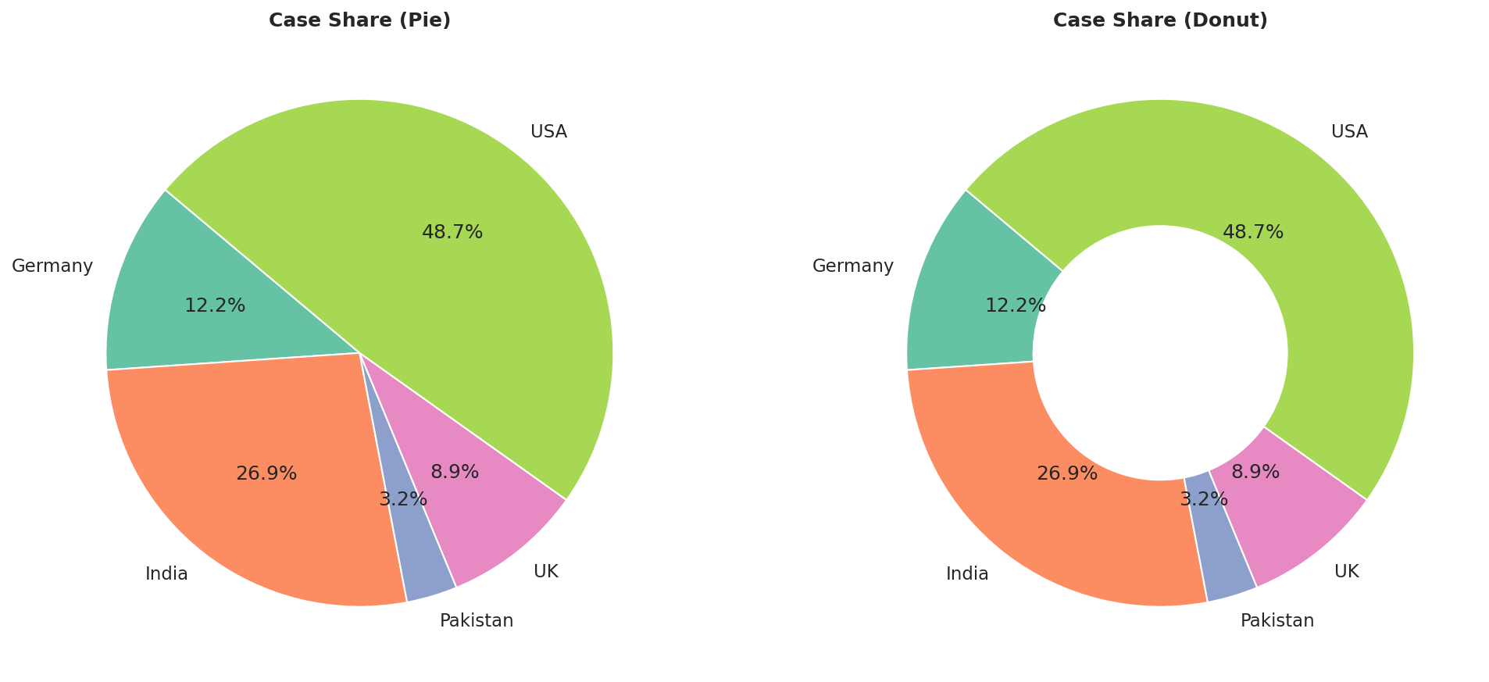
Chart 9: Pie and donut — case share
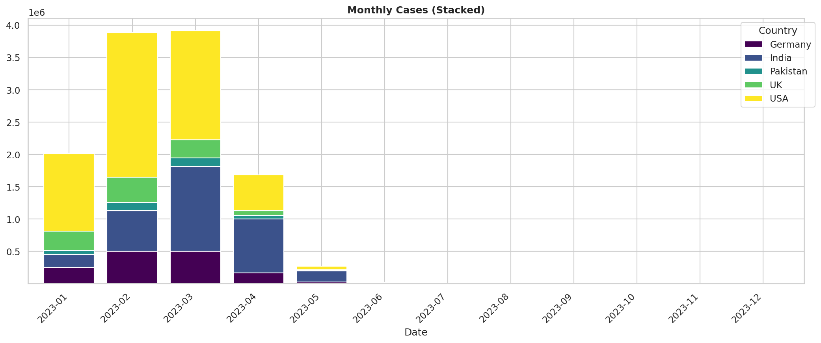
Chart 10: Stacked bar — monthly breakdown
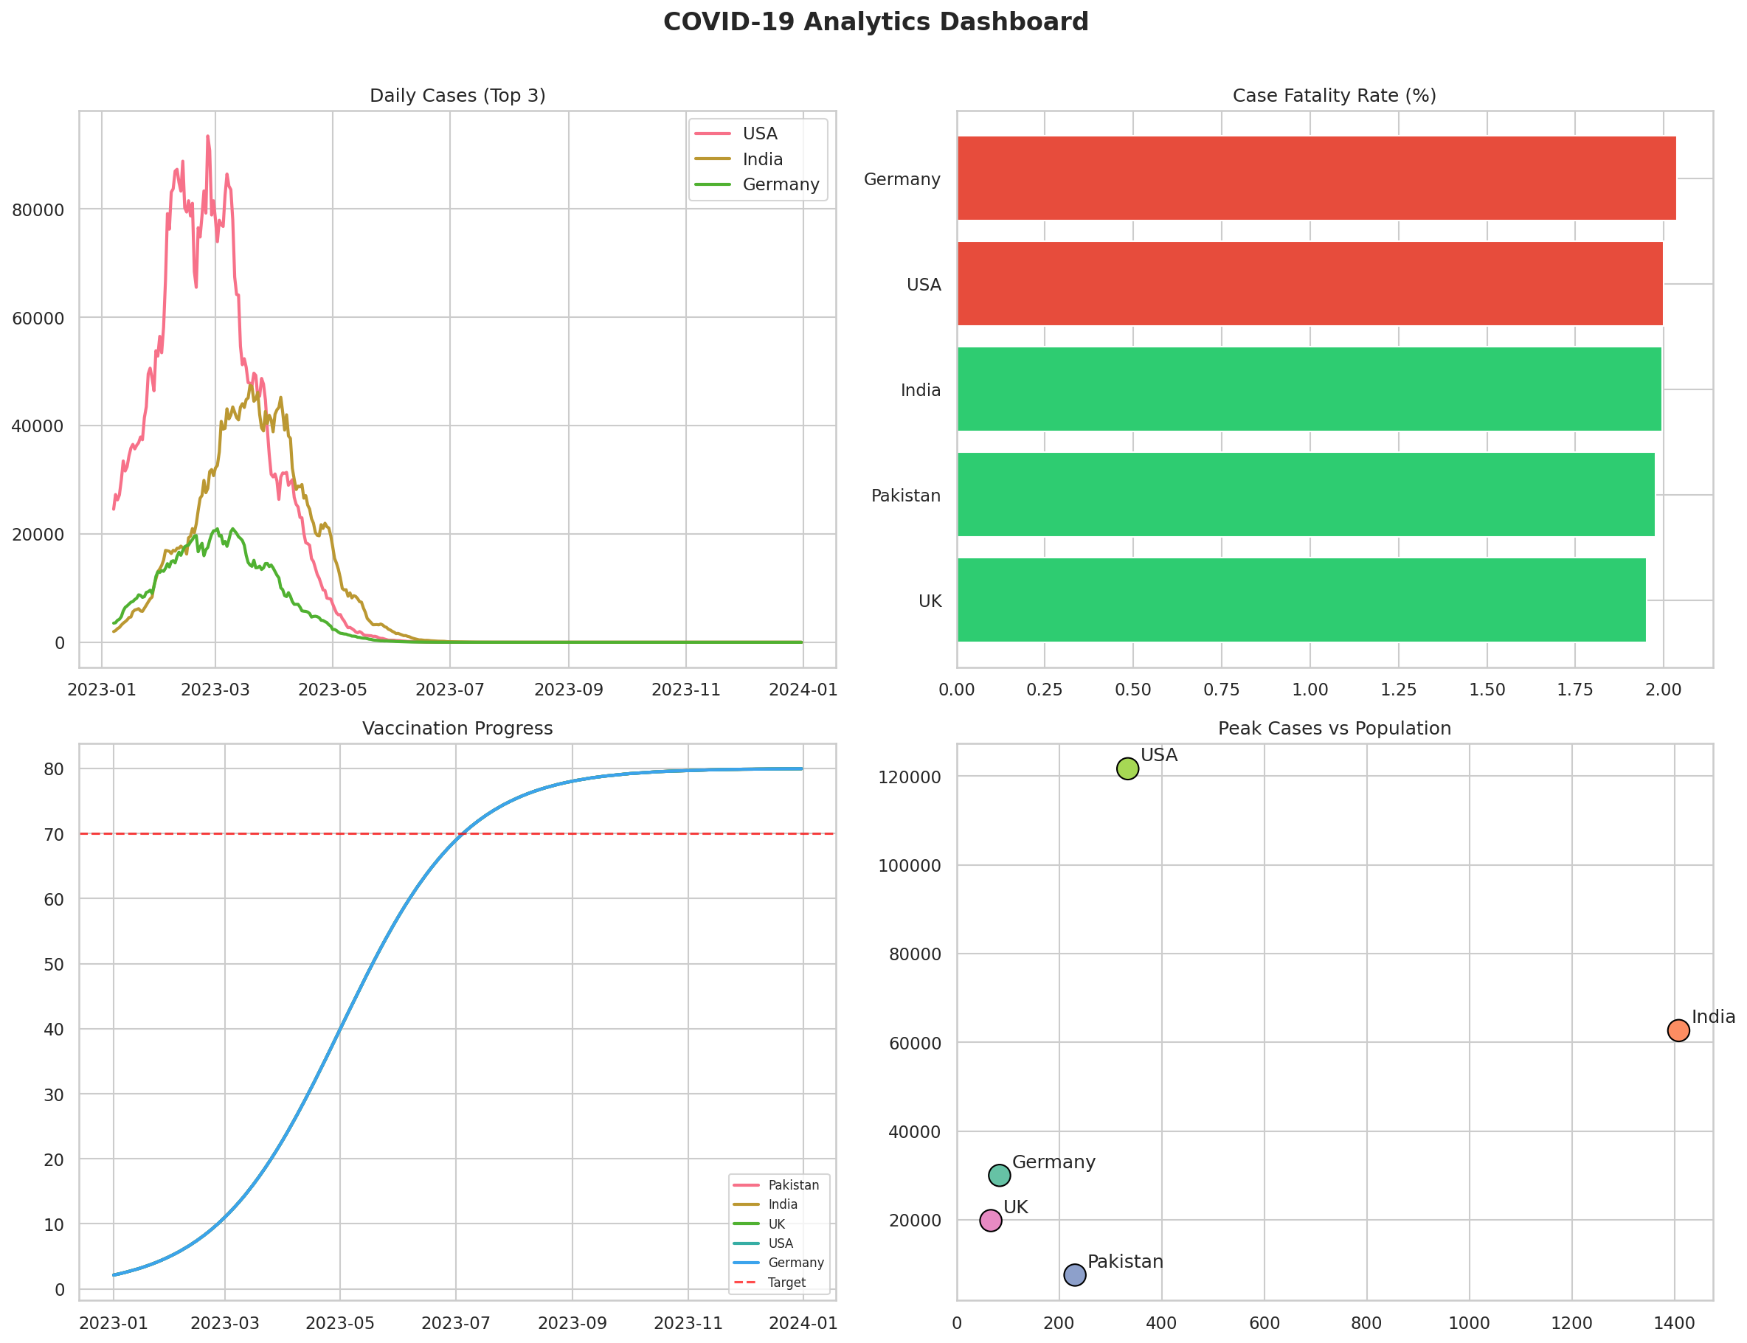
Chart 11: Multi-panel dashboard (4 subplots)
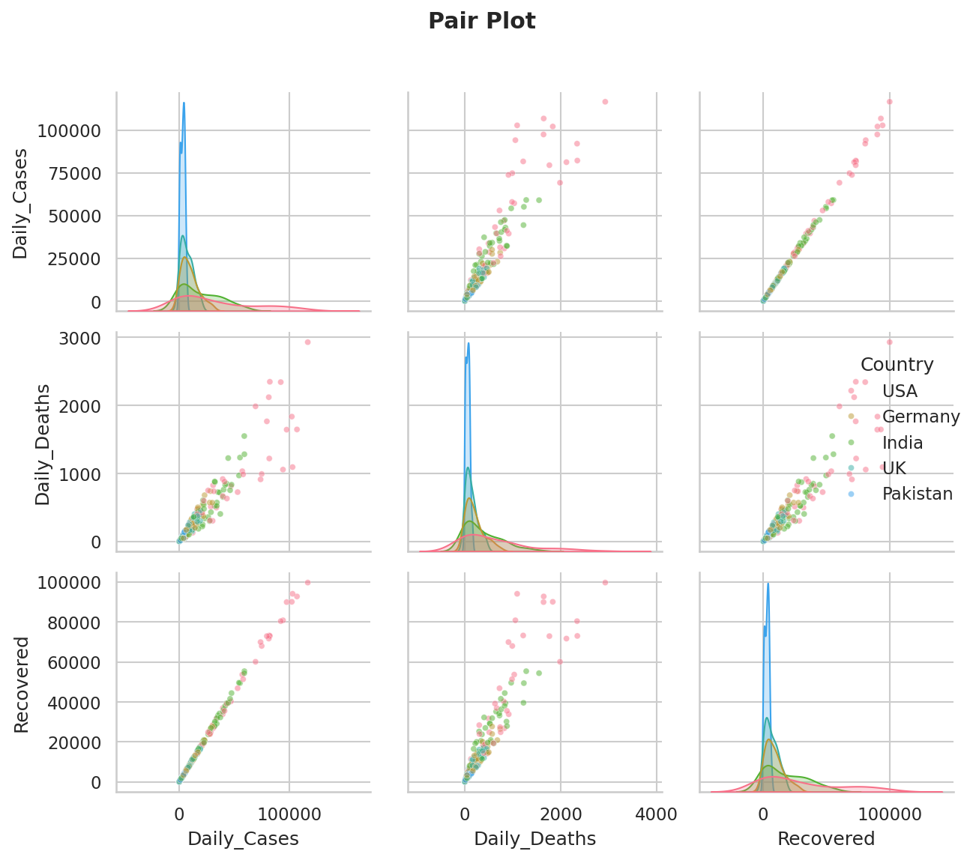
Chart 12: Pair plot — multivariate analysis

