

SRI LANKA INSTITUTE OF ADVANCE TECHNOLOGICAL EDUCATION
HIGHER NATIONAL DIPLOMA IN INFORMATION TECHNOLOGY

Project Report
Driving School Management System

Supervisor :
Mr.K.W.G.S.K. Konthasinghe

KUR/IT/2324/F/0056
M.R.M.Hameed

Table of Contents
Table of Contents 2
List of Figures 4
1.0. Executive Summary 5
1.1. Brief Overview of the Project 5
1.2. Key Objectives and Outcomes 5
1.3. Summary of Major Findings and Results 6
2.0. Introduction 7
2.1. Background Information 7
2.2. Purpose of Project 7
2.3. Scope of Project 8
2.4. Project Objectives 8
3.0. Requirements Analysis 9
3.1. Functional Requirements 9
3.2. Non-Functional Requirements 11
3.3. Use Case Diagram 12
4.0. System Design 13
4.1. Software Requirements 13
4.2. Hardware Requirements 13
4.3. Detailed Design 14
4.3.1. Sequence Diagram 14
4.3.3. Activity Diagram 15
4.3.4. Class Diagram 16
4.3.5. DFD Diagram 17
4.4. Design Considerations 17
4.5. Database Design 24
4.6. Code Snippets 25
5.0. Implementation 29
5.1. Development Environment 29
5.2. Technologies Used 29
5.3. Implementation Details 29
6.0. Testing 32
7.0. Results 33
7.1. Outcomes of the Project 33
7.2. Performance Metrics 33
7.3. Issues Encountered and Resolutions 33
8.0. Conclusion 34
8.1. Summary of the Work Done 34
8.2. Achievements 34
8.3. Limitations of the Project 35
9.0. References 36
10.0. Appendices 37
10.0.1. Additional Diagram 37
10.0.2. System Architecture 38

List of Figures

1.0. Executive Summary

1.1. Brief Overview of the Project
The LankaDrive Driving School Management System is an offline desktop application developed to simplify and automate the daily operations of driving schools in Sri Lanka. The system is built using Electron, React, Tailwind CSS, and SQLite, providing a modern desktop interface with local data storage.
The application centralizes all administrative activities, including candidate registration, admission processing, batch scheduling, instructor management, vehicle management, attendance tracking, payment management, examination scheduling, report generation, and messaging. By replacing manual record keeping with a digital system, LankaDrive improves efficiency, reduces paperwork, and ensures accurate management of driving school operations.

1.2. Key Objectives and Outcomes
The Primary Objectives of the project are:
- Develop an offline desktop management system for Sri Lankan driving schools.
- Automate candidate registration and admission processes.
- Simplify batch scheduling and training session management.
- Manage instructors and training vehicles efficiently.
- Record attendance for candidates, instructors, and office staff.
- Manage candidate fees, instructor salaries, and staff payments.
- Schedule theory and practical driving examinations.
- Generate administrative reports for management.
- Improve data accuracy while reducing manual work.

Expected outcomes include:
- Faster administrative operations.
- Improved record management.
- Better scheduling of instructors, vehicles, and training batches.
- Accurate financial and examination records.
- Reliable offline access without an internet connection.

1.3. Summary of Major Findings and Results
The completed system successfully demonstrates that an offline desktop application can effectively manage the core operations of a driving school. Major achievements include:
- Centralized management of all driving school information.
- Efficient scheduling of batches, instructors, and vehicles.
- Automated attendance and payment recording.
- Examination scheduling with result management.
- Generation of useful reports for administrative decision-making.
- Secure local data storage using SQLite.
The system provides an intuitive user interface that allows administrators to complete daily tasks quickly while minimizing errors associated with manual processes.

2.0. Introduction

2.1. Background Information
Driving schools in Sri Lanka continue to rely heavily on paper-based records and separate spreadsheets to manage candidates, instructors, vehicles, payments, and examinations. These traditional methods often lead to misplaced records, duplicated information, scheduling conflicts, and delays in administrative work.
As the number of learner drivers increases, managing training schedules, vehicle allocations, instructor assignments, attendance, and payments manually becomes increasingly difficult.
The LankaDrive Driving School Management System was developed to address these challenges by providing an integrated offline desktop solution specifically designed for Sri Lankan driving schools. The system enables administrators to manage all major operational activities from a single application while maintaining accurate and secure records using a local SQLite database.

2.2. Purpose of Project
The purpose of the LankaDrive - Driving School Management System is to develop an integrated offline desktop application that automates and manages the daily operations of driving schools in Sri Lanka. The system is designed to replace manual record-keeping and paper-based processes with a centralized digital solution, improving efficiency, accuracy, and data management.
The application enables administrators to manage candidate registrations, admissions, batch scheduling, instructor assignments, vehicle allocation, attendance, payments, examinations, and reporting from a single platform. By storing all information in a local SQLite database, the system ensures reliable operation without requiring an internet connection, making it suitable for driving schools operating in offline environments.
Furthermore, the system aims to reduce administrative workload, minimize scheduling conflicts, improve record accuracy, simplify report generation, and provide better overall management of driving school activities.

2.3. Scope of Project
- Candidate Management: Register, update, search, and maintain candidate information, including personal details and license categories.
- Admission Management: Process admissions by recording medical status, verifying required documents, and confirming candidate enrollment.
- Batch Scheduling: Create and manage training batches, allocate candidates, assign instructors and vehicles, and schedule theory, practical, and trial practice sessions.
- Instructor Management: Maintain instructor profiles, license information, availability, qualifications, and batch assignments.
- Vehicle Management: Register and manage training vehicles, monitor availability, maintain service records, and allocate vehicles to training sessions.
- Attendance Management: Record and monitor attendance for candidates, instructors, and office staff, with attendance summaries and reports.
- Payment Management: Record candidate fee payments, manage outstanding balances, generate receipts, and maintain salary payment records.
- Examination Management: Schedule theory and practical driving examinations, record results, and manage issued driving license details.
- Report Generation: Generate reports related to candidates, admissions, attendance, payments, examinations, instructors, vehicles, and overall system activities.
- Notification and Message Management: Send announcements to candidates and maintain communication records within the system.
The current scope does not include online candidate registration, online payment gateways, SMS integration, GPS tracking, or direct integration with the Sri Lanka Department of Motor Traffic (DMT). These features may be considered as future enhancements.

2.4. Project Objectives
- To provide a secure administrator login for accessing the system.
- To manage candidate registration and personal information efficiently.
- To streamline the admission process by verifying required documents and approving admissions.
- To organize candidates into training batches and assign instructors and vehicles.
- To maintain instructor and vehicle information in a centralized database.
- To record and monitor candidate, instructor, and staff attendance.
- To manage candidate fee payments and record staff and instructor salary payments.
- To schedule and manage theory examinations and practical driving trials.
- To issue and record L Permit details for candidates who pass the theory examination.
- To record examination results and track candidate progress until licence completion.
- To generate reports for candidates, admissions, attendance, payments, examinations, instructors, vehicles, and licences.

3.0. Requirements Analysis
Requirements analysis was conducted by studying the daily operations of driving schools in Sri Lanka and identifying the challenges associated with manual record management. Many driving schools still rely on paper files, handwritten registers, and spreadsheets to manage candidates, admissions, training schedules, payments, examinations, and reports, which often leads to data duplication, misplaced records, scheduling conflicts, and delayed report generation.

3.1. Functional Requirements
User Authentication
- The system shall provide a secure login interface for authorized administrators.
- The system shall validate usernames and passwords before granting access.
- The system shall restrict access to unauthorized users.
Candidate Registration
- The system shall allow administrators to register, edit, delete, search, and filter candidate records.
- The system shall store candidate personal information, contact details, and license category.
Admission Management
- The system shall process candidate admissions, record medical verification status, maintain document verification information, and update admission status.
Batch Scheduling
- The system shall allow creation of training batches, allocation of candidates, assignment of instructors and vehicles, and scheduling of theory, practical, and trial practice sessions.
Instructor Management
- The system shall store instructor information, license and qualification details, availability, and allow updates to instructor records.
Vehicle Management
- The system shall maintain vehicle registration information, category, availability, maintenance and service records.
Attendance Management
- The system shall record candidate, instructor, and office staff attendance, and generate attendance summaries and reports.
Payment Management
- The system shall record candidate fee payments, calculate outstanding balances, generate payment receipts, and record instructor and staff salary payments.
Examination Management
- The system shall schedule theory examinations and practical driving trials, record results, maintain examination history, and record issued driving license details.
Report Generation
- The system shall generate candidate, attendance, payment, examination, and administrative summary reports.
Notification and Message Management
- The system shall allow administrators to send internal notifications, maintain message records, and display notifications within the application.

Database Management
- The system shall store all data in a local SQLite database and support database backup and restore operations.

3.2. Non-Functional Requirements
Performance
- The system shall provide fast response times and retrieve records efficiently, generating reports within a reasonable time.
Reliability
- The system shall operate reliably offline, ensure data consistency, and recover successfully after unexpected shutdowns.
Security
- The system shall provide secure administrator authentication and restrict access to authorized users only.
Usability
- The system shall provide a simple, user-friendly interface with clear navigation and validation messages.
Maintainability
- The system shall follow a modular architecture that supports future enhancements.
Scalability
- The system shall support an increasing number of candidates, instructors, vehicles, and administrative records.
Availability
- The system shall be available for daily operations without requiring an internet connection.
Data Integrity
- The system shall maintain accurate and consistent data and validate input before saving to the database.

Compatibility
- The system shall be compatible with Windows 10 and Windows 11 (64-bit) operating systems.
Backup and Recovery
- The system shall support manual database backup and restoration of previously backed-up SQLite databases.

3.3. Use Case Diagram
Since the LankaDrive Driving School Management System is designed with a single Administrator login, the Administrator is the only actor who interacts with all system functions, including login, dashboard management, candidate management, admission management, batch scheduling, instructor management, vehicle management, attendance management, payment management, examination management, report management, notification management, settings, and logout.

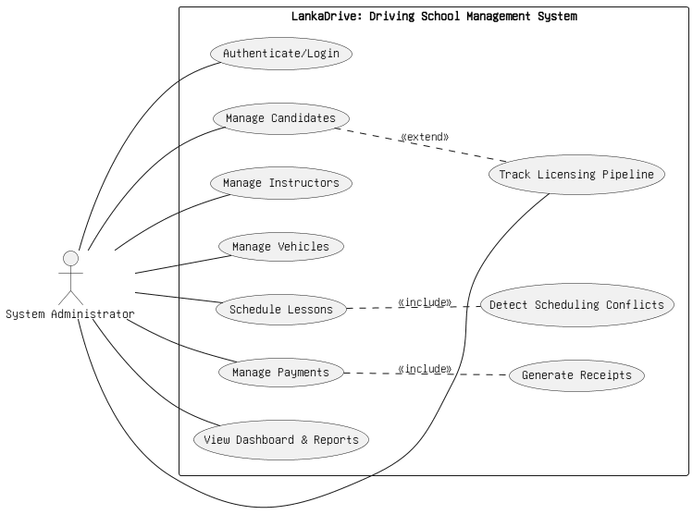
Figure 1 - Use Case Diagram

4.0. System Design

4.1. Software Requirements
- Electron - Desktop application framework.
- React.js - Front-end user interface development.
- Tailwind CSS - Responsive user interface styling.
- SQLite - Local database management system.
- Node.js - JavaScript runtime environment.
- npm (Node Package Manager) - Package and dependency management.
- Visual Studio Code - Source code editor.
- Git - Version control system.
- GitHub - Source code repository and version management.
- Electron Builder - Packaging and generating Windows executable (.exe) installer.

4.2. Hardware Requirements
Component | Minimum Requirement | Recommended Requirement
Processor | Intel Core i3 | Intel Core i5 or Higher
RAM | 4 GB | 8 GB
Storage | 2 GB Free Disk Space | 5 GB Free Disk Space
Operating System | Windows 10 (64-bit) | Windows 11 (64-bit)

4.3. Detailed Design

4.3.1. Sequence Diagram
The sequence diagram illustrates the interaction between the Administrator, the React front end, the Electron application logic, and the SQLite database during a typical operation such as candidate registration or batch scheduling.

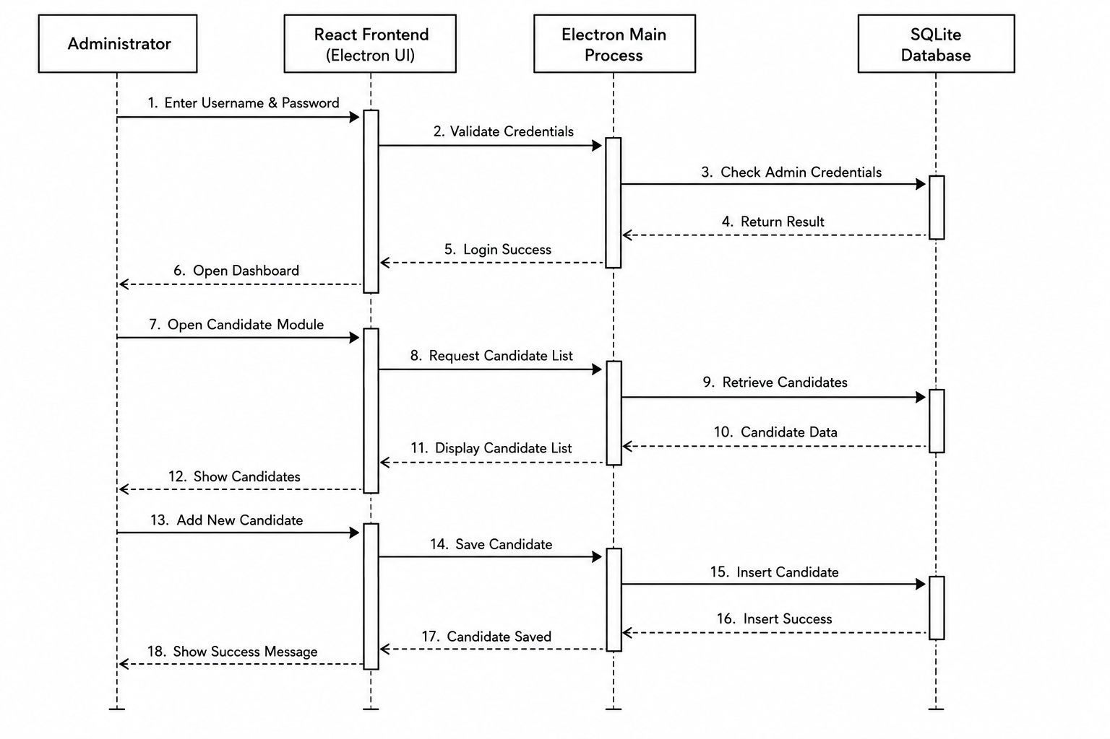

Figure 3 - Sequence Diagram

4.3.3. Activity Diagram
The activity diagram describes the step-by-step flow of a core process within the system, from administrator login through record creation, validation, and confirmation.

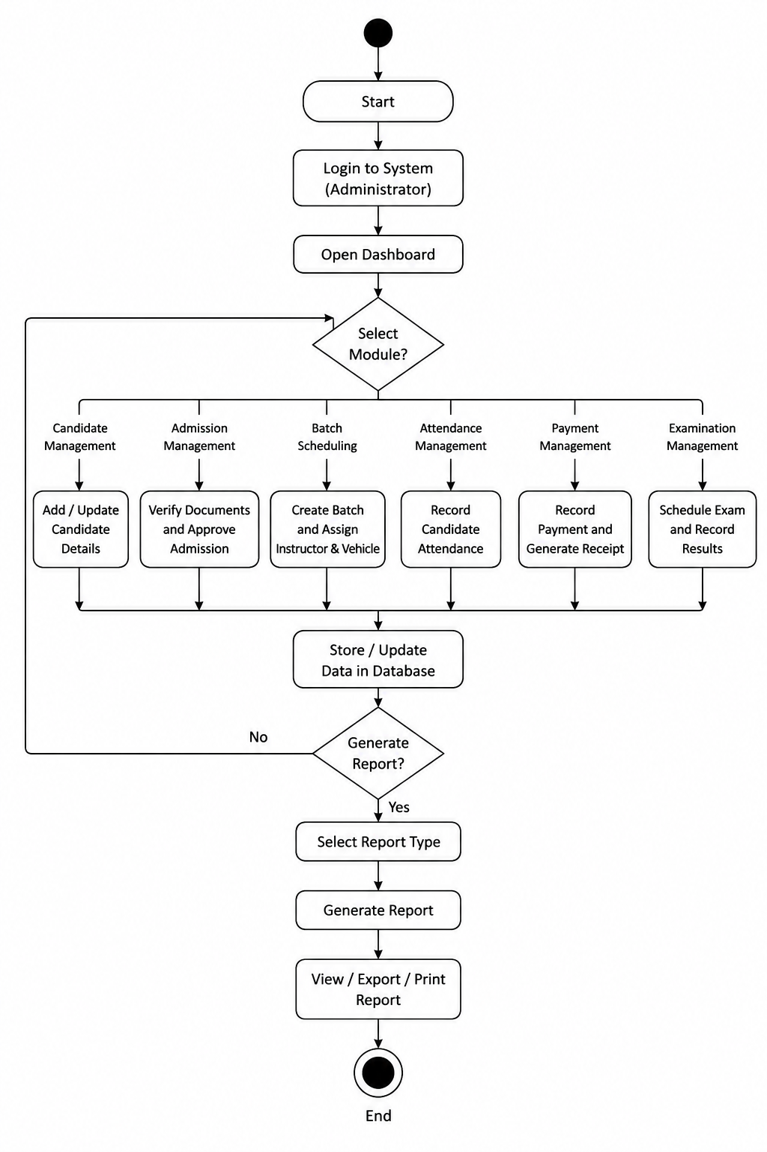

Figure 4 - Activity Diagram

4.3.4. Class Diagram
The class diagram represents the major entities of the system — Administrator, Candidate, Batch, Instructor, Vehicle, Attendance, Payment, and Examination — along with their attributes, operations, and relationships.

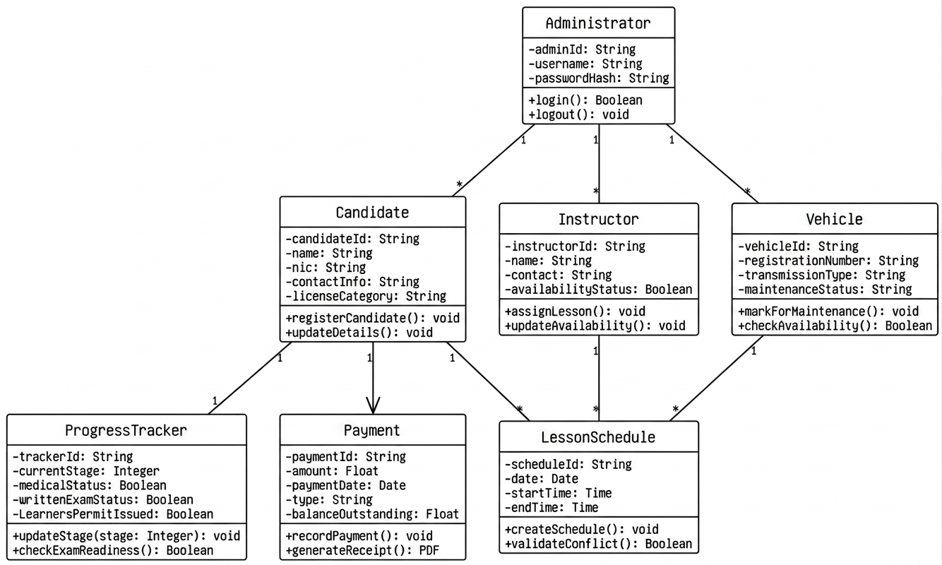

Figure 5 - Class Diagram

4.3.5. DFD Diagram
The Data Flow Diagram illustrates how data moves between the Administrator, the LankaDrive application processes, and the SQLite database across the major modules of the system.

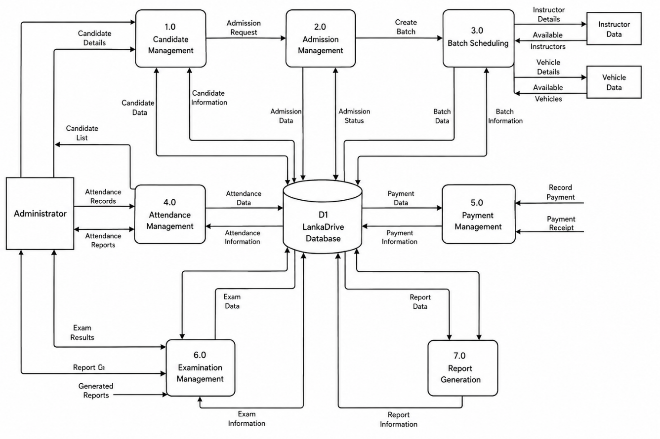

Figure 6 - DFD Diagram

4.4. Design Considerations

Login Page
Provides a secure split-screen login interface for the Administrator to sign in using a username and password before accessing the system.
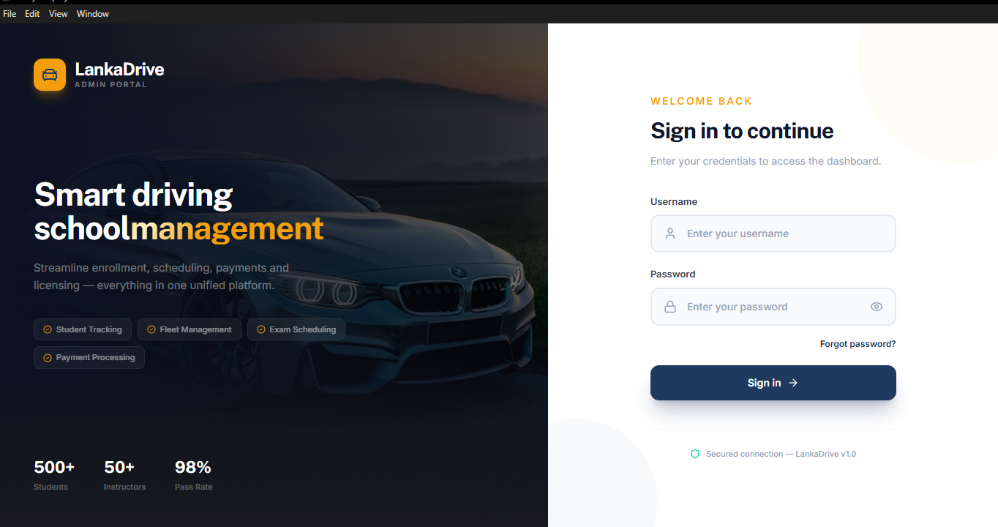

Figure 7 - Login Page
Dashboard
Displays an overview of the entire driving school operation, including total candidates, active batches, available instructors, available vehicles, today's sessions, pending payments, and upcoming examinations.

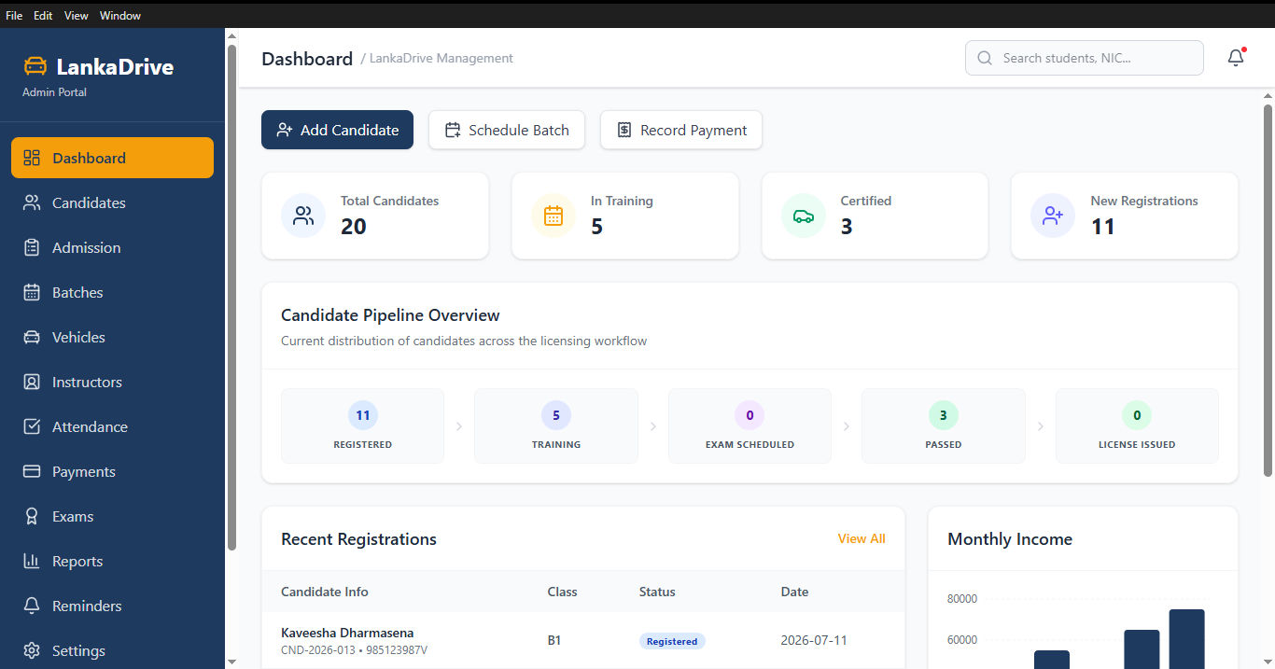

Figure 8 – Dashboard
Candidate Management Page
Allows the Administrator to register, edit, delete, search, and filter candidate records, including license category and medical status.
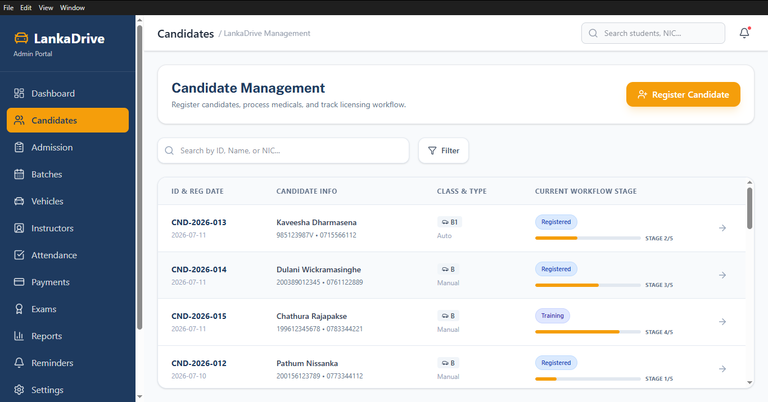
Figure 9 - Candidate Management Page

Admission Management Page
Allows the Administrator to process admissions, verify documents, record medical status, and track admission status.
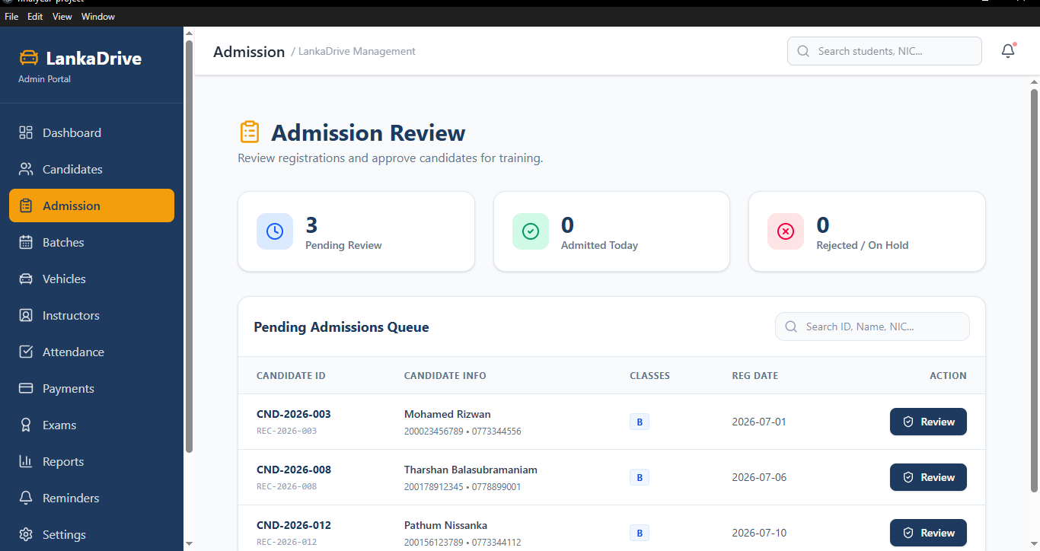
Figure 10 - Admission Management Page
Batch Scheduling Page
Allows the Administrator to create and manage training batches, allocate candidates, assign instructors and vehicles, and schedule theory, practical, and trial sessions using a calendar view.
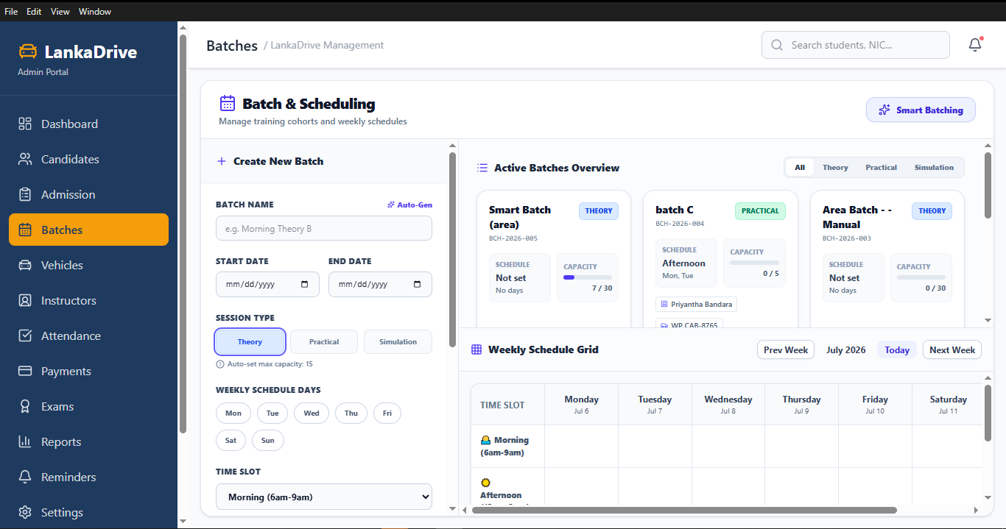
Figure 11 - Batch Scheduling Page

Instructor Management Page
Allows the Administrator to register and manage instructor details, licence information, availability, and assigned batches.
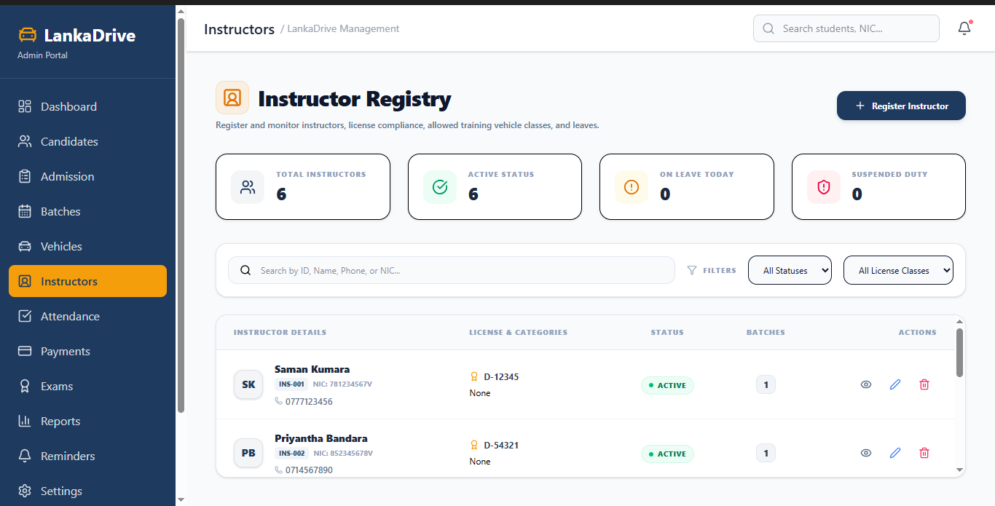
Figure 12 - Instructor Management Page
Vehicle Management Page
Allows the Administrator to register and manage training vehicles, including category, availability, insurance, and maintenance records.
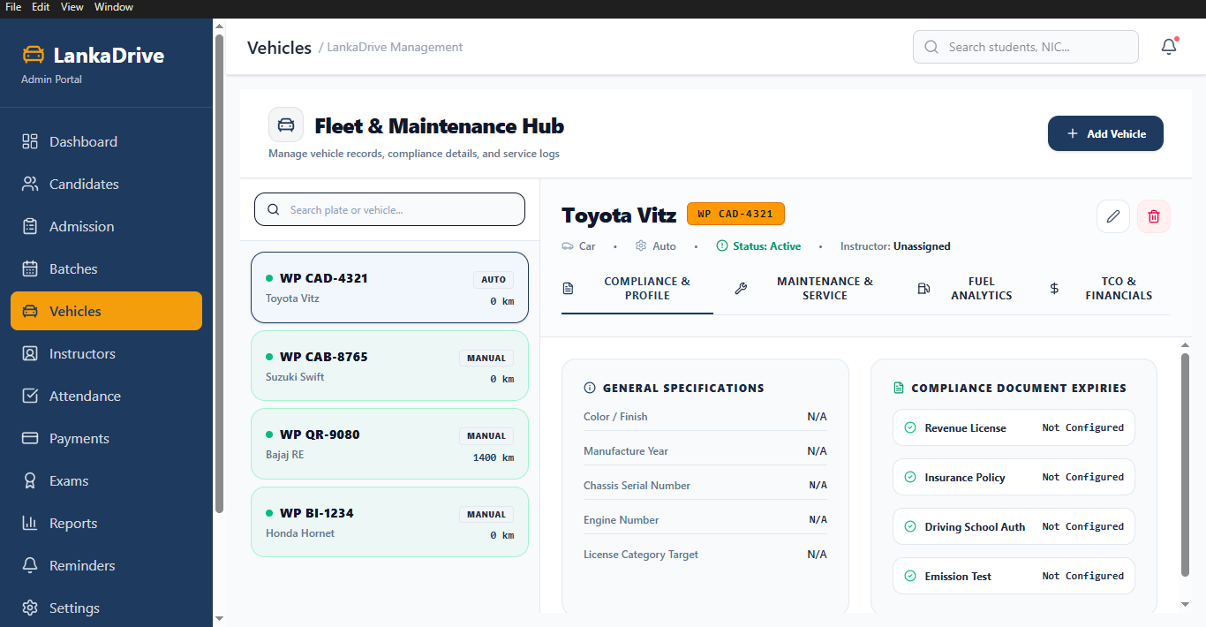
Figure 13 - Vehicle Management Page

Attendance Management Page
Allows the Administrator to record daily attendance for candidates, instructors, and office staff, and view attendance summaries.
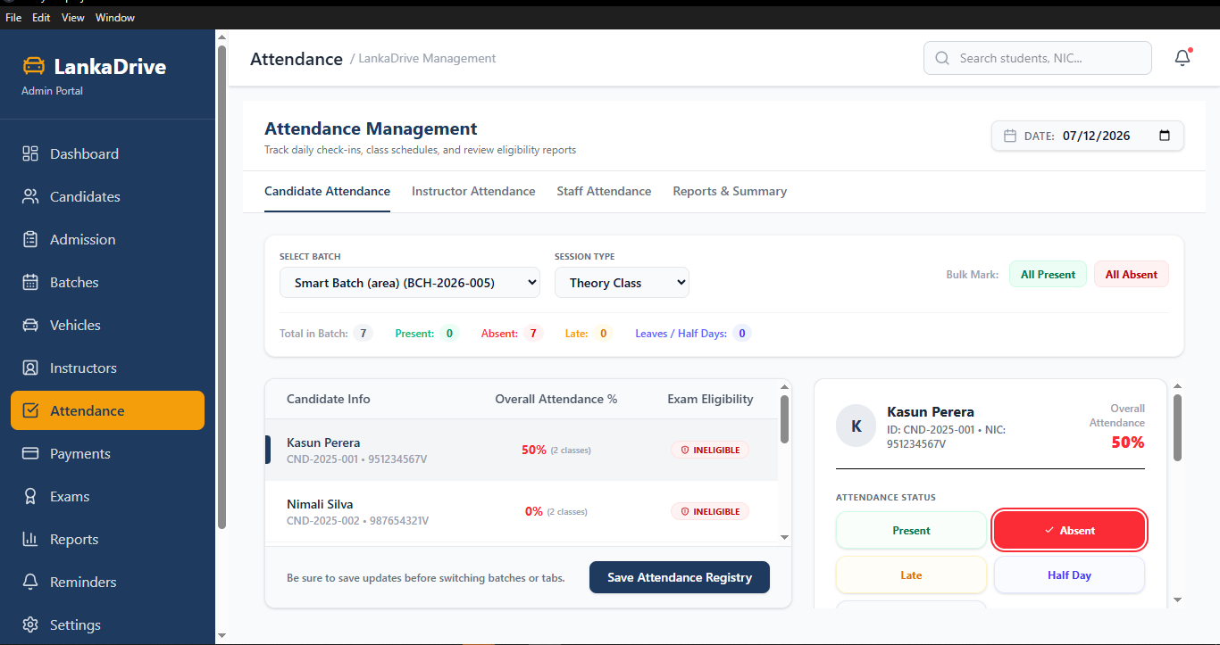
Figure 14 - Attendance Management Page
Payment Management Page
Allows the Administrator to record candidate fee payments, calculate outstanding balances, generate receipts, and record salary payments.
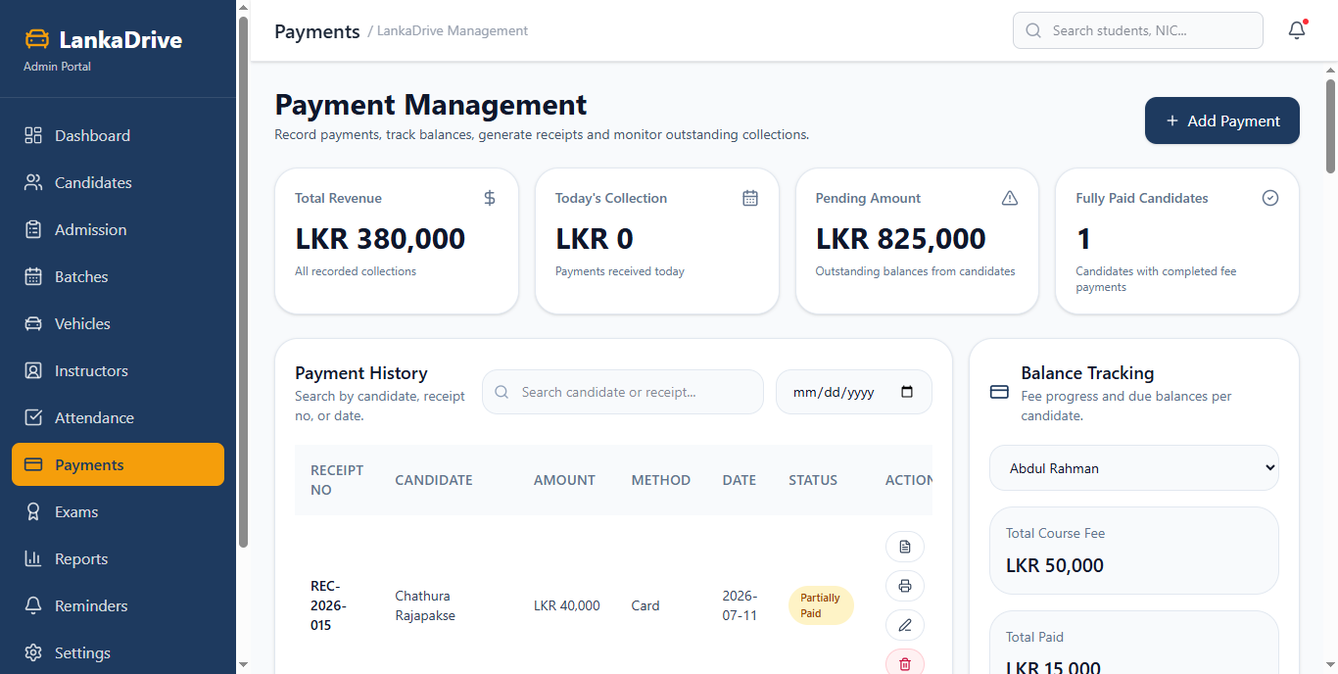
Figure 15 - Payment Management Page

Examination Management Page
Allows the Administrator to schedule theory examinations and practical driving trials, record results, and manage issued license details.
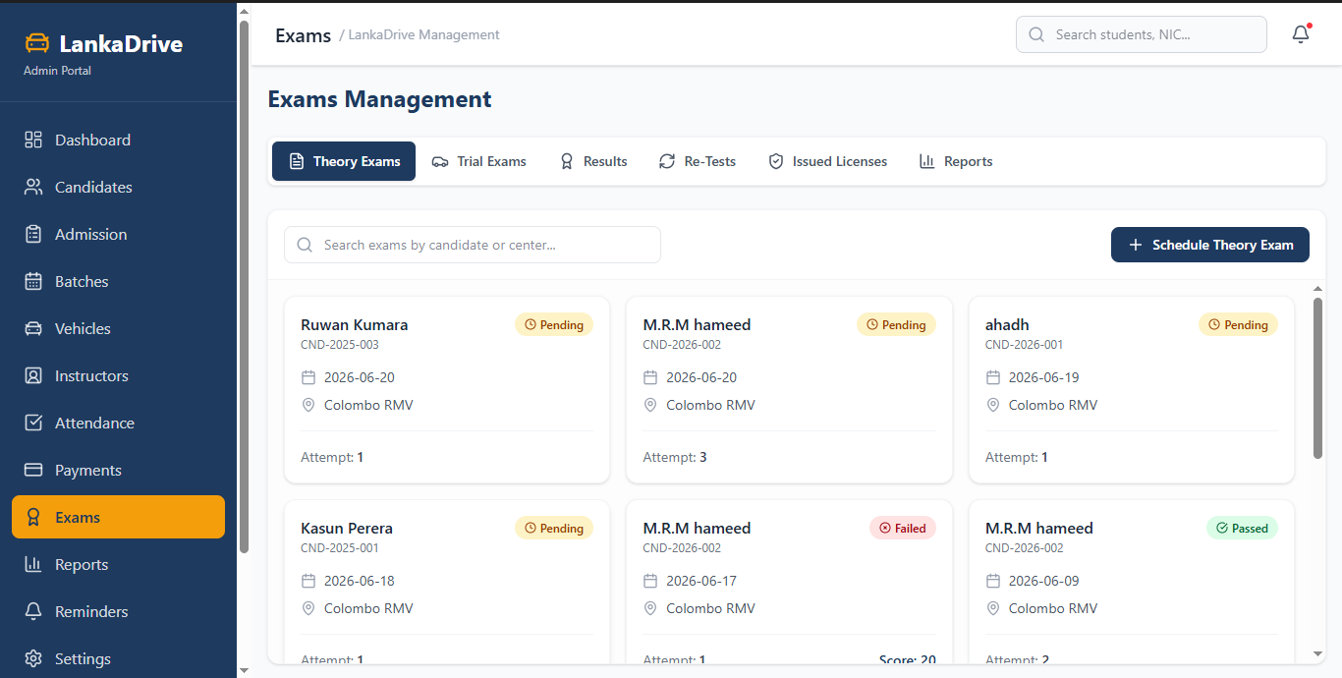
Figure 16 - Examination Management Page
Report Page
Displays candidate, admission, batch, attendance, payment, examination, vehicle, instructor, and licence reports for administrative decision-making.
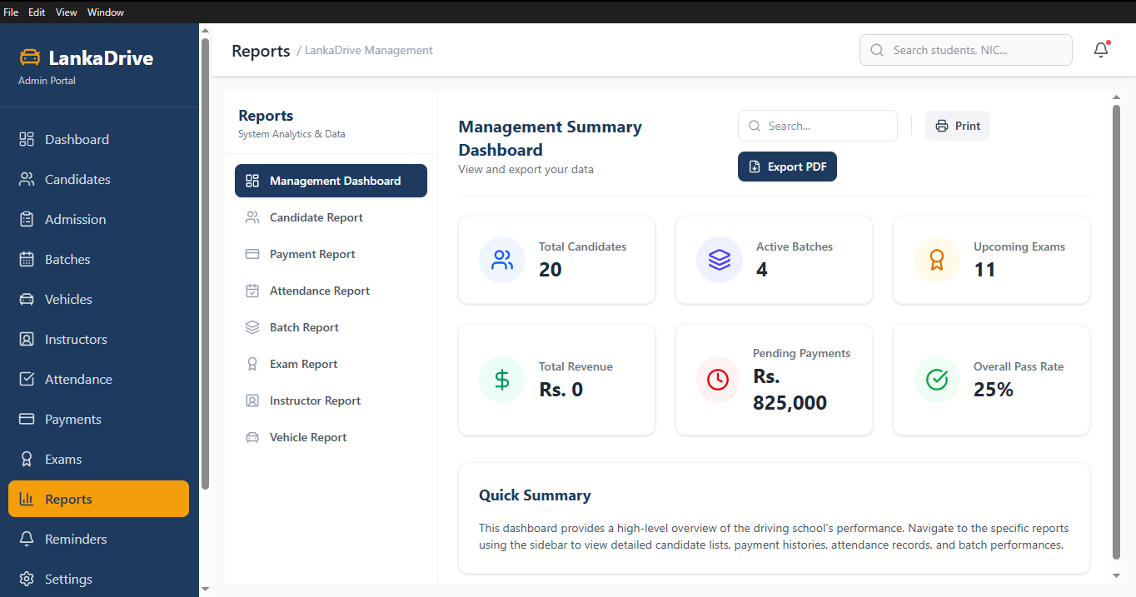
Figure 17 - Report Page
Notification Page
Allows the Administrator to send internal notifications, view system announcements, and review notification history.
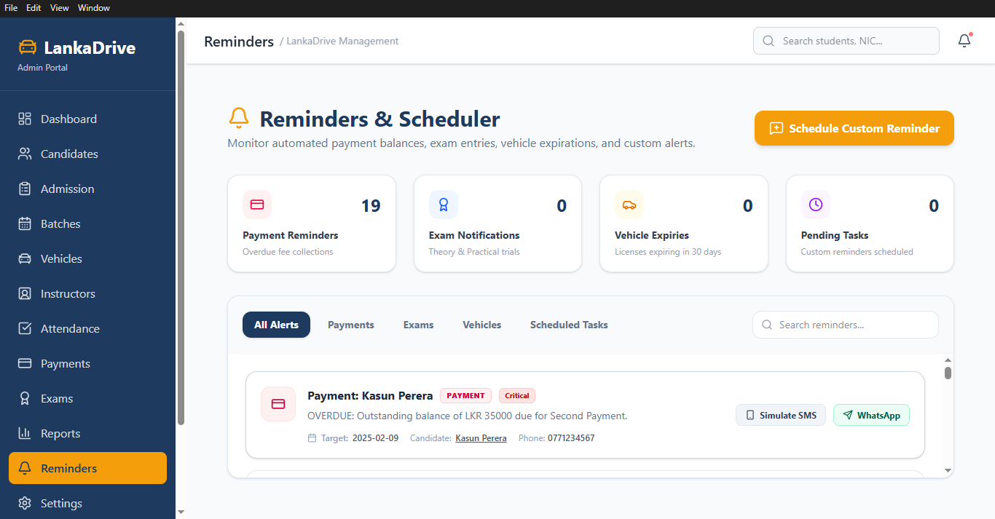
Figure 18 - Notification Page

4.5. Database Design
The LankaDrive-Driving School Management System uses SQLite as its database management system. SQLite is a lightweight, serverless, and self-contained relational database well suited for offline desktop applications, storing all application data in a single database file.

Database Tables
Table Name | Purpose
Admin | Stores administrator login credentials
Candidates | Stores candidate information
Admissions | Stores admission records
Batches | Stores training batch information
Batch Candidates | Stores candidate allocations to batches
Instructors | Stores instructor details
Vehicles | Stores training vehicle information
Sessions | Stores theory and practical training sessions
Attendance | Stores attendance records
Candidate Payments | Stores candidate payment details
Staff Payments | Stores instructor and office staff salary records
Examinations | Stores theory and practical examination schedules
Exam_Results | Stores examination results
Licenses | Stores issued driving license information
Notifications | Stores system notifications and messages

Primary Key and Foreign Key Relationships
- Each Admission record belongs to one Candidate.
- Each Batch contains multiple Candidates.
- Each Training Session belongs to one Batch.
- Each Training Session is assigned one Instructor.
- Each Training Session uses one Vehicle.
- Each Attendance record belongs to one Candidate.
- Each Payment belongs to one Candidate.
- Each Exam Result belongs to one Examination and one Candidate.
- Each License record belongs to one successful Candidate.
Database Integrity
- Every table contains a unique Primary Key.
- Foreign Keys maintain relationships between related tables.
- Mandatory fields cannot be left empty.
- Duplicate records are prevented where applicable.
- Invalid references are not permitted.
- Input validation is performed before data is stored.
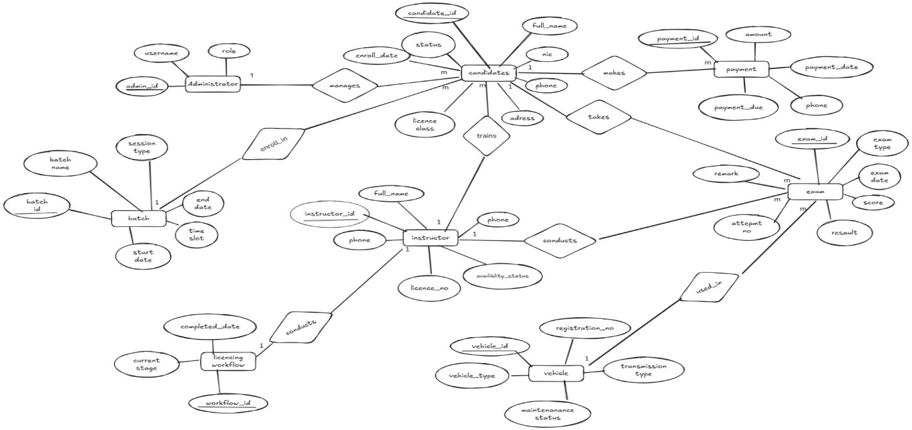

Figure 19 - ER Diagram

4.6. Code Snippets
This section reserves space for representative code screenshots from the LankaDrive implementation (Electron main process, React components, and SQLite queries) covering key modules such as Candidate Registration, Batch Scheduling, Attendance, Payment, and Examination Management.
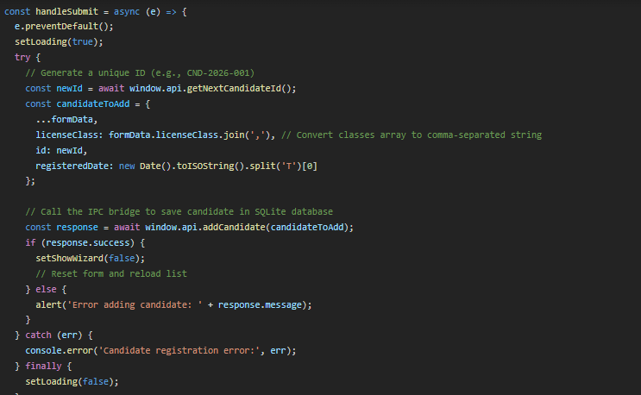
Figure 20 - Candidate Registration Code
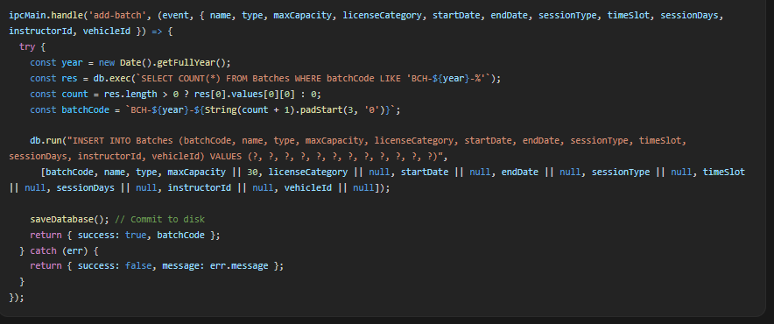
Figure 21 - Batch Scheduling Code
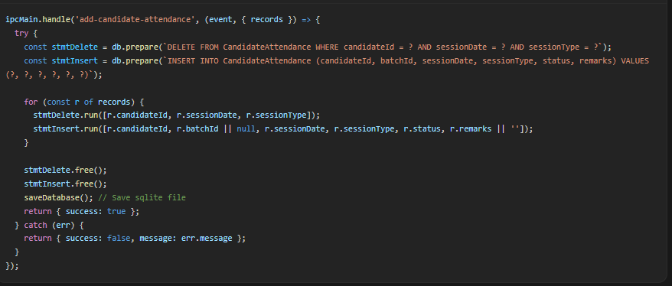
Figure 22 - Attendance Management Code
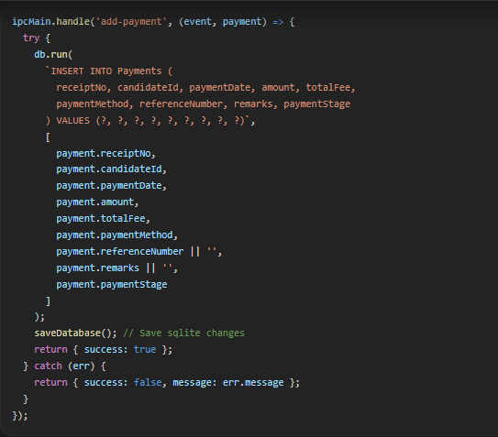
Figure 23 - Payment Management Code
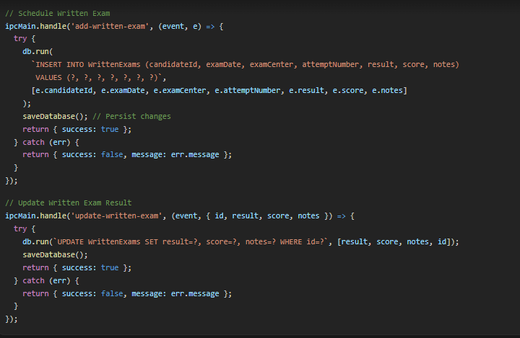
Figure 24 - Examination Management Code
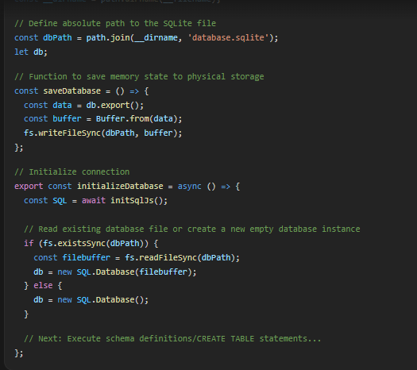
Figure 25 - Database Connection Code

5.0. Implementation

5.1. Development Environment
Component | Technology Used
Programming Language | JavaScript
Desktop Framework | Electron
Front-end Library | React.js
UI Framework | Tailwind CSS
Database | SQLite
Package Manager | npm
Development Environment | Visual Studio Code
Version Control | Git
Repository Hosting | GitHub
Build Tool | Vite
Desktop Packaging | Electron Builder

5.2. Technologies Used
- Frontend Framework - React.js with Tailwind CSS.
- Desktop Runtime - Electron with Node.js.
- Database - SQLite (local, serverless, file-based).
- Packaging - Electron Builder for Windows installer (.exe).

5.3. Implementation Details
The LankaDrive system consists of twelve major functional modules, each implemented as an independent, reusable component sharing data through the centralized SQLite database.
Dashboard Module
- Total Candidates, Active Batches, Available Instructors, Available Vehicles, Today's Sessions, Pending Payments, Upcoming Examinations, Quick Navigation Cards.
Candidate Management Module
- Register, Edit, Delete, View Profile, Search, Filter, License Category Management, Medical Status Display, License Issued Status.
Admission Management Module
- Admission Registration, Medical Verification, Document Verification, Admission Approval, Status Tracking.
Batch Scheduling Module
- Create/Update/Delete Batch, Candidate Allocation, Instructor Assignment, Vehicle Assignment, Theory/Practical/Trial Scheduling, Calendar View, Batch Status Management.
Instructor Management Module
- Register/Edit/Delete Instructor, License Information, Availability, Experience Details, Assigned Batches, Salary Information.
Vehicle Management Module
- Register/Update/Delete Vehicle, Category, Registration Number, Availability Status, Insurance Information, Maintenance Records, Allocation.
Attendance Management Module
- Candidate/Instructor/Office Staff Attendance, Daily and Monthly Attendance, Attendance Summary and Reports.
Payment Management Module
- Candidate Fee Collection, Instalment Payments, Balance Calculation, Receipt Generation, Instructor/Staff Salary Payment, Payment History and Reports.
Examination Management Module
- Theory Examination, Practical Driving Trial, Examination Schedule, Candidate Assignment, Results, Pass/Fail Status, License Issued Records.
Report Module
- Candidate, Admission, Batch, Attendance, Payment, Examination, Vehicle, Instructor, and License Reports.
Notification Module
- Send Notification, System Announcements, Reminder Messages, Notification History.
Security Implementation
- Administrator Authentication, Password Validation, Input Validation, Required Field Validation, Data Integrity Checks, Confirmation Before Delete, Secure SQLite Storage.
Application Deployment
- Packaged as a Windows desktop application using Electron Builder, producing a Windows Installer (.exe) with offline installation, local SQLite database, and no internet requirement.

6.0. Testing
Comprehensive testing was performed throughout the development process. Each module was tested individually (unit testing) and then integrated with the complete system to verify overall functionality, data consistency, and usability (integration and system testing). User Acceptance Testing (UAT) was conducted with a driving school administrator to confirm the system met operational requirements.
Test Cases
Test Case | Input | Expected Result | Actual Result | Status
Administrator Login | Valid Username and Password | Dashboard Opens Successfully | Dashboard Opened Successfully | Pass
Candidate Registration | Complete Candidate Details | Candidate Saved Successfully | Candidate Saved Successfully | Pass
Batch Scheduling | Batch Details, Instructor, Vehicle | Batch Created Successfully | Batch Created Successfully | Pass
Attendance Recording | Attendance Details | Attendance Saved | Attendance Saved | Pass
Payment Recording | Candidate Payment Information | Payment Recorded | Payment Recorded | Pass
Examination Management | Examination Schedule | Examination Saved | Examination Saved | Pass
Report Generation | Generate Candidate Report | Report Displayed Successfully | Report Generated Successfully | Pass

Testing confirmed that all modules functioned correctly, database operations were performed accurately, reports were generated successfully, search and filtering worked correctly, CRUD operations functioned without errors, data validation prevented invalid input, and the application operated smoothly in an offline environment. No critical defects were identified during final system testing.

7.0. Results

7.1. Outcomes of the Project
The project successfully delivered a fully functional offline desktop application for driving school management. Administrators can efficiently register candidates, process admissions, schedule training batches, assign instructors and vehicles, record attendance, manage payments, schedule examinations, and generate reports all from a single centralized interface backed by a local SQLite database.

7.2. Performance Metrics
The system demonstrates strong performance across all key areas. Common administrator actions, such as registering a candidate, creating a batch, or recording a payment, are completed with fast response times due to the lightweight, file-based nature of SQLite. Reports are generated within a reasonable time even as the volume of candidate and administrative records grows, and the offline architecture ensures consistent performance without dependency on network conditions.

7.3. Issues Encountered and Resolutions
[Space reserved - add specific issues encountered during development, e.g., scheduling conflict handling, SQLite migration issues, Electron packaging challenges, and how each was resolved.]

8.0. Conclusion

8.1. Summary of the Work Done
The LankaDrive Driving School Management System was successfully designed and developed as an offline desktop application to improve the efficiency of administrative operations within Sri Lankan driving schools. The system addresses the limitations of manual record-keeping by providing a centralized platform for managing candidate registration, admissions, batch scheduling, instructor and vehicle management, attendance, payments, examinations, reports, and notifications.
The application was implemented using Electron, React, Tailwind CSS, and SQLite, providing a modern user interface with reliable local data storage. Its offline architecture ensures that driving schools can continue daily operations without depending on an internet connection.

8.2. Achievements
- Centralized management of all driving school operations.
- Faster candidate registration and admission processing.
- Efficient batch scheduling and resource allocation.
- Improved instructor and vehicle management.
- Accurate attendance recording.
- Simplified payment and salary management.
- Better examination scheduling and result recording.
- Automated report generation.
- Reduced paperwork and administrative workload.
- Reliable offline operation using SQLite.
- User-friendly interface developed with React and Electron.

8.3. Limitations of the Project
- The system supports only a single Administrator role; multi-user access with different permission levels is not yet implemented.
- The application does not integrate directly with the Sri Lanka Department of Motor Traffic (DMT); license information is maintained manually.
- SQLite is not designed for multiple users accessing the same database simultaneously over a network.
- Online candidate registration, online payment gateways, and SMS/email notifications are not included in the current scope.
- Performance depends on the hardware of the host computer; older machines may experience slower response times with large datasets.

9.0. References
Electron. (2025). Electron Documentation. https://www.electronjs.org/docs
React. (2025). React Documentation. https://react.dev
Tailwind Labs. (2025). Tailwind CSS Documentation. https://tailwindcss.com/docs
SQLite. (2025). SQLite Documentation. https://www.sqlite.org/docs.html
Node.js. (2025). Node.js Documentation. https://nodejs.org/docs
Vite. (2025). Vite Documentation. https://vite.dev/guide
Git. (2025). Git Documentation. https://git-scm.com/doc
GitHub. (2025). GitHub Documentation. https://docs.github.com
Sri Lanka Department of Motor Traffic. (2025). https://dmt.gov.lk

10.0. Appendices

10.0.1. Additional Diagram

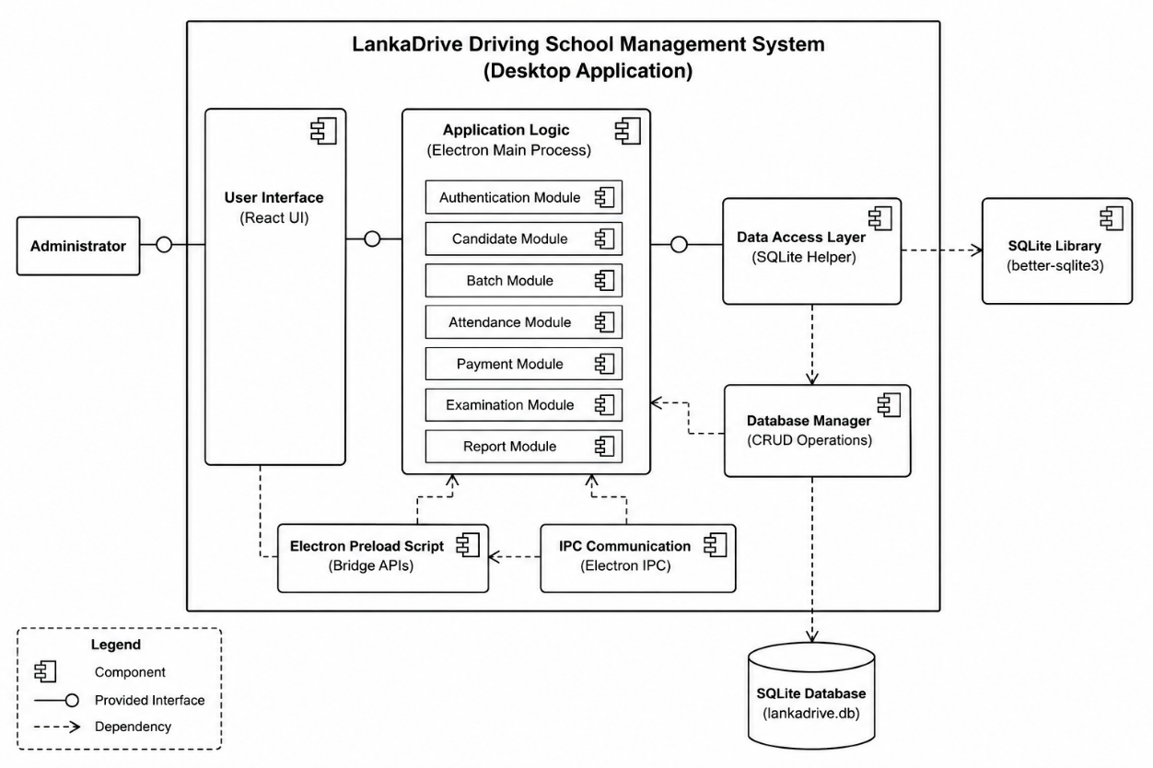

Figure 27 - Component Diagram

10.0.2. System Architecture
The LankaDrive system follows a three-layer architecture, consisting of the Presentation Layer (React + Tailwind CSS interface), the Application Layer (Electron application logic for authentication, CRUD operations, scheduling, and reporting), and the Data Layer (SQLite database storing candidates, admissions, batches, instructors, vehicles, attendance, payments, examinations, and notifications).

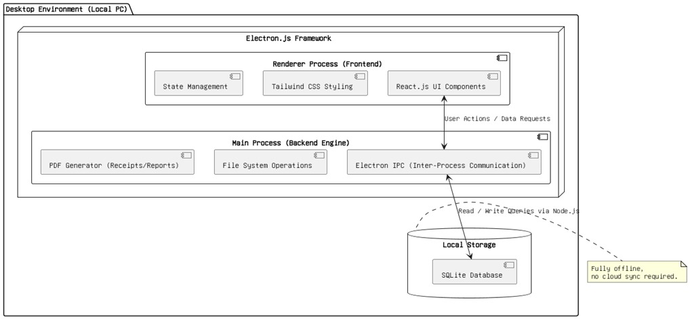
Figure 28 - System Architecture

