Computer Architecture Lab
(EL-2012)
LABORATORY REPORT

Fall 2026

(Lab#_03)
Write Lab Title Here

Student Name: Abdul Ahad Minhas Roll No: 24i-6531 Section: CE-A

Date performed: 1 Sep, 2026

MARKS AWARDED: ________ / 10

Signature and date of Instructor: _________________
Lab Instructors: Dr. Nasir Ali Shah, Engr. Fasih Ahmad

______________________________________________________________________________________________________________________________________________________

NATIONAL UNIVERSITY OF COMPUTER AND EMERGING SCIENCES, ISLAMABAD
Prepared by: | Fasih Ahmad |  | Version: 1.0
Verified by: | Dr. Nasir Ali Shah |  | Updated: Fall 2026

Task 1:

Description:
In this task, we made full adder and subtractor by using behavioural level. In this level, we actually use addition and subtraction concept for bits and write code for it by using built in function not build it by ourself.

Code:
module full_adder(a,b,m,out);

input [3:0] a;
input [3:0] b;
input m;
output reg [4:0] out;
always @*
begin
if(m ==0)
out = a+b;
else
out = a-b;
end
endmodule

module testbench_adder();
reg [3:0] x;
reg [3:0] y;
reg m;
wire [4:0] z;

full_adder as(x,y,m,z);
initial
begin
x=4;
y= 3;
m=0;
#50;

x=5;
y= 2;
m=0;
#50;

x=3;
y= 1;
m=1;
#50;

x=6;
y= 3;
m=1;
#50;

end
endmodule
Output:
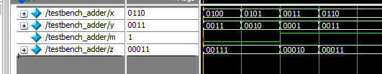

Task 2:

Description:
In this task, we made 2X1 Mux by using behavioural level. In this level, we actually use multiplication in it by using selection lines with 2 inputs and M value that give choice and write code for it by using built in function not build it by ourself.

Code:
module MUX_2to1(a,b,m,out);

input a,b,m;
output reg out;
always @*
begin
if(m ==0)
out = a;
else
out = b;
end
endmodule

module testbench_MUX();
reg x,y,m;
wire o;

MUX_2to1 mux(x,y,m,o);

initial
begin
x=0;y=0;m=0;
#50;
x=0;y=1;m=0;
#50;
x=1;y=0;m=1;
#50;
x=1;y=1;m=1;
#50;

end
endmodule
Output:
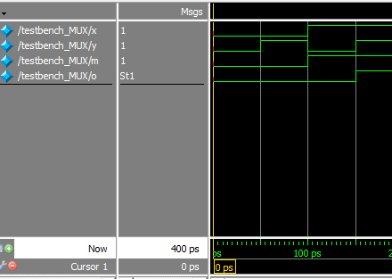

Task 3:

Description:
In this task, we made 2 bit comparator by using behavioural level. In this level, we actually compare bits if they are equal then specific output = 1, and same goes for other two outputs and write code for it by using built in function not build it by ourself.

Code:
module comparator_2bit(a,b,eq,gt,lt);

input [1:0] a,b;
output reg eq,gt,lt;
always @*
begin
if(a==b)
begin
eq=1;
gt=0;
lt=0;
end
else if(a>b)
begin
eq=0;
gt=1;
lt=0;
end
else
begin
eq=0;
gt=0;
lt=1;
end
end
endmodule

module testbench_comparator();

reg [1:0] a,b;
wire eq,gt,lt;
comparator_2bit comp(a,b,eq,gt,lt);

initial
begin
a=2'b00; b=2'b00;
#50;
a=2'b00; b=2'b01;
#50;
a=2'b00; b=2'b10;
#50;
a=2'b00; b=2'b11;
#50;
a=2'b01; b=2'b00;
#50;
a=2'b01; b=2'b01;
#50;
a=2'b01; b=2'b10;
#50;
a=2'b01; b=2'b11;
#50;
a=2'b10; b=2'b00;
#50;
a=2'b10; b=2'b01;
#50;
a=2'b10; b=2'b10;
#50;
a=2'b10; b=2'b11;
#50;
a=2'b11; b=2'b00;
#50;
a=2'b11; b=2'b01;
#50;
a=2'b11; b=2'b10;
#50;
a=2'b11; b=2'b11;
#50;

end
endmodule
Output:
