Computer Architecture Lab
(EL-2012)
LABORATORY REPORT

Fall 2026

(Lab#01)
Write Lab Title Here

Student Name: Abdul Ahad Minhas Roll No: 24i-6531 Section: CE-A

Date performed: 21 Aug, 2026

MARKS AWARDED: ________ / 10

Signature and date of Instructor: _________________
Lab Instructors: Dr. Nasir Ali Shah, Engr. Fasih Ahmad

______________________________________________________________________________________________________________________________________________________

NATIONAL UNIVERSITY OF COMPUTER AND EMERGING SCIENCES, ISLAMABAD
Prepared by: | Fasih Ahmad |  | Version: 1.0
Verified by: | Dr. Nasir Ali Shah |  | Updated: Fall 2026

Task 1:

Description:
In this task, we applied concepts of all 7 basic gates on Verilog. Here, we initialized three variables and applied test bench and used basic gate function test combinations also get output on simulation of waves.

Code:
//AND GATE
module LogicGates(a,b,c);
input a;
input b;
output c;
and a1(c,a,b);
endmodule
module testbench();
reg x;
reg y;
wire z;
LogicGates uut(x,y,z);
initial
begin
x=0; y=0;
#50 x=0;y=1;
#50 x=1;y=0;
#50 x=1;y=1;
end
endmodule

//OR GATE
module LogicGates(a,b,c);
input a;
input b;
output c;

and a1(c,a,b);

endmodule
module testbench();

reg x;
reg y;
wire z;

LogicGates uut(x,y,z);

initial
begin
x=0; y=0;
#50 x=0;y=1;
#50 x=1;y=0;
#50 x=1;y=1;
end
endmodule
//NOT GATE
module LogicGates(a,b);
input a;
output b;
not a1(b,a);
endmodule
module testbench();
reg x;
wire z;
LogicGates uut(x,z);
initial
begin
x=0;
#50 x=1;
end
endmodule
//NAND GATE
module LogicGates(a,b,c);
input a;
input b;
output c;

nand a1(c,a,b);

endmodule
module testbench();

reg x;
reg y;
wire z;

LogicGates uut(x,y,z);

initial
begin
x=0; y=0;
#50 x=0;y=1;
#50 x=1;y=0;
#50 x=1;y=1;
end
endmodule

//NOR GATE
module LogicGates(a,b,c);
input a;
input b;
output c;

nor a1(c,a,b);

endmodule
module testbench();

reg x;
reg y;
wire z;

LogicGates uut(x,y,z);

initial
begin
x=0; y=0;
#50 x=0;y=1;
#50 x=1;y=0;
#50 x=1;y=1;
end
endmodule

//XOR GATE

module LogicGates(a,b,c);
input a;
input b;
output c;

xor a1(c,a,b);

endmodule
module testbench();

reg x;
reg y;
wire z;

LogicGates uut(x,y,z);

initial
begin
x=0; y=0;
#50 x=0;y=1;
#50 x=1;y=0;
#50 x=1;y=1;
end
endmodule

//XNOR GATE

module LogicGates(a,b,c);
input a;
input b;
output c;

xnor a1(c,a,b);

endmodule
module testbench();

reg x;
reg y;
wire z;

LogicGates uut(x,y,z);

initial
begin
x=0; y=0;
#50 x=0;y=1;
#50 x=1;y=0;
#50 x=1;y=1;
end
endmodule
Output:
AND GATE
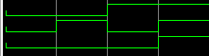
OR GATE
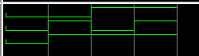
NOT GATE
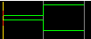
NAND GATE
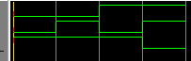
NOR GATE
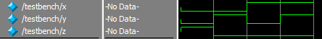

XOR GATE
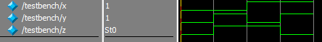
XNOR GATE
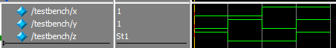

Task 2:

Description:
In this task, we applied concepts of all 7 basic gates on Verilog. Here, we initialized three variables and applied test bench and used basic gate function test combinations also get output on simulation of waves.
But, here we used dataflow method in which we assigned variables for each basic gate functions too.

Code:
module LogicGates(a,b,and_out,or_out,not_out,nand_out,nor_out,xor_out,xnor_out);
input a;
input b;
output and_out,or_out,not_out,nand_out,nor_out,xor_out,xnor_out;
assign and_out = a&b;
assign or_out = a|b;
assign not_out = ~a;
assign nand_out = ~(a&b);
assign nor_out = ~(a|b);
assign xor_out = a^b;
assign xnor_out = ~(a^b);
endmodule
module testbench();
reg x;
reg y;
wire and_outt,or_outt,not_outt,nand_outt,nor_outt,xor_outt,xnor_outt;
LogicGates uut(x,y,and_outt,or_outt,not_outt,nand_outt,nor_outt,xor_outt,xnor_outt);
initial
begin
x=0; y=0;
#50 x=0;y=1;
#50 x=1;y=0;
#50 x=1;y=1;
end
endmodule
Output:
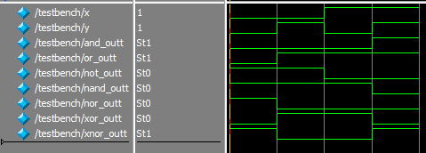

Task 3:

Description:
Here, we made all basic logic gate circuits on Logisim. We made circuits of for each gate with input probes and output LED. Further, we tested all four combinations of logic gates for each one.

Code:
Output:
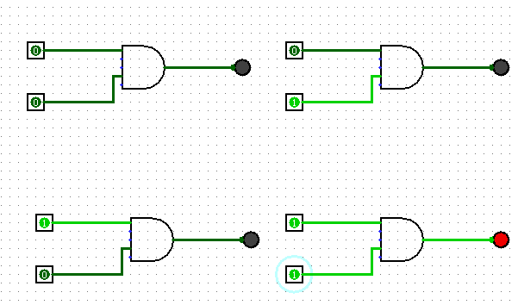
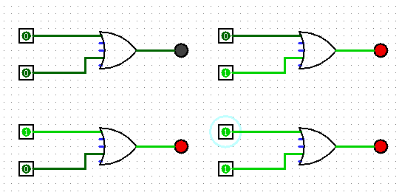
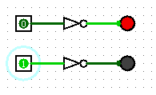
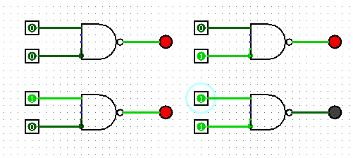
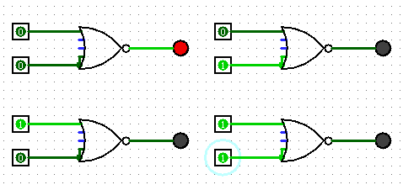
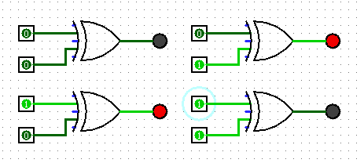
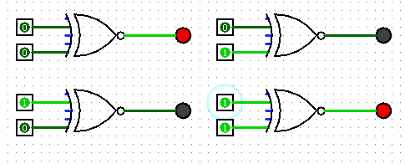

Task 4:

Description:
Here, we applied logic gate concepts on a given circuit which basically giving output of XOR gate. We initialized three variables and then, applied gate functions and created testbench to get desired output.

Code:
module Logic_circuit(a,b,c);
input a,b;
output c;
wire A1;
not a1(A1,a);
wire B1;
not b1(B1,b);
wire and1;
and c1(and1,A1,b);
wire and2;
and d1(and2,B1,a);
or e1(c,and1,and2);

endmodule;

module testbench();
reg x;
reg y;
wire z;

Logic_circuit uut(x,y,z);
initial
begin
x=0;y=0;
#50 x=0;y=1;
#50 x=1;y=0;
#50 x=1;y=1;
end
endmodule;
Output:
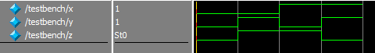

Task 5:

Description:
We created circuit of task 4 on Logisim using concepts of logic gates. And tested all 4 combinations of logics and get desired output of XOR gate.

Code:
Output:
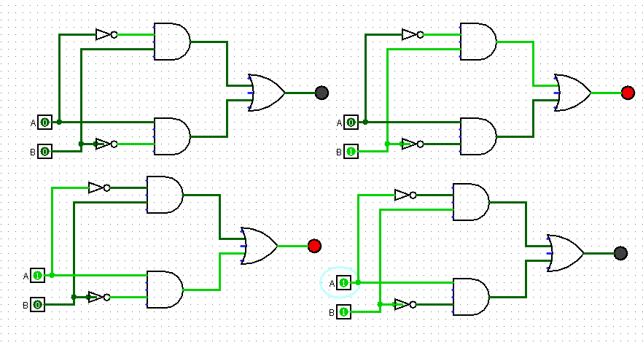

Task 6:

Description:
Here, we write code on Verilog for complementing values. We basically initialized 8 variables and 4 are input and other 4 are output variables which actually give us result of complemented variables. Then, made testbench and tested result by simulation.

Code:
module one_complement(a,b,c,d,e,f,g,h);
input a,b,c,d;
output e,f,g,h;
assign e=~a;
assign f=~b;
assign g=~c;
assign h=~d;
endmodule

module testbench();
reg l,m,n,o;
wire p,q,r,s;
one_complement uu(l,m,n,o,p,q,r,s);
initial
begin
l=0; m=0; n=0; o=0;
#50 l=0; m=0; n=0; o=1;
#50 l=0; m=0; n=1; o=0;
#50 l=0; m=0; n=1; o=1;
#50 l=0; m=1; n=0; o=0;
#50 l=0; m=1; n=0; o=1;
#50 l=0; m=1; n=1; o=0;
#50 l=0; m=1; n=1; o=1;
#50 l=1; m=0; n=0; o=0;
#50 l=1; m=0; n=0; o=1;
#50 l=1; m=0; n=1; o=0;
#50 l=1; m=0; n=1; o=1;
#50 l=1; m=1; n=0; o=0;
#50 l=1; m=1; n=0; o=1;
#50 l=1; m=1; n=1; o=0;
#50 l=1; m=1; n=1; o=1;
#50;
end
endmodule
Output:
