Computer Architecture Lab
(EL-2012)
LABORATORY REPORT

Fall 2026

(Lab#_04)
Write Lab Title Here

Student Name: Abdul Ahad Minahas Roll No: 24i-6531 Section: CE-A

Date performed: 15 sep, 2026

MARKS AWARDED: ________ / 10

Signature and date of Instructor: _________________
Lab Instructors: Dr. Nasir Ali Shah, Engr. Fasih Ahmad

______________________________________________________________________________________________________________________________________________________

NATIONAL UNIVERSITY OF COMPUTER AND EMERGING SCIENCES, ISLAMABAD
Prepared by: | Fasih Ahmad |  | Version: 1.0
Verified by: | Dr. Nasir Ali Shah |  | Updated: Fall 2026

Task 1:

Description:
Here in 1st table, beq, blt, bge, bne are all instructions that are actual because, they are directly supported by RISC-V.
ble, and bgt are pseudo instructions they both can be created by swaping operands in bge and blt.
In 2nd table, only j instruction is pseudo other 2 are actual. Because, j- instruction’s working is already happen in jal. So, it covers in that that’s why it is pseudo.

Code:
Output:

Task 2:

Description:
According to code,
beq instruction works is as a condition that if both operands are equal then, it jumps to the target.
But in case of j instruction that it does not wait for any condition as long as code reaches to j instruction then it cause it jump to the target.

Code:
.text

addi s0, x0, 5
addi s1, x0, 5

beq s0, s1, equal

addi s2, x0, 10
j end

equal:
addi s2, x0, 20

end:
Output:
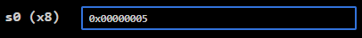
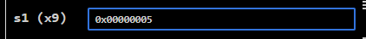
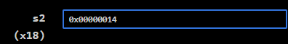

Task 3:

Description:
In this code, we add value in s0 and s1. After that, here is beq instruction that check if both are equal then, jumps to Fin function. But, as they are not equal so, it moves to next line where is True function then , it add there according to condition the, j target it to end.

Code 1:
addi s0, s0, 4
addi s1, s1, 6
beq s0, s1, Fin
True:
add s2, s1, s0
j end
Fin:
sub s2, s1, s0
end:

Output:
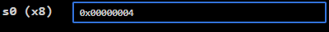
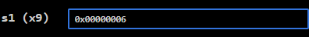
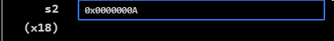

Task 1(3):

Description:
In this code, we add value in s0 and s1. After that, here is beq instruction that check if both are equal then, jumps to Fin function. As, both operand are equal so, they just satisfies condition and jumps to Fin function and then, subtract operands then , move to next line and code ended.

Code 2:
addi s0, s0, 4
addi s1, s1, 4
beq s0, s1, Fin
True:
add s2, s1, s0
j end
Fin:
sub s2, s1, s0
end:
Output:
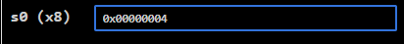
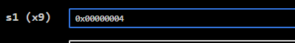
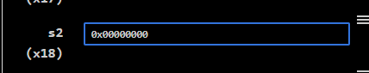

Task 4:

Description:
In this code, we implemented operands and if first 2 are equal then, subtract other 2 operands but if not equal then, add them.

Code:
addi s0,x0,3
addi s1,x0,3
addi s2,x0,5
addi s3,x0,6

beq s0,s1,Equal

add s4,s2,s3
j end
Equal:
sub s4,s2,s3

end:
Output:
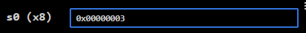
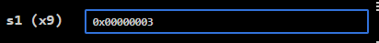
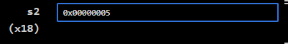
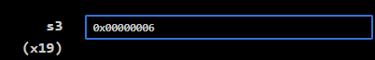
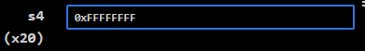

Task 5:

Description:
In this code, we implemented applied slli instruction to left shift. As, we take 2 and when shift by 1 bit it causes to on 4 value bit then again to 8 value bit.

Code:
addi s0,x0,2
slli s1,s0,1
slli s2,s1,1
Output:
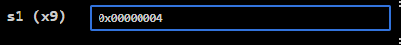
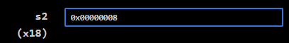

Task 6:

Description:
In this code, we are making an iterator and counter. Then, using bgt instruction for condition which checks for iterator. After that, after every iteration counter incremented. At last, loop end in iteration 6 and counter reaches to 5

Code:
.text

addi s0,x0,1
addi s1,x0,0
addi s2,x0,5

loop:
bgt s0,s2,end

addi s0,s0,1
addi s1,s1,1

j loop
end:
Output:
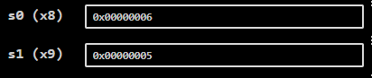

Task 7:

Description:
In this code, we are making an iterator and counter. Then, using bgt instruction for condition which checks for iterator. After that, after every iteration counter incremented. At last, loop end in iteration 6 and counter reaches to 5

Code:
.data

num: .word 0,0,0,0,0,0,0,0,0,0 # array

.text
la s3,num # load address of num
addi t0,x0,0 # iterator
addi s1,x0,5 # loop ending

loop:

bgt t0,s1,end # s0>s1 then end
slli t2,t0,2
add t2,s3,t2
addi t1,t0,5 # i+5
sw t1,0(t2)
addi t0,t0,1

j loop

end:
Output:
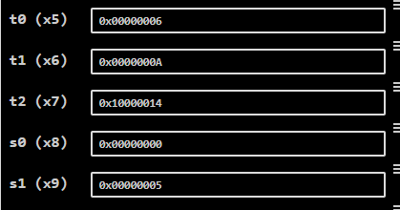

Task 8:

Description:
In this code, we are using 2 loops that where actually iterators are adding together and this process repeates until loop ends.

Code:
.text

addi s0, x0, 0 # Counter = 0
addi s1, x0, 0 # x = 0

addi s3,x0,3
addi s4,x0,2

outer:
bge s1,s3,End # if x>=3, end outer loop

addi s2, x0, 0 # y=0

inner:
bge s2,s4,next # if y>=2, go to next x

add s0, s1, s2 # Counter=x+y
addi s2, s2, 1 # y=y+1

j inner # repeat inner loop

next:
addi s1,s1,1 # x=x+1
j outer # repeat outer loop

End:
Output:
