Computer Architecture Lab
(EL-2012)
LABORATORY REPORT

Fall 2026

(Lab#02)
Write Lab Title Here

Student Name: Abdul Ahad Minhas Roll No: 24i-6531 Section: CE-A

Date performed: 25 Aug, 2026

MARKS AWARDED: ________ / 10

Signature and date of Instructor: _________________
Lab Instructors: Dr. Nasir Ali Shah, Engr. Fasih Ahmad

______________________________________________________________________________________________________________________________________________________

NATIONAL UNIVERSITY OF COMPUTER AND EMERGING SCIENCES, ISLAMABAD
Prepared by: | Fasih Ahmad |  | Version: 1.0
Verified by: | Dr. Nasir Ali Shah |  | Updated: Fall 2026

Task 1(Gate level):

Description:
In this task, we created half and full adder by gate level system. I initialized inputs and outputs and then, made functions for each gate applied to create half adder and and combining 2 half adders getting a full adder.

Code:
module half_adder(a,b,z,s,c,S,c2,C);

input a,b,z;
output s,c,S,c2,C;

xor sum1(s,a,b);
and carry1(c,a,b);

xor sum2(S,s,z);
and carry(c2,s,z);
or carry2(C,c,c2);
endmodule

module testbench();
reg x,y,z;
wire A,B,C,D,E;
half_adder HA(x,y,z,A,B,C,D,E);

initial
begin
x=0; y=0; z=0;
#50 x=0; y=0; z=1;
#50 x=0; y=1; z=0;
#50 x=0; y=1; z=1;
#50 x=1; y=0; z=0;
#50 x=1; y=0; z=1;
#50 x=1; y=1; z=0;
#50 x=1; y=1; z=1;
#50;
end
endmodule
Output:
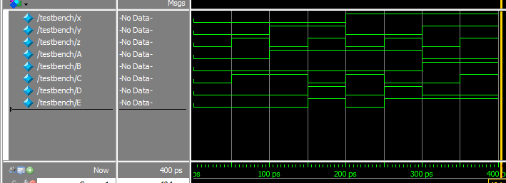

Task 1(DATA Flow):

Description:
In this task, we created half and full adder by Data Flow system. I initialized inputs and outputs and then, made functions for each gate applied to create half adder and and combining 2 half adders getting a full adder.

Code:
module half_adder(a,b,z,s,c,S,c2,C);

input a,b,z;
output s,c,S,c2,C;

xor sum1(s,a,b);
and carry1(c,a,b);

xor sum2(S,s,z);
and carry(c2,s,z);
or carry2(C,c,c2);
endmodule

module testbench();
reg x,y,z;
wire A,B,C,D,E;
half_adder HA(x,y,z,A,B,C,D,E);

initial
begin
x=0; y=0; z=0;
#50 x=0; y=0; z=1;
#50 x=0; y=1; z=0;
#50 x=0; y=1; z=1;
#50 x=1; y=0; z=0;
#50 x=1; y=0; z=1;
#50 x=1; y=1; z=0;
#50 x=1; y=1; z=1;
#50;
end
endmodule
Output:

LogiSim Output :
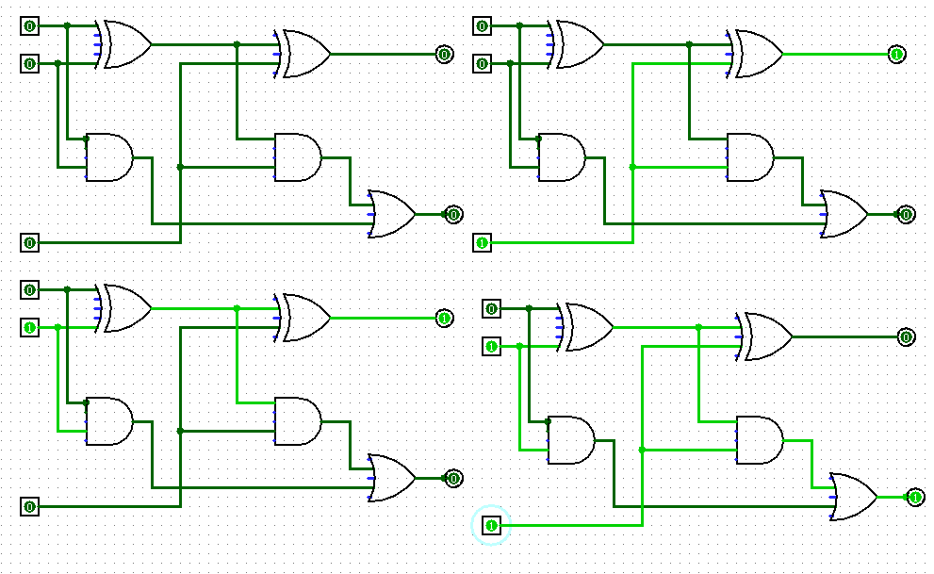
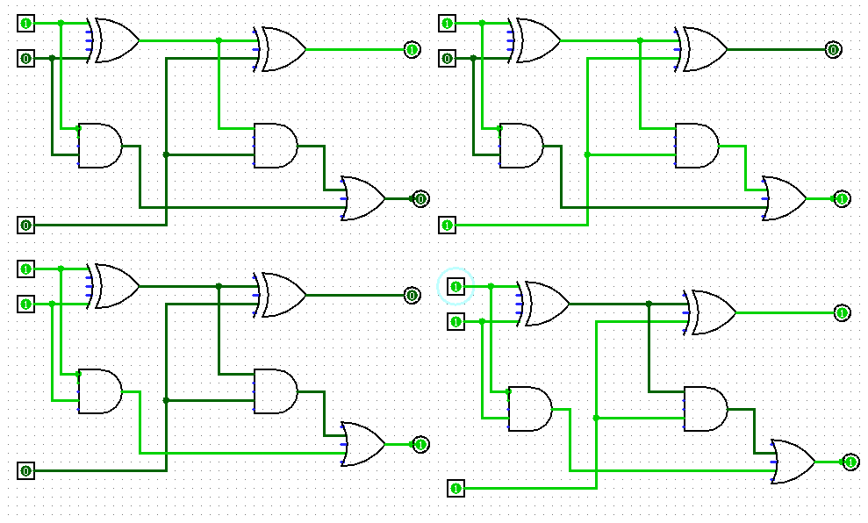

Task 2(Data Flow):

Description:
In this task, I used Data Flow system then, created 3X8 decoder. By initializing 3 inputs and 8 outputs for decoders and each specific is getting me true on specific input.

Code:
module decoder(a,b,c,d0,d1,d2,d3,d4,d5,d6,d7);

input a,b,c;
output d0,d1,d2,d3,d4,d5,d6,d7;

assign d0 = ~a&~b&~c;
assign d1 = ~a&~b&c;
assign d2 = ~a&b&~c;
assign d3 = ~a&b&c;
assign d4 = a&~b&~c;
assign d5 = a&~b&c;
assign d6 = a&b&~c;
assign d7 = a&b&c;

endmodule

module testbench_decode();

reg x,y,z;
wire a,b,c,d,e,f,g,h;

decoder dec(x,y,z,a,b,c,d,e,f,g,h);

initial
begin
x=0; y=0; z=0;
#50 x=0; y=0; z=1;
#50 x=0; y=1; z=0;
#50 x=0; y=1; z=1;
#50 x=1; y=0; z=0;
#50 x=1; y=0; z=1;
#50 x=1; y=1; z=0;
#50 x=1; y=1; z=1;
#50;
end
endmodule;
Output:
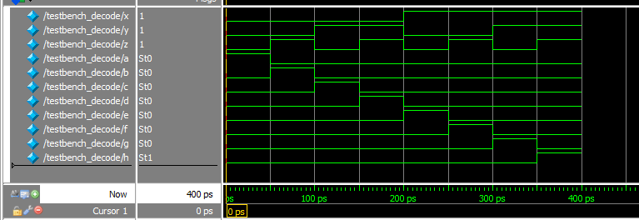

Task 2(Gate level):

Description:
In this task, I used Gate level system then, created 3X8 decoder. By initializing 3 inputs and 8 outputs for decoders and each specific is getting me true on specific input.

Code:
module decoder(a,b,c,d0,d1,d2,d3,d4,d5,d6,d7);

input a,b,c;
output d0,d1,d2,d3,d4,d5,d6,d7;

wire A,B,C;
not not1(A,a);
not not2(B,b);
not not3(C,c);

wire D0,D1,D2,D3,D4,D5,D6,D7;
and dd0(D0,A,B);
and ddd0(d0,D0,C);
and dd1(D1,A,B);
and ddd1(d1,D1,c);
and dd2(D2,A,b);
and ddd2(d2,D2,C);
and dd3(D3,A,b);
and ddd3(d3,D3,c);
and dd4(D4,a,B);
and ddd4(d4,D4,C);
and dd5(D5,a,B);
and ddd5(d5,D5,c);
and dd6(D6,a,b);
and ddd6(d6,D6,C);
and dd7(D7,a,b);
and ddd7(d7,D7,c);

endmodule

module testbench_decode();

reg x,y,z;
wire a,b,c,d,e,f,g,h;

decoder dec(x,y,z,a,b,c,d,e,f,g,h);

initial
begin
x=0; y=0; z=0;
#50 x=0; y=0; z=1;
#50 x=0; y=1; z=0;
#50 x=0; y=1; z=1;
#50 x=1; y=0; z=0;
#50 x=1; y=0; z=1;
#50 x=1; y=1; z=0;
#50 x=1; y=1; z=1;
#50;
end
endmodule;
Output:
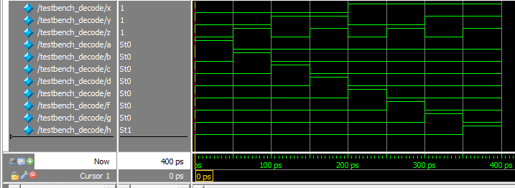

Logi Sim Output:
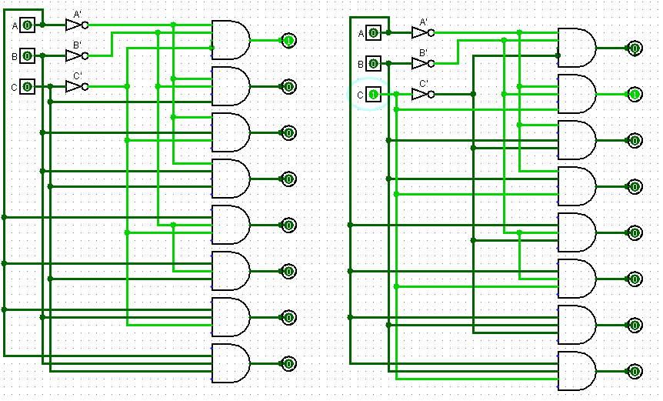
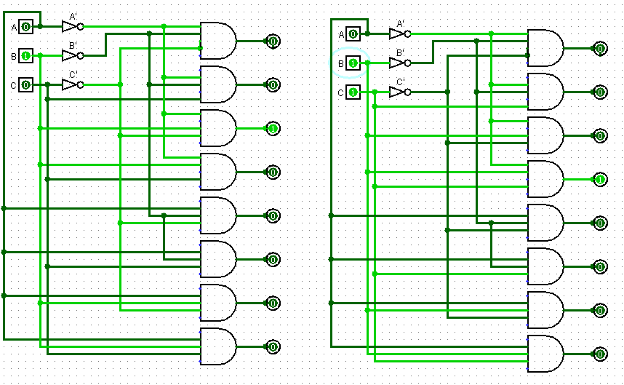
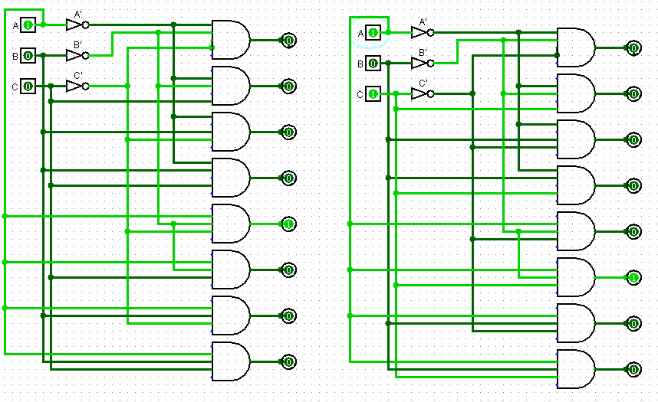
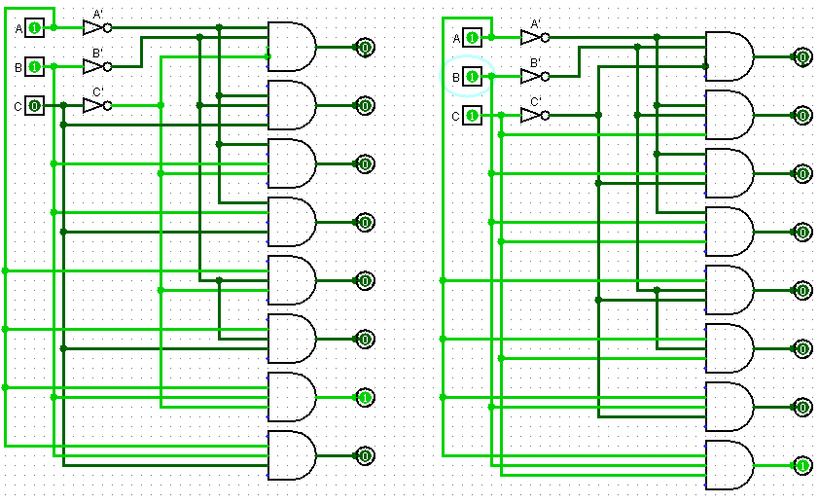
Task 3(Gate level):

Description:
In this task, I used gate level system. By initializing 3 inputs and 9 outputs which I taken for 8 decoders and one final output for multiplexer. So, created first decoder then applied or gate implementation to get desired output.

Code:
module decoder(a,b,c,d0,d1,d2,d3,d4,d5,d6,d7,out);

input a,b,c;
output d0,d1,d2,d3,d4,d5,d6,d7,out;

wire A,B,C;
not not1(A,a);
not not2(B,b);
not not3(C,c);

wire D0,D1,D2,D3,D4,D5,D6,D7;
and dd0(D0,A,B);
and ddd0(d0,D0,C);
and dd1(D1,A,B);
and ddd1(d1,D1,c);
and dd2(D2,A,b);
and ddd2(d2,D2,C);
and dd3(D3,A,b);
and ddd3(d3,D3,c);
and dd4(D4,a,B);
and ddd4(d4,D4,C);
and dd5(D5,a,B);
and ddd5(d5,D5,c);
and dd6(D6,a,b);
and ddd6(d6,D6,C);
and dd7(D7,a,b);
and ddd7(d7,D7,c);
or OUT(out,d0,d1,d2,d3,d4,d5,d6,d7);
endmodule

module testbench_multiplexer();

reg x,y,z;
wire a,b,c,d,e,f,g,h,O;

decoder dec(x,y,z,a,b,c,d,e,f,g,h,O);

initial
begin
x=0; y=0; z=0;
#50 x=0; y=0; z=1;
#50 x=0; y=1; z=0;
#50 x=0; y=1; z=1;
#50 x=1; y=0; z=0;
#50 x=1; y=0; z=1;
#50 x=1; y=1; z=0;
#50 x=1; y=1; z=1;
#50;
end
endmodule;
Output:
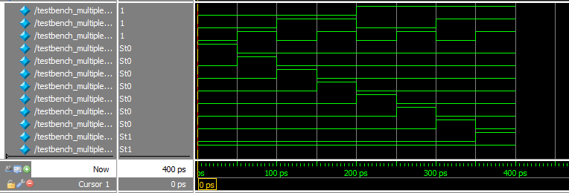

Task 3(Data Flow):

Description:
In this task, I used Data Flow system. By initializing 3 inputs and 9 outputs which I taken for 8 decoders and one final output for multiplexer. So, created first decoder then applied or gate implementation to get desired output.

Code:
module multiplexer(a,b,c,d0,d1,d2,d3,d4,d5,d6,d7,out);

input a,b,c;
output d0,d1,d2,d3,d4,d5,d6,d7,out;

assign d0 = ~a&~b&~c;
assign d1 = ~a&~b&c;
assign d2 = ~a&b&~c;
assign d3 = ~a&b&c;
assign d4 = a&~b&~c;
assign d5 = a&~b&c;
assign d6 = a&b&~c;
assign d7 = a&b&c;
assign out = d0|d1|d2|d3|d4|d5|d6|d7;

endmodule

module testbench_decode();

reg x,y,z;
wire a,b,c,d,e,f,g,h,O;

multiplexer dec(x,y,z,a,b,c,d,e,f,g,h,O);

initial
begin
x=0; y=0; z=0;
#50 x=0; y=0; z=1;
#50 x=0; y=1; z=0;
#50 x=0; y=1; z=1;
#50 x=1; y=0; z=0;
#50 x=1; y=0; z=1;
#50 x=1; y=1; z=0;
#50 x=1; y=1; z=1;
#50;
end
endmodule;
Output:
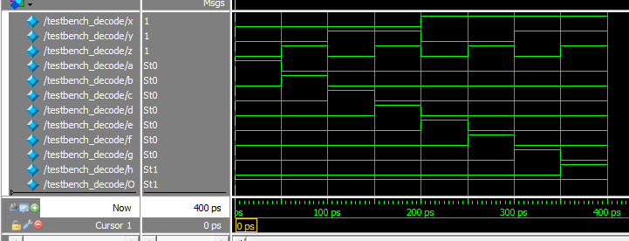

Logi Sim Output:

