Computer Architecture Lab
(EL-2012)
LABORATORY REPORT

Fall 2026

(Lab#06)
Write Lab Title Here

Student Name: Abdul Ahad Minhas Roll No: 24i-6531 Section: CE-A

Date performed : 27 Sep, 2026

MARKS AWARDED: ________ / 10

Signature and date of Instructor: _________________
Lab Instructors: Dr. Nasir Ali Shah, Engr. Fasih Ahmad

______________________________________________________________________________________________________________________________________________________

NATIONAL UNIVERSITY OF COMPUTER AND EMERGING SCIENCES, ISLAMABAD
Prepared by: | Fasih Ahmad |  | Version: 1.0
Verified by: | Dr. Nasir Ali Shah |  | Updated: Fall 2026

Task 1:

Description:
This task demonstrates how a procedure can modify registers and why important register values must be preserved. The stack is used to save and restore s0 so that the correct result is obtained after returning from the procedure.
Code:
.text

main:
li a0, 1
li s0, 2500
jal ra, procedure

add t1, s0, a0
li a0, 1
mv a1, t1
ecall

li a0, 10
ecall
procedure:
addi sp, sp, -4
sw s0, 0(sp)

li s0, 3
li t0, 1000
add a0, s0, t0
lw s0, 0(sp)
addi sp, sp, 4
jalr zero, ra, 0
Output:
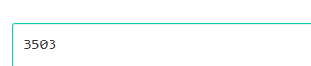
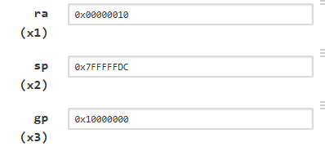
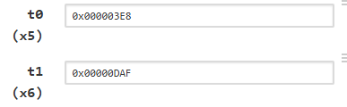
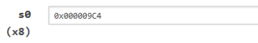
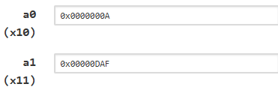

Task 2:

Description:
This task demonstrates how registers can be stored temporarily on the stack using sw and retrieved using lw. The stack pointer sp is adjusted to allocate and release the required memory.
Code:
.text

main:
addi s0, zero, 5
addi t1, zero, 10
addi t0, zero, 15

addi sp, sp, -12

sw s0, 0(sp)
sw t0, 4(sp)
sw t1, 8(sp)

lw t4, 8(sp)
lw t2, 4(sp)
lw t3, 0(sp)
addi sp, sp, 12

li a0, 10
ecall
Output:
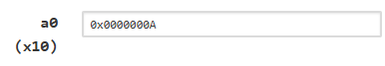
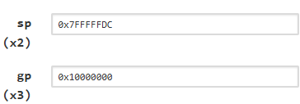

Task 3:

Description:
This task implements the given EqSolver(a,b) function as a RISC-V procedure. Arguments are passed through a0 and a1, and the calculated result (a+b)(a-b) is returned through a0.
Code:
.text

main:
li a0, 7
li a1, 3
jal ra, EqSolver

mv t0, a0
li a0, 1
mv a1, t0
ecall
li a0, 10
ecall

EqSolver:
add t0, a0, a1
sub t1, a0, a1
mul a0, t0, t1
jalr zero, ra, 0
Output:


Task 4:

Description:
This task calculates the area and perimeter of a square using two separate procedures, AreaFinder and PerimeterFinder. Both procedures are called from the main program and return their results through a0.
Code:
.text

main:
li a0, 5
jal ra, AreaFinder
mv t0, a0
li a0, 5
jal ra, PerimeterFinder
mv t1, a0

li a0, 1
mv a1, t0
ecall

li a0, 1
mv a1, t1
ecall
li a0, 10
ecall

AreaFinder:
mul a0, a0, a0
jalr zero, ra, 0
PerimeterFinder:
li t0, 4
mul a0, a0, t0
jalr zero, ra, 0
Output:


Task 5:

Description:
This task implements a procedure to calculate the polynomial x³ + 5x² + 6x. Different RISC-V multiplication and addition instructions are used to calculate the individual terms and produce the final result.
Code:
.text

main:
li a0, 2
jal ra, EqSolver
mv t0, a0

li a0, 1
mv a1, t0
ecall
li a0, 10
ecall
EqSolver:
mul t0, a0, a0
mul t1, t0, a0
li t2, 5
mul t3, t0, t2

li t2, 6
mul t4, a0, t2
add t5, t1, t3
add a0, t5, t4
jalr zero, ra, 0
Output:

Task 6:

Description:
This task implements multiple functions and uses conditional statements to decide which procedure should be called. Depending on the values of n and k, the program executes F1, F2, or F3.
Code:
.text

main:

li a0, 4 # n
li a1, 2 # k

li t0, 1
beq a1, t0, CALL_F1
bgt a0, a1, CALL_F2

j CALL_F3
CALL_F1:
jal ra, F1
j PRINT
CALL_F2:
jal ra, F2
j PRINT
CALL_F3:
jal ra, F3
PRINT:
mv t1, a0
li a0, 1
mv a1, t1
ecall

li a0, 10
ecall

F1:
mul t0, a0, a0
mul t1, a1, a1
add a0, t0, t1
jalr zero, ra, 0

F2:
mul t0, a0, a0
mul a0, t0, a0
jalr zero, ra, 0

F3:
addi a0, a0, 5
jalr zero, ra, 0
Output:


Task 7:

Description:
This task uses conditional branching to select one of three functions: fun1, fun2, or fun3. The selected function performs square, cube, or addition operations according to the given conditions.
Code:
.text

main:

li a0, 4 # n
li a1, 4 # k

beq a1, zero, CALL_FUN1
beq a0, a1, CALL_FUN2

j CALL_FUN3
CALL_FUN1:
jal ra, fun1
j PRINT
CALL_FUN2:
jal ra, fun2
j PRINT
CALL_FUN3:
jal ra, fun3

PRINT:
mv t0, a0

li a0, 1
mv a1, t0
ecall
li a0, 10
ecall

fun1:
mul a0, a0, a0
jalr zero, ra, 0

fun2:
mul t0, a0, a0
mul a0, t0, a0
jalr zero, ra, 0

fun3:
addi a0, a0, 1
jalr zero, ra, 0
Output:


Task 8: Without Recursion

Description:
This task calculates the Fibonacci sequence using an iterative loop instead of recursion. The values of consecutive Fibonacci numbers are updated using registers until the required nth value is obtained.
Code:
.text

main:
li a0, 10
jal ra, fib
mv t0, a0

li a0, 1
mv a1, t0
ecall

li a0, 10
ecall

fib:
beq a0, zero, FIB_ZERO
li t0, 0
li t1, 1
li t2, 2
FIB_LOOP:

bgt t2, a0, FIB_DONE
add t3, t0, t1
mv t0, t1
mv t1, t3
addi t2, t2, 1

j FIB_LOOP
FIB_ZERO:
li a0, 0
jalr zero, ra, 0
FIB_DONE:
mv a0, t1
jalr zero, ra, 0
Output:
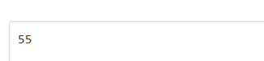

Task 8: With Recursion

Description:
This task implements the Fibonacci function using recursive procedure calls. The stack is used to preserve the return address and required values during multiple nested function calls.
Code:
.text

main:
li a0, 6
jal ra, fib

mv t0, a0
li a0, 1
mv a1, t0
ecall

li a0, 10
ecall

fib:

beq a0, zero, FIB_ZERO

li t0, 1
beq a0, t0, FIB_ONE

addi sp, sp, -12
sw ra, 8(sp)
sw a0, 4(sp)

addi a0, a0, -1
jal ra, fib
sw a0, 0(sp)
lw a0, 4(sp)

addi a0, a0, -2
jal ra, fib

lw t0, 0(sp)
add a0, t0, a0
lw ra, 8(sp)

addi sp, sp, 12
jalr zero, ra, 0
FIB_ZERO:
li a0, 0
jalr zero, ra, 0

FIB_ONE:
li a0, 1
jalr zero, ra, 0
Output:


