Computer Architecture Lab
(EL-2012)
LABORATORY REPORT

Fall 2026

(Lab#_04)
Write Lab Title Here

Student Name: Abdul Ahad Minhas Roll No: 24i-6531 Section: CE-A

Date performed: 11 Sept, 2026

MARKS AWARDED: ________ / 10

Signature and date of Instructor: _________________
Lab Instructors: Dr. Nasir Ali Shah, Engr. Fasih Ahmad

______________________________________________________________________________________________________________________________________________________

NATIONAL UNIVERSITY OF COMPUTER AND EMERGING SCIENCES, ISLAMABAD
Prepared by: | Fasih Ahmad |  | Version: 1.0
Verified by: | Dr. Nasir Ali Shah |  | Updated: Fall 2026

Task 1:

Description:
This task performs basic arithmetic operations on two given numbers, A = 5 and B = 4. We calculate addition, subtraction, multiplication, and square of A using RISCV instructions.
Code:
.text
addi s0, x0, 5
addi s1, x0, 4
add s2, s0, s1
sub s3, s0, s1
mul s4, s0, s1
mul s5, s0, s0
Output:
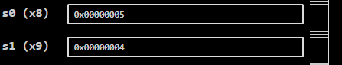
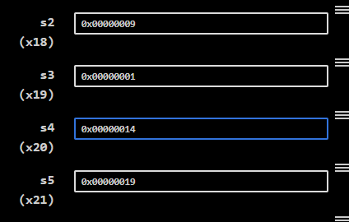

Task 2:

Description:
This task converts the given mathematical expression m = (a − c) + (d + e) × f into RISC-V assembly language. Different registers are used to store the values and intermediate results.
Code:
.text
.globl main

main:
li t0, 10
li t1, 3
li t2, 4
li t3, 5
li t4, 2
sub t5, t0, t1
add t6, t2, t3
mul t6, t6, t4
add t5, t5, t6
Output:
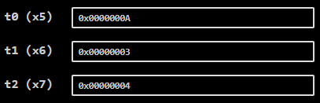
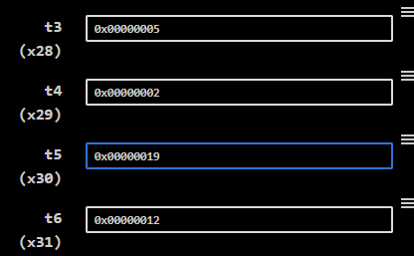

Task 3:

Description:
This task performs AND, OR, and XOR operations on the hexadecimal values 0xFFF and 0xF0F. The results are stored in separate registers for observation in Venus.
Code:
.text
.globl main

main:
li t0, 0xFFF
li t1, 0xF0F
and t2, t0, t1
or t3, t0, t1
xor t4, t0, t1
Output:
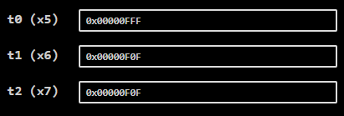

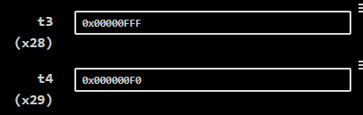

Task 4:

Description:
This task calculates the sum of all elements in an integer array using RISCV assembly. A loop is used to access each array element and add it to the total sum.
Code:
.data

array:
.word 10
.word 20
.word 30
.word 40
.word 50

.text
.globl main

main:
la a0, array
li a1, 5

jal ra, arraysum
j end
arraysum:
li t0, 0
li t1, 0
loop:
bge t1, a1, done

slli t2, t1, 2
add t2, a0, t2
lw t2, 0(t2)

add t0, t0, t2

addi t1, t1, 1
j loop
done:
mv a0, t0
ret

end:
Output:

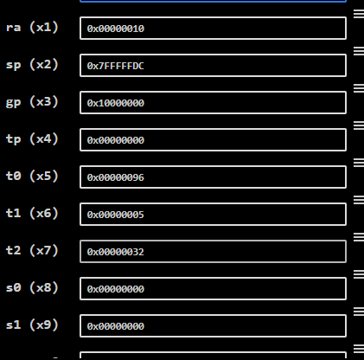
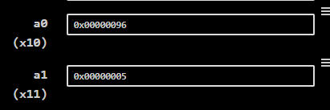

Task 5:

Description:
This task creates a table of two in the .data section using an array of values. The values are then loaded from memory into different registers using the lw instruction.
Code:
.data

table2:
.word 2
.word 4
.word 6
.word 8
.word 10
.word 12
.word 14
.word 16
.word 18
.word 20

.text
.globl main
main:
la t0, table2
lw t1, 0(t0)
lw t2, 4(t0)
lw t3, 8(t0)
lw t4, 12(t0)
lw t5, 16(t0)
lw t6, 20(t0)
lw s0, 24(t0)
lw s1, 28(t0)
lw s2, 32(t0)
lw s3, 36(t0)
Output:
