Muhammad Abdullah Khan | SU92-BSSEM-S25-027
Artificial Intelligence (Lab)
Mr. Rasikh Ali
October 29, 2026
AI Lab Tasks
Lab 05
The Superior University

Contents
Task 01 3
Task 02 3

Task 01
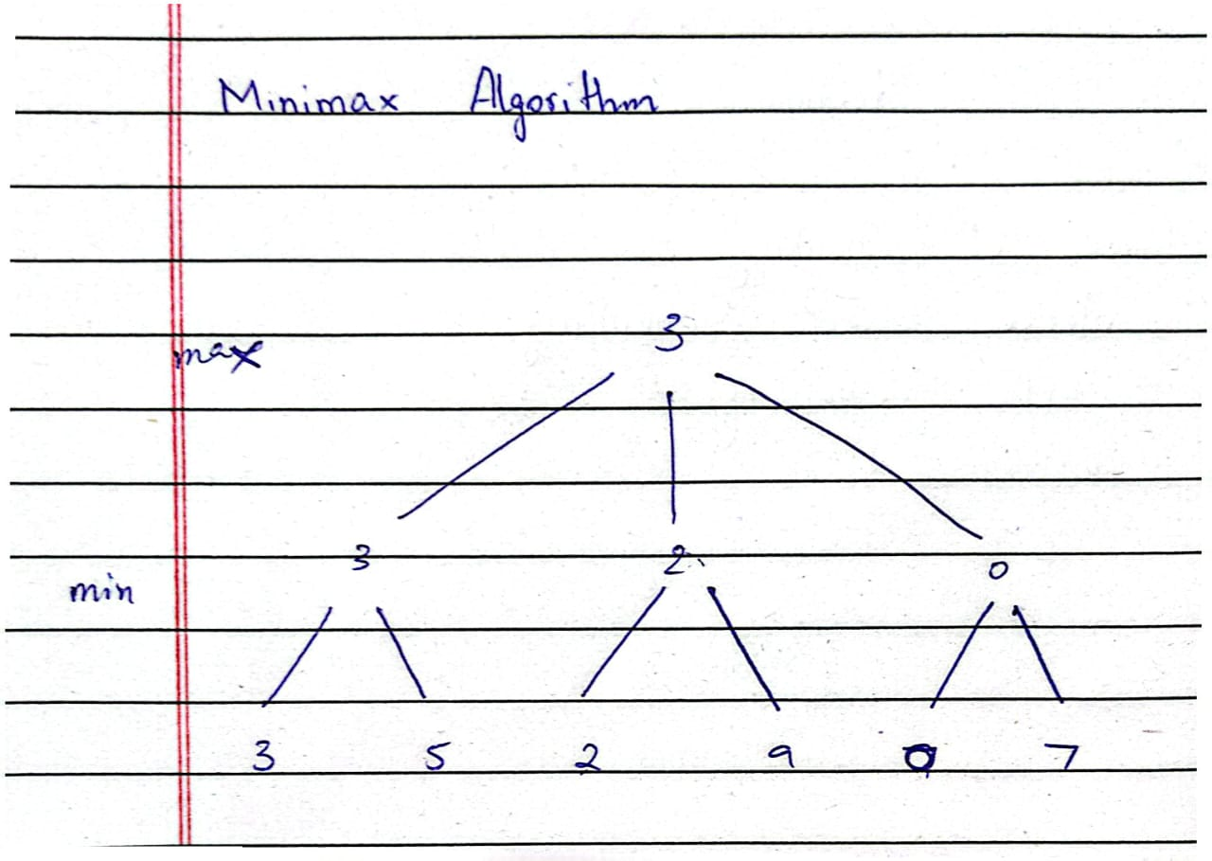

Task 02
Added a global leaf evaluation counter ‘leaf_count = 0’ that counts how many leaf nodes each algorithm evaluates. It increments by 1 each time when either function reaches its base case.

