Muhammad Abdullah Khan | SU92-BSSEM-S25-027
Artificial Intelligence (Lab)
Mr. Rasikh Ali
October 24, 2026
AI Lab Tasks
Lab 05
The Superior University

Table of Contents
Graph 3
Task 1 3
Task 2 4
UCS Traversal 4
A* Traversal 5
Task 3 5

Graph
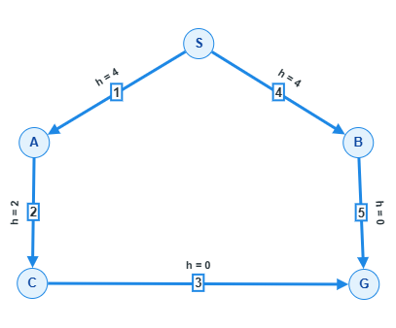

Task 1
A* search uses the cost already travelled plus the estimated cost remaining to reach the goal. It uses heuristics – estimates that help the algorithm decide which path is most likely to lead to goal. For A*, the evaluation function is:
f(n) = g(n) + h(n)
where:
- g(n) = actual cost from starting point to node n
- h(n) = estimated cost from node n to goal.
- f(n) = estimated total cost of path through node n

Let’s compute g, h, and f values for the given graph:
Path | f(n) | g(n) + h(n) | Selection
S → A | 5 | 1 + 4 | ✔
S → B | 8 | 4 + 4 | ✗
A → C | 5 | (1 + 2) + 2 | ✔
C → G | 6 | (3 + 3) + 0 | ✔

There are 2 complete routes to the goal but our algorithm selected S → A → C → G route because it was more likely to reach the goal with minimum cost.

Task 2
UCS stands for Uniform Cost Search. It uses g(n) to calculate cost from starting point to goal. It does not use any heuristic value to determine which path leads to the goal. On the other hand, A* Search uses the already travelled cost g(n) plus the estimated cost h(n) remaining to reach the goal.

UCS Traversal
Path | f(n) | g(n) | Selection
S → A | 1 | 1 | ✔
S → B | 4 | 4 | ✗
A → C | 3 | 1 + 2 | ✔
B → G | 9 | 4 + 5 | ✗
C → G | 6 | 3 + 3 | ✔

A* Traversal
Path | f(n) | g(n) + h(n) | Selection
S → A | 5 | 1 + 4 | ✔
S → B | 8 | 4 + 4 | ✗
A → C | 5 | (1 + 2) + 2 | ✔
C → G | 6 | (3 + 3) + 0 | ✔

Both algorithms are returning the same path S → A → C → G at cost 6. A* expands 3 nodes (S, A, C) and UCS expands 4 nodes (S, A, C, B).

Task 3
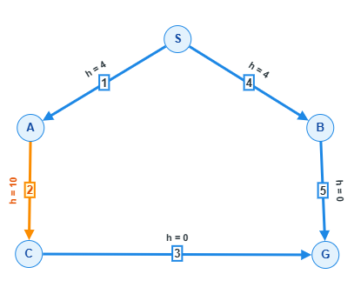
Changed h(c) to 10;

Let’s compute g, h, and f values with the evaluation formula of A* search algorithm:
f(n) = g(n) + h(n)

Path | f(n) | g(n) + h(n) | Selection
S → A | 5 | 1 + 4 | ✗
S → B | 8 | 4 + 4 | ✔
A → C | 13 | (1 + 2) + 10 | ✗
B → G | 9 | (4 + 5) + 0 | ✔

Changing h(c) from 2 to 10 makes A* return S → B → G at cost 9 instead of 6.

