Muhammad Abdullah Khan | SU92-BSSEM-S25-027
Artificial Intelligence (Lab)
Mr. Rasikh Ali
September 26, 2026
AI Lab Tasks
Lab 01
The Superior University

Task 01
Run the program below. Try different integer values, and note down what happens and any error you need to fix:
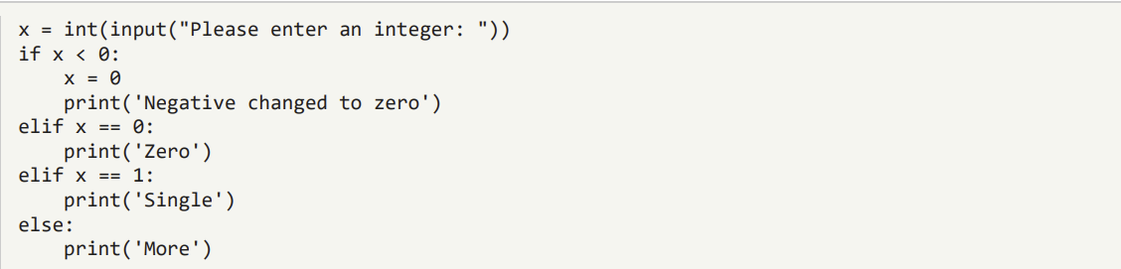

Explanation
This program takes an integer input from the user and stores it in the variable x. If the integer is negative, it updates the value of x to 0 and prints the message “Negative changed to zero”. If the integer is 0, it prints “Zero”. If the integer is 1, it prints “Single”. If the integer is 2 or higher, it prints “More”.
The program is syntactically correct and executes without any errors. The only error occurs if the user does not enter an integer.
To resolve this problem, we can use an exception handling block (try/except).
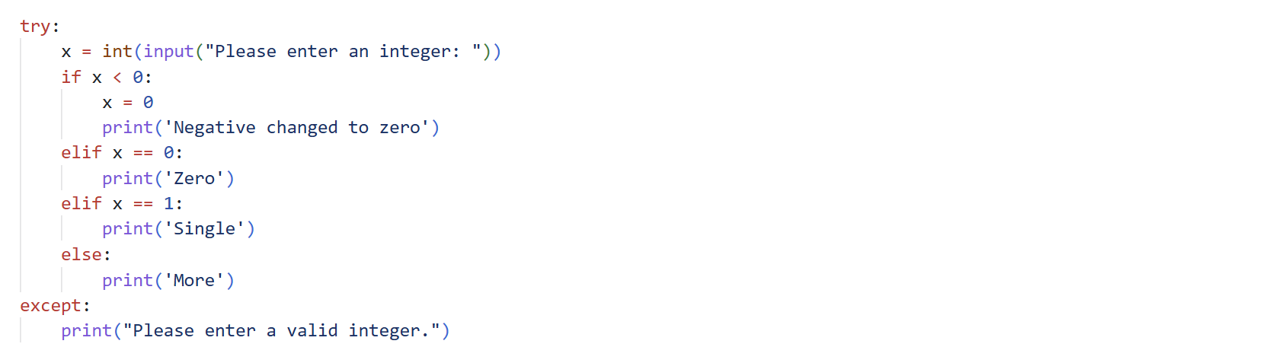

Task 02
Mini Project: A Dynamic To-Do List (add/remove/view items in a loop

Explanation
This project is a command line To-Do List application built in Python. It allows a user to view, add, and remove tasks repeatedly through a menu-driven loop, until they choose to exit the program. It demonstrates Python fundamentals such as functions, lists, loops, conditional matching, user input handling, and error handling.
This program is organized into five functions, each responsible for a single, well-defined task:
- show_menu() – displays the list of available options to the user.
- view_items(todo_list) – prints all current items in the to-do list.
- add_items(todo_list) – asks the user for a new item and appends it to the list.
- remove_items(todo_list) – shows the list, then removes an item chosen by number.
- main() – creates the list, runs the menu loop, and calls the correct function based on user choice.
Each function does one job, which makes the code easier to read, test, and fix.
