


NAME: ABDULAI HARUNA KWASI
INDEX NUMBER: UEB3208922
COURSE: ENTERPRISE RESOURCE PLANNING
CLASS: L400 IT A

ASSIGNMENT
With the aid of the diagrams, explain
- One tier
- Two Tier
- Three Tier
- Cloud based architecture

ANSWERS

1. Tier 1 Architecture (One-Tier / Single-Tier)
Your diagram shows:
Presentation + Application + Database all inside one box labeled "CLIENT TIER"
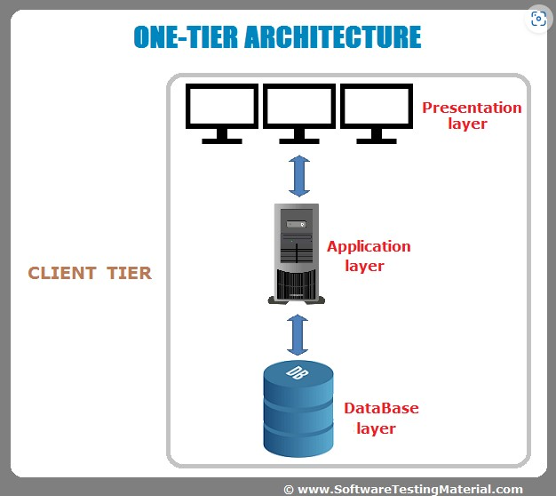

How it works:
The user’s machine is the entire system
The software directly reads/writes to a local database file
No network calls involved

Advantages:
- Very fast (no network delay)
- Simple to build and test
- No server costs

Disadvantages:
- Only one user at a time
- No remote access
- If machine crashes, data is lost

2. Tier 2 Architecture (Two-Tier / Client-Server)
Your diagram shows:
Client Tier (multiple computers) → Database Tier (one database server)
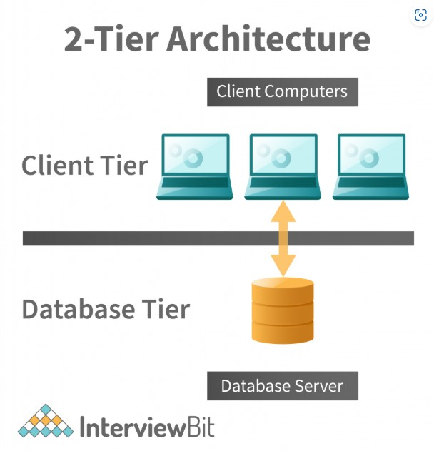

How it works:
Each client runs an application (contains UI + business logic).
Client connects directly to the database server.
Database handles data storage and some basic validation

Advantages:
- Simple to understand
- Good for small groups (10–50 users)
- Database server centralizes data

Disadvantages:
- Every client needs a database connection (uses memory on DB server)
- Business logic is duplicated on every client
- Updating logic means updating every PC
- Security risk – clients can directly query the database

3. Tier 3 Architecture (Three-Tier)
Your diagram shows:
Client Tier → Business Tier (application server) → Database Tier (database server)
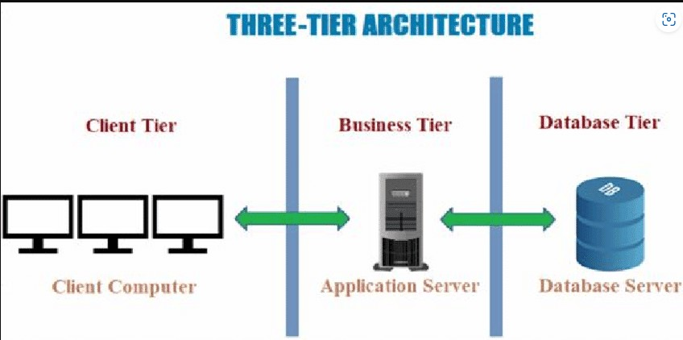

How it works:
Client only shows the UI (web browser or thin client)
Application server contains all business logic (rules, calculations, workflows)
Database server only stores and retrieves data
Client and database never talk directly

Advantages:
- Security – clients cannot touch database directly
- Scalability – add more application servers as users grow
- Maintainability – change logic in one place (the app server)
- Reusability – one app server can serve web, mobile, and API clients

Disadvantages:
- More complex to build
- More servers to manage
- Network latency between tiers

Cloud-Based Architecture
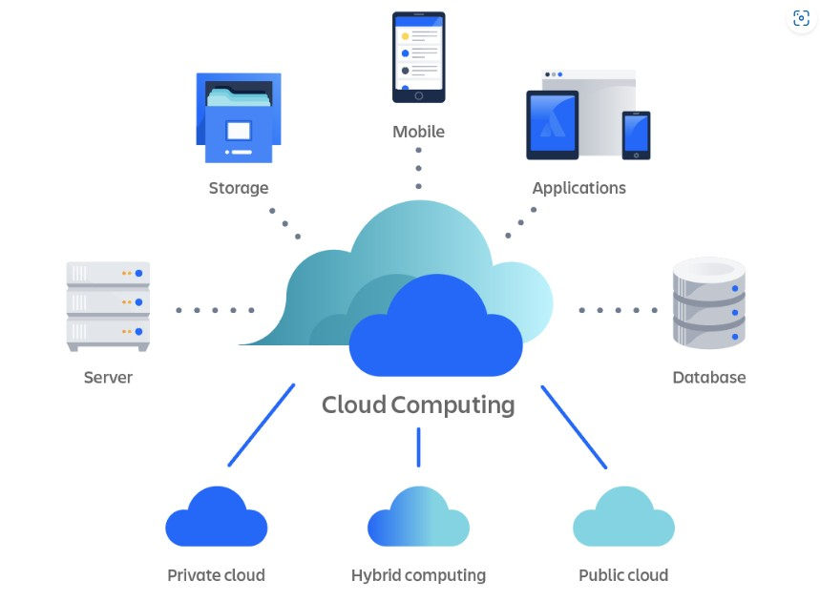
Your diagram shows:
Server + Database + Cloud Computing with three options:
Public cloud: Cloud services provided by a third-party vendor (like AWS, Microsoft Azure, or Google Cloud) over the public internet, shared among multiple customers (called "multi-tenant").
Private cloud: Cloud infrastructure dedicated solely to one organization, either hosted on-premises or by a private provider. It offers cloud-like features (self-service, elasticity) but with full isolation.
Hybrid computing: A combination of public cloud and private cloud (or on-premises) that allows data and applications to move between them. The two environments remain separate but are connected (usually by VPN or dedicated link).

How it works:
Cloud architecture takes the three-tier model and runs it on virtualized, on-demand infrastructure managed by a provider.

The three deployment models (from your diagram):
Model | Where it runs | Who manages | Best for
Public cloud | Provider’s data center (AWS, Azure, GCP) | Provider together with you | Startups, dynamic workloads
Private cloud | Your own data center | Your IT team | Banks, government (high security)
Hybrid computing | Mix of both | Both | Bursting: normal load on private, peak on public

