Pair and Tuple
#include <bits/stdc++.h>
using namespace std;

int main() {
ios::sync_with_stdio(false);
cin.tie(nullptr);

pair<int, string> p = {1, "sujon"};
// auto [roll,name] = p;

// cout << p.first << " << " << p.second << "\n";
int n;
cin >> n;
//// pair<string, int> students[n];

// for (int i = 0;i < n; i++) {
// cin >> students[i].first >> students[i].second;
// }
// for(auto [x,y]: students){
// cout << x << " " << y;
// }
// for(auto n: students){
// cout << n.first << " " << n.second;
// }

// tuple<string,int ,int> t = {"alim", 23, 101};

// cout << get<0>(t) << " " << get<1>(t) << " " << get<2>(t) << "\n";
// auto [name, age, roll] = t;
// cout << name << " " << age << " " << roll << "\n";

// pair<int, pair<string, double>> student;
// student = {101, {"alim", 3.75}};

// cout << student.first << " " << student.second.first << " " << student.second.second << "\n";
return 0;
}

Vector
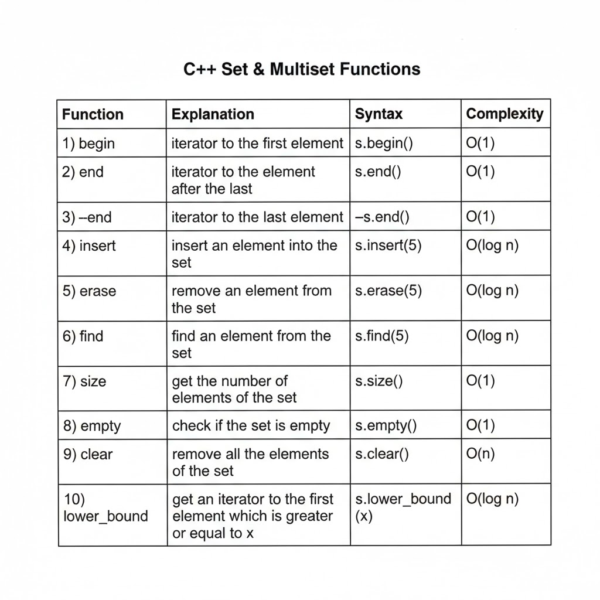

#include <bits/stdc++.h>
using namespace std;

int main() {
ios::sync_with_stdio(false);
cin.tie(nullptr);

int n;
cin >> n;
vector<int> v(n);
for (int i = 0; i < n; i++)
{
cin >> v[i];
}

// vector<int> v(n,5); // initialize all elements with 5

// for(auto x:v){
// cout << x << " ";
// }
cout << "\n";
// cout << "front " << v.front() << "\n";
// cout << "back " << v.back() << "\n";
// cout << "size " << v.size() << "\n";
// cout << "empty " << v.empty() << "\n"; // 0 means false, 1 means true
// v.clear();
// cout << "size after clear " << v.size() << "\n";

// v.resize(5); // resize vector to size 5

//begin end rbegin rend

// cout << "begin iterator" << *v.begin() << "\n";
// cout << "last element using end-1 " << *(v.end() - 1) << "\n";
// cout << "reverse begin iterator " << *v.rbegin() << "\n";
// cout << "reverse end iterator " << *(v.rend() - 1) << "\n";

// for (auto i = v.begin(); i != v.end(); i++){
// cout << *i << " ";
// }

// cout << *--v.end() << "\n"; // last element

// reverse(v.begin()+2, v.end());
// sort(v.begin(), v.end());
// sort(v.begin(), v.end(), greater<int>());
for (auto x : v) {
cout << x << " ";
}

// auto mx = *max_element(v.begin(), v.end());
// auto mn = *min_element(v.begin(), v.end());
// auto maxElemIndex = max_element(v.begin(), v.end()) - v.begin();

//insert,erase--> best use in array
v.insert(v.begin() + 2, 10); // insert 10 at index 2

v.erase(v.begin() + 4); // erase element at index 4
auto nextOfBegin = *v.begin() + 1; // we cannot do it in set multiset and in map
cout << "\n";
for (auto x : v)
{
cout << x << " ";
}
v.erase(v.begin() + 3);

cout << "\n";
return 0;
}

Deque

#include <bits/stdc++.h>
using namespace std;

int main() {
ios::sync_with_stdio(false);
cin.tie(nullptr);
// deque -- >double ended queue
deque<int> dq;
dq.push_back(10);
dq.push_front(5);
dq.push_back(20);
dq.push_front(1);
dq.push_back(30);
dq.push_front(2);
dq.pop_back();
dq.pop_front();
for(auto x:dq){
cout << x << " ";
}
cout << "\n";
cout << "front " << dq.front() << "\n";
cout << "back " << dq.back() << "\n";
dq.insert(dq.begin()+1,15); // insert 15 at index 1
//deque // extra memory use that is drawback
return 0;
}

String

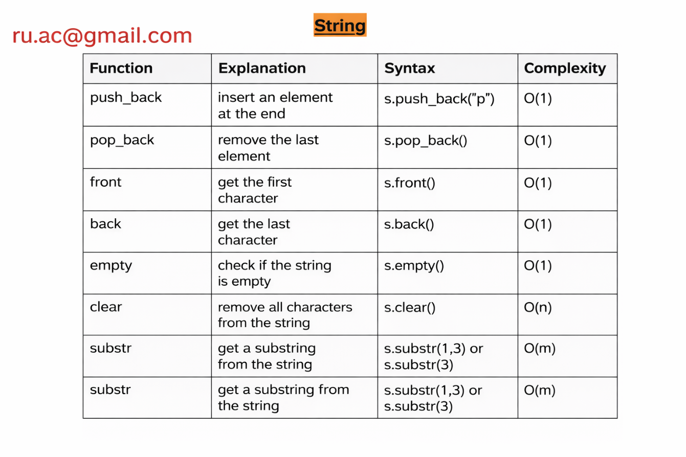

#include <bits/stdc++.h>
using namespace std;

int main() {
ios::sync_with_stdio(false);
cin.tie(nullptr);

string s;
int n;
cin >> n;
for (int i = 0; i < n; i++)
{
char c;
cin >> c;
s.push_back(c);
// s.pop_back(); // remove last character
}

for(int i=0;i<s.size();i++){
cout << s[i] << " ";
}
// cout << "\n";
// cout << "front " << s.front() << "\n";
// cout << "back " << s.back() << "\n";
// s.pop_back(); // remove last character

string str = s.substr(0,2);
cout << "\n" << str << "\n";

cout << "\n";
for(int i=0;i<s.size();i++){
cout << s[i] << " ";
}
cout << s.empty(); // if string is empty return 1 else 0

return 0;
}

2D Vector
#include <bits/stdc++.h>
using namespace std;

int main() {
ios::sync_with_stdio(false);
cin.tie(nullptr);

int n;
cin >> n;

// vector<vector<int>> v(n, vector<int>(m));
// for (int i = 0; i < n; i++) {

// cin >> m;
// for (int j = 0; j < m; j++) {
// cin >> v[i][j];
// }
// }

vector<vector<int>> v;
for (int i = 0; i < n; i++) {
int m;
cin >> m;
vector<int> v2;
for (int j = 0; j < m; j++) {
int x;
cin >> x;
v2.push_back(x);
}

for(auto x : v2) {
cout << x << " ";
}

cout << '\n';

v.push_back(v2);
}
return 0;
}

Set And MultiSet

#include <bits/stdc++.h>
using namespace std;

//multiset
// sorted non unique elements

int main() {
ios::sync_with_stdio(false);
cin.tie(nullptr);
int n;
cin >> n;
multiset<int> ms;
for (int i = 0; i < n; i++) {
int x;
cin >> x;
ms.insert(x); // O(log n)
}
// if want to erase single in many occurence of particular element
// auto it = ms.find(3); // it will return first occurence of 3
// if(it != ms.end()){
// ms.erase(it); // erase only first occurence of 3
// }
// ms.erase(5); // it will erase all occurence of 5
for(auto x:ms){
cout << x << "\n";
}

auto p = ms.count(3);

//complexity of count is O(log n)
//if multiple occurence then O(log n) + O(k) where k is number of occurence

// it will return how many occurence of 3 present in multiset
cout << p;

return 0;
}

Map
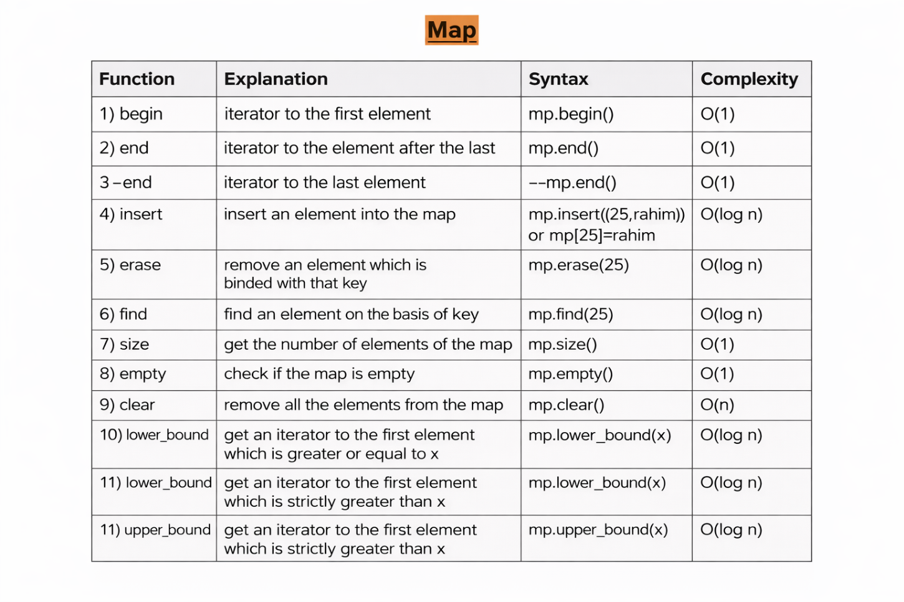

#include <bits/stdc++.h>
using namespace std;

int main() {
ios::sync_with_stdio(false);
cin.tie(nullptr);
//map is used for key value pair
//always sorted based on key and unique keys
// if we keep differnt values for same key , it will consider last value only

map<int, int> mp;
mp.insert({51, 10}); //set and map are used insert
mp.insert({3, 6});
mp.insert({6, 6});
mp[8] = 12; // another way to insert key value pair
mp[52] = 15; // update value for key 5

for(auto[key, value]: mp){
cout << key << "==>" << value << "\n";
}

for(auto it:mp){
cout << it.first << "==>" << it.second << "\n";
}

auto it = mp.find(3);
cout << "Found key 3 with value: " << it->second << "\n";

// auto it = mp.find(500);
// if(it == mp.end()){
// cout << "Key not found\n ";
// }

// cout << mp[24]; // if key not found it will insert key with default value 0

// for(auto[key, value]: mp){
// cout << key << "==>" << value << "\n";
// }

///if i know the value exists then erase it directly
// mp.erase(3);
// consfused a value exist or not and find it and erase it

auto it = mp.find(24);

if(it != mp.end()){
mp.erase(it);
} else {
cout << "Key 24 not found, cannot erase\n";
}

// cout << "Size of map: " << mp.size() << "\n";
// cout <<"empty " << mp.empty() << "\n"; // 0 means not empty , 1 means empty

// auto it = mp.begin();
// it++;
// cout << it->first << "==>" << it->second << "\n";

for(auto a: mp){
cout << a.first << "==>" << a.second << "\n";
}
// Returns an iterator to the first element whose key is NOT LESS THAN key
// (i.e. >= key)

auto it = mp.lower_bound(5); // >= 5
cout << "Lower bound of 5: " << it->first << "==>" << it->second << "\n";
auto i = mp.upper_bound(9); // > strictly upper value 9 ans
// Returns an iterator to the first element whose key is GREATER THAN key
// (i.e. > key)
cout << "Upper bound of 5: " << i->first << "==>" << i->second << "\n";
return 0;
}

Priority_Queue
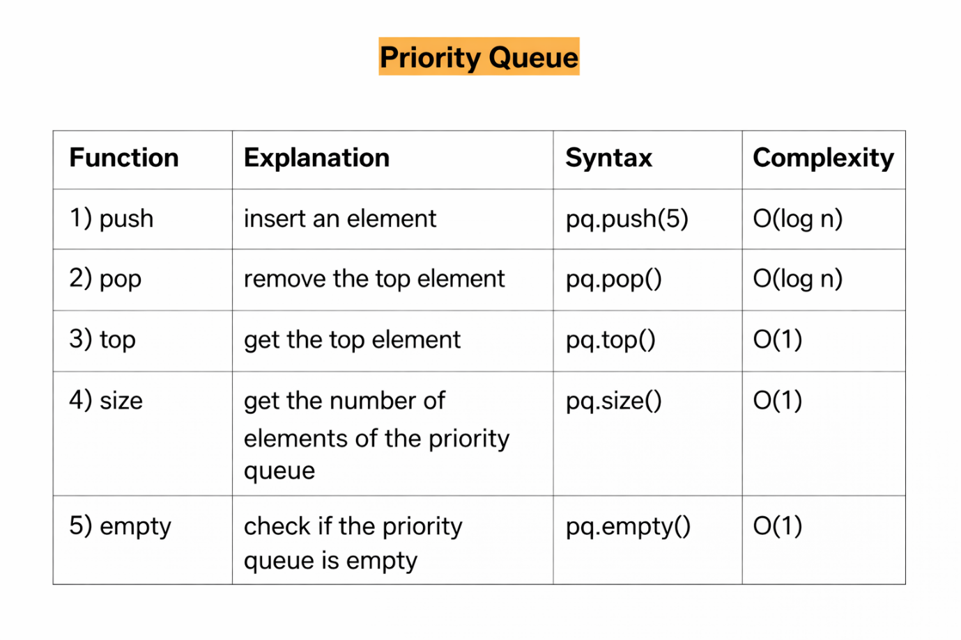

#include <bits/stdc++.h>
using namespace std;

int main() {
ios::sync_with_stdio(false);
cin.tie(nullptr);

// priority_queue<int> pq;
priority_queue<int, vector<int>, greater<int>> pq; // Min-heap
pq.push(5);
pq.push(2);
pq.push(8);
pq.push(1);

while (!pq.empty()) {
cout << pq.top() << " "; // Outputs: 8 5 2 1 we
//just get the top from the top of the priority queue
pq.pop();
}
cout << "size ==>" << pq.size() << endl; // Outputs: 0, since we popped all elements
return 0;
}

