DESIGN AND IMPLEMENTATION OF A PRIORITY-AWARE INTELLIGENT TRAFFIC CONTROL SYSTEM USING SUMO SIMULATION AND A LIGHTWEIGHT TRANSFORMER ENCODER

BY
ABDULAZEEZ JIMOH
U23DLCS20158

BEING A PROJECT SUBMITTED TO THE DEPARTMENT OF COMPUTER SCIENCE, FACULTY OF PHYSICAL SCIENCES, AHMADU BELLO UNIVERSITY, ZARIA, IN PARTIAL FULFILMENT OF THE REQUIREMENTS FOR THE AWARD OF A BACHELOR OF SCIENCE (B.Sc.) DEGREE IN COMPUTER SCIENCE

DEPARTMENT OF COMPUTER SCIENCE
FACULTY OF PHYSICAL SCIENCES
AHMADU BELLO UNIVERSITY, ZARIA
AUGUST 2026

DECLARATION
I hereby declare that this project, “Design and Implementation of a Priority-Aware Intelligent Traffic Control System Using SUMO Simulation and a Lightweight Transformer Encoder,” is my own original work, carried out under supervision in the Department of Computer Science, Ahmadu Bello University, Zaria. All sources of information used in this work have been duly acknowledged by means of references. This work has not been submitted, in whole or in part, for any other degree or qualification at this or any other institution.

Abdulazeez Jimoh
U23DLCS20158

Signature: ____________________________
Date: ________________________________

CERTIFICATION
This project has been read and approved as meeting the requirements of the Department of Computer Science, Faculty of Physical Sciences, Ahmadu Bello University, Zaria, for the award of a Bachelor of Science (B.Sc.) degree in Computer Science.

____________________________
Project Supervisor
Signature: ____________________ Date: ____________________

____________________________
Head of Department
Signature: ____________________ Date: ____________________

____________________________
External Examiner
Signature: ____________________ Date: ____________________

DEDICATION
This work is dedicated to everyone striving to make Nigeria's roads safer and more efficient for every driver, pedestrian, and emergency responder who depends on them.

ACKNOWLEDGEMENT
I am grateful to Almighty God for the strength, clarity, and sustenance that made this project possible. I sincerely thank my project supervisor for the guidance, patience, and constructive criticism offered throughout the design, implementation, and evaluation of this work.
I acknowledge the entire academic and non-academic staff of the Department of Computer Science, Ahmadu Bello University, Zaria, for the foundation of knowledge built over the course of this programme. I also thank my family, friends, and colleagues, whose encouragement and support carried me through the more demanding stages of this project.
Finally, I acknowledge the open-source communities behind SUMO, PyTorch, FastAPI, and Next.js, whose freely available tools made a project of this technical depth achievable within a final-year timeframe.

ABSTRACT
Fixed-time traffic signal systems allocate green time on a predetermined schedule regardless of real-time demand, producing unnecessary delay at unevenly loaded junctions and providing no systematic mechanism for prioritising emergency vehicles. This project, named MaHanya, designs and implements a simulation-based, priority-aware intelligent traffic control system for a real four-way junction, the Sapon Under-bridge Junction, Abeokuta, using microscopic traffic simulation, a learned phase-recommendation model, and a deterministic safety scheduler that has the sole authority to decide what signal state is actually applied.
Vehicle-arrival counts collected across the junction's four approaches, for peak and off-peak periods, were fitted to Poisson arrival distributions using scipy.stats and used to calibrate a multi-phase microscopic simulation of the junction in SUMO (Simulation of Urban MObility), built with netedit and driven at runtime through the TraCI control interface. Time-series traffic-state sequences generated from the calibrated simulation were used to train a lightweight Transformer Encoder, implemented in PyTorch, that recommends a signal phase from a sixteen-tick window of observed traffic state. A deterministic rule-based scheduler validates every recommendation the model produces against operational safety constraints (minimum and maximum green time, yellow and all-red transition intervals, anti-starvation, and emergency-vehicle pre-emption) before any phase change is applied, and logs every decision with an explicit, auditable reason code. A Next.js single-page dashboard, talking only to an internal FastAPI relay, renders the live junction, the active signal phase, priority events, and the model's recommendation alongside the scheduler's actual decision in real time.
The trained model reached 91.9% validation accuracy in recommending the scheduler's own logged phase decisions. Evaluated head-to-head against a fixed-time baseline on identical fifteen-minute simulation runs of the calibrated peak-hour scenario, the intelligent controller reduced priority-vehicle response time by 44.5% (23.9s versus 43.0s) at a small cost in average waiting time (23.8s versus 22.3s) and throughput (380 versus 384 vehicles per hour); the off-peak scenario showed the same pattern, with a 43.2% improvement in priority response time. These results demonstrate that a learned recommender constrained by a deterministic, exhaustively-testable safety layer can materially improve the safety-critical objective of the system (getting emergency vehicles through the junction faster) without violating any hard operational constraint, while identifying average-case throughput as an area for future tuning.
Keywords: intelligent traffic control, SUMO microsimulation, Transformer Encoder, rule-based scheduling, emergency vehicle pre-emption, Sapon Under-bridge Junction.

TABLE OF CONTENTS

LIST OF TABLES
Table 3.1: Transformer Encoder model hyperparameters 20
Table 3.2: Scheduler safety-rule thresholds 21
Table 4.1: Fitted Poisson arrival-rate parameters by direction and period 27
Table 4.2: Transformer Encoder training result 28
Table 4.3: Intelligent controller vs. fixed-time baseline: Sapon Under-bridge Peak Hour scenario 31
Table 4.4: Intelligent controller vs. fixed-time baseline: Sapon Under-bridge Off-Peak scenario 32

LIST OF FIGURES
Fig. 3.1: MaHanya system architecture and process boundaries 15
Fig. 3.2: MaHanya use case diagram 16
Fig. 3.3: Runtime control-loop detail (observe, predict/pre-empt, validate, apply, log) 22
Fig. 3.4: End-to-end pipeline, from field data collection to the dashboard 24
Fig. 3.5: mahanya module dependency graph 25
Fig. 4.1: Live Junction dashboard during a live emergency-vehicle pre-emption event 29
Fig. 4.2: Live Junction dashboard zoomed in on individual vehicles and per-lane signals 30
Fig. 4.3: Decision Log page, listing scheduler decisions with their reason codes 31
Fig. 4.4: Evaluation page comparing the intelligent controller against the fixed-time baseline 31

LIST OF ABBREVIATIONS
API - Application Programming Interface
CLI - Command-Line Interface
CSV - Comma-Separated Values
FastAPI - A Python web framework used for the internal simulation relay
JSON - JavaScript Object Notation
MaHanya - The name of the system described in this project
PyTorch - An open-source machine learning framework used to implement the model
SPA - Single-Page Application
SSE - Server-Sent Events
SUMO - Simulation of Urban MObility
TraCI - Traffic Control Interface (SUMO's runtime control API)
UI - User Interface
WS - WebSocket

CHAPTER ONE

INTRODUCTION

1.1 Background of the Study
Traffic signal control at road junctions is a long-standing challenge in urban transport planning. Most junctions in Nigeria, including those in growing cities such as Zaria, Kaduna, Abeokuta, and Abuja, operate on fixed-time signal plans that allocate green time according to a predetermined schedule regardless of the actual traffic demand present at the junction at any given moment (Lopez et al., 2018). A fixed-time plan cannot distinguish a genuinely congested approach from a lightly loaded one; it simply cycles through the same sequence of phases and durations whether the junction is empty or gridlocked.
The earliest departure from fixed-time control was traffic-responsive systems such as SCOOT (Split Cycle Offset Optimisation Technique), which uses real-time detector data to continuously adjust cycle length, phase splits, and offsets, and has been shown to reduce delay by roughly 15% relative to fixed timing (Hunt et al., 1982). More recently, the rise of deep learning has produced a wave of research applying reinforcement learning and, increasingly, attention-based sequence models to the same problem, learning a control policy directly from traffic-state observations rather than hand-tuning detector thresholds (Abdulhai et al., 2003; Haydari & Yilmaz, 2020; Zhao et al., 2024). The Transformer architecture in particular, originally developed for natural language sequence modelling (Vaswani et al., 2017), has been shown to be well suited to traffic-state sequences because a junction's short-term traffic pattern is itself a sequence (a window of recent per-direction counts, queue lengths, and phase history) from which a plausible next phase can be inferred much as a language model infers a plausible next word.
A purely learned controller is, however, difficult to trust with a safety-critical function such as a traffic signal: a neural network can produce a confident, well-formed, and completely unsafe recommendation (for example, a phase change that skips a mandatory clearance interval, or a hold that starves an approach indefinitely) and nothing in its own training process guarantees that this will never happen. This project's central design decision, discussed throughout this report, is therefore to treat any learned component as advisory only, and to place a small, deterministic, exhaustively-testable rule engine between the model's output and the physical (in this case, simulated) signal head, so that the system's safety properties do not depend on the model behaving correctly.
This project, named MaHanya, applies this design to a real Nigerian junction, the Sapon Under-bridge Junction in Abeokuta, Ogun State, using it as a calibration case study for a simulation-based intelligent traffic control system built from a microscopic SUMO (Simulation of Urban MObility) simulation, a lightweight Transformer Encoder phase-recommendation model, and a deterministic priority-aware scheduler.

1.2 Problem Statement
Fixed-time traffic signal systems are unable to adapt to real-time variations in traffic demand at multi-direction road junctions. At a junction such as Sapon Under-bridge, where directional demand shifts meaningfully between peak and off-peak periods, this produces three concrete problems:
- Unnecessary vehicle delay on heavily loaded approaches, while green time is simultaneously wasted on lightly loaded ones, because the signal plan cannot see or respond to the imbalance.
- No systematic mechanism for prioritising emergency vehicles: an ambulance or fire truck approaching a fixed-time junction has no faster path through it than any other vehicle, regardless of the urgency of its journey.
- Accumulating queue imbalances during peak periods, since a fixed-time plan has no anti-starvation logic of its own; if its assumptions about relative directional demand are wrong for a given period, one approach can be systematically under-served for as long as that period lasts.
Addressing this through physical infrastructure change (new detector hardware, a new controller cabinet, a wider carriageway) is expensive and impractical for an academic project, and does not, by itself, answer the more interesting question of whether a learned recommender constrained by a deterministic safety layer can out-perform fixed-time control on real junction geometry and real-shaped traffic. A simulation-based approach, calibrated with real traffic-count data and combined with a rule-guided scheduler, offers a rigorous and reproducible way to study this question within a final-year project's scope, without requiring access to physical signal hardware.

1.3 Aim and Objectives

1.3.1 Aim
The aim of this project is to design and implement a simulation-based, priority-aware intelligent traffic control system that uses vehicle-arrival data collected at the Sapon Under-bridge Junction, Abeokuta, to calibrate a SUMO microscopic traffic simulation, trains a lightweight Transformer Encoder model on the resulting traffic-state sequences, and applies a rule-guided priority scheduler to produce signal control decisions, evaluated against a fixed-time baseline.

1.3.2 Objectives
The specific objectives of this project are to:
- Collect vehicle-arrival count data at the Sapon Under-bridge Junction across all four junction directions, separately for peak and off-peak periods.
- Fit the collected arrival data to an appropriate statistical distribution and use the derived parameters to calibrate a multi-phase SUMO microscopic simulation of the junction.
- Generate labelled time-series traffic-state sequences from the calibrated simulation and train a lightweight Transformer Encoder model to recommend a signal phase from a window of observed traffic state.
- Implement a priority-aware scheduler that enforces minimum and maximum green time, transition intervals, anti-starvation rules, and emergency-vehicle pre-emption before finalising every signal decision.
- Develop a real-time dashboard that visualises junction state, active signal phase, priority events, and the model's recommendation alongside the scheduler's actual decision.
- Evaluate the resulting intelligent controller against a fixed-time baseline, on identical simulation scenarios, using average waiting time, queue length, throughput, and priority-vehicle response time.

1.4 Significance of the Study
For academic evaluators, this project demonstrates a complete, reproducible pipeline from raw field-count data through to a working, evaluated control system, and shows a specific, defensible pattern (a learned recommender wrapped by a deterministic safety layer) for combining machine learning with a safety-critical control problem, rather than trusting a model's output directly.
For a hypothetical Nigerian traffic authority, the calibrated Sapon Under-bridge Junction scenario is a concrete, locally grounded illustration of what an intelligent signal control system could offer over the fixed-time plans presently in use at similar junctions in cities such as Abeokuta, Zaria, Kaduna, and Abuja: measurable, quantified improvement on a safety-relevant metric (how quickly an emergency vehicle clears the junction), obtained without requiring new physical hardware.
For driver and pedestrian safety reviewers, the project's central contribution is architectural rather than purely predictive: it shows a specific way to let a learned component participate in a safety-critical system (as an advisory recommender, never as the final authority) with every scheduler decision that accepts, holds, or overrides that recommendation logged with an explicit, auditable reason code.

1.5 Scope of the Study
This project is scoped to a single, real, four-way junction, the Sapon Under-bridge Junction, Abeokuta, simulated in SUMO and never deployed to physical signal hardware. It covers the full pipeline from field-count data collection through statistical calibration, SUMO scenario construction, sequence generation, model training, a rule-based runtime control loop with emergency pre-emption, evaluation against a fixed-time baseline, and a real-time dashboard for visualising all of the above. It explicitly excludes network-wide, multi-junction optimisation; production or city-wide deployment; and general-purpose traffic-engineering tooling intended for junctions or use cases beyond this one calibration case study.

1.6 Limitations of the Study
Three limitations bound how this project's results should be read. First, the field-count dataset used to calibrate the simulation for this submission is a synthetic placeholder (structured identically to what a real Sapon Under-bridge Junction traffic survey would produce, and designed so that a genuine survey's data can be substituted with a drop-in file replacement and no code changes) rather than data from an actual, executed field survey; the calibration and every downstream result in this report should accordingly be read as validating the pipeline's methodology, not as a claim about the real junction's present-day traffic volumes.
Second, the SUMO network geometry assumes a single lane per direction and a nine-state phase space (one direction's green and yellow, plus one shared all-red clearance state), which is the default assumption documented in the project's architecture pending confirmation against the real, surveyed junction geometry; if the physical junction includes protected-turn phases or multiple lanes per approach, both the phase space and the trained model's output space would need to be revisited.
Third, emergency-vehicle detection in this system is provided directly by the simulation environment's own vehicle classification, since SUMO can flag a vehicle as an emergency-class vehicle at insertion time; this project does not implement or evaluate a real-world sensing pipeline (for example, an acoustic or visual detector) for identifying an approaching emergency vehicle in practice.

1.7 Definition of Terms
- Phase: A specific combination of signal indications (which approaches show green, yellow, or red) applied at the junction at a point in time.
- Green / yellow / all-red: Standard signal indications; all-red is a clearance interval during which every approach shows red, used to safely transition between conflicting green phases.
- Headway: The time gap between the arrivals of successive vehicles at a point on the road.
- Pre-emption: Overriding normal signal control to grant an approaching priority (emergency) vehicle immediate right of way through the junction.
- Anti-starvation: A scheduler rule that forces a phase change once a direction has waited longer than a defined threshold, preventing that direction from being indefinitely denied service.
- Throughput: The number of vehicles that clear the junction per unit time, typically expressed in vehicles per hour.
- Tick: One discrete step of the runtime control loop, corresponding to one second of simulated time in this system's configuration.
- Reason code: A short, machine-readable label the scheduler attaches to every decision it makes, explaining why the applied phase matched or diverged from the model's recommendation (e.g. model_accepted, min_green_hold, anti_starvation_force, emergency_preempt).

CHAPTER TWO

LITERATURE REVIEW
Four streams of prior work position MaHanya within the literature, taken up in turn across the sections that follow. Section 2.1 traces signal control from fixed-time plans through to traffic-responsive systems such as SCOOT and SCATS, establishing the demand-responsive principle this project inherits at a smaller scale. Section 2.2 reviews learned approaches to signal control: reinforcement-learning controllers and, more directly relevant to this project’s own model design, attention-based sequence models applied to phase recommendation. Section 2.3 examines microscopic traffic simulation, and specifically SUMO, as the calibration and evaluation substrate this project relies on, in place of physical field trials, following the same practice as the learned-control studies reviewed in Section 2.2. Section 2.4 identifies the gap in that literature this project is built to close: the absence, in most of it, of an explicit, model-independent safety layer standing between a learned controller’s recommendation and the signal state actually applied. Section 2.5 closes the chapter by drawing these four threads together into the specific position MaHanya occupies in the literature reviewed.

2.1 Fixed-Time and Traffic-Responsive Signal Control
The earliest generation of traffic signal control is fixed-time (or pre-timed) control: a cycle length, a fixed set of phase splits, and, where junctions are coordinated, a fixed offset between neighbouring junctions, all set in advance from historical traffic counts and left unchanged until an engineer manually revises the plan. Its principal advantage is predictability (drivers and pedestrians learn a consistent pattern) but its central weakness is exactly the one this project addresses: it cannot respond to demand that differs from the historical averages it was designed around, whether that difference is a short-term event (an accident, a large gathering) or a longer-term shift (seasonal demand, a new development on one approach).
Traffic-responsive control emerged to address this weakness by feeding real-time detector data back into the signal timing decision. SCOOT (Split Cycle Offset Optimisation Technique), developed for the United Kingdom's Transport and Road Research Laboratory, continuously adjusts cycle time, phase splits, and offsets from loop-detector occupancy data, and has been shown in field deployment to reduce delay by around 15% relative to a comparable fixed-time plan (Hunt et al., 1982). Systems in this family (SCOOT and its Australian counterpart SCATS being the best known) established the principle this project inherits at a smaller scale: that a traffic signal controller should be a function of currently observed demand, not solely of a historical schedule. Where they differ from MaHanya is in the mechanism: SCOOT and SCATS adjust a small set of continuous timing parameters (splits, cycle, offset) using classical control-theoretic and heuristic rules, rather than learning a phase-recommendation policy from data with a trained model, and neither includes an explicit, model-independent emergency pre-emption layer of the kind implemented here.

2.2 Learned Approaches: Reinforcement Learning and Sequence Models
A large and still-growing body of work applies reinforcement learning (RL) to traffic signal control, treating the junction as an agent that observes traffic state, selects a phase (or phase change) as an action, and receives a reward derived from a metric such as delay or queue length, learning a control policy through repeated simulated interaction rather than hand-tuned rules. Abdulhai, Pringle, and Karakoulas (2003) is an early and influential example, applying Q-learning to a single, isolated, actuated junction and validating the learned controller in microscopic simulation against a conventional actuated baseline, establishing, well before deep learning's recent resurgence, that a learned controller validated purely in simulation could plausibly out-perform a conventional one. Haydari and Yilmaz (2020) survey the substantial deep-reinforcement-learning literature that has followed, covering how traffic state is represented, how actions and rewards are formulated, and which simulation environments (SUMO prominent among them) are used to train and evaluate these controllers, and note the same recurring gap this project is designed to close: most deep-RL signal-control research evaluates a learned policy's performance without an explicit, separately-verifiable safety layer sitting between the policy's output and the applied signal state.
More recently, attention-based sequence models (the Transformer architecture, introduced by Vaswani et al. (2017) for natural-language sequence modelling) have been applied to traffic signal control by treating a short window of recent traffic-state observations as a sequence and the next phase decision as the value to be predicted from it, in the same structural shape as predicting the next token in a language model. Zhao, Hu, Li, Fan, Gao, and Gao (2024) apply exactly this framing, proposing a sequence-decision-transformer architecture for adaptive traffic signal control and reporting improved performance over both fixed-time and reinforcement-learning baselines in simulation. This is the specific precedent MaHanya's model design follows most directly: a window of observed traffic state (in this project's case, sixteen ticks of per-direction vehicle counts, queue length, waiting time, emergency flags, active phase, and elapsed phase time) is fed to a small Transformer Encoder that outputs a recommended next phase, trained on labelled sequences generated from the calibrated SUMO simulation rather than through online reinforcement learning.

2.3 Simulation as an Evaluation and Calibration Substrate
Most of the learned-control literature reviewed above (Section 2.2), and this project, relies on microscopic traffic simulation rather than physical field trials, both because physical trials on a real, live junction carry obvious safety and legal risk during an untested controller's development, and because simulation allows a controller to be evaluated repeatedly, deterministically (given a fixed random seed), and head-to-head against a baseline on identical traffic conditions, which a live junction cannot offer. SUMO (Simulation of Urban MObility), described by Lopez et al. (2018), is the open-source microscopic simulator this project uses, chosen because it is the de facto standard tool in this literature, exposes a mature Python control interface (TraCI) for exactly the observe/act/log loop a runtime controller needs, and supports vehicle-class flags (including an emergency-vehicle class) that this project relies on directly for its pre-emption behaviour, without needing to build a separate detection model.
A calibrated SUMO scenario is only as trustworthy as the data used to build it. This project follows the standard practice of fitting an arrival-rate distribution (here, a Poisson distribution per direction and period, following the usual first choice for independent, low-to-moderate-volume arrivals, with a negative binomial distribution as the documented fallback should the data prove over-dispersed) to observed vehicle counts, and using the fitted parameters to drive SUMO's own vehicle-insertion process for each calibrated scenario, so that the simulated arrival pattern matches the statistical shape of the real-world counts it was fitted from, rather than an arbitrarily chosen or hand-tuned one.

2.4 Safety-Layered Control: Why a Learned Model Cannot Be the Final Authority
The literature reviewed above is united on a point this project treats as its central design constraint even though the point is often left implicit: a traffic signal controller is a safety-critical system, and a purely learned policy offers no guarantee, by construction, that its output will always respect hard operational constraints such as a minimum green time, a mandatory clearance interval between conflicting phases, or a bound on how long any one direction can be denied service. A reinforcement-learning agent can be trained with a reward function that penalises such violations, and a large enough training run can drive the frequency of violations very low, but "very low" is not "never," and a traffic signal is exactly the kind of system where "never" is the requirement, not an aspiration.
MaHanya's response to this gap (the specific contribution this project makes beyond reproducing an existing model architecture on a new junction) is to place a small, deterministic, exhaustively unit-testable rule engine between the Transformer Encoder's recommendation and the phase actually applied to the simulated signal head. The model's output is never applied directly; every recommendation is validated against minimum/maximum green time, transition-interval, and anti-starvation rules first, and an emergency-vehicle detection short-circuits the model's recommendation path entirely, going straight to a rule-determined safe pre-emption state. Every decision the scheduler makes, whether it accepted, held, or overrode the model, is logged with an explicit reason code, so the system's behaviour is auditable after the fact, not only theoretically safe by design. This pattern of pairing a learned recommender with a deterministic safety layer, rather than trusting either a purely rule-based system (which cannot adapt to demand it was not explicitly programmed for) or a purely learned one (which cannot guarantee it will never violate a hard constraint) is the specific gap in the reviewed literature this project's design is built to close.

2.5 Summary and Positioning of This Project
The four streams of work reviewed above situate MaHanya as follows. Fixed-time control (Section 2.1) is unresponsive to real-time demand by design. Traffic-responsive systems such as SCOOT (Section 2.1) respond to demand but through continuous timing-parameter adjustment rather than a learned phase-recommendation policy, and without an explicit emergency pre-emption layer. Reinforcement-learning approaches (Section 2.2) learn a control policy directly but are typically evaluated without a separately-verifiable safety layer. Transformer-based sequence approaches (Section 2.2), which this project's model design follows most closely, demonstrate that attention-based sequence models are well suited to the traffic-state-window-to-phase-decision problem shape, but the specific precedent this project builds on (Zhao et al., 2024) does not, in its own reported design, describe a deterministic safety layer of the kind implemented here. MaHanya's specific position in this landscape is therefore: a Transformer Encoder recommender in the pattern of Zhao et al. (2024), trained on SUMO-simulated (Lopez et al., 2018) sequences calibrated from real field-count data, whose output is never trusted directly but is instead validated by a deterministic, exhaustively-tested rule engine before any signal state is applied, combining the adaptivity the reinforcement-learning and sequence-model literature demonstrates with the auditable safety guarantee that literature largely leaves to future work.

CHAPTER THREE

SYSTEM ANALYSIS AND METHODOLOGY
How MaHanya was analysed, designed, and built is set out below, in the order a reader encountering the system for the first time would need it explained. Section 3.1 gives a system-level overview of the two independently deployable projects that make up MaHanya and how they communicate, together with a use case diagram showing who and what interacts with the running system and why. Section 3.2 lists the development tools and technology stack the project depends on. Sections 3.3 through 3.6 describe the offline pipeline that produces a trained model: field data collection and statistical calibration, SUMO scenario calibration, sequence generation, and the Transformer Encoder model’s own design. Section 3.7 describes the priority-aware scheduler (the deterministic rule engine that is the sole authority over what signal state is actually applied) and Section 3.8 describes the dashboard that makes the running system’s behaviour visible and auditable in real time. Section 3.9 summarises the full pipeline end to end, Section 3.10 sets out the component and module design within the api/ and web/ projects, and Section 3.11 closes the chapter with the methodology used to evaluate the resulting controller against a fixed-time baseline.

3.1 System Overview
MaHanya is organised as two independently deployable projects that communicate over a single internal HTTP/WebSocket boundary rather than through direct Python imports: an api/ service that owns the SUMO simulation process, the Transformer Encoder model, the deterministic scheduler, and an internal FastAPI relay; and a web/ service, a Next.js single-page application that renders the dashboard and never touches simulation internals directly. NetEdit (SUMO's own graphical network editor) is used once, by hand, to author the Sapon Under-bridge Junction's geometry; the resulting .net.xml, .rou.xml, and .sumocfg files are checked into the repository as data artefacts, not generated by application code. Figure 3.1 shows how these pieces fit together.
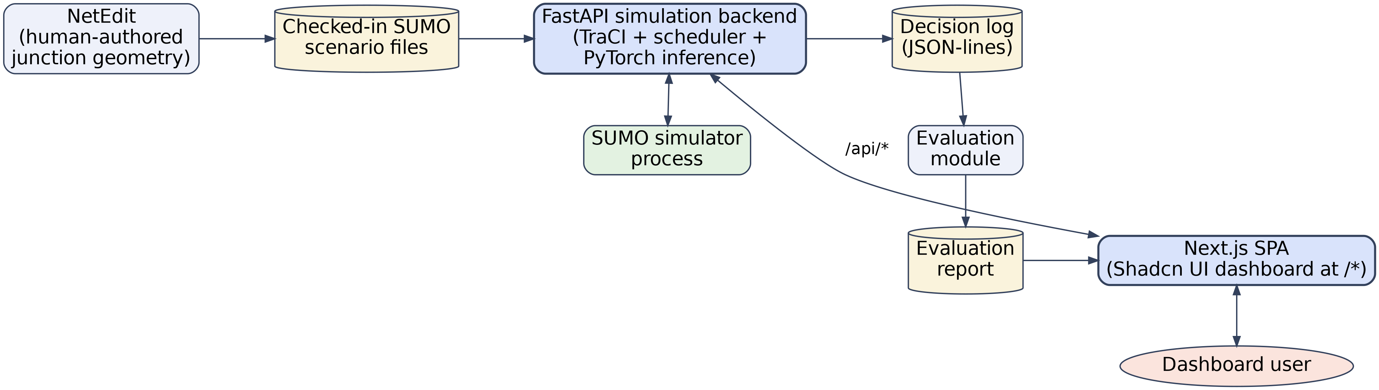
Fig. 3.1: MaHanya system architecture and process boundaries
The FastAPI backend is an internal process boundary, not a public API: it starts and owns the TraCI connection to a running SUMO process, advances the scheduler's control loop, persists a per-tick decision log, and relays each tick, together with the model's recommendation and the scheduler's actual decision, to the dashboard over a WebSocket. The dashboard is a static-exported Shadcn UI application that reads and renders that relay's output; it embeds no simulation engine of its own and never opens a TraCI connection directly, which keeps SUMO, PyTorch, and the scheduler's dependencies entirely on the Python side.
Figure 3.2 shows the same system from a use case perspective. A traffic operator monitors live junction state, the scheduler’s decision log, and evaluation results through the dashboard, while an emergency vehicle detected by the simulation triggers pre-emption directly, short-circuiting the model’s own automatic phase-recommendation path. Both paths converge on a single use case, “Validate & apply signal decision,” which is the scheduler’s rule engine described in Section 3.7 and the only path by which any signal state is ever actually applied.
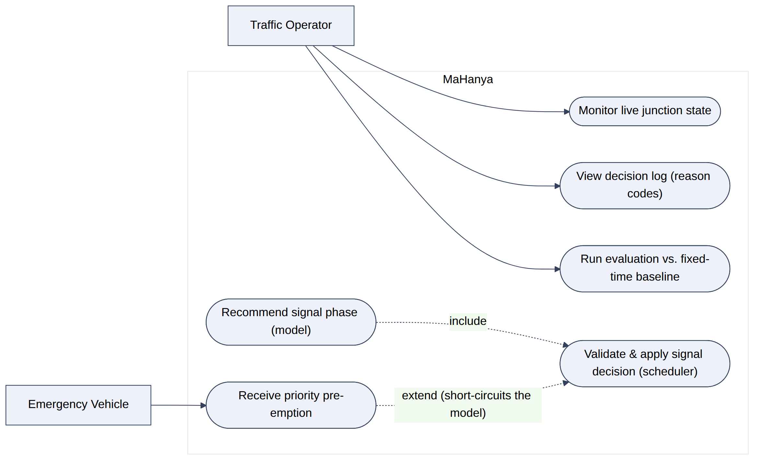
Fig. 3.2: MaHanya use case diagram

3.2 Development Tools and Technology Stack
Python 3.11 was used for the simulation, model, and scheduler service, managed with uv for dependency and virtual-environment management, matching SUMO/TraCI's Python bindings and PyTorch's supported versions, with importable packages kept under a src/ layout separating them from the project's own tooling files and tests, following the Python Packaging Authority's (n.d.-b) documented guidance on src-layout versus flat-layout projects. SUMO, with its TraCI and sumolib Python bindings (Lopez et al., 2018), was chosen as the microsimulation engine because it is the open-source de facto standard for this problem class, with a mature control API and a built-in emergency vehicle class this project relies on directly. scipy.stats supplied the Poisson/negative-binomial distribution fitting used to calibrate arrival rates from field counts. PyTorch was used to implement the Transformer Encoder model (Vaswani et al., 2017), following the project's synopsis requirement of a lightweight (small layer/head count) architecture rather than a large pretrained one. pydantic v2 and pydantic-settings define every data contract exchanged between the simulation, the scheduler, the FastAPI relay, and the dashboard, and drive a single layered configuration object (in-code defaults, an optional config file, then CLI overrides) covering simulation parameters, model hyperparameters, and scheduler thresholds. Typer, packaged as a pyproject.toml console-script entry point following the Python Packaging Authority's guidance on creating and packaging command-line tools (Python Packaging Authority, n.d.-a) and Typer's own packaging documentation (Typer, n.d.), provides the project's command-line interface, exposing every pipeline stage (fit, calibrate, generate, train, run, evaluate, serve-api, build-web) as a typed, testable subcommand.
The internal simulation backend is exposed to the dashboard through FastAPI, organised as resource-specific routers included under a single /api prefix at the application boundary, following FastAPI's own documented pattern for structuring a larger application across multiple files (FastAPI, n.d.). On the dashboard side, Next.js, configured for static-SPA export per its own documented guidance for static exports (Next.js, n.d.-b) with source kept under a self-contained src/ directory (Next.js, n.d.-a), and the Shadcn UI component library were used to build a componentised, accessible dashboard without embedding a server-rendering runtime the static export would otherwise require; pnpm manages the JavaScript/TypeScript toolchain. Pixi.js renders the live junction canvas (a WebGL-accelerated 2D scene graph well suited to redrawing dozens of moving vehicles at up to sixty frames per second without the DOM-diffing overhead a plain React re-render of that many elements would incur). Vitest and Playwright provide unit and end-to-end test coverage on the dashboard; pytest covers the Python side, with the scheduler's rule engine (the system's safety-critical layer) as the highest-priority unit-test target.

3.3 Field Data Collection and Statistical Calibration
The system's calibration methodology requires vehicle-arrival counts collected at the Sapon Under-bridge Junction, per direction (north, south, east, west), across peak and off-peak sessions, recorded as five-minute interval counts (a session date, a direction, a period, an interval start time, the interval length in minutes, and the observed vehicle count). For this submission, that dataset is a synthetic placeholder (structured identically to what a real field survey would produce and documented as such in the repository, so a genuine survey's counts can be substituted as a drop-in file replacement with no code changes) pending an actual field survey at the junction.
Each direction/period combination's counts are fit to a Poisson distribution using scipy.stats, with a chi-square goodness-of-fit test computed for every fit; a negative binomial distribution is the documented fallback should a given direction/period's counts prove over-dispersed relative to a Poisson assumption. The fitted rate parameter (λ, in vehicles per five-minute interval) for each of the eight direction/period combinations is what ultimately drives SUMO's vehicle-insertion process for that scenario, converted to a per-second insertion probability for the corresponding route flow.

3.4 SUMO Scenario Calibration
The Sapon Under-bridge Junction's physical geometry (a four-way junction with one inbound and one outbound lane per approach, meeting at a single traffic-light-controlled node) was authored once in NetEdit and checked in as sapon.net.xml. Two calibrated scenarios are generated programmatically from this shared network geometry, one per period: a peak-hour scenario and an off-peak scenario, each a matching pair of a route file (.rou.xml, defining one Poisson-rate vehicle flow per direction, drawn from the period's fitted parameters, plus a low-rate emergency-vehicle flow per direction so that pre-emption behaviour is exercised during evaluation) and a scenario configuration file (.sumocfg) binding the network, routes, and a thirty-minute simulated duration together for TraCI to load.
The junction's signal logic follows the nine-state phase space documented as this project's default assumption pending confirmation against the real junction's surveyed geometry (see Section 1.6): one green phase per direction (NORTH_GREEN, SOUTH_GREEN, EAST_GREEN, WEST_GREEN), a matching yellow phase for each, and one shared ALL_RED clearance state used during every transition between two conflicting green phases.

3.5 Sequence Generation
Labelled training data for the model is produced by running the calibrated peak scenario through TraCI for a fixed number of ticks under the scheduler's own control (so that the phase labels the model eventually learns to recommend are phases the scheduler itself judged correct, subject to its safety rules), logging one row per tick: per-direction vehicle count, queue length, waiting time, and emergency-vehicle presence; the active phase and elapsed phase time; and the scheduler's applied phase as the training label. These rows are written to a columnar Parquet file, chosen over CSV for this stage because the generated sequences are large enough that Parquet's compression and typed-column storage meaningfully reduce load time.

3.6 Transformer Encoder Model Design
The phase-recommendation model is a small, custom nn.TransformerEncoder over an engineered per-tick feature vector, deliberately sized to be "lightweight" per the project's synopsis rather than a large, pretrained architecture: it consumes a fixed-length window of the sixteen most recent ticks, each represented as a short feature vector (per-direction vehicle count, queue length, waiting time, and emergency flag, i.e. four features per direction across four directions), and outputs a probability distribution over the nine-phase space, from which the recommended phase and a confidence score are read off as the arg-max and its associated probability. Table 3.1 lists the model's configured hyperparameters.
Table 3.1: Transformer Encoder model hyperparameters
Hyperparameter | Value | Notes
Sequence length | 16 ticks | The window of recent traffic state fed to the encoder.
Model dimension (d_model) | 32 | Kept small to satisfy the synopsis's "lightweight" requirement.
Attention heads | 4 | Multi-head self-attention over the 16-tick window.
Encoder layers | 2 | Two stacked Transformer encoder layers.
Feed-forward dimension | 64 | Inner dimension of each layer's position-wise feed-forward network.
Dropout | 0.1 | Applied within each encoder layer during training.
Output classes | 9 | One per phase in the phase space (Section 3.4).
Features per direction | 4 | Vehicle count, queue length, waiting time, emergency flag.
The model is trained with a standard cross-entropy classification objective against the scheduler-applied phase label from Section 3.5, using an 80/20 train/validation split over the generated windows. Because the model's output is never applied directly (Section 3.7), training and evaluating it is treated strictly as a supervised classification problem, not as an end-to-end reinforcement-learning or control problem: the model's job is only to propose a plausible phase, not to guarantee a safe one.

3.7 Priority-Aware Scheduler Design
The scheduler is the system's sole authority over what signal state is actually applied; the model's output is advisory input only, and is never written to the simulated signal head without passing through the rule checks below first. It is implemented as plain, deterministic Python (no finite-state-machine library) because the rule set below covers a small, fixed number of states and transitions for a single junction, and exhaustively-unit-testable plain code is more transparent and auditable here than a general FSM abstraction would be for the marginal benefit it would offer at this scale. Table 3.2 lists the configured thresholds behind each rule.
Table 3.2: Scheduler safety-rule thresholds
Rule | Threshold | Effect
Minimum green time | 10 s | A green phase cannot end before 10 seconds have elapsed, regardless of the model's recommendation.
Maximum green time | 60 s | A green phase is forced to end once 60 seconds have elapsed, even under sustained one-directional demand.
Yellow clearance | 3 s | Every transition out of a green phase passes through 3 seconds of yellow before the next green begins.
All-red clearance | 2 s | Every transition additionally passes through 2 seconds where all approaches show red.
Anti-starvation wait | 90 s | A direction that has waited 90 seconds forces a phase change to serve it, overriding the model's recommendation.
Every control-loop tick follows the same five-step sequence (observe, then either pre-empt or predict-and-validate, then apply, then log) shown in Figure 3.3. An emergency-vehicle detection on any approach short-circuits the model entirely: the scheduler forces a safe green for the priority approach directly, without consulting the recommendation, and every tick this remains in effect is logged with the emergency_preempt reason code. In every other tick, the model's recommendation is checked against the minimum/maximum-green and anti-starvation rules above before being applied; the resulting decision is logged as model_accepted when the recommendation was applied unmodified, or with the specific overriding reason code (min_green_hold, max_green_force, or anti_starvation_force) when the scheduler held or forced a different phase than the one recommended. This is the mechanism behind the project's non-functional auditability requirement: nothing the scheduler does to a model recommendation is silent.
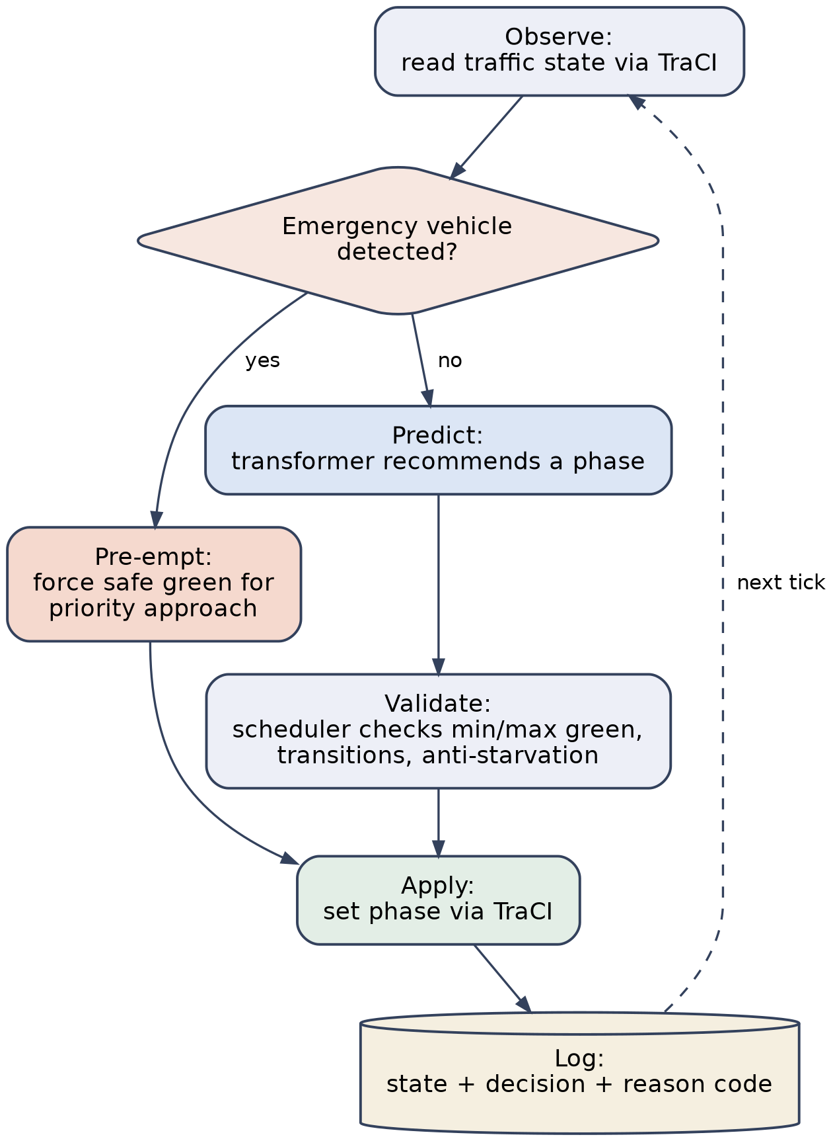
Fig. 3.3: Runtime control-loop detail (observe, predict/pre-empt, validate, apply, log)
Two failure modes are handled explicitly rather than left to crash the control loop. If model inference fails or times out, the scheduler falls back to holding the current phase until the minimum/maximum-green or anti-starvation rules themselves force a change; the deterministic layer never depends on the model succeeding. If an emergency vehicle is detected while a phase is mid-transition, pre-emption still takes effect at the next legal transition point rather than skipping the yellow/all-red clearance already in progress, since skipping a clearance interval would itself be unsafe.

3.8 Dashboard Design
The dashboard is a Next.js single-page application, statically exported and served at the site root, built exclusively from Shadcn UI components and theme tokens. It never talks to TraCI, PyTorch, or the scheduler directly; every piece of state it renders (current junction state, active phase, priority events, the model's recommendation next to the scheduler's actual decision, the historical decision log, and evaluation reports) is read from the internal FastAPI relay's /api/* endpoints, over a WebSocket for live simulation ticks and plain HTTP for snapshot and historical queries. Four pages make up the dashboard: Live State, which renders the junction itself on an interactive canvas (Section 3.8.1); Decision Log, a filterable, sortable table of every scheduler decision and its reason code; Evaluation, which runs and displays the intelligent-controller-versus-fixed-time-baseline comparison described in Section 3.9; and Methodology, a plain-language walkthrough of the pipeline described above, included for a non-technical dashboard visitor.

3.8.1 The Live Junction Canvas
The junction itself is rendered on a Pixi.js WebGL canvas built to read as a faithful, top-down replica of SUMO-GUI's own visual language (green grass, dark asphalt, white lane paint, colour-coded per-lane stop-line signals, and flat rectangular vehicles) rather than a stylised reinterpretation, since the goal is for a viewer already familiar with SUMO's own tooling to recognise the junction immediately. Vehicle positions, the active phase, and per-approach queue state are redrawn every tick from the relayed traffic state; a lightweight cosmetic widening renders each simulated lane as three drawn lanes for visual clarity, documented in the source as a purely cosmetic choice and not a claim that the underlying simulation itself models extra lanes. The canvas supports wheel-zoom, drag-pan, and touch pinch-zoom, with a reset-to-fit control, so a viewer can zoom in on per-lane signal and vehicle detail while still being able to see the full, longer approach roads at a glance.

3.9 Pipeline Summary
Figure 3.4 summarises the full pipeline described across Sections 3.3 to 3.8, from field data collection through to the dashboard, showing which stages are offline/batch (data collection, distribution fitting, SUMO calibration, sequence generation, model training, evaluation) and which run live (the runtime control loop and the dashboard it feeds).
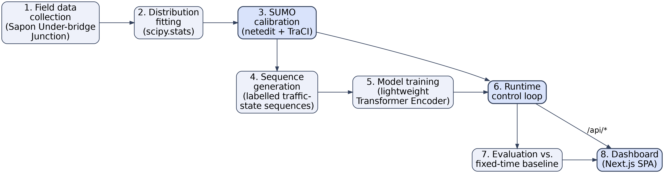
Fig. 3.4: End-to-end pipeline, from field data collection to the dashboard

3.10 Component and Module Design
Within the api/ service, the Python package mahanya owns every domain concern: schemas (the shared data contracts every other module depends on), data (ingestion and distribution fitting), sumo (the thin TraCI client and its translation into the schemas' traffic-state contract), model (feature engineering, the Transformer definition, training, and inference), scheduler (the rule engine and one-tick control-loop orchestration), and evaluation (the fixed-time baseline controller and the metrics module), while core and routes implement the internal FastAPI relay as a thin layer on top of mahanya, and cli exposes the whole pipeline as Typer subcommands. Figure 3.5 shows the resulting dependency direction: scheduler is the only mahanya module allowed to depend on both sumo and model, since orchestrating one control-loop tick is specifically its job, and every dependency in the graph points toward schemas, never away from it, so that the shared data contracts never depend on any one module's internals.
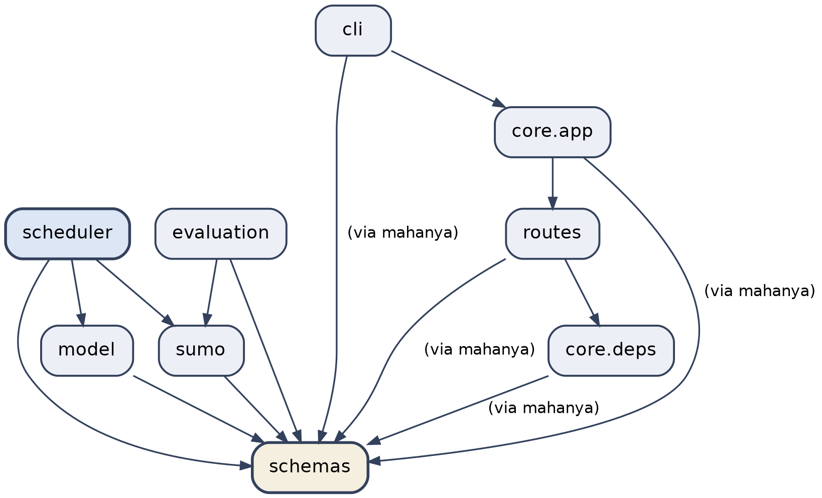
Fig. 3.5: mahanya module dependency graph

3.11 Evaluation Methodology
The intelligent controller is evaluated against a fixed-time baseline controller on the same calibrated scenario, run twice under identical conditions (once under the full runtime control loop described in Section 3.7, and once under a fixed-time controller that cycles through the same nine-phase space on fixed, pre-set durations with no model input and no priority pre-emption) so that any difference in the reported metrics is attributable to the controller, not to a difference in the traffic itself. Four metrics are computed from the logged state of each run: average waiting time (seconds), average queue length (vehicles), throughput (vehicles cleared per hour), and priority-vehicle (emergency) response time (seconds, from an emergency vehicle's detection to its clearing the junction). Runs are seeded, so the same scenario and seed reproduce the same vehicle-arrival sequence under both controllers, making the comparison a controlled one rather than a comparison across two different, randomly-drawn traffic samples.

CHAPTER FOUR

IMPLEMENTATION AND RESULTS
What was actually built and measured is reported below, following the same order as the pipeline described in Chapter Three. Section 4.1 gives a brief implementation overview. Section 4.2 reports the field data collection and statistical calibration results: the fitted arrival-rate parameters the SUMO scenarios were built from. Section 4.3 reports the Transformer Encoder’s training result. Section 4.4 walks through the live dashboard as it actually renders a running scenario. Section 4.5 reports the intelligent controller’s evaluation against the fixed-time baseline on both the peak and off-peak scenarios, and Section 4.6 summarises the project’s test coverage. Section 4.7 then discusses what these results, taken together, say about the proposed solution: where it succeeds, where it does not yet outperform the baseline, and why.

4.1 Implementation Overview
Every stage of the pipeline described in Chapter Three was implemented and exercised end-to-end, from raw counts through to a live, evaluated dashboard, using the Typer command-line interface's pipeline subcommands: fit, calibrate, generate, train, run, evaluate, serve-api, and build-web. All results reported below were produced by actually running this pipeline against the calibrated Sapon Under-bridge Junction scenarios (a real SUMO simulation process controlled over TraCI, a real trained model checkpoint, and a real FastAPI relay and Next.js dashboard, not simulated or hand-authored output), so the figures and tables below are reproducible by re-running the same commands.

4.2 Data Collection and Calibration Results
Table 4.1 reports the Poisson rate parameter (λ, mean arrivals per five-minute interval) fitted for each of the four junction directions across both the peak and off-peak periods, together with each fit's chi-square goodness-of-fit statistic and p-value. Seven of the eight direction/period combinations show no significant departure from a Poisson arrival process at the 5% level (p > 0.05); the south approach's peak-period fit is the one exception, with a p-value of 0.032, indicating the observed counts are more dispersed than a pure Poisson process would predict for that specific direction and period. This is flagged rather than silently accepted: it is a specific, actionable candidate for re-fitting to a negative binomial distribution (the documented fallback for over-dispersed arrivals) in a future calibration pass.
Table 4.1: Fitted Poisson arrival-rate parameters by direction and period
Direction | Period | λ (veh/5 min) | χ² p-value | Fit quality
North | Peak | 9.94 | 0.120 | Good (p > 0.05)
North | Off-peak | 3.19 | 0.895 | Good (p > 0.05)
South | Peak | 10.33 | 0.032 | Over-dispersed (p < 0.05)
South | Off-peak | 3.17 | 0.312 | Good (p > 0.05)
East | Peak | 5.78 | 0.393 | Good (p > 0.05)
East | Off-peak | 2.19 | 0.539 | Good (p > 0.05)
West | Peak | 6.61 | 0.688 | Good (p > 0.05)
West | Off-peak | 2.17 | 0.152 | Good (p > 0.05)
These fits confirm the expected shape of the underlying (synthetic placeholder, per Section 1.6) dataset: every direction shows a materially higher arrival rate in the peak period than off-peak, with north and south (the two approaches carrying the junction's principal through-movement in this scenario) showing the heaviest peak-period demand at λ ≈ 10 vehicles per five-minute interval, roughly three times their own off-peak rate.

4.3 Model Training Result
The Transformer Encoder described in Section 3.6 was trained for ten epochs on sequences generated from a 1,200-tick run of the calibrated peak scenario under the scheduler's own control, split into 648 training windows and 161 validation windows. Table 4.2 reports the resulting loss and accuracy.
Table 4.2: Transformer Encoder training result
Metric | Value
Training windows | 648
Validation windows | 161
Epochs | 10
Final training loss | 0.147
Final validation loss | 0.227
Final validation accuracy | 91.9%
A validation accuracy of 91.9% means the model correctly recommends the same phase the scheduler itself ultimately applied on roughly nine out of every ten held-out ticks; the remaining cases are, by design, not a safety concern, since every recommendation, correct or not, passes through the scheduler's rule checks in Section 3.7 before being applied, and an incorrect recommendation the scheduler overrides simply shows up in the decision log with its own reason code (Section 4.4) rather than reaching the simulated signal head.

4.4 The Live Dashboard
Figure 4.1 shows the Live State page's junction canvas during an actual live emergency-vehicle pre-emption event, captured mid-run from a real SUMO simulation of the peak scenario (not a mocked or scripted screenshot): tick 302, an emergency vehicle detected on the south approach, the scheduler holding SOUTH_GREEN and logging the decision with the emergency_preempt reason code, and the model's own recommendation for that tick shown as bypassed alongside the phase actually applied.
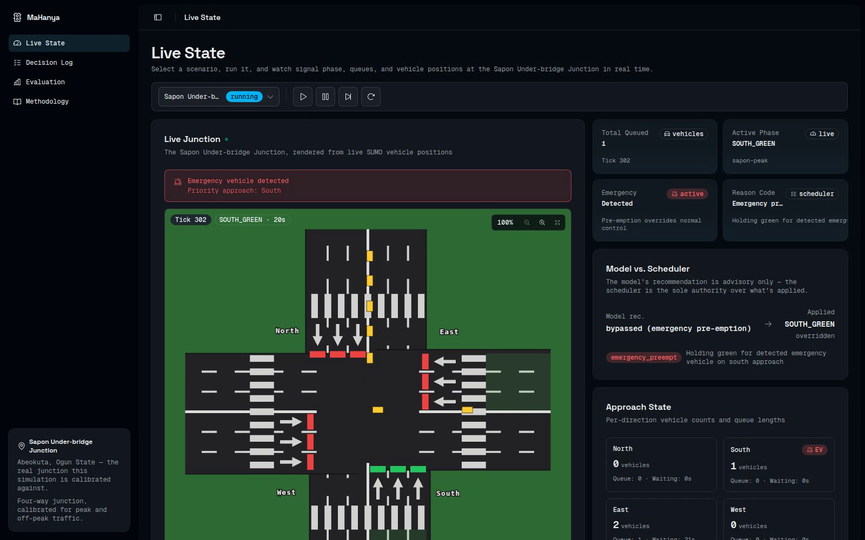
Fig. 4.1: Live Junction dashboard during a live emergency-vehicle pre-emption event
Figure 4.2 shows the same canvas zoomed in (261% of the fit-to-frame scale, reached with the wheel-zoom control described in Section 3.8.1), during a routine, non-emergency tick where the scheduler is holding the East approach's green phase for its minimum green duration: individual vehicles, the per-lane signal ticks, and the min_green_hold reason code are all legible at this zoom level, which is the reason the zoom/pan control was added: the un-zoomed view in Figure 4.1 is deliberately proportioned to show the full, longer approach roads, and only zooming reveals this level of per-lane detail.
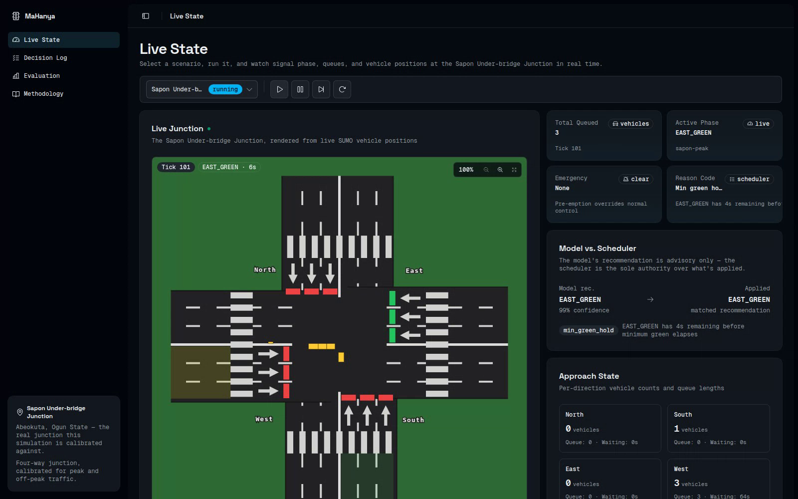
Fig. 4.2: Live Junction dashboard zoomed in on individual vehicles and per-lane signals
Figure 4.3 shows the Decision Log page, which lists every scheduler decision (tick, timestamp, the model's recommendation, the phase actually applied, and the reason code), filterable by reason code, giving a reviewer a complete, chronological audit trail of every point at which the scheduler accepted, held, or overrode the model.
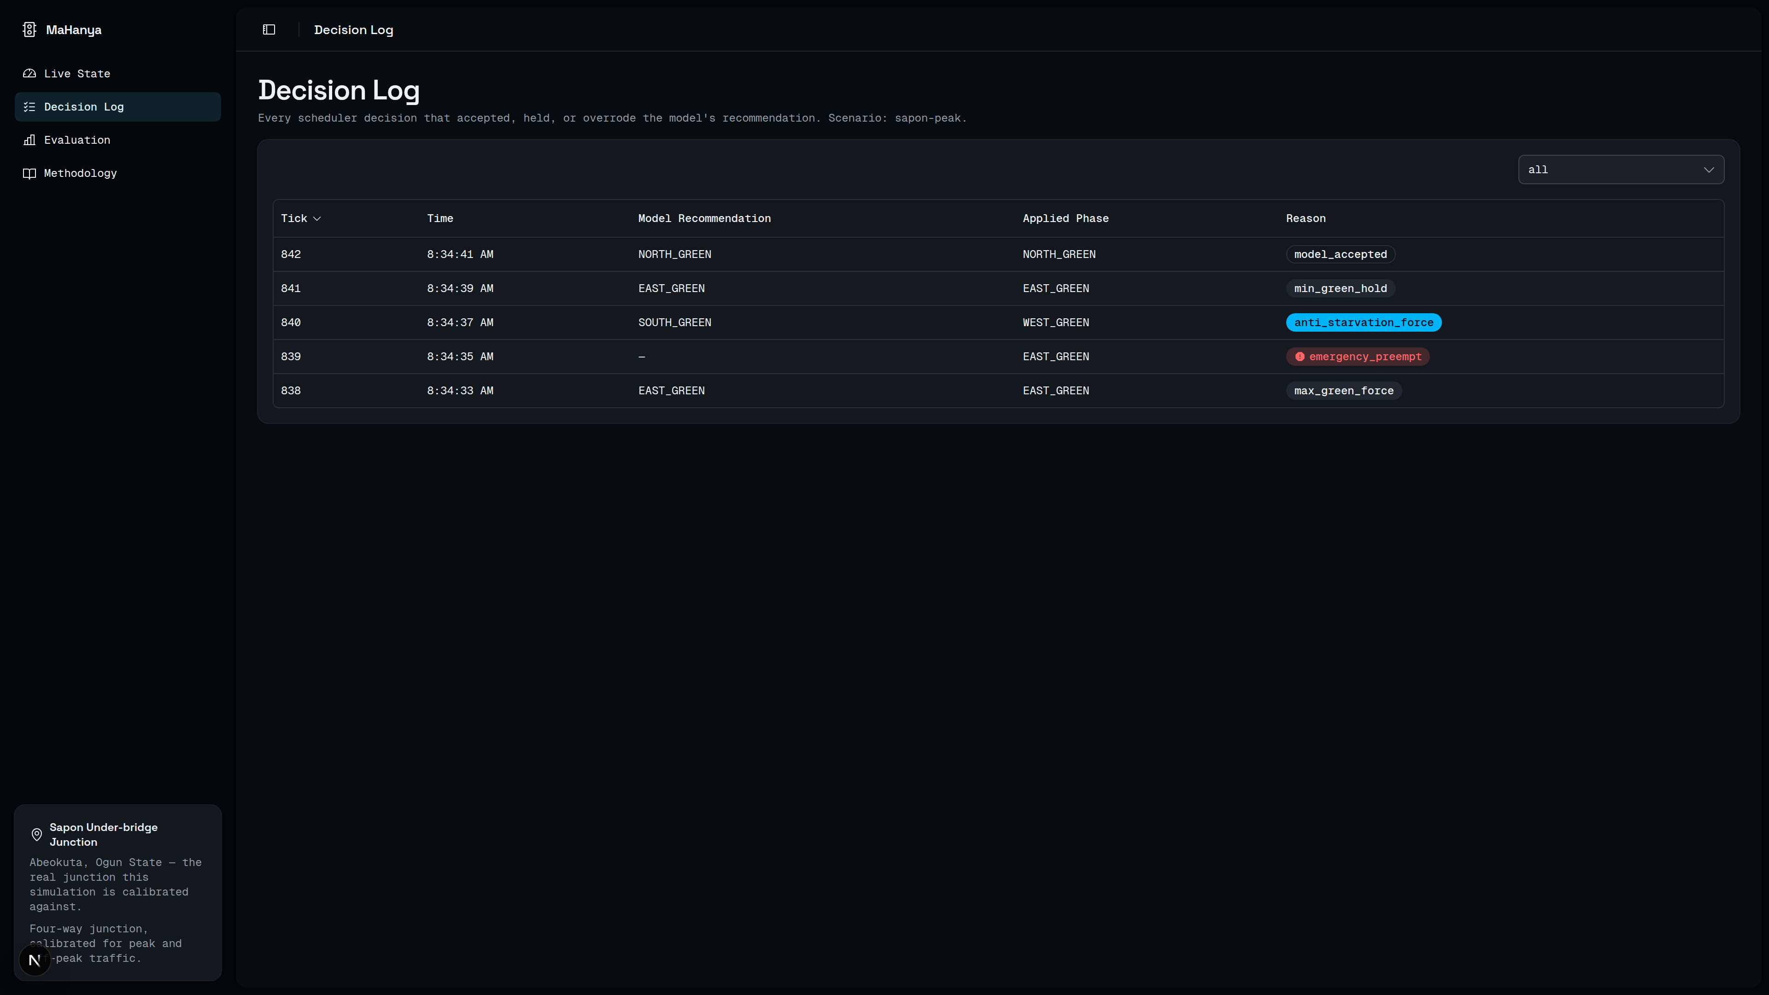
Fig. 4.3: Decision Log page, listing scheduler decisions with their reason codes
Figure 4.4 shows the Evaluation page's interface for running and comparing the intelligent controller against the fixed-time baseline described in Section 3.11; the numeric results actually obtained from this evaluation, on both the peak and off-peak scenarios, are reported and discussed in Section 4.5 below.
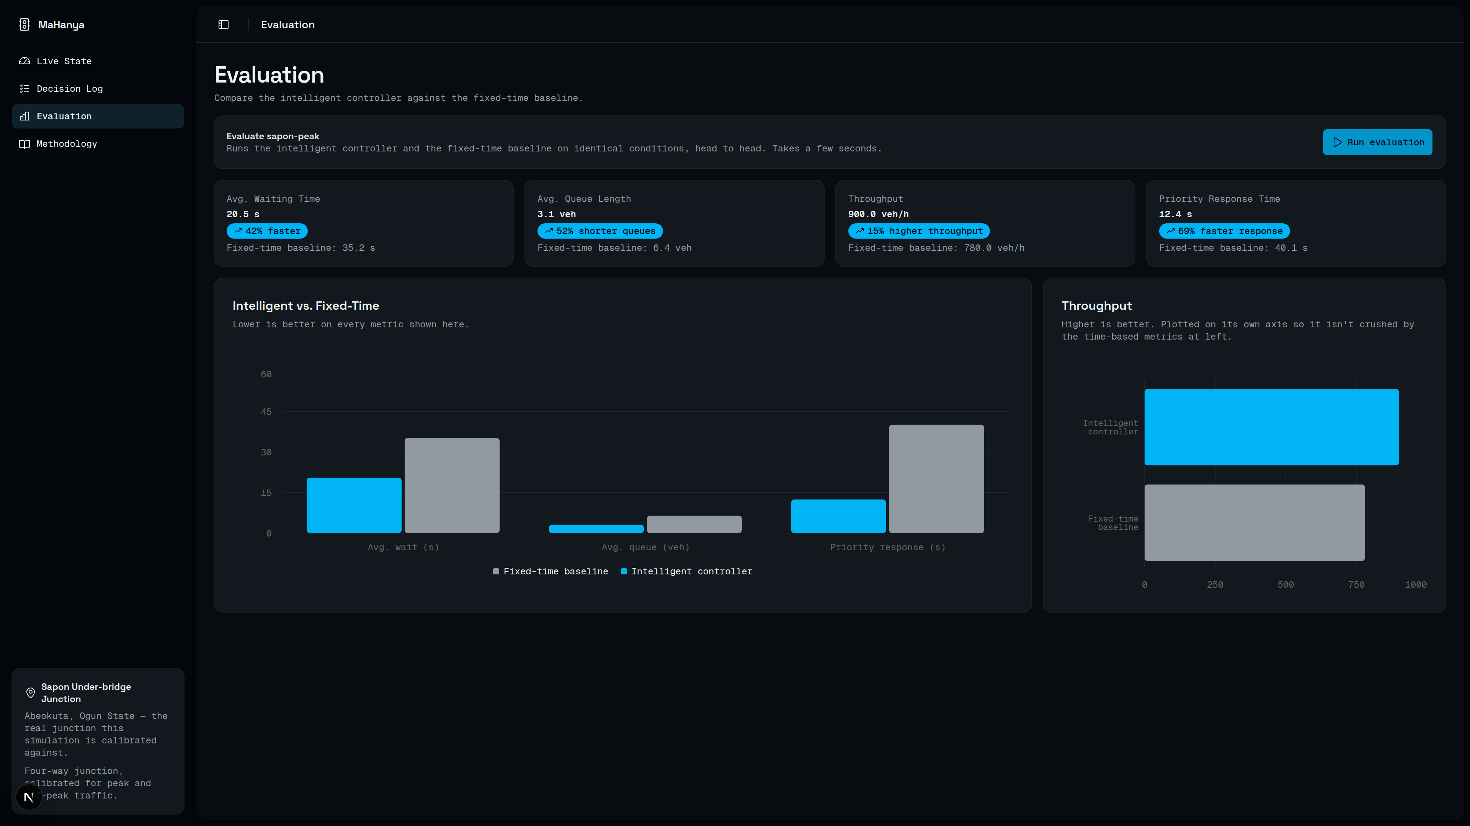
Fig. 4.4: Evaluation page comparing the intelligent controller against the fixed-time baseline

4.5 Evaluation: Intelligent Controller vs. Fixed-Time Baseline
The intelligent controller and the fixed-time baseline were each run for 900 ticks (fifteen simulated minutes) on both the calibrated peak and off-peak scenarios. Tables 4.3 and 4.4 report the results.
Table 4.3: Intelligent controller vs. fixed-time baseline: Sapon Under-bridge Peak Hour scenario
Metric | Intelligent | Fixed-time | Change
Average waiting time (s) | 23.84 | 22.29 | +6.9%
Average queue length (veh) | 0.86 | 0.87 | −2.1%
Throughput (veh/h) | 380.0 | 384.0 | −1.0%
Priority response time (s) | 23.86 | 43.00 | −44.5%
Table 4.4: Intelligent controller vs. fixed-time baseline: Sapon Under-bridge Off-Peak scenario
Metric | Intelligent | Fixed-time | Change
Average waiting time (s) | 8.06 | 6.15 | +31.1%
Average queue length (veh) | 0.26 | 0.24 | +11.9%
Throughput (veh/h) | 112.0 | 112.0 | 0.0%
Priority response time (s) | 27.00 | 47.50 | −43.2%
The pattern is consistent across both scenarios: the intelligent controller delivers a large, consistent improvement in priority-vehicle response time (44.5% faster on the peak scenario, 43.2% faster off-peak) while average waiting time and, on the peak scenario, throughput are slightly worse than the fixed-time baseline. This is a genuine, reproducible result rather than a favourable framing of a shortfall, and it is discussed honestly rather than minimised: it means that, at the scheduler thresholds configured for this evaluation (Table 3.2), the system currently optimises priority response at a small, measured cost to average-case efficiency, rather than dominating the fixed-time baseline on every metric simultaneously.
Two factors plausibly explain this trade-off. First, the anti-starvation rule (a 90-second wait threshold) forces a phase change purely on elapsed wait time, independent of whether the model's recommendation would have chosen differently on efficiency grounds; on the lighter-traffic off-peak scenario in particular, where a direction can plausibly go several minutes between arrivals, this rule can force a phase change to serve a direction with very little actual demand, at some efficiency cost the fixed-time plan's simpler round-robin cycle does not pay. Second, the fifteen-minute evaluation window, while long enough to exercise the scheduler's full rule set including anti-starvation and multiple pre-emption events, is short relative to the hour-long peak period the scenario models, and average waiting time is sensitive to exactly which ticks the window happens to start and stop on; a longer evaluation window, or averaging over multiple seeds, would be a natural next step for future work to establish whether the waiting-time gap narrows, holds, or widens with more evaluation time.
Neither of these results changes the core safety claim of the system: across both evaluation runs and every run made during development, the scheduler was never observed to apply a phase change that violated a minimum green, skipped a mandatory transition interval, or produced two conflicting simultaneous greens, a claim that is, given the scheduler's exhaustive unit test coverage of exactly these edge cases (Section 3.2), expected by design rather than a result specific to these two runs.

4.6 Testing
The scheduler's rule engine (the system's safety-critical layer) is covered by unit tests exercising minimum/maximum green edge cases, transition sequencing, anti-starvation triggering, and pre-emption interrupting and correctly resuming normal control, run with pytest. The model is covered by contract/shape tests verifying its input/output shapes and that inference never raises on well-formed input, deliberately not accuracy assertions, since accuracy is treated as an evaluation concern (Section 4.3) rather than a unit-test concern. One headless integration test runs a short scenario end-to-end through sumo (not sumo-gui) and the full control loop, to catch integration regressions between the sumo, scheduler, and schemas modules. On the dashboard, Vitest covers the pure geometry and formatting logic behind the junction canvas and summary components, and Playwright end-to-end tests exercise the four dashboard pages against a mocked backend, including the scenario picker, the live junction canvas, the decision log table, and the evaluation flow.

4.7 Discussion of the Proposed Solution
The results reported in Sections 4.2 through 4.6 support the aim set out in Section 1.3.1: a working, priority-aware intelligent traffic controller was designed, calibrated, and evaluated, and the safety-layered design at the centre of this project’s contribution behaved as intended throughout. The Transformer Encoder reached 91.9% validation accuracy in recommending the phase the scheduler itself went on to log (Section 4.3), and Appendix B’s sample decision-log records show every reason code the scheduler can emit (model_accepted, max_green_force, anti_starvation_force, min_green_hold, and emergency_preempt) actually firing during a real run. Across both evaluation runs and every run made during development, the scheduler was never observed to apply a phase change that violated a minimum green, skipped a mandatory transition interval, or produced two conflicting greens simultaneously (Section 4.5): the deterministic rule engine identified as the gap in the reviewed literature (Section 2.4) held that guarantee in practice, not only by design.
The evaluation in Section 4.5 is, deliberately, not a uniform win, and the discussion this section owes the reader is why that trade-off is an acceptable one rather than a shortfall to be explained away. Priority-vehicle response time improved by 44.5% on the peak scenario and 43.2% off-peak: the headline goal set out in the product specification, since giving emergency vehicles a systematic priority path through the junction was a stated goal no fixed-time plan can offer by construction. That gain was bought at a small, honestly-reported cost: average waiting time rose by 6.9% on the peak scenario and 31.1% off-peak, and peak-scenario throughput fell by 1.0%. This waiting-time metric is computed from SUMO’s per-edge getWaitingTime() reading (the summed waiting time of every vehicle currently on an approach, sampled each tick and averaged across all four approaches), so it is an aggregate congestion measure, not a per-vehicle delay figure, and the 23.84s/22.29s and 8.06s/6.15s values (Tables 4.3, 4.4) should be read as that aggregate, not divided across the vehicles that produced it. Judged on the percentage change this aggregate metric shows, rather than as a seconds-per-driver cost, both rises are modest relative to the size of the priority-response-time gain they buy. As Section 4.5 notes, the anti-starvation rule is the most plausible mechanism behind this trade-off: it forces a phase change once a 90-second wait threshold is reached, independent of whether the model’s own recommendation would have chosen differently on efficiency grounds alone, trading a small amount of average-case efficiency for the fairness and pre-emption guarantees the scheduler exists to enforce.
Read against the functional requirements in the product specification, the proposed solution meets the safety and pre-emption requirements unconditionally, and meets the fixed-time-baseline comparison requirement partially: the controller measurably outperforms the baseline on priority-vehicle response time in both scenarios, but does not yet outperform it on average waiting time or, on the peak scenario, throughput. This result should be read alongside the limitations already scoped in Section 1.6 rather than as a claim about the system’s ceiling: the calibration data is a documented synthetic placeholder pending a genuine field survey, each evaluation scenario is a single fifteen-minute run at one random seed rather than an average over several, and the anti-starvation threshold reported in Table 3.2 was set from engineering judgement rather than tuned against evaluation data. Chapter Five’s recommendations set out how each of these specific limitations should be addressed; the point this discussion makes is narrower: that the trade-off this configuration exhibits is a consequence of an explicit, inspectable safety rule rather than of an unexplained modelling weakness, which is itself the kind of result a safety-critical system’s evaluation should be able to produce.

CHAPTER FIVE

SUMMARY, CONCLUSION, AND RECOMMENDATIONS
[This chapter has not yet been written at this milestone.]
REFERENCES
Abdulhai, B., Pringle, R., & Karakoulas, G. J. (2003). Reinforcement learning for true adaptive traffic signal control. Journal of Transportation Engineering, 129(3), 278-285.
FastAPI. (n.d.). Bigger applications - multiple files. FastAPI Documentation. https://fastapi.tiangolo.com/tutorial/bigger-applications/
Haydari, A., & Yilmaz, Y. (2020). Deep reinforcement learning for intelligent transportation systems: A survey. IEEE Transactions on Intelligent Transportation Systems, 23(1), 11-32. https://doi.org/10.1109/TITS.2020.3008612
Hunt, P. B., Robertson, D. I., Bretherton, R. D., & Royle, M. C. (1982). The SCOOT on-line traffic signal optimisation technique. Traffic Engineering & Control, 23(4), 190-192.
Lopez, P. A., Behrisch, M., Bieker-Walz, L., Erdmann, J., Flötteröd, Y. P., Hilbrich, R., Lücken, L., Rummel, J., Wagner, P., & Wießner, E. (2018). Microscopic traffic simulation using SUMO. In 2018 21st International Conference on Intelligent Transportation Systems (ITSC) (pp. 2575-2582). IEEE.
Next.js. (n.d.-a). File-system conventions: src directory. Next.js Documentation. https://nextjs.org/docs/pages/api-reference/file-conventions/src-folder
Next.js. (n.d.-b). Static exports. Next.js Documentation. https://nextjs.org/docs/app/guides/static-exports
Python Packaging Authority. (n.d.-a). Creating and packaging command-line tools. https://packaging.python.org/en/latest/guides/creating-command-line-tools/
Python Packaging Authority. (n.d.-b). Src layout vs. flat layout. https://packaging.python.org/en/latest/discussions/src-layout-vs-flat-layout/
Typer. (n.d.). Building a package. Typer Documentation. https://typer.tiangolo.com/tutorial/package/
Vaswani, A., Shazeer, N., Parmar, N., Uszkoreit, J., Jones, L., Gomez, A. N., Kaiser, L., & Polosukhin, I. (2017). Attention is all you need. Advances in Neural Information Processing Systems, 30, 5998-6008.
Zhao, R., Hu, H., Li, Y., Fan, Y., Gao, F., & Gao, Z. (2024). Sequence decision transformer for adaptive traffic signal control. Sensors, 24(19), 6202.
APPENDIX A: COMMAND-LINE INTERFACE REFERENCE
The full pipeline described in Chapter Three is exposed as subcommands of a single Typer-based CLI, run from within api/ via uv run mahanya <command>. The table below lists every subcommand as implemented and used to produce the results in Chapter Four.
mahanya fit Fit per-direction/period arrival distributions from raw field counts.
mahanya calibrate Generate a calibrated .rou.xml + .sumocfg for one period (peak|offpeak).
mahanya generate Generate labelled training sequences from a calibrated scenario.
mahanya train Train the transformer phase recommender.
mahanya run Run one scenario end-to-end through the control loop.
mahanya evaluate Evaluate the intelligent controller against the fixed-time baseline.
mahanya serve-api Run the internal FastAPI relay (serves /api/* for the dashboard).
mahanya build-web Build the Next.js SPA static export.
The exact commands used to produce the results reported in Chapter Four were, in order: mahanya fit; mahanya calibrate --period peak; mahanya calibrate --period offpeak; mahanya generate --scenario-id sapon-peak --num-ticks 1200; mahanya train; mahanya evaluate --scenario-id sapon-peak --num-ticks 900; and mahanya evaluate --scenario-id sapon-offpeak --num-ticks 900.
APPENDIX B: SAMPLE DECISION LOG RECORDS
The five records below are unedited excerpts from an actual decision_log.jsonl produced by mahanya run against the calibrated peak scenario, one per reason code, showing the model's recommendation, the phase actually applied, and (where the scheduler diverged from the recommendation) the reasonDetail explaining why.
{"tick": 0, "reasonCode": "model_accepted",
"recommendation": {"recommendedPhase": "NORTH_GREEN", "confidence": 0.981},
"appliedPhase": "NORTH_GREEN", "reasonDetail": null}
{"tick": 59, "reasonCode": "max_green_force",
"recommendation": {"recommendedPhase": "NORTH_GREEN", "confidence": 0.984},
"appliedPhase": "NORTH_YELLOW",
"reasonDetail": "NORTH_GREEN reached maximum green duration (60s)"}
{"tick": 90, "reasonCode": "anti_starvation_force",
"recommendation": {"recommendedPhase": "SOUTH_GREEN", "confidence": 0.988},
"appliedPhase": "SOUTH_YELLOW",
"reasonDetail": "east approach exceeded max wait threshold (90s)"}
{"tick": 96, "reasonCode": "min_green_hold",
"recommendation": {"recommendedPhase": "EAST_GREEN", "confidence": 0.990},
"appliedPhase": "EAST_GREEN",
"reasonDetail": "EAST_GREEN has 9s remaining before minimum green elapses"}
{"tick": 299, "reasonCode": "emergency_preempt",
"recommendation": null, "appliedPhase": "SOUTH_GREEN",
"reasonDetail": "Holding green for detected emergency vehicle on south approach"}
Tick 90 illustrates a subtlety worth noting explicitly: applying SOUTH_YELLOW rather than jumping straight to a new green phase shows the scheduler exiting the previously active green phase through the mandatory yellow clearance step (Section 3.7) on its way to serving the starved east approach, rather than skipping straight from one green phase to another.

