UAE Pass SP Authentication Questionnaire
Draft Responses — Emirati Human Development Platform
Emirati Human Resources Development Council (EHRDC)
❗ IMPORTANT: Review each answer carefully before submitting. Items marked ⚠️ need your confirmation or input.

Compliance Terms (All ☑)
All 6 terms should be checked:
# | Term | Check?
1 | Comply and implement the use case described and presented in this questionnaire. | ☑
2 | Comply with UAE PASS authentication, branding and account linking guidelines. | ☑
3 | Availability of the technical team to perform the integration (Confirmation to be provided) | ☑
4 | Deploy on production the exact copy of build assessed and signed off by UAE PASS | ☑
5 | Address and fix any issues on Production within 48 hours from Go Live. | ☑
6 | Train internal employees about UAE PASS. | ☑

Application Details (Questions 1–15)

Q1. Official name of Entity, Ministry, Organization, or Establishment owning the integration?
Emirati Human Resources Development Council (EHRDC)
(Operating under the Government of Dubai — Dubai Human Resources sector)
⚠️ Confirm whether to use the full Arabic name alongside: مؤسسة الإمارات لتنمية الموارد البشرية

Q2. Brief description about your Business
Year of Establishment: EHRDC is a Dubai Government entity.
User Segments: UAE Nationals (Emirati citizens) seeking career development, employment opportunities, and skills enhancement.
Key Services:
• Career development platform for UAE nationals
• CV building and ATS-compatible resume management
• Job matching and recruitment pipeline
• Skills assessment and certification tracking
• Mentorship matching (mentor–mentee pairing)
• Interview preparation and scheduling
• Career pathway guidance and advisor matching
• Profile Readiness scoring across 10 professional pillars
Number of clients: Platform is in pre-launch phase; targets UAE nationals across Dubai and the wider UAE. Expected initial user base: 1,000–5,000 UAE nationals.
⚠️ Adjust the numbers based on your target projection.

Q3. Type of integration channel (SPC)? {Web or Mobile App}
Web
(The platform is a responsive web application accessible via desktop and mobile browsers. There is no standalone mobile app at this time.)

Q4. Name of the Service Provider channel (SPC)?
Emirati Human Development Platform
(This is the name shown to users when the authentication request appears on their UAE PASS mobile app.)

Q5. Specify the user segments covered part of online services
G2C (Government-to-Citizen)
The platform provides government career development services directly to individual UAE national citizens.

Services available to individuals:
• User registration and secure sign-in via UAE PASS
• Career profile creation with CV upload and parsing
• Job search, matching, and application
• Skills assessment and certification tracking
• Mentorship programme enrolment
• Career advisory services

Q6. OAuth Callback URL of web app
Staging (Lower Environment):
https://stg-emirati.ehrdc.gov.ae/api/auth/uaepass/callback

Production:
https://emirati.ehrdc.gov.ae/api/auth/uaepass/callback
ℹ️ NOTE: The current development/staging setup uses http://localhost:8089/api/auth/uaepass/callback via Vite proxy. The production URLs above will be active once DNS records are pointed to the WAF public IP 213.42.53.236 and the SSL wildcard certificate (*.ehrdc.gov.ae) is installed.

Q7. Detailed description of current use case (with current screenshots)
Current Use Case: Secure Sign-in for UAE Nationals Career Platform

The Emirati Human Development Platform enables UAE nationals to:
1. Authenticate securely using their UAE PASS digital identity — no manual registration required
2. Auto-populate their profile with verified data from UAE PASS (full name in EN/AR, Emirates ID, email, mobile, nationality)
3. Access career services including CV management, job matching, mentorship, skills assessment, and career guidance

Current Login Flow:
• User visits the platform login page
• User clicks the "Sign in using UAE PASS" button (black button with green fingerprint icon)
• User is redirected to UAE PASS authentication page
• After authenticating on UAE PASS, user is redirected back to the platform
• Platform creates/links the user account and redirects to the appropriate dashboard
Screenshot — Login Page:
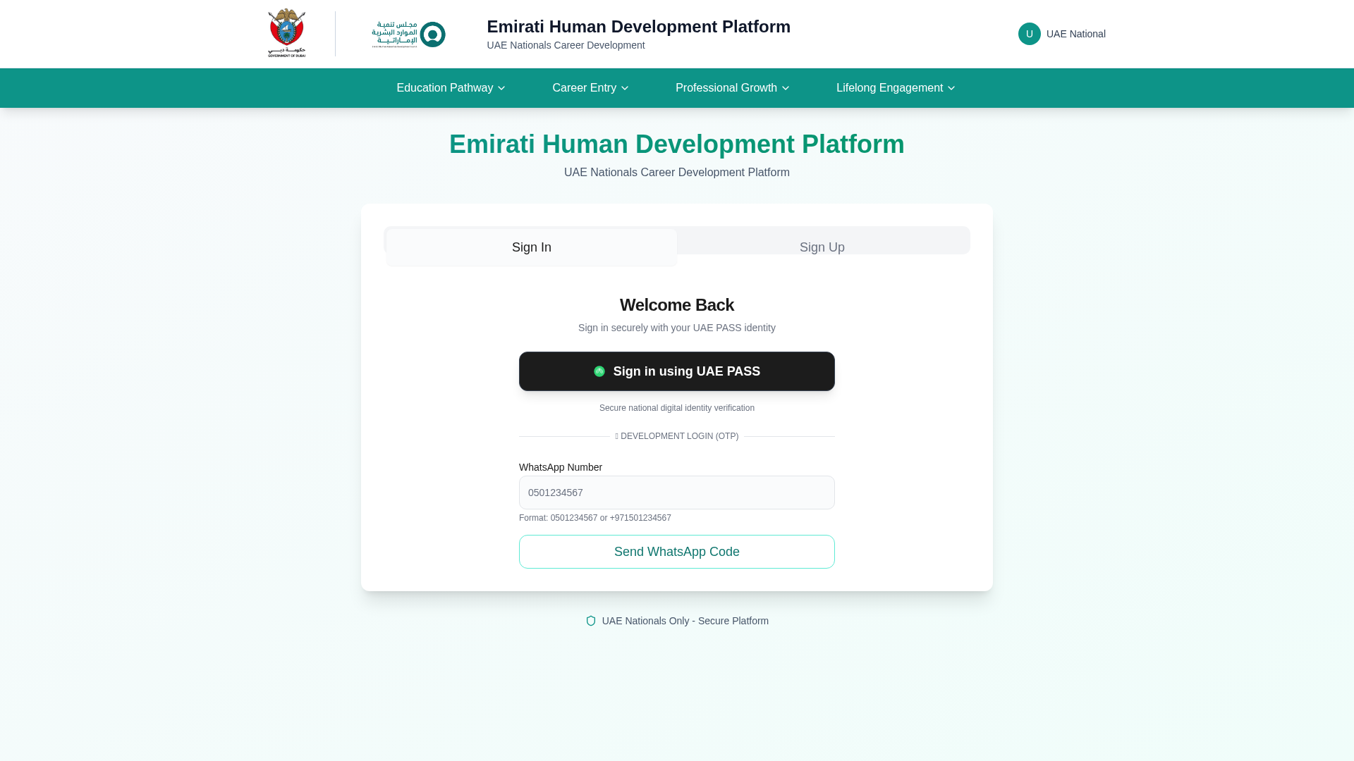
ℹ️ NOTE: The "DEVELOPMENT LOGIN (OTP)" section at the bottom will be removed in production.

Q8. Current registration (before UAE PASS integration) process
Before UAE PASS integration, the platform offered:
1. Manual Email/Phone Registration: Users filled a form with first name, last name, email, phone number, emirate, and selected a role
2. OTP Verification: Phone number verified via SMS OTP
3. No document submission was required during registration

With UAE PASS integration (current state):
• UAE PASS is the primary and recommended sign-in method
• The manual OTP exists as a development-only fallback and will be disabled in production
• UAE PASS provides verified identity data automatically — no manual form filling needed

Q9. Detailed description of "To Be" use case
Target State (Production):
UAE PASS will be the sole authentication method for the Emirati Human Development Platform.

User Journey (Sign In — Existing User):
1. User visits https://emirati.ehrdc.gov.ae
2. Clicks "Sign in using UAE PASS"
3. Redirected to https://id.uaepass.ae/idp/authorize with scope openid
4. User authenticates on UAE PASS (biometric/PIN on mobile app, or SMS OTP)
5. UAE PASS redirects back to platform with authorization code
6. Platform exchanges code for tokens, fetches user profile from /idp/userinfo
7. Platform matches user by UAE PASS UUID → existing account found
8. Platform issues session JWT tokens and redirects to user's dashboard

User Journey (Sign Up — New User):
1. Steps 1–6 same as above
2. No matching user found → platform creates new account using:
• Emirates ID (idn) as primary key (CHAR(15) format, hyphens stripped)
• Full name (EN + AR), email, mobile, nationality (EN + AR) from UAE PASS
3. User assigned default role "candidate"
4. User redirected to /welcome page for onboarding

Account Linking (Existing Users):
If a user already has an account, the platform links their UAE PASS identity by matching on:
• UAE PASS UUID (primary lookup)
• Email address (fallback)
• Phone number (secondary fallback)

Logout:
• Platform clears local JWT session
• Redirects to UAE PASS logout endpoint (/idp/logout)
• UAE PASS redirects back to platform login page

Q10.
(Not applicable)

Q11. Who will be the target audience to avail the Authentication feature?
Citizens and Residents

Emirati Citizens (UAE Nationals) can access all platform services, including:
• Job seeking, matching, and application
• Career profile and CV management
• Skills assessment and certification
• Mentorship, advisory, and career guidance
• Interview preparation and scheduling

Residents with valid UAE PASS accounts can access select services, including:
• Recruiting and talent acquisition tools
• Training programme facilitation
• Mentoring (as mentors)
• Advisory and consulting services
• Assessment and evaluation services

Residents cannot access: Job seeking and job application features (reserved exclusively for UAE Nationals).

Q12. Count of Services available after enabling UAE PASS?
8
1. Career Profile Management (auto-populated from UAE PASS)
2. CV Upload, Parsing & ATS Scoring
3. Job Search & Smart Matching
4. Job Application & Tracking
5. Skills Assessment & Certification Tracking
6. Mentorship Programme (Mentor/Mentee Matching)
7. Interview Preparation & Scheduling
8. Career Pathway Guidance & Advisory

Q13. Value added by enabling login with UAE PASS
• Seamless onboarding: No manual registration — verified identity data auto-populated
• Enhanced security: Government-grade digital identity verification
• Verified identity: Emirates ID verification ensures only legitimate users access the platform
• Single sign-on: Users leverage existing UAE PASS credentials
• Bilingual support: Arabic and English names and nationality captured automatically
• Trust: Users trust the government-backed UAE PASS authentication

Q14. Expected transaction volume?
Phase 1 (Launch — First 6 months): 500–2,000 authentication transactions per month
Phase 2 (Scaling — 6–18 months): 5,000–15,000 authentication transactions per month
Phase 3 (Mature): 15,000–50,000 authentication transactions per month
⚠️ Adjust these projections based on your actual rollout plan.

Q15. Timelines to implement this integration?
Start Date: 1 May 2026 (integration development started)
Staging Assessment Ready: 1 June 2026 (pending DNS + SSL activation)
Target Go-Live (Production): 1 July 2026
⚠️ Adjust dates based on your actual project timeline.

Appendix-A: UAE PASS Static Attributes Selection
Attributes that will be passed by UAE PASS upon successful authentication.
No. | Attribute Name | Description | User Type | Select
1 | userType | Level of assurance | All User Types | ☑
2 | Mobile | Verified phone number | All User Types | ☑
3 | Email | Verified email | All User Types | ☑
4 | UUID | UAE PASS Unique User Identifier | All User Types | ☑
5 | SPUUID | SmartPass Unique User Identifier | All User Types | ☐
6 | Idn | Verified Emirates ID number | Only SOP2 & SOP3 | ☑
7 | fullnameEN | Full name (English) | All User Types | ☑
8 | fullnameAR | Full name (Arabic) | All User Types | ☑
9 | firstnameEN | Given name (English) | All User Types | ☐
10 | firstnameAR | Given name (Arabic) | All User Types | ☐
11 | lastnameEN | Last name (English) | All User Types | ☐
12 | lastnameAR | Last name (Arabic) | All User Types | ☐
13 | nationalityEN | Nationality (English) | All User Types | ☑
14 | nationalityAR | Nationality (Arabic) | All User Types | ☑
15 | Gender | Gender | All User Types | ☑
16 | idType | ID Type | All User Types | ☑
17 | titleEN | Title (English) | Only SOP3 | ☑
18 | titleAR | Title (Arabic) | Only SOP3 | ☐

Rationale for Selected Attributes
Attribute | Platform Column | Why Needed
userType | users.uaepass_usertype | Differentiate citizen vs. resident for feature access control
Mobile | users.phone | Contact information + account linking fallback
Email | users.email | Primary communication channel + account linking fallback
UUID | users.uaepass_uuid | Primary user lookup key for returning users
Idn | users.id (PK) | Emirates ID is the database primary key — stored as CHAR(15)
fullnameEN | users.first_name, last_name | Split into first/last name for profile display
fullnameAR | users.fullname_ar | Arabic name for bilingual (EN/AR) platform UI
nationalityEN | users.nationality | Profile display, defaults to UAE if not provided
nationalityAR | users.nationality_ar | Arabic nationality for bilingual UI
Gender | users.gender | User profile information
idType | users.id_type | Distinguish Emirates ID vs. other document types
titleEN | users.title_en | Professional title from UAE PASS profile
❗ IMPORTANT: SOP Level: Because we require the Idn (Emirates ID) attribute — which is only available at SOP2 and SOP3 — the platform must request SOP2 level access at minimum. Current acr_values in code needs to be updated from level:low (SOP1) to the SOP2-level ACR value before staging assessment.

Appendix-B: Use Case Scenarios Diagram
Selected Use Case: UC 1.2.3 — Automatic and Manual Linking for Existing Users and New User Registration
Reference: https://docs.uaepass.ae/guidelines/use-case-guidelines/standard-authentication-scenarios-for-service-provider-use-cases

Why UC 1.2.3?
Criteria | Our Platform
Existing users? | Yes — users already registered via OTP/WhatsApp during pre-launch
Verified attribute in DB? | Yes — Emirates ID (Idn) stored as CHAR(15) primary key → Automatic Linking
Users without verified attribute? | Yes — some early accounts only have email/phone → Manual Linking
New user registration? | Yes — first-time UAE PASS users are auto-registered
SOP Level | SOP2 (required for Idn attribute access)

UC 1.2.3 — Master Flow Diagram
ℹ️ NOTE: The diagram below shows the complete user journey for all three scenarios combined. Each numbered path (A, B, C, D) corresponds to a detailed sub-flow.
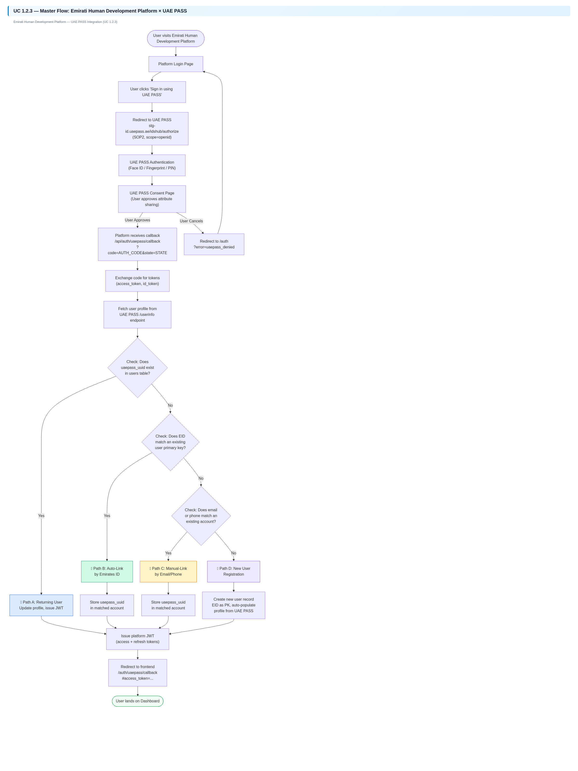

Path A — Returning User (UUID Match)
Applies to: Users who have previously signed in via UAE PASS. Their uaepass_uuid is already stored.
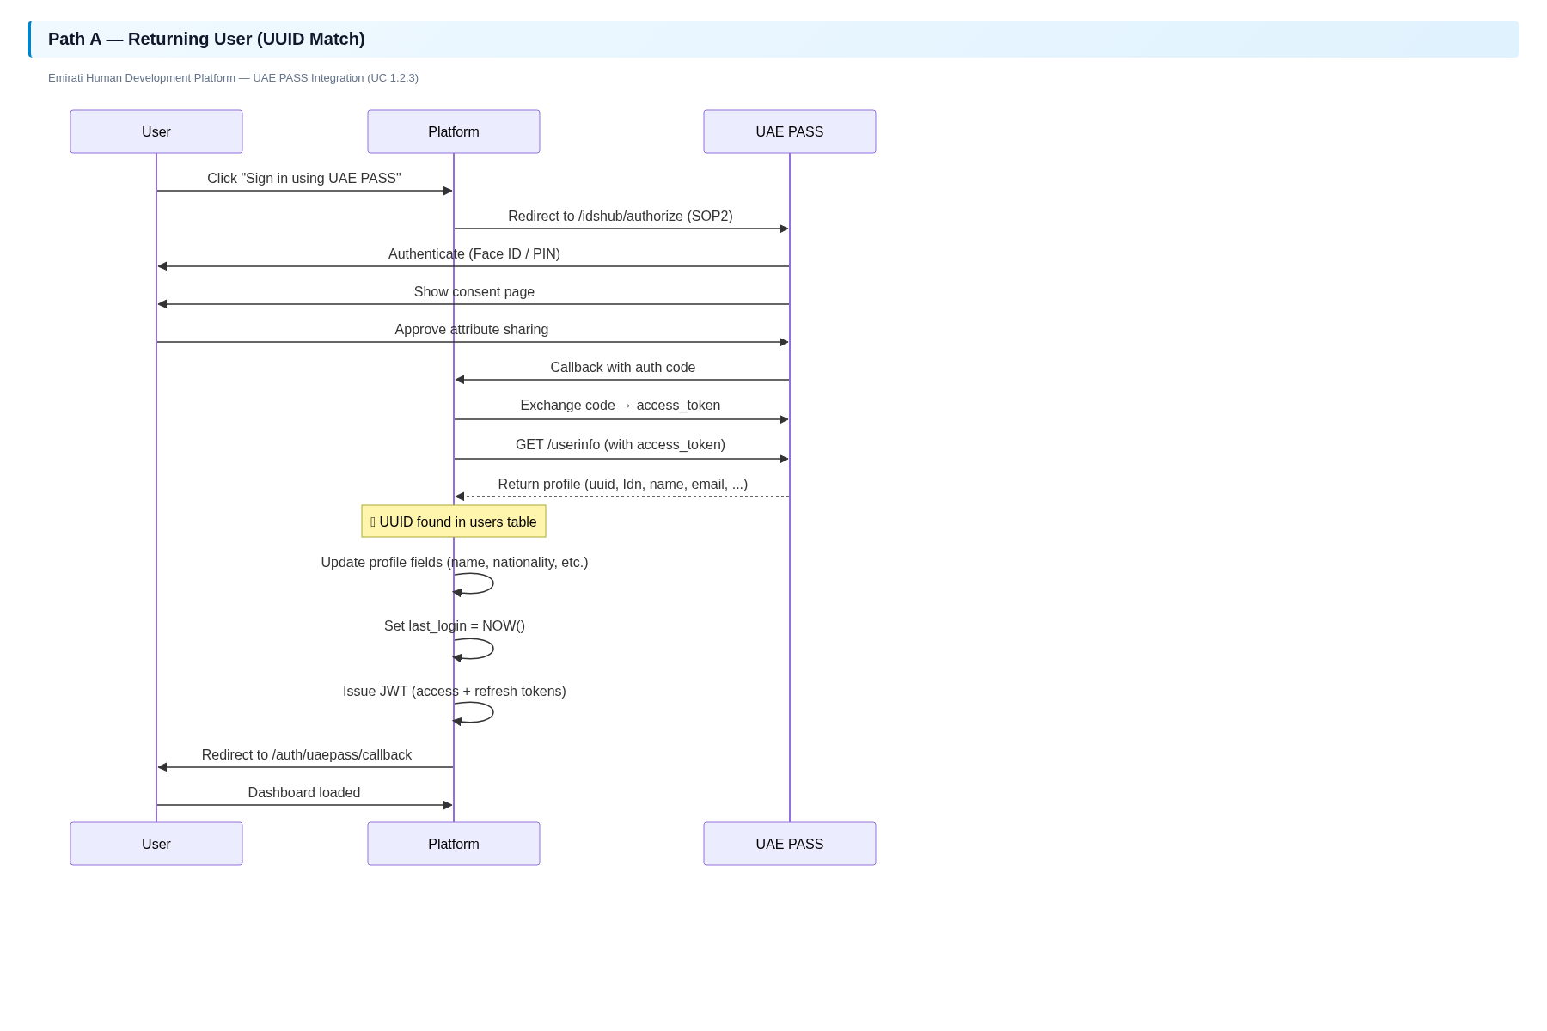

Path B — Existing User, Automatic Linking (EID Match)
Applies to: Users who registered via OTP and have a valid EID stored as their PK, but have not yet linked UAE PASS.
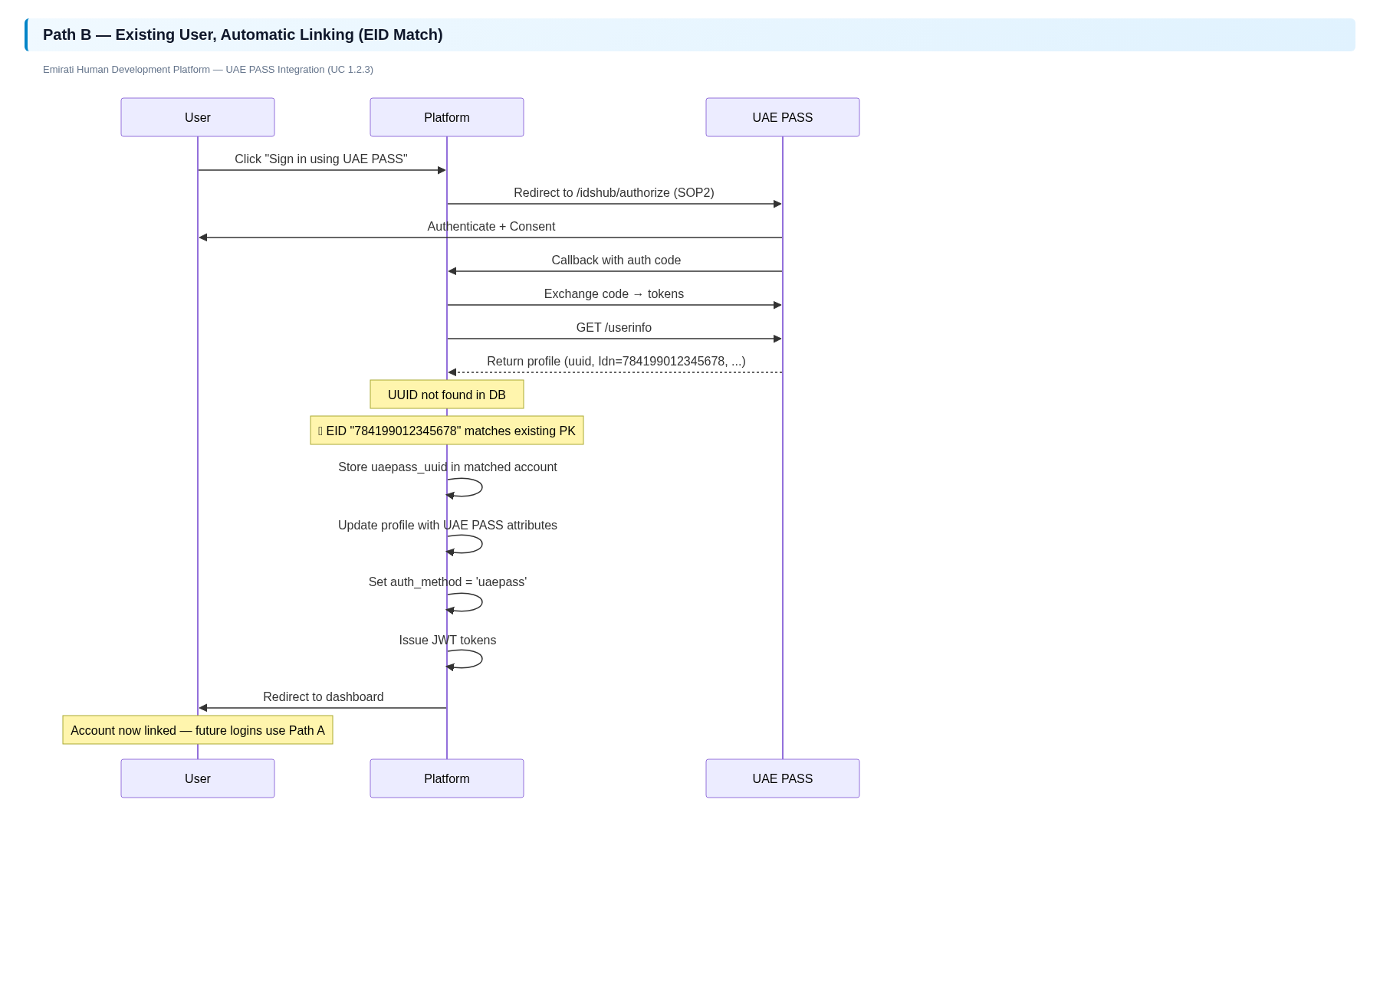

Path C — Existing User, Manual Linking (Email/Phone Match)
Applies to: Early adopters who registered without a valid EID. Manual matching by email or phone is used.
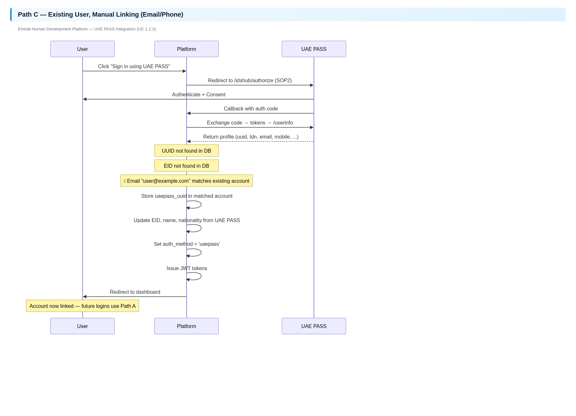

Path D — New User Registration
Applies to: First-time users who have no existing account on the platform.
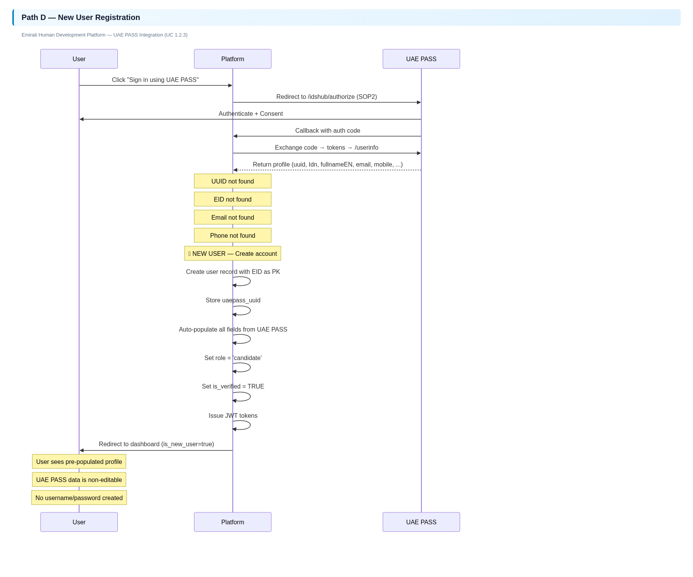
❗ IMPORTANT: New User Registration Guidelines (per UAE PASS policy): ✅ SP determines if user is existing or new (cascade: UUID→EID→email→phone→new). ✅ User is NOT prompted to create username/password (JWT-only). ✅ No username/password shared via email or SMS. ✅ Data auto-populated from UAE PASS is non-editable.

Error Scenarios
Scenario | Platform Handling
User cancels on UAE PASS | Callback receives error=cancelledOnApp → Redirect to /auth?error=uaepass_denied
Invalid/expired state token | State not found → Redirect to /auth?error=invalid_state
Token exchange fails | UAEPassError caught → Redirect to /auth?error=uaepass_error&message=...
No UUID in profile | UAEPassError("No UUID in user profile") → Redirect to /auth?error=uaepass_error
Database error | Generic exception → Redirect to /auth?error=server_error&message=Authentication+failed
User not verified on UAE PASS | UAE PASS returns error before callback → Standard UAE PASS error page shown

Logout Flow
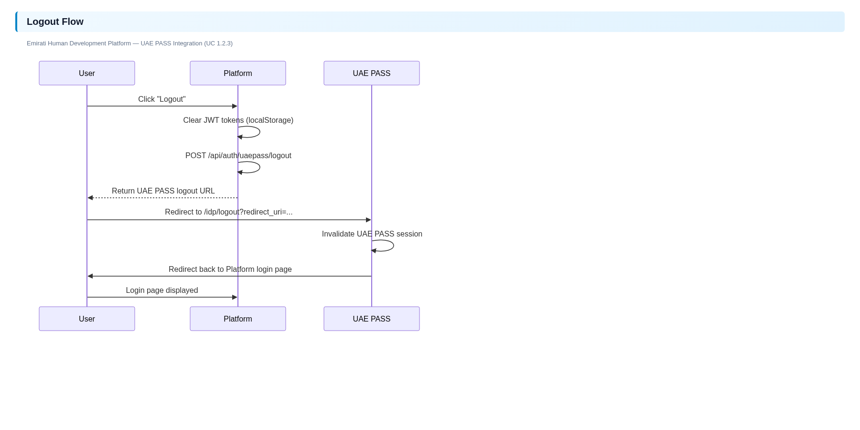

Appendix-C: User Journey Mockup Scenarios
Which scenarios apply to our platform:
# | Scenario | Applicable? | Notes
1 | Sign in with UAE PASS | ☑ | Primary sign-in method. Button: "Sign in using UAE PASS"
2 | Sign up with UAE PASS | ☑ | New users auto-registered on first UAE PASS login
3 | Redirection to UAE PASS Login page (WEB) | ☑ | Full-page redirect to stg-id.uaepass.ae/idshub/authorize
4 | Redirection to UAE PASS Consent Page | ☑ | Standard UAE PASS consent flow
5 | SOP1 scenario | ☐ | Not applicable — we need SOP2 for Idn
6 | SOP2 scenario | ☑ | Our scenario — we require Idn (Emirates ID)
7 | SOP3 scenario | ☐ | SOP3 not required
8 | Manual linking page | ☐ | Not applicable — linking is automatic
9 | Manual linking (NO) scenario | ☐ | Not applicable
10 | Manual linking (YES) scenario | ☐ | Not applicable
11 | Only registration/Sign up Scenario | ☐ | Not applicable — sign-in and sign-up are combined
12 | Auto populate Form | ☑ | Profile data auto-populated from UAE PASS
13 | Only existing users error message | ☐ | Not applicable — new users are auto-created
14 | Unverified user restriction error | ☑ | Platform shows error if UAE PASS returns error
15 | Something went wrong error message | ☑ | Redirects to /auth?error=uaepass_error with message
16 | User cancels login scenario | ☑ | Handles error=cancelledOnApp → /auth?error=uaepass_denied
17 | Logout scenario | ☑ | Clears JWT, redirects to UAE PASS /idp/logout
18 | APP-WEB scenario (mobile only) | ☐ | Not applicable — web only

Summary of Key Technical Details
Item | Value
Entity | Emirati Human Resources Development Council (EHRDC)
Platform Name | Emirati Human Development Platform
Channel Type | Web Application
SOP Level | SOP2
OAuth Flow | Authorization Code Grant
Scope | openid
ACR Values | Needs update from level:low to SOP2 level
Staging Callback URL | https://stg-emirati.ehrdc.gov.ae/api/auth/uaepass/callback
Production Callback URL | https://emirati.ehrdc.gov.ae/api/auth/uaepass/callback
Key Attribute | Idn (Emirates ID) — used as database primary key
Account Linking | Automatic (by UUID → email → phone)
User Segment | G2C (Government-to-Citizen)
Target Audience | Citizens and Residents

⚠️ WARNING: Action Required Before Submission: 1) Confirm entity name. 2) Confirm SPC display name. 3) Confirm target audience. 4) Confirm transaction volume projections. 5) Confirm timeline dates. 6) Prepare screenshots. 7) Update acr_values in code from level:low to SOP2.

