King Abdulaziz University  
 Department of information technology Facility of computing and information technology   
First term 2020

CPIT490 (mobile appliction)

**Project Proposal**

**Project title:**

(Car services system)

**Project members:**

|  |  |  |
| --- | --- | --- |
| **Name** | **ID** | **Section** |
| Abdulaziz Kuwaity | 1846150 |  |
| Mohammed fadel | 1740426 |  |
| Khaled abdulaziz | 1845082 |  |

In this activity user enter his email and password to sign in or if he don’t has account he click on sign up

User enter his location to new appointment or skip to go to homepage

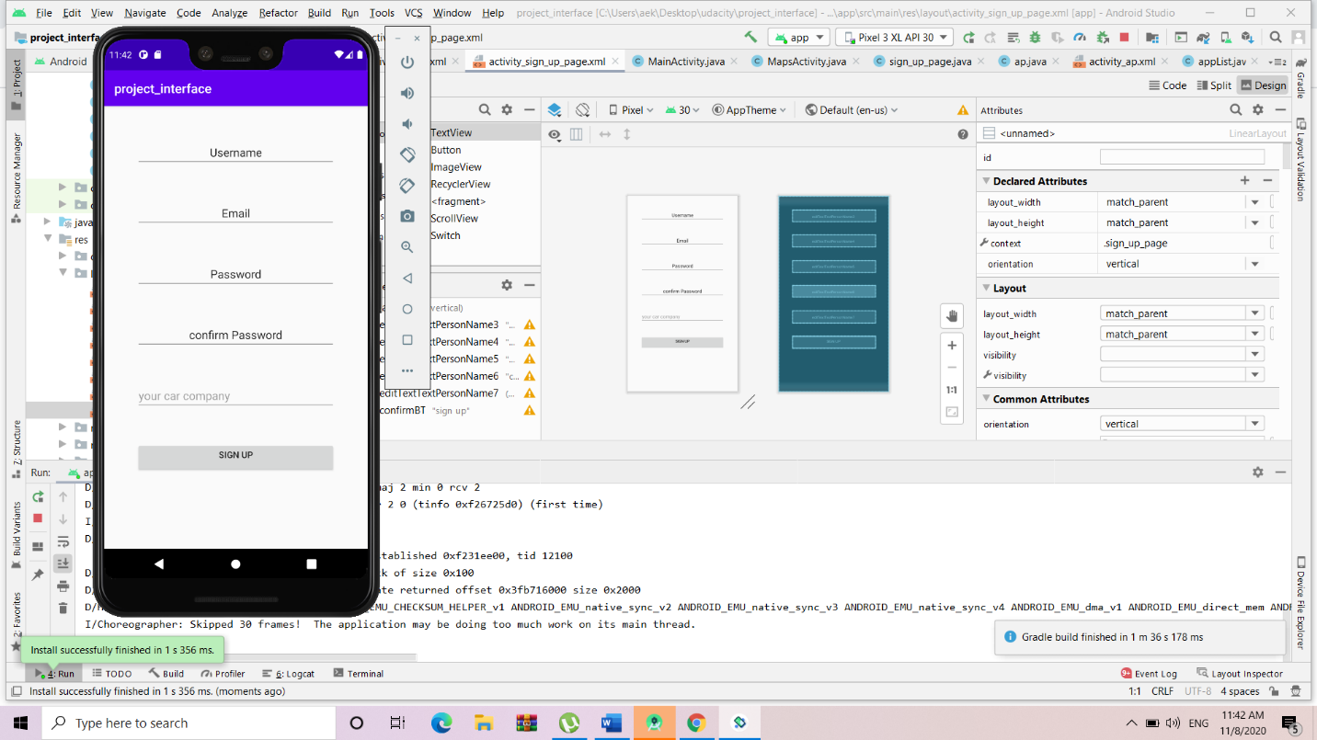

In this activity user enter his information to create new account

In this activity user can rate the service and can see his appointment list and edit his information (design is initial version)

User rate the service

This page will show to the user his upcoming and previous appointment (design is initial version)

In this activity user edit his information

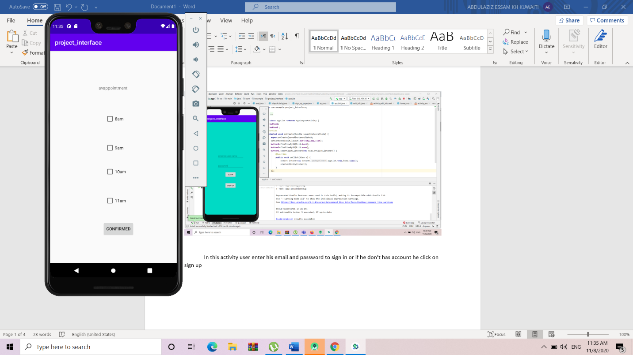

In this activity user will choose appointment