## 

## e-Project

## 

## Batch Code

PR2-202205C

## Group Members

|  |  |  |
| --- | --- | --- |
| Serial Number | Enrollment Number | Student Name |
| 1 | 1379366 | M. Abdul Aziz |
| 2 | 1385765 | Junaid Ahmed |
| 3 | 1374129 | Agha Ali |
| 4 | 1379224 | Nathen Bhatii |

# **ACKNOWLEDGEMENT**

## 

The first, we would like to express my special thanks of gratitude to my teacher **Muhammed Aqueel**, who helped us a lot in finalizing this project within the limited time frame, valuable counselling and assistance for the accomplishment of this project.

Secondly, we would also like to thank the e-Project team at Aptech Head Office, who gave us the golden opportunity to do this wonderful project about brand of Chairs and thirdly, we also thank the e-Project team, some of the benefits are as under:

* Re-enforcement of skills happens in the experiential learning process.
* A mentor, ensuring that we do not get drifted, constantly guides us.
* It gives us a lot of confidence to face an interview as we have worked on a project. We can explain virtually everything on the subject we have learnt.

# **SYNOPSIS**

Follow the strong development of the internet, technology watches and the growing watch market, every business needs a website design to display products on the internet.

* Ryana Calender is designed with many different designs, styles, fonts and much more.
* Ryana Calender have 3 brands each having 3 categories with an amount of variety.
* Which is the most special suggestion from rich fields.
* So, the Ryana Calender give the best product under your budget.
* However, purchases can be made directly from the website to your door step.

# **PROBLEM STATEMENT**

Ryana Calendars is selling various Calendars and Dairy products. The company advertises by distributing the pamphlets, advertising on television and so on. Due to rapid development in internet field, the company decides to launch a website where people will get all the information about the various products available with them easily.

# **Requirement Specification:**

The Web site is to be created based on the following requirements.

1) The Home Page should be created making use of Sections with a suitable logo

2) The site should display a menu which will contain the options for brief introduction about the various products available, location of the shop and any other information if required.

3) The information should be categorized according to different type of products like if a User wants to see only ‘Journal’ then he click on a Link/button/menu etc and he will see different type of Journal. Similarly for ‘Calendars’, ‘Diaries’ and other products

4) When a user selects any product type, a list of products for that product type will be displayed.

5) A brief summary of features of individual products should be displayed on the Web Page along with the product but detailed Features should be stored in Individual Word documents which can be downloaded or viewed by the User who wishes to see the same.

6) Price List should be available for download.

7) There should be a “Contact Us” page which will have the Address of the Company which is as follows and the mail address which when clicked will invoke the local mail client from where they can send an email.

# **Hardware/ Software Requirements**

***Hardware:***

* A minimum computer system that will help you access all the tools in the courses is a Pentium 166 or better.
* 64 Megabytes of RAM or better Software Notepad/HTML editor VS-Code IE 5.0/ Netscape 6.0.

***Software:***

* Notepad/Html Editor.
* Dreamweaver
* IE 5.0/ Netscape 6.0

# **Objectives of the project**

The Objective of this program is to give a sample project to work on real life projects. These applications help you build a larger more robust application.

The Objective is not to teach you HTML/JavaScript/Dreamweaver/HTML5 but to provide you with a real-life scenario and help you create basic applications using the tools.

You can revise the chapters before you start with the project.

This project is meant for students who have completed the module of Dreamweaver. These programs should be done in the Lab sessions with assistance of the faculty if required.

It is very essential that a student has a clear understanding of the subject. Students should go through the project and solve the assignments as per requirements given.

Kindly get back to eProjects Team in case of any doubts regarding the application or its objectives.

# **SCOPE OF THE WORK**

The website is to be developed for the Windows Platform using HTML5, JavaScript and jQuery bootstrap 5.1.3. The site should work well in all leading browsers including Chrome, IE, Firefox etc.

Homepage show Top best **Ryana Calender** buy your different, new collection, new shop...

Every content direct to relative content.

# ***Screen Shots***

## Home Page:

## 

***Product Categories:***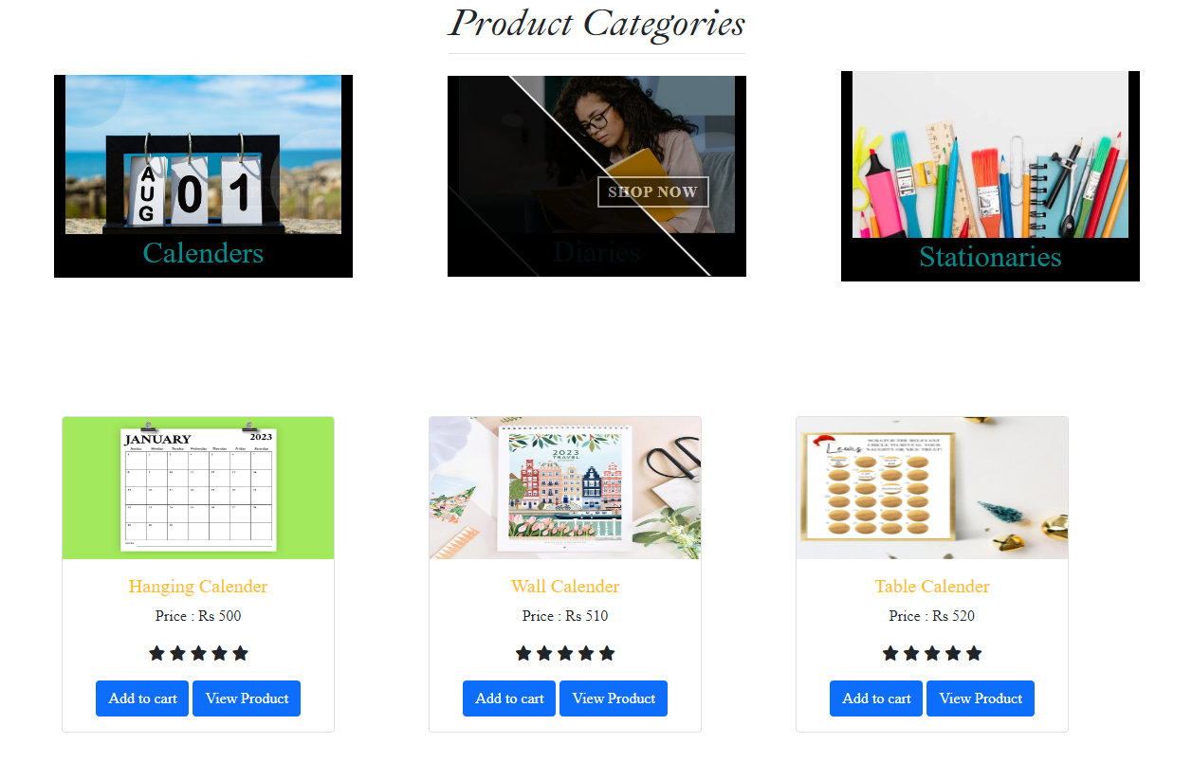

***About Us:***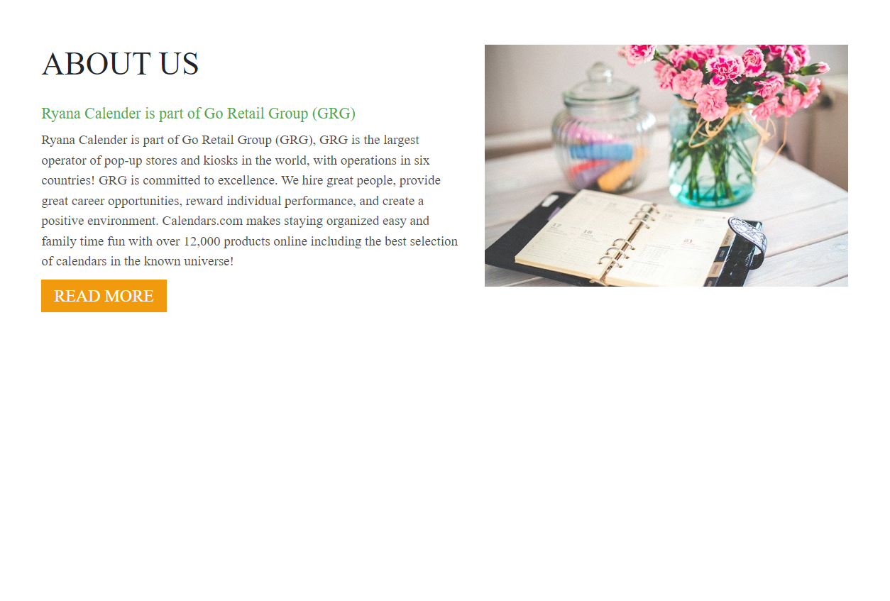

***Footer:***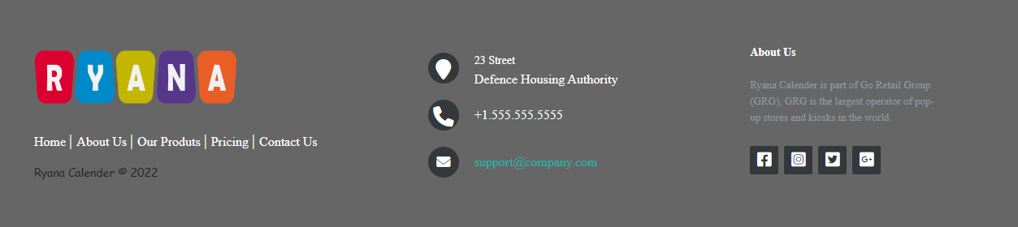

***Project Categories:***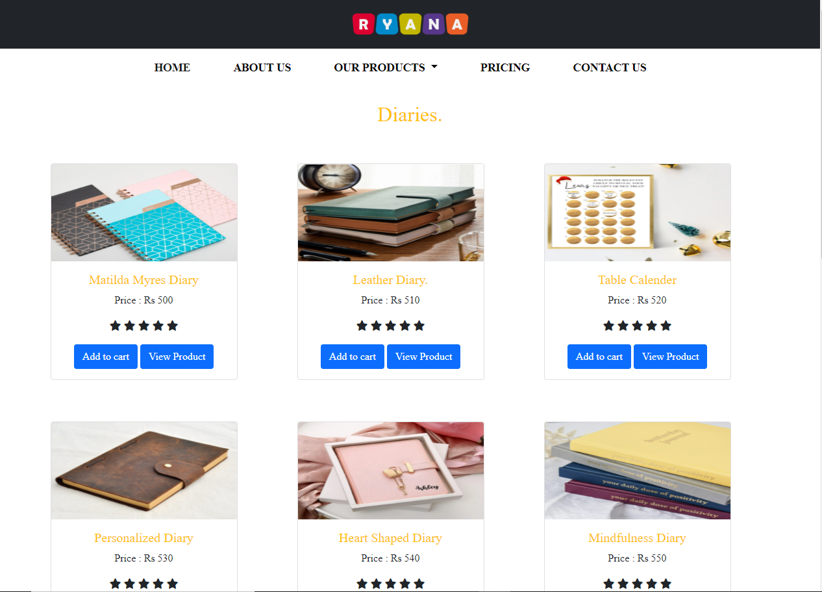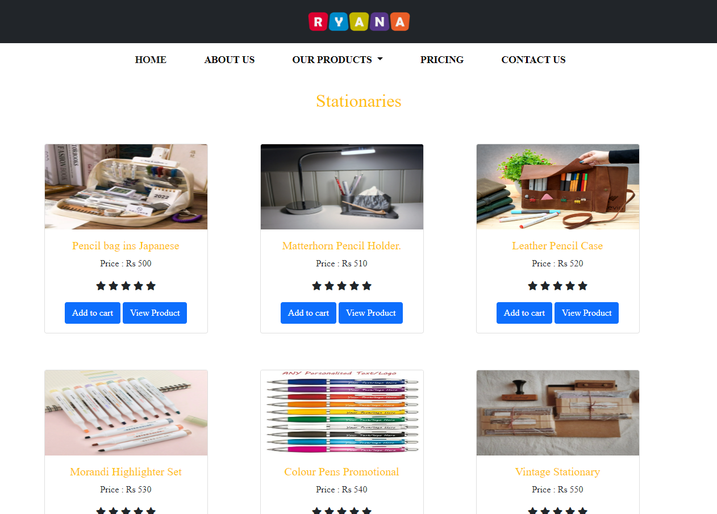

***roduct Page***

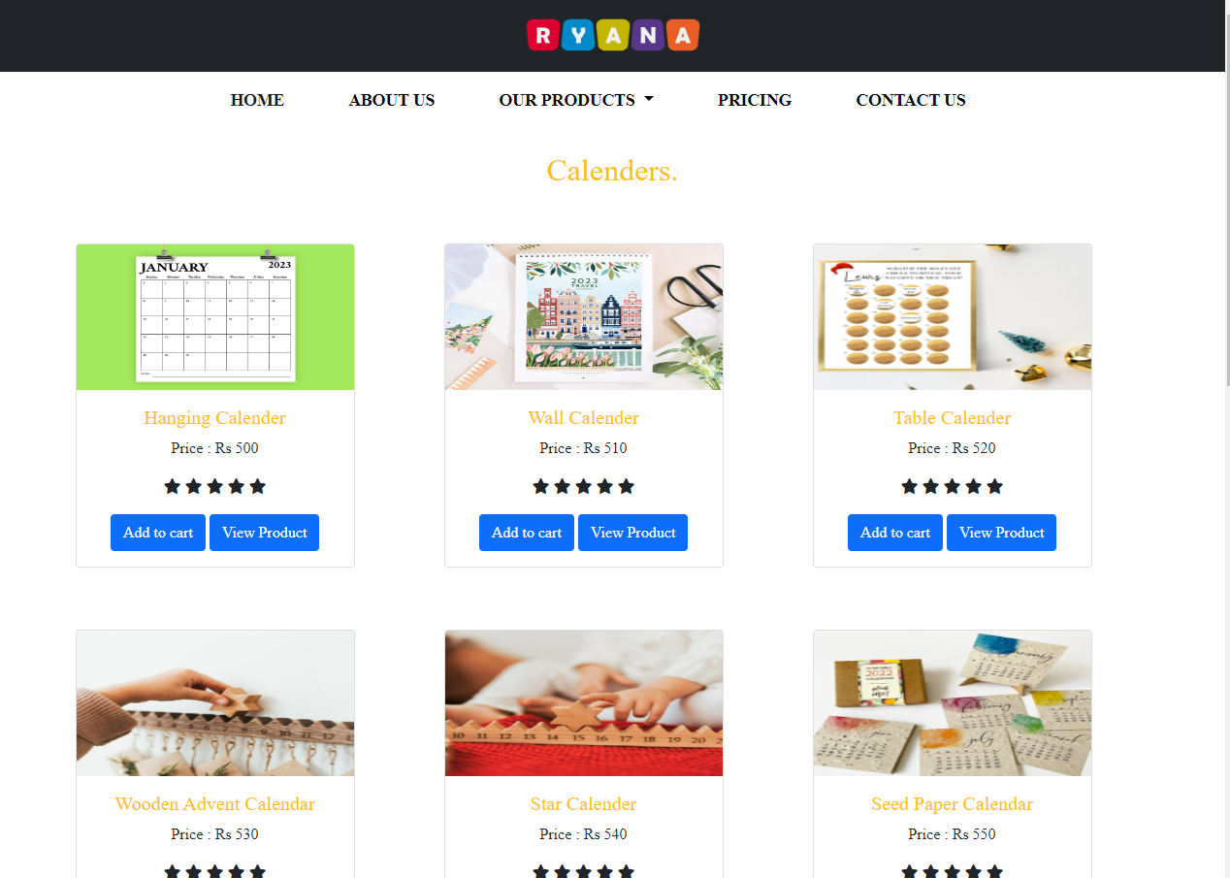

WIRE FRAME

1. **Main Layout**

**Sliders**

**Products**

**Navbar**

**Logo**

Products

**Background Image**

Button

Button

Button

**Img**

**Img**

**Img**

**Text**

**Text**

**Text**

**Img**

**Products**

**Img**

**Img**

**Img**

**Img**

**Button**

**IMAGE**

**TEXT**

**Text**

2.**About Us Page**

z

**Footer**

Contact U

Form

Map

Contact Us

IMAGE

IMAGE

IMAGE

**IMAGE**

**IMAGE**

**IMAGE**

**IMAGE**

**IMAGE**

**IMAGE**

**IMAGE**

**IMAGE**

**IMAGE**

**IMAGE**

**IMAGE**

**IMAGE**

4**.Product Page**

## ­­Text Sheet Review

|  |  |  |  |
| --- | --- | --- | --- |
| **Serial Num** | **Names** | **Project Title** | **Task** |
|  | M.Abdul Aziz | Ryana Calendar | Logo, Products Pics, Eproject Documentation,Home Page, About Us , Footer |
|  | Junaid Ahmed | Ryana Calendar | Map & Products Cards |
|  | Agha Ali | Ryana Calendar | Products Cards |
|  | Nathen Bhatti | Ryana Calendar | Nothing |