### Requirement 1: Post job listings on the ‘Google for Jobs’ search engine , through my website create a careers pages.

### USER CASE 1: Be able to add post job listings on the ‘Google for Jobs’ search engine, through on our website, by adaptation the careers pages.

### USER CASE: 2 by default the job listings will ´ll pick up our logo, but with the possibility to change it if we need to. (To use another logo instead of our own)

### USER CASE: 3

### Appear in Google for Jobs Google for Jobs, and once they do click in apply the link on that page redirect the user to our web, which means; we need to drive job applicants to from Google for Jobs to our web.

Reference Material

[Connect your job postings](https://jobs.google.com/about/#!)

[How to Post a Job on Google](https://movementseo.co.uk/recruitment-seo/how-to-post-a-job-on-google/)

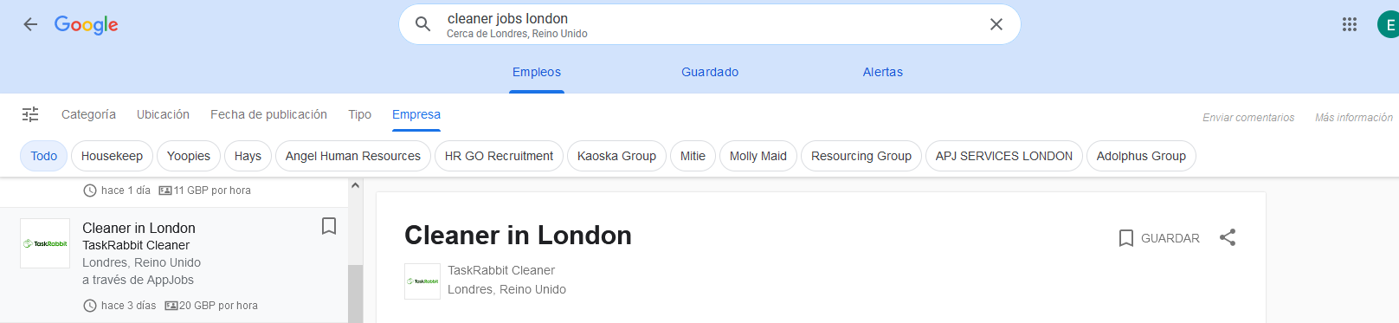Real example as expect out.

### The keyword is Jainer, call me Jainer is are you clear.