**Hotel Booking EDA Report**

**Introduction:**

This report presents a detailed exploratory analysis of hotel booking and cancellation trends using the given dataset.

The primary goal of this analysis is to uncover insights into customer booking behavior, cancellation patterns,

and factors influencing these trends. Additionally, actionable recommendations for hotel management will be provided to optimize their strategies.

**1. Booking and Cancellation Trends**

**Booking Trends**:

The analysis reveals distinct booking patterns across the months.

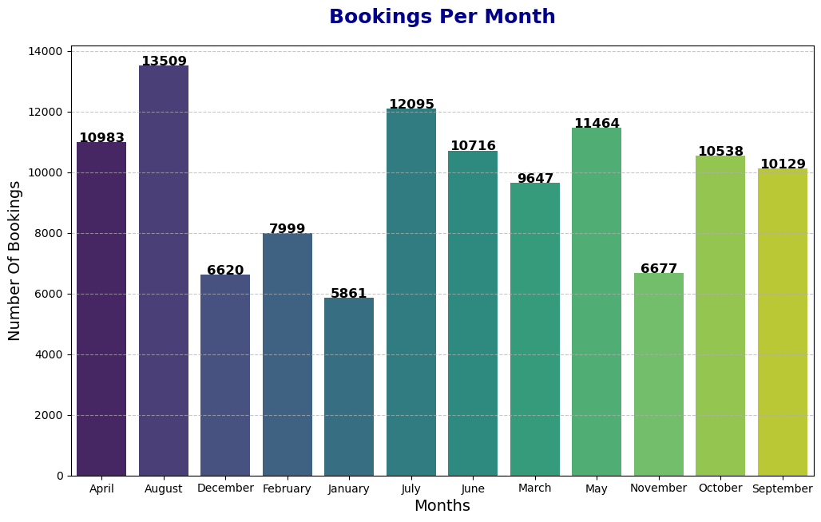

Certain months experience significantly higher booking volumes, particularly during the August, July, April etc.

Number of bookings per room type has been analyzed, with the following insights:

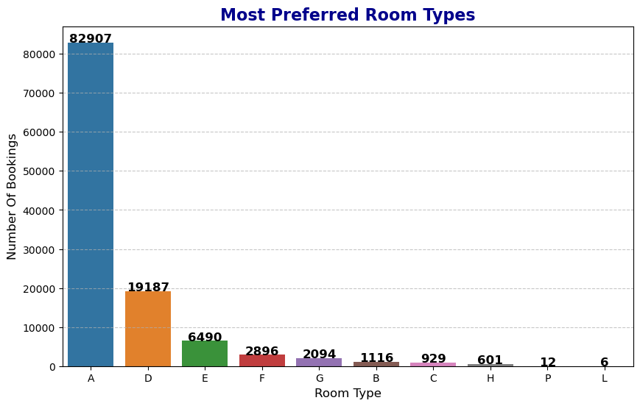

* Demand for Room Type A: Remarkably higher, indicating potential for premium pricing or special packages.
* Room Type D and E: Moderate preference, could be explored for mid-range offers.
* Least Preferred Rooms: Types B, C, F, G, H, P, and L have very low demand. Strategies could be developed to increase their appeal or repurpose these rooms.

Cancellation Patterns:

Out of the total bookings, 42093 were canceled of the bookings.

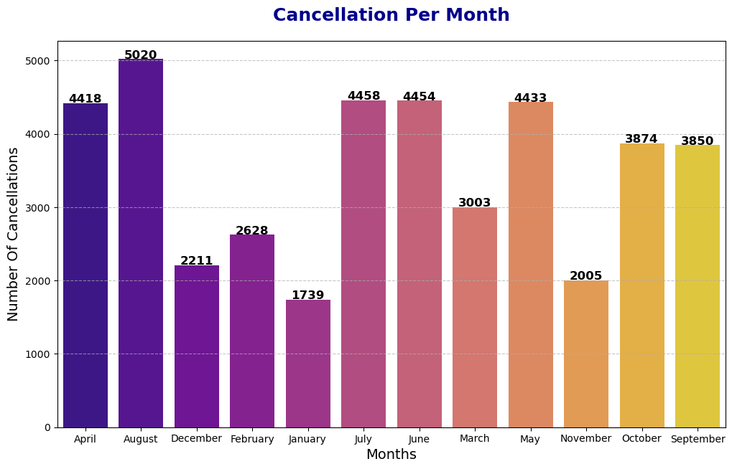

Further, cancellations are particularly high during April, August, July, June etc.

**2. Lead Time Analysis**

Lead Time Visualize:

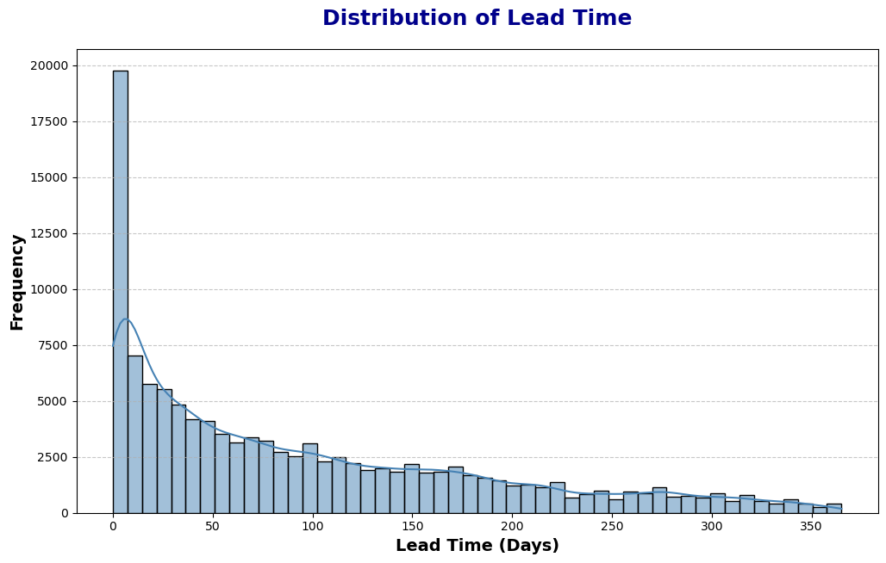

**3. Customer Preferences**

Room Type Preferences:

The most preferred room type was A. This can be attributed to reasons like affordability, comfort, etc.



Special Requests:

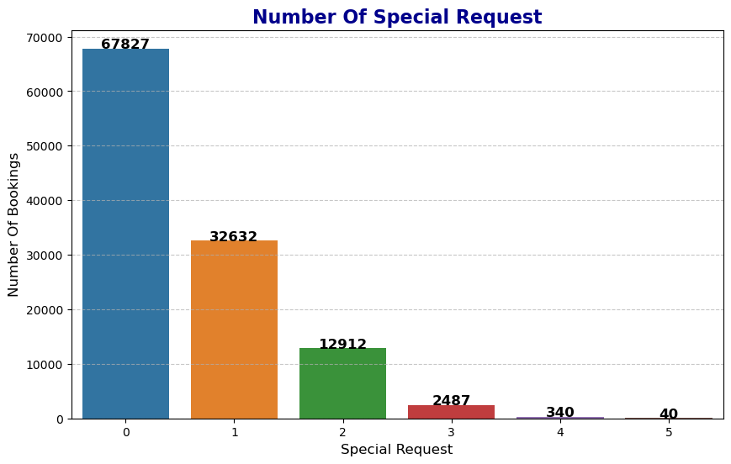

No Requests (0) : Most guests (67,827) don’t make any special requests. This might indicate a large portion of guests are either flexible or simply unaware they can make requests.

One Special Request: A significant number (32,632) of guests make one special request. This could suggest that most people have a primary concern, such as dietary restrictions or accessibility needs.

Two Requests: There are 12,912 bookings with two special requests. This might indicate guests who are slightly more particular or have multiple specific needs.

Three to Five Requests: The number of bookings drastically drops off for three (2,487), four (340), and five (40) special requests, showing that highly specific guests are few and far between.

**Insights:**

Simplify Booking Process: Since the majority of guests don’t make special requests, simplifying the booking process could enhance user experience.

Promote Customization: Highlight the ability to make special requests during the booking process to cater to specific needs.

Tailor Services: Use this data to anticipate and tailor services for guests with one or two common requests, such as offering more detailed options for dietary needs or room preferences.

**4. Factors Influencing Cancellations**

Lead Time and Cancellations:

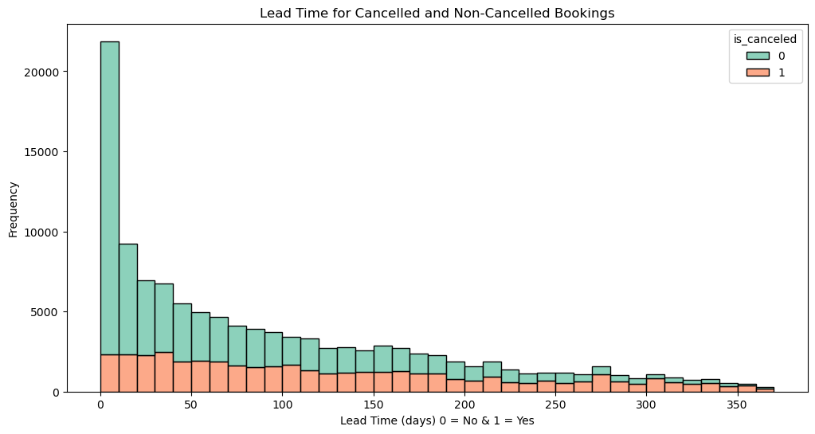

The relationship between lead time and cancellations shows that bookings with a lead time of 0-50 days are more likely to be canceled. Data reveals a trend where shorter lead times have higher cancellation rates. This is vital for understanding booking patterns and can be a springboard for improving cancellation policies. By offering incentives for longer lead times, like discounts or flexible cancellation terms, you might reduce cancellations.

Seasonality and Cancellations:

Seasonal trends indicate a spike in cancellations during March, April, and July, which may correlate with spring break, summer vacations, or other seasonal events.

This pattern can help in anticipating high-risk periods and tailoring strategies to minimize cancellations. You could consider offering special packages, flexible booking options, or additional incentives during these peak months to encourage customers to stick with their reservations.

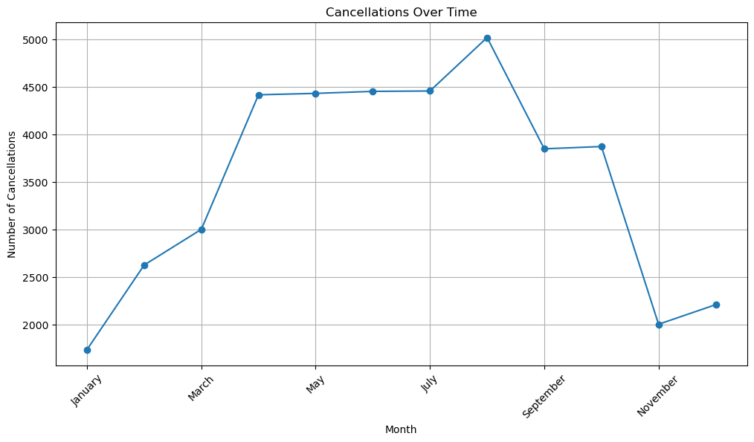

**5. Actionable Recommendations**

Based on the findings, the following recommendations can be made to hotel management:

**Reduce cancellations**: Consider implementing stricter cancellation policies during the high-cancellation months to minimize loss.

**Early Booking Discounts**: Offer discounts or promotions for bookings made early, especially those with long lead times.

**Optimize Room Availability:** Ensure that preferred room types like [Insert room type] are adequately stocked to meet customer demand.

**Seasonal Promotions:** Tailor marketing strategies around seasonal demand to encourage higher bookings during low periods and reduce cancellations.

**Conclusion:**

The analysis provides valuable insights into customer booking behavior and preferences, as well as factors driving cancellations.

By leveraging these insights, hotels can better optimize their operations, reduce cancellations, and enhance customer satisfaction.