Parallel and Distributed Computing

Project Abstract

Topic: Conversion Of Black and White Images into Colored Using OpenCV

**Technology**:

OpenCV , Python, Flask, HTML, CSS, ngrok etc

**Abstract:**

I will be creating a project on ‘Conversion Of Black and White Images into Colored’. The basic Idea is to create a web app that will convert Black and White Images in Colored.

The project is applicable in converting old Black and White photos to Colored. I followed the research paper as ‘Zhang et al.’s 2016 ECCV paper, [Colorful Image Colorization](http://richzhang.github.io/colorization/)’. For this project I used the research paper to get the insight into this realm of technology. Zhang used the method of conversion of colored images that are originally in RGB format to LAB format. The LAB format of training proved to be much more efficient that the RGB format. He devised the idea of converting an image into its Lightness(Intensity), A(Green Red) component and B(Blue Yellow) Component. The convolutional neural network was fed ith L component for training and it had to predict th a and b component. Using forward and backward propagation concept of Convolutional Neural Network, a model was developed by Zhang. The L, a and b components were combined at the end to get the respective colored image.

I on behalf of my team developed an app that harnessed the model devised by Zangg to create an API for the model. We used the concept of Client Server Distributed Computing model to implement an environment that can be used on any device without caring about the resources. My Laptop acting as a server will do all the computation and provide services at port 80 to any device that wants to connect to the app.

Any user can log into a website and get his black and white images converted to Colored without caring about the resources.

I used flask microframework to layout the design of the app. Use flask I was able to create routes to the Converter Model. On running the app using flask it can be used on local host. But in order to provide a global compatibility for other devices to connect I use ngrok framework to convert my laptop as a server for the app. Hence running thr flask app on port 80 and setting up the ngrok terminal, a gobal URL can be generated to provide services to any device on the internet.

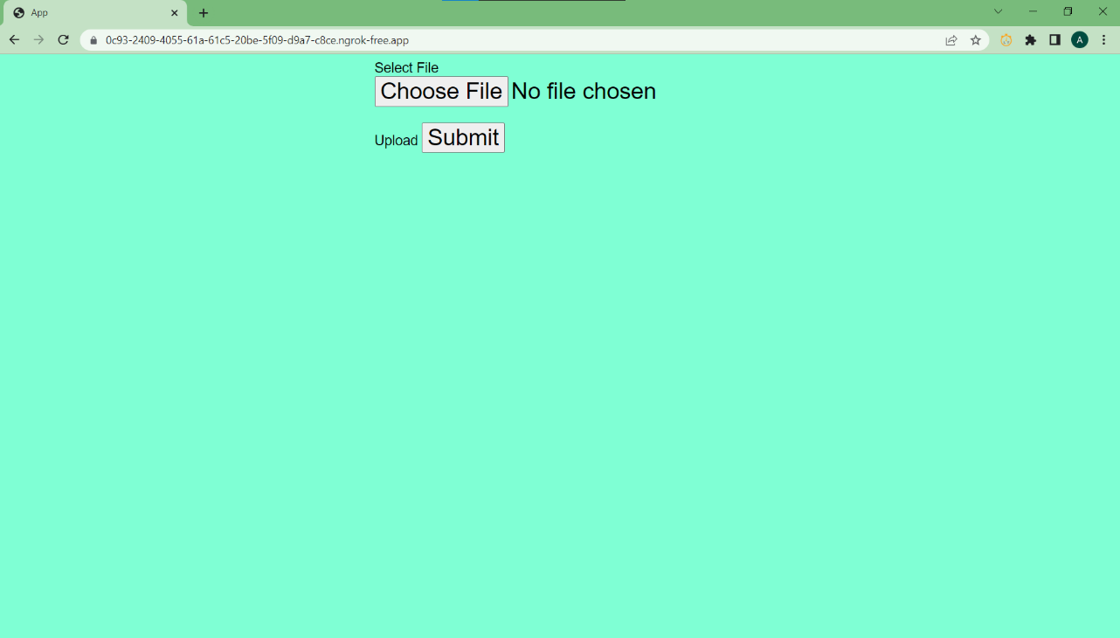**Interface**

**Some Examples**

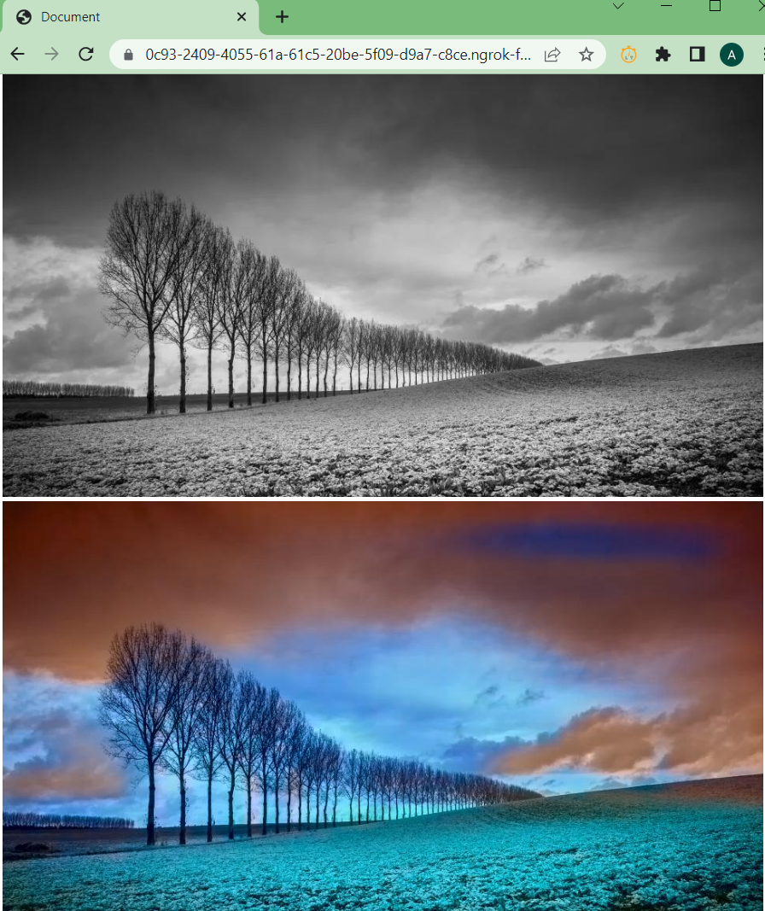

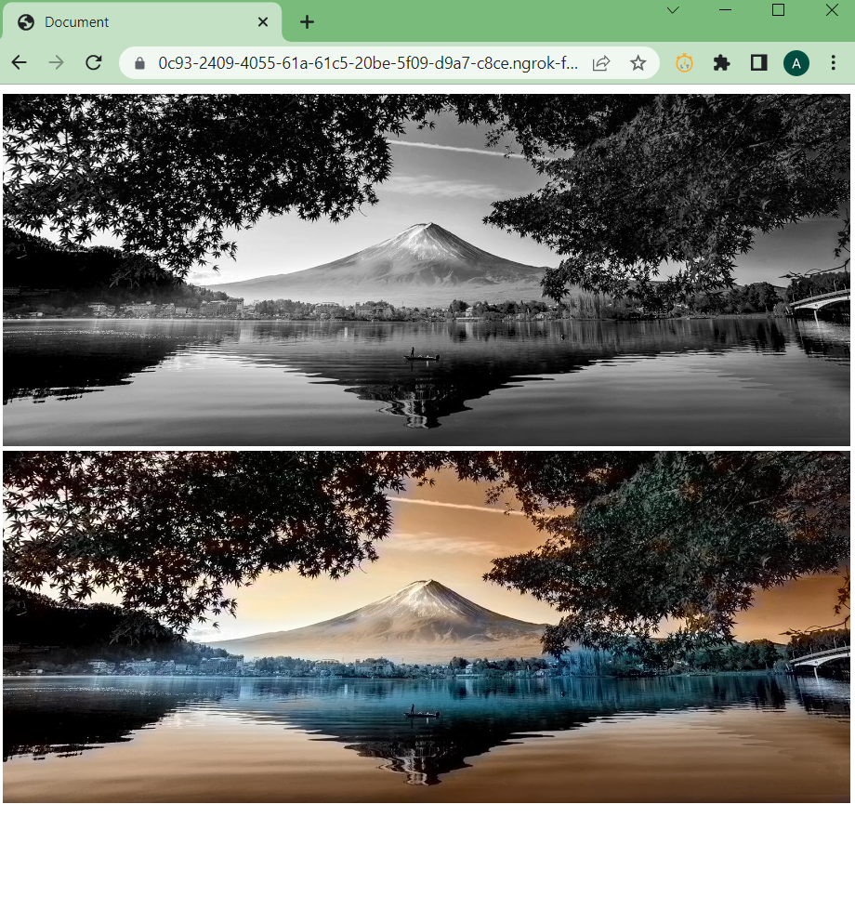

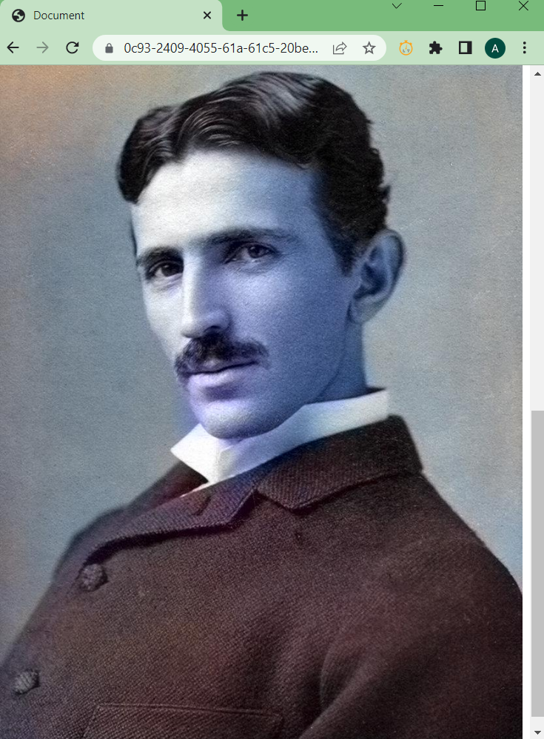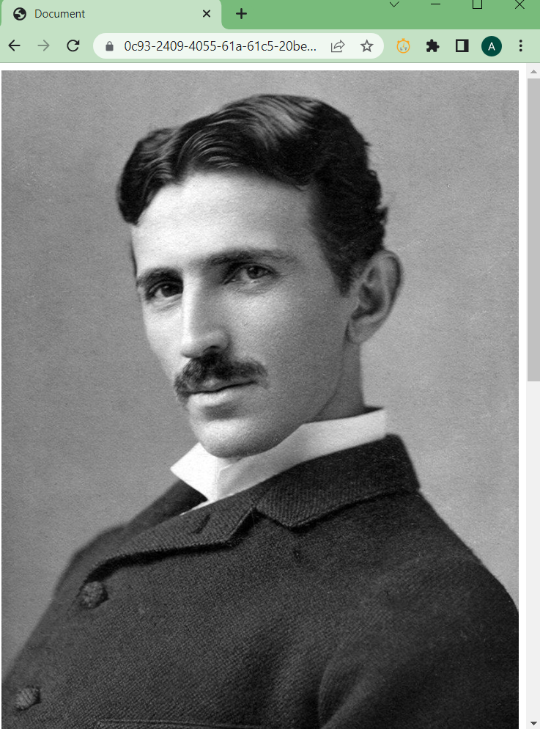

Conclusion:

The model Worked well and accepted a black and white Image. It processed the image using Open CV Convolutional Neural Network Model and Developed a Colored version of the Input Image.

Note: While the model dose not provide optimal results in some cases when the images are of low resolution, It ensures that it converts the image to a better one in color resolution than the original. With proper tuning of hyperperameters I am sure the color accuracy can be increased. Also the Server has the capability of serving one client at a time which can also be increased by increasing the budget of the project and making some minor changes in the system structure.

References for the project:

<https://analyticsindiamag.com/a-guide-to-parallel-and-distributed-deep-learning-for-beginners/>