Fresh Helpdesk Ticket User Manual
Create ticket, status movement, details screen, filters, and role-wise actions
This document explains how Fresh Helpdesk tickets are created, how each status changes, what each status means, what details are shown in the Ticket Details page, and how filters work.
Screenshot note: Images in this document are sample screenshots created from the current application screens and labels. They do not contain live ticket/user data.
1. Who Can Create Tickets
Tickets can be created by User, State Admin, and NIC Admin roles. A normal user-created ticket is first auto-forwarded to State Admin. State Admin can then forward it to NIC Admin when NIC action is required.
Role | Can Create Ticket | Initial Currently With
User | Yes | State Admin
State Admin | Yes | NIC Admin
NIC Admin | Yes | NIC Admin
Senior Developer / Developer | No | Not applicable

2. Create Ticket Screen
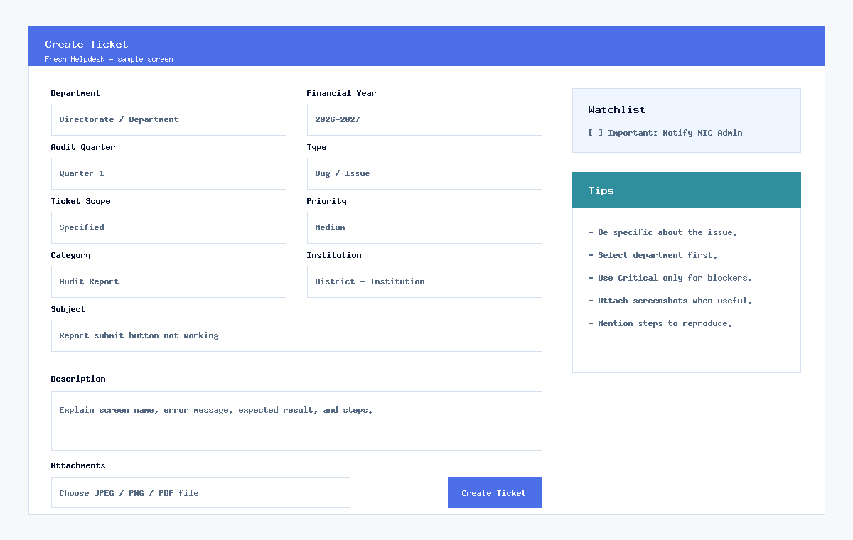
Required fields in the Create Ticket page are Department, Financial Year, Audit Quarter, Type, Ticket Scope, Priority, Category, Subject, and Description. Attachments are optional and support JPEG, PNG, and PDF files up to 500 KB per file.
Field | Meaning / Guidance
Department | Department related to the ticket. For normal users it is taken from the login session.
Financial Year | Financial year linked with the ticket.
Audit Quarter | Audit quarter or plan mapping related to the issue.
Type | Support, New Feature, Bug / Issue, or Data Correction.
Ticket Scope | Specified means limited to selected context. All means common/all-department scope.
Priority | Low, Medium, High, or Critical. Use Critical only for blocking/urgent issues.
Category | Module or issue category.
Subject | Short searchable title for the ticket.
Description | Clear details: screen name, exact issue, error, expected result, actual result, steps.
Watchlist | Marks ticket as Important and notifies NIC Admin.

3. Ticket Movement Flow
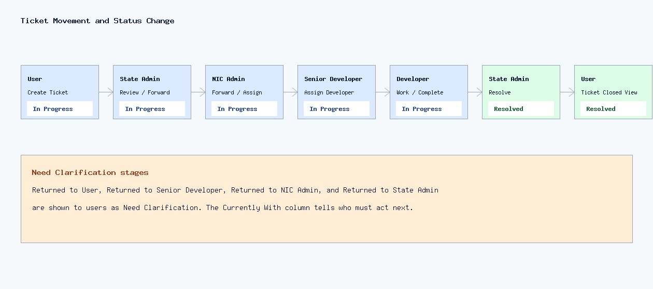
Normal user tickets move through State Admin first. NIC Admin can then return to State Admin, forward to Senior Developer, or assign directly to Developer.
Path | Movement
User to NIC Admin | User creates ticket -> State Admin reviews -> State Admin forwards to NIC Admin -> NIC Admin returns to State Admin -> State Admin resolves and returns to User.
User to Developer through Senior | User -> State Admin -> NIC Admin -> Senior Developer -> Developer -> Senior Developer -> NIC Admin -> State Admin -> User.
User to Developer direct | User -> State Admin -> NIC Admin -> Developer -> Senior Developer if available, otherwise NIC Admin -> State Admin -> User.

4. Status Meaning
Status Shown | Meaning | Typical Stored Status Values
In Progress | Ticket is active and currently with one role for action. | in_progress, pending_nic_admin, pending_senior_dev, pending_developer
Need Clarification | Ticket was returned to a previous role/user for clarification, review, or next action. | returned_user, returned_state_admin, returned_nic_admin, returned_senior_dev, need_clarification
Resolved | Ticket is completed/closed from workflow side and returned to user. | resolved, closed

5. Ticket Details Grid
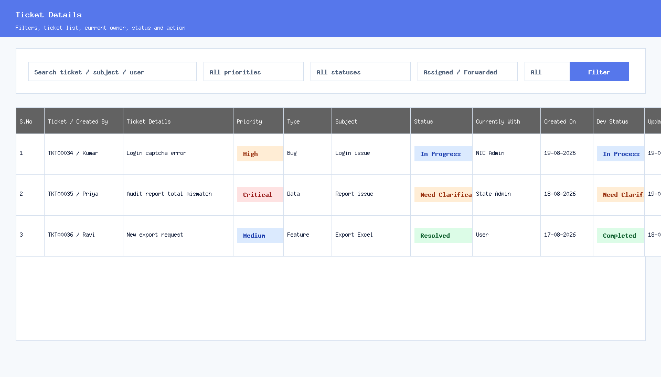
Column | What It Shows
S.No | Serial number in the grid.
Ticket / Created By | Ticket number and created user name.
Ticket Details | Description/summary of the ticket.
Priority | Priority badge: Low, Medium, High, or Critical.
Type | Support, Bug / Issue, New Feature, or Data Correction.
Subject | Ticket subject.
Status | User-friendly status badge.
Currently With | Role/person who must act next. This is the most important workflow column.
Created On | Ticket created date/time.
Dev Status | Developer work status if developer tracking is enabled.
Updated On | Last update date/time.
Action | View/open ticket detail action.

6. Filters In Ticket Details
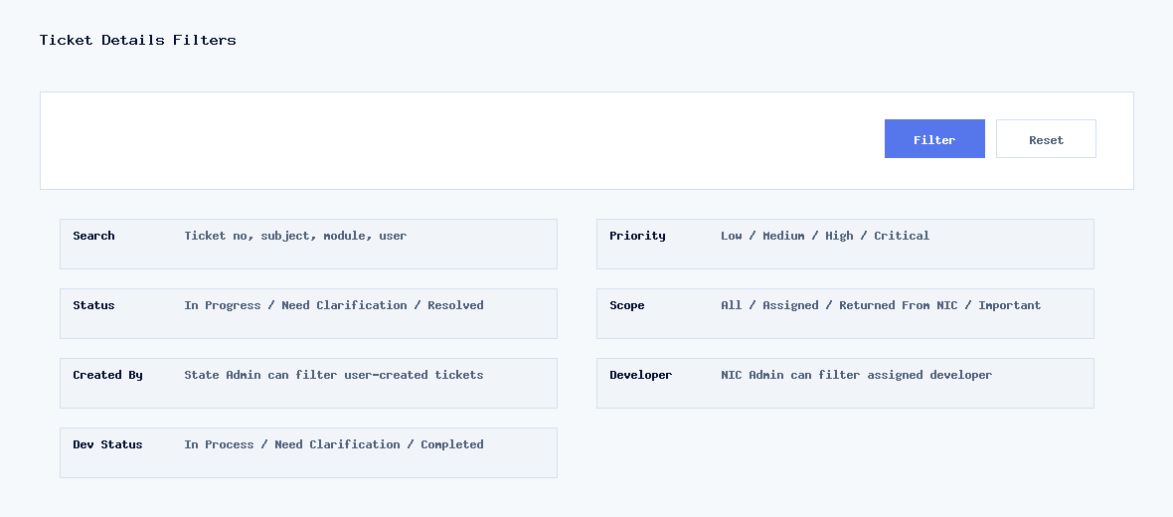
Filter | How It Works
Search | Searches ticket number, subject, module/details, or user text.
Priority | Shows only tickets with selected priority.
Status | Shows In Progress, Need Clarification, or Resolved tickets.
Assigned / Forwarded | Shows tickets currently assigned or forwarded to the logged-in role/user.
Returned From NIC | State Admin-only filter. Shows tickets returned by NIC Admin to State Admin.
Important | State Admin/NIC Admin filter. Shows tickets marked as important/watchlist.
Created By | State Admin can filter by ticket creator/user.
Developer | NIC Admin can filter tickets assigned to a selected developer.
Developer Status | Filters by In Process, Need Clarification, or Completed developer status.
Filter Button | Applies selected filters and refreshes the grid.
Reset / Clear | Clears filter values and returns to default ticket list.

7. Ticket Actions By Role
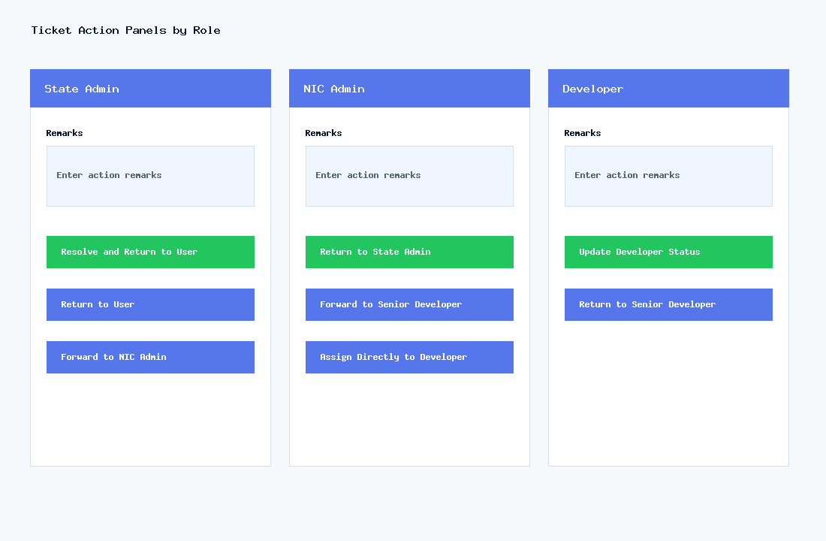
Role | Available Actions | Guidance
State Admin | Return to User, Forward to NIC Admin, Resolve and Return to User | State Admin screens user tickets and closes tickets after NIC/developer response.
NIC Admin | Return to State Admin, Forward to Senior Developer, Assign Directly to Developer, Update Status | NIC Admin controls technical routing.
Senior Developer | Assign Developer, Return to NIC Admin | Senior Developer reviews and assigns work to a developer.
Developer | Update Developer Status, Return to Senior Developer | Developer must mark Completed before returning to Senior Developer.
User | Return to State Admin, Reopen after resolved | User can return or reopen when the ticket is back with user/resolved.

8. Developer Status Meaning
Developer Status | Meaning | Forward Rule
In Process | Developer is working on the ticket. | Cannot return to Senior Developer yet.
Need Clarification | Developer needs more details. | Cannot return to Senior Developer from this status.
Completed | Developer work is finished. | Can return to Senior Developer.

9. Practical User Guidance
Always mention the screen name and exact error message.
Add steps to reproduce for bugs.
Attach screenshots or PDF proof when possible.
Use Critical priority only for urgent blocking issues.
Check the Currently With column to know who must act next.
Use Need Clarification status to identify tickets returned for more input.

