**Project: A simpleApp**

**Background: Simple app purpose was to swork with database. It was my android assignment that I used for testing purpose**

**Repository:**

**Videos link:**

**Video#1**

**Video#2**

**Video#3**

**MainMenu:**

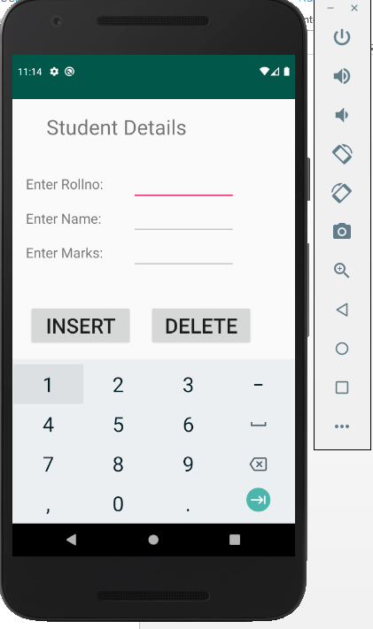

**Inserting Data:**

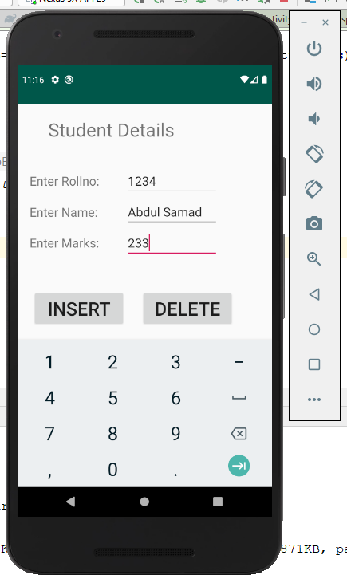

**After Insertion:**

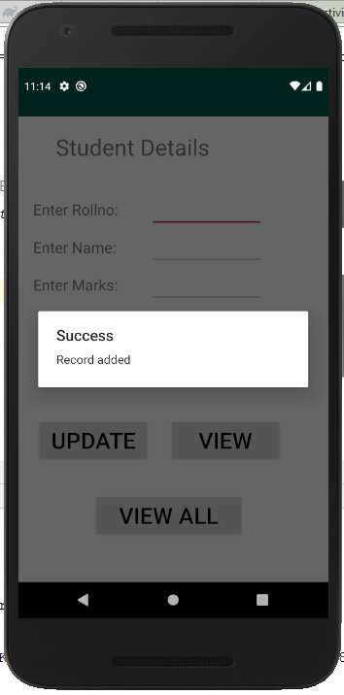

**To View Record:**

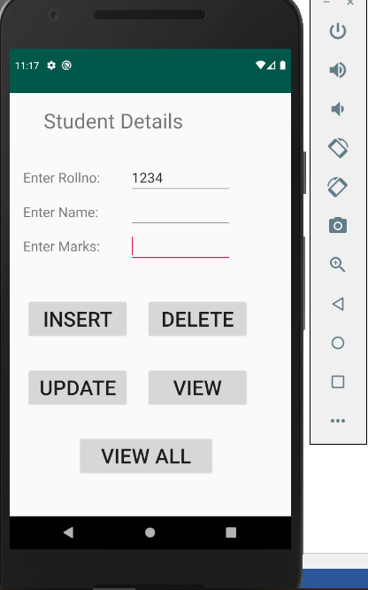

**Wrong Entery:**

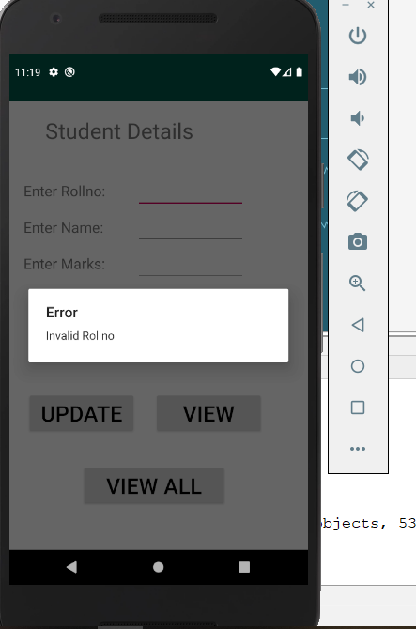

**View All Records:**

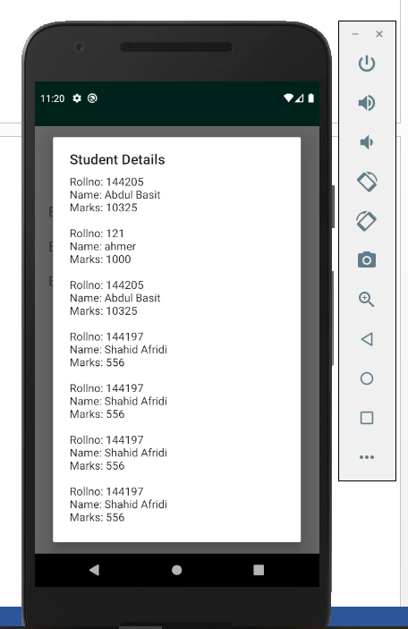

**Login Screen with shared Preferences:**

