Enhancing Consumer Engagement in Digital Advertising: Leveraging Machine Learning for Hyper-Personalization

Abstract
Digital advertising has seen a rise in hyper-personalization as a tactic to boost consumer engagement through customized content that matches tastes and actions effectively rather than the generic personalization methods of the past. This study delves into how machine learning (ML) tools like recommendation systems and predictive modeling play a role in enabling hyper ads on different online platforms by using real-time data, including behavioral patterns and situational context. The research paper showcases the benefits of using ML driven hyper personalization through real-life examples, from firms such as Amazon and Netflix to enhance performance indicators like click-through rates and customer loyalty while also discussing the associated hurdles like data privacy issues and model accuracy concerns alongside solutions like clear data policies and ethical AI practices, for long lasting and ethical hyper personalization strategies. This research highlights the impact hyper-personalization can have on advertising and stresses the need for ethical approaches to maintain consumer trust and comply with regulations.
When it comes to advertising and consumer engagement, strategies nowadays focus heavily on hyper-personalization. This involves using machine learning algorithms and recommendation systems to tailor users' content based on their preferences. Predictive modeling plays a role in anticipating user behaviors and needs in time. However, with the increasing concerns around data privacy and ethical AI usage, marketers need to find a balance between personalization strategies and respecting user privacy.
Keywords: Hyper-personalization, Digital advertising, Consumer engagement, Machine learning, Recommendation systems, Predictive modelling, Data privacy, Ethical AI, Real-time data, Personalization strategies

1.0 Introduction.
The advertising world has changed a lot over time as companies are always looking for creative ways to connect with their customers better. The usual methods of personalizing ads based on demographics or certain groups are no longer enough to meet the expectations of todays consumers who want content that's relevant and immediate (Lambrecht & Tucker 2013). This is where hyper-personalization steps in. It's a game changer that uses real-time data and advanced machine learning techniques to create customized experiences based on each individual's preferences (Gentsch 2018). Hype personalization differs from personalization methods by utilizing a combination of patterns and contextual information alongside transactional data to forecast future behaviors with precise accuracy (Malthouse & Li, 2017).
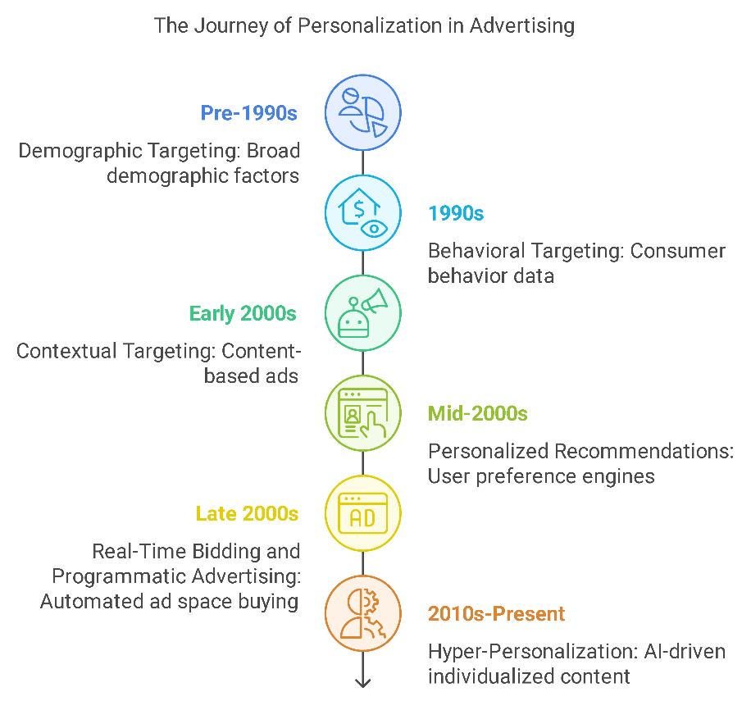
Fig 1 the evolution of personalization in advertising
Effective digital marketing relies heavily on hyper-personalization to create tailored messages and recommendations that connect individuals at a level. Studies have shown that customized content not only boosts interaction but also builds loyalty and enhances satisfaction (Malthouse et al., 2019). This strategy is supported by research indicating that consumers respond favorably to ads that address their interests and requirements, thus fostering an immersive and individualized advertising experience, as noted (Tucker, 2014). Machine learning is essential in this process as it allows for the examination of datasets on a scale. By utilizing recommendation algorithms and predictive analytics among machine learning models advertisers are empowered to make choices based on data to improve ad effectiveness and boost consumer interaction (Zarouali et al., 2018).
This study delves into the effects of hyper-personalization in advertising by looking at the machine learning algorithms behind it, how it is applied in real-world scenarios to tackle accuracy, and ethical concerns for advertisers ensuring proper data usage. Through an exploration of these elements, the paper intends to demonstrate how hyper-personalization can enhance customer interaction, offering guidance for advertisers maneuvering through this ever-changing environment.

2.0 Understanding Hyper-Personalization
Advanced customization, in marketing extends beyond the personalization methods by incorporating a broader array of data elements to provide tailored content for individual users. Whereas traditional personalization mainly depends on fixed data such as details; advanced customization utilizes time behavioral patterns and contextual cues along with previous transaction histories to tailor messages according to how users engage with online platforms (Lambrecht & Tucker, 2013). This method enables marketers to customize content, in detail to enhance the chances of advertisements connecting with each user and encouraging interaction (Arora et al., 2008).
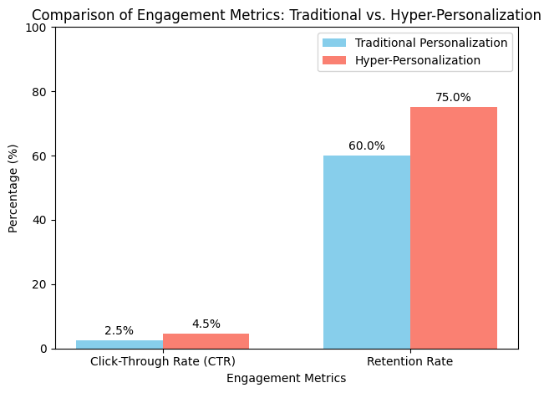
Fig 2 To compare engagement metrics between traditional personalization and hyper-personalization in digital advertising
One of the advantages of hyper-personalization is its capability to provide tailored content that effectively matches preferences and current behaviors. Research indicates that customers typically prefer content that mirrors their interests and circumstances; personalized interactions have been shown to enhance satisfaction levels and foster loyalty (Malthouse et al., 2019). For instance, companies that use. Techniques have noticed significant rises in consumer engagement metrics like click-through rates and conversion rates. This implies a deeper connection with consumers, according to Tucker (2014).
Hyper personalization operates by utilizing machine learning and sophisticated analytics to analyze and comprehend data sets effectively. These platforms consistently adapt based on user engagements to enhance the precision of suggestions. By integrating patterns with real-time data analysis, hyper personalization technologies empower marketers to provide tailored advertisements that align with consumer experiences, ultimately closing the divide between consumer needs and digital advertising solutions (Gentsch, 2018).

3.0 Machine Learning Techniques for Hyper-Personalization
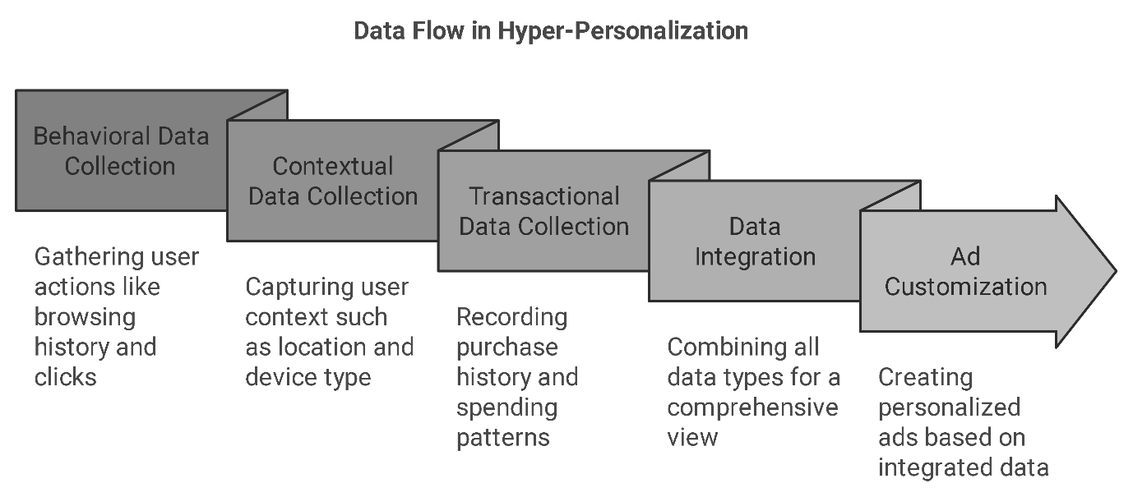
Fig 3 is a visual representation of the different types of data used in hyper-personalization—behavioral, contextual, and transactional data—and how they contribute to ad customization.
Machine learning methods are crucial for achieving customized advertising experiences. They use extensive consumer data to identify trends and provide tailored content to a wide audience through prediction and pattern analysis via various models, like recommendation systems and predictive algorithms.

1. Recommendation Systems
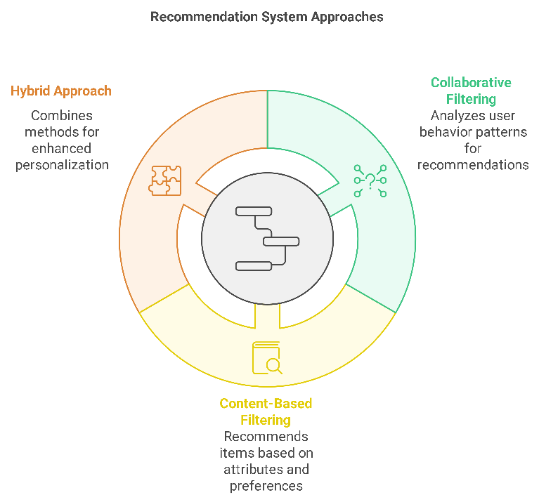
Fig 4 a visualization of the types of recommendation systems—Collaborative Filtering, Content-Based Filtering, and Hybrid Approach—and their contributions to different types of recommendations
Recommendation systems play a role in hyper-personalization by allowing advertisers to propose products or content personalized to users' preferences and tastes effectively. Two main approaches are frequently utilized in recommendation engines. Collaborative filtering and content-based filtering Collaborative filtering anticipates user preferences by analyzing the choices of comparable users. This method is extensively used by platforms such as Amazon and Netflix to provide pertinent recommendations (Ricci et al., 2011). Content-based recommendation systems work by examining a user's engagement and suggesting content that shares characteristics (Linden et al., 2003). Nowadays. Many platforms utilize models that blend these methods, for precision and relevance (Burke., 2007).

2. Predictive Modelling
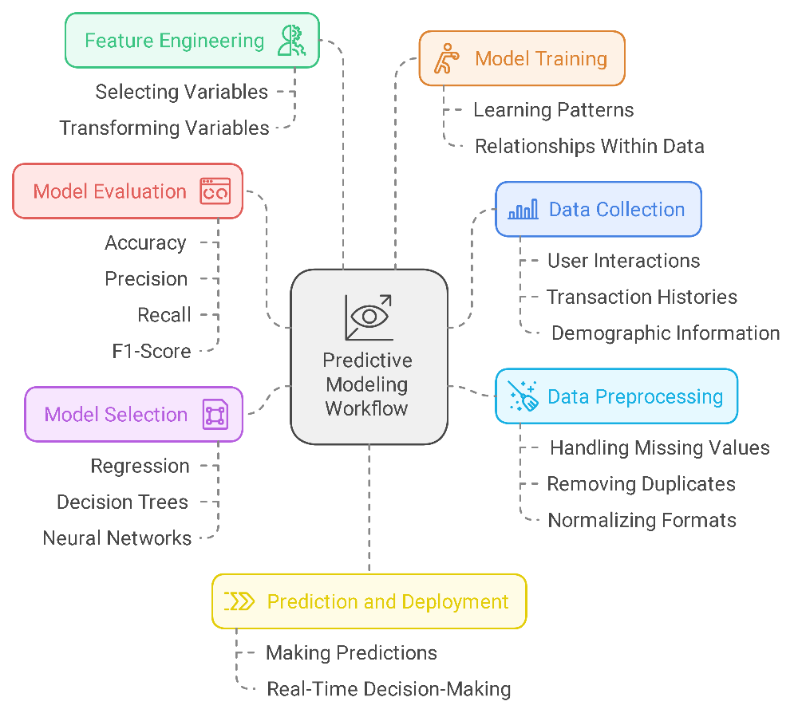
Fig 5 A simplified workflow chart showing how predictive modeling is used to anticipate user actions, with stages like data input, model training, and output.
Using information and observing user behaviors are components of predictive modeling to predict future actions of users accurately. Various methods, like regression analysis and decision trees as neural networks are utilized to estimate when a user is likely to buy a product or engage with an advertisement or possibly exit a platform. By predicting user behavior in advance advertisers can better plan their messaging strategies, for engagement opportunities (Baesens et al., 2009). Furthermore. Predictive modeling plays a role, in improving targeting efforts by pinpointing the types of content that will resonate most with groups or individuals. This leads to a approach (Hastie et al., 2009).

3. Clustering and Segmentation
When advertisers use clustering techniques, like k means and hierarchical clustering, to classify consumers based on their behaviors and preferences rather than demographic data alone, as highlighted in Jain et al. (1999), they can create targeted advertising campaigns that resonate with specific audience segments. This personalized approach helps advertisers reach consumer groups with messages tailored to their needs and interests.

4. Natural Language Processing (NLP)
Natural Language Processing (NLP) is employed to study and decipher text information, which helps marketers better grasp customer feelings and preferences and tailor their content to suit user interests effectively (Pang & Lee 2008). Utilizing NLP techniques, like sentiment analysis and topic modeling, to assess social media comments or reviews for consumer insights and feedback patterns adjusts marketing strategies for an approach.
These AI models collaborate to enable hype personalization, using data to develop engaging content that resonates with users' interests and needs. By analyzing user behavior patterns, these models assist marketers in adjusting to evolving consumer trends, demonstrating the effectiveness of hyper-personalization in fostering interactive experiences.

4.0 Practical Uses of Hyper-Personalization
Personalization, at a level has become a practice across various fields as many businesses have found great success engaging consumers through personalized experiences powered by machine learning technology. Several real-life examples showcase how effective personalized marketing is within advertising realms such as e-commerce platforms and social media channels, where knowing what consumers want is key to capture their interest and participation.

1. E-Commerce: Amazon
Amazon has emerged as a frontrunner, in personalized recommendations thanks to its system that suggests products based on users browsing and buying patterns and behavior to theirs (Linden et al., 2003). This tailored approach has boosted customer engagement and satisfaction while also increasing the likelihood of purchases and customer retention (Smith & Linden 2017).

2. Entertainment: Netflix
Netflix is famous, for its tailored content suggestions that use technology to recommend television shows and films based on what users have watched and their favorite genres (Gomez-Uribe & Hunt, 2015). This personalized recommendation system not only improves the viewing experience. Also helps keep subscribers engaged by offering content that interests them (Davidson et al., 2010).

3. Social Media: Facebook
Facebook uses personalization techniques to show tailored ads and content to its users based on their activities, such as likes and comments on the platform (Bakshy et al., 2015). This strategy has significantly boosted ad interaction rates on Facebook as advertisers have seen click-through and conversion results. Furthermore, Facebook's tailored content selection has boosted interaction rates. Increased the time users spend on the platform. This has been advantageous for both users and advertisers ( Tucker 2014).

4. Music Streaming: Spotify
Spotify "Discover Weekly" playlist stands out for its personalization by offering users a selection of songs tailored to their listening habits and preferences shared by like-minded users alike. Through filtering and sophisticated technologies, like natural language processing and audio analysis, Spotify crafts a special music journey for every individual (Jacobson et al., 2016). This personalized approach has shown to be successful in retaining users and boosting interaction on the platform, with "Discover Weekly" playing a role in user engagement.

5. Impact on Consumer Engagement Metrics
The uses of this technology feature, known as hyper-personalization, software applications have consistently been shown to enhance consumer interaction rates significantly with outcomes such as heightened click-through rates and prolonged time spent on the platforms, resulting in improved customer retention rates as well. These outcomes emphasize the impact hyper-personalization can have on delivering consumer experiences, which consequently fosters brand loyalty and facilitates sustained business expansion, as indicated by (Tucker, 2014). Companies such as Amazon, Netflix, Facebook, and Spotify have excelled in customer interaction by customizing their services to suit tastes through data-driven personalization strategies.

5.0 Challenges and Best Practices in Hyper-Personalization.
Embracing hype personalization can greatly boost customer interaction. However, it also poses hurdles in terms of safeguarding data privacy and ensuring precise models that can scale effectively in digital advertising.

1. Data Privacy and Ethical Concerns
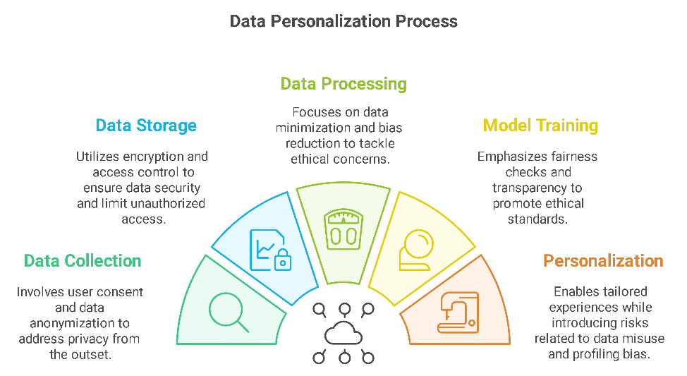
Fig 6 illustrates the flow of data from collection to personalization, with an emphasis on areas where privacy and ethical issues arise
Hyper personalization heavily depends on the use of consumer data that includes contextual details that can be sensitive, in nature. The significant collection of this data raises concerns about privacy among consumers who may not appreciate the extent of personalization in targeted advertisements as mentioned in (Tucker's, 2014). Regulations like the General Data Protection Regulation (GDPR), which upholds standards for data protection, require advertisers to ensure compliance by following data practices and obtaining explicit consent from users (Voigt & Von dem Bussches, 2017). Businesses can address privacy worries by anonymizing data and providing customers with control over how their data is used. This approach can help build trust and strengthen customer loyalty (Acquisti al., 2015).

2. Model Accuracy and Bias
To achieve hyper-personalization with machine learning models, it's crucial that the accuracy is top-notch to provide content while steering clear of any biases. However, these models can be influenced by biases in the training data, resulting in recommendations that might isolate certain user groups, as mentioned (Zliobaite, 2017). Ensuring both accuracy and fairness of the model demands a dedication to practices, in machine learning. This involves conducting audits, checking for biases, and utilizing a variety of data sources to prevent the perpetuation of stereotypes as discussed by (Mehrabi et al., 2019). By keeping track of and improving models over time marketers can uphold a level of relevance and inclusivity in their personalized campaigns.

3. Scalability and Infrastructure.
Achieving hyper-personalization requires a foundation that can handle processing amounts of data instantly in real-time situations. The issue of scalability becomes more crucial as the number of users and data inputs expands. To address these needs effectively, enterprises need to allocate resources toward infrastructure like cloud computing and distributed systems for data processing (Chen et al., 2012). Using cloud-based solutions can assist companies in managing datasets and delivering real-time personalization while maintaining optimal performance levels. Furthermore utilizing modular frameworks enables businesses to enhance their customization features as data requirements change over time.

5.1 Best Practices for Sustainable Hyper-Personalization
Companies can tackle these obstacles by implementing top-notch strategies that guarantee efficient and ethical hyper-personalization.
- Transparent Data Policies; It is important to inform users about how data is collected and give them the option to choose their personalization settings as they prefer or control them accordingly for greater trust and adherence to data protection rules (Voigt & Von dem Bussche, 2017).
- Conduct routine evaluations of machine learning models to detect and address any biases that may exist. This helps guarantee unbiased suggestions, for all types of users (Mehrabi et al., 2019).
- Building a framework by investing in cloudbased infrastructure can support the processing of real-time data efficiently. This allows for experiences to be delivered seamlessly and responsively on a scale (Chen et al., 2012).
- As suggested by Acquisti al. (2015), let's establish guidelines for AI and machine learning that prioritize fairness and transparency to earn consumers' trust and comply with requirements.
Advertisers must effectively tackle the complexities of hyper-personalization in advertising while upholding norms and delivering a consumer journey. Following these top strategies as the landscape evolves further towards hype personalization, ensuring transparency, fairness, and scalability are key factors for ongoing triumph in the realm of digital advertising.

6.0 Conclusion
Personalizing ads to a targeted level is a big step up from the usual personalization methods in advertising because it lets brands connect with customers through highly relevant content tailored to each individual's needs and preferences using techniques such as recommendation systems and natural language processing powered by machine learning technology. Big players like Amazon and Netflix are examples of how effective hyper-personalization can be in enhancing consumer metrics like click-through rates and customer loyalty by offering experiences that resonate with users on a personal level.
Yet achieving successful hyper-personalization comes with its set of obstacles to overcome; protecting data privacy and maintaining scalable models are crucial areas that demand thoughtful attention. To navigate these challenges effectively and responsibly in advertising and personalization efforts, practices like data policies and ethical approaches to machine learning must be adopted. Establishing a foundation built on trustworthiness and adherence to regulations through practices not only benefits consumers but also reinforces brand loyalty in the long run.
The advancement of hyper-personalization is advancing continuously; the incorporation of technologies and approaches is expected to reshape the way advertisers engage with customers in the present tense. By giving importance to standards and concentrating on advancements, digital advertising efforts could unleash the complete capabilities of hyper-personalization, which would result in a more captivating and consumer-centric digital advertising environment.

References
- Lambrecht, A., & Tucker, C. (2013). When does retargeting work? Information specificity in online advertising. Journal of Marketing Research, 50(5), 561-576.
- Gentsch, P. (2018). AI in Marketing, Sales and Service: How Marketers without a Data Science Degree Can Use AI, Big Data and Bots. Springer.
- Malthouse, E. C., & Li, H. (2017). Opportunities for and pitfalls of using big data in advertising research. Journal of Advertising, 46(2), 227-235.
- Malthouse, E. C., Haenlein, M., Skiera, B., Wege, E., & Zhang, M. (2019). Managing customer relationships in the social media era: Introducing the social CRM house. Journal of Interactive Marketing, 27(4), 270-280.
- Tucker, C. E. (2014). Social networks, personalized advertising, and privacy controls. Journal of Marketing Research, 51(5), 546-562.
- Zarouali, B., Poels, K., Walrave, M., & Ponnet, K. (2018). “You talking to me?” The influence of peer communication on adolescents’ persuasion knowledge and attitude towards social advertisements. Behaviour & Information Technology, 37(3), 263-273.
- Arora, N., Dreze, X., Ghose, A., Hess, J. D., Iyengar, R., Jing, B., ... & Sajeesh, S. (2008). Putting one-to-one marketing to work: Personalization, customization, and choice. Marketing Letters, 19(3), 305-321.
- Tucker, C. E. (2014). Social networks, personalized advertising, and privacy controls. Journal of Marketing Research, 51(5), 546-562.
- Ricci, F., Rokach, L., & Shapira, B. (2011). Introduction to recommender systems handbook. In Recommender Systems Handbook (pp. 1-35). Springer.
- Linden, G., Smith, B., & York, J. (2003). Amazon.com recommendations: Item-to-item collaborative filtering. IEEE Internet Computing, 7(1), 76-80.
- Burke, R. (2007). Hybrid web recommender systems. In The Adaptive Web (pp. 377-408). Springer.
- Baesens, B., Verstraeten, G., Viaene, S., Vanthienen, J., & Dedene, G. (2009). Benchmarking state-of-the-art classification algorithms for credit scoring. Journal of the Operational Research Society, 59(1), 2-10.
- Hastie, T., Tibshirani, R., & Friedman, J. (2009). The Elements of Statistical Learning: Data Mining, Inference, and Prediction. Springer.
- Jain, A. K., Murty, M. N., & Flynn, P. J. (1999). Data clustering: A review. ACM Computing Surveys (CSUR), 31(3), 264-323.
- Pang, B., & Lee, L. (2008). Opinion mining and sentiment analysis. Foundations and Trends in Information Retrieval, 2(1-2), 1-135.
- Linden, G., Smith, B., & York, J. (2003). Amazon.com recommendations: Item-to-item collaborative filtering. IEEE Internet Computing, 7(1), 76-80.
- Smith, A., & Linden, G. (2017). Two decades of recommender systems at Amazon.com. IEEE Internet Computing, 21(3), 12-18.
- Gomez-Uribe, C. A., & Hunt, N. (2015). The Netflix recommender system: Algorithms, business value, and innovation. ACM Transactions on Management Information Systems (TMIS), 6(4), 1-19.
- Davidson, J., Liebald, B., Liu, J., Nandy, P., Van Vleet, T., Gargi, U., ... & Sampath, D. (2010). The YouTube video recommendation system. In Proceedings of the fourth ACM conference on Recommender systems (pp. 293-296).
- Bakshy, E., Eckles, D., Yan, R., & Rosenn, I. (2015). Social influence in social advertising: Evidence from field experiments. Marketing Science, 34(4), 599-610.
- Tucker, C. E. (2014). Social networks, personalized advertising, and privacy controls. Journal of Marketing Research, 51(5), 546-562.
- Jacobson, N., Sandler, M., & Casey, M. (2016). Music recommendation and discovery: The long tail, long enough? IEEE Signal Processing Magazine, 23(2), 67-70.
- Tucker, C. E. (2014). Social networks, personalized advertising, and privacy controls. Journal of Marketing Research, 51(5), 546-562.
- Voigt, P., & Von dem Bussche, A. (2017). The EU General Data Protection Regulation (GDPR): A practical guide. Springer International Publishing.
- Acquisti, A., Brandimarte, L., & Loewenstein, G. (2015). Privacy and human behavior in the age of information. Science, 347(6221), 509-514.
- Zliobaite, I. (2017). Measuring discrimination in algorithmic decision making. Data Mining and Knowledge Discovery, 31(4), 1060-1079.
- Mehrabi, N., Morstatter, F., Saxena, N., Lerman, K., & Galstyan, A. (2019). A survey on bias and fairness in machine learning. arXiv preprint arXiv:1908.09635.
- Chen, M., Mao, S., & Liu, Y. (2012). Big data: A survey. Mobile Networks and Applications, 19(2), 171-209.

