

**THE STATE UNIVERSITY OF ZANZIBAR (SUZA)**

**BUSINESS NAME:** **PIXLOGY**

**TITLE OF PROPOSAL:** BUSINESS PHOTOGRAPHY IN ZANZIBAR

**DATE OF SUBMISSION: 16 th JAN 2025**

|  |
| --- |
| MEMBERS $ REGISTRATION |
| |  |  | | --- | --- | | **1.OTHMAN HAMAD FAKI** | **DIT/13/23/001/TZ** | | **2.AHMED ZUBEIR SULEIMAN** | **DIT/12/22/048/TZ** | | **3.HUSNA JUMA HAMDU** | **DIT/13/23/038/TZ** | | **4.ZAITUNI AHMADA SHEHE** | **DIT/13/23/036/TZ** | | **5.THAMLLA SHARIF AHMED** | **DIT/13/23/017/TZ** | |

**EXECUTIVE SUMMARY**

**PIXLOGY** is a Zanzibar based photographer business focused on delivering professional service for various events such as wedding, graduation and corporate activities. Our mission is to capture memorable moments while ensuring customer satisfaction.

**Key highlights:**

Specialized services tailored to individual needs.

Modern equipment ensuring high-quality photography.

A clear plan for financial sustainability and market expansion.

The proposal aims to establish **PIXLOGY** as market leader, leveraging Zanzibar’s vibrate culture and tourism landscape to attract clients.

# TABLE OF CONTENTS:

Contents

TABLE OF CONTENTS: 3

INTRODUCTION. 4

OBJECTIVES AND GOALS. 5

BUSINESS DESCRIPTION 6

DESCRIPTION OF THE PRODUCT 6

OUR PRODUCT 8

EQUIPMENT USED 9

MARKET ANALYSIS 11

COMPETITIVE ANALYSIS: 12

MARKETING STRATEGIES: 13

OPERATION AND MANAGEMENT 14

FINANCIAL ANALYSIS 15

FUTURE PROJECTIONS 16

CONCLUSION 17

# INTRODUCTION.

**PIXLOGY** is a new photography business operation in Zanzibar. It was founded to address the growing need for high quality, reliable, and affordable photography services. With Zanzibar being a hub for tourism and cultural events there is a strong demand for creative photography services.

**Purpose of the Business:**

To outline the business strategies for **PIXLOGY.**

To secure partnerships and funding for growth.

**Our vision:**

To become the most trusted and innovative photography service provider in Zanzibar.

**Our mission:**

To deliver exceptional photography services that create lasting memories.

# OBJECTIVES AND GOALS.

**Objectives:**

Deliver high quality photography services to wide range of clients.

Create a robust online presence through social media and website.

Achieve financial stability within two years.

**Goals:**

Serve at least 300 clients in the first years.

Expand services to include video production and editing.

Establish a permanent studio within three years.

# BUSINESS DESCRIPTION

**PIXLOGY** specializes in professional photography services, focusing on both local and international clients in Zanzibar.

# DESCRIPTION OF THE PRODUCT

**PIXLOGY** offers the following products and services:

**Event photography:**

Capturing memorable moments with high quality equipment and creative angles.

**Studio photography:**

Customizable portrait sessions for individuals, families and professionals.

**Tourism photography:**

Specialized services for tourism and travel agencies to showcase Zanzibar beauty.

**Key futures:**

* Rapid delivery of edited photos.
* Customized packages for different client needs.
* Competitive pricing starting from 30,000/=TZS.

**Event photography:**



**weddings graduations**



**corporate functions.**

**Studio photography**:



**Family portraits, professional headshots.**

**Tourism photography:**

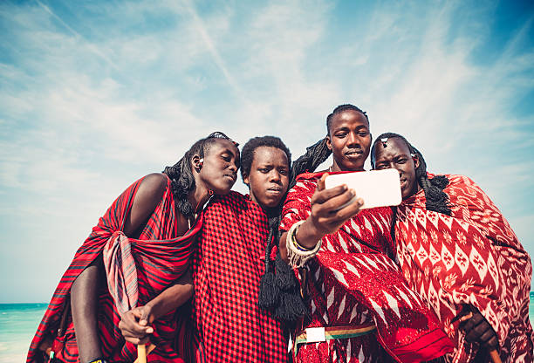

**culture landscape**

# OUR PRODUCT

**   **

**   **

**   **

# EQUIPMENT USED

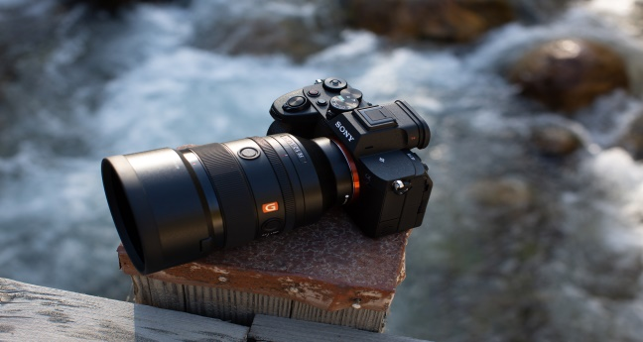 

**Sony-A7-1V** **Sony -A5-Pro**

 

**Studio A**  **Studio B**

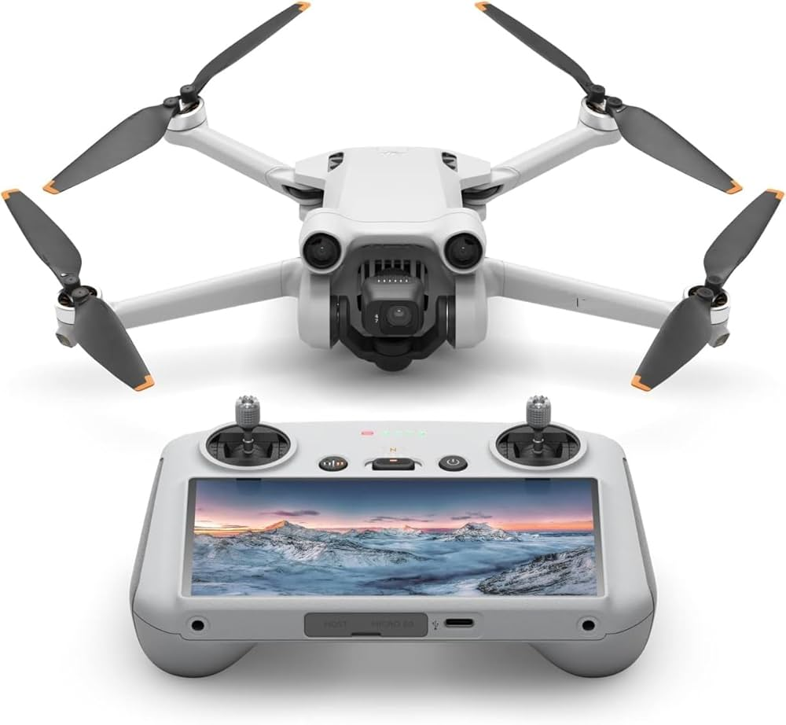 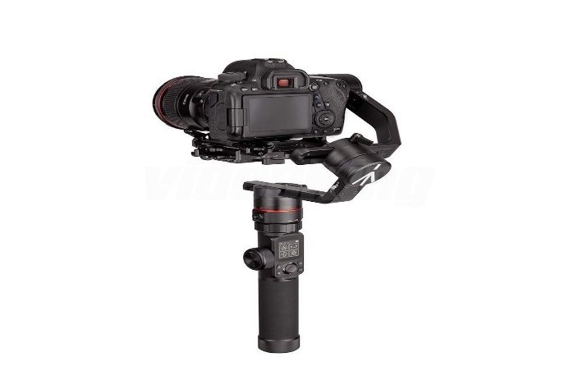

**Drone**  **Gimbal**

**Business structure:**

**PIXLOGY** operate s as a Partnership, managed by the owners with a team of skill photographers and support stuff.

This includes:

* **Owner**: HUSNAYNAT
* **Photographers:** DHUNNURAYN & GABI
* **Customer Services Team:** MRS TUNY & THASHAA

# MARKET ANALYSIS

Zanzibar’s vibrate tourism and cultural events offer a growing market for photography services.

**Target audience:**

* Local residents celebrating personal milestones.
* Tourism exploring Zanzibar’s attractions.
* Corporate clients hosting events.

**Customer Segments:**

* High income earners requiring premium services.
* Middle income families seeking affordable photography packages.
* Organization in need of professional event coverage.

# COMPETITIVE ANALYSIS:

**PIXLOGY** operates in a competitive market but stands out with its focus on modern technology, creativity, and customer service.

**Competitor Strengths:**

* Established client base.
* Experienced teams.

**Competitor weakness:**

* Competitor weakness.
* Delayed delivery of photos.

**PIXLOGY strengths:**

* Use of cutting-edge equipment.
* Personalized client experiences.
* Faster service delivery.

**PIXLOGY weakness:**

* Higher price.
* Redetection of customer

# MARKETING STRATEGIES:

**Online Marketing:**

* Utilize social media platforms like Instagram and Facebook to showcase work.
* Create a professional website with booking options.

**Offline Marketing:**

* Distribute flyers at key tourist spots and event venues.
* Collaborate with local event planners and tourism agencies.

**Promotions:**

* Offer discount for time clients.
* Introduce referral bonuses to encourage word of mouth marketing.

# OPERATION AND MANAGEMENT

**MANAGEMENT STRUCTURE:**

**Owner:** Oversees the overall operation.

**Photographers:** Handle shoots and editing.

**Customer Service team:** Manage booking and inquiries.

**Daily operation**

Scheduling and planning shoot.

Editing and delivering photos.

Marketing and client communication.

# FINANCIAL ANALYSIS

**Funding sources:**

* Personal savings:5,000,000
* Small business loans:22,000,000/-TZS
* Company funds:15,000,000/-TZS

**Startup Coasts:**

* Equipment: 28,000,000
* Marketing: 5,600,000/-TZS
* Office setup: 8,400,000/-TZS

TOTAL=42,000,000/-TZS

**Revenue Streams:**

* Event Photography: 50,000/-TZS -200,000/-TZS per booking.
* Studio Photography: 25,000/-TZS per session.

# FUTURE PROJECTIONS

**Years**

**1st Year:** Break-even point achieved with 300+clients.

**2nd Year:** Expand services and open a physical studio.

**3rd Year**: Increase revenue by 50% through tourism focused services.

**Community Impact**

**PIXLOGY** will create employment opportunities for local photographers and assistants. Additionally, it will promote Zanzibar as a top photography destination.

# CONCLUSION

PIXLOGY aims to be the leading photography business in Zanzibar by combining high-quality services with eco-friendly practices.

Through our commitment to professionalism, creativity, and sustainability, we will provide memorable experiences for our clients while contributing to the protection of our environment.

Our business plan outlines a clear path to success by focusing on our target market, efficient operations, and innovative marketing strategies.

PIXLOGY is not just a business it’s a step toward creating a sustainable and impactful photography service in Zanzibar.