
THE STATE UNIVERSITY OF ZANZIBAR
SCHOOL OF COMPUTING COMMUNICATION AND MEDIA STUDIES
DEPARTMENT OF COMPUTER SCIENCE AND INFORMATION TECHNOLOGY

FIELD WORK ON SYSTEM DEVELOPMENT, MAINTENANCE, DATABASE
AND NETWORKING CONDUCTING AT MINISTRY OF HEALTH ZANZIBAR
BETWEEN 8stAUG 2024 UP TO 20rdSEPT 2024

STUDENT NAME: ABDULMAJID MOHD ALI
REGISTRATION NO: BCS/18/23/004/TZ
ACADEMIC YEAR: 2023/2024

SUPERVISOR NAME: MR. ABDUL-RAHMAN MALIK

DECLARATION
I, ABDULMAJID MOHD ALI a student from State University of Zanzibar (SUZA) in DEGREE IN COMPUTER SCIENCE I declare that the field report presented is my own work and has not been previously submitted to any other Universities and has been carried out under the supervision of Mr. Abdul-rahman Malik of The State University of Zanzibar (SUZA).

ACKNOWLEDGEMENT
To the whole period of Practical Training from the starting to the end was essential activity. With all of the assistance and support to the closeness people. I would like to give my gratitude to them. First of all, I would like to thanks the almighty Allah who provided me with health confidence and opportunity for the whole time of my field.
Secondly, I would like to thanks my industrial supervisor and finally my special thanks to field supervisor Mr. Abdul-rahman Malik for accepting be my supervisor and consult me with good advisor for complete this practical training.

ABSTRACT
During my Practical Training, I performed various tasks, particularly in Maintenance, Database Management, Web Design, Networking, and Operational tasks. These tasks included router configuration, installing Kaspersky antivirus, subnetting, installing Windows, customizing blogs, understanding the setup and operation of a server room, designing with and crimping Ethernet cables, including learning how to arrange and crimp the wires correctly, among other duties.
I also collaborated with colleagues to perform network configuration at a Ministry office

TABLE OF CONTENTS
DECLARATION i
ACKNOWLEDGEMENT ii
ABSTRACT iii
TABLE OF FIGURE vi
LIST OF ABBREVIATION vii
CHAPTER ONE 1
1.1 Introduction 1
1.2 Types of Practical Training 1
1.3 Student Background 1
1.4 General Objectives of Practical Training 2
CHAPTER TWO 3
2.1 Introduction 3
2.2 Organization Background 3
2.3 Type of Business/ Organization 4
2.4 Location of The Organization 4
2.5 Mission and Vision of Ministry of Health (Mohz) 4
2.5.1 Mission of the Ministry of Healthy 4
2.5.2 Vision of the Ministry of Healthy 4
2.5.3 Organization Structure 5
CHAPTER THREE 6
3.1 Activities Performed 6
3.2 How to change the cartridge 7
3.3 How to configure new Printer 8
3.4 Steps 10
3.5 Step for window installation 13
3.5.0 Working Environment 18
3.5.1 Duties and Task Performed Interesting 19
3.5.2 Challenge Tasks 19
3.5.3 Expectation Before Going Practical Training 19
3.5.4 Attachment Relevant and study gap 20
CHAPTER FOUR 21
4.1 Lesson Learned and Challenge Faced 21
4.1.1 Lesson learned 21
4.1.2 Challenges faced 21
4.2 Employment Prospects 22
CHAPTER FIVE 23
CONCLUSION AND RECOMMENDATION 23
5.1 Conclusion 23
5.2 Recommendation 23

TABLE OF FIGURE
Figure 1 MOHZ Location 4
Figure 2 Organization Structure 5
Figure 3 Hp Printer 6
Figure 4 Hp Printer 8
Figure 5 Dell Laptop 10
Figure 6 Window Installation 12
Figure 7 Window Installation 13
Figure 8 Use Case Diagram 16
Figure 9 Class Diagram 17
Figure 10 Sequence Diagram 18

LIST OF ABBREVIATION
SUZA: State University of Zanzibar.
MOHz: Ministry of Healthy Zanzibar.
ICT: Information Communication Technology.
IT: Information Technology.
BCS: Bachelor in Computer Science
CBR: Crude birth rate.
ZAMEP: Zanzibar Malaria Elimination Program.
PT: Practical Training.
CMS: Content Management System.
HDMI: High-Definition Multimedia Interface.
VGA: Video Graphics Array.

CHAPTER ONE

1.1 Introduction
Practical Training (PT): This refers to a brief yet intensive period during which students are placed within various organizations to enhance their theoretical knowledge through hands-on experience, by engaging in tasks akin to those performed by regular employees. The primary objective of this Practical Training is to equip students with the requisite competencies to operate seamlessly in global professional environments upon the completion of their academic programs. The overarching aim of PT is to enable students to practically apply the theoretical knowledge acquired in their studies. In contemporary academia, there exists a wide array of PT opportunities, which are largely contingent upon the student’s specific area of study. In the realm of Information Technology, for instance, Practical Training may encompass fields such as Web Development, Software Programming, Information Security, Multimedia, Networking, and other related disciplines.

1.2 Types of Practical Training
Optional Practical Training (OPT): This form of practical training offers greater flexibility, allowing students to engage in work experiences directly related to their major field of study. However, unlike mandatory programs, it is not required to be integrated within the academic curriculum. OPT can be undertaken either concurrently with the academic course of study or after its completion.
Curricular Practical Training (CPT): This type of practical training mandates that the work experience must not only be directly related to the student's major but also form an integral component of the academic curriculum. It is typically pursued while the student remains actively enrolled in the university.

1.3 Student Background
My name is Abdulmajid Mohd Ali, and I am a student at The State University of Zanzibar (SUZA), pursuing a Bachelor's Degree in Computer Science. I began my studies in 2023, and this is my first year. Both semesters have been exceptionally rewarding for me, as I have gained significant exposure and faced various challenges that have contributed to my growth.

1.4 General Objectives of Practical Training
The general objectives of this PT were to develop an Inventory system called Malaria Inventory System. Not only that but also a to ensure those concern of Information Technology is taking care of during PT time.

CHAPTER TWO

2.1 Introduction
This chapter includes the organization background and establishment of The Ministry of Health Zanzibar (MOHz), Organization structure of (MOHz), Type of business/Organization, Location, Mission and Vision statement and activities done by (MOHz).

2.2 Organization Background
Zanzibar, a semi-autonomous region comprising two sister islands, Unguja and Pemba, constitutes a part of the United Republic of Tanzania. The population of Zanzibar is approximately 1,303,568, with a crude birth rate (CBR) of 38.1 births per 1,000 live births and a total fertility rate of 5.3 children per woman. Life expectancy at birth has demonstrated a positive upward trajectory, increasing from 53 years in 2003 to 60 years in 2008.
The Ministry of Health Zanzibar oversees all health-related matters within the islands. In the early 1990s, the Ministry initiated a reform process that became fully operational in 2002. The Zanzibar Health Sector Reform Strategic Plan I (ZHSRSP I) for the period 2002/03–2006/07 was subsequently succeeded by ZHSRSP II (2006/07–2010/11), both of which were founded on the 1999 Zanzibar Health Policy.
These reforms aimed to decentralize planning, prioritize, and integrate health services at the district level. Furthermore, the reform sought to ensure equitable access to high-quality healthcare services for all Zanzibaris, with a particular emphasis on priority diseases and the overall burden of disease, in accordance with an Essential Health Care Package.
The plan of the Ministry of Health Zanzibar (MOHz) aims to promote integration, transparency, accountability, and community participation in decision-making processes related to health at all levels. It strives to enhance health service delivery, improve referral systems across all healthcare settings—including private sector involvement—and facilitate universal access to comprehensive care, treatment, and prevention of both communicable and non-communicable diseases. This approach is intended to be conducted in a coordinated, efficient, equitable, and dignified manner, thereby improving the integration and management of social services among various stakeholders at all levels.

2.3 Type of Business/ Organization
The type of this Organization (MOHz) is a Government Organization.

2.4 Location of The Organization
Ministry Of Health
https://maps.app.goo.gl/9SfuECGnqJGJnT3t9
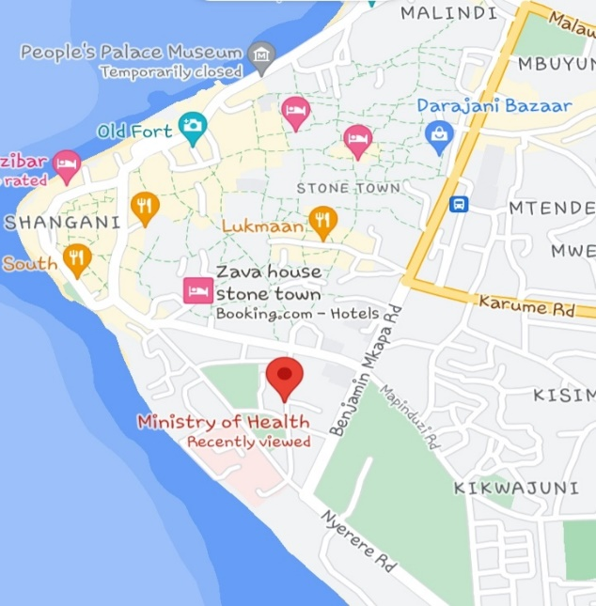
Figure 1 MOHZ Location

2.5 Mission and Vision of Ministry of Health (Mohz)

2.5.1 Mission of the Ministry of Healthy
To provide strategic leadership by the Ministry of Health Zanzibar that will ensure all Zanzibaris secure their right to quality and equitable health services rendered in a cost effective and affordable manner.

2.5.2 Vision of the Ministry of Healthy
A healthy Zanzibar population with reliable, accessible and equitable health care services.

2.5.3 Organization Structure
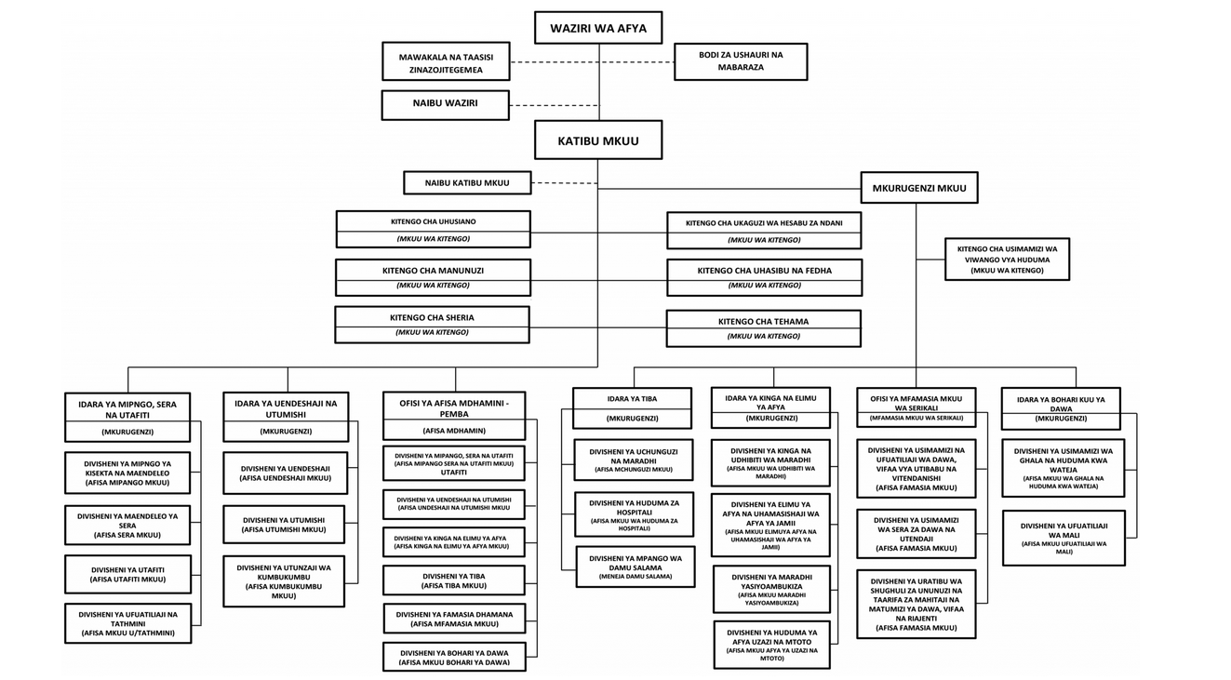
Figure 2 Organization Structure

CHAPTER THREE

3.1 Activities Performed
PRINTER MAINTANANCE
There was a problem of printer that does not print. After doing a check and analysis I realize that there was with cartridge need to be changed.
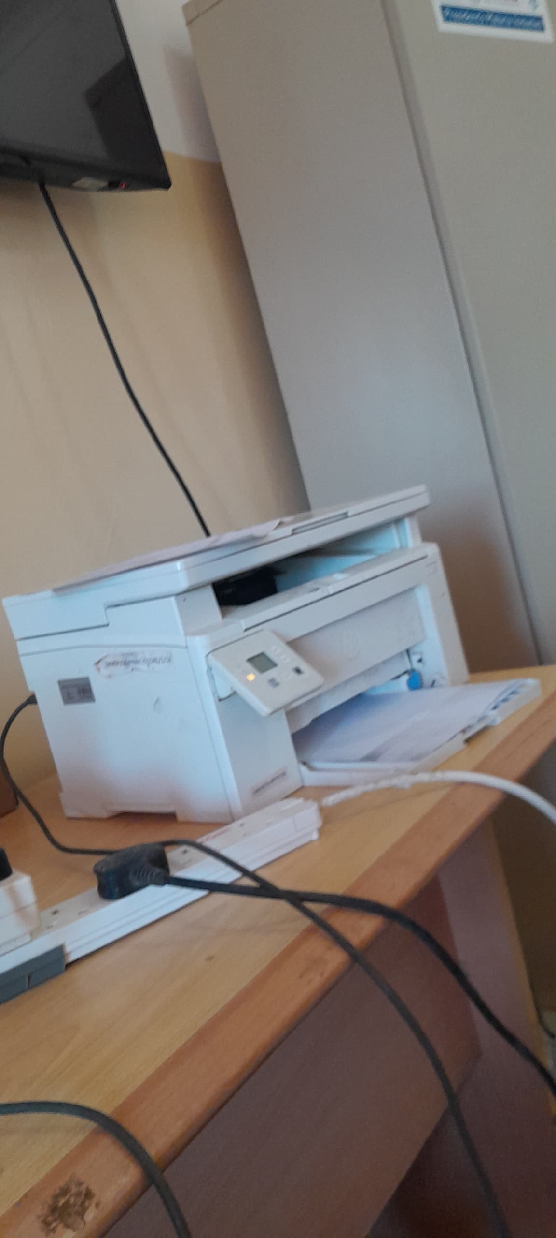

Figure 3 Hp Printer

3.2 How to change the cartridge
Turn off the printer: For safety and to avoid damage, make sure the printer is turned off before starting the process.
- Open the printer cover: Locate and open the printer’s top or front cover to access the cartridges. Some printers might have a specific compartment door for cartridges.
- Wait for the cartridge to move into place: Once the cover is open, the cartridge holder will typically move to the center or accessible area for easy removal.
- Release the cartridge: Depending on the printer model, press the tab, lever, or clip holding the cartridge in place to release it.
- Gently remove the cartridge: Carefully lift or pull the cartridge out of its slot without forcing it and place it with the new one.
- Dispose or store the cartridge properly: If you are replacing the cartridge, store the old one in a proper bag or dispose of it following local recycling guidelines.
- Close the printer cover: Once the cartridge is removed, close the printer cover to finish the process.

3.3 How to configure new Printer
Also, drug distributor department has received a new printer that are required to be configured and set to the network.
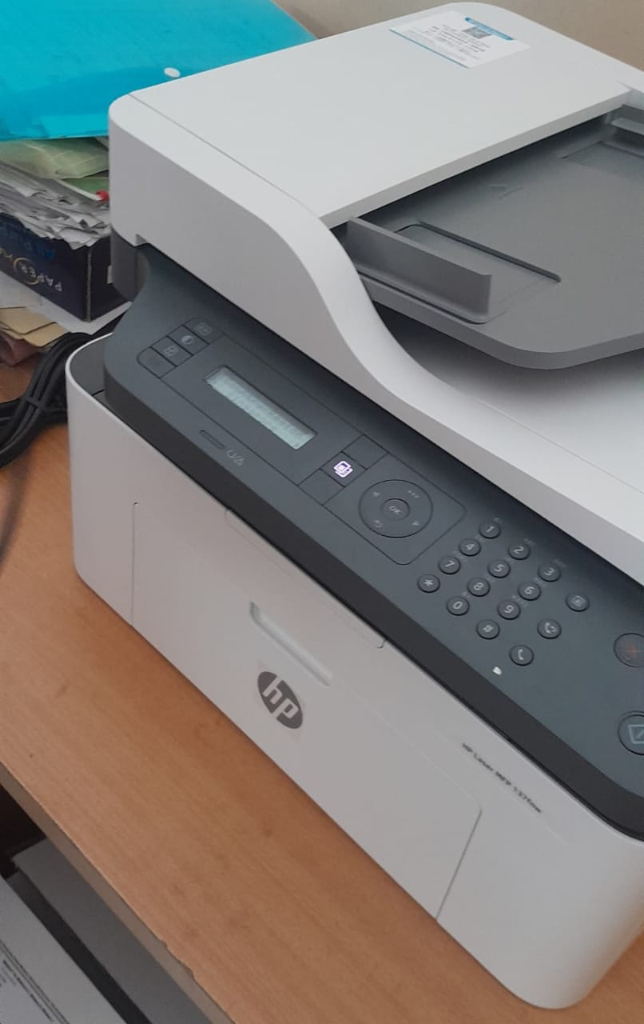

Figure 4 Hp Printer
Unpack and Set Up the Printer:
- Remove the printer from its packaging and place it on a flat, stable surface.
- Connect the power cord to the printer and plug it into a power outlet.
- Turn on the printer and follow the on-screen prompts to set the language, date, and time.
Install Ink Cartridges and Load Paper:
- Open the ink cartridge access door.
- Insert the ink cartridges into their respective slots, ensuring they are securely seated.
- Close the access door and let the printer initialize.
- Load plain white paper into the input tray.
Connect the Printer to Your Computer or Network:
For Wireless Connection:
  - On the printer’s control panel, go to the Wireless or Setup menu.
  - Select "Network Setup" or "Settings," then choose "Restore Network Settings" to enable Wi-Fi setup mode.
  - Within two hours, use the HP Smart app to add the printer and configure the wireless connection.
For USB Connection:
  - Connect the printer to your computer using the provided USB cable.
  - Your computer should automatically detect and install the necessary drivers. If not, install them manually.
Install Printer Drivers and Software:
- Visit 123.hp.com to download the latest drivers and software for your printer model.
- Follow the on-screen instructions to complete the installation.
- Complete the Setup:
- After installation, run a test print to ensure the printer is functioning correctly.
- Configure additional settings, such as the default paper size or print quality, based on your preferences.

COMPUTER MAINTENENCE
This laptop required to change ram and hard disk in order to increase the perfomance of the laptop
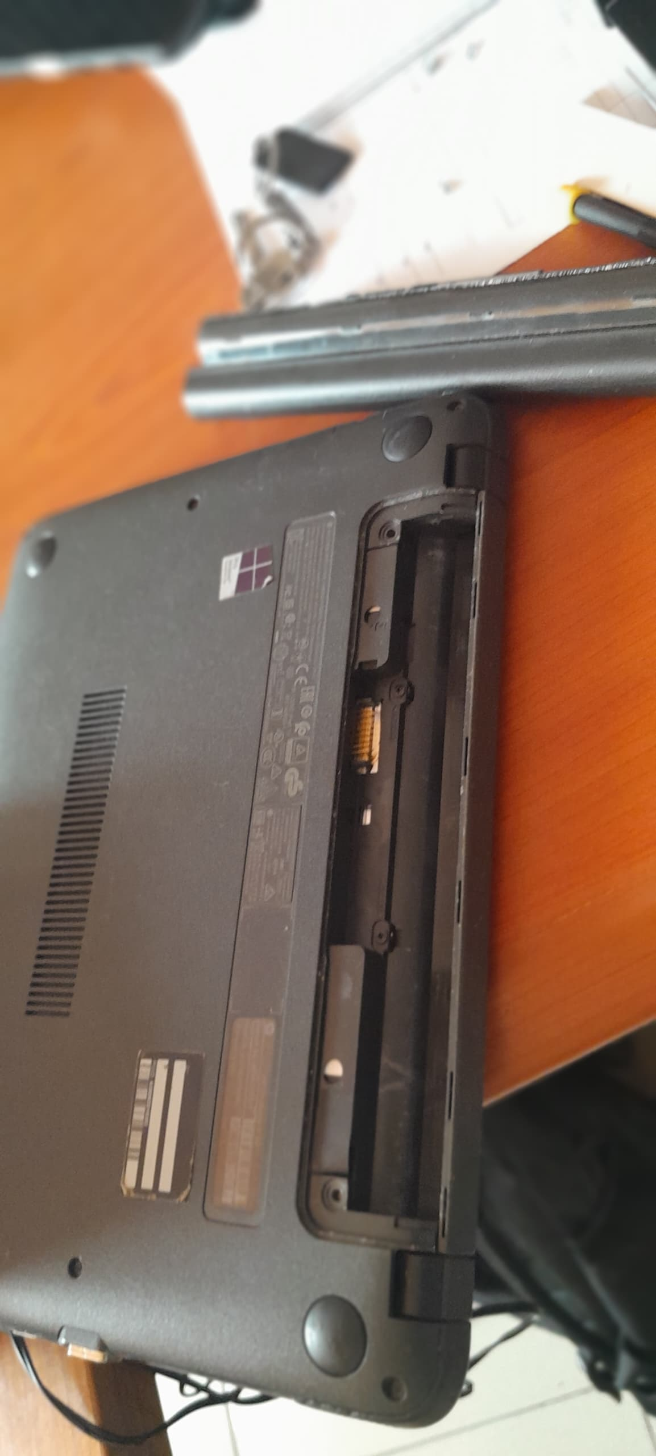

Figure 5 Dell Laptop

3.4 Steps
1. Turn Off and Unplug the Laptop: Make sure it is powered off, unplugged, and remove any connected peripherals.
2. Discharge Static Electricity: Wear an anti-static wrist strap or touch a metal surface to ground yourself and prevent static damage.
3. Remove the Battery (if possible): For laptops with a removable battery, take it out to ensure safety.

Open the Laptop
1. Unscrew the Back Cover: Use a small Phillips screwdriver to remove all screws on the laptop's back cover. Some screws may be hidden under rubber feet.
2. Pry Open the Back Cover: Carefully use a plastic prying tool to lift the back cover off. Start at the edges, and gently work your way around.
Upgrading RAM
1. Locate the RAM Slot: RAM slots are usually under a small metal cover or may be directly accessible.
2. Remove Existing RAM (if needed): Pull the clips on either side of the RAM module outward, and the module will pop up at an angle. Gently pull it out.
3. Install New RAM: Align the new RAM module with the slot at a slight angle, then press down until the clips snap into place.
4. Double-Check: Ensure the RAM module is securely seated.
Upgrading the Hard Disk (HDD/SSD)
1. Locate the Storage Drive: It may be under a mounting bracket or a metal cover.
2. Disconnect the Old Drive:
For SATA SSD/HDD: Unscrew any brackets or holders, then gently pull the drive away from the connector.
For M.2 NVMe SSD: Unscrew the holding screw, slide the SSD out of its slot.
3. Install the New Drive:
For SATA SSD/HDD: Insert the drive into the connector, secure it with any brackets, and reattach screws.
For M.2 NVMe SSD: Insert it at an angle, press it down, and secure it with a screw.
4. Confirm Connections: Ensure the drive is securely connected and properly seated.
Reassemble and Test
1. Reattach the Back Cover: Place the cover back on, press down around the edges to secure clips (if any), and screw it back in place.
2. Reconnect Battery (if removed): Insert the battery back into the laptop.
3. Power On and Test:
For RAM: Check the new memory in system settings.
For Hard Disk: If needed, initialize or format the new drive in Disk
Management (Windows) or Disk Utility (Mac).
WINDOW INSTALLATION
Also, in a lab department they received a new computer which has Window 10 so they need to replace window to window 11.
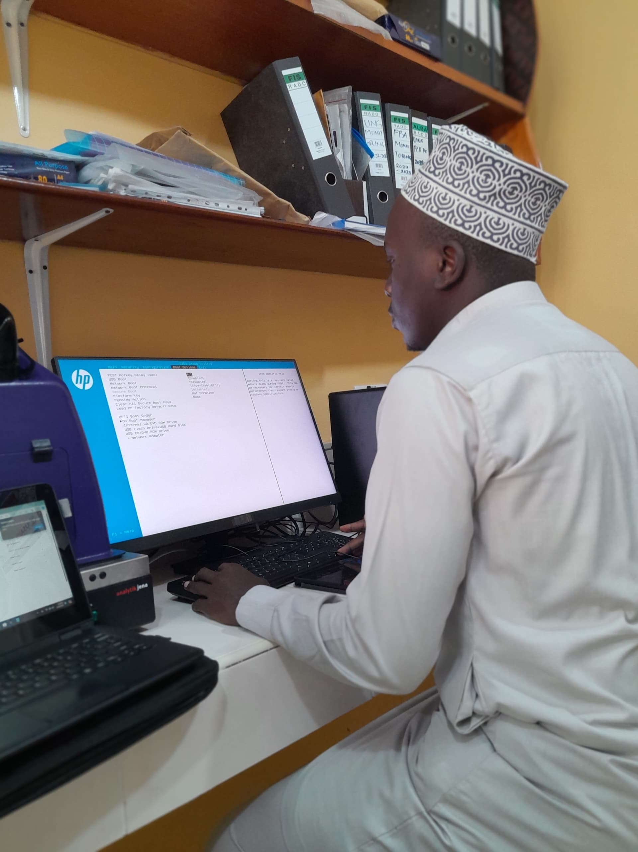

Figure 6 Window Installation
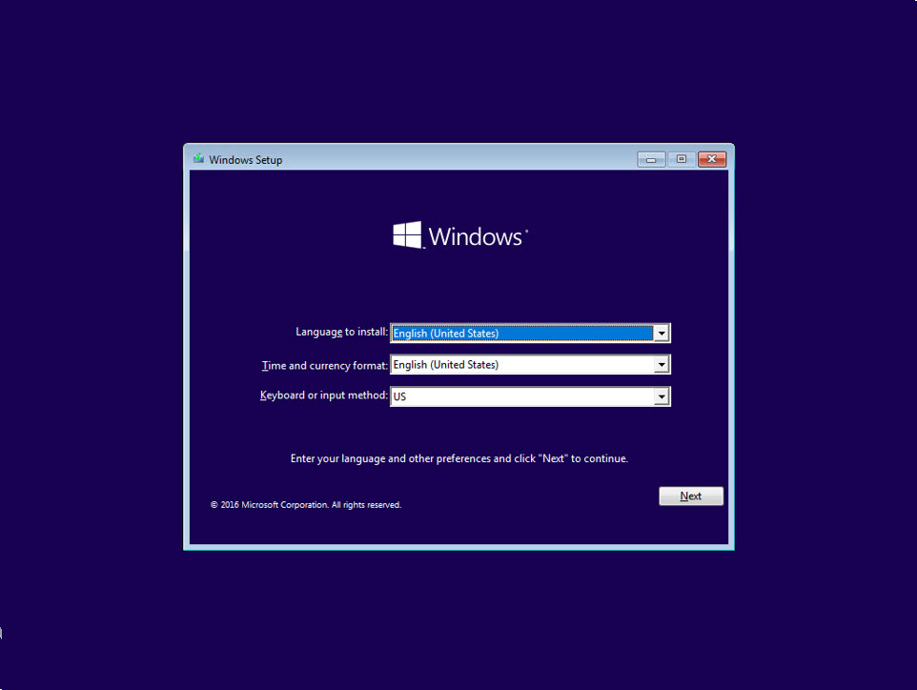
Figure 7 Window Installation

3.5 Step for window installation
1. heck System Requirements
Ensure your PC meets the minimum system requirements for Windows 11:
Processor: 1 GHz or faster with 2 or more cores on a compatible 64-bit processor.
RAM: 4 GB or more.
Storage: 64 GB or more.
System Firmware: UEFI, Secure Boot capable.
2. Download Windows 11
Visit Microsoft's Windows 11 Download page.
Choose one of the following:
Create Windows 11 Installation Media: Make a bootable USB drive or DVD.
Download Windows 11 Disk Image (ISO): For manual installation.
3. Create a Bootable USB Drive (if clean installing)
Insert a USB drive (at least 8 GB).
Use Rufus or Windows Media Creation Tool to create a bootable USB with the Windows 11 ISO.
4. Back Up Your Data
Back up important files to an external drive or cloud storage.
5. Boot from Installation Media
Insert the USB drive and restart your PC.
Enter the BIOS or Boot Menu (usually by pressing keys like F2, F10, Delete, or Esc during startup).
Select the USB drive to boot from.
6. Install Windows 11
Language, Time, and Keyboard: Choose your preferences and click Next.
Click Install Now.
If asked, enter a product key, or select "I don’t have a product key" to enter it later.
Select Custom: Install Windows only (for a clean installation) or Upgrade (to keep files and settings).
Choose the partition where you want to install Windows and click Next.
7. Wait for Installation to Complete
The PC will restart multiple times during installation.
8. Initial Setup and Personalization
After installation, Windows will guide you through initial setup, including:
Connecting to Wi-Fi.
Signing in with or creating a Microsoft account.
Setting up preferences like privacy settings.
9. Install Drivers and Updates
Go to Settings > Windows Update to install the latest updates.
Update drivers from Device Manager if necessary.
10. Restore Files and Reinstall Applications
If you backed up files, restore them to your system.
Reinstall any necessary applications.
REQUIREMENT DESIGN
one of the tasks I have been given is to prepare or to design Use case diagram Class Diagram and Sequence Diagram based on the requirement. So, I designed them using lucid chart web site.

USE CASE DIAGRAM
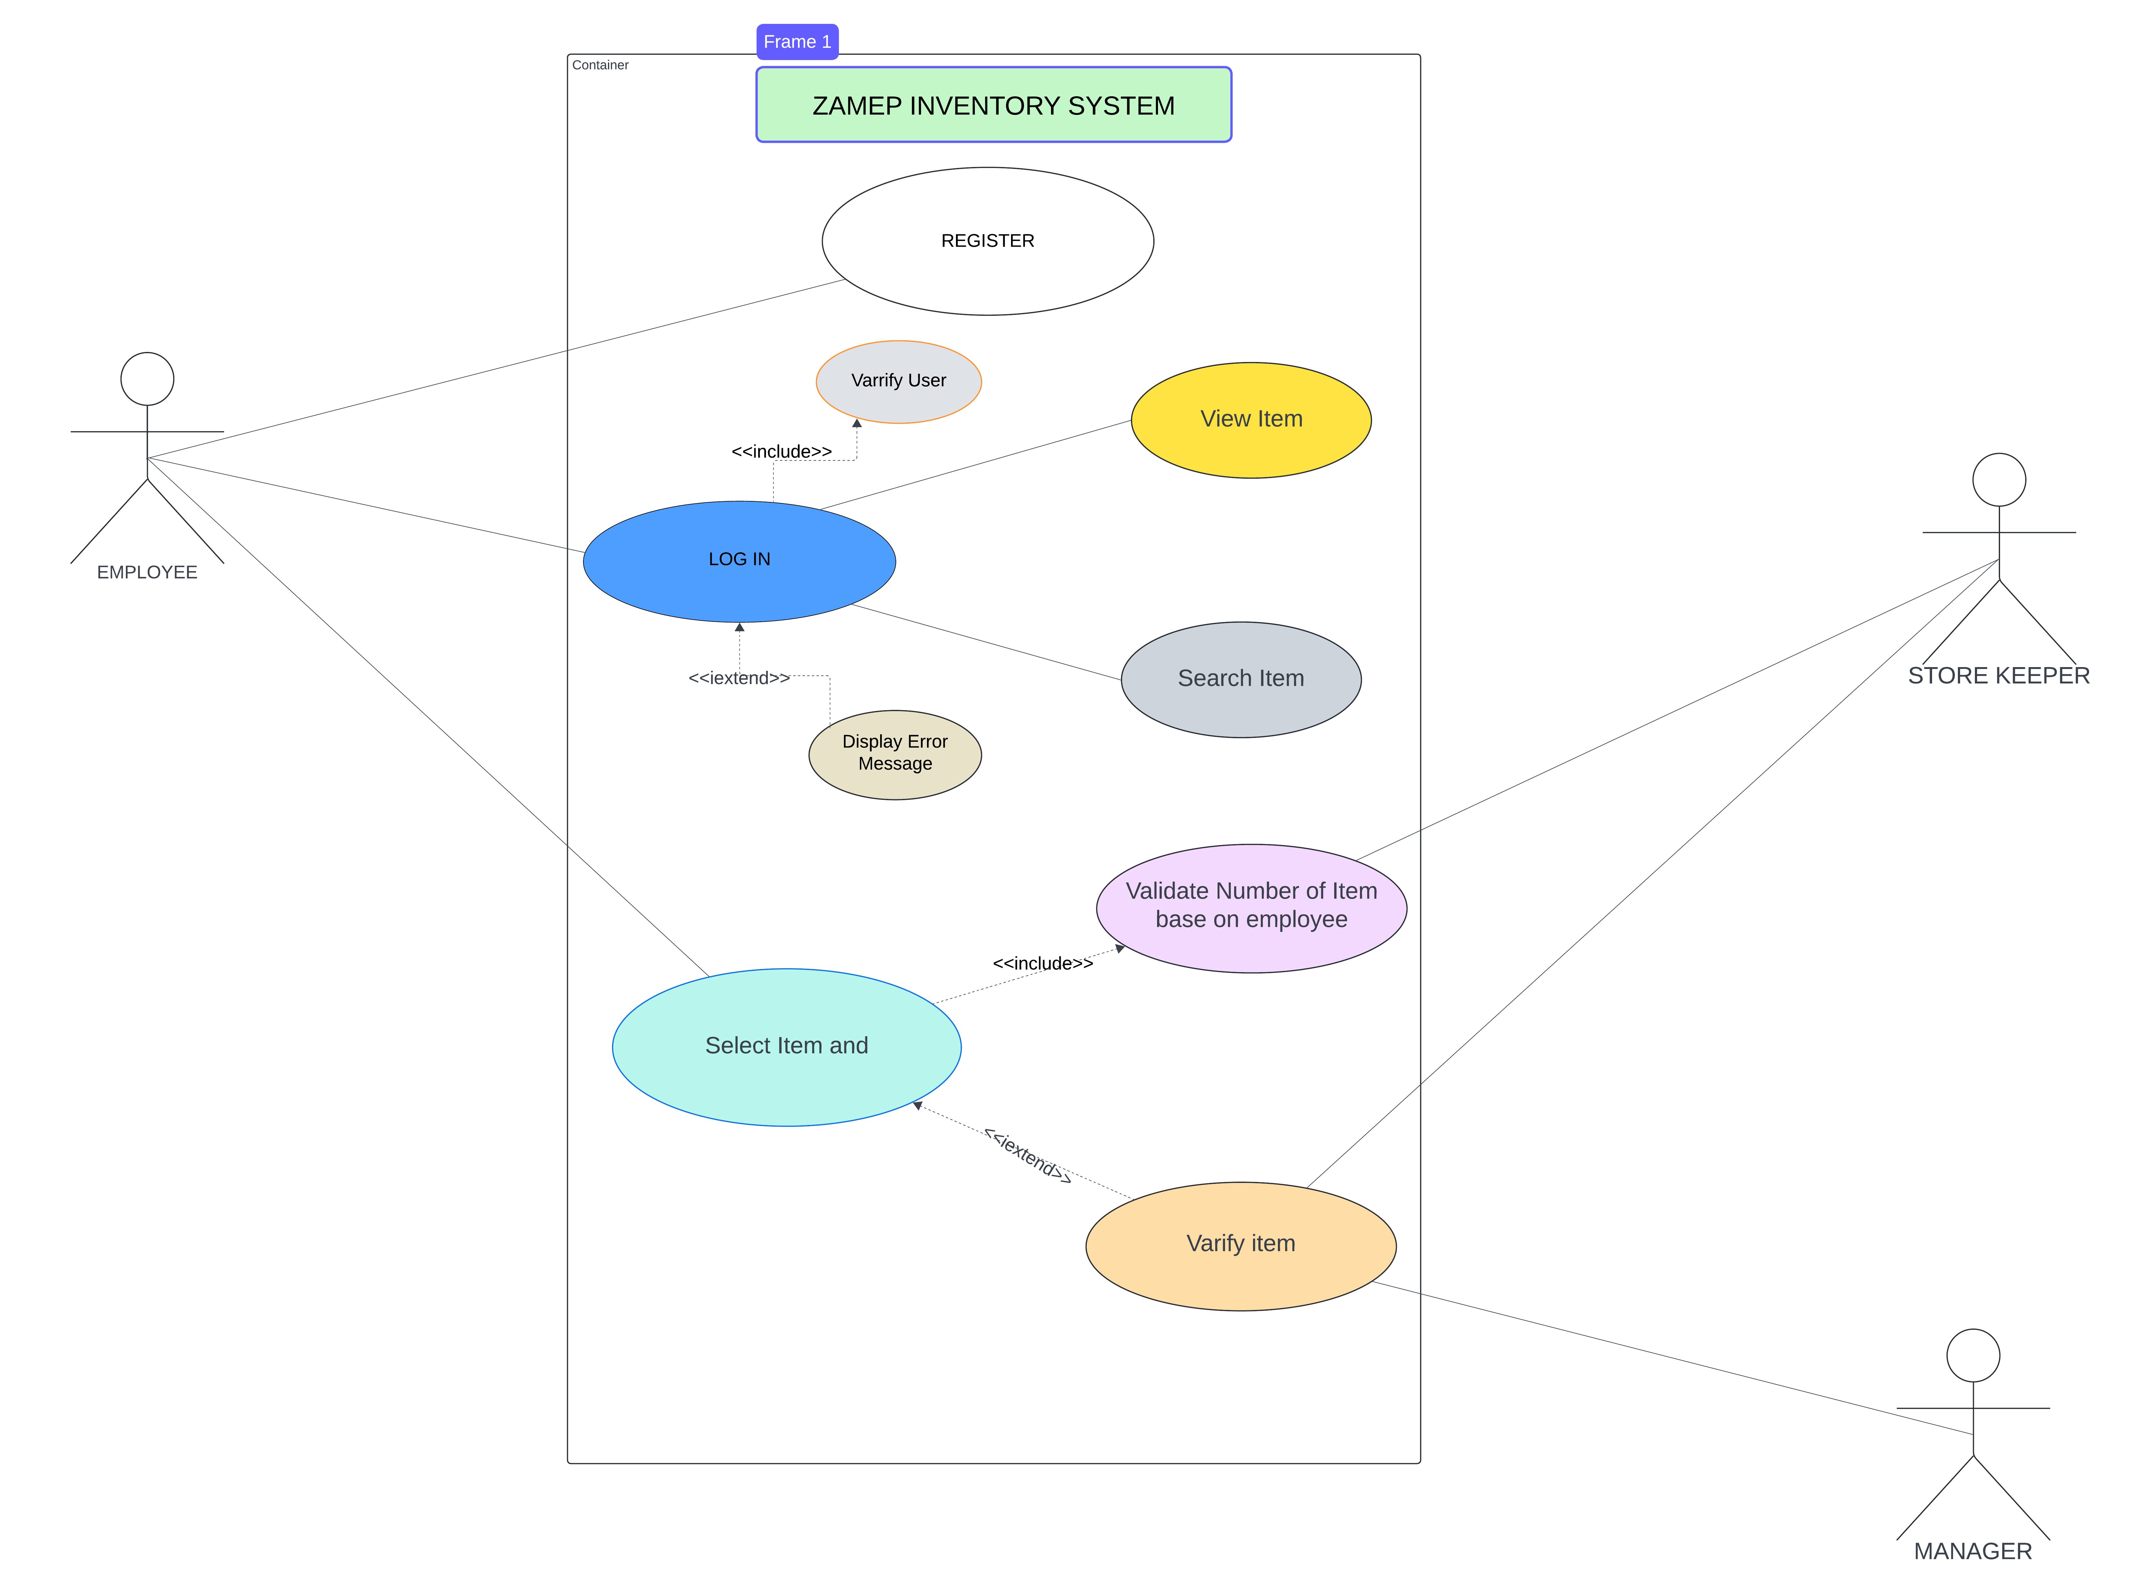
Figure 8 Use Case Diagram

CLASS DIAGRAM
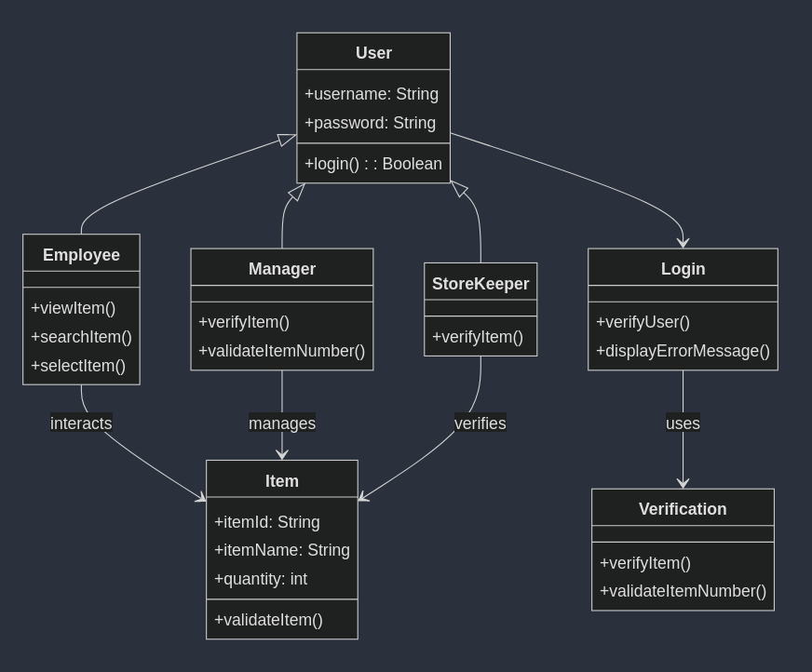
Figure 9 Class Diagram

SEQUENCE DIAGRAM
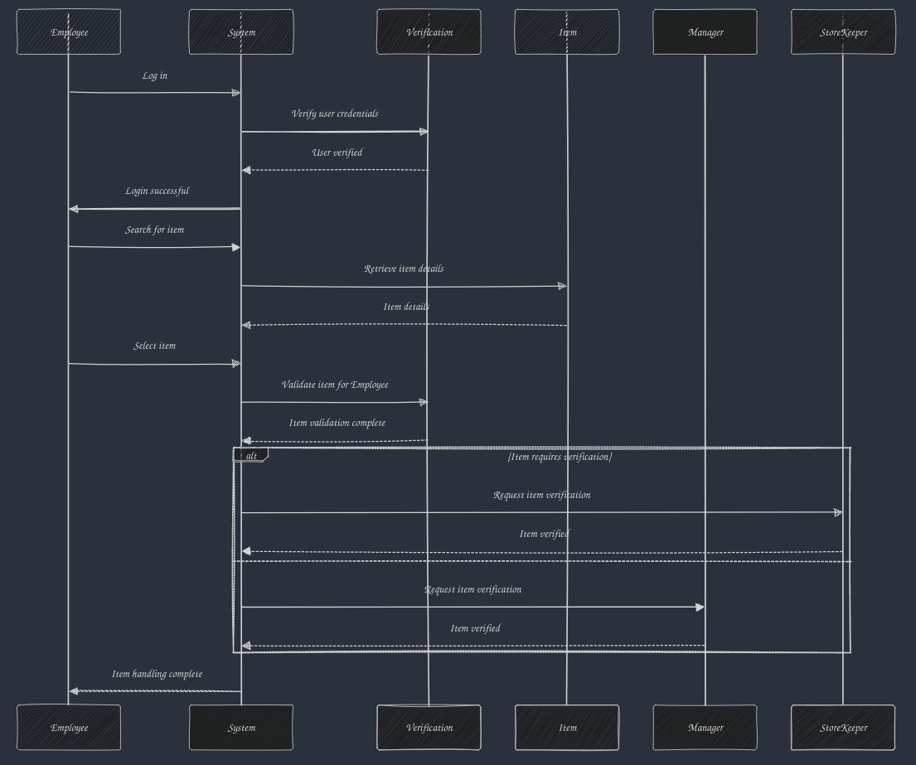
Figure 10 Sequence Diagram

3.5.0 Working Environment
When we were in PT the working environment was good and comfortable for the PT students and staff of MOHz office. We worked together as a team and accomplish different task meant to be finished on time. The staff and other member in office made us to understand one another ways of working and to achieve a goal.
During the training, we develop a Inventory System where everyone get a chance to contribute their ideas and opinions. Also, we have learnt a different task and lessons from supervisor Mr. Juma and other members in the office. Among the lessons we learnt during PT was, how to live with people in working area, how to be responsible on your duties and how to accomplish its, how business intelligence and analysis be and so on. The organization activities done in ICT department at MOHz office such as: -
- Maintenance.
- Networking.
- System Design
- And Operational task.

3.5.1 Duties and Task Performed Interesting
A system called Inventory Management using a using javascript was a very interesting task for me because I have got ability to learn everything that I need to know about System designing. This System gave me a great knowledge and skills.

3.5.2 Challenge Tasks
During implementation of different task at MOHz office I had learnt a lot of tasks which helped me to know professionally how work are done and how overcome the consequences occurred during perform work and the challenge that I faced during my PT time are: -
- Working time was not enough to accomplish a task, there was a many different tasks and they are required to accomplished at the same time, because of the limit time I was unable to complete the tasks.
- Internet access, when I was committing my tasks the access of internet was needed from starting day of my PT up to the ending day of my PT, so I was getting the difficulty to complete the task that my supervisor gave me and it was cost me on my finance.

3.5.3 Expectation Before Going Practical Training
Before going to the field, I had some expectation due to the knowledge and experience that I got from my teacher at the university and some of them were: -
- Learning skills and development opportunities will be offered continuously to the student.
- The training will be simple and effectively to the students who is going to the organization.
- The Practical training will relevant skills and knowledge of doing a work to the PT students.
- The Practical training contents will be easier and simple to understand that will make the students to be a more responsible.

3.5.4 Attachment Relevant and study gap
Most of the tasks I've worked on have aligned closely with what I studied at university. These tasks include gathering and preparing system requirements, developing systems, designing requirements, and performing system maintenance, which has also involved tasks like installing Windows. This experience highlights my expertise in information technology and software engineering.

CHAPTER FOUR

4.1 Lesson Learned and Challenge Faced

4.1.1 Lesson learned
During my field training, the following are the things that I learned in MOhz office: -
Networking:
I have learned different task related to networking issues how to troubleshooting networking problem, installation of window, configuration of router, installation of server, sharing file using a peer-to-peer network and other task that done during my PT time.
Database:
I have learned how to create database, table, connecting the database with php and other some basics of SQL operations such as to create, add, delete, insert and select using a command and how to use a xampp software in database.
Maintenance:
I have learned how to install a printer, Ethernet cable creations, installation of antivirus and updating and how to solve a maintenance problem like PC fan failed to work, replacement of keyboard, replacement of fan, pc freeze suddenly and become slow & so on.

4.1.2 Challenges faced
The challenge that I have faced during my field training are as follow:
Maintenance:
The challenges that I faced in this part of maintenance were Installation of hp laser printer and Installation of antivirus setup. Where on installation of hp laser printer was difficult for me to install so I download the printer software, I connect the network cable to the printer, then on the printer control panel, I open the Network setup and select to show the IP address then I went to LaserJet and download the software to install and click next and finally I customize the software selection. & Click finish to complete installation.
Where on installation of antivirus setup, I Install the Kaspersky set up (cd) in the PC, I enter the activation code, install and scan for a virus, then I updates until complete and finally I set the auto Protections and Finish.
Networking:
The challenges that I faced in this part of networking were troubleshooting network problem in the organization, I troubleshooting different problem such as connecting PC with monitor where I booting up the PC with the HDMI cable that was connected to a monitor (TV) and connect the HDMI cable to both PC and monitor. Also, Internet was fine but wasn’t connected where I turn off the WI-FI connection and restart the PC again. And a thermal printer was not working where a thermal printer was not connected between printer and computer and I reconnect the cable and turn on the thermal printer & everything back to a normal.

4.2 Employment Prospects
In the future, I would like to apply for a job in the Ministry of Health Zanzibar and work in Web development department because they saw me how capable I am able to develop a software, applicants, blog and website a during the Practical Training.

CHAPTER FIVE

CONCLUSION AND RECOMMENDATION

5.1 Conclusion
In generally, PT has been changing my life experiences in my Information Technology career have learnt a lot of thing and appropriately that a theory without practical is no means, so should considered practical during theory. I conclude that the training I carried out at Ministry of Health was very important and convenient to me because it has taught me so many knowledge in the world of technology, I sincerely thanks the university supervisor and industrial supervisor together with team member of Ministry of Health for their support that now I am better person in both workingly and experiencedly.

5.2 Recommendation
This is my first industrial training in my University and I strongly recommend that lectures should provide more frequent monitoring and support to the students who are undergoing to the industrial training because there may be a problem faced to the students during at the workplace. Also, supervisor should responsible for helping the students to conduct industrial training by demonstrating and guidance them about organization.

