**Malla Reddy Institute of Engineering & Technology**

**(Sponsored by Malla Reddy Educational Society)**

**ISO 9001-2008 Certified institution, Affiliated to JNTU, Hyderabad**

**Maisammaguda, Dhulapally (Post via Hakimpet), Sec’Bad - 500 100.**

**Department of Electronics & Communication Engineering**

**Report of Faculty Development Programme**

**on**

**“Protocols and Architectures for Wireless Sensor Networks”**

A FIVE days Faculty development programme was successfully conducted in the **Malla Reddy Institute of Engineering & Technology**, on 28th November 2016 – 2nd December 2016 by Department of **Electronics & Communication Engineering**. The FDP programme received an overwhelming response with 45 participants.

**Date wise brief Report for each of the five days FDP programme is given:**

**Date: 28th November 2016 (First Day)**

**Inaugural Session**

The programme was inaugurated in the morning at auditorium on 28th November 2016 by hands of Dr. K.E.Balachandrudu (Principal, MRIET), Dr.J.Vishwanatha Rao (Acadamic Dean, MRIET), Prof. R.Madan Mohan (Director, Academics, MRGI), Dr. H.L.Viswanath (Guest of honor), Dr. Manoj Priyatham.M(Guest of honor), Dr. VSSN Srinivasa Baba(Guest of honor) & Dr. M.N.Yadav (Coordinator, FDP)

In welcome speech, Hon. Principal Dr. K.E.Balachandrudu shared his views with the faculty participants that if faculty wants to develop themselves and their students, then attending such faculty development programmes would enhance their skills of teaching concepts practically.

In the inaugural speech, Hon. Dr. H.L.Viswanath shared his views on faculty development. He further added that this programme will provide special benefits to faculty members. The inauguration programme ended with vote of thanks by Dr. N.Rajesha.

In the second session, resource person **Dr. VSSN Srinivasa Baba** started his discussion with very basic concept of **Wireless Sensor Networks.**

**Date: 29th November 2016 (Second Day)**

On the second day, **Dr. H.L.Viswanath** started his discussion on **Wireless Sensor Networks-Challenges in under Water Applications,** and also discussed about IOT (Internet of Things).

**Date: 30th November 2016 (Third Day)**

On the third day, **Dr. Manoj Priyatham.M** highlighted the **Importance of Wireless Sensor Networks.** and also discussed about the usage of Wireless Sensor Networks now a days.

**Date: 01st December 2016 (Fourth Day)**

On the fourth day, **Dr. N.Rajesha** started his discussion on **Wireless sensor platforms: OS Development and Overview.** And have a lab session in the afternoon.

**Date: 2nd December 2016 (Fifth Day)**

On the fourth day **Mr. Raj Gopal** have hands on session on **Wireless Sensor Networks by using NS2.**

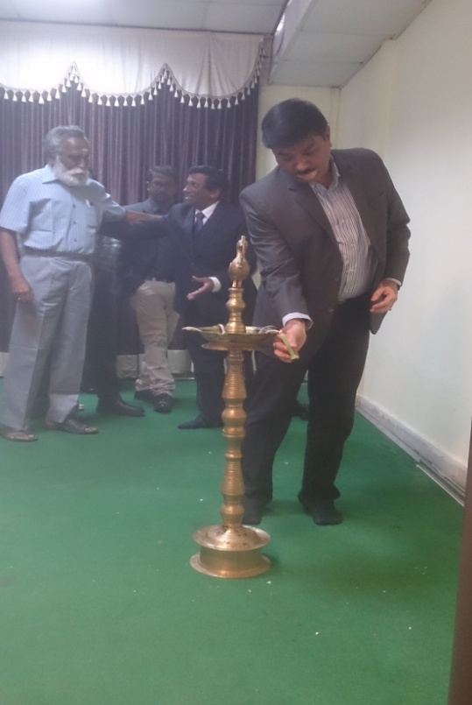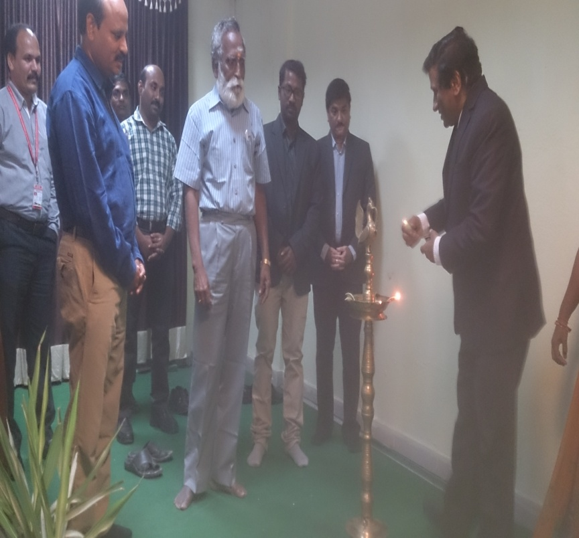

***Dr. K.E.Balachandrudu (Principal, MRIET) Dr. H.L.Viswanath (Guest of honor)***

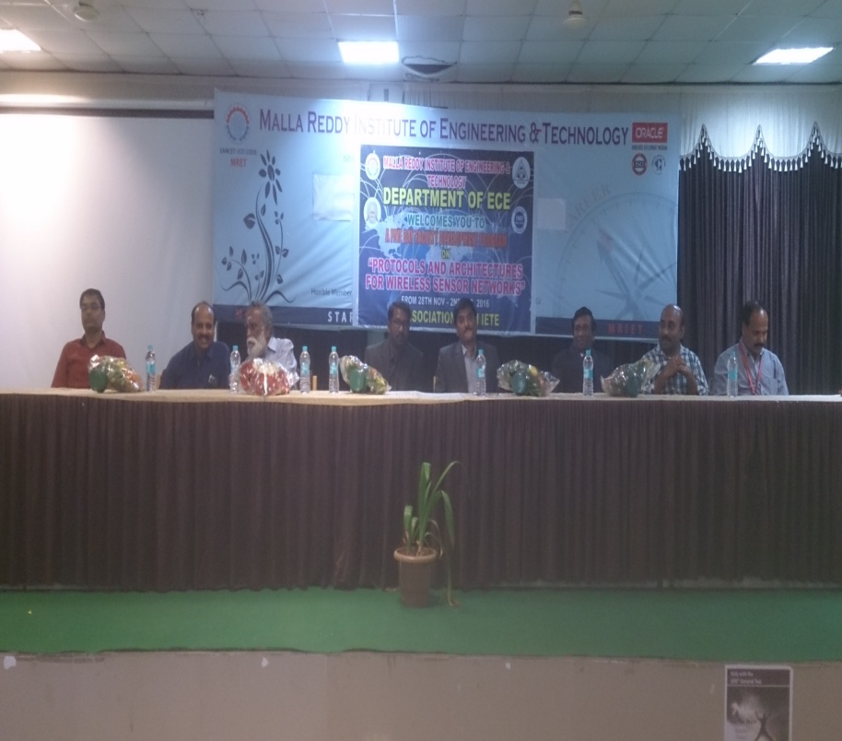 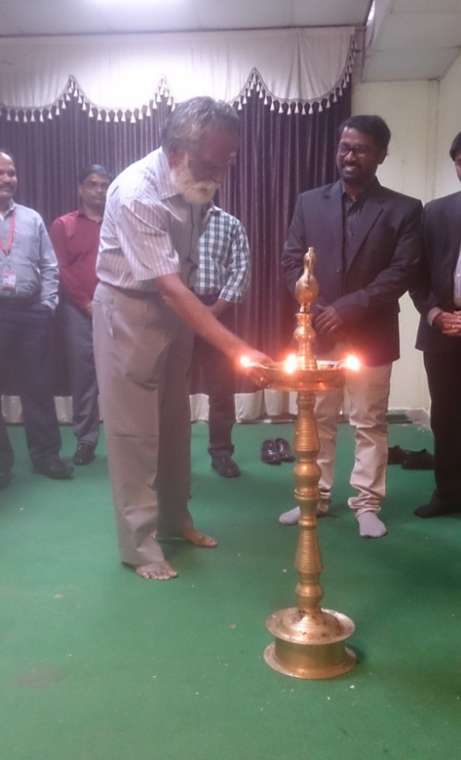

***Inaugural Session Prof. R.Madan Mohan (Director, Academics, MRGI)***

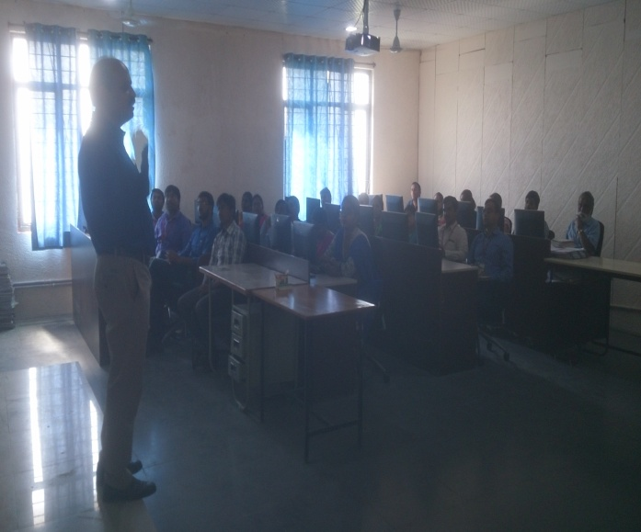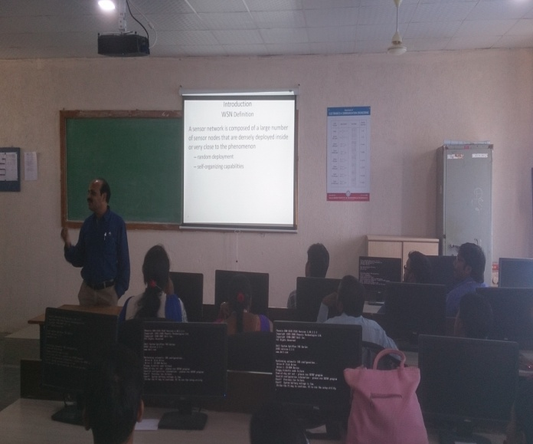

***First Day; Dr. VSSN Srinivasa Baba (Guest of honor)***

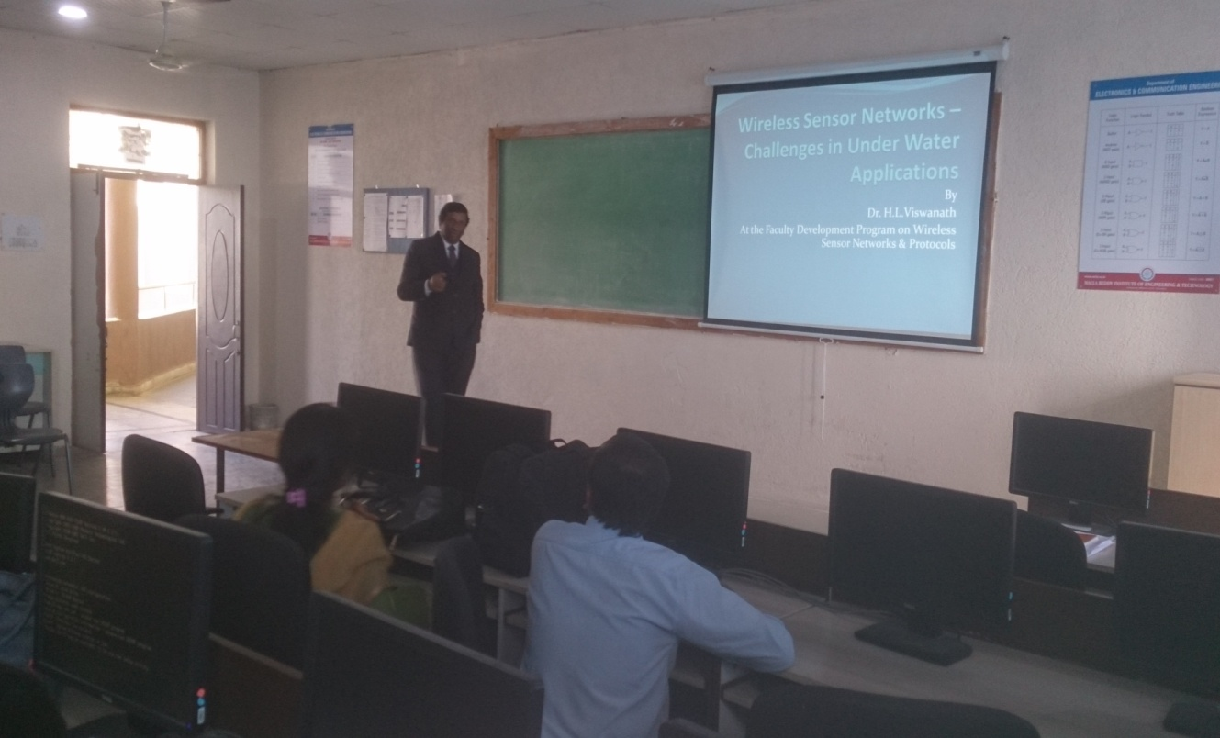

***Second Day; Dr. H.L.Viswanath (Guest of honor)***

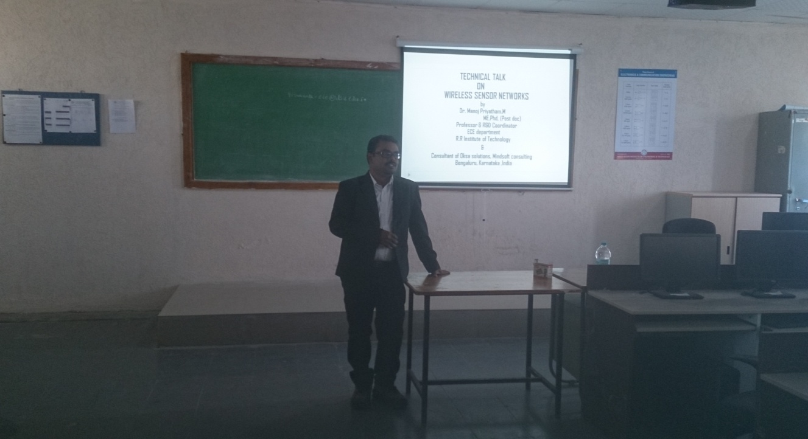

***Third Day; Dr. Manoj Priyatham.M (Guest of honor)***

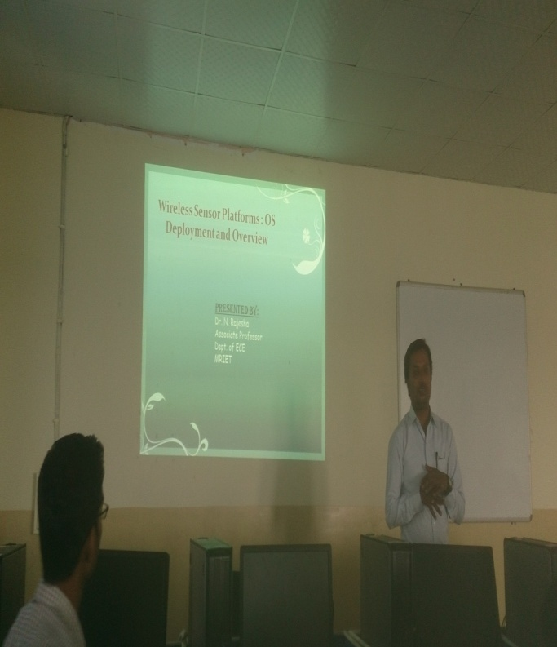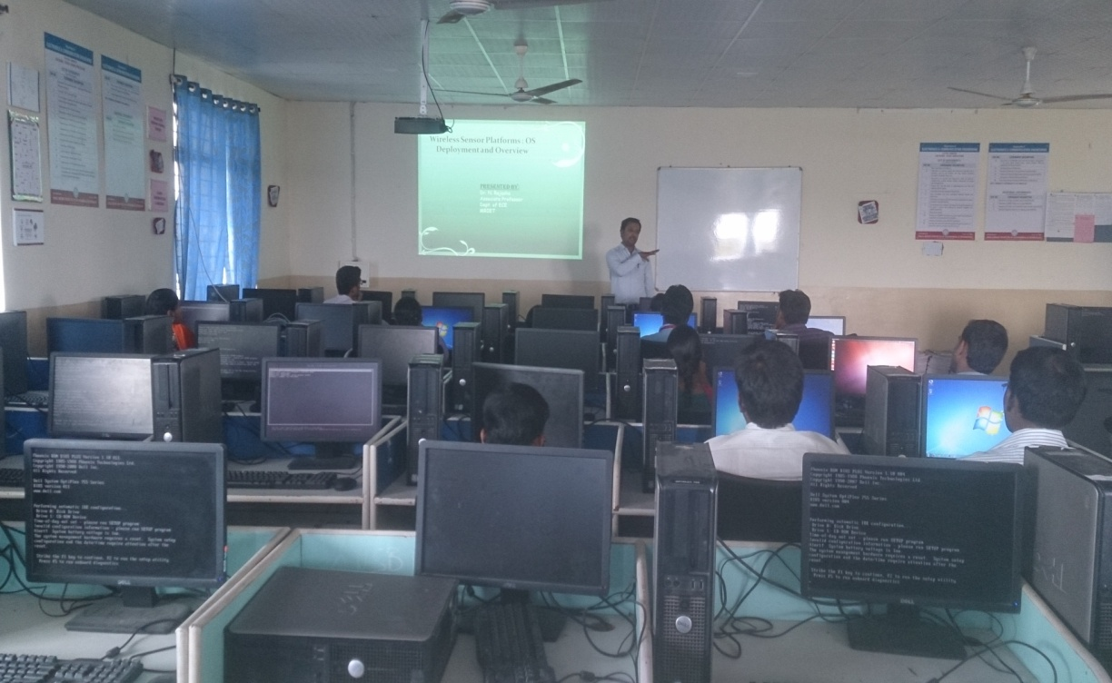

***Fourth Day; Dr. N.Rajesha***

Prof. M.N.Yadav

(Coordinator-FDP)