**9. E-BUDGET**

1. **ABSTRACT**

All departments are expected to submit their entries against various expense heads in this year. An automated system is required for entering & monitoring of proposed budget plan that includes Account heads, Budget figures to given as a breakup for each quarter.

1. **INTRODUCTION:**

Budgeting, corporate governance, capital markets, accounting practices, and investment appraisal methods. To discuss these concepts and their interrelationships, some relevant theories are discussed including the following: agency theory, stakeholder theory, stewardship theory and resource dependence theory. The capital market variables include interest rates (cost of capital) and agency costs, which impact on corporate governance, which in turn have an impact on corporate governance, which in turn have an impact on capital budgeting decisions.

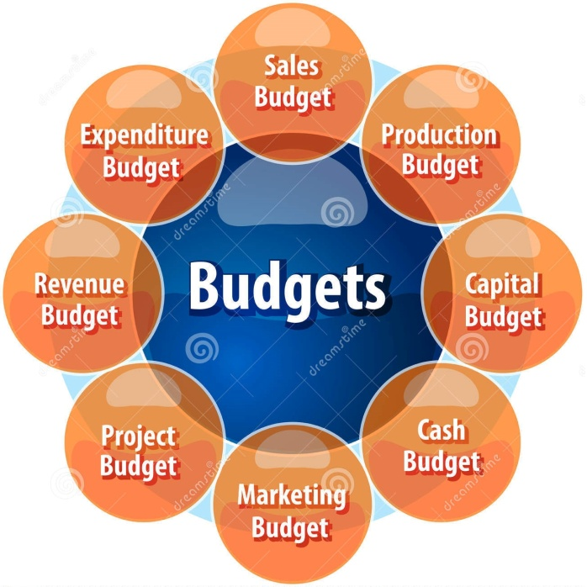

Fig. 2.1 Budget

It is mainly supplied by capital markets including commercial banks, investment banks and other financial institutions such as insurance companies, superannuation funds, etc. The company (the borrower) and the financial institution (the lender) enter into a contract which specifies the interest rate to be charged and other restrictive debt conditions which have to be observed during the life of the debt. Through the interest charges and other conditions imposed on the borrower (investor), capital markets influence the firm’s corporate governance, agency costs and capital budgeting decisions.

Therefore, making capital budgeting decisions without considering capital market interactions ignores one of the major factors that influence investment appraisal decisions.

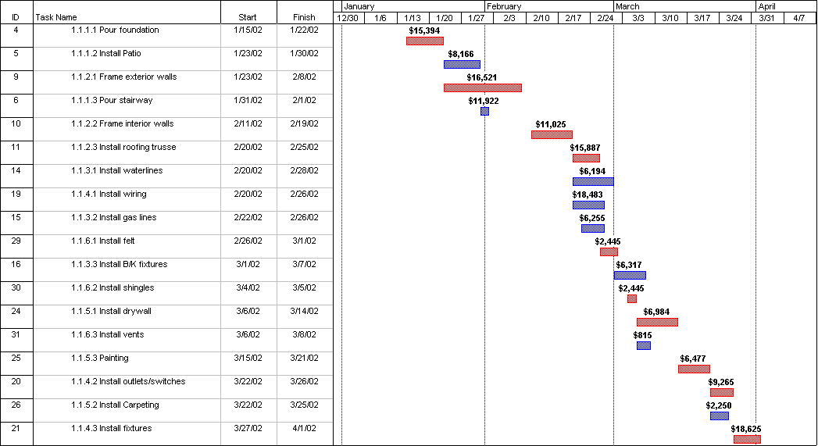

Fig2.2 Schedule and Cost

1. **EXISTING SYSTEM :**

Because budget allocations have changed very little from year to year, the current budgeting system must be labeled as incremental. Incremental budgeting is characterized by relatively few new investments during healthy financial years and across-the-board cuts in difficult years. MTU has attempted to add an element of non-incremental budgeting by creating a pool of funds to be allocated for projects deemed to be of significant strategic importance to the university. Unfortunately, the current financial crisis has minimized the size of the pool. Across-the-board cuts and target of opportunity savings are used, not to make strategic resource changes, but to move the institution quickly toward financial safety with the least amount of organizational resistance. In fact, target of opportunity cuts can be anti-strategic, falling on strategically important areas. Rather than foster strategic change, incremental budgeting.

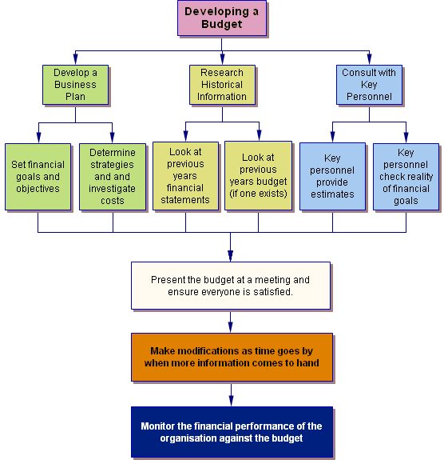

Fig. 3.1.: Existing system

* 1. **DISADVANTAGES OF EXISTING SYSTEM:**
* The major strength of budgeting is that it coordinates activities across departments.
* Budgets translate strategic plans into action. They specify the resources, revenues, and activities required to carry out the strategic plan for the coming year.
* Budgets provide an excellent record of organizational activities.
* Budgets improve communication with employees.
* Budgets improve resources allocation, because all requests are clarified and justified.

1. **PROPOSED SYSTEM:**

The main objective of this project is to reduce the congestion when data transfers between source and destination. When data transfers between source and destination there may be chances of occurrence of congestion and also it monitor when congestion occurs. If so that has to be intimated or warned to the user. In this System, using several algorithms viz. Leaky bucket algorithm and Virtual scheduling algorithm congestion can be avoided. Virtual scheduling algorithm monitors the congestion occurrence, when congestion occurs it intimates or warns user and simultaneously intimates when the router is free and data transferred successfully to destination. This system can be implemented in a real network to control the traffic occurred in a network. User can get to know the status of the router whether router is busy in controlling the inflow and outflow of data to transfer data to the destination.

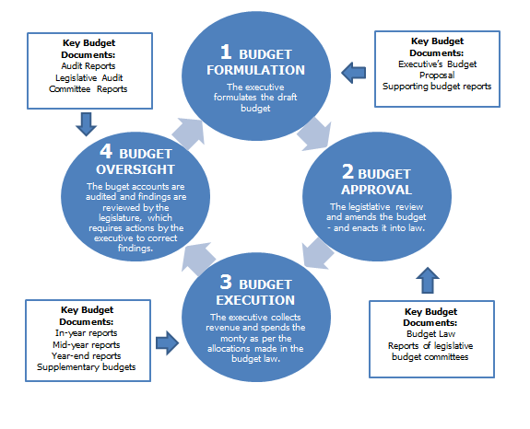

Fig. 4. Budget Formulation

1. **CONCLUSION:**

Budgeting allows you to make long- and short-term projections about your financial situation, prevent crises, get the most out of your money, plan for major life changes and enjoy peace of mind. Budgeting systems - ranging from a simple notepad and pen to online financial management software - are available for all needs and preferences.